**Q. 1 Functional Requirements:**

**Answer:** Functional requirements are requirements which shows ability of system to meet user needs.

|  |  |  |  |
| --- | --- | --- | --- |
| **Req ID** | **Req Name** | **Req Description** | **Priority** |
| FR001 | Farmer download application | Farmer should able to download application. |  |
| FR002 | Farmer registration | Farmer should able to register in application. |  |
| FR003 | Browse products | Farmer should able to browse products of fertilizers, seeds, pesticides. |  |
| FR004 | Search products | Farmer should able to search required specific product. |  |
| FR005 | Login application | Farmer should able to login application using their credentials. |  |
| FR006 | Add a User | Farmer should able to add ad new user in application by submitting their email ID and password. |  |
| FR007 | Payment | Farmer should able to make payment through Cash on Delivery, UPI and cards. |  |
| FR008 | Delivery confirmation | Farmer should able to get delivery confirmation to their email ID. |  |
| FR009 | Order Tracking | Farmer should able to track their order through delivery tracker. |  |
| FR010 | Manufactures registration | Manufacturers should able to register in application. |  |
| FR011 | Manufactures Login | Manufacturers should able to login in application. |  |
| FR012 | Upload of products | Manufactures should able to upload and display their products. |  |
| FR013 | Mail confirmation | When manufactures upload products they should get mail confirmation. |  |
| FR014 | Delivery tracking | Manufactures should able to track delivery of their products. |  |
| NFR101 | Page Loading Time | Each page should load within 2 sec of time. |  |
| NFR102 | WCAG 2.1 | The system must meet Web content accessibility guidelines WCAG 2.1. |  |

**Q. 2 Wireframe and Prototype**

**Answer: Wireframe for first page**

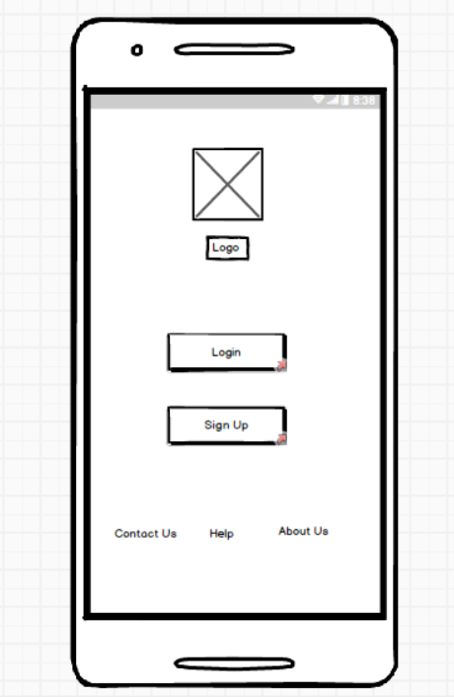

**Wireframe for Login**

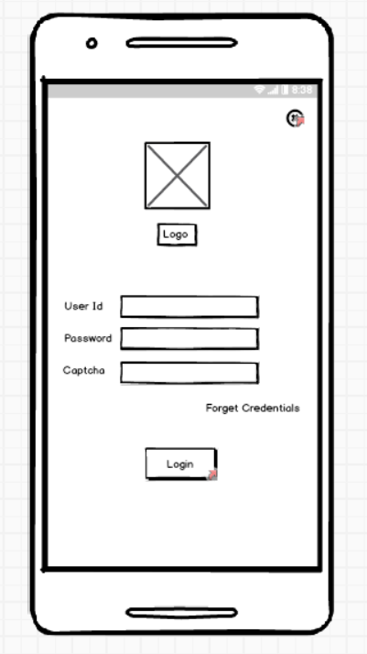

**Wireframe for Sign Up Page:**

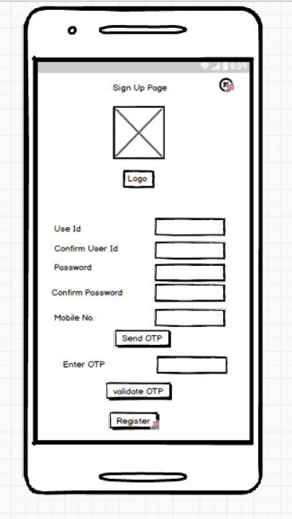

**Wireframe for Home Page:**

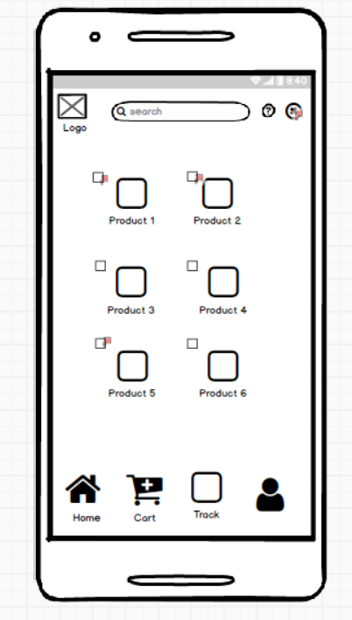

**Wireframe For Order Confirmation:**

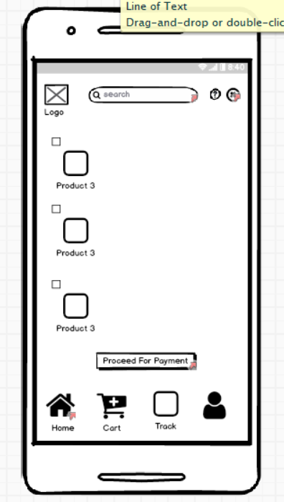

**Wireframe for Payment:**

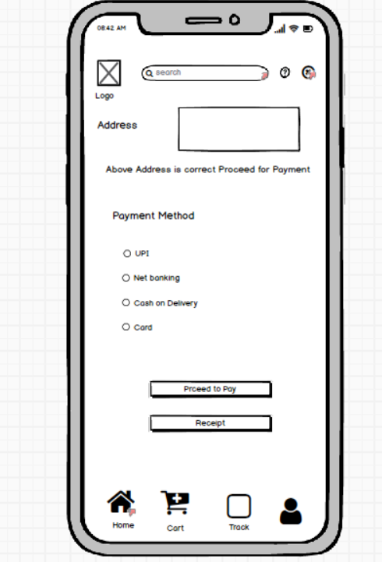

**Q. 3 – Tools (Visio, Balsamiq)**

**Answer:**

**1. Balsmiq:**

-It is a type of wire framing tool.

-It is a low fidelity wire framing UI or UX design.

-Can be best used for quick UI sketches.

-It can be used on the platforms like the web and desktop.

**2. MS Visio:**

-It is a type of diagramming and vector graphics tool.

-It is medium fidelity in drawing Flow Charts, Network Diagrams.

-Best to draw flowcharts and network diagrams.

-It can be used on the platforms like the web and the desktop.

**3. Axure RP:**

-It is UI or UX prototyping or wire framing tool.

-Has High fidelity interactive prototypes and wireframes.

-Best to draw interactive UI and Wireframes.

-It is used on platforms like Windows and Mac.

**Q.4 RTM**

**Answer:**

RTM (Requirements Traceability Matrix) is a document which shows requirements are met as per time and requirements of customer.

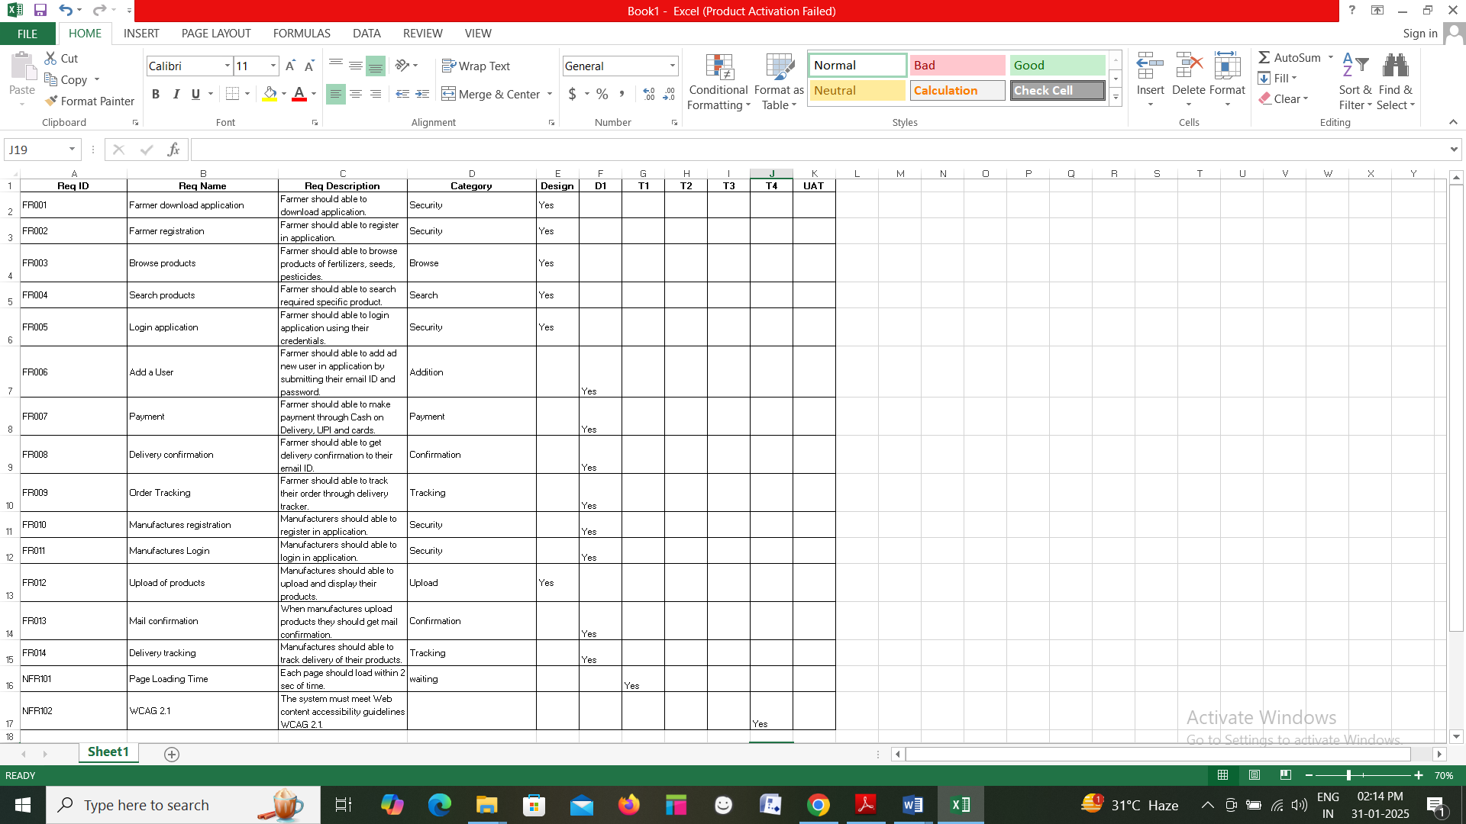

**Q.5 Test Case Documents**

**Answer:**

|  |  |  |  |
| --- | --- | --- | --- |
| **Test Case ID** | TC_001 | **Test Case Name** | Login |
| **Project ID** | PR_001 | **Project Name** |  |
| **PM ID** |  | **PM Name** |  |
| **Test Strategy ID** |  | **Tester ID** |  |
| **Test Plan ID** |  | **Tester Name** |  |
| **Test Schedule ID** |  | **Date of Test** |  |
| **Scenario** | Verify the login Functionality | | |
| **Link to that page:** |  | | |
| **Input Data** | Enter valid User id and Valid Password | | |
| **Expected Behaviour** | User will be successfully logged in. | | |
| **Actual Behaviour** | User will be successfully logged in. | | |
| **Comments** |  | | |
| **Result (Pass/Fail)** | Pass | | |

**Q.6 DB Design**

**Answer:**

Database Schema is diagram which shows how data is organized in database and how it is related with each other. ER diagrams are diagrams which shows relationship between two entities.

**Database Schema:**

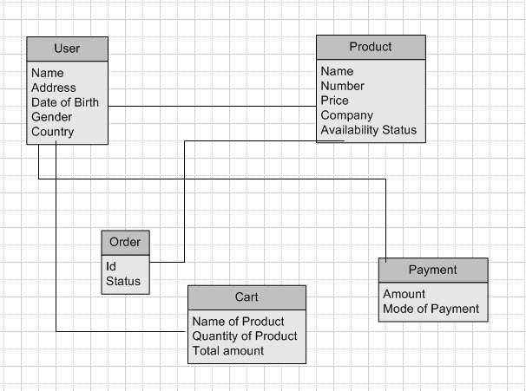

**Q.7 Data Flow Diagram (DFD)**

**Answer:** Data Flow diagram is a diagram which mainly focuses on data movement from system to show how data flows between different processes. DFD focuses on data flow, inputs, outputs and data storage points. Data Flow Diagram does not show parallel activities. DFD is more concerned with `**what data is flowing**’.

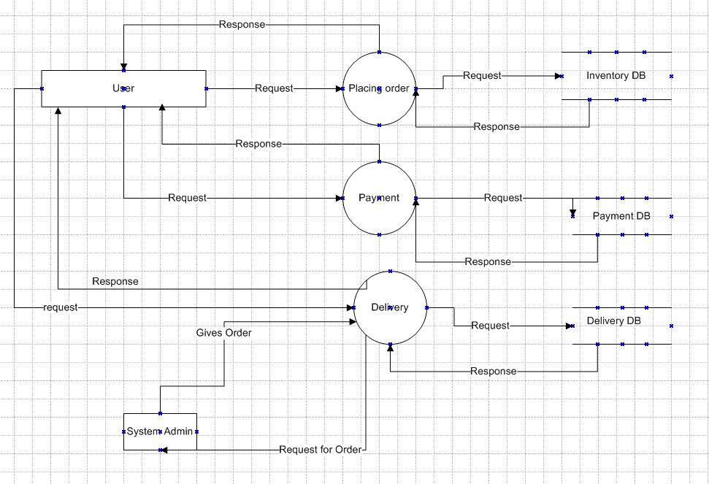

**Q. 8 Change Request**

**Answer:** Process to handle change request

* BA should always be prepared for change requests and their management. This change request is regarding Government Taxation, initially the BA documents the change request.
* BA performs a Feasibility study to accept the change request. The BA will analyse the change request of Taxation.
* After approval for the project manager BA needs to move further in analysing the change request.
* The BA will help the stakeholders to understand, the impact change request will have on the organization.
* Successful change efforts necessitate the BA to articulate a realistic or convincing vision that appeals to both internal and external stakeholders.

**Q.9 Change request Vs Enhancement**

**Answer:**

Change Request is type of request which can be changed in existing collected requirements. i.e. we can modify existing product which includes new features or fixing issues. But enhancement is a condition which we can add more functions in product on basis of additional stakeholders requirements i.e. we can add more functions to increase its value and improve existing functions quality.

Here, stakeholders want to add new function of sale of crops. So it is case of enhancement.

As per earlier discussion with primary stakeholders, they have not mentioned any facility to sell crops through application. If stakeholders wants to add sales facility through application it will be enhancement.

**Q.10 Estimations**

**Answer:**

Total Budget: 2 Cr

Total Period: 18 Months

Resources: 11

* 40Hrs of work / Week by each individual.
* Per week work by 11 Resources is 440Hrs.

**Q.11 UAT**

**Answer:** User Acceptance Testing (UAT) is type of testing where user tests product to ensure it works as he wants. User acceptance testing done by user who wants to use product on regular basis. It decreases chances of problems after delivery of product.

**Planning:**

* In this step, Blueprints are made to implement UAT testing for every feature that needs to be tested and minimum standards for accepting the test.

**Designing:**

* Here the test cases are designed to hide all the possibilities of software packages in a real world environment.

**UAT Testers:**

* A testing team consists of a end user that meet the criteria for implementing testing. The end user must have expertise in subject matter and the ability to report the problems.

**Bug Fixing:**

* Whatever bugs are found in the UAT testing, the development team should work on them and make it software error free.

**Sign Off:**

* After removing all the bugs, the testing team indicates acceptance of the completion of the bugs. In this phase, all the stakeholders come to a conclusion that the software is ready to GO LIVE and sign it off.

**Q.12 Project Closure Document**

**Answer:**

Project closure document explains about outcomes of project after completion of project.

|  |  |  |  |
| --- | --- | --- | --- |
| **Sr.No.** | **Points To Include** | **Details** | **Reference Link** |
| **1.** | **Did the client Sign Off on the UAT Testing** | |  |
|  | Date of sign off: |  |
|  | Name of the resourse: |  |
| **2.** | **Objectives of the Project** | |
|  | User friendliness: | Achieved |  |
|  | Customer satisfaction: | Achieved |  |
|  | Misc: | Achieved |  |
| **3.** | **Functionalities worked on** |  |  |
|  | Secure payment Processing | Achieved |  |
|  | Categories | Achieved |  |
| **4.** | **Infrastructure** |  |  |
|  | Software Installed | Achieved |  |
|  | Laptops Purchased | Achieved |  |
| **5.** | **Funding** |  |  |
|  | Amount Approved | Rs. 2 Cr |
|  | Amount Used | Rs. 1.85 Cr |
| **6.** | **Overall project Information** |  |  |
|  | Escalations |  |  |
|  | Customer Satisfaction | High |  |
| **7.** | **Value to company** |  |  |
|  |  | -Trained Employees  -Increased Clients |  |