A company is having manufacturing plants and warehouses in various parts of the country. They

manufacture ice-cream and milk products. They want to build software to achieve two goals.

• Manage the inventory

• Quickest delivery to the customers

**Assignment 1:**

1. Please make a BRD which can be presented to the client along with complete development

and resource plan.

2. Prepare process flow diagram using your imagination.

**Assignment 2:**

1. Write an introduction letter to a client introducing yourself as a business analyst in charge of working with the client and his team to start the business understanding process.

2. Prepare a brief BRD and SRS for a project- Horoscope or Ticketing system or online store.

3. Make an ERD of creating a support ticket/Ticketing life cycle.

4. User story of shopping from e-commerce.

Q1. Please make a BRD which can be presented to the client along with complete development

and resource plan.

**Assignment 1**

**Answer 1**

**Title: Inventory and Delivery Management System for Ice Cream and Milk Products**

**Version: 1.0  
Date: April 25, 2025**

**Prepared By:  Kavya Garg  
Role: Business Analyst**

**Business Requirements Document (BRD)**

**Inventory and Delivery Management System for Ice Cream and Milk Products**

1. **Document Revisions**

|  |  |  |
| --- | --- | --- |
| **Date** | **Version Number** | **Document Changes** |
| 2025-03-20 | 1.0 | Initial draft of the Business Case Document. |
| 2025-03-22 | 1.1 | Updated the "Background and Context" section with additional market insights. |
| 2025-03-25 | 1.2 | Added risk mitigation strategies under the "Risks and Mitigation Strategies" section. |
| 2025-04-01 | 1.3 | Revised "Cost and Resource Estimates" section based on updated budget from finance team. |
| 2025-04-05 | 1.4 | Clarified implementation timeline and added milestones for each phase. |
| 2025-04-10 | 1.5 | Added stakeholder approval section, and revised governance structure. |
|  |  |  |

1. **APPROVALS**

|  |  |  |  |  |
| --- | --- | --- | --- | --- |
| **Role** | **Name** | **Title** | **Signature** | **Date** |
| **Project Sponsor** | **Raj Singh** | **Director - Operations** |  | 3/31/2025 |
| **Business Owner** | **Anjali Sharma** | **Head of Supply Chain** |  | 3/31/2025 |
| **IT Manager** | **Sandeep Verma** | **IT Infrastructure Lead** |  | 3/31/2025 |
| **Business Analyst** | **Sneeha Kapoor** | **Lead Business Analyst** |  | 3/31/2025 |
| **Development Lead** | **Rammesh Rao** | **Software Development Head** |  | 3/31/2025 |
| **Quality Assurance** | **Ankita Nair** | **QA Manager** |  | 3/31/2025 |
| **Logistics Manager** | **Vikram Das** | **Delivery & Distribution Head** |  | 3/31/2025 |
| **Finance Representative** | **Rohit Bansal** | **Finance Controller** |  | 3/31/2025 |
|  |  |  |  |  |

1. **RACI Matrix :-**

|  |  |  |  |  |  |  |  |  |
| --- | --- | --- | --- | --- | --- | --- | --- | --- |
| **Task / Activity** | **Project Sponsor (Raj Singh)** | **Business Owner (Anjali Sharma)** | **IT Manager (Sandeep Verma)** | **Business Analyst (Sneeha Kapoor)** | **Dev Lead (Rammesh Rao)** | **QA Manager (Ankita Nair)** | **Logistics Manager (Vikram Das)** | **Finance (Rohit Bansal)** |
|
| **Requirement Gathering** | **A** | **R** | **C** | **I** | **C** | **I** | **I** | **I** |
|
| **Solution Design & Architecture** | **C** | **C** | **R** | **A** | **R** | **C** | **I** | **I** |
|
| **Software Development** | **I** | **I** | **C** | **C** | **R** | **I** | **I** | **I** |
|
| **System Integration** | **I** | **I** | **R** | **C** | **A** | **C** | **I** | **I** |
|
| **Testing & Quality Assurance** | **I** | **I** | **C** | **C** | **C** | **R** | **I** | **I** |
|
| **Inventory Management Implementation** | **C** | **R** | **C** | **C** | **R** | **C** | **A** | **C** |
|
| **Logistics & Delivery Optimization** | **C** | **A** | **C** | **C** | **R** | **C** | **R** | **C** |
|
| **Budget Approval** | **A** | **C** | **I** | **I** | **I** | **I** | **I** | **R** |

1. **Introduction**

**4.1 Business Goals**

* **Efficient Inventory Management**: Create a robust system to manage real-time inventory, track product availability, and maintain an accurate record of stock across multiple manufacturing plants and warehouses.
* **Faster Delivery**: Optimize delivery processes to guarantee faster customer deliveries while ensuring product quality and minimizing transportation costs.

**4.2 Business Objectives**

* **Real-time Inventory Tracking**: Provide a system that updates product quantities in real time, ensuring accurate stock levels across all locations.
* **Automated Replenishment**: Trigger automatic reordering when stock levels fall below predefined thresholds.
* **Optimized Delivery Routes**: Use software tools to optimize delivery routes, ensuring faster delivery times and reducing transportation costs.
* **Prioritize Orders**: Implement a priority-based system to process orders faster based on their urgency or special requests.

**4.3 Business Rules**

* **Stock Replenishment**: When inventory reaches a certain low level, automatic notifications will trigger restocking requests to the nearest warehouse or manufacturing plant.
* **Delivery Deadlines**: Orders within 100 miles of the warehouse must be delivered within 48 hours. Orders beyond that distance will be delivered within 72 hours.
* **Shelf Life Management**: Perishable products like ice cream and milk must have their expiration dates monitored in the system, with alerts for products nearing expiration.
* **Order Prioritization**: Orders marked as high priority or express should be processed and shipped first, ahead of regular orders.
* **Warehouse Capacity Management**: The system must prevent overstocking by alerting when warehouse capacity is close to being reached.

**4.4 Background**

The company operates multiple manufacturing plants and warehouses located throughout the country, producing ice cream and milk-based products. Currently, inventory management is mostly manual, leading to inefficiencies, stockouts, and delayed deliveries. The existing system also lacks integration for optimizing delivery processes. This project seeks to replace the legacy system with an automated, real-time solution to improve inventory management and speed up deliveries.

**4.5 Project Objective**

Develop a comprehensive software solution to:

* Efficiently manage inventory across plants and warehouses.
* Optimize delivery routes and prioritize orders for faster delivery times.
* Provide real-time visibility into stock levels, order statuses, and delivery progress.

**4.6 Project Scope**

The scope of the project includes:

* **Inventory Management**: Real-time tracking of stock, automated reorder triggers, and expiration tracking.
* **Delivery Management**: Route optimization, priority handling of orders, and real-time delivery tracking.
* **User Roles**: Different access levels for Admin, Warehouse Staff, and Delivery Staff.
* **Integration**: The new system must integrate with existing order management and ERP systems.

**5. Assumptions**

* All plants and warehouses will have internet access for synchronization of data in real time.
* Delivery staff will have GPS-enabled devices for route optimization.
* The system will be compatible with existing warehouse and delivery infrastructure.
* Adequate training will be provided to all users to ensure effective use of the system.

**6. Constraints**

* **Budget**: The software development must remain within the allocated budget.
* **Timeline**: The system must be completed and operational within 6 months.
* **Data Migration**: All data from legacy systems must be accurately migrated to the new system.
* **Hardware Compatibility**: The software must be compatible with existing hardware and equipment.

**7. Risk Identification and Mitigation Strategies**

**Technological Risks:**

* **Risk**: System integration challenges with legacy software.
  + **Mitigation**: Conduct thorough testing before integration, use phased implementation for smoother transition.

**Skills Risks:**

* **Risk**: Lack of expertise in new software technologies.
  + **Mitigation**: Hire external consultants or provide intensive internal training for the team.

**Political Risks:**

* **Risk**: Changes in regulatory compliance for food products or transportation.
  + **Mitigation**: Regularly review and adapt the software to comply with new laws.

**Business Risks:**

* **Risk**: Delays in product delivery may affect customer satisfaction.
  + **Mitigation**: Optimize inventory and delivery routes and use predictive analytics to anticipate delays.

**Requirements Risks:**

* **Risk**: Unclear or changing requirements.
  + **Mitigation**: Regular communication with stakeholders to gather and finalize clear business requirements.

**Other Risks:**

* **Risk**: Data security breaches.
  + **Mitigation**: Implement advanced encryption, access control, and regular audits.

**8. Business Process Overview**

**8.1 Legacy System (AS-IS)**

* The current system is manually operated, which results in stockouts, overstocking, and delayed deliveries.
* The system lacks automation in inventory management and does not provide real-time data on stock levels or delivery status.
* The delivery process is not optimized, leading to longer delivery times.

**8.2 Proposed Recommendations (TO-BE)**

* **Inventory Management**: Implement automated inventory tracking with real-time stock updates and low-stock alerts.
* **Order Fulfillment**: Prioritize and process orders based on urgency and customer needs.
* **Delivery Optimization**: Use route optimization tools to ensure quicker deliveries with real-time tracking available for customers.
* **User Access Control**: Assign different user roles such as Admin, Warehouse Staff, and Delivery Staff, each with specific access permissions.

**9. Business Requirements**

1. **Inventory Management:**
   * Real-time tracking of products across manufacturing plants and warehouses.
   * Ability to trigger automatic stock replenishment when stock reaches a minimum threshold.
   * Monitoring and alerting of product expiration for perishable goods like ice cream and milk.
   * Ability to generate real-time inventory reports and forecasts.
2. **Delivery Management:**
   * Route optimization to ensure the fastest delivery times.
   * Real-time tracking for deliveries with notifications sent to customers.
   * Order prioritization system based on delivery urgency and quantity.
   * Integration with GPS systems for accurate tracking of delivery progress.
3. **User Roles:**
   * Admins can access all system functions, including inventory management and reporting.
   * Warehouse staff can access inventory and order fulfillment features.
   * Delivery staff can view delivery assignments, update status, and track routes.
4. **System Integrations:**
   * Integration with existing ERP (Enterprise resource planning) and order management systems.
   * Integration with GPS and route optimization tools for delivery management.

**10. Timeline & Milestones**

|  |  |  |
| --- | --- | --- |
| **Phase** | **Duration** | **Milestone** |
| Discovery & Analysis | 2 weeks | Gather all requirements |
| Design & Architecture | 3 weeks | System design and architecture |
| Development | 8 weeks | Core functionality developed |
| Testing & QA | 4 weeks | Final testing and bug fixing |
| Deployment & Go-Live | 2 weeks | System goes live |

**1.9. Resource Plan**

|  |  |  |
| --- | --- | --- |
| **Role** | **No. of Resources** | **Skillsets Needed** |
| **Project Manager** | 1 | Project management, stakeholder management |
| **Business Analyst** | 1 | Requirement gathering, documentation |
| **Development Team** | 3-4 | Full-stack developers (front-end, back-end, databases) |
| **QA Engineer** | 2 | Testing, performance testing, bug tracking |
| **UI/UX Designer** | 1 | Design of user interface and experience |
| **Logistics Expert** | 1 | Expertise in delivery management systems |

**10. Appendices**

**10.2 Glossary of Terms**

1. **Demand Forecasting:** The process of predicting future inventory needs based on data.
2. **Real-Time Tracking:** Live monitoring of stock levels across warehouses.
3. **Warehouse Management System (WMS):** Software for handling inventory and logistics.
4. **Order Fulfillment:** The process of receiving, processing, and delivering customer orders.
5. **Stock Optimization:** Maintaining ideal stock levels to prevent excess or shortage.

**10.3 Related Documents**

1. **Enterprise ERP Integration Guide**
2. **Inventory Management System Functional Specification**
3. **AI Demand Forecasting Model Documentation**
4. **Warehouse Logistics & Routing Strategy Report**
5. **User Training Manual for New System**

**Q2. Prepare process flow diagram using your imagination.**

**Answer- 2**

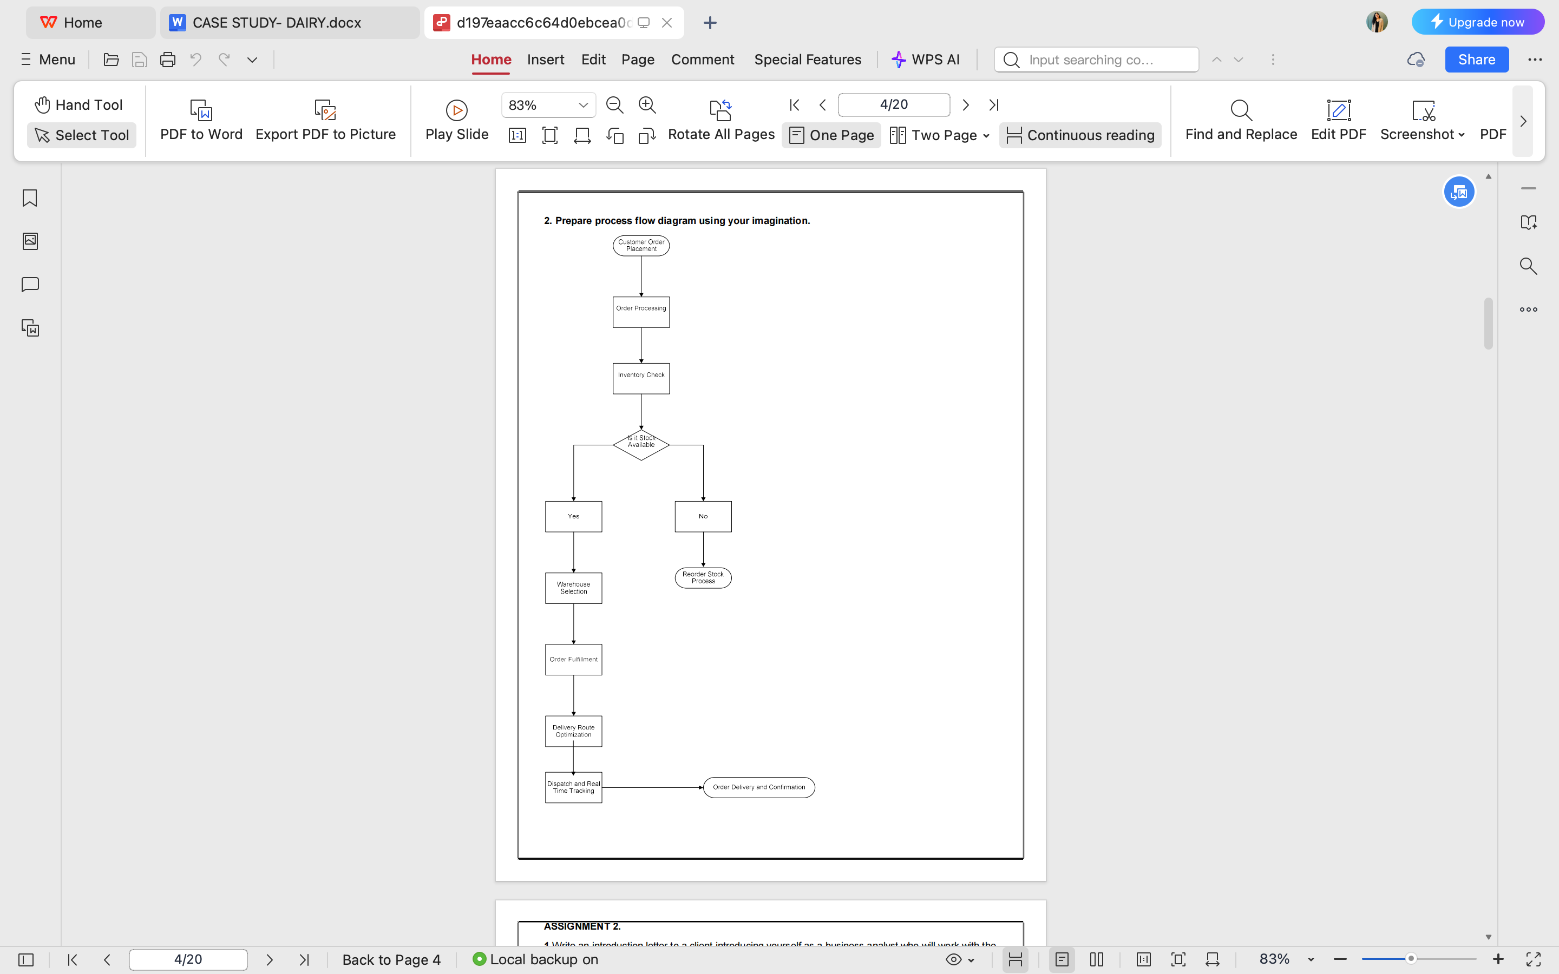

**ASSIGNMENT-2**

**1. Write an introduction letter to a client introducing yourself as a business analyst in charge of**

**working with the client and his team to start the business understanding process.**

**Answer:**

Kavya Garg

Kavya.2209@gmail.com  
91xxxxxxxx  
April 25, 2025

Ajay Singh

Operations Manager  
Dairy Company

Subject: [ Introduction as Your Business Analyst for Demand Forecasting & Inventory Management Project]

Dear Ajay,

I hope this message finds you well.

My name is Kavya Garg and I am the Business Analyst at cotivity , assigned to work with you and your team on the upcoming project. I am excited to collaborate with you as we embark on the journey of understanding your business objectives and refining the requirements for the new Inventory and Delivery Management System for your ice cream and milk products.

As a Business Analyst, my role will involve gathering vital information about your current processes and understanding the unique challenges your company faces. By working closely with you and your team, I aim to ensure that the new system aligns with your operational goals and enhances efficiency in inventory management and delivery.

Throughout this process, I will facilitate discussions, conduct interviews, and analyze data to capture the requirements accurately. I believe that open communication is key to a successful project, and I encourage your team to share their insights and perspectives. Together, we can identify opportunities for improvement and design a solution that meets your needs.

I will be reaching out to schedule an initial meeting within the next few days to discuss the project scope and gather your input. If you have any questions or specific topics you would like to address during our meeting, please feel free to let me know.

I look forward to working with you and your team, and I am confident that together we will create a system that adds significant value to your business.

Thank you, and I look forward to our collaboration!

Best regards,

Kavya Garg,

Business Analyst  
91xxxxxxxx

**Answer-2**

**Prepare a brief BRD and SRS for a project- Horoscope or Ticketing system or online store.**

**Title: Ticketing System**

**Version: 1.0  
Date: April 25, 2025**

**Prepared By:  Kavya Garg  
Role: Business Analyst**

|  |  |  |  |
| --- | --- | --- | --- |
| **Functional requirement** | | | |
| **ID** | **Req Name** | **Req Description** | **Priority** |
| F001 | User Login | The system shall allow users to log in using a username and password. | 1 |
| F002 | Role-Based Access | The system shall provide different access levels for admins, support agents, and customers. | 1 |
| F003 | Ticket Creation | Users shall be able to create new support tickets by providing issue details. | 1 |
| F004 | Ticket Tracking | Users shall be able to view the status of their submitted tickets. | 2 |
| F005 | Ticket Assignment | Admins shall assign tickets to support agents based on availability. | 1 |
| F006 | Email Notifications | The system shall send email updates on ticket status changes. | 2 |
| F007 | Ticket Prioritization | Tickets shall have priority levels (Low, Medium, High, Critical). | 2 |
| F008 | Ticket Resolution | Support agents shall update tickets with resolutions before closing them. | 1 |
| F009 | Ticket History | Users shall be able to view past tickets and their resolutions. | 3 |
| F010 | Reporting & Analytics | Admins shall generate reports on ticket resolution time, agent performance, and issue trends. | 3 |
|  |  |  |  |
| **Non-functional requirement specification** | | | |
| **Req ID** | **Req Name** | **Req Description** | **Priority** |
| NF001 | System Availability | The system shall have 99.9% uptime availability. | 1 |
| NF002 | Performance | The system shall handle up to 10,000 concurrent users without performance degradation. | 1 |
| NF003 | Security | All data shall be encrypted, and user authentication shall follow multi-factor authentication (MFA). | 1 |
| NF004 | Scalability | The system shall support future growth and additional features without performance issues. | 2 |
| NF005 | Response Time | The system shall respond to user actions within 2 seconds. | 2 |
| NF006 | Compliance | The system shall comply with GDPR and other relevant data protection regulations. | 1 |
| NF007 | Cross-Platform Support | The system shall be accessible via web, mobile, and desktop applications. | 3 |
| NF008 | Backup & Recovery | The system shall perform automated daily backups and allow recovery within 30 minutes. | 2 |
| NF009 | User Experience | The UI shall be intuitive and easy to navigate for all user roles. | 3 |
|
| NF010 | Logging & Monitoring | The system shall maintain logs of all activities for audit and troubleshooting. | 3 |
|

**Document Revisions :-**

|  |  |  |  |
| --- | --- | --- | --- |
| **Version** | **Date** | **Author** | **Changes Made** |
| **1** | **3/30/2025** | **Business Analyst** | **Initial draft of the Ticketing System BRD** |
| **1.1** | **3/31/2025** | **Business Analyst** | **Added functional and non-functional requirements** |
| **1.2** | **4/1/2025** | **Business Analyst** | **Updated process flow and RACI matrix** |
| **1.3** | **4/2/2025** | **Business Analyst** | **Added risk assessment and mitigation strategies** |

**2. Document Approvals**

|  |  |  |  |  |
| --- | --- | --- | --- | --- |
| **Role** | **Name** | **Title** | **Signature** | **Date** |
| **Project Sponsor** | **Akshay rout** | **CEO, XYZ Solutions** | **__________** | **4/2/2025** |
| **Business Owner** | **Shama Irfan** | **Head of Customer Support** | **__________** | **4/2/2025** |
| **Business Analyst** | **Kavya Garg** | **Lead Business Analyst** | **__________** | **4/2/2025** |
| **Solution Architect** | **Arjun Reddy** | **Solution Architect** | **__________** | **4/2/2025** |
| **Development Lead** | **Vikram Singh** | **Technical Lead** | **__________** | **4/2/2025** |
| **QA Lead** | **Ritu Joshi** | **Quality Assurance Manager** | **__________** | **4/2/2025** |
| **IT Security** | **Sandeep Reddy** | **Security Analyst** | **__________** | **4/2/2025** |
| **Compliance Officer** | **Vikram Patel** | **Compliance & Risk Manager** | **__________** | **4/2/2025** |

**3. RASCI Chart**

|  |  |  |  |  |  |
| --- | --- | --- | --- | --- | --- |
| **Task / Activity** | **Responsible (R)** | **Accountable (A)** | **Support (S)** | **Consulted (C)** | **Informed (I)** |
| **Requirement Gathering** | **Business Analyst** | **Project Sponsor** | **Development Team** | **Business Owner, Customer Support** | **Stakeholders** |
| **System Design & Architecture** | **Solution Architect** | **CTO** | **Development Team** | **Business Analyst, IT Security** | **Project Sponsor** |
| **Development & Coding** | **Development Team** | **Technical Lead** | **QA Team** | **Business Analyst** | **Stakeholders** |
| **Testing & Quality Assurance** | **QA Team** | **QA Lead** | **Development Team** | **Business Analyst** | **Stakeholders** |
| **Security Compliance** | **IT Security Team** | **Compliance Officer** | **Development Team** | **Solution Architect** | **Project Sponsor** |
| **User Training & Documentation** | **Business Analyst** | **Business Owner** | **Support Team** | **End Users** | **Stakeholders** |
| **Deployment & Go-Live** | **DevOps Team** | **Technical Lead** | **Support Team** | **IT Security** | **Stakeholders** |
| **Ongoing Maintenance & Support** | Support Team | Business Owner | Development Team | IT Security, Business Analyst | Stakeholders |

**4. Introduction**

The Ticketing System project aims to streamline issue tracking, automate ticket resolution, and enhance customer service efficiency. This document outlines the functional and non-functional requirements, scope, risks, and assumptions related to the project.

**4.1 Business Goals**

* Improve response time for customer queries and technical issues.
* Automate ticket assignment and tracking for efficient issue resolution.
* Reduce manual workload and improve operational efficiency.
* Enhance customer satisfaction through faster issue resolution.
* Provide data-driven insights for continuous service improvement.

**4.2 Business Objectives**

* Implement a centralized ticketing system for all customer requests.
* Automate ticket categorization, priority setting, and escalation.
* Ensure seamless integration with existing CRM and ITSM tools.
* Provide real-time status updates to customers and support teams.
* Enable reporting and analytics to identify trends and optimize operations.

**4.3 Business Rules**

* Tickets will be categorized based on predefined priority levels.
* Urgent tickets will be escalated automatically if not resolved within SLA.
* Agents must update ticket status after every interaction.
* Customers will receive automated email/SMS notifications for ticket updates.
* Tickets cannot be closed without customer acknowledgment (where applicable).

**4.4 Background**

The organization currently lacks a structured system for managing customer complaints and IT service requests. The manual process leads to delays, miscommunication, and unresolved issues. Implementing an automated ticketing system will address these inefficiencies.

**4.5 Project Objective**

To develop a robust ticketing system that automates issue tracking, enhances customer support efficiency, and ensures timely resolution of reported problems through a structured and scalable platform.

**4.6 Project Scope**

**4.6.1 In-Scope Functionality**

* User authentication and role-based access.
* Ticket creation, assignment, and escalation workflows.
* Automated notifications and SLA tracking.
* Integration with CRM and ITSM tools.
* Reporting and analytics dashboard.

**4.6.2 Out-Scope Functionality**

* Social media ticket integration.
* AI-powered chatbot for self-service support (future enhancement).
* Multi-language support beyond English (future consideration).

**5. Assumptions**

* Users will have access to the internet and required credentials.
* Integration with third-party systems will be feasible.
* Users will undergo training for smooth adoption.
* System performance will meet standard SLA requirements.

**6. Constraints**

* Budget limitations for additional third-party tool integrations.
* Limited support for non-web-based ticketing requests.
* Compliance with internal IT security policies and GDPR regulations.
* Dependence on external vendors for CRM/ITSM integration.

**7. Risks**

**7.1 Technological Risks**

* Integration challenges with legacy systems.
* System downtime affecting ticket resolution.

**7.2 Skills Risks**

* Lack of trained staff to operate the system effectively.
* Resistance to change from employees.

**7.3 Political Risks**

* Conflicting priorities within IT and customer support teams.
* Resistance from departments reluctant to automate processes.

**7.4 Business Risks**

* Increased workload during system transition phase.
* Delays in adoption affecting customer satisfaction.

**7.5 Requirements Risks**

* Changes in requirements after development starts.
* Incomplete understanding of user needs leading to rework.

**7.6 Other Risks**

* Data privacy concerns while storing sensitive customer data.
* Scalability issues if the system needs expansion.

**8. Business Process Overview**

**8.1 Legacy System (AS-IS)**

* Manual ticket logging via emails and phone calls.
* Delays in ticket resolution due to lack of automation.
* Poor tracking and reporting of resolved/unresolved tickets.

**8.2 Proposed Recommendations (TO-BE)**

* Automated ticket assignment and escalation.
* Centralized dashboard for real-time tracking.
* SLA-based ticket prioritization.

**9. Business Requirements**

The business requirements will define system capabilities, user interactions, and performance expectations.

**10. Appendices**

**10.1 List of Acronyms**

* **SLA** – Service Level Agreement
* **CRM** – Customer Relationship Management
* **ITSM** – IT Service Management

**10.2 Glossary of Terms**

* **Ticket** – A customer request or issue logged in the system.
* **Escalation** – Automatic prioritization of unresolved high-priority tickets.

**Answer-3**

ERD

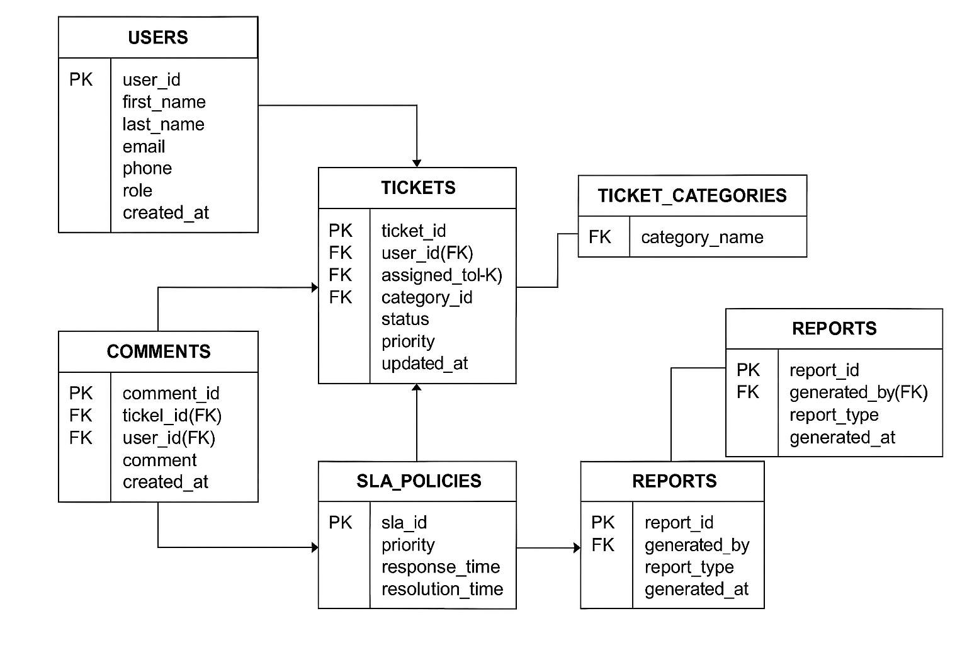

**Answer-4**

**User story of shopping from e-commerce.**

1. User story of shopping from ecommerce.

|  |  |  |  |
| --- | --- | --- | --- |
| User Story No: 01 | Tasks: User Registration | | Priority: High |
| As a User  I want to Register an account  So that I Can find my desired product | | | |
| BV: 500 | | CP: 03 | |
|  | |  | |
| Acceptance Criteria:  1) User can click on register option  2) User can enter personal information  3) User can create an account with email/phone | | | |

|  |  |  |  |
| --- | --- | --- | --- |
| User Story No: 02 | Tasks: Authentication | | Priority: High |
| As a User  I want to Log in with credentials  So that I can Access my account | | | |
| BV: 500 | | CP: 03 | |
| Acceptance Criteria:  1) Click on Login  2) Enter user name and password  3) Login works with correct credentials | | | |

|  |  |  |  |
| --- | --- | --- | --- |
| User Story No: 03 | Tasks: Product Browsing and Search | | Priority: High |
| As a User  I want to browse and search for products  So that I can Find the items I want to purchases | | | |
| BV: 500 | | CP: 05 | |
| Acceptance Criteria:  1) User can view product categories  2) User can search by keyword  3) Filters (price, brand, rating) are functional | | | |

|  |  |  |  |
| --- | --- | --- | --- |
| User Story No: 04 | Tasks: Add items to shopping cart | | Priority: High |
| As a User  I want to add products to my cart  So that I Can purchase them later | | | |
| BV: 100 | | CP: 05 | |
| Acceptance Criteria:   1. Item is added to cart successfully 2. Cart icon updates with count 3. Cart persists during session | | | |

|  |  |  |  |
| --- | --- | --- | --- |
| User Story No: 05 | Tasks: Perform checkout and payment | | Priority: High |
| As a User  I want to check out and make payment  So that I can complete my order and get confirmation | | | |
| BV: 500 | | CP: 08 | |
| Acceptance Criteria:   1. User can enter shipping and billing info 2. User selects payment method 3. Order summary is displayed 4. Confirmation message shown after successful payment | | | |

|  |  |  |  |
| --- | --- | --- | --- |
| User Story No: 06 | Tasks: Track order status | | Priority: Medium |
| As a User  I want to track the status of my order  So that I can know when it will be delivered | | | |
| BV: 100 | | CP: 03 | |
| Acceptance Criteria:   1. Order status updates available 2. Delivery date is visible 3. Tracking link or number is shown | | | |

|  |  |  |  |
| --- | --- | --- | --- |
| User Story No: 07 | Tasks: Add products to Wishlist | | Priority: Medium |
| As a User  I want to add products to my Wishlist  So that I can save them for future consideration | | | |
| BV: 500 | | CP: 02 | |
| Acceptance Criteria:   1. Products can be added/removed from Wishlist 2. Wishlist persists in user account 3. Option to move item from Wishlist to cart | | | |

|  |  |  |  |
| --- | --- | --- | --- |
| User Story No: 08 | Tasks: Submit product review | | Priority: Medium |
| As a User  I want to rate and review a product  So that I can share my experience with other customers | | | |
| BV: 100 | | CP: 03 | |
| Acceptance Criteria:   1. User can leave text and star rating 2. Only verified buyers can review 3. Reviews are displayed on product pages | | | |

|  |  |  |  |
| --- | --- | --- | --- |
| User Story No: 09 | Tasks: Receive order and offer notifications | | Priority: Medium |
| As a User  I want to get notifications about my order and promotions  So that I can stay informed about order progress and deals | | | |
| BV: 500 | | CP: 04 | |
| Acceptance Criteria:   1. User receives order updates via email/SMS 2. Promotional offers sent if opted in 3. Notifications can be managed in account settings | | | |

|  |  |  |  |
| --- | --- | --- | --- |
| User Story No: 10 | Tasks: Ensure secure and reliable payment | | Priority: High |
| As a User  I want to make payments through a secure gateway  So that I can protect my personal and financial information | | | |
| BV: 500 | | CP: 05 | |
| Acceptance Criteria:   1. Payment is encrypted and secure 2. Supports multiple payment options 3. User receives a payment confirmation instantly | | | |

­­­

|  |  |  |  |
| --- | --- | --- | --- |
| User Story No: 11 | Tasks: Manage user profile | | Priority: Medium |
| As a User  I want to update my personal information  So that I can keep my profile current. | | | |
| BV: 100 | | CP: 03 | |
| Acceptance Criteria:   1. User can edit name, address, and contact 2. Changes are saved after confirmation 3. Update reflects in future orders | | | |

|  |  |  |  |
| --- | --- | --- | --- |
| User Story No: 12 | Tasks: Cancel or modify order | | Priority: High |
| As a User  I want to cancel or modify my order  So that I can make changes before it ships | | | |
| BV: 500 | | CP: 05 | |
| Acceptance Criteria:   1. Cancel option available before shipping 2. Modify quantity or address within timeframe 3. Refund initiated upon cancellation | | | |

|  |  |  |  |
| --- | --- | --- | --- |
| User Story No: 13 | Tasks: View order history | | Priority: Medium |
| As a User  I want to view my previous orders  So that I can track my shopping history | | | |
| BV: 500 | | CP: 03 | |
| Acceptance Criteria:   1. List of all past orders 2. Order details viewable (items, date, amount) 3. Reorder option available | | | |

|  |  |  |  |
| --- | --- | --- | --- |
| User Story No: 14 | Tasks: Apply coupon codes | | Priority: High |
| As a User  I want to use discount codes during checkout  So that I can save money on purchases | | | |
| BV: 100 | | CP: 03 | |
| Acceptance Criteria:   1. Coupon field available at checkout 2. Code is validated in real-time 3. Discount reflected in order summary | | | |

|  |  |  |  |
| --- | --- | --- | --- |
| User Story No: 15 | Tasks: Multi-language support | | Priority: High |
| As a User  I want to the platform in my preferred language  So that I can navigate it comfortably | | | |
| BV: 100 | | CP: 05 | |
| Acceptance Criteria:   1. Language selector available 2. Text changes dynamically 3. Default language saved in user profile | | | |

|  |  |  |  |
| --- | --- | --- | --- |
| User Story No: 16 | Tasks: Guest checkout | | Priority: Medium |
| As a User  I want to place an order without registration  So that I can quickly complete my purchase | | | |
| BV: 100 | | CP: 05 | |
| Acceptance Criteria:   1. Guest checkout option visible 2. Guest provides minimal necessary details 3. Confirmation email sent post-order | | | |

|  |  |  |  |
| --- | --- | --- | --- |
| User Story No: 17 | Tasks: Compare products | | Priority: Medium |
| As a User  I want to compare multiple products  So that I can make an informed decision | | | |
| BV: 500 | | CP: 03 | |
| Acceptance Criteria:   1. Comparison option available on product listings 2. Products compared by features, price, and rating 3. Easy navigation between compared items | | | |

|  |  |  |  |
| --- | --- | --- | --- |
| User Story No: 18 | Tasks: Responsive design | | Priority: High |
| As a User  I want to site to work on all devices  So that I can shop from any screen size | | | |
| BV: 500 | | CP: 05 | |
| Acceptance Criteria:   1. Pages adjust to mobile, tablet, desktop 2. Navigation and buttons are touch-friendly 3. No content overlaps or UI breaks | | | |

|  |  |  |  |
| --- | --- | --- | --- |
| User Story No: 19 | Tasks: Manage shipping addresses | | Priority: Medium |
| As a User  I want to add and manage multiple shipping addresses  So that I can choose where to send my orders | | | |
| BV: 100 | | CP: 03 | |
| Acceptance Criteria:   1. Option to add/edit/delete addresses 2. Address book available at checkout 3. Default address can be set | | | |

|  |  |  |  |
| --- | --- | --- | --- |
| User Story No: 20 | Tasks: Loyalty rewards system | | Priority: Low |
| As a User  I want to earn rewards for my purchases  So that I can I can redeem them later | | | |
| BV: 100 | | CP: 03 | |
| Acceptance Criteria:   1. Points are added after order confirmation 2. Points viewable in user profile 3. Redeemable during checkout | | | |