AGILE DOCUMENTS – CRM TOOL

Document -1 Definition of done

**User Story Level**

Produced Code for Presumed Functionalities:

* Code is written to implement the required CRM features, including customer management, lead tracking, and sales pipeline visualization.
* Features like notifications, reports, and dashboards are functional.

Assumptions of User Story Met:

* User stories are validated to ensure customer needs are met (e.g., accurate customer data storage, lead progress tracking).
* Business logic and rules are applied as per user story acceptance criteria.

Project Builds Without Errors:

* The code compiles successfully without errors or warnings using the build pipeline.

Unit Tests Written and Passing:

* Unit tests are created for core CRM functions (e.g., lead creation, task assignment, deal closing).
* All unit tests are executed, achieving a minimum 90% code coverage.

**2️⃣ Sprint Level**

Project Deployed on the Test Environment Identical to Production Platform:

* The CRM is deployed to a staging environment using the same infrastructure and configurations as the production environment.

Tests on Devices/Browsers Listed in Project Assumptions Passed:

* Features are tested on all supported browsers (e.g., Chrome, Edge, Firefox) and devices (desktop, tablet, mobile).
* Cross-browser compatibility is ensured.

Feature Ok-ed by UX Designer:

* UI/UX is verified against approved wireframes and prototypes.
* User experience is aligned with design guidelines and provides a seamless experience.

QA Performed & Issues Resolved:

* Comprehensive testing (functional, UI, integration, and regression) is conducted.
* Critical and high-priority bugs are resolved, and QA has approved the feature.

Feature is Tested Against Acceptance Criteria:

* All acceptance criteria defined in the user story are validated using test cases.
* Both functional and non-functional requirements are tested.

Feature Ok-ed by Product Owner:

* Product Owner reviews and confirms the functionality matches business expectations.
* Acceptance criteria are signed off.

**3️⃣ Release Level**

Refactoring Completed:

* Code is refactored to improve readability, maintainability, and performance.
* Unused or redundant code is removed.

Any Configuration or Build Changes Documented:

* All configuration changes (e.g., environment variables, database schema updates) are recorded in the project documentation.

Documentation Updated:

* User guides, API documentation, and internal system documentation are updated.
* Release notes highlighting new features, improvements, and bug fixes are prepared.

Peer Code Review Performed:

* Code has been reviewed by at least one other developer to ensure it follows coding standards.
* Feedback is addressed, and all required changes are implemented.

Document 2- Product Vision

|  |  |  |  |
| --- | --- | --- | --- |
| Scrum project Name: | CRM Solution for Enhanced Customer Management | | |
| Venue | Microsoft Teams (Virtual) | | |
| Date: March 25, 2025 | Start Time: 10:00 AM | End Time: 4:00 PM | Duration: 6 Hours |
| Client: | ABC Enterprises | | |
| Stakeholder List: | * Business Owners (CEO, COO): * Sales Managers: * Customer Support Managers: * Marketing Team Leads: * IT and Development Managers: | | |
| Scrum Team | | | |
| Scrum Master: | Priya Sharma  Rajesh Verma  Ankit Mehta  Neha Joshi  Rohit Malhotra  Pooja Singh  Sameer Khan | | |
| Product owner: |
| Scrum Developer 1: |
| Scrum Developer 2: |
| Scrum Developer 3: |
| Scrum Developer 4: |
| Scrum Developer 5: |

|  |  |  |  |
| --- | --- | --- | --- |
| **Vision:** To deliver a user-friendly, scalable CRM solution that centralizes customer interactions, enhances sales tracking, and optimizes customer support. The goal is to provide actionable insights, streamline operations, and ensure customer satisfaction. | | | |
| Target Group | Needs | Product | Value |
| Which market segment does the product address?   * SMEs (Small and Medium Enterprises) * Large Enterprises with dedicated sales and support teams * E-commerce and Service-Based Companies   Who are the target users and customers?   * Sales Representatives and Managers * Customer Support Agents * Marketing Executives * Business Decision-Makers | What problem does the product solve?   * Disorganized customer data across different systems * Lack of visibility into the sales pipeline * Inefficient lead management and poor follow-ups * Delayed customer support responses   Which benefits does it provide?   * Centralized customer data management * Real-time sales tracking and reporting * Improved customer support through ticket management * Predictive insights using AI analytics | What product is it?   * A cloud-based CRM platform with mobile and desktop accessibility.   What makes it desirable and special?   * Intuitive dashboard with customizable views * Seamless integration with third-party apps (e.g., email, calendar, ERP systems) * AI-powered customer insights for predictive sales analysis   Is it feasible to develop the product?   * Yes, using Agile development, it will be built in iterative sprints with regular stakeholder feedback. | How is the product going to benefit the company?   * Improve sales conversion rates by 30% within six months. * Enhance customer support response times by 40%. * Provide data-driven insights for faster decision-making.   What are the business goals?   * Increase revenue through better sales tracking. * Improve customer retention with proactive support. * Reduce operational costs by automating tasks.   What is the business model?   * Subscription-based pricing with different tiers for small, medium, and large businesses. * Additional revenue from premium features like advanced analytics and AI predictions. |

Document 3: User stories

|  |  |  |
| --- | --- | --- |
| User story No:1 Customer Management | Tasks:   * Develop a customer profile creation form. * Implement search and filter functionality. * Enable customer data updates and deletions. | Priority:  High |
| Value Statement:  As a Sales Representative,  I want to add, view, edit, and delete customer profiles,  so that I can maintain an up-to-date and accurate customer database. | | |
| BV: 90  CP: 8 | | |
| Acceptance Criteria:   * Users can add, search, edit, and delete customer profiles. * Data validation ensures accurate input. * Only authorized users can manage profiles. | | |

|  |  |  |
| --- | --- | --- |
| User story No:2 Lead Management | Tasks:  Lead Creation, Assignment, Status Tracking, Notifications | Priority:  High |
| Value Statement:  As a Sales Manager, I want to manage and assign leads to team members so that I can ensure timely follow-ups and close deals efficiently. | | |
| BV: 85  CP: 7 | | |
| Acceptance Criteria:   * Leads can be created and assigned to team members. * Notifications are sent for status updates. * Leads progress through defined pipeline stages. | | |

|  |  |  |
| --- | --- | --- |
| User story No:3 Sales Pipeline Management | Tasks:  Visual Pipeline, Drag-and-Drop, Filters | Priority:  High |
| Value Statement:  As a Sales Representative, I want to track my leads using a visual sales pipeline so that I can focus on high-priority opportunities. | | |
| BV: 95  CP: 9 | | |
| Acceptance Criteria:   * Leads are visible on a drag-and-drop pipeline. * Pipeline stages are customizable. * Data is filtered by status, priority, or date. | | |

|  |  |  |
| --- | --- | --- |
| User story No:4 Task Management | Tasks:  Task Creation, Assignment, Reminders, Tracking | Priority:  Medium |
| Value Statement:  As a Sales Representative, I want to create and manage tasks so that I can ensure timely completion of my responsibilities. | | |
| BV: 75  CP: 5 | | |
| Acceptance Criteria:   * Users can create, assign, and edit tasks. * Reminders are sent for upcoming deadlines. * Task status is updated in real-time. | | |

|  |  |  |
| --- | --- | --- |
| User story No:5 Contact Management | Tasks:  Add Contacts, Import/Export, Bulk Actions | Priority:  Medium |
| Value Statement:  As a Sales Representative, I want to manage contacts effectively so that I can maintain proper communication with customers. | | |
| BV: 80  CP: 6 | | |
| Acceptance Criteria:   * Contacts can be added, edited, or deleted. * Bulk import and export options are available. * Duplicate contacts are flagged. | | |

|  |  |  |
| --- | --- | --- |
| User story No:6 Reporting and Analytics | Tasks:  Create Reports, Visualize Data, Export Report | Priority:  High |
| Value Statement:  As a Sales Manager, I want to generate reports and view performance metrics so that I can make data-driven decisions. | | |
| BV: 100  CP: 8 | | |
| Acceptance Criteria:   * Users can generate custom reports. * Reports are available in visual formats. * Reports can be exported as PDFs or Excel files. | | |

|  |  |  |
| --- | --- | --- |
| User story No:7 Notification System | Tasks:  Real-Time Notifications, Preferences Management | Priority:  Medium |
| Value Statement:  As a Sales Representative, I want to receive notifications for lead updates and task deadlines so that I can respond promptly. | | |
| BV: 70  CP: 4 | | |
| Acceptance Criteria:   * Notifications are received in real-time. * Users can customize notification settings. * Notifications are available via email and in-app. | | |

|  |  |  |
| --- | --- | --- |
| User story No:8 User Role Management | Tasks:  Role Creation, Permission Assignment, Admin Control | Priority:  High |
| Value Statement:  As an Admin, I want to manage user roles and permissions so that I can ensure data security and access control. | | |
| BV: 95  CP: 7 | | |
| Acceptance Criteria:   * Users are assigned roles with specific permissions. * Admin can add, edit, or delete roles. * Role changes are effective immediately. | | |

|  |  |  |
| --- | --- | --- |
| User story No:9 Integration with Third-Party Tools | Tasks:  Email and Calendar Sync, API Integration | Priority:  Medium |
| Value Statement:  As a Sales Representative, I want to sync my calendar and emails with the CRM so that I can track customer interactions efficiently. | | |
| BV: 80  CP: 10 | | |
| Acceptance Criteria:   * Users can integrate their email accounts with the CRM. * Calendar events are synced. * Third-party API connections are available. | | |

|  |  |  |
| --- | --- | --- |
| User story No:10 Customer Support Ticketing | Tasks:  Ticket Creation, Assignment, Status Tracking | Priority:  High |
| Value Statement:  As a Support Agent, I want to manage customer tickets so that I can resolve issues quickly and improve customer satisfaction. | | |
| BV: 90  CP: 8 | | |
| Acceptance Criteria:   * Tickets can be created, assigned, and tracked. * Support agents receive notifications for new tickets. * Ticket status updates are reflected in real-time | | |

Document 4: Agile PO Experience

My Experience as a Product Owner for the CRM Tool Project

1. Market Analysis

As a Product Owner, I conducted a comprehensive market analysis to evaluate the demand for a CRM tool tailored to our target audience. My responsibilities included:

* Assessing market needs and identifying gaps in the current CRM landscape.
* Conducting competitor analysis to benchmark features and understand unique selling points.
* Gathering insights from industry trends and customer feedback to determine key functionalities.

2. Enterprise Analysis

I performed due diligence on the market opportunity by collaborating with stakeholders and understanding the specific requirements of various departments. This helped in:

* Evaluating the feasibility of the product.
* Estimating the ROI for different features.
* Aligning the CRM tool's objectives with business goals.

3. Product Vision and Roadmap

I defined the product vision by considering both the market need and internal business objectives. Key responsibilities included:

* Creating a clear, actionable vision statement.
* Developing a high-level product roadmap that outlined major milestones, features, and release timelines.
* Ensuring stakeholder alignment through continuous feedback and iterative updates.

4. Managing Product Features

My role involved defining and managing product features by:

* Collaborating with stakeholders to capture feature requests and expectations.
* Prioritizing features based on business impact, ROI, and technical feasibility.
* Continuously refining the product backlog to reflect changing priorities and market needs.

5. Managing Product Backlog

I ensured the backlog was well-structured and prioritized using Scrum principles. Responsibilities included:

* Breaking down high-level epics into user stories with clear acceptance criteria.
* Conducting backlog refinement meetings to reprioritize items based on feedback.
* Collaborating with the Scrum team to ensure clarity and alignment on sprint goals.

6. Managing Overall Iteration Progress

To ensure smooth progress during sprints, I actively participated in:

* Sprint progress reviews to track deliverables and address challenges.
* Reprioritizing sprints and epics based on stakeholder feedback.
* Sprint retrospective meetings to gather insights and apply improvements.

Sprint Management Experience

I led and managed various sprint meetings to foster collaboration and ensure successful deliveries:

* Sprint Planning Meeting: Defined sprint goals, prioritized backlog items, and estimated story points with the team.
* Daily Scrum Meeting: Ensured clear communication, identified roadblocks, and maintained alignment on progress.
* Sprint Review Meeting: Demonstrated completed work to stakeholders for feedback and validation.
* Sprint Retrospective Meeting: Facilitated discussions to identify successes, challenges, and opportunities for process improvement.
* Backlog Refinement Meeting: Reviewed and prioritized backlog items, ensuring user stories were well-defined and ready for future sprints.

User Story Creation Experience

In this project, I created detailed user stories, ensuring they captured the business value and aligned with the project goals. Each user story included:

* Story Number: Unique identification for tracking.
* Tasks: Clearly defined development and testing activities.
* Priority: Classification based on business impact (High, Medium, Low).
* Acceptance Criteria: Objective measures to determine when a story is complete.
* BV (Business Value): A numeric value representing the expected benefit to the business.
* CP (Critical Path): A numeric value reflecting its impact on project completion.

Conclusion:

As the Product Owner, I served as a key liaison between stakeholders and the development team. I ensured that the CRM tool's development aligned with business goals, met customer needs, and delivered value. By maintaining transparent communication, prioritizing effectively, and managing product features strategically, I contributed to the successful development and delivery of the CRM tool.

Document 5: Product and sprint backlog and product and sprint burndown charts

**Product backlog:**

|  |  |  |  |  |  |  |
| --- | --- | --- | --- | --- | --- | --- |
| User story ID | User Story | Tasks | priority | BV | CP | Sprint |
| 1 | Customer Management | Develop, Search, Edit, Delete Customer Profiles | High | 90 | 8 | Sprint 1 |
| 2 | Lead Management | Lead Creation, Assignment, Status Tracking | High | 85 | 7 | Sprint 1 |
| 3 | Sales Pipeline Management | Visual Pipeline, Drag-and-Drop, Filters | High | 95 | 9 | Sprint 2 |
| 4 | Task Management | Task Creation, Assignment, Reminders, Tracking | Medium | 75 | 5 | Sprint 2 |
| 5 | Contact Management | Add Contacts, Import/Export, Bulk Actions | Medium | 80 | 6 | Sprint 3 |
| 6 | Reporting and Analytics | Create Reports, Visualize Data, Export Reports | High | 100 | 8 | Sprint 3 |
| 7 | Notification System | Real-Time Notifications, Preferences Management | Medium | 70 | 4 | Sprint 4 |
| 8 | User Role Management | Role Creation, Permission Assignment, Admin Control | High | 95 | 8 | Sprint 4 |
| 9 | Integration with Third-Party Tools | Email and Calendar Sync, API Integration | Medium | 80 | 10 | Sprint 5 |
| 10 | Customer Support Ticketing | Ticket Creation, Assignment, Status Tracking | High | 90 | 7 | Sprint 5 |

**Sprint backlog:**

|  |  |  |  |  |  |
| --- | --- | --- | --- | --- | --- |
| User story ID | User Story | Tasks | Owner | status | Estimation Efforts |
| 1 | Customer Management | Develop, Search, Edit, Delete Customer Profiles | Dev Team  1 | In progress | 10 Days |
| 2 | Lead Management | Lead Creation, Assignment, Status Tracking | Dev Team 2 | To Do | 8 Days |
| 3 | Sales Pipeline Management | Visual Pipeline, Drag-and-Drop, Filters | Dev Team 1 | Planned | 12 Days |
| 4 | Task Management | Task Creation, Assignment, Reminders, Tracking | Dev Team 1 | To Do | 7 days |
| 5 | Contact Management | Add Contacts, Import/Export, Bulk Actions | Dev Team 2 | To Do | 9 days |
| 6 | Reporting and Analytics | Create Reports, Visualize Data, Export Reports | Dev Team 3 | In progress | 11 days |
| 7 | Notification System | Real-Time Notifications, Preferences Management | Dev Team 2 | Planned | 6 Days |
| 8 | User Role Management | Role Creation, Permission Assignment, Admin Control | Dev Team  3 | Planned | 9 days |
| 9 | Integration with Third-Party Tools | Email and Calendar Sync, API Integration | Dev Team 2 | Planned | 10 days |
| 10 | Customer Support Ticketing | Ticket Creation, Assignment, Status Tracking | Dev Team 1 | To Do | 8 days |

Product Burndown chart:

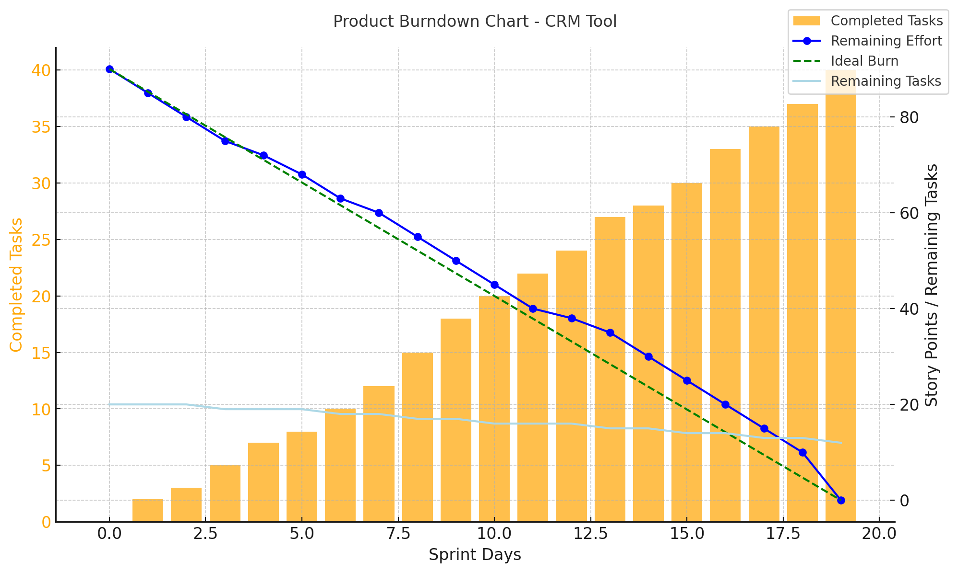

Sprint Burndown chart:

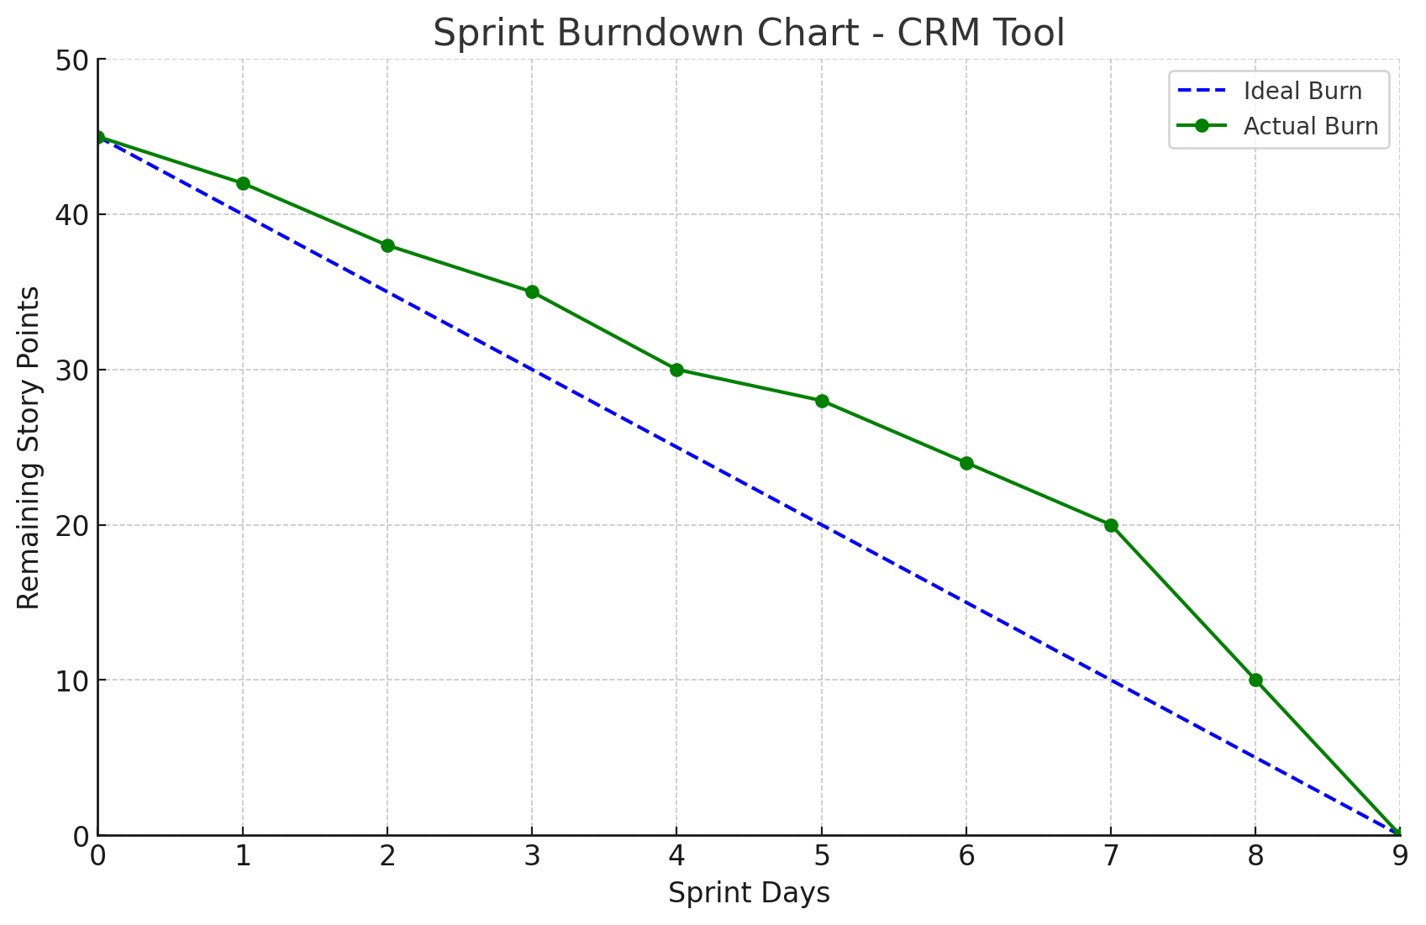

Document 6: Sprint meetings

Meeting Type 1: Sprint Planning meeting

|  |  |
| --- | --- |
| Date: | 22-03-2025 |
| Time: | 10:00 AM - 12:00 PM |
| Location: | Microsoft Teams |
| Prepared By: | Tanisha Mohane |
| Attendees | Product Owner, Scrum Master, Development Team, QA, UX Designer |

Agenda Topics:

|  |  |  |
| --- | --- | --- |
| Topic | Presenter | Time allotted |
| Project Overview and Objectives | Product Owner | 15 mins |
| User Story Prioritization | Scrum Master | 30 mins |
| Development Tasks Assignment | Development Team Lead | 30 mins |
| Test Cases and QA Plan | QA Lead | 20 mins |
| UI/UX Review | UX Designer | 15 mins |

Other Information:

|  |  |  |
| --- | --- | --- |
| Observer | Resources | Special notes |
| None | Sprint Backlog, Product Vision | Ensure alignment with Product Roadmap |

Meeting Type 2: Sprint Review Meeting

|  |  |
| --- | --- |
| Date: | 05-04-2025 |
| Time: | 3:00 PM - 4:30 PM |
| Location: | Microsoft Teams |
| Prepared By: | Scrum Master |
| Attendees | Product Owner, Stakeholders, Development Team, QA |

|  |  |  |  |
| --- | --- | --- | --- |
| Sprint status | Things to demo | Quick update | What’s Next |
| Sprint Completed | CRM Dashboard, Login Flow | Minor bug fixes pending | Start Sprint 2 with new tasks |
| 90% Tasks Completed | Report Generation Feature | Performance issues resolved | Address UX feedback |

Meeting Type 3: Sprint Retrospective Meeting

|  |  |
| --- | --- |
| Date: | 06-04-2025 |
| Time: | 11:00 AM - 12:00 PM |
| Location: | Microsoft Teams |
| Prepared By: | Scrum Master |
| Attendees | Scrum Team |

|  |  |  |  |  |
| --- | --- | --- | --- | --- |
| Agenda | What Went Well | What Didn’t Go Well | Questions | Reference |
| Team Collaboration | Smooth Development Process | Delays due to unclear requirements | How to improve estimations? | Sprint 1 Review Report |
| Process Improvement | Fast Bug Resolution | Slow feedback from stakeholders | Better feedback channel? | Feedback Report |

Meeting Type 4: Daily Stand-Up Meeting

Week: 22-03-2025 to 28-03-2025

|  |  |  |  |  |  |  |  |  |
| --- | --- | --- | --- | --- | --- | --- | --- | --- |
| Question | Name/Role | Monday | Tuesday | Wednesday | Thursday | Friday | Saturday | Sunday |
| What did you do yesterday? | Developer 1 | |  | | --- | | ✅ |  |  | | --- | |  | | |  | | --- | | ✅ |  |  | | --- | |  | | |  | | --- | | ✅ |  |  | | --- | |  | | |  | | --- | | ✅ |  |  | | --- | |  | | |  | | --- | | ✅ |  |  | | --- | |  | | ❌ | ❌ |
|  | Developer 2 | |  | | --- | | ✅ |  |  | | --- | |  | | |  | | --- | | ✅ |  |  | | --- | |  | | |  | | --- | | ✅ |  |  | | --- | |  | | |  | | --- | | ✅ |  |  | | --- | |  | | |  | | --- | | ✅ |  |  | | --- | |  | | ❌ | ❌ |
|  | Developer 3 | |  | | --- | | ✅ |  |  | | --- | |  | | |  | | --- | | ✅ |  |  | | --- | |  | | |  | | --- | | ✅ |  |  | | --- | |  | | |  | | --- | | ✅ |  |  | | --- | |  | | |  | | --- | | ✅ |  |  | | --- | |  | | ❌ | ❌ |
| What will you do today? | Developer 1 | Work on Login UI | Backend API | Testing | Debugging | Report Generation | N/A | N/A |
|  | Developer 2 | API Creation | Frontend Fixes | QA Testing | Documentation | API Enhancements | N/A | N/A |
|  | Developer 3 | UI Design | Component Testing | Bug Fixing | Integration Testing | Final Review | N/A | N/A |
| What (if any) is blocking you? | Developer 1 | No | No | Minor Bug | No | No | N/A | N/A |
|  | Developer 2 | No | No | API Delay | No | No | N/A | N/A |
|  | Developer 3 | No | Minor UI Glitch | No | No | No | N/A | N/A |