Online Agriculture Product Store
Question 1 – Functional Requirements - Identify minimum 20 functional requirements.
Answer:
Functional Requirements: Functional requirements define what the system should do — the specific features, actions, and behaviors it must support.
Non-Functional Requirements: Non-functional requirements define how the system should be — its quality attributes, performance, security, usability, and constraints.
FUNCTIONAL REQUIREMENTS
Req ID | Req Name | Requirement Description | Priority
FR001 | Farmer Registration | The system shall allow farmers to register by providing details such as name, email, and mobile. | 9
FR002 | User Login | The system shall allow users to log in securely using their registered email/mobile and password. | 9
FR003 | Password Recovery | The system shall allow users to recover/reset their password using OTP or email verification. | 8
FR004 | Browse Catalogue | The system shall allow farmers to browse the catalogue of available products (Seeds, Fertilizers, Pesticides). | 8
FR005 | Search Products | The system shall allow farmers to search products by entering keywords for product name, price range, category (Seeds, Fertilizers, Pesticides), and brand, with search results | 8
FR006 | Product Categorization | The system shall categorize products into Seeds, Fertilizers, and Pesticides for easier browsing. | 7
FR007 | Add to Cart | The system shall allow farmers to add products to their shopping cart for purchase. | 9
FR008 | Update/Remove from Cart | The system shall allow farmers to update quantities or remove products from their shopping cart. | 8
FR009 | Place Order | The system shall allow farmers to place orders for products selected in the shopping cart. | 9
FR010 | Enter Delivery Address | The system shall allow farmers to enter or update their delivery address during checkout. | 7
FR011 | Payment Options | The system shall allow users to choose payment methods such as COD, UPI, and Cards. | 9
FR012 | Payment Validation | The system shall validate online payments through an integrated payment gateway. | 9
FR013 | Order Tracking | The system shall allow farmers to track their order status (Processing, Shipped, Delivered). | 8
FR014 | Delivery Confirmation | The system shall allow farmers to confirm delivery of products once received. | 7
FR015 | Manage Products | The system shall allow manufacturers to add, update, and delete products in the catalogue. | 9
FR016 | Admin Monitoring | The system shall allow admins to view and manage user accounts (e.g., activate, deactivate, or modify user details), transactions (e.g., view, refund, or cancel), and generate reports (e.g., sales summary, user activity, and inventory status) | 8
FR017 | Notifications | The system shall send SMS/email notifications for orders, payments, and delivery updates. | 7
FR018 | Order Cancellation | The system shall allow farmers to cancel orders before dispatch. | 7
FR019 | Feedback & Rating | The system shall allow farmers to provide product ratings and reviews after purchase. | 7
FR020 | Wishlist | The system shall allow farmers to add/remove products to a Wishlist for future purchases. | 6

NON FUNCTIONAL REQUIREMENTS
Req ID | Req Name | Requirement Description | Priority
NFR001 | Performance | The system shall load catalogue pages within 3 seconds under normal conditions. | 9
NFR002 | Scalability | The system shall support at least 10,000 concurrent users without performance degradation. | 9
NFR003 | Availability | The system shall provide 99.9% uptime annually. | 9
NFR004 | Reliability | The system shall process transactions with no more than 0.1% failure rate. | 8
NFR005 | Security | The system shall encrypt sensitive data such as passwords and payments using AES-256. | 9
NFR006 | Data Privacy | The system shall comply with data protection regulations such as GDPR for user data. | 9
NFR007 | Usability | The system shall have an intuitive and user-friendly interface for farmers and manufacturers. | 8
NFR008 | Compatibility | The system shall be accessible on multiple platforms (Web, Android, iOS). | 8
NFR009 | Responsiveness | The system shall adapt to different screen sizes (desktop, tablet, mobile). | 8
NFR010 | Maintainability | The system shall support software updates and fixes with a maximum downtime of 15 minutes per update, scheduled during off-peak hours, and maintain an average update deployment time. | 7
NFR011 | Testability | The system shall support automated and manual testing with traceable test cases. | 8
NFR012 | Auditability | The system shall maintain logs of all user activities and transactions for auditing. | 8
NFR013 | Backup & Recovery | The system shall provide daily backups and restore capability within 2 hours. | 8
NFR014 | Localization | The system shall support user interfaces and notifications in at least three regional languages (Hindi, Tamil and Telugu) for farmers in remote regions, with the ability to switch languages seamlessly within 2 seconds. | 7
NFR015 | Accessibility | The system shall comply with accessibility standards (WCAG 2.1) for differently-abled users. | 7
NFR016 | Portability | The system shall operate across different OS platforms (Windows, Linux, Android, iOS). | 7
NFR017 | Integration | The system shall integrate with third-party Payment Gateways and Delivery Partner APIs. | 8
NFR018 | Documentation | The system shall include user guides, FAQs, and technical documentation. | 6
NFR019 | Disaster Recovery | The system shall recover within 4 hours after a major failure through disaster recovery plans. | 8
NFR020 | Supportability | The system shall provide 24/7 customer support through chat/email. | 7

Question 2 – Minimum 5 pages designs - Make wireframe and prototypes
Answer:
Wireframes - Wireframes are low-fidelity visual layouts that show the basic structure and placement of elements on a page or screen.
Prototypes - Prototypes are interactive, high-fidelity representations of a system that simulate the real user experience and workflow.

User Registration Page
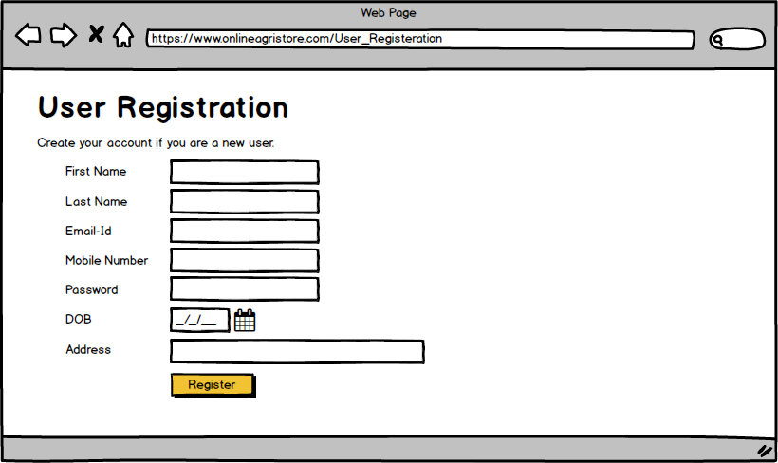
User Login Page
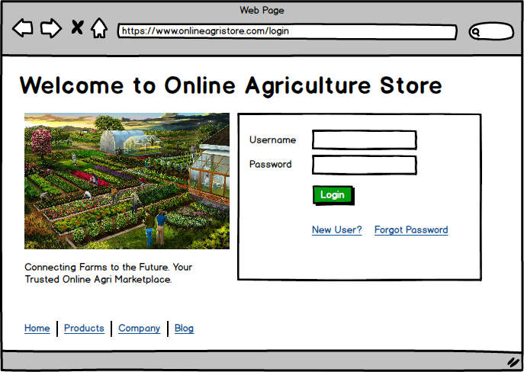
Home Page
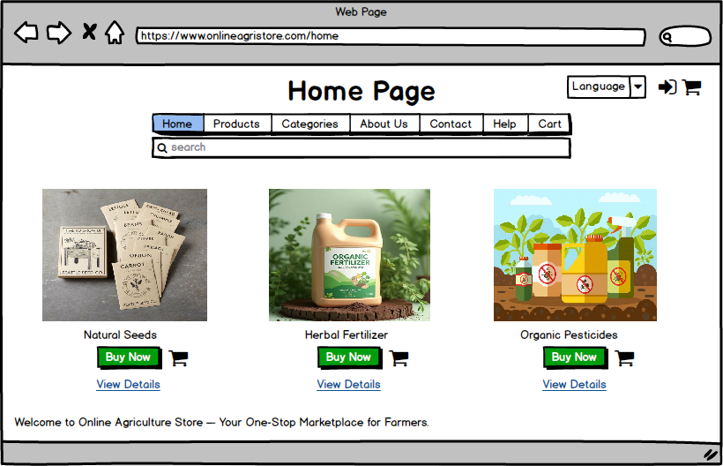
Product List Page
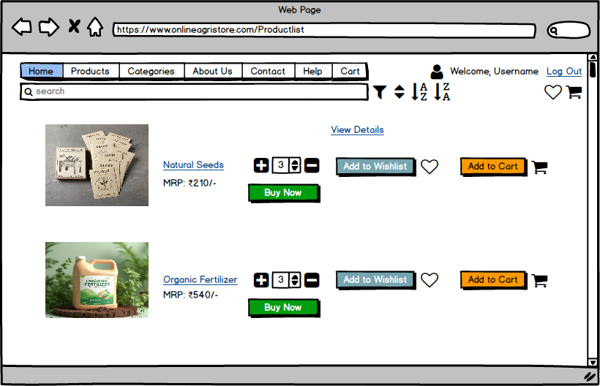

Order Summary Page
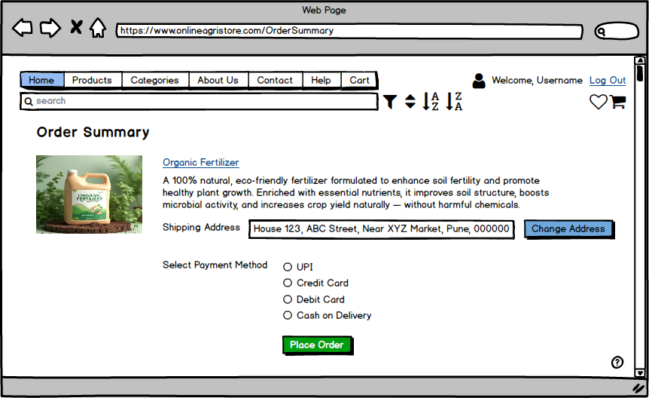
Order Placed Page
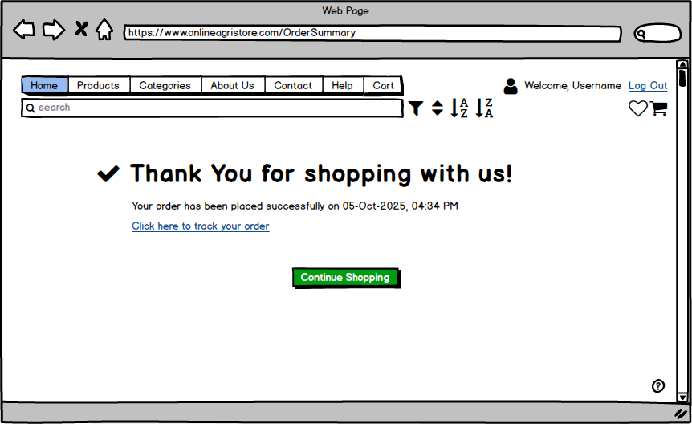
Question 3 – Tools (Visio, Balsamiq) - Make a note of the Tools, which you are using for above concepts.
Answer:
Microsoft Office Visio
Microsoft Visio is a diagramming and vector graphics application that is part of the Microsoft Office family. It is used to create various types of diagrams such as Flowcharts, Organizational Charts, Floor Plans, Network Diagrams, UML Diagrams, and Mind Maps. Visio is commonly utilized for process mapping, visual collaboration, and system design. The latest versions of Visio also support data visualization, allowing users to create diagrams from Excel data and embed them into Power BI dashboards.
Microsoft Office Visio simplifies the process of creating complex diagrams for business and technical purposes. It helps in designing business workflows, presentations, floor plans, and organizational structures.
The following diagrams can be created by a Business Analyst using MS Office Visio:
Flowchart - A flowchart helps visualize the sequential steps in a process. It effectively conveys information and decision paths, making it useful for understanding workflows in various domains.
Organization Chart - An organization chart displays the hierarchy and reporting relationships within an organization. It identifies employee roles and positions, showing the overall structure of the company.
Floor Plan - A floor plan illustrates the layout or structure of a physical space. It is often used by architects and planners to show the arrangement of rooms, windows, and doors.
Business Process Modelling Notation (BPMN) - BPMN provides a visual representation of business processes. It helps in understanding and communicating workflows clearly through standardized symbols and notations.
Balsamiq
Balsamiq Mockups is an effective tool for designing software wireframes that represent software requirements visually. It allows Business Analysts and design teams to sketch and communicate the structure, layout, and functionality of an application during the early stages of development.
This tool helps teams and stakeholders visualize how the final product will look and function before actual development begins. It promotes quick feedback, iteration, and collaboration.
Balsamiq is especially useful for creating low-fidelity mockups such as login pages, registration screens, product listings, and dashboards, enabling clear communication between developers, designers, and clients.
Question 4 – RTM - A business analyst’s key responsibilities are to keep track of the requirements and make sure that no requirement is missed. Mr. Henry and peter have approached you regarding the current status of the project. How will you tackle this situation? Prepare RTM.
Answer:
A Requirements Traceability Matrix (RTM) is a document that maps and tracks requirements through different project phases ensuring that each requirement is tested, validated, and not missed during development.
Req ID | Req Name | Requirement Description | D1 | T1 | D2 | T2 | D3 | T3 | D4 | T4 | UAT
FR001 | Farmer Registration | System shall allow farmers to register by providing name, email, mobile. | Complete | Complete | Complete | Complete | Complete | Complete | Complete | Complete | Complete
FR002 | User Login | System shall allow users to log in securely using registered email/mobile & password. | Complete | Complete | Complete | Complete | Complete | Complete | Complete | Complete | Complete
FR003 | Password Recovery | System shall allow users to recover/reset password using OTP or email verification. | Complete | Complete | Complete | Complete | Complete | Complete | Complete | Complete | Complete
FR004 | Browse Catalogue | System shall allow farmers to browse catalogue of products (Seeds, Fertilizers, Pesticides). | Complete | Complete | Complete | Complete | Complete | Complete | Complete | Complete | Complete
FR005 | Search Products | System shall allow search by product name, price range, category and brand. | Complete | Complete | Complete | Complete | Complete | Complete | Complete | Complete | Complete
FR006 | Product Categorization | System shall categorize products into Seeds, Fertilizers, Pesticides. | Complete | Complete | Complete | Incomplete | Complete | Complete | Incomplete | Incomplete | Complete
FR007 | Add to Cart | System shall allow farmers to add products to shopping cart. | Complete | Complete | Complete | Complete | Complete | Complete | Complete | Complete | Complete
FR008 | Update/Remove from Cart | System shall allow update quantities or remove products from cart. | Complete | Complete | Complete | Complete | Complete | Complete | Incomplete | Complete | Complete
FR009 | Place Order | System shall allow farmers to place orders for cart items. | Complete | Complete | Complete | Complete | Complete | Complete | Complete | Complete | Complete
FR010 | Enter Delivery Address | System shall allow farmers to enter/update delivery address during checkout. | Complete | Complete | Complete | Incomplete | Complete | Complete | Incomplete | Incomplete | Complete
FR011 | Payment Options | System shall allow payment methods such as COD, UPI, Cards. | Complete | Complete | Complete | Complete | Complete | Complete | Complete | Complete | Complete
FR012 | Payment Validation | System shall validate online payments via integrated payment gateway. | Complete | Complete | Complete | Complete | Complete | Complete | Complete | Complete | Complete
FR013 | Order Tracking | System shall allow farmers to track order status (Processing, Shipped, Delivered). | Complete | Complete | Complete | Complete | Complete | Complete | Complete | Complete | Complete
FR014 | Delivery Confirmation | System shall allow farmers to confirm delivery once received. | Complete | Complete | Complete | Complete | Complete | Complete | Complete | Complete | Complete
FR015 | Manage Products | System shall allow manufacturers to add, update, delete products in catalogue. | Complete | Complete | Complete | Complete | Complete | Complete | Complete | Complete | Complete
FR016 | Admin Monitoring | System shall allow admins to view/manage user accounts, transactions, reports. | Complete | Complete | Complete | Complete | Complete | Complete | Complete | Complete | Complete
FR017 | Notifications | System shall send SMS/email notifications for orders, payments, delivery updates. | Complete | Complete | Complete | Complete | Complete | Complete | Complete | Complete | Complete
FR018 | Order Cancellation | System shall allow farmers to cancel orders before dispatch. | Complete | Complete | Complete | Complete | Complete | Complete | Complete | Complete | Complete
FR019 | Feedback & Rating | System shall allow farmers to provide product ratings and reviews after purchase. | Complete | Complete | Complete | Incomplete | Complete | Complete | Incomplete | Incomplete | Complete
FR020 | Wishlist | System shall allow farmers to add/remove products to Wishlist. | Complete | Complete | Complete | Incomplete | Complete | Complete | Incomplete | Incomplete | Complete

Req ID | Req Name | Req Description | D1 | D2 | D3 | D4 | T1 | T2 | T3 | T4 | UAT
NFR001 | Performance | The system should load pages quickly and respond within 2 seconds under normal conditions. | Complete | Complete | Complete | Incomplete | Complete | Complete | Incomplete | Incomplete | Complete
NFR002 | Scalability | The system should handle a large number of users at the same time without slowing down. | Complete | Complete | Complete | Incomplete | Complete | Complete | Incomplete | Incomplete | Complete
NFR003 | Availability | The system should be available and running almost all the time, with very little downtime. | Complete | Complete | Incomplete | Incomplete | Complete | Incomplete | Incomplete | Incomplete | Complete
NFR004 | Reliability | The system should work correctly and complete transactions without frequent failures. | Complete | Complete | Incomplete | Incomplete | Complete | Complete | Incomplete | Incomplete | Complete
NFR005 | Security | The system should keep all user and payment data safe and prevent unauthorized access. | Complete | Complete | Complete | Incomplete | Complete | Complete | Incomplete | Incomplete | Complete
NFR006 | Data Privacy | The system should protect user data and ensure it is used only for intended purposes. | Complete | Complete | Complete | Complete | Complete | Complete | Incomplete | Incomplete | Complete
NFR007 | Usability | The system should have a simple and user-friendly interface that is easy to understand. | Complete | Complete | Complete | Incomplete | Complete | Complete | Incomplete | Incomplete | Complete
NFR008 | Compatibility | The system should work smoothly on different devices such as computers and mobile phones. | Complete | Complete | Incomplete | Incomplete | Complete | Complete | Incomplete | Incomplete | Complete
NFR009 | Responsiveness | The system’s layout should adjust properly to fit all screen sizes (mobile, tablet, desktop). | Complete | Complete | Incomplete | Incomplete | Complete | Complete | Incomplete | Incomplete | Complete
NFR010 | Maintainability | The system should be easy to update or fix without causing long interruptions. | Complete | Complete | Complete | Incomplete | Complete | Incomplete | Incomplete | Incomplete | Complete
NFR011 | Testability | The system should support easy testing of all features to make sure they work as expected. | Complete | Complete | Incomplete | Incomplete | Complete | Complete | Incomplete | Incomplete | Complete
NFR012 | Auditability | The system should keep a record of user activities for review and tracking purposes. | Complete | Complete | Incomplete | Incomplete | Complete | Incomplete | Incomplete | Incomplete | Complete
NFR013 | Backup & Recovery | The system should take regular backups and restore information quickly if something goes wrong. | Complete | Complete | Complete | Incomplete | Complete | Complete | Incomplete | Incomplete | Complete
NFR014 | Localization | The system should support multiple languages so farmers can use it in their regional language. | Complete | Complete | Incomplete | Incomplete | Complete | Complete | Incomplete | Incomplete | Complete
NFR015 | Accessibility | The system shall be accessible and easy to use for differently-abled users. | Complete | Complete | Incomplete | Incomplete | Complete | Complete | Incomplete | Incomplete | Complete
NFR016 | Portability | The system should run properly on different operating systems like Windows, Android, and iOS. | Complete | Complete | Complete | Incomplete | Complete | Incomplete | Incomplete | Incomplete | Complete
NFR017 | Integration | The system should connect easily with other services such as payment or delivery systems. | Complete | Complete | Complete | Complete | Complete | Complete | Complete | Incomplete | Complete
NFR018 | Documentation | The system should include simple user guides, FAQs, and help sections for easy understanding. | Complete | Complete | Incomplete | Incomplete | Complete | Incomplete | Incomplete | Incomplete | Complete
NFR019 | Disaster Recovery | The system should be able to recover quickly after a major failure or technical issue. | Complete | Complete | Incomplete | Incomplete | Complete | Complete | Incomplete | Incomplete | Complete
NFR020 | Supportability | The system should provide customer support through chat or email whenever users need help. | Complete | Complete | Incomplete | Incomplete | Complete | Incomplete | Incomplete | Incomplete | Complete

Question 5 – 10 Test Case Documents - Prepare 10 Test Case Documents
Answer:
A test case is a detailed specification that defines input data, execution conditions, and expected outcomes to verify that a system’s functionality meets its requirements.

Test Case for User Login
Pre-Condition | The user has a valid registered account (username and password).  The user is on the login page of the online agriculture store.  Internet connection and test environment are active.
Post-Condition | If login is successful, the user is redirected to the Home Page.  If login fails, an error message is displayed, and the user remains on the login page.
Test Case ID | TC001 | Test Case Name | User Login
Project ID | P001 | Project Name | Online Agriculture Product Store
PM ID | PM001 | PM Name | Mr. Pandu
Test Strategy ID | TS001 | Tester ID | QA001
Test Plan ID | TP001 | Tester Name | Ms. Alekya / Mr. Jason
Test Schedule ID | SCH001 | Date of Test | —
Scenario | Verify that a user can log in with valid credentials and that invalid credentials are correctly rejected.
Link to that page
Input Data | Set 1 | Set 2 | Set 3 | Set 4 | Set 5
Username | Valid Username | Valid Username | Invalid Username | Invalid Username | Empty Username
Password | Valid Password | Invalid Password | Valid Password | Invalid Password | Empty Password
Expected Behavior | Successful login → Redirect to Home Page | Error message “Invalid Password” | Error message “Invalid Username” | Error message “Invalid Credentials” | Error message “Fields cannot be blank.”
Actual Behavior
Result (Pass/Fail)

Test Case for Farmer Registration
Pre-Condition | The user is on the registration page of the online agriculture store.  Internet connection is active and the test environment is running properly.
Post-Condition | If registration is successful, a new farmer account is created and the user is redirected to the login or home page.  If registration fails, no account is created, and an error message is shown.
Test Case ID | TC002 | Test Case Name | Farmer Registration
Project ID | P001 | Project Name | Online Agriculture Product Store
PM ID | PM001 | PM Name | Mr. Pandu
Test Strategy ID | TS001 | Tester ID | QA002
Test Plan ID | TP001 | Tester Name | Ms. Alekya / Mr. Jason
Test Schedule ID | SCH002 | Date of Test | —
Scenario | Verify farmer registration flow for valid data and validate system behavior for duplicates, invalid formats, weak passwords, and missing mandatory fields.
Link to that page
Input Data | Set 1 | Set 2 | Set 3 | Set 4 | Set 5
Full Name | Ramesh Kumar | Priya Sharma | Test User | Rahul Singh | (blank)
Email | ramesh.test+01@example.com | existing.user@example.com | invalid-email-format | arun.test@example.com | newuser@example.com
Mobile | 9876543201 | 9876543211 | 9876543210 | 9876543212 | 9876543213
Password | StrongPass@123 | StrongPass@123 | StrongPass@123 | weak | ValidPass123!
Confirm Password | StrongPass@123 | StrongPass@123 | StrongPass@123 | weak | (blank)
Accept Terms | Yes | Yes | Yes | Yes | Yes
Expected Behavior | Registration successful → Confirmation message / OTP sent → Account created; redirect to Login or Dashboard. | Registration blocked → Error message “Email already registered”. No account created. | Registration blocked → Error message “Enter a valid email address”. No account created. | Registration blocked → Error message “Password does not meet complexity requirements”. No account created. | Registration blocked → Error message “Confirm Password is required”. No account created.
Actual Behavior
Result (Pass/Fail)

Test Case for Product Search
Pre-Condition | The user is logged into the online agriculture store.  Internet connection is active, and the test environment is running properly.  Products (seeds, fertilizers, pesticides) are already listed in the system.
Post-Condition | Search results are displayed based on user input.  User can view product details or refine search results.  If no product matches, a “No products found” message is shown.
Test Case ID | TC003 | Test Case Name | Product Search
Project ID | P001 | Project Name | Online Agriculture Product Store
PM ID | PM001 | PM Name | Mr. Pandu
Test Strategy ID | TS001 | Tester ID | QA003
Test Plan ID | TP001 | Tester Name | Ms. Alekya / Mr. Jason
Test Schedule ID | SCH003 | Date of Test | —
Scenario | Verify that the system allows the user to search for products by keyword, category, brand, and price range, and displays correct search results or an appropriate message if no match is found.
Link to that page
Input Data | Set 1 | Set 2 | Set 3 | Set 4 | Set 5
Search Keyword | “Organic Fertilizer” | “Hybrid Seeds” | “Neem Pesticide” | “Invalid Product Name” | (blank)
Category | Fertilizers | Seeds | Pesticides | Fertilizers | Seeds
Price Range (₹) | 100–500 | 200–800 | 300–1000 | 100–300 | 100–1000
Brand | AgriGrow | GreenSeeds | BioNeem | AgriGrow | Any
Expected Behavior | Displays all organic fertilizers priced between ₹100–₹500. | Displays hybrid seeds between ₹200–₹800. | Displays neem-based pesticides between ₹300–₹1000. | Shows message “No products found” for invalid product names. | Prompts user to enter a keyword or select a filter.
Actual Behavior
Result (Pass/Fail)

Test Case for Add to Cart
Pre-Condition | The user is logged in to the Online Agriculture Product Store.  Products are available in the catalogue (Seeds, Fertilizers, Pesticides).  Internet connection and test environment are stable.
Post-Condition | Items are successfully added, updated, or removed in the cart.  Total amount and quantity automatically update.  User remains on cart page after performing action.
Test Case ID | TC004 | Test Case Name | Add to Cart
Project ID | P001 | Project Name | Online Agriculture Product Store
PM ID | PM001 | PM Name | Mr. Pandu
Test Strategy ID | TS001 | Tester ID | QA004
Test Plan ID | TP001 | Tester Name | Ms. Alekya / Mr. Jason
Test Schedule ID | SCH004 | Date of Test | —
Scenario | Verify that the system allows users to add products to the shopping cart, update quantities, and remove items correctly, reflecting accurate totals and item counts.
Link to that page
Input Data | Set 1 | Set 2 | Set 3 | Set 4 | Set 5
Product Name | Organic Fertilizer | Hybrid Seeds | Neem Pesticide | Hybrid Seeds | Organic Fertilizer
Action | Add to Cart | Add to Cart (then update quantity to 3) | Add to Cart (then remove item) | Add to Cart (quantity exceeds stock limit) | Add to Cart (without selecting quantity)
Quantity | 1 | 1 → 3 | 1 → Remove | 6 (when only 5 available) | (blank)
Expected Behavior | Product added to cart successfully. | Quantity updated successfully; total recalculated. | Product removed from cart successfully. | Error message: “Only 5 items available in stock.” | Error message: “Please select a quantity before adding to cart.”
Actual Behavior
Result (Pass/Fail)

Test Case for Place Order / Checkout
Pre-Condition | User is logged in and has at least one item in the cart.  Delivery address is available in the user profile or entered at checkout.  Payment method (COD/UPI/Card) is available in the environment.
Post-Condition | On success: Order is created, Order ID generated, status set to Processing, and confirmation (email/SMS) sent.  On failure: No order created; appropriate error message displayed; cart remains intact.  Test data cleanup: Cancel or remove test orders if needed in test environment.
Test Case ID | TC005 | Test Case Name | Place Order / Checkout
Project ID | P001 | Project Name | Online Agriculture Product Store
PM ID | PM001 | PM Name | Mr. Pandu
Test Strategy ID | TS001 | Tester ID | QA005
Test Plan ID | TP001 | Tester Name | Ms. Alekya / Mr. Jason
Test Schedule ID | SCH005 | Date of Test | —
Scenario | Verify end-to-end checkout flow: select address, choose payment method, place order, and verify order creation, payment handling and notifications.
Link to that page
Input Data | Set 1 | Set 2 | Set 3 | Set 4 | Set 5
Cart Items | 2 items (in stock) | 1 item + coupon | 1 item (out of stock) | 1 item | 1 item
Delivery Address | Valid saved address | Valid saved address | Valid saved address | New address entered at checkout | Valid saved address
Payment Method | COD | UPI | COD | Card | Card (invalid card)
Coupon | None | SAVE50 (valid) | None | None | None
Expected Behavior | Order placed; Order ID generated; status Processing; confirmation email/SMS sent. | Coupon applied; discounted total reflected; order placed; confirmation sent. | System shows “Item out of stock” and prevents order creation. | Card payment processed successfully; order status Paid; confirmation sent. | Payment fails; user shown payment error and allowed to retry; no order created in Paid state.
Actual Behavior
Result (Pass/Fail)

Test Case for UPI Payment
Pre-Condition | User is logged in and has at least one item in the cart.  Delivery address is selected.  Payment gateway for UPI testing (test UPI IDs available).  Internet connection and test environment active.
Post-Condition | On success: Payment status = Paid, receipt shown, confirmation notification sent.  On failure or cancel: Payment not captured, user shown clear message and allowed to retry; order not marked Paid.
Test Case ID | TC006 | Test Case Name | UPI Payment
Project ID | P001 | Project Name | Online Agriculture Product Store
PM ID | PM001 | PM Name | Mr. Pandu
Test Strategy ID | TS001 | Tester ID | QA006
Test Plan ID | TP001 | Tester Name | Ms. Alekya / Mr. Jason
Test Schedule ID | SCH006 | Date of Test | —
Scenario | Verify UPI payment flow: success, invalid UPI ID, user-cancel, and timeout handling.
Link to that page
Input Data | Set 1 | Set 2 | Set 3 | Set 4
Payment Method | UPI | UPI | UPI | UPI
UPI Test Data | valid-upi@test | invalid-upi@test | valid-upi@test (user cancels) | valid-upi@test (simulate timeout)
Amount | ₹350 | ₹200 | ₹150 | ₹500
Action | Complete payment | Attempt payment → gateway returns invalid VPA | User initiates payment then cancels at bank / app | Gateway/Network timeout simulated
Expected Behavior | Payment succeeds → status Paid; receipt & notification sent. | Payment fails → show “Invalid UPI ID” message; order not marked Paid; user can retry or change method. | Payment cancelled → show “Payment cancelled by user”; no payment captured; user returned to checkout. | Payment timeout → show “Payment timeout” message; transaction not captured; user can retry.
Actual Behavior
Result (Pass/Fail)

Test Case for Cash on Delivery (COD)
Pre-Condition | User is logged in and has items in the cart.  Delivery address is available.  COD payment option is enabled in test environment.  Internet connection and test environment active.
Post-Condition | On checkout with COD: Order is created with payment status Pending (COD) or COD depending on system design; confirmation notification is sent indicating COD selected.  No online payment is captured.  If COD is disabled or not available in the region, user sees clear message and cannot place order with COD.
Test Case ID | TC007 | Test Case Name | COD Payment
Project ID | P001 | Project Name | Online Agriculture Product Store
PM ID | PM001 | PM Name | Mr. Pandu
Test Strategy ID | TS001 | Tester ID | QA007
Test Plan ID | TP001 | Tester Name | Ms. Alekya / Mr. Jason
Test Schedule ID | SCH007 | Date of Test | —
Scenario | Verify COD checkout: order creation, status, notifications and behavior when COD not available.
Link to that page
Input Data | Set 1 | Set 2 | Set 3 | Set 4
Cart Items | 2 items (in stock) | 1 item | 1 item | 1 item
Delivery Address | Valid saved address | Address in unsupported COD region | Valid address | Valid address
Payment Method | COD | COD | COD | COD
Action | Place order with COD | Try to place order with COD (COD disabled for region) | Place order then cancel from user before dispatch | Place order with high-value order (check COD limit if any)
Expected Behavior | Order created; payment status Pending (COD); confirmation message indicates COD selected; notification sent. | System shows “Cash on Delivery not available in your area”; prompts to choose another method. No order created. | Order created; if user cancels before dispatch, order status updated to Cancelled; refund not applicable (since COD). | If business restricts COD for high-value orders, system blocks COD and asks for online payment OR marks as manual verification required.
Actual Behavior
Result (Pass/Fail)

Test Case for Order Tracking & Notifications
Pre-Condition | User has placed an order and Order ID is available.  Order exists in the system and tester has access to admin tools (or API) to simulate status changes.  Notification gateway (email/SMS) configured in test environment.  Internet connection and test environment active.
Post-Condition | Order status updates are reflected in user UI and admin UI.  Notifications (email/SMS/in-app) are sent for status changes.  Audit logs contain status change entries for the order.
Test Case ID | TC008 | Test Case Name | Order Tracking & Notifications
Project ID | P001 | Project Name | Online Agriculture Product Store
PM ID | PM001 | PM Name | Mr. Pandu
Test Strategy ID | TS001 | Tester ID | QA008
Test Plan ID | TP001 | Tester Name | Ms. Alekya / Mr. Jason
Test Schedule ID | SCH008 | Date of Test | —
Scenario | Verify order status transitions (Processing → Shipped → Out for Delivery → Delivered → Returned/Cancelled) are visible to users and corresponding notifications are sent.
Link to that page
Input Data | Set 1 | Set 2 | Set 3 | Set 4 | Set 5
Order ID | 10045 (test order) | 10046 (test order) | 10047 (test order) | 10048 (test order) | 10049 (test order)
Initial Status | Processing | Shipped | Out for Delivery | Delivered | Processing
Action | Admin → change to Shipped | Delivery partner → change to Out for Delivery | Delivery partner → change to Delivered | User → confirm delivery | Admin → change to Cancelled or Returned
Notifications to verify | Email and SMS content, timestamp, and delivery status. | Email and SMS content, timestamp, and delivery status. | Email and SMS content, timestamp, and delivery status. | Email/SMS & in-app confirmation; audit log entry. | Email/SMS about cancellation/return; audit log entry.
Audit Log | Status change entry with timestamp and actor (admin/delivery API). | Status change entry with timestamp and actor. | Status change entry and delivery confirmation entry. | Delivery confirmation recorded. | Cancellation / return entry logged with reason.
Expected Behavior | UI shows status = Shipped; user receives SMS/email “Your order is shipped”. | UI shows status = Out for Delivery; user receives SMS/email “Your order is out for delivery”. | UI shows status = Delivered; user receives SMS/email “Your order delivered” and can confirm delivery. | UI shows status = Delivered and Delivery Confirmation accepted; order marked complete. | UI shows status = Cancelled/Returned; user notified; refund/refund-notification flow initiated if applicable.
Actual Behavior
Result (Pass/Fail)

Test Case for Feedback & Rating
Pre-Condition | User is logged in and has at least one completed order (i.e., order status = Delivered).  Product(s) to be rated exist in the user’s order history.  Internet connection and test environment are active.
Post-Condition | On success: Rating and review are saved and visible on product details or review section; rating aggregate (average) updates; user can edit/delete own review if allowed.  On failure: Review not saved; error message shown; no change to rating aggregate.
Test Case ID | TC009 | Test Case Name | Feedback & Rating
Project ID | P001 | Project Name | Online Agriculture Product Store
PM ID | PM001 | PM Name | Mr. Pandu
Test Strategy ID | TS001 | Tester ID | QA009
Test Plan ID | TP001 | Tester Name | Ms. Alekya / Mr. Jason
Test Schedule ID | SCH009 | Date of Test | —
Scenario | Verify that a user who bought a product can submit a rating (1–5 stars) and a text review, that the system validates input, and that the product’s average rating and review list update accordingly.
Link to that page
Input Data | Set 1 | Set 2 | Set 3 | Set 4 | Set 5
User State | Delivered order, eligible | Delivered order, eligible | Delivered order, eligible | Delivered order, eligible | No delivered order (not eligible)
Product | Organic Fertilizer (productId 201) | Hybrid Seeds (productId 105) | Neem Pesticide (productId 331) | Organic Fertilizer (productId 201) | Hybrid Seeds (productId 105)
Rating (stars) | 5 | 3 | 1 | 4 | 5
Review Text | “Great quality — helped yield.” | (blank) | “Poor packaging; product damaged” | 300-character long review (boundary) | “Trying to post without purchase”
Action | Submit rating + review | Submit rating only (no text) | Submit rating + review (negative) | Submit long review (boundary test) | Attempt to submit without eligible order
Additional Checks | Verify DB entry, timestamp, user id linked, and updated average. | Verify DB entry and UI shows rating. | Verify moderation flags (if any) and UI displays negative review. | Verify review length stored correctly and UI displays full/truncated text per spec. | Verify no DB entry created.
Expected Behavior | Rating & review saved; average rating updated; review visible under product. | Rating saved; review list shows rating with empty/No comment” or disallow blank review depending on rules. | Rating & review saved; negative review recorded; flagged if abuse rules apply. | Long review accepted up to limit (or truncated) and saved; boundary validated. | System prevents review submission; shows message “You can review items only after delivery.”
Actual Behavior
Result (Pass/Fail)

Test Case for Wishlist
Pre-Condition | User is logged into the Online Agriculture Product Store.  Products are available in the catalogue.  Internet connection and test environment are active.
Post-Condition | On success: Selected product is added to the Wishlist and visible under the user’s Wishlist tab.  On removal: Product is successfully deleted from the Wishlist.  System maintains correct count of Wishlist items; duplicates are not allowed.
Test Case ID | TC010 | Test Case Name | Wishlist Functionality
Project ID | P001 | Project Name | Online Agriculture Product Store
PM ID | PM001 | PM Name | Mr. Pandu
Test Strategy ID | TS001 | Tester ID | QA010
Test Plan ID | TP001 | Tester Name | Ms. Alekya / Mr. Jason
Test Schedule ID | SCH010 | Date of Test | —
Scenario | Verify that users can add or remove products from their Wishlist, that duplicates are restricted, and Wishlist data is retained between sessions.
Link to that page
Input Data | Set 1 | Set 2 | Set 3 | Set 4 | Set 5
User State | Logged in | Logged in | Logged in | Logged in | Logged out
Product Name | Organic Fertilizer | Hybrid Seeds | Neem Pesticide | Hybrid Seeds (duplicate add) | Organic Fertilizer
Action | Add to Wishlist | Add to Wishlist | Add to Wishlist then Remove | Add same product again | Try to add to Wishlist while not logged in
UI Checks | Wishlist badge updates to correct count; “Added to Wishlist” icon changes color. | Wishlist updates; item visible in list. | Item disappears from list; count decrements. | Message displayed; count unchanged. | Redirects to login page or shows alert.
Persistence Check | Verify item persists after logout/login. | Verify item persists after page reload. | Verify removal persists after refresh. | Verify no duplicate in DB/UI. | Verify Wishlist empty before login.
Expected Behavior | Product added to Wishlist; confirmation shown; Wishlist count updated. | Product added successfully; confirmation message displayed. | Product removed successfully; Wishlist updated; confirmation shown. | System prevents duplicate entry; shows “Already in Wishlist.” | System prompts “Please log in to add items to your Wishlist.”; no entry created.
Actual Behavior
Result (Pass/Fail)

Question 6 – DB Design – After the requirements are thoroughly explained to the entire project team by business analyst, the Database architects have decided to do the database design and also to represent the in-flow and out-flow of data. Draw database schema and ER diagram
Answer:
Database Schema (DB Schema): A database schema is the logical structure that defines how data is organized in a database — including tables, fields, data types, primary keys, and relationships between them.
ER Diagram (Entity Relationship Diagram): An ER diagram is a visual representation of the entities (tables), their attributes (fields), and the relationships between those entities in a database.
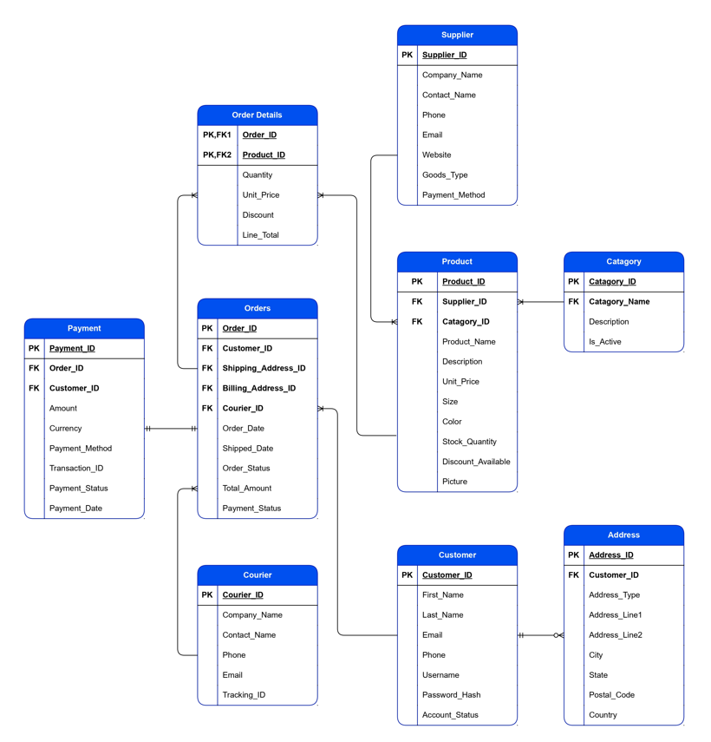
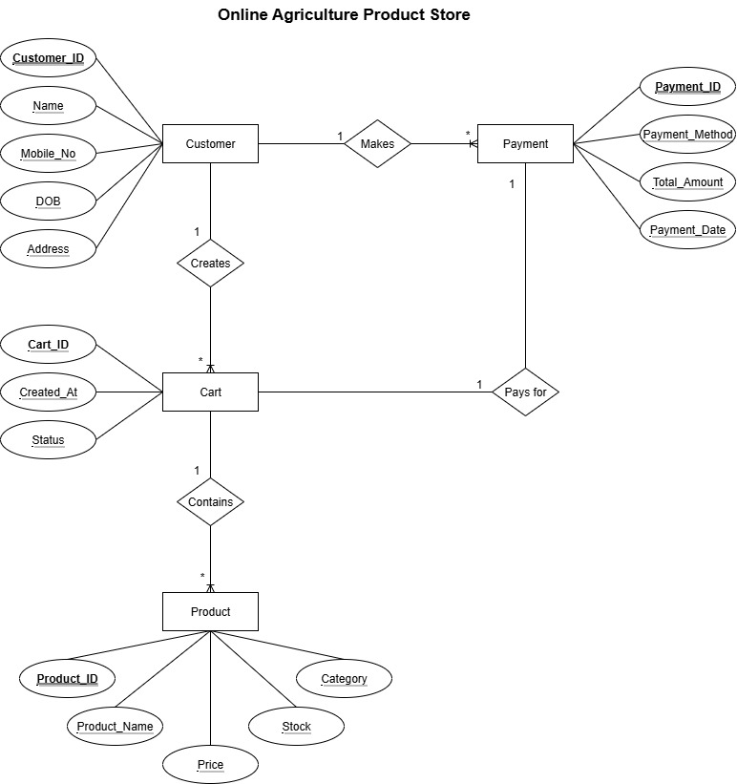
Question 7 – Data Flow Diagram – What is a data flow diagram? Draw a data flow diagram to represent the in-flow and out-flow of data when a Farmer is placing an order for the product.
Answer:
A Data Flow Diagram is a graphical representation that shows how data flows through a system from input to processing to output.
It focuses on:
- Where data comes from (source/input)
- How it is processed (processes/functions)
- Where it is stored (data stores)
- Where it goes (outputs/destinations)
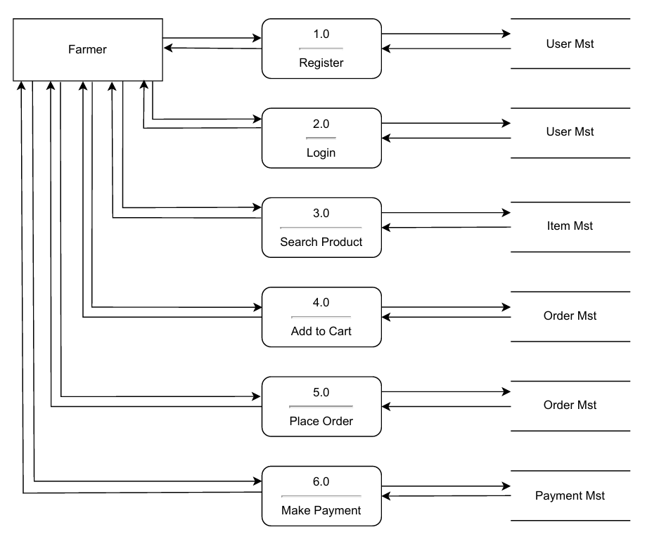
Question 8 – Change Request – Due to change in the Government Taxation structure. we should change the Tax structure. How do you handle change requests in a project?
Answer:
Change requests occur when a stakeholder — either a client or an internal team/department — requests a modification to the processes or deliverables that were already decided in the project scope.
In this scenario, the change request has come up due to a change in the Government Taxation Structure. As a Business Analyst (BA), I would analyze the request and clarify with the stakeholders exactly what this change involves for the Online Agriculture Product Store project.
In a normal scenario, I would first conduct a Feasibility Test to check how practical it is to introduce changes to the ongoing project.
However, in this case, since it is a Government-mandated change, a feasibility study is not required. Such changes must be updated and followed as per the new government policy. Therefore, I would follow the below steps to modify the project according to the client’s and government’s requirements:
Steps to Handle the Change Request:
Document the Change Request: Record all relevant details of the change — who raised it, why it’s needed, and what parts of the system it impacts.
Collect Supporting Materials: Gather all necessary references or official documents to help in implementing this change accurately.
Assess the Scope of Change: Determine whether the change falls inside or outside the project scope. Since this is an external change due to government policy, it may affect both budget and timeline.
Classify the Change: The BA and Project Manager (PM) should identify whether the change is minor or major. As this involves government taxation rules, it qualifies as a major change, and we must ensure it is implemented according to the official guidelines.
Fill the Change Request Form: Complete the change request form and obtain formal approval from the Project Manager.
Team Communication: Ensure the team clearly understands the priority and purpose of this change request to avoid confusion during implementation.
Review with Change Control Board: Discuss the request with the change control board, who will recommend and approve the necessary changes to the project plan.
Update Project Deliverables: Once approved, update all affected project deliverables such as plans, schedules, and business documents.
Implement and Communicate: After updates are made, the Project Manager communicates the new course of action to all stakeholders. The BA then coordinates with the team to ensure the change is implemented smoothly and aligns with the updated requirements.
Question 9 – Change Request Vs an Enhancement
As the project is in process, Ben and Kevin have contacted you. The reason is to inform you that they want the Farmers to sell their crop yields through this application i.e. Farmers should be able to add their crop yields or products and display to general public and should be able to sell them. They also want to introduce Auction system for their Crop yields. As a BA, what will be your response?
Is this a change request or an enhancement?
Answer:
The request from Ben and Kevin is an Enhancement Request, as they want to add a new feature to the Online Store, allowing Farmers to sell their crop yields directly through the platform — in addition to the existing feature where customers can buy products. Hence, my response would be a positive one toward implementing this enhancement.
As a Business Analyst (BA), I would analyze the request and prepare a project plan, requirements document, design, and testing plan for this enhancement. I would also prepare an Enhancement Request Form and estimate the manpower and man-hours required for successful implementation.
Question 10 – Estimations
Come up with estimations – How many Manhours required
Answer:
Manhours Required = Total Working Hours per Day × Total Number of Members × Total Number of Working Days
Number of working hours per day = 8 hours
Number of resources = 12
Time period provided = 18 months = 547 days = 78 weeks (including weekends and public holidays)
Assuming weekends = 156 days
Assuming public holidays = 10 days
Total non-working days = 166 days
Hence, Working Days = 547 – 166 = 381 days
Estimated Manhours = 8 hours × 12 resources × 381 working days = 36,576 hours
The total estimated effort required for this enhancement project is approximately 36,576 man-hours over an 18-month duration. This estimation includes time for requirement gathering, design, development, testing, and deployment activities.
Question 11 – UAT
Project has finally completed all the stages i.e., design, development, testing etc. Now, it is the role of a business analyst to contact the client for testing of the final product and have to successfully complete it. How are you going to handle this situation? And once it is done, what will be the process to close the project?
Explain UAT Acceptance process
Answer:
User Acceptance Testing (UAT) is a phase in the Software Development Life Cycle (SDLC) where end users of the Online Agriculture Product Store validate whether the application meets their business needs.
As a Business Analyst (BA), I will verify all the validations before designing the UAT test cases. These test cases will cover product functionality, system environment, potential defects, and how such defects should be handled or reported.
Steps for UAT
Analysis of Business Requirements: One of the most critical activities in UAT is identifying and developing test scenarios. These are derived from the following documents:
- Business Use Cases
- Process Flow Diagrams
- Business Requirements Document (BRD)
- System Requirements Specification (SRS)
Creation of UAT Plan: The UAT Plan outlines the strategy for validating that the application meets business requirements. It documents entry and exit criteria for UAT, test scenarios, test case approaches, and testing timelines.
Identify Test Scenarios and Test Cases: Based on high-level business processes, the BA creates UAT test cases with clear steps. Test cases should cover most user scenarios and focus on real-world workflows.
Preparation of Test Data: It is best to use live or realistic data for UAT, with sensitive data scrambled for privacy. The tester should be familiar with the database and process flow.
Run and Record the Results: Execute UAT test cases and record results. Log any defects found, retest after fixes, and track status using test management tools.
Confirm Business Objectives Met: Once testing is complete and all issues are resolved, the BA or UAT tester sends a formal UAT Sign-off to the client. After sign-off, the system is ready for production deployment.
Question 12 – Project Closure Document – Explain Project closure document.
Answer:
Project Closure
Online Agriculture Product Store
Revision Date: MM/DD/YYYY |  | Version: 1.0
Approver Name | Title/Role | Signature | Date
Peter and Ben | Project Stakeholder | Ok | xx/xx/xxxx
Mr. Henry | Sponsor | Ok | xx/xx/xxxx
Mr. Pandu | Financial Head | Ok | xx/xx/xxxx
Mr. Vandanam | Project Manager | Ok | xx/xx/xxxx
Mr. Kartik | Delivery Head | Ok | xx/xx/xxxx
Mr. Dooku | Project Coordinator | Ok | xx/xx/xxxx
**By authorizing this Project Closure, the Project Stakeholder(s), and Sponsor agree to all terms within this document.
Revision History
Identify document changes.
Version | Date | Name | Description
1.0 | xx/xx/xxxx | Mr. Henry | Ok to process

Section 1. General Information
Project Activity | Date
Project Start | 13-Aug-24
Project Closure | 14-Sep-25
**Date of Project Closure refers to the project finish date, meaning all project tasks have been completed.
Section 2. Business Objectives (As identified in Business Case Document)
Business Case Ref # | Business Objective | Met/ Not Met | Comments
BI0001 | Farmer should be able to buy and sell agricultural product online | Yes | Ok

Section 3. Customer Expectation Management
Item | Questions | Description | Comments
1 | Were all expected benefits and business outcomes realized? | Yes | Ok
2 | Were all expected performance standards satisfied? | Yes | Ok

Section 4. Outstanding Actions Items and Issues
Action Item | Transition/ Resolution
N/A | N/A

Section 5. Project Office Checklist
Deliverable | Description
Deliverable | Yes | No
Risk Assessment completed and posted on suitable shared storage.
Business Case completed and posted on suitable shared storage.
Project Charter completed and posted on suitable shared storage.
Meeting Notes completed and posted on suitable shared storage.
Additional project documentation and artifacts posted on suitable shared storage, including Requirements Template, Project Change Requests, Milestone Timeline, Work Breakdown Structure, etc.
Lessons Learned documented.
Project folder moved completed projects on suitable shared storage.
Support Handover Document completed and archived.
Comments
Ok to process. Application running properly.

