**Document 1: Definition of Done (DoD)**

**Purpose:**

**The Definition of Done (DoD) helps the team agree on what "done" means for each task or user story. It makes sure everyone understands when a task is completely finished and ready to be delivered. This DoD is shared by all team members and sets clear, measurable criteria to ensure quality and customer satisfaction.**

**What is the Definition of Done?**

**It’s a checklist of tasks that need to be completed before we consider any piece of work (like a user story, sprint, or release) finished. This checklist includes customer requirements (acceptance criteria) and quality standards.**

**Checklist for Definition of Done (DoD)**

**1. Code Production:**

**- We write the necessary code to develop the feature or functionality described in the user story.**

**2. Assumptions Met:**

**- All the assumptions made in the user story (like what the user wants) are addressed and confirmed to be correct.**

**3. Successful Project Build:**

**- The project can be built (compiled and executed) without any errors or issues.**

**4. Unit Testing:**

**- We create unit tests to check individual parts of the code. These tests must pass to confirm that each part works correctly.**

**5. Feature Deployed to Test Environment:**

**- The feature is moved to a test environment, which is a setup that looks like the production environment (the real one that users will see).**

**6. Cross-Device and Cross-Browser Testing:**

**- The feature is tested on all required devices (like phones, tablets, etc.) and browsers (like Chrome, Firefox, etc.) to ensure it works properly everywhere.**

**7. UX Designer Approval:**

**- The UX (User Experience) designer reviews the feature to make sure it is easy to use and looks good. They give their approval when everything looks and works as expected.**

**8. Quality Assurance (QA):**

**- The QA team tests the feature thoroughly to find any bugs or issues. Any problems they find are fixed before moving on.**

**9. Meets Acceptance Criteria:**

**- The feature must meet all the conditions or requirements specified in the acceptance criteria. This ensures the feature works as the customer expects.**

**10. Product Owner Approval:**

**- The Product Owner, who represents the customer, reviews the feature to confirm it meets their needs. Once they give their approval, the feature is considered ready.**

**11. Refactoring Completed:**

**- If any part of the code needs to be cleaned up or improved (refactoring), this is done before moving forward to keep the code high quality.**

**12. Configuration and Build Changes Documented:**

**- Any changes made to the system’s configuration (settings) or the way the project is built are documented clearly, so others can understand what was done.**

**13. Documentation Updated:**

**- All necessary documentation (technical details, user manuals, etc.) is updated to reflect the new feature.**

**14. Peer Code Review:**

**- Another developer reviews the code to catch any issues or improvements. All feedback is addressed before the feature is considered done.**

**---**

**This detailed checklist ensures that everything we develop is fully tested, meets all requirements, and is ready for delivery. Each step helps make sure the work is complete, with no loose ends, and that everyone—developers, designers, testers, and the product owner—is happy with the result.**

**Document 2**

|  |  |  |  |
| --- | --- | --- | --- |
| **Scrum Project** |  |  |  |
| **Name:** | **Loan Management System** |  |  |
| **Venue:** | **Mumbai, India** |  |  |
| **Date:** | **Start time: 10 AM** | **End time:4 PM** | **Duration:6 HOURS** |
| **Client:** | **ANZ BANK** |  |  |
| **Stakeholder list:** | **Rajesh Sharma (Head of Digital Transformation)** |  |  |
|  | **Neha Verma (IT Director)** |  |  |
|  | **Suresh Kumar (Product Manager)** |  |  |
|  | **Kavita Iyer (Head of Compliance)** |  |  |
| **Scrum Team** | **Amit Patel** |  |  |
| **Scrum Master:** | **Pooja Deshmukh** |  |  |
| **Product owner:** | **Ravi Mehta** |  |  |
| **Scrum Developer 1:** | **Vikas Reddy** |  |  |
| **Scrum Developer 2:** | **Anjali Singh** |  |  |
| **Scrum Developer 3:** | ***Kiran Shah*** |  |  |
| **Scrum Developer 4:** | ***Meera Nair*** |  |  |
| **Scrum Developer 5:** | **Ram sharma** |  |  |

|  |  |
| --- | --- |
| **Category** | **Details** |
| **Vision** | **Create a seamless digital process with digitally apply for loan, credit card, overdraft features.** |
| **Target Group - Market Segment** | **Retail banking customers seeking fast, digital onboarding.** |
| **Target Group - Target Users and Customers** | **New customers, existing account holders, and individuals applying for loans, credit cards, overdraft services.** |
| **Needs - Problem Solved** | **Inefficient manual processes causing delays and errors.** |
| **Needs - Benefit Provided** | **A faster, more efficient, and user-friendly digital system integrating multiple services.** |
| **Product - What It Is** | **A digital platform for loan application, credit card, overdraft.** |
| **Product - Desirability and Special Features** | **Reduces paperwork, offers real-time updates, and is scalable for future services.** |
| **Product – Feasibility** | **Yes, given the bank’s existing digital infrastructure.** |
| **Value - Benefit to the Company** | **Reduces operational costs, improves customer satisfaction, positions the bank as a digital leader.** |
| **Value - Business Goals** | **Increase customer acquisition, improve cross-selling, grow digital market share.** |
| **Value - Business Model** | **Revenue generation through cross-selling and premium digital banking services.** |

**Document 3: User stories**

|  |  |
| --- | --- |
| **User story No:** | **US-01** |
| **Tasks:** | **Develop the login interface for bank executives.** |
| **Priority:** | **HIGH** |
| **Value statement:** | **As a bank executive, I want to log into the system securely,** |
|  | **so that I can access customer information and manage accounts efficiently.** |
| **BV:** | **8** |
| **CP:** | **3** |
| **Acceptance criteria:** | **Bank executive can enter their username and password to log in.** |

|  |  |
| --- | --- |
| **User story No:** | **US- 2** |
| **Tasks:** | **Implement authentication and authorization mechanisms.** |
|  |  |
| **Priority:** | **HIGH** |
| **Value statement:** | **As a bank executive, I want to log into the system securely,** |
|  | **so that I can access customer information and manage accounts efficiently.** |
| **BV:** | **8** |
| **CP:** | **3** |
| **Acceptance criteria:** | **System verifies credentials and grants access to authorized users only.** |

|  |  |
| --- | --- |
| **User story No:** | **US-3** |
| **Tasks:** | **Create a password recovery option.** |
| **Priority:** | **HIGH** |
| **Value statement:** | **As a bank executive, I want to log into the system securely,** |
|  | **so that I can access customer information and manage accounts efficiently.** |
| **BV:** | **8** |
| **CP:** | **3** |
| **Acceptance criteria:** | **User receives an error message for incorrect login attempts.** |
|  | **Password recovery option is available and functional.** |

|  |  |
| --- | --- |
| **User story No:** | **US-04** |
| **Tasks:** | **Create a user interface for bank executives to enter customer details.** |
| **Priority:** | **High** |
| **Value statement:** | **As a bank executive, I want to enter basic customer details into the system,** |
|  | **so that I can maintain accurate records and facilitate account management.** |
| **BV:** | **9** |
| **CP:** | **5** |
| **Acceptance criteria:** | **Bank executive can fill in and submit customer details (name, address, phone number, email).** |

|  |  |
| --- | --- |
| **User story No:** | **US-05** |
| **Tasks:** | **Implement data validation for customer fields (e.g., name, address, contact information).** |
| **Priority:** | **High** |
| **Value statement:** | **As a bank executive, I want to enter basic customer details into the system,** |
|  | **so that I can maintain accurate records and facilitate account management.** |
| **BV:** | **9** |
| **CP:** | **5** |
| **Acceptance criteria:** | **System validates that all required fields are completed correctly.** |

|  |  |
| --- | --- |
| **User story No:** | **US-06** |
| **Tasks:** | **Implement data validation for customer fields (e.g., name, address, contact information).** |
| **Priority:** | **High** |
| **Value statement:** | **As a bank executive, I want to enter basic customer details into the system,** |
|  | **so that I can maintain accurate records and facilitate account management.** |
| **BV:** | **9** |
| **CP:** | **5** |
| **Acceptance criteria:** | **Confirmation message is displayed upon successful entry of customer details.** |
|  | **Customer details are securely saved in the database for future reference.** |

|  |  |
| --- | --- |
| **User story No:** | **US-07** |
| **Tasks:** | **Create a user interface for bank executives to input financial details of customers.** |
| **Priority:** | **HIGH** |
| **Value statement:** | **As a bank executive, I want to enter financial customer details into the system,** |
|  | **so that I can assess eligibility for products and provide tailored financial advice.** |
| **BV:** | **7** |
| **CP:** | **3** |
| **Acceptance criteria:** | **Bank executive can fill in and submit financial details (income, monthly expenses, account balances).** |

|  |  |
| --- | --- |
| **User story No:** | **US-08** |
| **Tasks:** | **Implement data validation for financial fields (e.g., income, expenses, account balances).** |
| **Priority:** | **HIGH** |
| **Value statement:** | **As a bank executive, I want to enter financial customer details into the system,** |
|  | **so that I can assess eligibility for products and provide tailored financial advice.** |
| **BV:** | **7** |
| **CP:** | **3** |
| **Acceptance criteria:** | **System validates that all required financial fields are completed correctly.** |
|  | **Confirmation message is displayed upon successful entry of financial details.** |

|  |  |
| --- | --- |
| **User story No:** | US-09 |
| **Tasks:** | **Ensure secure storage of financial information in the database.** |
| **Priority:** | **HIGH** |
| **Value statement:** | **As a bank executive, I want to enter financial customer details into the system,** |
|  | **so that I can assess eligibility for products and provide tailored financial advice.** |
| **BV:** | **7** |
| **CP:** | **3** |
| **Acceptance criteria:** | **Financial information is securely saved in the database for future reference and compliance.** |

|  |  |
| --- | --- |
| **User story No:** | **US-10** |
| **Tasks:** | **Create a user interface for bank executives to input employment details of customers.** |
| **Priority:** | **HIGH** |
| **Value statement:** | **As a bank executive, I want to enter employment customer details into the system,** |
|  | **so that I can evaluate customer stability and tailor financial solutions accordingly.** |
| **BV:** | **8** |
| **CP:** | **9** |
| **Acceptance criteria:** | **Bank executive can fill in and submit employment details (employer name, job title, start date, income).** |

|  |  |
| --- | --- |
| **User story No:** | **US-11** |
| **Tasks:** | **Implement data validation for employment fields (e.g., employer name, job title, duration of employment).** |
| **Priority:** | **HIGH** |
| **Value statement:** | **As a bank executive, I want to enter employment customer details into the system,** |
|  | **so that I can evaluate customer stability and tailor financial solutions accordingly.** |
| **BV:** | **8** |
| **CP:** | **9** |
| **Acceptance criteria:** | **System validates that all required employment fields are completed correctly.** |

|  |  |
| --- | --- |
| **User story No:** | **US-12** |
| **Tasks:** | **Ensure secure storage of employment information in the database.** |
| **Priority:** | **HIGH** |
| **Value statement:** | **As a bank executive, I want to enter employment customer details into the system,** |
|  | **so that I can evaluate customer stability and tailor financial solutions accordingly.** |
| **BV:** | **8** |
| **CP:** | **9** |
| **Acceptance criteria:** | **Confirmation message is displayed upon successful entry of employment details.** |
|  | **Employment information is securely saved in the database for future reference and compliance.** |

|  |  |
| --- | --- |
| **User story No:** | **US-13** |
| **Tasks:** | **Create a user interface for bank executives to enter credit card application details.** |
|  | **Implement data validation for credit card application fields (e.g., customer details, financial information).** |
|  | **Ensure secure submission and processing of credit card applications.** |
| **Priority:** | **HIGH** |
| **Value statement:** | **As a bank executive, I want to assist customers in applying for a credit card,** |
|  | **so that I can facilitate their access to credit and enhance customer satisfaction.** |
| **BV:** | **9** |
| **CP:** | **3** |
| **Acceptance criteria:** | **Bank executive can fill in and submit credit card application details (customer information, income, employment status).** |
|  | **System validates that all required fields are completed correctly.** |
|  | **Confirmation message is displayed upon successful submission of the application.** |
|  | **Application details are securely saved in the database for review and processing.** |

|  |  |
| --- | --- |
| **User story No:** | **US-14** |
| **Tasks:** | **Create a user interface for bank executives to enter insurance application details.** |
|  | **Implement data validation for insurance application fields (e.g., customer details, coverage type, premium amount).** |
|  | **Ensure secure submission and processing of insurance applications.** |
| **Priority:** | **HIGH** |
| **Value statement:** | **As a bank executive, I want to assist customers in applying for insurance,** |
|  | **so that I can provide them with financial protection and peace of mind.** |
| **BV:** | **8** |
| **CP:** | **7** |
| **Acceptance criteria:** | **Bank executive can fill in and submit insurance application details (customer information, coverage type, health status).** |
|  | **System validates that all required fields are completed correctly.** |
|  | **Confirmation message is displayed upon successful submission of the application.** |
|  | **Application details are securely saved in the database for review and processing.** |

|  |  |
| --- | --- |
| **User story No:** | **US-15** |
| **Tasks:** | **Create a user interface for bank executives to enter overdraft application details.** |
|  | **Implement data validation for overdraft application fields (e.g., customer details, account information, requested limit).** |
|  | **Ensure secure submission and processing of overdraft applications.** |
| **Priority:** | **HIGH** |
| **Value statement:** | **As a bank executive, I want to assist customers in applying for an overdraft facility,** |
|  | **so that I can provide them with financial flexibility and better cash flow management.** |
| **BV:** | **9** |
| **CP:** | **7** |
| **Acceptance criteria:** | **Bank executive can fill in and submit overdraft application details (customer information, account number, requested overdraft limit).** |
|  | **System validates that all required fields are completed correctly.** |
|  | **Confirmation message is displayed upon successful submission of the application.** |
|  | **Application details are securely saved in the database for review and processing.** |

|  |  |
| --- | --- |
| **User story No:** | **US-16** |
| **Tasks:** | **Create a user interface for bank executives to facilitate document uploads for KYC compliance.** |
|  | **Implement validation checks for document types and sizes.** |
|  | **Ensure secure storage of uploaded documents in the database.** |
| **Priority:** | **HIGH** |
| **Value statement:** | **As a bank executive, I want to assist customers in uploading required documents for KYC,** |
|  | **so that I can ensure compliance and streamline the onboarding process.** |
| **BV:** | **7** |
| **CP:** | **5** |
| **Acceptance criteria:** | **Bank executive can guide customers to upload necessary documents (salary slips, offer letters).** |
|  | **System validates that all required documents are uploaded and meet specified criteria (type, size).** |
|  | **Confirmation message is displayed upon successful upload of documents.** |
|  | **Uploaded documents are securely saved in the database for review and compliance.** |

|  |  |
| --- | --- |
| **User story No:** | **US-17** |
| **Tasks:** | **Create a user interface to input referral codes from BDMs or Sales Executives.** |
|  | **Implement validation checks to ensure referral codes meet specified format and criteria.** |
|  | **Ensure secure storage of the entered referral code in the customer database.** |
| **Priority:** | **MEDIUM** |
| **Value statement:** | **As a bank executive, I want customers to input their referral codes from BDMs or Sales Executives,** |
|  | **so that I can track referrals accurately and improve customer engagement.** |
| **BV:** | **8** |
| **CP:** | **7** |
| **Acceptance criteria:** | **Customers can enter the referral code during the application process.** |
|  | **System validates that the referral code is in the correct format and matches an existing BDM or Sales Executive.** |
|  | **Confirmation message is displayed upon successful submission of the referral code.** |
|  | **Referral code is securely saved in the customer’s profile for tracking and reporting purposes.** |

|  |  |
| --- | --- |
| **User story No:** | **US-18** |
| **Tasks:** | **Develop a screen for the backend team to raise rejections for applications.** |
|  | **Implement functionality for sales executives to view and resolve the raised rejections.** |
|  | **Ensure that the system tracks the status of rejections and resolutions.** |
| **Priority:** | **HIGH** |
| **Value statement:** | **As a backend user, I want to raise rejections on incomplete or incorrect applications,** |
|  | **so that the sales executive can resolve them efficiently.** |
| **BV:** | **7** |
| **CP:** | **9** |
| **Acceptance criteria:** | **Backend users can raise rejections with a clear reason against an application.** |
|  | **Sales executives can view all rejections related to their applications.** |
|  | **Sales executives can update the status after resolving rejections.** |
|  | **Notifications are sent to the sales executives when a rejection is raised.** |
|  | **Rejection resolution status is tracked and updated in real-time.** |

|  |  |
| --- | --- |
| **User story No:** | **US-19** |
| **Tasks:** | **Create a system to send a soft application to the customer for review.** |
|  | **Implement functionality for the customer to confirm their details are correct.** |
|  | **Allow customers to receive a confirmation OTP via their registered email or phone number.** |
| **Priority:** | **HIGH** |
| **Value statement:** | **As a bank executive, I want customers to receive a soft application for review and confirm their information via OTP,** |
|  | **so that I can ensure the accuracy of their details and enhance the security of the application process.** |
| **BV:** | **7** |
| **CP:** | **9** |
| **Acceptance criteria:** | **Customers receive a soft application summarizing their details for review.** |

|  |  |
| --- | --- |
| **User story No:** | **US -20** |
| **Tasks:** | **Implement functionality for the customer to confirm their details are correct.** |
| **Priority:** | **HIGH** |
| **Value statement:** | **As a bank executive, I want customers to receive a soft application for review and confirm their information via OTP,** |
|  | **so that I can ensure the accuracy of their details and enhance the security of the application process.** |
| **BV:** | **7** |
| **CP:** | **9** |
| **Acceptance criteria:** | **Customers can confirm that the information is correct directly from the application.** |
|  | **System generates and sends an OTP to the customer’s registered email or phone number for confirmation.** |

|  |  |
| --- | --- |
| **User story No:** | **US -21** |
| **Tasks:** | **Allow customers to receive a confirmation OTP via their registered email or phone number.** |
| **Priority:** | **HIGH** |
| **Value statement:** | **As a bank executive, I want customers to receive a soft application for review and confirm their information via OTP,** |
|  | **so that I can ensure the accuracy of their details and enhance the security of the application process.** |
| **BV:** | **7** |
| **CP:** | **9** |
| **Acceptance criteria:** | **Confirmation message is displayed once the OTP is sent, and successful verification occurs when the customer enters the correct OTP.** |

|  |  |
| --- | --- |
| **User story No:** | **US-22** |
| **Tasks:** | **Develop a secure admin login interface for managers and bank executives.** |
|  | **Implement functionality to search and filter applications by mobile number, application number, applicant name, and date.** |
|  | **Ensure that the system displays the relevant application details once searched.** |
| **Priority:** | **HIGH** |
| **Value statement:** | **As an admin, I want to log in and track customer applications by mobile number, application number, applicant name, and date,** |
|  | **so that I can efficiently manage and oversee the application process.** |
| **BV:** | **7** |
| **CP:** | **9** |
| **Acceptance criteria:** | **Admins can log in securely using their credentials.** |
|  | **Admins can input search criteria (mobile number, application number, applicant name, date) to retrieve applications.** |
|  | **The system displays a list of applications matching the search criteria, including relevant details.** |
|  | **Admins can view detailed information for each application selected from the search results.** |

**Document 4: Agile PO Experience**

**1. Market Analysis**

**- As a Product Owner, I conducted a market demand analysis to understand the need for a digital loan application system identifying key features like real-time approvals and integrated services. I researched competitors like HDFC, ICICI, and SBI to benchmark their offerings, identifying gaps such as limited integration of loan application, credit card and overdraft applications. By analyzing these gaps, I proposed adding seamless service integration during account opening to give our product a competitive edge, ensuring it meets user needs while offering unique value.**

**2. Enterprise Analysis**

**As a Product Owner, I conducted due diligence to assess the market opportunity for the digital loan application system. This involved analyzing customer pain points, such as lengthy onboarding processes, and ensuring regulatory compliance. By evaluating potential business benefits, like increased customer satisfaction and reduced processing time, I worked with stakeholders to confirm the system's feasibility and its potential for a strong ROI, ensuring it aligned with both market needs and business goals.**

**3. Product Vision and Roadmap**

**As a Product Owner, I defined the Product Vision to create a fully digital, secure, and user-friendly onboarding system that integrates loan application , credit card applications. For the Product Roadmap, I established a timeline prioritizing critical features. Sprint 1 focused on customer detail entry, Sprint 3 on credit card applications, and Sprint 4 on KYC document uploads. Each sprint ensured the delivery of essential functionalities to streamline the onboarding process efficiently.**

**4. Managing Product Features**

**- As a Product Owner, I focused on Managing Stakeholder Expectations by maintaining regular communication to understand their needs and align priorities. For example, I discussed and adjusted the priority of features like KYC document upload (US-008) based on compliance requirements and customer feedback.**

**In terms of Prioritization of Epics, Stories, and Features, I prioritized tasks based on ROI and criticality. High-value user stories like "Login as Bank Executive" (US-001) were completed in Sprint 1 to ensure core functionalities were established early, laying a strong foundation for the project.**

**5. Managing Product Backlog**

**As the Product Owner, Managing the Product Backlog was crucial for aligning the project with business goals. I focused on the Prioritization of User Stories, ensuring that high-priority tasks related to regulatory compliance and customer onboarding were placed at the top of the backlog. For example, stories like KYC (US-008) were prioritized based on their business value and customer importance.**

**Reprioritization Based on Stakeholder Needs was an ongoing task. If stakeholders raised urgent compliance changes, I would move features like KYC higher in the backlog to meet legal standards.**

**In terms of Epics Planning, larger goals like "Customer Details" and "Apply for Credit Card" were split into smaller, actionable user stories with clear acceptance criteria and tasks, making them easier for the team to tackle within sprints.**

**6. Managing Overall Iteration Progress**

**As the Product Owner, Managing Overall Iteration Progress was a key responsibility to ensure smooth project execution. During the Sprint Progress Review, I regularly monitored the team's progress to ensure that the sprint goals were being met. If any blockers or delays surfaced, I worked with the team to resolve them promptly.**

**When roadblocks occurred or priorities shifted, I handled the Reprioritization of Sprints and Epics, adjusting tasks to make sure the most critical features, such as KYC or credit card application, were delivered on time.**

**In the Sprint Retrospectives, I actively participated to identify successes and areas for improvement. These discussions helped enhance team collaboration and refine the development process for future sprints, ensuring continuous improvement.**

**7. Sprint Meetings Experience**

**As the Product Owner, my Sprint Meetings Experience involved several key activities to guide the team and ensure the product’s success.**

**- Sprint Planning Meeting: I facilitated these meetings by ensuring that the team fully understood each user story, breaking them into tasks, and estimating the effort required. This allowed us to set achievable sprint goals.**

**- Daily Scrum Meeting: I ensured alignment during daily stand-ups by checking progress and addressing any blockers or dependencies that could hinder development.**

**- Sprint Review Meeting: I reviewed the completed work with stakeholders, confirming that it met the acceptance criteria and expectations, ensuring stakeholder satisfaction.**

**- Sprint Retrospective Meeting: I gathered feedback during retrospectives to identify areas of improvement, helping to optimize our processes for future sprints.**

**- Backlog Refinement Meeting: I led these sessions, ensuring that user stories were clearly defined, prioritized, and ready for development, keeping the backlog aligned with the product vision and priorities.**

**8. User Story Creation**

**As the Product Owner, my experience in User Story Creation involved several critical tasks to ensure smooth project execution:**

**- Story No: I assigned unique identifiers to each user story, like US-001 for the login functionality, to easily track and manage them within the backlog.**

**- Tasks: Each user story was broken down into smaller, actionable tasks, such as "Create login interface" or "Integrate with database." This made the work clearer and easier for the development team to execute.**

**- Priority: I set priority levels for each story based on the project's business needs, ensuring that critical functionalities, such as regulatory compliance or customer onboarding, were completed first.**

**- Acceptance Criteria: For each user story, I defined clear acceptance criteria. For example, US-001 (login functionality) required successful authentication and appropriate error messages for failed login attempts to be considered complete.**

**- BV & CP Values: Business value (BV) and customer priority (CP) were assigned to each user story. Stories with high BV and CP, like US-001, were prioritized to ensure we delivered maximum value for both the business and customers.**

**Conclusion:**

**This project provided valuable experience in managing key responsibilities as a Product Owner. I learned how to effectively conduct market analysis, define a clear product vision, and prioritize the backlog to align with business needs and stakeholder expectations. Additionally, overseeing sprint progress and ensuring smooth collaboration between stakeholders and development teams helped me sharpen my agile management skills. Overall, this experience built a strong foundation for delivering high-quality product features while navigating the complexities of agile processes.**

**Document 5: Product and sprint backlog and product and sprint burndown**

**charts**

**Product backlog:**

|  |  |  |  |  |
| --- | --- | --- | --- | --- |
| **User Story ID** | **Tasks** | **Priority** | **BV** | **CP** |
| US-01 | Develop the login interface for bank executives. | HIGH | 8 | 3 |
| US-02 | Implement authentication and authorization. | HIGH | 8 | 3 |
| US-03 | Create a password recovery option. | HIGH | 8 | 3 |
| US-04 | Create UI for entering customer details. | HIGH | 9 | 5 |
| US-05 | Data validation for customer fields. | HIGH | 9 | 5 |
| US-06 | Securely save customer details. | HIGH | 9 | 5 |
| US-07 | Create UI for entering financial details. | HIGH | 7 | 3 |
| US-08 | Data validation for financial fields. | HIGH | 7 | 3 |
| US-09 | Secure storage of financial information. | HIGH | 7 | 3 |
| US-10 | UI for entering employment details. | HIGH | 8 | 9 |
| US-11 | Data validation for employment fields. | HIGH | 8 | 9 |
| US-12 | Secure storage of employment details. | HIGH | 8 | 9 |
| US-13 | UI and validation for credit card applications. | HIGH | 9 | 3 |
| US-14 | UI and validation for insurance applications. | HIGH | 8 | 7 |
| US-15 | UI and validation for overdraft applications. | HIGH | 9 | 7 |
| US-16 | UI for KYC document uploads. | HIGH | 7 | 5 |
| US-17 | UI for entering referral codes. | MEDIUM | 8 | 7 |
| US-18 | Screen for backend rejections and resolutions. | HIGH | 7 | 9 |
| US-19 | Soft application for customer review. | HIGH | 7 | 9 |
| US-20 | Confirmation of customer details via OTP. | HIGH | 7 | 9 |
| US-21 | OTP for customer confirmation. | HIGH | 7 | 9 |
| US-22 | Secure admin login and application search. | HIGH | 7 | 9 |

**Sprint backlog:**

|  |  |  |  |  |  |
| --- | --- | --- | --- | --- | --- |
| **User Story ID** | **User Story** | **User Story Tasks** | **Owner** | **Status** | **Estimated Effort (hours)** |
| US-01 | As a bank executive, I want to log into the system securely | Develop the login interface for bank executives | Arjun Mehta | To Do | 10 |
| US-02 | As a bank executive, I want to log into the system securely | Implement authentication and authorization mechanisms | Priya Sharma | In Progress | 15 |
| US-03 | As a bank executive, I want to log into the system securely | Create a password recovery option | Arjun Mehta | To Do | 8 |
| US-04 | As a bank executive, I want to enter basic customer details into the system | Create a user interface to enter customer details | Priya Sharma | To Do | 12 |
| US-05 | As a bank executive, I want to enter basic customer details into the system | Implement data validation for customer fields | Arjun Mehta | To Do | 7 |
| US-06 | As a bank executive, I want to maintain accurate records | Ensure customer details are saved securely | Priya Sharma | To Do | 6 |
| US-07 | As a bank executive, I want to enter financial customer details | Create a UI for entering financial details | Arjun Mehta | In Progress | 12 |
| US-08 | As a bank executive, I want to validate financial information | Implement validation for financial fields | Priya Sharma | To Do | 8 |
| US-09 | As a bank executive, I want to ensure secure storage of financial information | Securely store financial information in the database | Arjun Mehta | To Do | 6 |
| US-10 | As a bank executive, I want to enter employment customer details | Create UI for entering employment details | Priya Sharma | In Progress | 10 |
| US-11 | As a bank executive, I want to validate employment information | Implement validation for employment fields | Arjun Mehta | To Do | 6 |
| US-12 | As a bank executive, I want to ensure secure storage of employment information | Securely save employment details in the database | Priya Sharma | To Do | 6 |
| US-13 | As a bank executive, I want to assist customers in applying for a credit card | Create UI and validation for credit card applications | Arjun Mehta | To Do | 15 |
| US-14 | As a bank executive, I want to assist customers in applying for insurance | Create UI and validation for insurance applications | Priya Sharma | To Do | 15 |
| US-15 | As a bank executive, I want to assist customers in applying for an overdraft facility | Create UI and validation for overdraft applications | Arjun Mehta | In Progress | 10 |
| US-16 | As a bank executive, I want to facilitate document uploads for KYC compliance | Create UI for document uploads, implement validation | Priya Sharma | To Do | 12 |
| US-17 | As a bank executive, I want to input referral codes | Create UI for referral codes and validation | Arjun Mehta | To Do | 8 |
| US-18 | As a backend user, I want to raise rejections on applications | Create rejection-raising screen for backend users, track rejections | Priya Sharma | To Do | 12 |
| US-19 | As a bank executive, I want customers to review and confirm their details via OTP | Send soft application and implement OTP confirmation | Arjun Mehta | In Progress | 10 |
| US-22 | As an admin, I want to log in and search/filter applications | Develop admin login, search and filter functionality | Priya Sharma | To Do | 15 |

|  |  |  |
| --- | --- | --- |
| **Sprint 1: Foundational Setup** |  |  |
|  |  |  |
| **User Story ID** | **User Story** | **Estimated Effort (hours)** |
| US-01 | As a bank executive, I want to log into the system securely | 10 |
| US-02 | Implement authentication and authorization mechanisms | 15 |
| US-03 | Create a password recovery option | 8 |
| US-04 | As a bank executive, I want to enter basic customer details into the system | 12 |
|  | **Total for Sprint 1** | **45 hours** |
|  |  |  |
| **Sprint 2: Customer Data and Validation** |  |  |
|  |  |  |
| **User Story ID** | **User Story** | **Estimated Effort (hours)** |
| US-05 | Implement data validation for customer fields | 7 |
| US-06 | Ensure customer details are saved securely | 6 |
| US-07 | Create a UI for entering financial details | 12 |
| US-08 | Implement validation for financial fields | 8 |
| US-09 | Securely store financial information in the database | 6 |
|  | **Total for Sprint 2** | **39 hours** |
|  |  |  |
| **Sprint 3: Employment and Financial Information** |  |  |
|  |  |  |
| **User Story ID** | **User Story** | **Estimated Effort (hours)** |
| US-10 | Create UI for entering employment details | 10 |
| US-11 | Implement validation for employment fields | 6 |
| US-12 | Securely save employment details in the database | 6 |
| US-13 | Create UI and validation for credit card applications | 15 |
| US-14 | Create UI and validation for insurance applications | 15 |
|  | **Total for Sprint 3** | **52 hours** |
|  |  |  |
| **Sprint 4: Overdraft and KYC Compliance** |  |  |
|  |  |  |
| **User Story ID** | **User Story** | **Estimated Effort (hours)** |
| US-15 | Create UI and validation for overdraft applications | 10 |
| US-16 | Create UI for document uploads, implement validation | 12 |
| US-17 | Create UI for referral codes and validation | 8 |
| US-18 | Create rejection-raising screen for backend users, track rejections | 12 |
|  | **Total for Sprint 4** | **42 hours** |
|  |  |  |
| **Sprint 5: Admin and Final Touches** |  |  |
|  |  |  |
| **User Story ID** | **User Story** | **Estimated Effort (hours)** |
| US-19 | Send soft application and implement OTP confirmation | 10 |
| US-22 | Develop admin login, search and filter functionality | 15 |
|  | **Total for Sprint 5** | **25 hours** |

**Product burndown Chart**

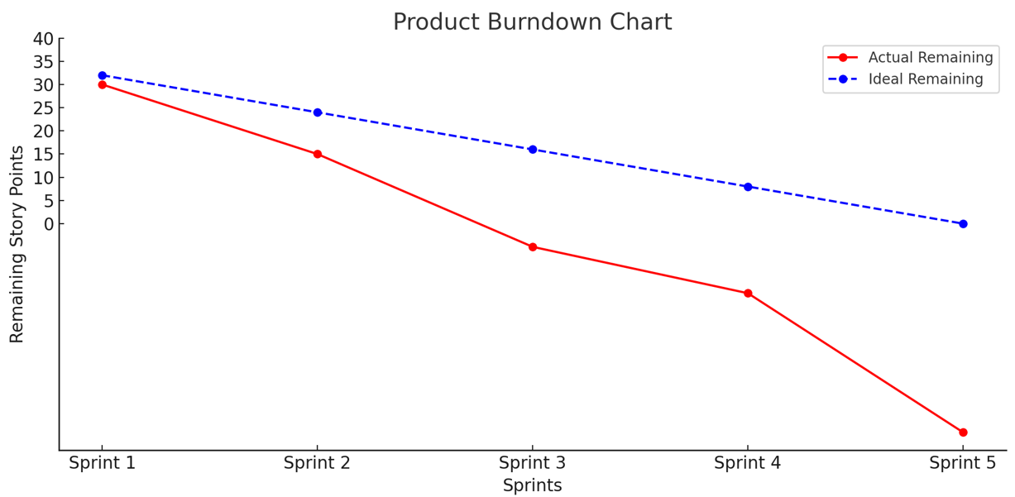

**Sprint burndown chart**

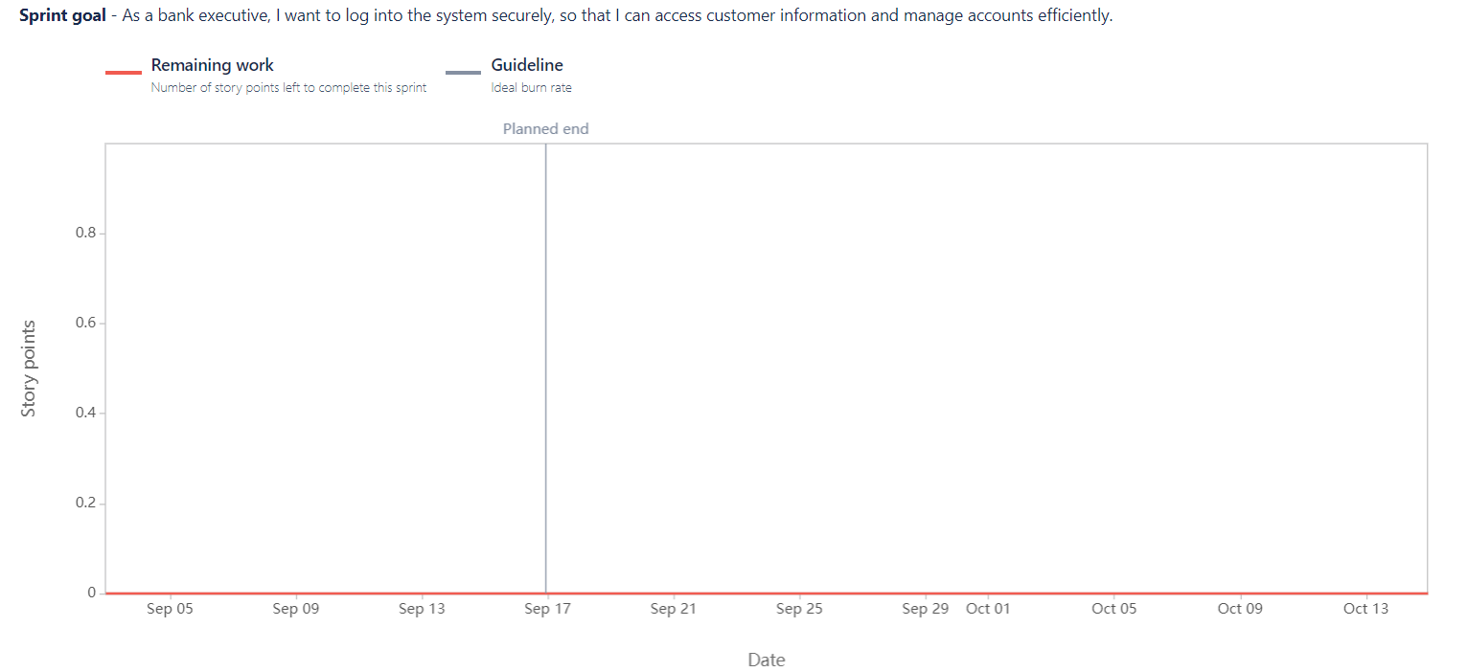

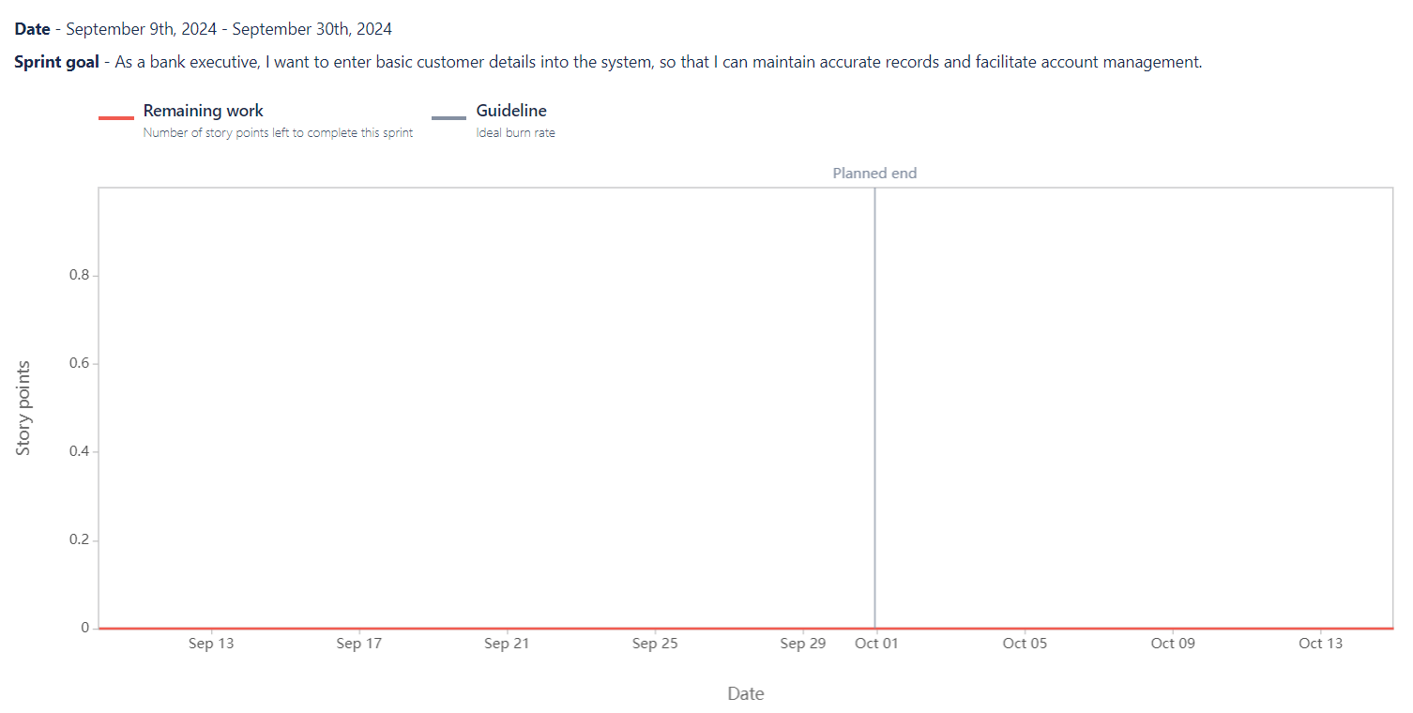

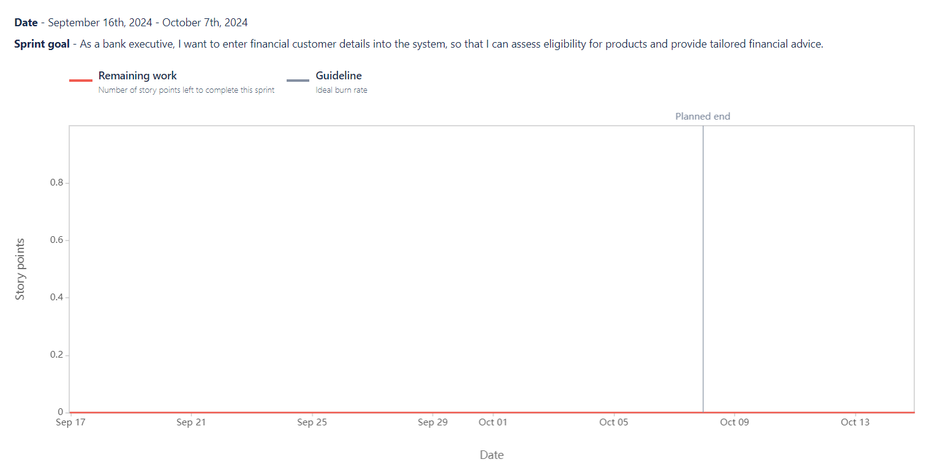

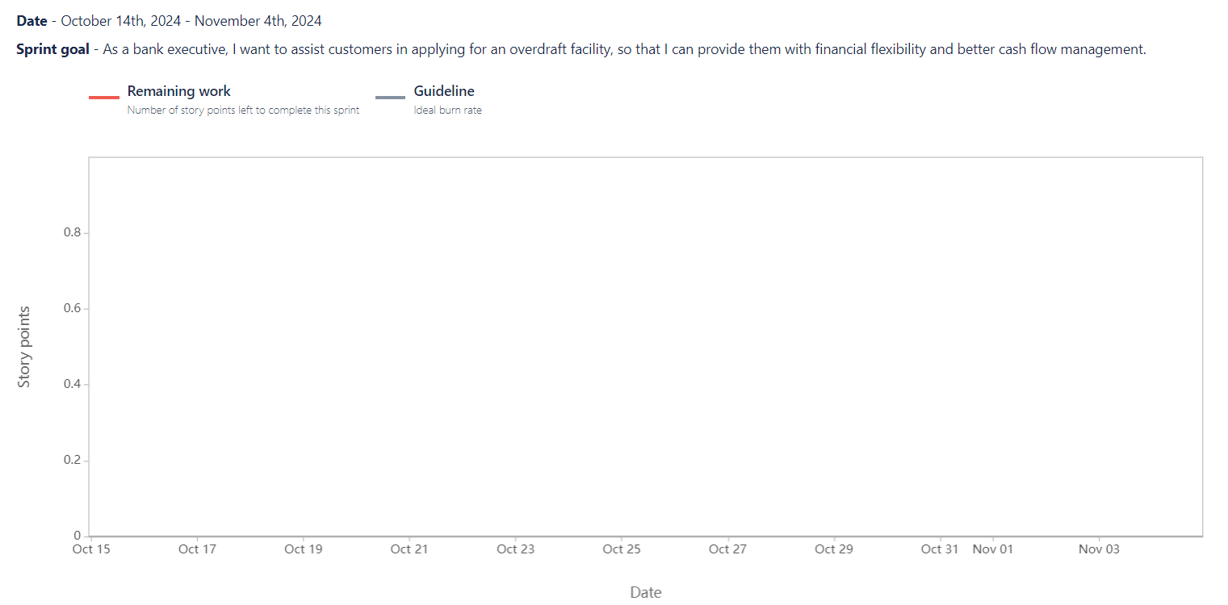

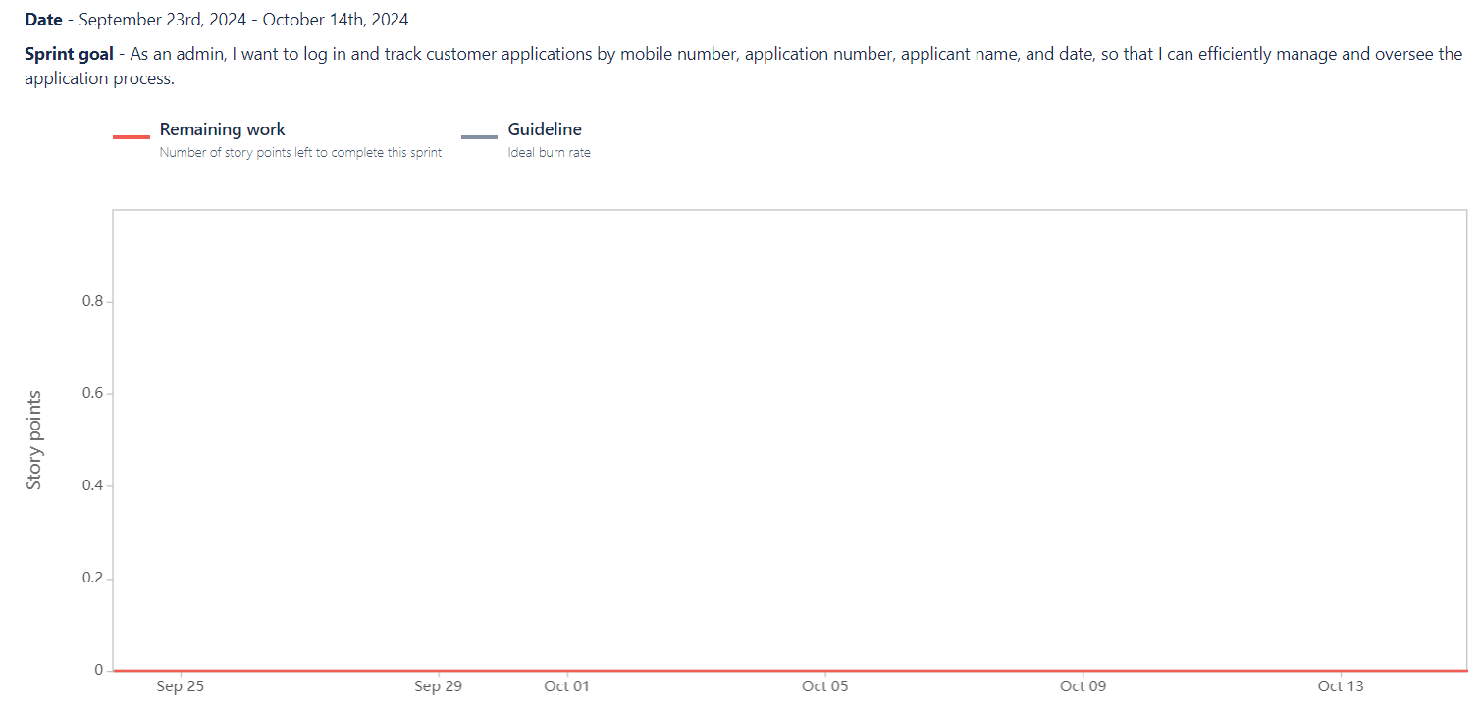

**Document 6: Sprint meetings**

**Meeting Type 1: Sprint Planning meeting**

|  |  |  |
| --- | --- | --- |
| **Date** | **10-07-2024** |  |
| **Time** | **11.30 am** |  |
| **Location** | **Pune** |  |
| **Prepared By** | **Satish Sargar** |  |
| **Attendees** | **Product owner:** | **Ravi Mehta** |
|  | **Scrum Master:** | **Pooja Deshmukh** |
|  | **Scrum Developer 1:** | **Vikas Reddy** |
|  | **Scrum Developer 2:** | **Anjali Singh** |
|  | **Scrum Developer 3:** | ***Kiran Shah*** |
|  | **Scrum Developer 4:** | ***Meera Nair*** |
|  | **Scrum Developer 5:** | **Ram sharma** |
| **Agenda Topics** |  |  |
| **Topic** | **Presenter** | **Time allotted** |
| **Topic** | **Presenter** | **Time Allotted** |
| **Review of Previous Sprint** | **Pooja Deshmukh** | **15 minutes** |
| **Discuss User Stories** | **Ravi Mehta** | **30 minutes** |
| **Estimate Efforts** |  | **20 minutes** |
| **Set Sprint Goals** | **Pooja Deshmukh** | **15 minutes** |
| **Finalize Sprint Backlog** | **Ravi Mehta** | **10 minutes** |
| **Observers** | **Business analyst** | **Ankur vadnere** |
| **Resources** | **Product Backlog Document** |  |
|  | **Sprint Planning Tools (JIRA, Excel)** |  |
| **Special Notes** | **Ensure all stakeholders have access to the backlog** |  |
|  | **Sprint goal should align with current project phase** |  |
|  | **Make sure to focus on high-priority tasks in this sprint** |  |

**Meeting Type 2: Sprint review meeting**

|  |  |  |  |
| --- | --- | --- | --- |
| **Date** | **20-07-2024** |  |  |
| **Time** | **3:00 PM - 4:00 PM** |  |  |
| **Location** | **Pune** |  |  |
| **Prepared By** | **Satish Sargar** |  |  |
| **Attendees** | **Scrum Master: Priya Sharma** |  |  |
|  | **Product Owner: Rohit Patel** |  |  |
|  | **Developers: Suresh Nair, Anjali Gupta, Manish Sharma** |  |  |
|  | **QA: Neha Verma** |  |  |
|  | **UI/UX: Rajat Singh** |  |  |
|  | **Business Analyst: Satish Sargar** |  |  |
|  | **Tech Support: Anil Reddy** |  |  |
| **Sprint status** | **Things to demo** | **Quick updates** | **What’s next** |
|  | **Customer login via mobile OTP (Suresh)** | **QA raised 3 bugs, fixed 2, 1 under review** | **Prioritize completion of pending stories** |
|  | **Employment details form functionality (Anjali)** | **UI/UX feedback incorporated for login screen** | **Focus on bug resolution for upcoming sprint** |
|  | **Credit card application integration (Manish)** | **Backend integration for insurance process delayed** | **Start planning for UAT phase** |

**Meeting Type 3: Sprint retrospective meeting**

|  |  |  |  |
| --- | --- | --- | --- |
| **Date** | **25-07-2024** |  |  |
| **Time** | **3:00 PM - 4:00 PM** |  |  |
| **Location** | **Pune** |  |  |
| **Prepared By** | **Priya Sharma** |  |  |
| **Attendees** | **Scrum Master: Priya Sharma** |  |  |
|  | **Product Owner: Rohit Patel** |  |  |
|  | **Developers: Suresh Nair, Anjali Gupta, Manish Sharma** |  |  |
|  | **QA: Neha Verma** |  |  |
|  | **UI/UX: Rajat Singh** |  |  |
|  | **Business Analyst: Kavita Iyer** |  |  |
|  | **Tech Support: Anil Reddy** |  |  |
| **Agenda** | **What went well** | **What didn’t go well** | **Questions** |
|  | **The login and OTP authentication for the customer was successfully developed and tested.** | **Delays in gathering financial details for customers due to unclear requirements, leading to minor bottlenecks** | **How can we improve communication with stakeholders to ensure clearer requirements before development starts?** |
|  | **The system for capturing basic customer details by bank executives was completed with minimal defect** | **The integration of the insurance module took longer than expected, affecting the sprint timeline** | **Can we allocate more resources or time for complex integrations like the insurance and overdraft facilities in the next sprint?** |
|  | **Communication among the team during daily scrums was highly effective, ensuring alignment on priorities** | **Technical challenges during document upload (KYC) implementation caused some setbacks** |  |
| **Reference** | **User stories for customer login, financial details, credit card applications, and insurance processing.** |  |  |
|  | **Sprint burndown charts and product backlog for tracking progress.** |  |  |

**Meeting Type 4: Daily Stand-up meeting**

|  |  |  |  |  |  |  |
| --- | --- | --- | --- | --- | --- | --- |
| **Meeting Type** | **Daily Stand-up Meeting** |  |  |  |  |  |
| **Week** | **Week “X” (from 10-07-2024 to 25-07-2024)** |  |  |  |  |  |

**Developer 1: Amit Sharma**

|  |  |  |  |  |  |  |  |
| --- | --- | --- | --- | --- | --- | --- | --- |
| **Question** | **Monday** | **Tuesday** | **Wednesday** | **Thursday** | **Friday** | **Saturday** | **Sunday** |
| **What did you do yesterday?** | **Worked on login module and OTP authentication integration.** | **Tested customer detail input feature.** | **Completed unit testing for credit card application.** | **Debugged KYC upload issues.** | **Worked on integration for financial details.** | **Finalized documentation for login feature.** | **—** |
| **What will you do today?** | **Continue testing on multiple devices for login.** | **Fix issues raised during testing for financial details input.** | **Begin work on employment details module.** | **Continue testing KYC upload.** | **Test insurance module integration.** | **Review code for document upload feature.** | **—** |
| **What (if any) is blocking your progress?** | **No blockers.** | **Minor delays due to lack of test data.** | **Issues with API integration for employment details.** | **None.** | **Insurance data unclear.** | **No blockers.** | **—** |

**Developer 2: Neha Patel**

|  |  |  |  |  |  |  |  |
| --- | --- | --- | --- | --- | --- | --- | --- |
| **Question** | **Monday** | **Tuesday** | **Wednesday** | **Thursday** | **Friday** | **Saturday** | **Sunday** |
| **What did you do yesterday?** | **Worked on UI for insurance module.** | **Completed front-end design for financial details input.** | **Fixed UI bugs for document upload section.** | **Updated interface for credit card module.** | **Finalized UI for customer detail form.** | **Documented UI changes for reference.** | **—** |
| **What will you do today?** | **Begin user testing on the insurance module UI.** | **Continue UI integration for financial details form.** | **Fix minor alignment issues in the credit card section.** | **Refactor code for employment detail UI.** | **Begin UI testing for document upload.** | **Review UI/UX feedback.** | **—** |
| **What (if any) is blocking your progress?** | **None.** | **Delays due to incomplete design specs.** | **Feedback from the team pending.** | **None.** | **Some UX decisions need review.** | **No blockers.** | **—** |

**Developer 3: Rahul Singh**

|  |  |  |  |  |  |  |  |
| --- | --- | --- | --- | --- | --- | --- | --- |
| **Question** | **Monday** | **Tuesday** | **Wednesday** | **Thursday** | **Friday** | **Saturday** | **Sunday** |
| **What did you do yesterday?** | **Worked on backend logic for financial details.** | **Completed logic for document upload validation.** | **Performed code review for credit card application.** | **Debugged issues in the overdraft module.** | **Set up API for KYC document submission.** | **Worked on backend integration for referral codes.** | **—** |
| **What will you do today?** | **Start testing backend for financial data processing.** | **Continue testing on document upload API.** | **Test the backend for employment details.** | **Work on fixing issues in the overdraft module.** | **Continue testing KYC validation process.** | **Begin backend testing for referral code entry.** | **—** |
| **What (if any) is blocking your progress?** | **None.** | **API data incomplete for testing.** | **Blocked by missing employment data.** | **None.** | **KYC validation test cases pending.** | **None.** | **—** |