Nurturing Process – Capstone Project 1 – Part -2/3

Question 1
4 quarterly Audits are planned Q1, Q2, Q3, Q4 for this project what is your knoeledge on how these audits will happen for a BA?
Answer
Stage | Quarter 1 Audit Report (Requirement Gathering phase)
Completed | 10 weeks (Week 1 to Week 10)
Check list | BRD template
 | Elicitation result report
 | Duplicate requirement
 | Grouping of functionalities/features
 | Client signoff
 | Email communication-To, CC, BCC

Stage | Quarter 2- Audit Report (Requirement analysis phase)
Completed | 7 Weeks (Week 16 to Week 23)
Check list | UML diagram
 | Business to functional requirement
 | Client signoff document
 | RTM document version control
 | Email communication-To, CC, BCC

Stage | Quarter 3 Audit report (Design)
Completed | 7 Weeks (Week 30 to Week 37)
Check list | Utilization
 | Document evidence on client communication
 | Stakeholder MOM (Minutes of Meeting)
 | Email communication – To, CC, BCC

Stage | Quarter 4 -Audit report (Development)
Completed | 20 Weeks (Week 40 to Week 60)
Check list | JAD session report
 | End user manual preparation document
 | BA and developer MOM
 | Email communication- To, CC, BCC
Stage |  | Quarter 5 – Audit report (testing)
Completed |  | 20 Weeks (Week 58 to week 78)
Check list |  | Test case summary
 |  | Training aspect to end users
 |  | Lessons learnt document
 |  | Email communication -To, CC, BCC

Question 2
Before the project is going to kick start, The Committee asked to submit BA Approch Strategy
Answer
- What Elicitation Technique to apply
We have many elicitation techniques to apply used to gather requirement some of them are:
- Brainstorming: Group session to generate ideas and solution.
- Document analysis: Reviewing any existing document to understand the current process.
- Reverse Engineering: Analyzing existing system (if any) to understand their functionally.
- Focus groups: Facilitated discussions with a select group of stakeholders to gather in -depth feedback.
- Observation: Observing the stakeholders in their natural environment to understand their needs and challenges firsthand.
- How to do stakeholder analysis RACI
- Stakeholder analysis can be done by using the RACI matrix involves identifying stakeholders and defining their roles and responsibilities within the project
- Identify stakeholders: Identify all individuals or groups impacted by the project.
- Creating RACI matrix:

R/A/C/I | Names | Designation | Details
Responsible | Mr. Jason | Manager Operations | Email Id- Jason@123.com  Ph No. 000000000  Reach out: - 9 AM To 1 PM
Responsible | Mr. Teyson | Technical SME Payment | Email Id- teyson@123.com  Ph No. 678567456  Reach out: - 9 AM to 1 PM
Responsible | Miss. Juhi | Software Developer | E mail Id- juhi@123.com  Ph No. 678567456  Reach out – 9 AM to 1 PM
Accountable | Mr. Vandanam | Project Manager | Email Id- vandanam@123.com  Ph No. 000000000  Reach out – 9 AM to 1 PM
Accountable | Me | Business Analyst | Email Id- ABC@gmail.com  Ph No. 123654789  Reach out – 9 AM to 1 PM
Accountable | Mr. John | DB Admin | Email Id- John@123.com  Ph No. 123456789  Reach out – 9 AM to 1 PM
Consulted | Mr. Pandu | HR Head | Email Id- pandu@123.com  Ph No. 456789123  Reach out – 9 AM to 1 PM
Consulted | Miss. Lucie | Process Manager | Email Id- lucie@123.com  Ph No. 456789123  Reach out – 9 AM to 1 PM
Consulted | Mr. Mike | Network Admin | Email Id- mike@123.com  Ph No. 456789123  Reach out – 9 AM to 1 PM
Informed | Mr. Henry | Sponsor | Email Id- henry@123.com  Ph No. 456789123  Reach out – 9 AM to 1 PM
Informed | Miss. Alekya | Tester | Email Id- alekya@123.com  Ph No. 456789123  Reach out – 9 AM to 1 PM
Informed | Mr. Karthik | Project Head | Email Id- karthik@123.com  Ph No. 456789123  Reach out – 9 AM to 1 PM

- Assign RACI Roles: Assign each stakeholder a role
R- Responsible: The person who performed the task.
A-Accountable: The person who is ultimately accountable for the task’s completion.
C- Consulted: Those who provide input before a decision is made.
I – Informed: Those who are kept up -to-date om progress.
3.What documents to write
- BRD (Businerss requirement document): A High -level document outlining the business needs and objectives.
- FRD (Functional requirement document): A detailed document specifying what the system must do.
- Use case documentation: Detailed descriptions of how users will interact with the system.
- Test Case Documents: Documenta outlining the scenarios and steps to be tested.
4.What process to follow to sign off on the documents
- Sign -off will be taken on the SRS (Software requirement specification), as it is the primary and most important document.
- Sign -off will be taken using E-mail confirmation from client and key stakeholder.
5.How to approval from the client
- By establishing a formal meeting with the clients (Mr. henry, the committee, and the farmers) to keep them informed and get continuous feedback.
- Approvals will be documented and communicated formally.
6.What communiction channels to establish and implement
- Regular meeting: By sheduling regular meetings with project team.
- Bi-weekly sprint reviews: Meeting to review completed work and provide feedback.
- Monthly stakeholder updates: Regular updates to the broader group of stakeholders to keep them informed of the project’s progress.
- Monthly stakeholder updates.
7.How to handle change request
A structured process will be in place to manage changes
- Change request form: Any change will be initiated via a formal request form.
- Impact analysis:it is a process used to understand the potential consequences of change or disruption on, process, or business. By performing impact analysis, we can determine the impact of the change or project’s scope, timeline and budget.
- Approval process: The change request and impact analysis will be presented to the project committee for approval.
- Documentation: All changes, approvals and decisions will be formally documented.
8.How to update the progress of the project to the stakeholders
- By providing weekly status report to the team and key stakrholders.
- By conducting monthly review meetings to present a more detailed overview of the project’s progress.
9.How to take signoff on UAT-Client project acceptance form
- UAT Preparation: By assist in preparing for user acceptance testing.
- Conduct UAT: The users(farmers)will conduct the UAT to validate that system meets their needs.
- Fix issues: Any issues identified during UAT will be addressed and fixed.
- Acceptance form: The client will sign an acceptance form to their satisfaction with product.
- Final review meeting: A final meeting will be held to obtain the official sign-off from the client.

Question 3
Explain and illustrate 3-tier architecture?
Answer
This divides the application into 3 logical layers-
- Application layer: topmost layer of the architecture -also known as “Presentation layer”, Where the user interacts with the application. It handles user interface (UI) and is responsible for diplaying information to the user and collecting their input.
Ex: E- commerce Website, A web browser.
- Business logic layer: This is the middle layer and the core of the application. It contains the business logic, which is the set of rules and instructions that process user requests and perform the application’s main functions. This layer acts as a mediator between the presentation tier and data tier.
Ex: Printer, Payment gateways.

- Database layer: This is the bottom most layer and responsible for storing, managing and retrieving the application’s data .it is protected from direct access by user.
Ex: MySQL, Oracle database.
How it works
- A farmer places an order (Presentation tier): A farmer browses the website (Tier 1). They select seeds and fertilizers and click “place order”. this action sends a request to the application server.
- The application processes the order (Application tier): The request arrives at the application server (tier 2). The apllication’s businrss logic takes over.
- It checks farmer’s credentials.
- It verifies that the products are in stock by sending a query to database.
- It calculates the total cost and delivery charges.
- It creates a new order record and updates the inventory in the database.
- The database stores the information (data tier): The application server sends commads to the database server(tier3) to update the orders and product table. The database executes these commands and confirms success.
- The application sends a response (Application tier to presentation tier): The application server recieves the confirmation from the database .it then generates a “order confirmed” page or message, which is sent to the farmer’s web browser.
- The farmer sees confirmation (Presentation tier): The web browser receives the response and diplays the order confirmation to the farmer.

Question 4
Business analyst should keep what points in his /her mind before he frames a question to ask to the stakeholder
Answer
5W1H framework: The BA should use 5W1H framework to ensure the questions are comprehensive. This involves asking question about
- Who: Who is involved? (e.g. Who are users, who are manufacturer)
- What is the specific need or requirement? (e.g. What products are sold, what features are needed)
- When: When will this need to be completed? (e.g. what is the timeline for delivery)
- Where: Where will this be used? (e.g. where are farmers located)
- Why: Why is this requirement important? (e.g.why is this feature a priority)
- How: How will the process work? (e.g. how will farmer select product; how will payment be handled?)
SMART Technique:BA should create question that led to answer that are
- Specific: Clear and unambigous.
- Measurable: Quantifiable, so progress can be tracked.
- Attainable: Realistic and achievable with in the project constraints.
- Relavant: Directly related to the project goals.
- Time-bound: Have a defined deadline or timeframe.
RACI Chart: BA should have an understanding of the RACI charty for the team and project. This will help them indentify who is:
- Responsible: Who is doing the work?
- Accountable: Who is ultimately answerable for the task ‘s completion?
- Consulted: Who needs to provide input?
- Informed: Who needs to be kept in the loop?
How it works
This helps the BA direct their questions to the appropriate stakeholders. For example, a question abiut the budget might go to the financial head (Mr. Pandu), While a question about the delivery process might go to project coordinator (Mr. dooku).
3 Tier Architecture:
- Application layer:
- What specific devices will farmers primarily use to access the applictaion?
- How do we plan to handle poor internet connectivity in remote areas to ensure the application remains user friendly?
- Business logic layer:
- What is business logic for the recommendation system? E.g how will we suggest specific fertilizera based on a farmer’s crop type?
- What is the key security protocol we need to implement to protect user data and financial transactions?
- Database layer:
- What data needs to be stored for each product?
- What are the backup and recovery procedures fir the database in case of a system failure?
- Questions about user intractions will help define use cases and activity diagram.
- Questions about specific functional requirements will help create detailed use case specification.
- Questions about the user experience and interface will be crucial for creating page designs.

Question 5
As a business analyst, what elicitation techniques you are aware of?
Answer
I.Brainstorming: A collaborative technique used to generate a large number of creative ideas in a short period. It encourages free thinking and is useful for solving problems or generating new requirement.

How it works
- Defines the problems or objectives clearly
- Set the stage
- Generate ideas
- Evaluate and refine the ideas
- Follow up

Advantages
- Increases the collaboration in team work
- Development of critical thinking skills
- Improve problem solving
II.Document analysis: Document analysis is done through reading a document and understanding the product, process and project.
How it works
- Planning and preparation
- Document review and analysis

Advantages
- Time saving
- Insight and understanding
III.Reverse engineering: also called back engineering, is the processes of extracting knowledge or design information from anything man -made and re-producing it or re-producing anything based on extracted information.

How it works
- Analysis and modelling
- Understanding design and functionality
Advantages
- Cost and time saving
- Improves product development
IV.Focus groups: A focus group is a means to elicit ideas and attitude about a specific product, service or opportunity in an interactive group environment.
Advantages:
- Speedup data collection
- Allow data collection scrunity

V.Observation: Watching stakeholders perform their task to understand their workflow and the challeges they face.
How it works:
- Systematically gathering data by watching people, places or events
Advantages:
- Direct data collection
- Ability to capture rich and detailed data
VI.Workshops: A structured, facilitated meeting with a group of stakeholders to collaborativelly define requirements, solve problems and make decision.
How it works
- People come together to learn about a specific topic, skill or to solve problem.
Advantage:
- Providing hand on learning experience
- Reamwork and collaboration
VII.JAD (Joint application development): A specific type of workshop that bring together business users, developers and other stakeholders in a structured setting to define and refine system requirement quikly.
How it works
- Identify project objectives and limitations
- Prepare workshop material
Advantages
- Improved communication
- Faster development
- Increased user staisfaction
- Reduced errors
VIII.Interview: An interview is a systematic approach where unterviewee is going to ask relevant questions related to software and documenting the responses.
Advantages
- In-depth information gathering
- Evaluation of cultural fit
- Assessment of soft skills
IX.Prototype: Creating a working model of the system to demonstrate functionality, gather feedback, and clarify requirements. Prototypes can be low fidelity or high fidelity.
How it works
- It allows designers and developers to identify flaws, gather feedback and iterateon the design
Advantages
- Cost and time saving
- Enhanced user involvement and feedback
- Design validation and iteration
- Risk mitigation
X.Questionnaire: A set of written questions distributed to a large number of stakeholders to gather quantitative or qualitative data efficiently.
How it works
- Define objectives
- Analyze data
- Develop questions
Advantages
- Cost- effective and time efficient
- Standardization and consistency
XI.Use case specs: Detailed documentation that describes the behavior of a system from the user’s perspective. while often a product of elicitation, the process of creating them is an elicitation technique in itself as it involves deep dives with stakeholders to define preconditions, postconditions and alternate flows.
How it works
- Define the specific tasks user will have with the system
- Guide developers in building the system
- Guide testers in verifyibg its functionality
Advantages
- They provide a common laguage for developers, business analyst and stakeholders to discus system requirements and functionality

Question 6
Which elicitation technique can be used in this project and justifuy your selection of elicitation technique?
Answer
The elicitation techniques can be used in this project are
- Interview
- Prototyping
- Document analysis
- Use case specs
- Brainstorming

a) Interview:
- Justification:The project has a specific ,key stakeholders (peter,kevinand ben)who have firsthand experience with the problem.Mr .Henry is the visionary and sponsor .Conducting one-on-one interview with each of them will allow the BA to delveinto their unique challenges and requirements.This technique is excellent for gathering detailed,quanlitative information from asmall ,influential group.The BA can ask open ended questions to uncover specific points and needs that a more structured method might miss .
b) Prototyping:
- Justification: The target users(farmers) are new to this type of application and the goal is for this application to be “user friendly “. Prototyping allows the BA and the development team to create a mock- up of the user interface early in the process. This can be shared with peter, kevinand ben to get their feedback on the look, feel and flow of the application. It helps to clarify requirement that might be difficult to describe in words, such as the layout of the product catalog or the steps to request a purchase. This iterative feedback process ensures the final product meets the usability needs of the farmers.

C) Documenting:
- Justification: While a new system is being created, there will be existing documents that can provide valuable information. These could include:
- Business plans or strategies from Mr. Henry’s Company, SOONY.
- Invoices, receipts, or delivery slips from existing transactions between farmers and manufacturers.
- Any existing marketing materials from manufacturers that the BA can analyze to understand their product offerings and branding.
- By analyzing these documents, the BA can gain a deeper understanding of the business processes, data elements, and existing workflows, which can be used to inform the new system’s design.
d)Use case specs:
- Justication: As stated in the provided information, the project already has some high-level business requirements defined (e.g. BROO1 and BR002). The BA’s role is to take these high-level needs and break them down into detailed,actionable requirement for the development team .Use case specifications are the ideal tool for this .The BA would work with stakeholders to document the detailed steps,pre-conditions,post conditions, and alterate flows for key user interactions like “request to buy product “or “upload product details”.This ensures that the technical team has a clear and unamdiguous understanding of what needs to be built.
e) Brainstorming:
- Justifictaion: This technique is valuable for generating new ideas, particularly in the initial phases of the project. The BA could facilitate a brainstorming session with key stakeholders, including Mr. henry and the farmers, to explore potential new featurwes or solutions.
- This technique is great for moving beyond the initial requirement and fostering innovation.

Question 7
Make suitable assumptions and identify at least 10 business requirements.
Answer
Business requirements are specific needs or conditions that a business must meet to achieve its objectives.
Login and user management
- BR001: The system must allow new users (farmers and manufactures) to create an account by submitting their Email ID and creating a secure password.
- BR002: The system must require all users to log in with their email ID and password before they can access core functionalities.
Product catalog and searching
- BR003: The system must enable manufacturers to upload and diplay their product details in tha application.
- BR004: The system must allow farmers to browse the product catalog.
- BR005: The system must allow farmers to search for products based on keywods, product type or manufacturers.
Purchase and order management
- BR006: The system must allow a farmer to select a product and place a purchase request.
- BR007: The system must allow the manufacturer to view and respond to a farmer’s purchase request (accept or reject).
- BR008: The system must provide a delivery tracker so that farmers can monitor the where about of their order.
- BR009: The system must send an email confirmation to the farmer regarding their order status.
Payment and financials
- BR010: The system must support multiple payment options, including cash-on -delivery (COD), credits/debits card and UPI.

Question 8
List your assumptions
Answer
- Assumption 1: internet access
Farmers in the remote areas have the necessary internet connectivity to use the application.
- Assumption 2: farmer’s digital literacy
Farmers possess a basic understanding of how to use a mobile or web application.
- Assumption 3: manufacturer by-in
Manufacturers are willing and able to participate by uploading product details and managing orders.
- Assumption 4: logistics &delivery
A reliable system exists to physically deliver products to the farmer’s remote location.
- Assumption 5: payment gateways integration
The project assumes that a secure and functional payment gateways can be integrated to process credit/debit card and UPI transactions.

Question 9
Give priority 1 to 10 numbers (1 being low priority -10 being high priority) to this requirement after discussions with the stakeholders
Answer
Project requirement priority
Req ID | Req name | Req description | Priority
BR001 | Farmer search for products | Farmers should able to search for avilable products in fertilizers, seeds, pesticides. | 8
BR002 | Manufacturers upload their products | Manufacturers should be able to upload and display their products in the application. | 8
BR003 | Users create login | Users should be able to create login id and password. | 7
BR004 | Users browse through products | Users should be able to browse through the available products. | 7
BR005 | Add to cart option | Users must be able to add items to a cart if they wish to buy them later. | 7
BR006 | Payment gateway | All the payment gateway methods (COD, Credit/debit card, and UPI) should be available. | 5
BR007 | Email confirmation | Users should get email confirmation for their order. | 4
BR008 | Product delivery tracking | Users must be able to track the delivery of the product. | 3
BR009 | Product information | Users must should get the details of the particular product. | 2
BR010 | User search the products | Users should be able to search for the available products. | 2

Question 10
Draw usecase diagram
Answer
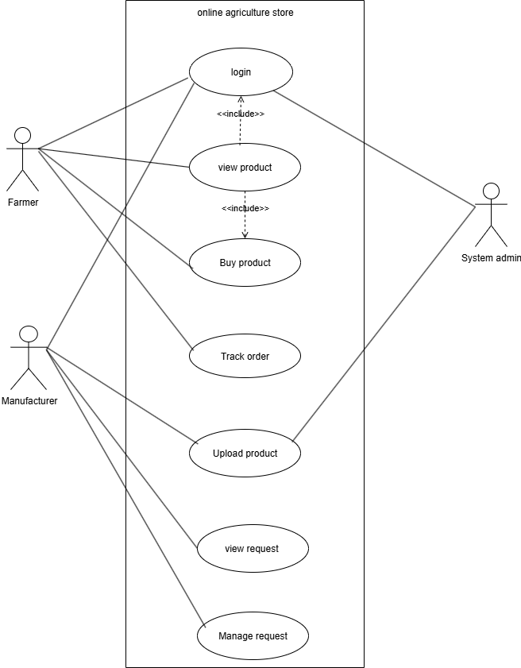

Defination: A use case diagram is a visual representation of the interaction between users and a system
Explanation of the diagram
- Actors: we have two main users
- Farmers
- Manufacturer
- System admin
- The box labelled is online agriculture store
- Use case: these are simple actions the users perform
- Farmer: Can login, view products, buy products and track order
- Manufacturer: can login, upload products, view purchase request, and accept/reject request.
- System admin: responsible for system management.
- Lines: A line simply means that an actor interacts with that specific function of the application.

Question 11
Prepare use case specs for all use cases
Answer
1.Use case specification: Login to system
Field | Description
Use case ID | UC-001
Use case name | Login to system
Actor | Farmers, manufacturer, admin
Goal | To securely log in and gain access to the system
Preconditions | The user must have a valid account on the platform. The user is currently logged out
Trigger | The user navigates to the login page and attempt to login.
Postconditions | Successful: the user is logged into the system and redirected to their respective dashboard.  Failed: the user remains on the login page with an error message.
Normal flow | 1.the user enters their email ID and password on the login page.  2.the uiser clicks the “login” button.  3.the system validates the credentials againast the database.  4.if credentilas are correct, the system logs the user in and redirect them to their dashboard.
Alternative flow | Incorrect credentials: if the entered credentials do not match, the system display an error message “invalid email or password”.  Forget password: the user clicks “forget password”, enter their email, and system sends a password reset link.
Frequency | High (daily for active users)
Assumptions | A valid email ID and password is required credentials.the system has a functioning reset mechanism.

2.Use case specification: Browse products
Field | Description
Use case ID | UC-002
Use case name | Browse products
Actor | Farmers
Goal | To view the list of all available agricultural products in online store
Preconditions | The farmer is logged into the system.
Trigger | The farmer navigates to the homepage or product catalog page
Postconditions | The farmer is successfully viewing a list of products.
Normal flow | 1.the farmer logs in and is redirected to dashboard.  2.the farmer clicks on the “products” or “catalog” link in the navigation menu.  3.the system displays a grid or list of avilable products, including images, names and prices.  4.the farmer can scroll through the list to view all products.
Alternative flow | No products available: If the products catalog is empty, the system displays a messege “no products are currently available”.
Frequency | High (for all active farmer)
Assumptions | Product data is available in the database.

3.Use case specification: Buy product
Field | Description
Use case ID | UC-003
Use case name | Request to buy product
Actor | Farmers
Goal | To submit a request to purchase a selected agricultural product.
Preconditions | The farmer is logged in and has loacted a product they wish to purchase.
Trigger | The farmer clicks the “buy” or “add to cart” button on a product detail page.
Postconditions | Successfull A purchase request is created and sent to manuafacturer. The order status is set to “pending”.  Failed: the system displays an error message
Normal flow | 1.the farmer is on a product details page.  2.the farmer enters the desired quantity.  3.the farmer clicks the “request to buy” button  4.the system validates the request  5.the system creates a new purchase request record  6.the system sends a notification to the manufacturer  7.the system sends a confirmation email to the farmer
Alternative flow | Out of stock: if the requested quantity exceeds the availble stock, the system displays an “out of stock” messege and does not proceed.  Invalid quantity: if the farmer enters a non numeric or negative quantity, the system displays an error message.
Frequency | Moderate to high (seasonal)
Assumptions | A product’s quantity and stock information are accurate and up -to-date.

4.Use case specification: upload product details
Field | Description
Use case ID | UC-004
Use case name | Upload product details
Actor | Manufacturer
Goal | To add new agricultural product to the store’s catalog
Preconditions | The manufacturer is logged in and has been approved to sell products
Trigger | The manufacturer is logged in and has been approved to sell products
Postconditions | Successful: a new product is added to the system and is visible in the catalog.  Failed: an error message is displayed, and the product is not added.
Normal flow | 1.the manufacturer log in and navigates to the “my product” section.  2.the manufacturer clicks the “add new product” button.  3.the manufacturer fills in the product form (name, description, price, stock, category, image etc).  4.the manufacturer clicks “submit”.  5.the system save the product details to the database and displays a success message.
Alternative flow | Missing inormation: if a required field is left blank, the system highlights the missing field with an error message upon submission.  Invalid file type: if an image is uploaded in an unsupported format, the system displays an error message.
Frequency | Moderate (when adding new stock or products)
Assumptions | The manufacturer has the required product information and Image ready to upload.

5.Use case specification: Manage purchase request
Field | Description
Use case ID | UC-005
Use case name | Manage request
Actor | Manufacturer
Goal | To respond to a farmer’s purchase request and initiate the delivery process.
Preconditions | The manufacturer is logged in and has a pending purchase request.
Trigger | The manufacturer views a pending purchase request.
Postconditions | Successful: the order status is updated to “accept” or “rejected”, and the farmer is notified. The order is either sent for delivery or canacelled.
Normal flow | 1.the manufacturer logs in and navigates to their “purchase requests” dashboard.  2.the manufacturer selects a pending request to view its details  3.the manufacturer reveiws the order and checks inventory  4.the manufacturer clicks either the “accept” or “reject” button  5.the system updates the order status accordingly  6.the system sends a notification to the farmer with the updated status.
Alternative flow | Low stock: if the manufacturer has insufficient stock, they can click “reject” and add reason. The system will then notify the farmer of the rejection.
Frequency | High (for an active manufacturer)
Assumptions | The manufacturer is responsible for managing their own inventory and fulfilling the order once accepted

Question 12
Activity diagram
Answer
- Login to system
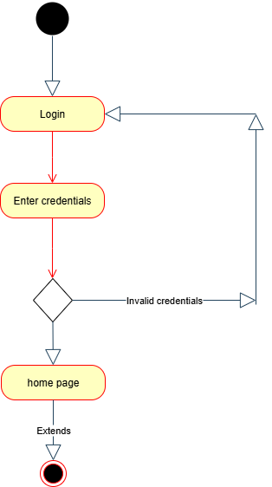

- Buy product
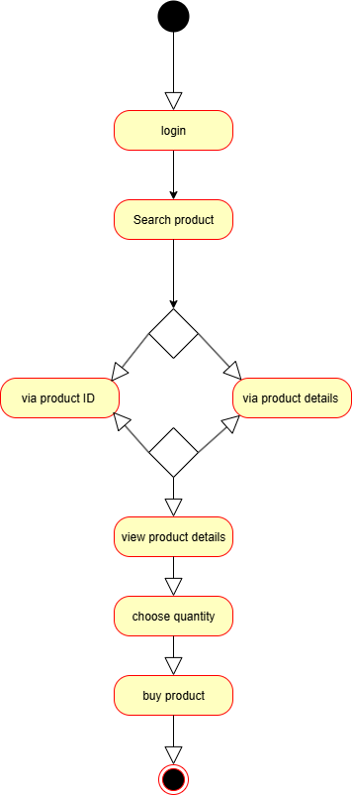

- Upload product details

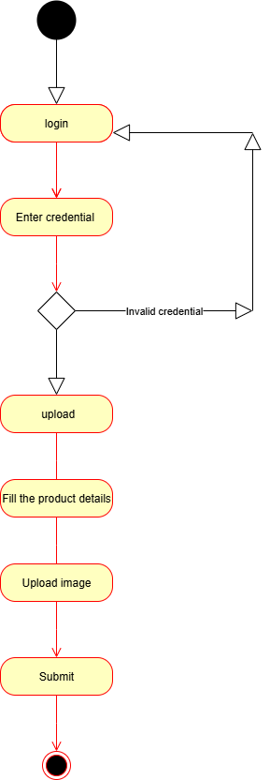
- Accept purchase request(manufacturer)
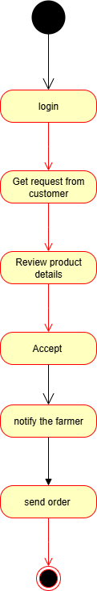

- Track order status

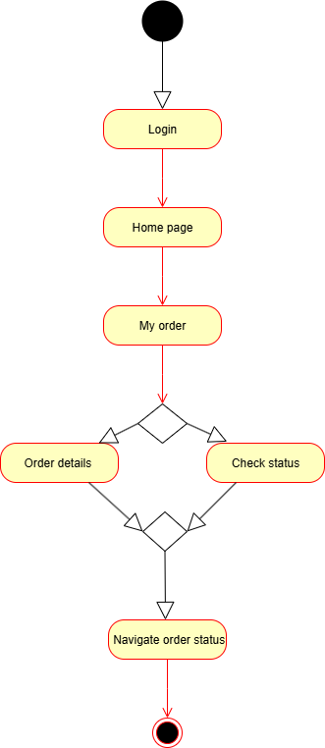
Defination:An activity diagram is a type of diagram in the unified modeling language (UML) that visually represents the flow of activities with in a system.

