Q1. What is the difference between Brainstorming and JAD Sessions? 3 Marks  
Answer 🡪  
Brainstorming is a technique for generating ideas, while Joint Application Development (JAD) sessions are a structured way to gather and refine project requirements:

**Brainstorming**

A technique to generate ideas quickly and encourage creative thinking. Participants share ideas without fear of criticism, and the ideas are then discussed, merged, and refined.

**JAD sessions**

A structured approach to gather and refine project requirements through collaborative efforts. JAD sessions bring together people from different disciplines for brainstorming and intensive discussions. The goal is to ensure that all stakeholders' perspectives are considered, leading to more accurate and efficient development outcomes.

JAD sessions typically involve a series of structured activities, such as brainstorming sessions, group discussions, user story mapping, process modelling, and prototyping exercises

Q 2. Why Document Analysis is one of the compulsory techniques we use in a Project? Justify  
Answer 🡪

Document analysis is a useful technique for projects because it can help you:

**Understand the context**: Analyse key documents and reports to understand the context of a project and the factors causing problems.

**Make informed decisions**: Examine documents to gain insights into an organization's processes, goals, and challenges.

**Triangulate findings**: Check assumptions by asking if they are supported by the documentation.

**Select appropriate resources**: Organize qualitative data into categories to make sense of resources and select the right pieces for studies.

**Track study development**: Use documentary material to track the development of studies.

**Confirm evidence**: Use documentary material to confirm evidence found in another research.

**Extract relevant information**: Analyse historical records, textual data, and archival documents to extract relevant information for scholarly investigations.

**Uncover insights**: Scrutinize existing policies, training manuals, and reports on customer complaints or feedback to uncover insights.

Document analysis can include:

1. Reports
2. Contracts
3. Proposals
4. Customer service policies
5. Training manuals
6. Reports on customer complaints or feedback
7. Emails
8. Recorded interviews or meetings

Q3. In Which Context we will use Reverse Engineering?   
Answer 🡪  
Reverse engineering is a business analysis technique that can be used in a variety of contexts, including:

* **Understanding software**

Reverse engineering can be used to understand how software processes business rules, sources data, and makes decisions. This can be helpful when:

* + The software documentation is out of date
  + Business users aren't aware of the business rules being enforced
* **Analyzing competitors**

Reverse engineering can be used to analyse competitors' value chains and apply their principles to your own business. This can help you:

* + Streamline features
  + Use cheaper materials
  + Reach a wider market
* **Understanding communication protocols**

Reverse engineering can be used to understand and analyse communication protocols used in IT systems or electronic devices.

* **Creating emulations or virtualizations**

Reverse engineering can be used to create emulations or virtual environments, which can be useful for testing software on different platforms.

Other contexts where reverse engineering can be used include:

* Regaining lost designs
* Recreating engine and auto body parts for older vehicles
* Researching new technologies
* Analyzing the properties of materials
* Exploring scientific problems
* Optimizing product assemblies
* Providing new and added features

Q4. What is the difference between Brainstorming and Focus Groups?   
Answer 🡪  
Brainstorming and focus groups are both data gathering techniques, but they differ in their purpose and the type of information they provide:

* **Brainstorming**

The goal of brainstorming is to generate ideas and solutions to a problem quickly. It encourages "out-of-the-box" thinking and can help increase creativity. Brainstorming sessions are typically free-form and don't require many rules. However, structured brainstorming sessions with clear ground rules and a facilitator can yield better results.

* **Focus groups**

The goal of a focus group is to gain insight into the perspectives and experiences of a group of stakeholders, such as customers or employees. Focus groups are structured discussions where participants provide feedback on a specific topic. Focus groups can provide insight into how the market will respond to solutions found through brainstorming. Focus groups typically involve prequalified participants and are best suited to groups of five to eight people

Q5. Observation Technique – Explain both Active and Passive approaches

Answer 🡪  
The two main approaches to observation are active and passive:

* **Active observation**

The observer asks questions, provides feedback, or offers assistance while the subject is working. This approach can help the observer understand the rationale and hidden processes behind the activity. However, it may introduce bias and affect user behaviour.

* **Passive observation**

The observer does not interrupt the subject while they are working. This approach allows the observer to capture authentic and unbiased data. However, it may raise ethical and privacy issues. The observer will usually take notes and ask follow-up questions after the session

Q6. How do you conduct the Requirements Workshop?

Answer 🡪  
 To conduct a successful requirements workshop, you can follow these steps:

* **Define goals**: Define the purpose, goals, and objectives of the workshop.
* **Identify attendees**: Determine who should attend the workshop.
* **Create an agenda**: Create a detailed agenda for the workshop.
* **Set a time and location**: Decide on the best time and location for the meeting.
* **Send out invites**: Send out the meeting invite and agenda several weeks in advance.
* **Lead the workshop**: Facilitate and lead the workshop.
* **Document action items**: Document and summarize the action items from the workshop.
* **Send out a summary**: Send out a meeting summary.
* **Follow up**: Follow up on action items and schedule additional meetings if needed.

Other techniques for gathering requirements include:

* **Stakeholder mapping**: Identify key stakeholders and ensure their opinions are gathered and analysed.
* **Prototyping**: Create a clickable prototype of the product so users can provide feedback.
* **Document analysis**: Review existing documentation related to the system, such as user manuals, design documents, and previous requirements documents.
* **Brainstorming**: Get as many ideas as possible and write them down.
* **Observation**: Visit a place multiple times to find domain requirements.
* **Focus groups**: Bring together a group of stakeholders to discuss the project and provide input on requirements.
* **Interviews**: Conduct interviews with stakeholders to gather requirements.
* **Prioritizing requirements**: Prioritize requirements to ensure the most important requirements are addressed first

Q7. In which context, Interview Technique can be conducted by a BA? How many approaches are there in conducting Interviews? (Structured – Unstructured) Explain them.  
Answer 🡪  
  
Business analysts (BAs) use interviews to gather information from stakeholders, subject matter experts, and end-users in a variety of contexts, including:

* **Understanding an organization**

BAs can use interviews to understand an organization's systems, processes, and workflows. This can help them identify areas for improvement.

* **Building rapport**

BAs can use interviews to build trust and rapport with stakeholders. This can lead to better collaboration throughout a project.

* **Eliciting information**

BAs can use interviews to ask open-ended questions to encourage meaningful discussions and uncover hidden issues or requirements

There are many approaches to conducting interviews, including different types of interviews and methods of interviewing:

* **Types of interviews**

Interviews can be structured, semi-structured, unstructured, or focus group interviews:

* 1. **Structured interviews**: Questions are predetermined in both topic and order.
  2. **Semi-structured interviews**: Some questions are predetermined, but others are not.
  3. **Unstructured interviews**: No questions are predetermined.
  4. **Focus group interviews**: Questions are presented to a group instead of an individual
* **Methods of interviewing**

Interviews can be conducted in person, by phone, video, or Skype, or via email or web page:

* 1. **Live interviews**: The most common type of interview, which can be one-on-one or a panel.
  2. **Phone interviews**: Can be one-on-one or a panel.
  3. **Video or Skype interviews**: Used for interviews with people in different locations.
  4. **Taped interviews**: Rarely used but can be used to hire a large number of people for the same position.
  5. **Email or web page interviews**: A popular type of interview that can be conducted via an online survey.

There are two basic types of interviews used to elicit business analysis information:   
**1. Structured Interview:**   
 A structured interview has structure. It is a set of sequential, close-ended questions, where all interviewees are asked the same set of questions with the same response choices. in which the interviewer has a predefined set of questions   
If quantitative data collection is your goal, then structured interviews may be right for you  
The answer selection may be presented as multiple choice, a sliding scale, or yes/no.   
You can use structured interviews to gather information on job applicants, product reviews, or during a marketing campaign. The applications for structured interviews are endless, but the most important thing to remember is that it is used to gather standardized, structured data.

Structured interview questions for a job applicant might be:

**What do people admire about you most?**  
1. Your honesty  
2. The fact you’re hard-working  
3. Your loyalty  
4. Your personality   
  
**2. Unstructured Interview:**   
 The interviewer may rely on spontaneity and ask questions about the topic being researched. It is more conversational, less formal, and usually more relaxed.   
Unstructured interviews ask open-ended questions and feel more friendly than structured interviews.  
Questions are unprepared, but the interviewer must know the subject to present relevant questions  
Unstructured interviews rely on questions asked at the discretion of the interviewer in which the interviewer does not have a predetermined format or order of questions.  
If you want more detail, to follow up on prior research, or if you are looking for qualitative data, unstructured interviews may not be the best format  
  
They are not standardized so can be very different across respondents. Other characteristics include:

* Informal approach
* Flexibility, because the interviewer can adapt and change the follow-up questions, depending on the interviewee’s responses
* Answers to unstructured interview questions are usually open-ended and based on personal preference or opinion
* Questions asked in an unstructured interview require spontaneity and thoughtful responses
* Descriptive in nature and a method of qualitative observation

**Explain the difference between Open Ended Questions and Closed ended Questions?**  
Answer 🡪  
The main difference between open-ended and closed-ended questions is that open-ended questions allow respondents to answer in their own words, while closed-ended questions limit respondents to a set of possible answers:

* **Open-ended questions**

Allow respondents to answer in their own words, and often begin with "why," "how," or "what". Open-ended questions encourage respondents to explore a topic and share information in as much detail as they want.

* **Closed-ended questions**

Limit respondents to a set of possible answers, such as multiple choice, true/false, or yes/no. Closed-ended questions are often easier to answer quickly, but they can lead to limited answers.

The way you phrase your questions can have a big impact on the answers you receive. For example, adding "and why?" to the end of a closed-ended question will usually result in simple answers.

Q8. Questionnaire Technique – Where we will use? Give one example - 6 Marks  
Answer 🡪  
  
A questionnaire is a list of questions or items used to gather data from respondents about their attitudes, experiences, or opinions. Questionnaires can be used to collect quantitative and/or qualitative information. Questionnaires are commonly used in market research as well as in the social and health sciences.  
They are a key component of primary surveys and can be used by a wide range of organizations, including private companies, government departments, and NGOs.

Here are some examples of when questionnaires can be used:

* **Mail questionnaires**

A series of questions are delivered to specific individuals to gather information about a particular topic.

* **Delphi surveys**

Also known as the expert survey method, this technique involves asking experts for their opinions on a problem, then summarizing and feeding back their r responses.

* **Structured questionnaires**

These questionnaires are used to collect data on a set of relevant questions. The questions are often designed based on input from stakeholders, interviews, and participant observation.

* **Rating-scale questions**

These questions are a valuable tool for generating quantitative data.   
  
Some examples of a questionnaire are: Customer Satisfaction Questionnaire: This type of research can be used in any situation where there's an interaction between a customer and an organization. For example, you might send a customer satisfaction survey after someone eats at your restaurant.  
  
Q9. How to Sort the Requirements – Where we will use? Give one example - 5 Marks  
Answer 🡪  
  
Here are some tips for sorting requirements:

* **Categorize by type**: Group requirements by type, such as functional, non-functional, technical, and non-technical.
* **Organize logically**: List requirements in a logical sequence so that stakeholders and IT developers can easily understand them.
* **Use identifiers**: Use separate identifiers for each requirement, such as Roman numerals or a combination of letters and numbers, to make them easier to trace.
* **Consider departments**: Prepare requirements so that each department can easily review them. For example, stakeholders in the administrative department will only want to review administrative requirements.
* **Outline constraints and risks**: Include constraints and risks in the document.
* **Analyse the impact of change**: Conduct an impact analysis to understand how your project will affect existing processes, products, and people.
* **Define clear objectives**: Clearly define and document the project's objectives and goals

Q10. Prioritise the Requirements – –Where we will use? Give one example - 5 Marks  
Answer 🡪  
Requirement prioritization is the process of identifying and ranking the importance of different requirements to achieve the project goals and objectives. Prioritization is important because it helps to ensure that resources and efforts are focused on the most critical requirements to achieve maximum value.

As a business analysts, one must understand the needs and expectations of stakeholders, prioritize requirements, and ensure that the most critical requirements are addressed first. However, let me mention that some stakeholders are stubborn and would either have it their way or no way. The best thing for you to do when you encounter such it to help them see the cost-benefit and risk of prioritizing the wrong requirement.

Below are some of the steps in requirement prioritization.

**Define criteria:**Before starting the prioritization process, it's essential to define the criteria that will be used to assess the requirements. Criteria may include factors such as business value, strategic alignment, technical feasibility, risk, and urgency.

**Identify stakeholders:**Identify stakeholders who will be involved in the prioritization process. Stakeholders may include project sponsors, end-users, subject matter experts, and technical teams.

**Collect and analyse requirements:**Collect all the requirements, and then analyse them based on the defined criteria. Some requirements may be eliminated at this stage if they are irrelevant or not feasible.

**Categorize requirements:**Categorize requirements into groups such as "must-haves," "should-haves," and "nice-to-haves." This helps to distinguish critical requirements from less critical ones.

**Rank requirements:**Rank the requirements within each category based on the defined criteria. Various prioritization techniques, such as MoSCoW (Must Have, Should Have, Could Have, Won't Have), Kano Analysis, Cost-Benefit Analysis, and Relative Weighting can be used to rank the requirements.

**Review and adjust:**Review and adjust the priorities as needed, based on feedback from stakeholders, changes in the business environment, and other factors.

**Communicate the priorities:**Communicate the prioritized requirements to all stakeholders, including the project team, end-users, and sponsors.  
**MoSCoW prioritization:** This technique categorizes requirements as Must Have, Should Have, Could Have, and Won't Have. Must Have requirements are critical and must be implemented, Should Have requirements are important but not critical, Could Have requirements are nice to have but not essential, and Won't Have requirements are out of scope.  
**Value-Based Prioritization:** This technique prioritizes requirements based on the value they provide to the business. The business analyst evaluates each requirement with stakeholders based on how well it aligns with the business objectives and strategy.  
**Cost-benefit Analysis:** This technique evaluates each requirement based on the costs and benefits associated with it. The business analyst assesses the cost of implementing each requirement and compares it with the expected benefits.  
  
For example, in a project to develop an inventory management system, the project team may compare requirements such as real-time inventory tracking, demand forecasting, and automated replenishment, assigning priority values based on their importance to the stakeholders

Q11. Weekly status reporting – How we will drive? 5 Marks  
Answer 🡪  
  
**A weekly status report (or weekly progress report) is an overview of what you accomplished in the previous week, including tasks completed, open projects, and plans for next week.**These status updates help teams stay on track of their project management goals, surface challenges, and roadblocks, and allow managers to gauge employee performance and see how they can better support their team members.  
  
**Examples of questions that can be asked in a weekly status report include:**

* What have you been working on recently?
* What have you accomplished this week?
* How are you feeling about your progress so far?
* What are your top priorities and action items?
* What are your challenges going into next week?
* Is there any project that is causing you frustration?
* Do you feel like your deadlines are achievable?
* Is there any part of your week that has been particularly stressful?
* Do you have any positive updates to share?

**How to write a weekly status report**

1. Start with a clear structure. Begin your weekly status report with a consistent structure that includes the key sections you need to monitor progress for on a weekly basis.
2. Be concise, but comprehensive.
3. Highlight key achievements.
4. Address challenges honestly.
5. Outline clear next steps.

Q12. Meeting Minutes Document – prepare one Sample -5 Marks  
Answer 🡪  
  
Meeting minutes are the notes that capture what happened at a meeting.  
Different than a meeting agenda, it records the decisions made and actions requested by the group.   
Despite the team, they are not a minute-by-minute record but include the key details that the team will want to know.  
 It's important in meeting minutes to capture information such as:

* decisions made
* next steps
* action items and who is responsible

Minutes are the record of who was there and what happened. They are an important source of information for people who were unable to attend or looking back to reflect on what happened. They're also an incredibly effective tool to notify or remind people of tasks assigned to them or timelines to keep everyone on track.

**What should go into meeting minutes?**

Here are some of the details that you should into the meeting minutes.

* Date and time of meeting
* Names of the participants
* Agenda items and topics discussed
* Action items

**Formal board meeting minutes template**

DATE: Date of the meeting

PRESENT: First and last names of all those present at the meeting

ABSENT: First and last names of Committee members who are unable to attend the meeting.

1. CALL TO ORDER/OPENING REMARKS

* The time that the meeting was called to order and by whom.
* Any opening remarks summarized here.

2. APPROVAL OF THE MINUTES FROM (DATE)

* You need a motion to approve the prior meeting's minutes.
* Motion: To approve the minutes of (DATE) as circulated (or AMENDED) Motion By: Name of person (FIRST & LAST) who made the motion
* Seconded By: Name of the person (FIRST & LAST)) who seconded the motion Carried or Defeated

3. ADDITIONS TO THE AGENDA

* If there are additions to the agenda or requests for the next meeting's agenda, these would be bulleted here.

4. APPROVAL OF THE AGENDA

* Motion: to approve the agenda as circulated (or AMENDED)
* Motion By: name of person (FIRST & LAST) who made the motion
* Seconded By: name of person (FIRST & LAST) who made the motion Carried or Defeated

5. BUSINESS FROM THE PREVIOUS MEETING

* Any items from the previous meeting that need to be discussed further

6. ITEM # 1 TO BE DISCUSSED

* Put a summary of the discussion around the topic
* If any motions were made, put the information here
* If further information is needed, put follow-ups, names, and a target date here

7. ITEM # 2 TO BE DISCUSSED

* Any other items

8. ADDITIONS TO THE AGENDA

* Any added agenda Item, including a summary of the discussions around this item
* If any motions were made, put information here
* If further information is needed, put follow-ups, names, and a target date here

9. ADJOURNMENT

* Record the time the meeting was adjourned

10. NEXT MEETING (DATE)

* The next meeting date should be decided at the end of the meeting before everyone leaves. It's a handy reminder to include it at the bottom of the minutes template so it isn't missed.

Q13. Change Tracker – Document - – prepare one Sample?  
Answer 🡪  
Change management is how projects stay on track.  
A change log, change management log, change order log or change control log template— is a document that allows you to capture change as it happens and track it throughout the project until the issue raised has been put to bed.  
Change impacts time and cost in a project, which are critical constraints that must be managed intelligently. Project management software like Project Manager gives teams ownership over change so the project can stay on track. Teams can then manage their own workload.

|  |  |  |  |  |  |  |  |  |  |  |  |  |  |  |
| --- | --- | --- | --- | --- | --- | --- | --- | --- | --- | --- | --- | --- | --- | --- |
| **Change No.** | **Type** | **Description** | **Date Identified** | **Status** | **Priority** | **Assigned** | **Expected Resolution** | **Action** | **Impact** | **Date Work Begins** | **Escalation Required** | **Date Work Resolved** | **Signoff** | **Comments** |
| 1 | Product | Not responding to on/off | 10-07-2019 | **Open** | Critical | Paul P. | One week | Troubleshoot and implement solution | Scope | 11-07-2019 | Y | 12-07-2019 | PM | Good job, team! |
| 2 | Product | Color should be green | 11-07-2019 | **Work in Progress** | Critical | Jamie C. | One week | Add new colour to production | Schedule | 12-07-2019 | N |  |  |  |
| 3 | Product | Add volume dial | 12-07-2019 | **Closed** | High | Loretta J. | One week | Design, implement and test | Schedule | 13-07-2019 | N |  |  |  |
| 4 | Team | Replace sick dev team member | 13-07-2019 | **Late** | Medium | Kate F. | Three days | Call HR | Resources | 14-07-2019 | N |  |  |  |
| 5 | Other | Shift resources for vacation | 14-07-2019 | **Combined** | Low | Juliet M. | Two weeks | Call HR | Resources | 15-07-2019 | N |  |  |  |

Q14. Difference between Traditional Development Model and Agile Development Models?  
Answer 🡪

|  |  |
| --- | --- |
| **Traditional Software Development** | **Agile Software Development** |
| It is used to develop simple software. | It is used to develop complicated software. |
| In this methodology, testing is done once the development phase is completed. | In this methodology, testing and development processes are performed concurrently. |
| It follows a linear organizationalexpectation structure. | It follows an iterative organizational structure. |
| It provides less security. | It provides high security. |
| Client involvement is less as compared to Agile development. | Client involvement is high as compared to traditional software development. |
| It provides less functionality in the software. | It provides all the functionality needed by the users. |
| It supports a fixed development model. | It supports a changeable development model. |
| It is used by freshers. | It is used by professionals. |
| Development cost is less using this methodology. | Development cost is high using this methodology. |
| It majorly consists of five phases. | It consists of only three phases. |
| It is less used by software development firms. | It is normally used by software development firms. |
| The expectation is favoured in the traditional model. | Adaptability is favoured in the agile methodology. |
| Traditional software development approaches are formal in terms of communication with customers. | Agile software development methodologies are casual. In other words, customers who work with companies that utilize Agile software development approaches are more likely to interact with them than customers who work with companies that use traditional software development methodology. |
| For starters, typical software development approaches employ a predictive approach. There is full specification and prediction of the software development processes because the product is produced through rigorous and explicit planning. Changes are not permitted in this technique because the time and cost of project development are fixed. | Here, a flexible approach is used as the software development approaches are founded on the notion of continual design improvement and testing relies on team and client feedback. |
| **Examples**   * Office productivity suites * Data management software * Media players * Security programs | **Examples**   * Sky * Phillips * JP Morgan Chase |
| **Models based on Traditional Software Development-**   * Spiral Model * Waterfall Model * V Model * Incremental Model | **Models based on Agile Software Development-**   * Scrum * Extreme Programming (XP) * Crystal * Dynamic Systems Development Method (DSDM) * Feature Driven Development (FDD) * Adaptive Software Development (ASD) |

Q15. Explain Brainstorming Technique – Where to use?   
Answer🡪  
Brainstorming is a method of generating ideas and sharing knowledge to solve a particular commercial or technical problem, in which participants are encouraged to think without interruption. Brainstorming is a group activity where each participant shares their ideas as soon as they come to mind.  
Brainstorming is a method for generating ideas and solving problems that can be used in many situations, including:

* **Teaching**

Brainstorming can be used in the classroom to encourage students to share ideas, think creatively, and collaborate. It can also help students learn to respect individual differences and take risks.

* **Problem-solving**

Brainstorming can be used to generate many ideas quickly and encourage "out-of-the-box" thinking. The ideas can then be discussed, refined, and merged to reach a consensus.

* **Project work**

Brainstorming can be used to explore different perspectives on a problem or question. For example, customer journey mapping can help you visualize how customers experience your product or service.

* **Idea generation**

Brainstorming can be used to generate new ideas in a specific area of interest.

Brainstorming sessions are usually held in a relaxed, informal environment where participants are encouraged to share their thoughts freely. Some tips for brainstorming include Establishing ground rules, setting a time limit, ensuring that everyone's ideas are heard, and Avoiding criticism

Case study (Q16 – Q20)

TTS Company is a multinational Company giving services on Software development in the BFSI

Vertical. They have multiple products available. They have Research and Development Wing, which

continuously try to improve the Quality of the products and innovation is their USP, this is helping

TTS Company to be in Top 10 List. TTS Company came up one initiative to help their Employees with

Loans based on their eligibility. To support this cause, they proposed the development of Employees

Loan Management System.

The Employees Loan Management System will help an organization to manage a loan for its

employees online in an efficient way. Employees can request loans, which will be reviewed by the

HR and Accounts departments and then loans will be approved or rejected. In case, the loan is

rejected, the employee will be informed of the reason for loan rejection.

However, in the case of loan approval, Loan approval terms and conditions, the loan

repayment schedule will be provided to the employee. If the employee will agree with the

loan offer, terms and condition, and repayment schedule, the loan will be granted to the

employee and automatic deduction from employee salary will be made.

Q16. What reports Accounts Departments will generate (minimum 5 reports)   
Answer 🡪  
Accounts Department will generate the following reports:

* 1. Employee Eligibility Report - The Eligibility Report is generated which includes all the background verification of the employee, the company type, company Category Etc.
  2. Loan Amount Eligibility Report – A report will be generated based on the Monthly Salary of the Employee and the current Employment status, Employment Tenure, Spending Habits, Risk Category, Current Loan Due etc, will be checked.
  3. KYC Verification Report – This report is to Know details about the Employees Address, Required Document Verification, Checking Banking Mandate etc.
  4. CIBIL Score Report – To check the Cibil Score and decide the Rate of Interest based on Cibil report.
  5. Loan Sanction Report – After checking all the Above Reports Finally a Sanction Report will be Issued which shows the Final Loan Sanctioned Amount And Rate of Interest with the Loan tenure.

Q17. What is the structure of the message/mail communicated from the HR department to  
the employee in case the Loan is rejected.   
Answer 🡪

This letter is in response to the loan request made by you this month. We have discussed the situation in a meeting for providing loans to the employees as already 20% of the employees have loans from the company.   
We have discussed your low credit score issue. We are sorry to hear that company would not be able to provide loans in this situation. Your only source of income is the salary, and we cannot make that many deductions as well. hope you will understand.   
Thanks,

Human Resource Office.

Q18. What is the structure of the message/mail communicated from the HR department to the employee in case the Loan is approved.   
Answer 🡪  
When an employee's loan is approved, the HR department's communication to the employee should include the following information:

* **Loan reference number**
* **Date of loan sanction**
* **Date of payment to employee**
* **Interest on loan, if any**
* **Number of instalments**
* **Monthly amount**
* **Mode of repayment**
* **Repayment schedule**
* **Loan Terms and Conditions**

Here are some tips for writing a loan approval letter:

* **Use simple language**: Avoid unnecessary jargon or complex terms.
* **Include a call-to-action**: Guide the recipient to the next step with a CTA like "Apply Now" or "Schedule an Appointment".
* **Provide clear instructions**: If you're requesting actions like submitting documents, use bullet points or numbered lists.
* **Proofread**: Review the letter for errors before sending it.
* **Confirm receipt**: Ask the employee to sign the letter if it's physical or follow up if it's an email.
* **Use a professional closure**: Finish with a professional closure like "Best regards" or "Sincerely".
* **Sign digitally**: Add a digital signature to authenticate the communication.  
    
    
  We are informing you that our bank has received your application for Home Loan amounting to INR Rs.2000000.00 (Rupees Twenty Lac Only). We are happy to inform you that your Home Loan request has been approved and is currently being processed.  
     
  Further, we inform you that we have sent an email containing attached documents. Also, we have sent you the terms and conditions of the loans sanctioned.

We would like to schedule your meeting with the finance officer of the company for any further information and clarifications that you might wish to know.  
   
We are happy to be doing business with you.

Thanking you.  
  
Q19. Design a sample report on the Loans applications Received by the accounts department   
Answer🡪

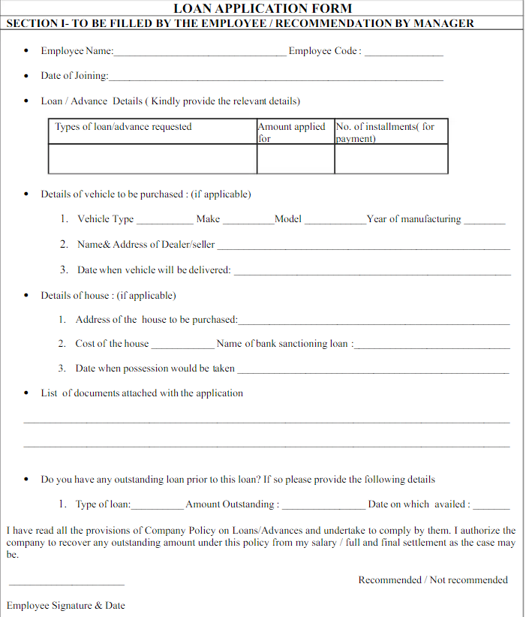

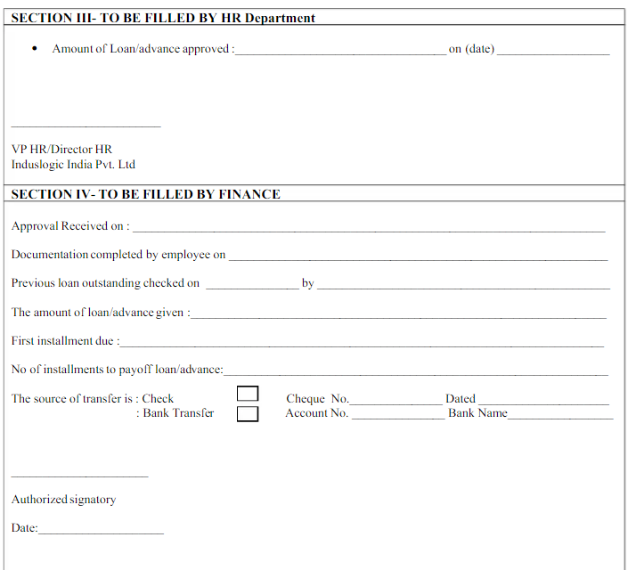

Q20. Which reporting Tools we will use for generating reports.   
Answer🡪  
There are many reporting tools available, including those that are free, those that are designed for visualization, and those that are designed for business intelligence:

* **Google Analytics 4**: A free reporting tool
* **Tableau**: A reporting and data visualization tool that helps simplify raw data into visuals
* **Zoho Analytics**: A business intelligence and reporting tool that allows users to create reports and charts using a drag-and-drop interface
* **Power BI**: A tool that uses software services, apps, and connectors to generate reports and insights

When choosing a reporting tool, you can consider things like:

* **User interface**: How visually appealing and easy to understand the reports are
* **Usability**: How intuitive the software is
* **Customization**: How customizable the reports are
* **Scalability**: Whether the software can scale with your business needs   
  So we will use Tableau for generating reports.

So, I choose Power BI for generating reports. It has many versions that can be used to make important decisions for the business.