**Question 1** – Functional Requirements - 15 Marks

Identify minimum 20 functional requirements

Example :

Functional requirement: When an order is fulfilled, the local printer shall print a packing slip.  
Non-Functional Requirement: Packing slips shall be printed on both sides of 4”x 6” white paper, the  
standard size for packing slips used by local printers.

**Answer : -**

Functional Requirements:

|  |  |  |
| --- | --- | --- |
| **Req ID** | **Req Name** | **Req Description** |
| FR001 | Farmer  Registration | Farmers should be able to register with the  application |
| FR002 | Farmer Login | Farmers shall be able to log in using their registered email/User ID and password |
| FR003 | Farmer browse the product | The system shall allow farmers to browse the product catalog for fertilizers, seeds, and pesticides |
| FR004 | Farmer searches the product | Farmers should be able to search for available  products in fertilizers, seeds, and pesticides |
| FR005 | Farmer search the product by catagory | Farmers shall be able to search for specific products by name or category using a search bar |
| FR006 | manufacturers to upload their products | The system shall allow manufacturers to upload their products with details (name, category, price, description, and availability) |
| FR007 | Farmer add product- buy later | The system shall allow farmers to add products to their "Buy Later" list. |
| FR008 | Manufacturers update details, stock availability | Manufacturers shall be able to update product details, such as stock availability. |
| FR009 | Farmers add the product to the cart as an immediate Purchase | The system shall provide a payment gateway that supports credit/debit card, UPI, and cash-on-delivery (COD) options. |
| FR010 | System valid user credential | The system shall validate and authenticate user credentials during login |
| FR011 | System provide payment gateway | The system shall provide a payment gateway supporting Credit/Debit Card, UPI, and Cash-on-Delivery (COD) options. |
| FR012 | Farmers notify about delivery status | The system shall enable farmers to track the delivery status of their orders. |
| FR013 | Farmers notify about Product delivery updates | The system shall notify farmers about product delivery updates through email. |
| FR014 | Farmers view order history | The system shall allow farmers to view their order history. |
| FR015 | Famers delete Product from buy later | Farmers shall have the ability to delete products from the "Buy Later" list or shopping cart. |
| FR016 | System Provide filter | The system shall provide filters (e.g., price range, brand) to refine product searches. |
| FR017 | System categorize Product | The system shall categorize products based on type (fertilizers, seeds, pesticides) for better navigation. |
| FR018 | System allow Manufactures to do analytics on sales and demand | The system shall allow manufacturers to view analytics on product sales and demand. |
| FR019 | System allow administrator to manage user accounts | The system shall allow the administrator to manage user accounts and product listings. |
| FR020 | Manufacturers view and manage order | Manufacturers shall be able to view and manage the orders placed for their products. |

Non-Functional Requirement-

|  |  |  |
| --- | --- | --- |
| Req ID | Req Name | Req Description |
| NFR0101 | App should be User-friendly | The application should have a user-friendly interface for farmers and manufacturers. |
| NFR0102 | Page Loading Time | Each Page should load within 2 seconds time. |
| NFR0103 | accessible 24/7 | The system shall be accessible 24/7 with 99.9% uptime. |
| NFR0104 | WCAG 2.1. | The system must meet Web Content Accessibility Guidelines WCAG 2.1. |
| NFR0105 | secure protocols for all transactions | All transactions shall be encrypted using secure protocols (e.g., HTTPS, SSL) |
| NFR0106 | Order confirmation email | The system shall send order confirmation emails within 30 seconds of order placement. |
| NFR0107 | App support for 10,000 concurrent user | The application shall support up to 10,000 concurrent users without performance degradation |
| NFR0108 | web browsers and mobile devices. | The system shall be compatible with both web browsers and mobile devices. |
| NFR0109 | Order, user account backup daily | The data related to user accounts and orders shall be backed up daily. |
| NFR0110 | Multi-language functionality | The application shall support multi-language functionality to cater to diverse users. |
| NFR0111 | Response Time | Payment gateway transactions must process within 5 seconds |
| NFR0112 | Browser Compatibility | The application must function seamlessly on all major browsers, including Chrome, Firefox, Edge, and Safari. |
| NFR0113 | Audit Trail | The application must maintain an audit trail of all user activities for at least six months. |
| NFR0114 | Data Security | User data (login credentials, payment details) must be encrypted using AES-256 encryption. |
| NFR0115 | Order Tracking Accuracy | The delivery tracker must refresh every 30 minutes with the latest shipment status. |
| NFR0116 | Load Handling | The application must handle peak traffic loads during seasonal sales without downtime. |
| NFR0117 | Error Handling | The system must provide clear and user-friendly error messages, including steps to resolve common issues. |
| NFR0118 | System Updates | All system updates and patches must be deployed with zero downtime using a rolling deployment strategy. |
| NFR0119 | Energy Efficiency | The server infrastructure must be optimized for energy efficiency to align with CSR goals. |
| NFR0120 | Legal Compliance | The application must comply with local e-commerce regulations and data protection laws like GDPR. |

**Question 2**–Minimum 5 page designs - 15 Marks

Make wireframe and prototypes

Answer –   
  
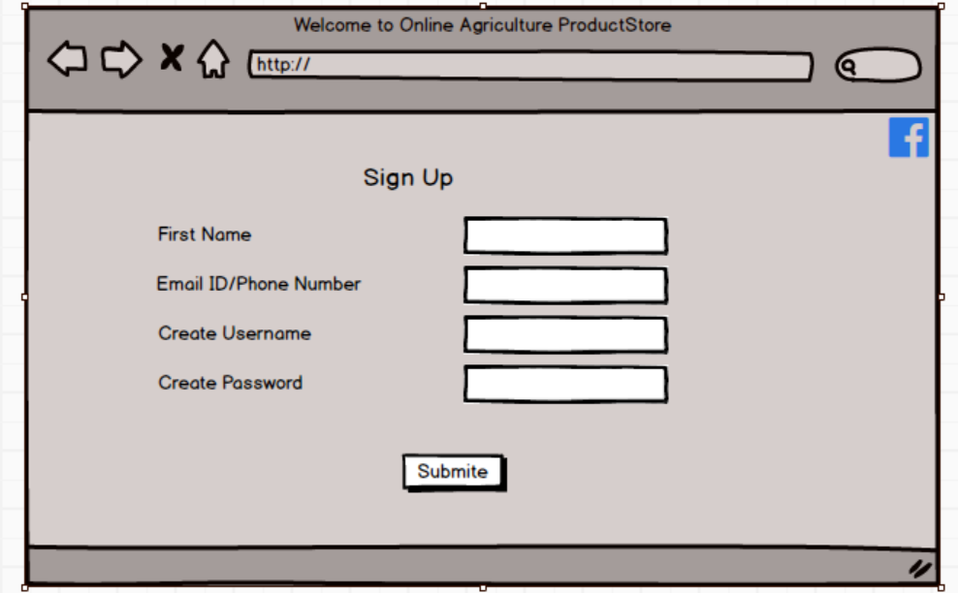

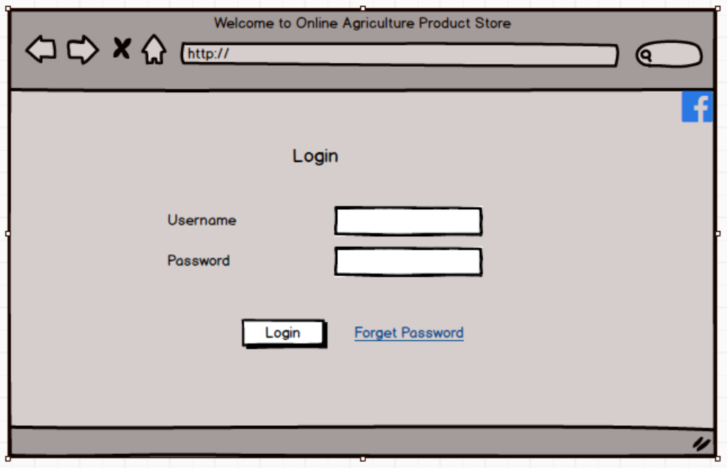

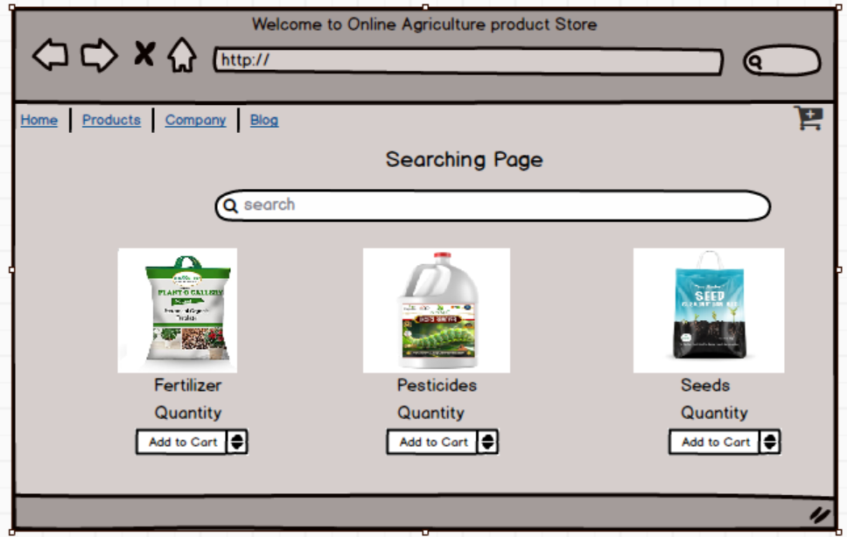

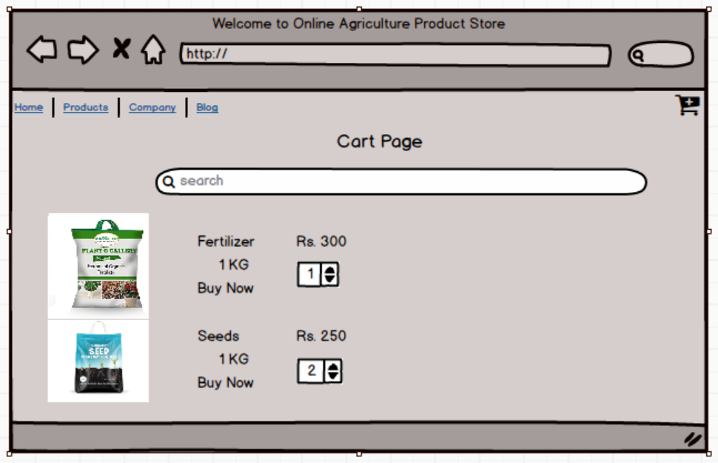

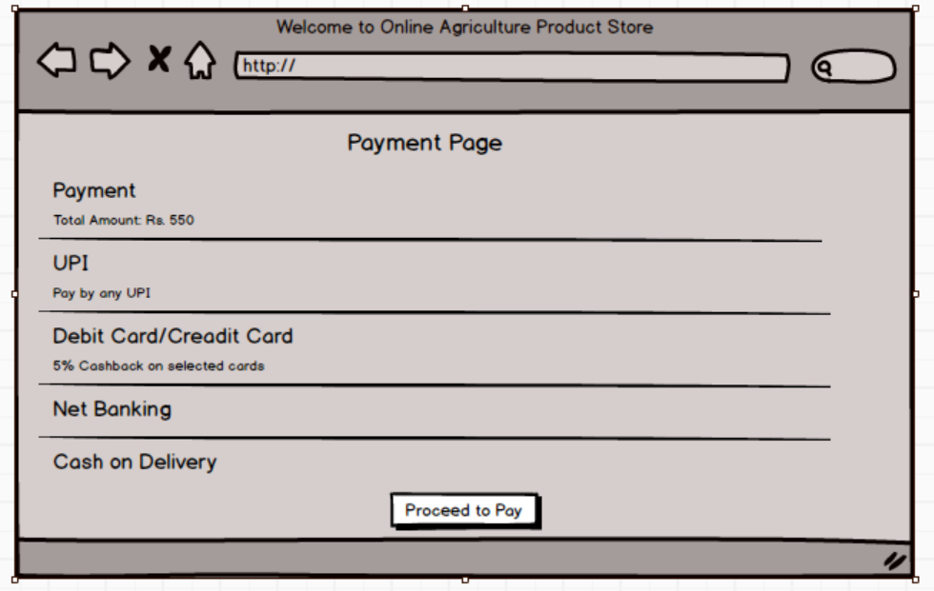

**Question 3 –** Tools (Visio, Balsamiq) - 15 Marks

1) Microsoft Visio- it is a diagramming and vector graphics application used to create diagrams, flowcharts, and other visual representations of complex information. Microsoft Visio is a diagramming tool used to create UML diagrams like Use Case, Activity, and Sequence diagrams. Its integration with Microsoft Office enhances documentation. Visio simplifies complex processes through drag-and-drop features and making it essential for business and technical analysis.

2) Balsamiq- it is rapid Wireframing tool used to create mock-up’s and prototype of user interface. It provides a simple, low-fidelity sketching approach to create mock-up’s quickly. With a drag-and-drop interface, it helps Business Analysts and designers visualize UI layouts, gather feedback, and refine designs before moving to high-fidelity prototypes, reducing development risks.

3) Axure- it is more advance prototype tool used to create high-fidelity, interactive wireframes and prototypes for web and mobile application. It supports dynamic panels, conditional logic, and data-driven elements to create realistic user experiences. Axure aids in user flow validation, stakeholder communication, and usability testing, ensuring a well-defined and structured design before development.

**Question 4** – RTM - 6 Marks

A business analyst’s key responsibilities are to keep track of the requirements and make sure that  
no requirement is missed

Mr. Henry and peter have approached you regarding the current status of the project. How will you tackle this situation?

**Answer: -**

|  |  |  |  |  |  |  |  |  |  |
| --- | --- | --- | --- | --- | --- | --- | --- | --- | --- |
| Req ID | Req Name | Req Description | Design | code | UT (Unit Testing) | CT (Component Testing) | ST (System Testing) | SIT | UAT (User Acceptance Testing) |
| FR001 | Farmer  Registration | Farmers should be able to register with the  application | Complete | Complete | Complete | Complete | Complete | Complete | Incomplete |
|  | Farmer  Login | Farmers shall be able to log in using their registered email/User ID and password | Complete | Complete | Complete | Complete | Incomplete | Incomplete | Incomplete |
|  | Farmer browse the product | The system shall allow farmers to browse the product catalog for fertilizers, seeds, and pesticides | Complete | Complete | Complete | Complete | Incomplete | Incomplete | Incomplete |
| FR004 | Farmer search the product | Farmers should be able to search for available  products in fertilizers, seeds, pesticides | Complete | Complete | Complete | Complete | Incomplete | Incomplete | Incomplete |
| FR005 | Farmer search the product by catagory | Farmers shall be able to search for specific products by name or category using a search bar | Complete | Complete | Complete | Complete | Incomplete | Incomplete | Incomplete |
| FR006 | manufacturers to upload their products | The system shall allow manufacturers to upload their products with details (name, category, price, description, and availability) | Complete | Complete | Complete | Complete | Incomplete | Incomplete | Incomplete |
| FR007 | Farmer add product- buy later | The system shall allow farmers to add products to their "Buy Later" list | Complete | Complete | Complete | Complete | Incomplete | Incomplete | Incomplete |
| FR008 | Manufacturers update details, stock availability | Manufacturers shall be able to update product details, such as stock availability | Complete | Complete | Complete | Complete | Incomplete | Incomplete | Incomplete |
| FR009 | System provide payment gateway | The system shall provide a payment gateway supporting Credit/Debit Card, UPI, and Cash-on-Delivery (COD) options. | Complete | Complete | Complete | Complete | Incomplete | Incomplete | Incomplete |
| FR010 | Farmers add product in cart as immediate Purchase | Farmers shall be able to add products to the shopping cart for immediate purchase | Complete | Complete | Complete | Complete | Incomplete | Incomplete | Incomplete |
| FR011 | System valid user credential | The system shall validate and authenticate user credentials during login | Complete | Complete | Complete | Complete | Incomplete | Incomplete | Incomplete |
| FR012 | Farmers notify about delivery status | The system shall enable farmers to track the delivery status of their orders. | Complete | Complete | Complete | Complete | Incomplete | Incomplete | Incomplete |
| FR013 | Farmers notify about Product delivery updates | The system shall notify farmers about product delivery updates through email. | Complete | Complete | Complete | Complete | Incomplete | Incomplete | Incomplete |
| FR014 | Farmers view order history | The system shall allow farmers to view their order history. | Complete | Complete | Complete | Complete | Incomplete | Incomplete | Incomplete |
| FR015 | Famers delete Product from buy later | Farmers shall have the ability to delete products from the "Buy Later" list or shopping cart. | Complete | Complete | Complete | Complete | Incomplete | Incomplete | Incomplete |
| FR016 | System Provide filter | The system shall provide filters (e.g., price range, brand) to refine product searches. | Complete | Complete | Complete | Complete | Incomplete | Incomplete | Incomplete |
| FR017 | System categorize Product | The system shall categorize products based on type (fertilizers, seeds, pesticides) for better navigation. | Complete | Complete | Complete | Complete | Incomplete | Incomplete | Incomplete |
| FR018 | System allow Manufactures to do analytics on sales and demand | The system shall allow manufacturers to view analytics on product sales and demand. | Complete | Complete | Complete | Complete | Incomplete | Incomplete | Incomplete |
| FR019 | System allow administrator to manage user accounts | The system shall allow the administrator to manage user accounts and product listings. | Complete | Complete | Complete | Complete | Incomplete | Incomplete | Incomplete |
| FR020 | Manufacturers view and manage order | Manufacturers shall be able to view and manage the orders placed for their products. | Complete | Complete | Complete | In Progress | Incomplete | Incomplete | Incomplete |

|  |  |  |  |  |  |  |  |  |  |
| --- | --- | --- | --- | --- | --- | --- | --- | --- | --- |
| **Req ID** | Req Name | Req Description | Design | code | UT (Unit Testing) | CT (Component Testing) | ST (System Testing) | SIT | UAT (User Acceptance Testing) |
| NFR0101 | App should be User-friendly | The application should have a user-friendly interface for farmers and manufacturers. | Complete | Complete | Complete | Complete | Complete | Complete | Incomplete |
| NFR0102 | Page Loading Time | Each Page should load within 2 seconds time. | Complete | Complete | Complete | Complete | Incomplete | Incomplete | Incomplete |
| NFR0103 | accessible 24/7 | The system shall be accessible 24/7 with 99.9% uptime. | Complete | Complete | Complete | Complete | Incomplete | Incomplete | Incomplete |
| NFR0104 | WCAG 2.1. | The system must meet Web Content Accessibility Guidelines WCAG 2.1. | Complete | Complete | Complete | Complete | Incomplete | Incomplete | Incomplete |
| NFR0105 | secure protocols for all transactions | All transactions shall be encrypted using secure protocols (e.g., HTTPS, SSL) | Complete | Complete | Complete | Complete | Incomplete | Incomplete | Incomplete |
| NFR0106 | Order confirmation email | The system shall send order confirmation emails within 30 seconds of order placement. | Complete | Complete | Complete | Complete | Incomplete | Incomplete | Incomplete |
| NFR0107 | App support for 10,000 concurrent user | The application shall support up to 10,000 concurrent users without performance degradation | Complete | Complete | Complete | Complete | Incomplete | Incomplete | Incomplete |
| NFR0108 | web browsers and mobile devices. | The system shall be compatible with both web browsers and mobile devices. | Complete | Complete | Complete | Complete | Incomplete | Incomplete | Incomplete |
| NFR0109 | Order, user account backup daily | The data related to user accounts and orders shall be backed up daily. | Complete | Complete | Complete | Complete | Incomplete | Incomplete | Incomplete |
| NFR0110 | Multi-language functionality | The application shall support multi-language functionality to cater to diverse users. | Complete | Complete | Complete | Complete | Incomplete | Incomplete | Incomplete |
| NFR0111 | Response Time | Payment gateway transactions must process within 5 seconds. | Complete | Complete | Complete | Complete | Incomplete | Incomplete | Incomplete |
| NFR0112 | Browser Compatibility | The application must function seamlessly on all major browsers, including Chrome, Firefox, Edge, and Safari. | Complete | Complete | Complete | Complete | Incomplete | Incomplete | Incomplete |
| NFR0113 | Audit Trail | The application must maintain an audit trail of all user activities for at least six months. | Complete | Complete | Complete | Complete | Incomplete | Incomplete | Incomplete |
| NFR0114 | Data Security | User data (login credentials, payment details) must be encrypted using AES-256 encryption. | Complete | Complete | Complete | Complete | Incomplete | Incomplete | Incomplete |
| NFR0115 | Order Tracking Accuracy | The delivery tracker must refresh every 30 minutes with the latest shipment status. | Complete | Complete | Complete | Complete | Incomplete | Incomplete | Incomplete |
| NFR0116 | Load Handling | The application must handle peak traffic loads during seasonal sales without downtime | Complete | Complete | Complete | Complete | Incomplete | Incomplete | Incomplete |
| NFR0117 | Error Handling | The system must provide clear and user-friendly error messages, including steps to resolve common issues. | Complete | Complete | Complete | Complete | Incomplete | Incomplete | Incomplete |
| NFR0118 | System Updates | All system updates and patches must be deployed with zero downtime using a rolling deployment strategy. | Complete | Complete | Complete | Incomplete | Incomplete | Incomplete | Incomplete |
| NFR0119 | Energy Efficiency | The server infrastructure must be optimized for energy efficiency to align with CSR goals. | Complete | Complete | Complete | Incomplete | Incomplete | Incomplete | Incomplete |
| NFR0120 | Legal Compliance | The application must comply with local e-commerce regulations and data protection laws like GDPR | Complete | Incomplete | Incomplete | Incomplete | Incomplete | Incomplete | Incomplete |

**Question 5** – 10 Test Case Documents - 10 Marks

Prepare 10 Test Case Documents

**Answer:-**

|  |  |  |  |  |  |  |
| --- | --- | --- | --- | --- | --- | --- |
| **Test Case ID** | **PQ786TS003** | **Test Case Name** | | **Registration** | | |
| **Project ID** | PQ786 | **Project Name** | | Online Agriculture Product store | | |
| **PM ID** | 4869 | **PM Name** | | Mr. Vandanam | | |
| **Test strategy ID** | PQ786TS001 | **Tester ID** | |  | | |
| **Test plan ID** | PQ786TS001 | **Tester Name** | | Mr. Jason and Ms Alekya | | |
| **Test Schedule ID** | PQ786TS001 | **Date of Test** | | 15-05-2024 | | |
| **Scenario** | User registers with valid details | | | | | |
| **Link to that page** | /Register/login | | | | | |
| **Input Data** | Set1 (User) **Email Id:** Shraddhad@gmail.com **Password:** Shraddha@123 | Set 2 (User) **Email Id:** Aishwaryab@gamil.com  **Password:** Aish@123 | Set 2 (User) **Email Id:** Supriyaw@gamil.com  **Password:** Supriya@123 | | Set 2 (User) **Email Id:** Mohinik@gamil.com  **Password:** Mohini@123 | Set 2 (User) **Email Id:** Rutujas@gamil.com  **Password:** Rutu@123 |
| **Expected Behaviour** | User account login successfully |  |  | |  |  |
| **Actual Behaviour** | User account login successfully |  |  | |  |  |
| **Comments** | No issue found |  |  | |  |  |
| **Result (Pass/fail)** | Pass |  |  | |  |  |

|  |  |  |  |  |  |  |
| --- | --- | --- | --- | --- | --- | --- |
| **Test case ID** | PQ786TS004 | | **Test Case Name** | | Login | |
| **Project Id** | PQ786 | | **Project Name** | | Online agriculture product store | |
| **PM ID** | 4869 | | **PM Name** | | Mr. Vandanam | |
| **Test Strategy ID** | PQ786TS001 | | **Tester ID** | |  | |
| **Teswt Plan ID** | PQ786TS002 | | **Tester Name** | | Mr. Jason and Ms Alekya | |
| **Test Schedule ID** | PQ786TS002 | | **Date of Test** | | 15- 04-2024 | |
| **Scenario** | User Login with Valid Details | | | | | |
| **Link to that page** | /Register/Login | | | | | |
| **Input Data** | Set1 (User) Email Id: Shraddhad@gmail.com Password: Shraddha@123 | Set 2 (User) Email Id: Aishwaryab@gamil.com  Password: Aish@123 | Set 2 (User) Email Id: Supriyaw@gamil.com  Password: Supriya@123 | Set 2 (User) Email Id: Mohinik@gamil.com  Password: Mohini@123 | | Set 2 (User) Email Id: Rutujas@gamil.com  Password: Rutu@123 |
| **Expected behaviour** | User account Login Successfully |  |  |  | |  |
| **Actual behaviour** | User Account Login Successfully |  |  |  | |  |
| **Comments** | No Issue Found |  |  |  | |  |
| **Result (Pass/Fail)** | Pass |  |  |  | |  |

|  |  |  |  |  |  |  |  |  |
| --- | --- | --- | --- | --- | --- | --- | --- | --- |
| **Test Case ID** | | PQ786TS006 | | **Test Case Name** | | Search Product | | |
| **Project ID** | | PQ786 | | **Project Name** | | Online Agriculture Products Store | | |
| **PM ID** | | 4869 | | **PM Name** | | Mr Vandanam | | |
| **Test Strategy ID** | | PQ786TS001 | | **Tester ID** | |  | | |
| **Test Plan ID** | | PQ786TS004 | | **Tester Name** | | Mr Jason and Ms Alekya | | |
| **Test Schedule ID** | | PQ786TS004 | | **Date of Test** | | 20-04-2024 | | |
| **Scenario** | | User Search Product | | | | | | |
| **Link to that Page:** | | /Register/Login/Browse/Search | | | | | | |
| **Input Data** | Set1  **Category:** Seeds  **Search Key Word:**  Wheat | | Set 2  **Category:** Fertilizers  **Search Key Word:**  Organic | | Set 3  **Category:** Pesticides  **Search Key Word:**  Neem | | Set 4 | Set 5 |
| **Expected Behaviour** | User Search Product Successfully | |  | |  | |  |  |
| **Actual Behaviour** | User Search Product Successfully | |  | |  | |  |  |
| **Comments** | No Issue Found | |  | |  | |  |  |
| **Results (Pass/Fail)** | Pass | |  | |  | |  |  |

|  |  |  |  |  |  |  |  |
| --- | --- | --- | --- | --- | --- | --- | --- |
| **Test Case ID** | PQ786TS007 | | | **Test Case Name** | | Search Product Category wise | |
| **Project ID** | PQ786 | | | **Project Name** | | Online Agriculture Products Store | |
| **PM ID** | 4869 | | | **PM Name** | | Mr Vandanam | |
| **Test Strategy ID** | PQ786TS001 | | | **Tester ID** | |  | |
| **Test Plan ID** | PQ786TS005 | | | **Tester Name** | | Mr Jason and Ms Alekya | |
| **Test Schedule ID** | PQ786TS005 | | | **Date of Test** | | 20-04-2024 | |
| **Scenario** | User Search Product Category wise | | | | | | |
| **Link to that page:** | /Register/Login/Browse/Search/Categories | | | | | | |
| **Input Data** | | Set1  Category: Seeds  Price- Low to High  Brand-  Discounts- | Set 2  Category: Fertilizers  Price- Low to High  Brand-  Discounts- | Set 3  Category: Pesticides  Price- Low to High  Brand-  Discounts- | Set 4 | | Set 5 |
| **Expected behaviour** | | User Search Product Category wise successfully |  |  |  | |  |
| **Actual behaviour** | | User Search Product Category wise successfully |  |  |  | |  |
| **Comments** | | No issue found |  |  |  | |  |
| **Result (Pass/fail)** | | Pass |  |  |  | |  |

|  |  |  |  |  |  |  |  |
| --- | --- | --- | --- | --- | --- | --- | --- |
| **Test Case ID** | PQ786TS008 | | **Test Case Name** | | Search Product into cart | | |
| **Project ID** | PQ786 | | **Project Name** | | Online Agriculture Products Store | | |
| **PM ID** | 4869 | | **PM Name** | | Mr Vandanam | | |
| **Test Strategy ID** | PQ786TS001 | | **Tester ID** | |  | | |
| **Test Plan ID** | PQ786TS006 | | **Tester Name** | | Mr Jason and Ms Alekya | | |
| **Test Schedule ID** | PQ786TS006 | | **Date of Test** | | 20-04-2024 | | |
| **Scenario** | User Search Product Category wise | | | | | | |
| **Link to that Page:** | /register/Login/Browse/search/Categories/Cart | | | | | | |
| **Input Data** | Set1  **Product Name:**  Wheat Seeds  **Category: S**eeds  **Quantity-** 1 | Set 2  **Product Name:**  Organic Urea  **Category: F**ertilizers  **Quantity-** 2 | | Set 3  **Product Name:**  Neem Pesticide  **Category:** Pesticides  **Quantity-** 1 | | Set 4 | Set 5 |
| **Expected behaviour** | User Add Product into cart successfully |  | |  | |  |  |
| **Actual behaviour** | User Add Product into cart successfully |  | |  | |  |  |
| **Comments** | No issue found |  | |  | |  |  |
| **Result (Pass/fail)** | Pass |  | |  | |  |  |

|  |  |  |  |  |  |  |  |
| --- | --- | --- | --- | --- | --- | --- | --- |
| **Test Case ID** | PQ786TS009 | | **Test Case Name** | | Make Payment | | |
| **Project ID** | PQ786 | | **Project Name** | | Online Agriculture Products Store | | |
| **PM ID** | 4869 | | **PM Name** | | Mr Vandanam | | |
| **Test Strategy ID** | PQ786TS001 | | **Tester ID** | |  | | |
| **Test Plan ID** | PQ786TS007 | | **Tester Name** | | Mr Jason and Ms Alekya | | |
| **Test Schedule ID** | PQ786TS007 | | **Date of Test** | | 22-04-2024 | | |
| **Scenario** | User Make Payment | | | | | | |
| **Link to that Page:** | /register/Login/Browse/search/Categories/Cart/Payment | | | | | | |
| **Input Data** | Set1  **Pay By:** UPI | Set 2  **Pay By:** Debit/Credit card | | Set 3  **Pay By:** COD | | Set 4 | Set 5 |
| **Expected behaviour** | User Pay successfully |  | |  | |  |  |
| **Actual behaviour** | User Pay successfully |  | |  | |  |  |
| **Comments** | No issue found |  | |  | |  |  |
| **Result (Pass/fail)** | Pass |  | |  | |  |  |

|  |  |  |  |  |  |  |  |
| --- | --- | --- | --- | --- | --- | --- | --- |
| **Test Case ID** | | PQ786TS010 | | **Test Case Name** | | Track Order Status | |
| **Project ID** | | PQ786 | | **Project Name** | |  | |
| **PM ID** | | 4869 | | **PM Name** | |  | |
| **Test Strategy ID** | | PQ786TS001 | | **Tester ID** | |  | |
| **Test Plan ID** | | PQ786TS008 | | **Tester Name** | |  | |
| **Test Schedule ID** | | PQ786TS008 | | **Date of Test** | | 22-04-2024 | |
| **Scenario** | | User Track Order Stustus | | | | | |
| **Link to that Page:** | | /register/Login/Browse/search/Categories/Cart/Payment | | | | | |
| **Input Data** | **Set1**  **Order ID:**  ORD12345  **User ID:** US001  **Status:**  Shipped | | **Set 2**  **Order ID:**  ORD12346  **User ID:** US002  **Status:**  In Transit | **Set 3**  **Order ID:**  ORD12347  **User ID:** US003  **Status:**  Out for Delivery | **Set 4**  **Order ID:**  ORD12348  **User ID:** US004  **Status:**  Delivered | | **Set 5**  **Order ID:**  ORD12349  **User ID:** US005  **Status:**  Cancelled |
| **Expected Behaviour** | User Track Order Successfully | |  |  |  | |  |
| **Actual Behaviour** | User Track Order Successfully | |  |  |  | |  |
| **Comments** | No Issue Found | |  |  |  | |  |
| **Result (Pass/Fail)** | Pass | |  |  |  | |  |

|  |  |  |  |  |  |  |  |
| --- | --- | --- | --- | --- | --- | --- | --- |
| **Test Case ID** | | PQ786TS011 | | **Test Case Name** | | **Order delivered** | |
| **Project ID** | | PQ786 | | **Project Name** | | Online Agriculture Products Store | |
| **PM ID** | | 4869 | | **PM Name** | | Mr Vandanam | |
| **Tester Strategy ID** | | PQ786TS001 | | **Tester ID** | |  | |
| **Test Plan ID** | | PQ786TS009 | | **Tester Name** | | Mr Jason and Ms Alekya | |
| **Test Schedule ID** | | PQ786TS009 | | **Date of Test** | | 26-04-2024 | |
| **Scenario** | | User Order delivered | | | | | |
| **Link to that Page:** | | /register/Login/Browse/search/Categories/Cart/Payment/Order Status/Delivered | | | | | |
| **Input Data** | Set1  **Order ID:**  ORD12345  **User ID:** US001  **Product Name:**  Wheat Seeds  **Quantity: 1**  **Delivery Status:**  Delivered | | Set 2  **Order ID:**  ORD12346  **User ID:** US002  **Product Name:**  Organic Urea  **Quantity: 2**  **Delivery Status:**  Delivered | Set 3  **Order ID:**  ORD12347  **User ID:** US003  **Product Name:**  Neem Pesticide  **Quantity: 3**  **Delivery Status:**  Delivered | Set 4 | | Set 5 |
| **Expected Behaviour** | User order delivered successfully | |  |  |  | |  |
| **Actual Behaviour** | User order delivered successfully | |  |  |  | |  |
| **Comments** | No Issue Found | |  |  |  | |  |
| **Result (Pass/Fail)** | Pass | |  |  |  | |  |

**Question 6** – Data Flow Diagram - 3 Marks

What is a data flow diagram? Draw a data flow diagram to represent the in-flow and out-flow of data when a Farmer is placing an order for the product

**Answer –**

A Data Flow Diagram is a graphical representation of the flow of data within a system. It visually shows how data moves from one process to another, how it's stored, and where it ends.



**Question 7 –** DB Design – 8 Marks

After the requirements are thoroughly explained to the entire project team by business analyst, the Database architects have decided to do the database design and also to represent the in-flow and out-flow of data.

Draw database schema and ER diagram

**Answer** –

|  |  |
| --- | --- |
| Product_Category | |
| ID | INT |
| name | VARCHAR |
| desc | TIMESTAMP |
| created_at | TIMESTAMP |
| modified_at | TIMESTAMP |
| deleted_at | TIMESTAMP |

|  |  |
| --- | --- |
| Product | |
| ID | INT |
| Name | VARCHAR |
| desc | TIMESTAMP |
| SKU | VARCHAR |
| Category_ID | INT |
| Inventary_ID | INT |
| price | DECIMAL |
| Discount_ID | INT |
| created_at | TIMESTAMP |
| modified_at | TIMESTAMP |
| deleted_at | TIMESTAMP |

|  |  |
| --- | --- |
| User | |
| ID | INT |
| user_name | VARCHAR |
| password | text |
| first_name | DECIMAL |
| last_name | VARCHAR |
| telephone | INT |
| created_at | TIMESTAMP |
| modified_at | TIMESTAMP |

|  |  |
| --- | --- |
| User Address | |
| ID | INT |
| User_ID | INT |
| Address_line1 | VARCHAR |
| Address_line2 | VARCHAR |
| city | VARCHAR |
| postal code | VARCHAR |
| country | VARCHAR |
| telephone | VARCHAR |
| mobile | VARCHAR |

|  |  |
| --- | --- |
| Product_Inventrary | |
| ID | INT |
| quantity | INT |
| created_at | TIMESTAMP |
| modified_at | TIMESTAMP |
| deleted_at | TIMESTAMP |

|  |  |
| --- | --- |
| Shopping session | |
| ID | INT |
| User_ID | VARCHAR |
| Total | DECIMAL |
| created_at | TIMESTAMP |
| modified_at | TIMESTAMP |

|  |  |
| --- | --- |
| Order details | |
| ID | INT |
| User_ID | VARCHAR |
| Total | DECIMAL |
| Payment_ID | INT |
| created_at | TIMESTAMP |
| modified_at | TIMESTAMP |

|  |  |
| --- | --- |
| User Payment | |
| ID | INT |
| User_ID | INT |
| payment_type | VARCHAR |
| provider | VARCHAR |
| account_no | INT |
| expiry | date |

|  |  |
| --- | --- |
| Discount | |
| ID | INT |
| Name | VARCHAR |
| desc | TIMESTAMP |
| discount_percent | DECEIMAL |
| created_at | TIMESTAMP |
| modified_at | TIMESTAMP |
| deleted_at | TIMESTAMP |

|  |  |
| --- | --- |
| Cart_item | |
| ID | INT |
| Session_ID | INT |
| Product_ID | INT |
| Quantity | INT |
| created_at | TIMESTAMP |
| modified_at | TIMESTAMP |

|  |  |
| --- | --- |
| Order_itams | |
| ID | INT |
| Order_ID | INT |
| Product_ID | INT |
| quantity | INT |
| created_at | TIMESTAMP |
| modified_at | TIMESTAMP |

|  |  |
| --- | --- |
| Payment_details | |
| ID | INT |
| Order_ID | INT |
| amount | INT |
| provider | VARCHAR |
| status | VARCHAR |
| created_at | TIMESTAMP |
| modified_at | TIMESTAMP |

**Question 8** – Change Request - 10 Marks

Due to change in the Government Taxation structure . we should change the Tax structure How do you handle change requests in a project?

**Answer -** A change request is a formal Proposal to alter a system, Product or Project.

1. Understand the scope of the change request and document the change. The change request is initiated by stakeholders, such as the Project Manager, Business Analyst, or Compliance Team.

2. Change Request Document (CRD) should include: a) Reason for change: Government regulation update b) Impact areas: Pricing calculations, invoices, financial reports, and database schema.

Do the Impact Analysis: Impact analysis affects product pricing; it could impact customer invoices and financial statements, resources and schedule are also affected, like Development effort estimation and Additional testing effort for financial accuracy. Modifications in the Database Schema to update tax rates. Changes in Reports & Billing System, changes in the Backend Logic for tax calculations, updates to the UI where tax information is displayed.

3. Prioritise change requests based on their urgency, importance and impact on the Project. Implement the Change- Update tax configuration tables in the database, Modify pricing and invoice logic, Validate correct tax calculations on different products, Check for compliance with government regulations, Ensure invoice accuracy with updated tax

4. Seek approval from the project sponsor for the change request. after approval, a Change Implementation Plan is created.

5. Communicate the change request and its potential impact to all relevant stakeholders, including the project team, Finance team, etc.

**Question 9** – Change Request Vs an Enhancement - 5 Marks

As the project is in process, Ben and Kevin have contacted you. The reason is to inform you that they want the Farmers to sell their crop yields through this application i.e. Farmers should be able to add their crop yields or products and display to general public and should be able to sell them. They also want to introduce Auction system for their Crop yields. As a BA, what will be your response? Is this a change request or an enhancement??

**Answer –**

Since it included introducing new features to the system, the introduction of the Farmers' Auction System and the Farmer Selling application would be regarded as an enhancement in this instance.

It is my responsibility as a BA to document the requirements and collaborate with the development team to ascertain the impact and viability of the new features. Before I make any recommendations to the client, I should also take into account the enhancement's possible costs, risks, and benefits. It increases the platform's capabilities without changing its current features.

**Question 10** – Estimations - 6 Marks

Come up with estimations – How many Manhours required

**Answer –**

Man-hours are the required effort of the resources to complete a project. There are 3 types of Projects.

1. Small: Up to 500 hours

2. Medium: Up to 1000 hours

3. Large: Up to 1500 hours

• Analysis: As per the case study, the duration of the project is 18 months and the current team size is around 15. This will come under a medium Project.

• As the trained resources are available so trainers are not required

• As the structure of the Project is available, New and enhanced infrastructure is not required.

**Question 11** – UAT – 6 Marks

Project has finally completed all the stages i.e., design, development, testing etc. Now, it is the roleof a business analyst to contact the client for testing of the final product and have to successfully complete it. How are you going to handle this situation? And once it is done, what will be the process to close the project? Explain UAT Acceptance process

**Answer –**

1)Planning- In this step Blue Prints are made to implement UAT Testing for every feature that needs to test and minimum standard for acceptance the test.

2) Designing- Here the Test cases are design to hide all possibilities of software packages in a real-world environment.

3) UAT Testers- A Testers team consists of a end users that meet the criteria for implement testing, they should know the test cases to run and understand the functionalities.

4) Bug Fixing- Whatever Bugs are found in the UAT Testing, the development team should work on them and make it software error free.

5) Sign off- After removing all bugs, the testing team indicates acceptances of the completion of the bugs, In this phase, all stakeholders come to a conclusion that the Software is ready to GO LIVE and Sign it off.

**Question 12** – Project Closure Document - 6 Marks

Explain Project closure document

**Answer –**

A Project closure document, also known as a project closure report, its is a formal document that summarizes the key outcome lessons learned and final details of the completed project.

Its serve as a comprehensive record of the project accomplishments, Challenges and overall performance and provide valuable insights for stakeholder and future projects.

Points included in the Project Closure document are:

Project Overview  
Achievements  
Lessons learned   
Quality Assurance  
Resource Utilizatio  
Risk Management  
Challenges

|  |  |  |  |
| --- | --- | --- | --- |
| Sr. No | Point to be include | | Business Scope document.docx |
| 1 | Did the client Signoff on the UAT Testing | |
|  | Date of Sign off: | 10-01-2025 |
|  | Name of the source: | Shital Kadam |
| 2. | Object od the project | |  |
|  | User friendliness | Achieved |  |
|  | Customer satisfaction | ROI in 6 Months |  |
|  | More categories | Achieved |  |
| 3. | Functionalities worked on | |  |
|  | Secured payment processing | Achieved |  |
|  | Categories | Achieved |  |
| 4. | Infrastructure | |  |
|  | Software Installed | Achieved |  |
|  | Laptop Purchased | Achieved |  |
| 5. | Funding |  |  |
|  | Amount Approvaed | Rs. 1 Crore | Finance breakdown.docx |
|  | Amount Used | Rs. 95 Lakhs |
| 6. | Overall Project Information | |  |
|  | Escalation | 50 |  |
|  | Customer Satisfaction | High |  |
| 7. | Value to the Company | |  |
|  | Achievements | Positive 90%  1) Company has gained an edge over the Customers  2) Increased Clients  3) New Project In Pipelines |  |
|  | Challenges | 1) Adapting to Change Requests: Midway through the project, the tax structure was changed, requiring system modifications.  2) Connectivity Constraints: Ensuring smooth operation in rural areas with limited internet access. |  |