**CAPSTONE PROJECT PART-3**

**Q1) Identify minimum 20 functional requirements**.

**Answer -1**

Functional Requirements

Non-Functional Requirements

|  |  |  |
| --- | --- | --- |
| **Req ID** | **Req Name** | **Req Description** |
| FR0001 | Farmer Registration | Farmers should be able to register with the application. |
| FR0002 | Farmer Login for existing /new | Farmers should be able to login once the have registered |
| FR0003 | Role based Registration | Ability to register, log in, and manage accounts for farmers, distributors, and administrators. |
| FR0004 | Access | Role-based access control for different types of users |
| FR0005 | Login | Login using email Id, mobile no |
| FR0006 | Farmer search for products | Manufacturers should be able to upload and display their products in the application. |
| FR0007 | Adding products to cart | Users should be able to add the products to the cart |
| FR0008 | Communication | A platform to facilitate farmers and companies can communicate directly with each other. |
| FR0009 | Selection and product | Application should be able to accept the product (fertilizers, seeds, pesticides) details from the  manufacturers and should be able to display them to the Farmers. |
| FR00010 | Selection and product | Farmers will browse through these  products and select the products what they need and request to buy them and deliver them to  farmers location. |
| FR0011 | Selected products | Add to cart or save for later option |
| FR0012 | Unavailable products | Show out of stock if products are unavailable. |
| FR0013 | Search and filters | Buyers can view categorized listings , with filtering options. |
| FR0014 | Order management | View orders, confirm orders |
| FR0015 | Order management | Place orders, modify quantities, and cancel or track orders. |
| FR0016 | Track Dispatch | Customer should be able to see the timelines, of order, packed, dispatch and shipped. |
| FR0017 | Payment Getaway | Payment gateway for secure transactions. |
| FR0018 | Multiple payment options | credit/debit cards, UPI, wallets, bank transfers, and cash on delivery (COD). |
| FR0019 | Pricing and discount | Farmers can set product prices and offer discounts on bulk purchases |
| FR0020 | Delivery Track | Real-time tracking of shipments. |

**Non-Functional Requirements**

|  |  |  |
| --- | --- | --- |
| NFR001 | Usability | Should have an intuitive and user friendly |
| NFR002 | Performance | The app must load pages within 3-4 seconds |
| NRF003 | Security | App must ensure secure user authentication |
| NRF004 | Compatibility | The application should be compatible with major web browsers |
| NRF005 | Respond Time | The app should respond to user inputs within 2 seconds |

Q2) Make wireframe and prototypes

**Answer -2**

Make wireframe and prototypes

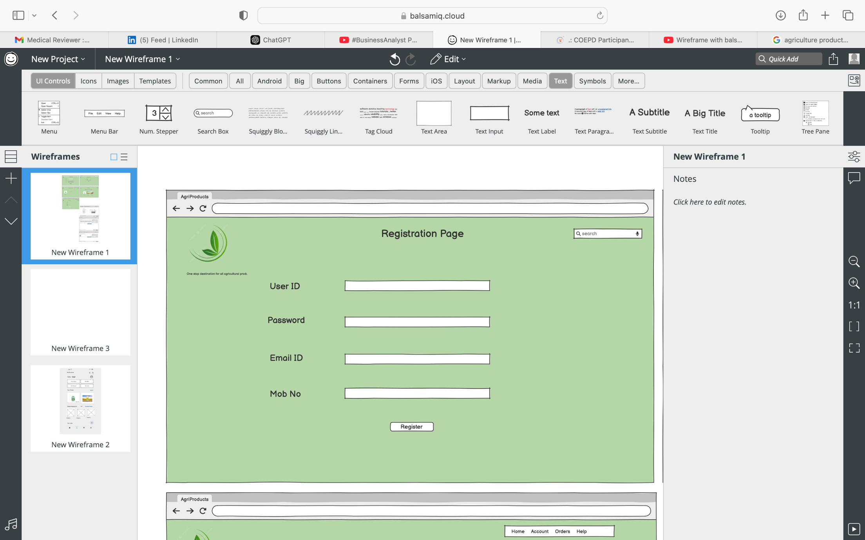

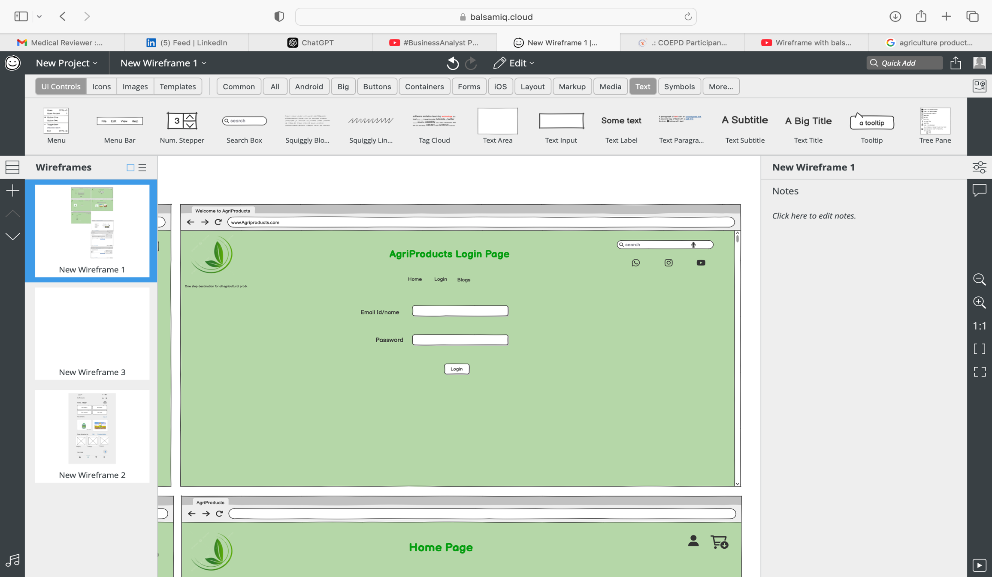

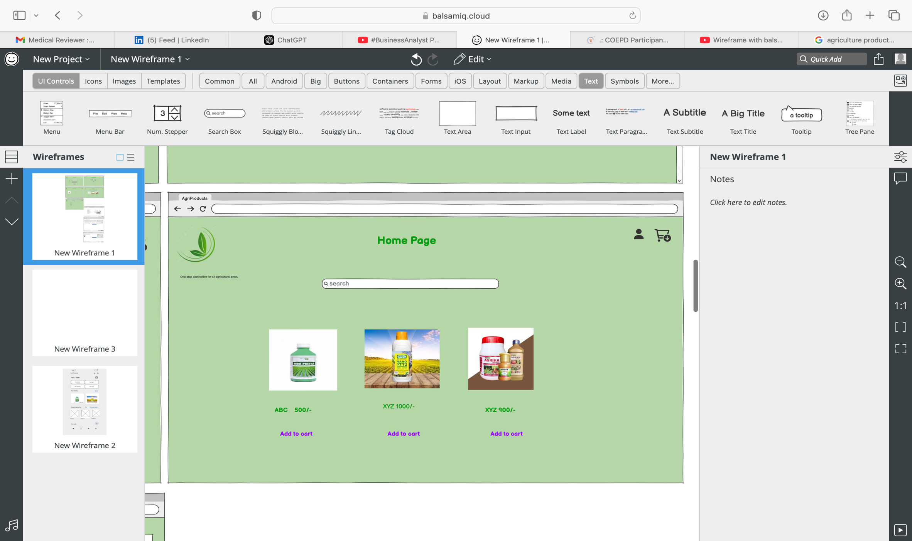

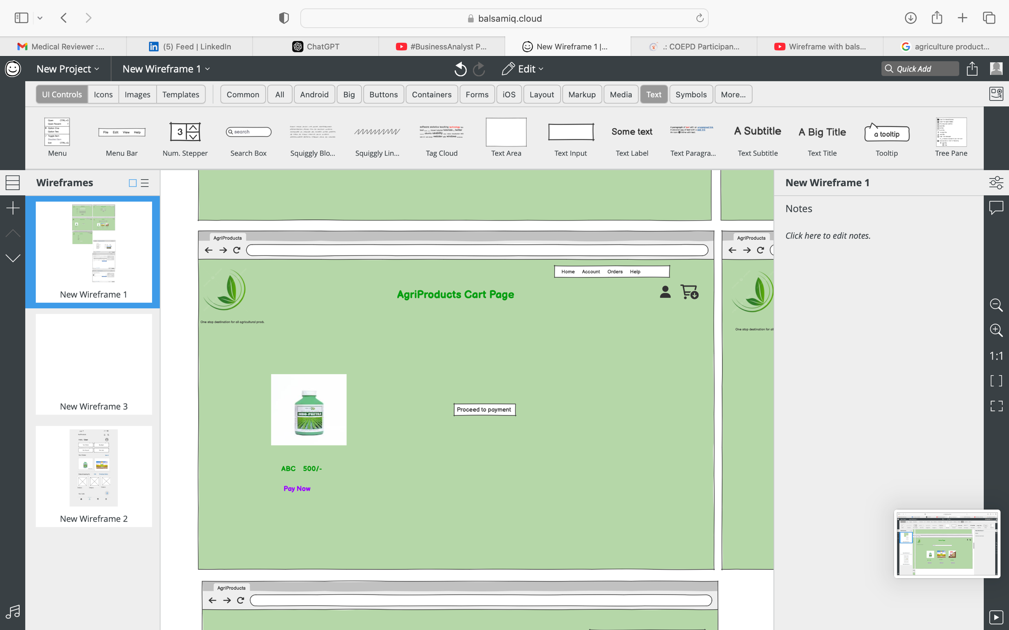

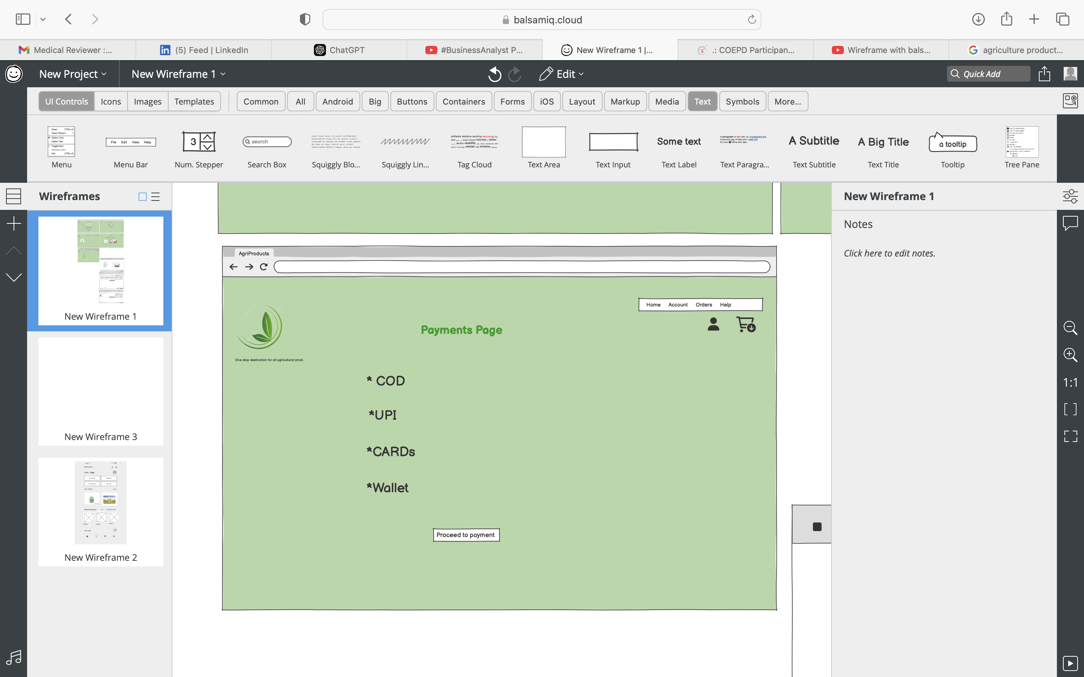

Q3) Make a note of the Tools, which you are using for above concepts

**Answer-3**

.

1. MS Visio : It is a diagramming and vector graphics application used to create diagrams, flowcharts, and other visual representations of complex information.

It is used to create professional diagrams, flowcharts, organizational charts, network designs, floor plans, and much more. It's a versatile tool for visually representing processes, systems, and structures, making it popular among business analysts, project managers, and IT professionals.

Features: Pre-Built Templates and Shapes ; Drag-and-Drop Interface ; Integration with Other Microsoft Tools; Customization, Cloud Support

Uses: Swimlane diagrams; Network diagrams; System Diagrams; Charts; Gantt charts.

1. Balsamiq: It is a rapid wireframing tool used to create mock-ups and prototypes of interfaces. Balsamiq is a popular wireframing tool designed to create low-fidelity mock-ups for websites, mobile apps, or any other software application. It is widely used by business analysts, UX/UI designers, and product managers to quickly visualize ideas and communicate design concepts to stakeholders.

Uses : Requirement gathering ; Prototyping; Stakeholder communication

UI design and usability testing.

It helps in Speed( rapid creation of mockups, saving time during the early stages of a project)

Ease of use; Cost-effective; Focus on functionality.

1. Azure : It is a more advanced prototyping tool used to create high-fidelity, interactive

wireframes , and prototypes for web and mobile applications. Azure provides a vast array of services, including Infrastructure as a Service (IaaS), Platform as a Service (PaaS), and Software as a Service (SaaS), making it a versatile tool for various use cases.

Uses : App development and hosting; Data storage and backup; Disaster recovery and business continuity; Big data and analytics.

**Q4) Prepare RTM**

**Answer-4**

It is a document to track the requirements throughout the project lifecycle, ensuring that they are met and that no requirements are overlooked.

**Purpose of the RTM:** The RTM ensures that all requirements are tracked throughout the project lifecycle, from initial identification to final delivery. This document will be used to ensure no requirement is missed and will provide clarity to Mr. Henry and Peter regarding the current status of the project.

|  |  |  |  |  |  |  |  |
| --- | --- | --- | --- | --- | --- | --- | --- |
| Req ID | Req Name | Req Description | Design | code | Unit Testing | UAT | System Testing |
| FR0001 | Farmer Registration | Farmers should be able to register with the application. | Complete | Complete | Complete | Incomplete | Complete |
| FR0002 | Farmer Login for existing /new | Farmers should be able to login once they have registered | Complete | Complete | Complete | Incomplete | Incomplete |
| FR0003 | Role based Registration | Ability to register, log in, and manage accounts for farmers, distributors, and administrators. | Complete | Complete | Complete | Incomplete | Complete |
| FR0004 | Access | Role-based access control for different types of users | Complete | Complete | Complete | Incomplete | Co mplete |
| FR0005 | Login | Login using email Id, mobile no | Complete | Complete | Complete | Incomplete | Co mplete |
| FR0006 | Farmer search for products | Manufacturers should be able to upload and display their products in the application. | Complete | Complete | Complete | Incomplete | Co mplete |
| FR0007 | Adding products to cart | Users should be able to add the products to the cart | Complete | Complete | Complete | Incomplete | Co mplete |
| FR0008 | Communication | A platform to facilitate farmers and companies can communicate directly with each other. | Complete | Complete | Complete | Incomplete | Incomplete |
| FR0009 | Selection and product | Application should be able to accept the product (fertilizers, seeds, pesticides) details from the  manufacturers and should be able to display them to the Farmers. | Complete | Complete | Complete | Incomplete | Co mplete |
| FR00010 | Selection and product | Farmers will browse through these  products and select the products what they need and request to buy them and deliver them to  farmers location. | Complete | Complete | Complete | Incomplete | Incomplete |
| FR0011 | Selected products | Add to cart or save for later option | Complete | Complete | Complete | Incomplete | Incomplete |
| FR0012 | Unavailable products | Show out of stock if products are unavailable. | Complete | Complete | Complete | Incomplete | Incomplete |
| FR0013 | Search and filters | Buyers can view categorized listings , with filtering options. | Complete | Complete | Complete | Incomplete | Incomplete |
| FR0014 | Order management | View orders, confirm orders | Complete | Complete | Complete | Incomplete |  |
| FR0015 | Order management | Place orders, modify quantities, and cancel or track orders. | Complete | Complete | Complete | Incomplete |  |
| FR0016 | Track Dispatch | Customer should be able to see the timelines, of order, packed, dispatch and shipped. | Complete | Complete | Complete | Incomplete |  |
| FR0017 | Payment Getaway | Payment gateway for secure transactions. | Complete | Complete | Complete | Incomplete |  |
| FR0018 | Multiple payment options | credit/debit cards, UPI, wallets, bank transfers, and cash on delivery (COD). | Complete | Complete | Complete | Incomplete |  |
| FR0019 | Pricing and discount | Farmers can set product prices and offer discounts on bulk purchases | Complete | Complete | Complete | Incomplete |  |
| FR0020 | Delivery Track | Real-time tracking of shipments. | Complete | Complete | Complete | Incomplete |  |

**Q5 )10 Test Case Documents**

**Answer- 5**

#### A test case document is a formal record created during software testing that outlines the specific steps, conditions, and expected outcomes to verify whether a particular functionality of an application works as intended. It serves as a guide for testers to systematically validate the application and ensure all requirements are met.

#### 1. User Registration

|  |  |  |  |  |
| --- | --- | --- | --- | --- |
| **Test Case ID** | TC001 |  | **Test Case Name** | User Registration |
|  |  |  | **Project Name** | Agricultural App |
| **Objective** | Verify that a new user can register successfully. |  | **PM Name** | Mr Vandanam Senior |
| **Preconditions** | The app must be accessible, and the registration page must be functional. |  | **Tester ID** | TD001 |
| **Steps** | 1. Open the app/website. 2. Navigate to the registration page. 3. Enter valid details (e.g., name, email, password, phone number). 4. Submit the registration form. |  | **Tester Name** | Mr Jason Ms Alekya |
| **Expected Result** | User account is created, and a confirmation email is sent. |  | **Date of Test** | 01/22/2025 |
| Pass/Fail Status |  |  | **BA** | Madhumita Sahoo |
|  |  |  |  |  |

2.

#### ****User Login****

|  |  |  |  |  |
| --- | --- | --- | --- | --- |
| **Test Case ID** | TC002 |  | **Test Case Name** | ****User Login**** |
| **Objective** | Verify that registered users can log in successfully |  | **Project Name** | Agricultural App |
| **Preconditions** | User account must be created |  | **PM Name** | Mr. Vandanam Senior |
| **Steps** | 1. Open the app/website. 2. Navigate to the login page. 3. Enter valid credentials (email and password). 4. Click on the login button. |  | **Tester ID** | TD002 |
| **Expected Result** | User is redirected to the dashboard/home page. |  | **Tester Name** | Mr Jason , Ms Alekya |
| Pass/Fail Status |  |  | **BA** | Madhumita Sahoo |

3.

#### ****Product Search Functionality****

|  |  |  |  |  |
| --- | --- | --- | --- | --- |
| **Test Case ID** | TC003 |  | **Test Case Name** | ****Product Search Functionality**** |
| **Objective** | Verify that users can search for agricultural products.  . |  | **Project Name** | Agricultural App |
| **Preconditions** | App must have a search bar and a database of products. |  | **PM Name** | Mr Vandanam Senior |
| **Steps** | 1. Log in to the app. 2. Enter a product name (e.g., "fertilizer") in the search bar. 3. Click on the search button. |  | **Tester ID** | TD003 |
| **Expected Result** | Relevant products are displayed in the search results |  | **Tester Name** | Mr Jason Ms Alekya |
| Pass/Fail Status | Pass |  | **BA** | Madhumita Sahoo |
|  |  |  |  |  |

4.

**Adding Products to Cart**

|  |  |  |  |  |
| --- | --- | --- | --- | --- |
| **Test Case ID** | TC004 |  | **Test Case Name** | **Adding Products to Cart** |
| **Objective** | Verify that users can add products to their cart. |  | **Project Name** | Agricultural App |
| **Preconditions** | User must be logged in, and products must be available. |  | **PM Name** | Mr Vandanam Senior |
| **Steps** | 1. Search for a product. 2. Click on the "Add to Cart" button for the product. |  | **Tester ID** | TD004 |
| **Expected Result** | Product is successfully added to the cart. |  | Tester Name | Mr Jason Ms Alekya |
| Pass/Fail Status | Pass |  | **BA** | Madhumita Sahoo |
|  |  |  |  |  |

5.

#### ****Checkout Process****

|  |  |  |  |  |
| --- | --- | --- | --- | --- |
| **Test Case ID** | TC005 |  | **Test Case Name** | ****Checkout Process**** |
| **Objective** | Verify that users can complete the checkout process. |  | **Project Name** | Agricultural App |
| **Preconditions** | User must have products in the cart. |  | **PM Name** | Mr Vandanam Senior |
| **Steps** | * Open the cart. * Click on the "Proceed to Checkout" button. * Enter delivery details and payment information. * Submit the order. |  | **Tester ID** | TD005 |
| **Expected Result** | Order is placed, and an order confirmation message is displayed. |  | **Tester Name** | Mr Jason , Ms Alekya |
| Pass/Fail Status | Pass |  | **BA** | Madhumita Sahoo |
|  |  |  |  |  |

6.

#### ****Viewing Order History****

|  |  |  |  |  |
| --- | --- | --- | --- | --- |
| **Test Case ID** | TC006 |  | **Test Case Name** | ****Viewing Order History**** |
| **Objective** | Verify that users can view their order history. |  | **Project Name** | Agricultural App |
| **Preconditions** | User must have placed at least one order.  . |  | **PM Name** | Mr Vandanam Senior |
| **Steps** | 1. Log in to the app. 2. Navigate to the "Order History" section. |  | **Tester ID** | TD006 |
| **Expected Result** | A list of previous orders is displayed. |  | **Tester Name** | Mr Jason Ms Alekya |
| Pass/Fail Status |  |  | **BA** | Madhumita Sahoo |

7.

|  |  |  |  |  |
| --- | --- | --- | --- | --- |
| **Test Case ID** | TC007 |  | **Test Case Name** | **Admin Adding New Products** |
| **Objective** | Verify that admins can add new products to the system.  . |  | **Project Name** | Agricultural App |
| **Preconditions** | Admin account must be logged in. |  | **PM Name** | Mr Vandanam Senior |
| **Steps** | 1. Log in with admin credentials. 2. Navigate to the "Add Product" section. 3. Enter product details (name, category, price, etc.). 4. Submit the product form. |  | **Tester ID** | TD007 |
| **Expected Result** | Product is successfully added and visible to users. |  | **Tester Name** | Mr Jason Ms Alekya |
| Pass/Fail Status | Pass |  | **BA** | Madhumita Sahoo |

8.

|  |  |  |  |  |
| --- | --- | --- | --- | --- |
| **Test Case ID** | TC008 |  | **Test Case Name** | ****Payment Gateway Integration**** |
| **Objective** | Verify that the payment gateway works as expected. |  | **Project Name** | Agricultural App |
| **Preconditions** | User must have items in the cart. |  | **PM Name** | Mr Vandanam Senior |
| **Steps** | 1. Proceed to the payment step in the checkout process. 2. Select a payment method (e.g., credit card). 3. Enter valid payment details and submit. |  | **Tester ID** | TD008 |
| **Expected Result** | Payment is processed successfully, and a receipt is generated. |  | **Tester Name** | Mr Jason Ms Alekya |
| Pass/Fail Status | Pass |  | **BA** | Madhumita Sahoo |

9.

|  |  |  |  |  |
| --- | --- | --- | --- | --- |
| **Test Case ID** | TC009 |  | **Test Case Name** | ****Notifications for Order Updates**** |
| **Objective** | Verify that users receive notifications for order updates. |  | **Project Name** | Agricultural App |
| **Preconditions** | User must have placed an order. |  | **PM Name** | Mr Vandanam Senior |
| **Steps** | 1. Place an order. 2. Update the order status in the admin panel (e.g., "Shipped"). |  | **Tester ID** | TD009 |
| **Expected Result** | User receives a notification about the order update. |  | **Tester Name** | Mr Jason Ms Alekya |
| Pass/Fail Status | Pass |  | **BA** | Madhumita Sahoo |

10.

|  |  |  |  |  |
| --- | --- | --- | --- | --- |
| **Test Case ID** | TC010 |  | **Test Case Name** | ****Handling Invalid Inputs**** |
| **Objective** | Verify that the app handles invalid inputs gracefully. |  | **Project Name** | Agricultural App |
| **Preconditions** | None |  | **PM Name** | Mr Vandanam Senior |
| **Steps** | 1. Attempt to register with invalid details (e.g., invalid email format, short password). 2. Attempt to search for a non-existent product." |  | **Tester ID** | TD010 |
| **Expected Result** | Appropriate error messages are displayed, and the system does not crash. |  | **Tester Name** | Mr Jason Ms Alekya |
|  |  |  | **BA Name** | Madhumita Sahoo |

**Q) Draw database schema and ER diagram**

**Answer-6**

DB Schema: It is a blueprint that outlines the structure of a database , including its tables, fields, relationships , constraints, other characteristics.

ERD: Entry -Relationship Diagram is a visual representation of the relationships between entities in a database. It depicts the entities (such as tables), attributes (properties or fields), and relationships between them.

**Entities and Relationships**

1. **Users**:
   * Farmers and manufacturers.
2. **Products**:
   * Fertilizers, seeds, pesticides.
3. **Orders**:
   * Requests made by farmers to purchase products.
4. **Categories**:
   * Groups for organizing products (Fertilizers, Seeds, Pesticides).
5. **Delivery**:
   * Logistics for delivering products to farmers.
6. **Notifications**:
   * Alerts for farmers regarding order status or new products.

**Database schema**

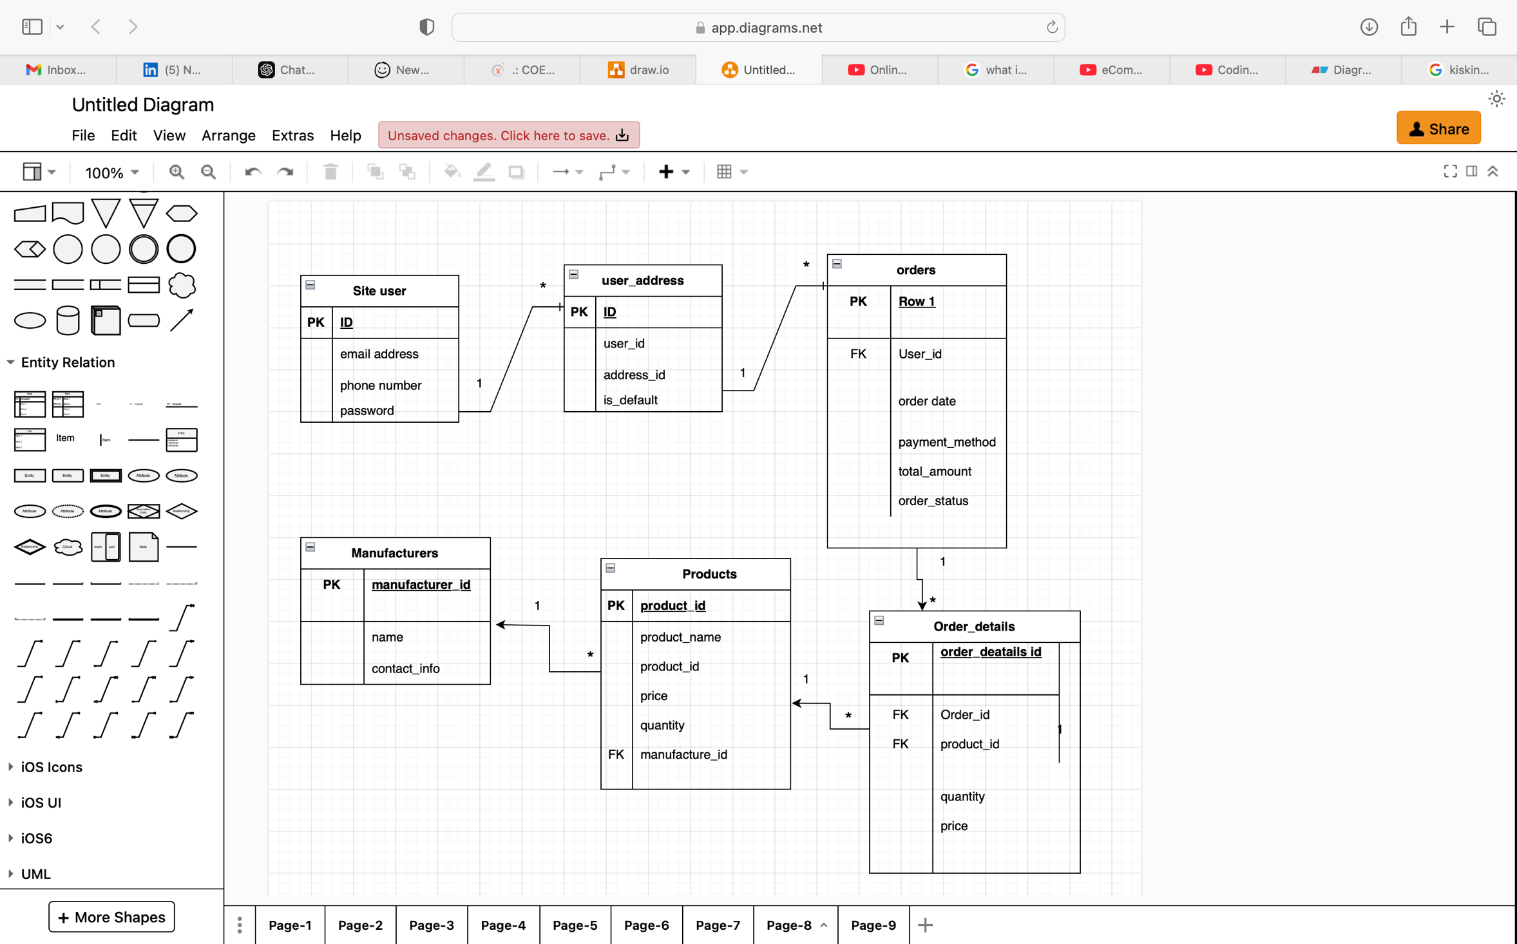

**Q7) Due to change in the Government Taxation structure . we should change the Tax structure**

**How do you handle change requests in a project?**

**Answer-7**

**Data Flow Diagram (DFD): Farmer Placing an Order**

**Definition:** A Data Flow Diagram (DFD) visually represents the flow of data within a system. It shows the input, process, and output stages and how they interact to accomplish a task. Below is a DFD for the process of a Farmer placing an order for a product on the Online Agriculture Product Store.

**Context-Level Diagram (Level 0):**

Entities and Processes:

* **External Entities:** Farmer, Manufacturer, Payment Gateway, Delivery System
* **Processes:** Order Placement, Payment Processing, Order Confirmation, Product Dispatch
* **Data Stores:** Farmer Data, Product Data, Order Data

**Level 0 DFD Representation:**

1. **Farmer Login/Register:**
   * Input: Farmer credentials (email, password) or registration details.
   * Process: Authentication or registration process.
   * Output: Login success or new account creation.
2. **Browse Products:**
   * Input: Product catalog request.
   * Process: Display product catalog with search and filter options.
   * Output: Product details displayed.
3. **Place Order:**
   * Input: Selected product, quantity, delivery details.
   * Process: Order is created and stored in the Order Data store.
   * Output: Order confirmation and total cost.
4. **Payment Processing:**
   * Input: Payment details (COD, Credit/Debit card, UPI).
   * Process: Validate and process the payment.
   * Output: Payment confirmation.
5. **Delivery Tracking:**
   * Input: Order ID.
   * Process: Track order through the delivery system.
   * Output: Order status and estimated delivery time.

**Level 1 Representation DFD**

* 1. **Process 1: Farmer login/Register**

Data flow : Farmer 🡪 Login module 🡪Farmer/customer datastore 🡪 Confirmation to customer/farmer.

* 1. **Browse Products**

Data flow : Farmer 🡪 Product catalogue module 🡪 Product Data Store 🡪 Category Display

* 1. **Place Order**

Data Flow: Farmer 🡪 Payment module 🡪 Payment gateway 🡪Confirmation to Farmer

* 1. **Payment Processing**

Data flow : farmer 🡪 payment module 🡪payment gateway🡪 confirmation to farmer

* 1. **Delivery tracking**

data flow : farmer🡪 Tracking module 🡪delivery system🡪 status update to farmer

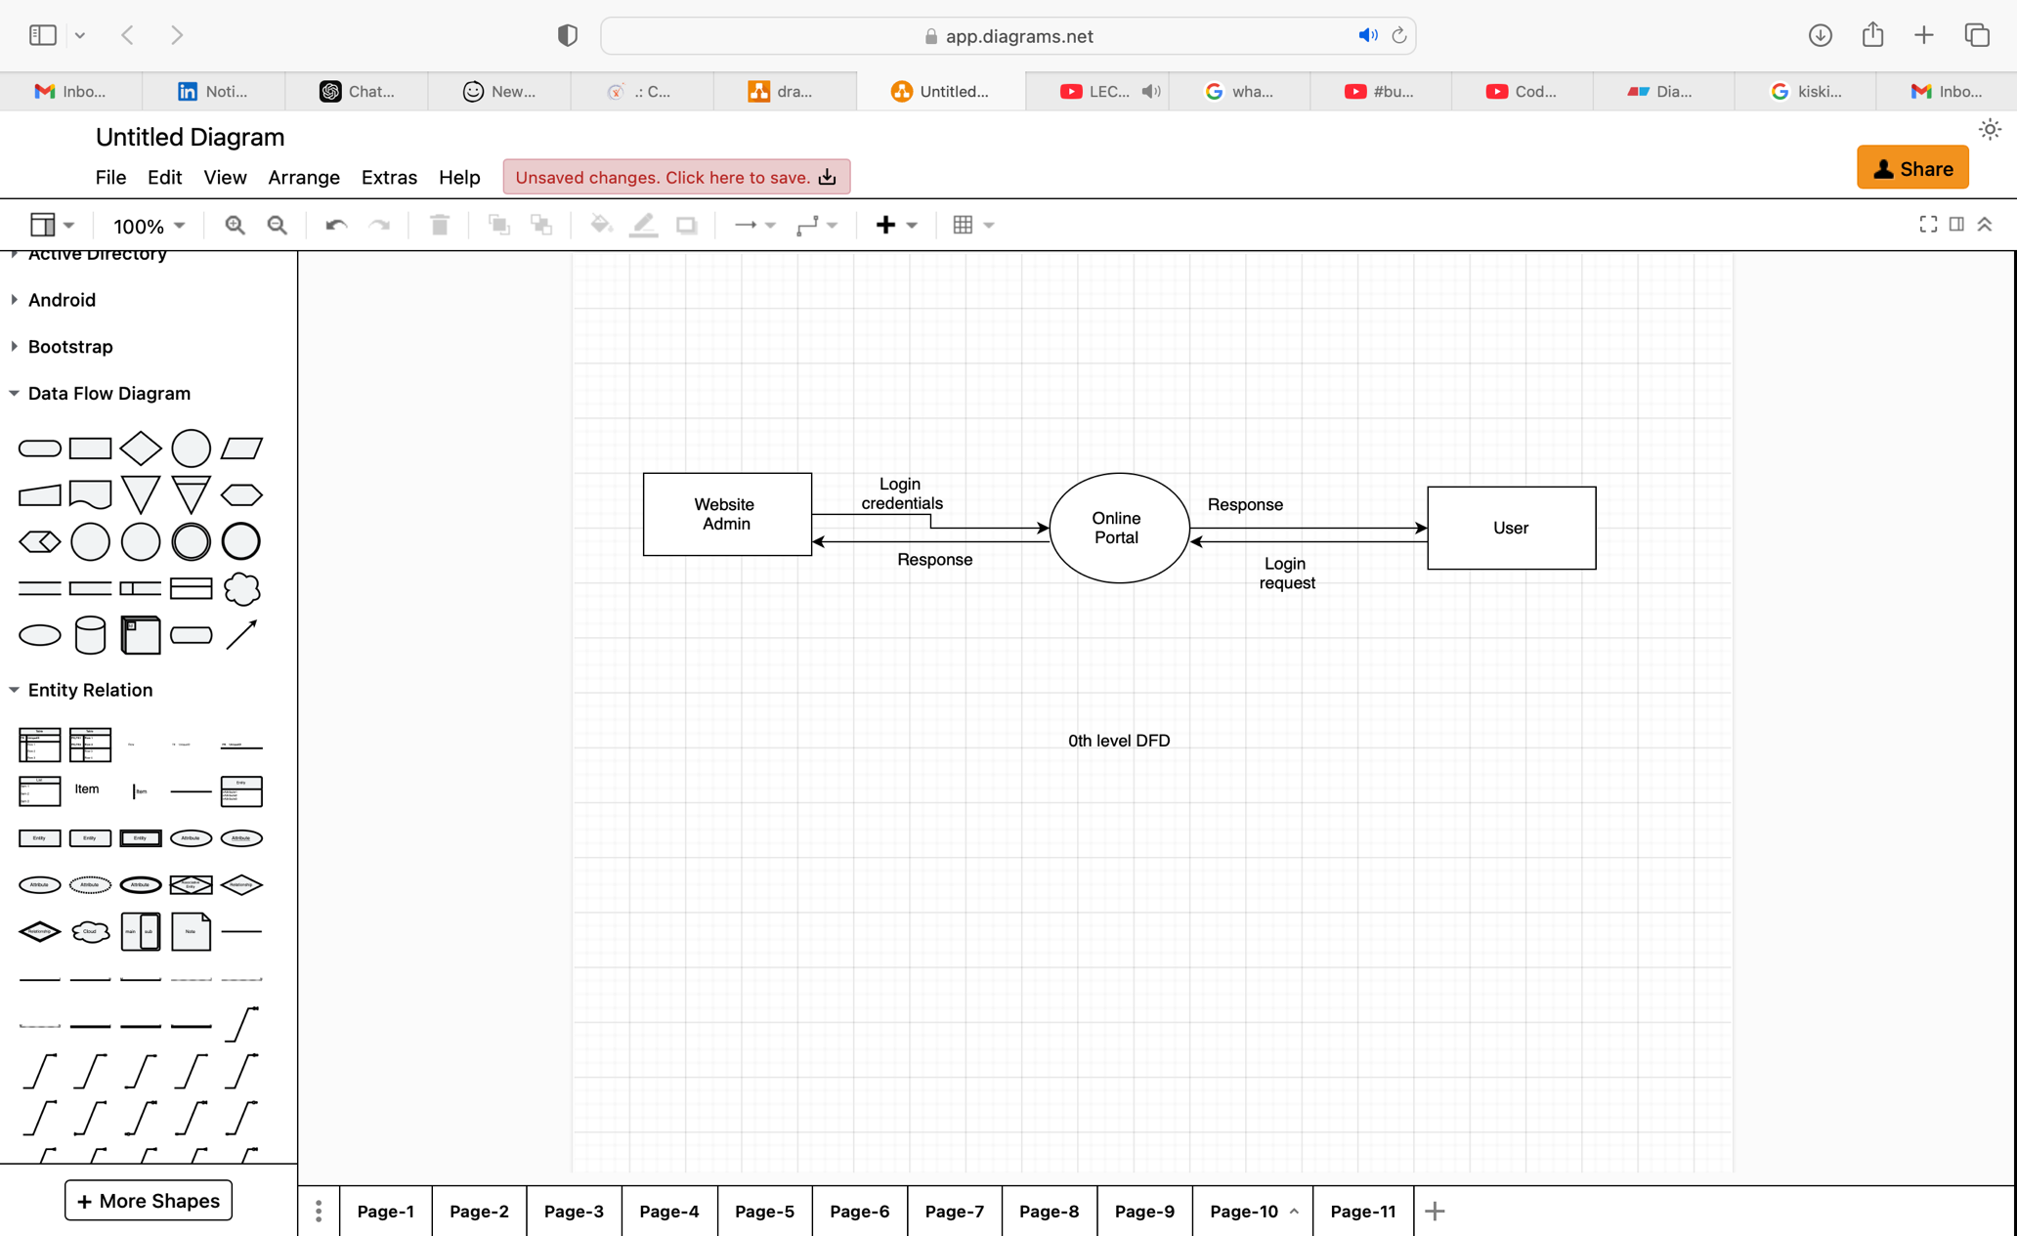

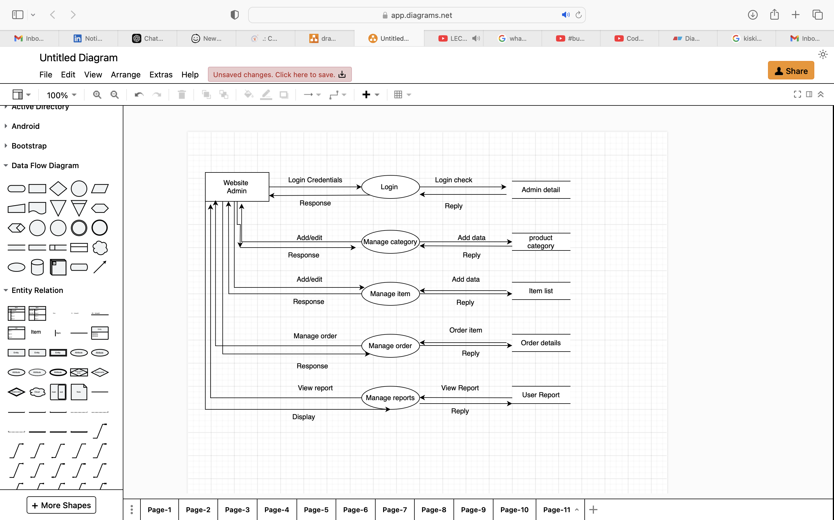

Q8) Due to change in the Government Taxation structure . we should change the Tax structure

How do you handle change requests in a project?

**Answer-8**

**Change Request Document**

**Project Name:** Online Agriculture Product Store Development

**Change Request Title:** Update Taxation Structure Due to Government Policy Change

**Change Request ID:** CR-2025-001

**Date of Request:** [Insert Date]

**Request Initiator:** [Stakeholder Name or Department]

**Change Summary:** Due to a change in the government taxation structure, the application must be updated to incorporate the new tax policies. This change impacts pricing, invoicing, and reporting modules within the system.

**Details of the Change Request:**

**1. Description of Change:** Update the tax rates and formulas used in the pricing module. Modify the invoicing functionality to reflect the updated tax structure. Update the database to store new tax categories and rates. Ensure financial reports and analytics include the updated tax data.

**2. Reason for the Change:** Compliance with the revised government taxation policies. Avoid legal penalties and ensure accurate tax reporting.

**3.** **Impact Analysis:**

**Scope Impact:** Changes required in pricing logic, invoicing, database structure, and reports.

**Time Impact:**

* Estimated additional time: 3 weeks for implementation and testing.

**Cost Impact:**

* Estimated additional cost: Rs. XYZ

**Resource Impact:**

* Involvement of backend developers, database administrator, and testers.

1. **Priority:** High

**Proposed Solution:**

1. Modify the tax calculation logic in the backend.
2. Update the database to store new tax rates and categories.
3. Revise the user interface to display updated taxes during checkout.
4. Conduct regression testing to ensure no disruptions to the existing functionality.
5. Update user manuals and documentation to reflect the changes.

**5. Stakeholders Affected:**

* Farmers using the platform.
* Manufacturers listing products.
* Internal finance and compliance teams.

**Implementation Plan:**

**1. Responsible Team Members:**

* **Backend Development:** Ms. Juhi, Mr. Teyson
* **Database Administration:** Mr. John
* **Testing:** Mr. Jason, Ms. Alekya

**2. Estimated Timeline:**

* Requirement Gathering & Analysis: 2 days
* Development: 10 days
* Testing: 7 days
* Deployment: 2 days

**3. Estimated Cost:** INR 3,00,000

**4. Testing Plan:**

* Validate tax calculations for all product categories.
* Test invoicing with different payment methods.
* Verify financial reporting with updated taxation.

**5. Risk Mitigation Plan:**

* Conduct thorough testing to ensure compliance.
* Provide training sessions for stakeholders to adapt to changes.

**Change Request Status:**

**Comments:** [Additional notes or comments]

**Sign-Off:**

**Project Manager:** Mr Vandanam Senior

**Date:** 23/01/2025

**Stakeholder/Client:** All stakeholders  
**Date:** 23/01/2025

Q9 )Change Request Vs an Enhancement

**Answer-9**

**Scenario:** Ben and Kevin, stakeholders in the online agriculture product store project, have approached the Business Analyst (BA) with a new request. They propose adding two new features:

1. **Crop Yield Sale by Farmers:**
   * Farmers should be able to list their crop yields or products on the platform.
   * These listings should be viewable by the general public for purchase.
2. **Auction System:**
   * Farmers should have the option to auction their crop yields.
   * The auction system should facilitate bidding, manage bid records, and finalize sales.

**Response and Analysis:** As a Business Analyst, it is crucial to classify the request appropriately and assess its impact on the current project scope, timeline, and budget.

### Classification: Change Request or Enhancement?

* **Change Request:** This would be the correct classification if the new features significantly alter the existing functionality or project objectives. For instance, the original scope of the project was limited to facilitating farmers to buy agricultural products from manufacturers. The introduction of a sales and auction platform for farmers expands the system’s scope and adds new processes, requiring additional analysis, design, and development efforts.
* **Enhancement:** If the existing system was initially planned to include farmer-centric features like product sales, and this request builds on that foundation, it could be considered an enhancement. However, since the original scope mentioned only procurement, this is better classified as a **Change Request**.

**Q) Come up with estimations – How many Manhours required**

**Answer-10**

* 1. **Assumptions**

**Team Composition :**

* Project Manager
* Business Analyst (1)
* Developers (4)
* QA Testers (2)
* UI/UX Designer (1)
* Network Admin (1)
* Database Admin

**Duration:** 18 months (approx. 396 working days)

**Working Hours per Day per Resource:** 8 hours

**Effort Distribution Across Phases:** Based on the complexity of activities.

* 1. **Estimation Table**

|  |  |  |  |  |
| --- | --- | --- | --- | --- |
| **Phase** | **Activity** | **Resources** | **Duration (Days)** | **Total hours** |
| Phase 1: Initiation | Requirement Gathering & Analysis | BA, PM | 30 | 480 |
|  | Stakeholder Meetings | PM , BA | 15 | 240 |
| Phase 2 : Design | UI/UX Design | Designer | 20 | 160 |
|  | System Architecture  Design | PM, DBA | 25 | 400 |
| Phase 3 : Development | Frontend development | 2 developers | 60 | 960 |
|  | Backend development | 2 developers | 90 | 1440 |
|  | API Integration | 1 developer | 30 | 240 |
|  | Database Setup & Optimization | DBA | 30 | 240 |
| Phase 4 : Testing | Functional Testing | 2 Testers | 30 | 480 |
|  | UAT Support | Tester , BA | 15 | 240 |
|  | Performance testing | 1 Tester | 15 | 120 |
| Phase 5 : Deployment | Deployment setup | Network Admin | 10 | 80 |
|  | Production Deployment | All | 10 | 80 |
| Phase 6: Post-Go-Live | Bug Fixes & Support | Developers, QA | 20 | 320 |
| Misc Activities | Documentation | BA, PM | 15 | 240 |
|  | Training | BA, PM | 10 | 160 |

**Total Members**

|  |  |
| --- | --- |
| Role | **Estimated Hours** |
| PM | 960 |
| BA | 720 |
| Developers (4 total) | 3360 |
| Testers (2 total) | 840 |
| UI/UX Designer | 160 |
| Network Admin | 160 |
| Database Admin | 400 |

**Grand Total: 6,600 Manhours.**

Contingency :

It’s advisable to add a 10-15% buffer for unforeseen challenges:  
**Contingency Hours:** 660–990 hours.  
**Adjusted total :** 7,260–7,590 manhours.

Q) How are you going to handle this situation? And once it is done, what will be the process

to close the project?

Explain UAT Acceptance process

**Answer-11**

### **Handling the Situation**

* **Scheduling the UAT with the Client:**

Coordinate with the client (Mr. Henry, SOONY Company, and stakeholders Peter, Kevin, and Ben) to schedule UAT sessions.

Share a plan that outlines the scope, objectives, testing approach, timeline, and responsibilities for UAT.

Ensure all necessary data, user accounts, and testing environments are set up and ready for client use.

* **Providing Documentation:**

Share relevant documentation with the client, including:

UAT test cases/scenarios.

Application user manuals or guides.

Known issues or limitations (if any).

Clearly explain the process and expectations for UAT to the client and their team.

* **Facilitating UAT:**

Assist the client in performing UAT by providing:

A demo of the product.

Step-by-step guidance on executing test cases.

Immediate support for any questions or technical issues. Record all feedback, issues, and enhancement requests.

### **User Acceptance Testing (UAT) Process**

#### ****1. Preparation Phase****

* **Objective:** Ensure readiness for UAT.
* Activities:
  + Define the scope of UAT.
  + Prepare UAT test cases based on client requirements.
  + Set up a UAT environment (separate from development and production).
  + Create test data to simulate real-world scenarios.
  + Provide training to stakeholders involved in UAT.

#### ****2. Execution Phase****

* **Objective:** Conduct UAT with the client.
* Activities:
  + Execute UAT test cases step by step with the client.
  + Verify each functionality matches the requirements stated in the project specifications.
  + Record feedback, including bugs, enhancement requests, and general observations.
  + Provide real-time support to resolve any testing issues.

#### ****3. Defect Resolution Phase****

* **Objective:** Address feedback and fix defects.
* Activities:
  + Categorize feedback (Critical, High, Medium, Low priority).
  + Fix defects and test the fixes internally.
  + Retest the resolved issues with the client.

#### ****4. Approval Phase****

* **Objective:** Obtain formal approval from the client.
* Activities:
  + Prepare a UAT sign-off document listing:
    - Test cases executed.
    - Results (Pass/Fail).
    - Pending issues (if acceptable).
  + Obtain formal sign-off from the client indicating that the product is accepted and ready for production deployment.

**Q) Explain Project closure document**

**Answer -12**

### **Project Closure Process**

#### ****1. Deployment to Production****

* Once UAT is successfully completed and signed off, deploy the application to the production environment.
* Ensure all configurations are accurate, and data is migrated successfully.

#### ****2. Handover to Client****

* Provide the final deliverables to the client, including:
  + Source code (if applicable).
  + User manuals and system documentation.
  + Training materials for end users.

#### ****3. Final Review Meeting****

* Conduct a meeting with the client and stakeholders to:
  + Review the overall project.
  + Discuss lessons learned and gather final feedback.
  + Address any remaining concerns.

#### ****4. Documentation and Archiving****

* Archive all project documentation for future reference, including:
  + Requirements documents.
  + Design and testing artifacts.
  + UAT sign-off documents.
  + Deployment records.

#### ****5. Formal Closure****

* Submit a project closure report summarizing the work completed, project outcomes, budget utilization, and final approval.
* Obtain formal project closure approval from the client and internal stakeholders.

### **Post-Closure Support**

* Agree on post-implementation support terms for a smooth transition to the operational phase.
* Provide a timeline for resolving any post-production issues (if included in the agreement).

**Project Closure Document:**

**Project Name:** Online Agriculture Products Store  
**Client:** SOONY Company (Mr. Henry, Mr. Pandu, Mr. Dooku)  
**Project ID:** AGRO-2025  
**Date:**22/01/2025

**Executive Summary**

The **Online Agriculture Products Store** project aimed to create a user-friendly platform to facilitate the purchase of fertilizers, seeds, and pesticides for farmers in remote areas. This platform connects farmers and manufacturing companies, enabling seamless communication and transactions. The project has been successfully delivered within the defined budget of ₹2 Crores INR and an 18-month timeline under the CSR initiative.

### **Objectives Achieved**

* Developed a web/mobile application for farmers to browse and purchase agricultural products.
* Implemented features to allow manufacturers to upload product details (fertilizers, seeds, pesticides).
* Enabled order placement, tracking, and delivery to remote areas.
* Integrated secure payment gateways (COD, Debit/Credit, UPI).
* Provided user manuals and training to end-users (farmers and manufacturers).

**Key Deliverables**

|  |  |  |
| --- | --- | --- |
| Web/Mobile Application | Completed | Tested and deployed in the production environment. |
| User Manuals | Delivered | Detailed guides shared with the client. |
| UAT Sign-Off | Approved | Final approval received from the client. |
| Training Sessions | Conducted | Provided training to end-users. |

**Project Performance**

|  |  |  |
| --- | --- | --- |
| **Metric** | **Target** | **Actual** |
| Budget | Rs. 2 crores INR | Rs. 1.95 crores |
| Timeline | 18 months | 18 months |
| Requirements Delivered | 100 % | 100 % |
| Client Satisfaction | | High | High (Positive feedback received) | |

**Lesson Learned**

#### ****Successes****

* Collaboration between developers and stakeholders ensured smooth progress.
* Early identification of user requirements minimized scope creep.

#### ****Challenges****

* Internet connectivity issues during testing in remote areas.
* Required additional iterations for UI improvements based on UAT feedback.

#### ****Recommendations****

* Allocate extra time for on-site testing in rural areas for similar projects.
* Include farmer representatives in early design discussions.

**Outstanding Issues**

|  |  |  |
| --- | --- | --- |
| **Issue** | **Priority** | **Resolution Plan** |
| Minor UI enhancements | Low | To be resolved in post-production support phase |
| Data sync optimization | Medium | Planned for next update cycle. |

1. **Handover**

The following items have been handed over to the client:

* Application Source Code.
* Deployment Guides.
* User Training Materials.
* Maintenance & Support Plan.

1. **Sign-Off**

|  |  |  |  |
| --- | --- | --- | --- |
| **Name** | **Role** | **Signature** | **Date** |
| Mr. Henry | Client Representative |  |  |
| Mr. Pandu | Financial Head |  |  |
| Mr. Dooku | Project coordinator |  |  |
| Madhumita | BA |  |  |
| Mr Vandaman | PM |  |  |