**Capstone Projects Prep 3 Part 2**

**1.What is the difference between Brainstorming and JAD Sessions?**

| **Feature** | **Brainstorming** | **JAD Sessions** |
| --- | --- | --- |
| **Definition** | A creative group activity aimed at generating a wide range of ideas or solutions. | A structured, facilitated workshop involving stakeholders and IT to gather and refine business requirements. |
| **Purpose** | To generate ideas freely, solve problems, or explore possibilities. | To define system requirements, processes, and design solutions collaboratively. |
| **Structure** | Informal and unstructured. Encourages free flow of ideas without criticism. | Highly structured with a clear agenda, roles (facilitator, scribe, users, developers), and goals. |
| **Participants** | Usually a small team of individuals (can be from different departments). | Key stakeholders including business users, subject matter experts (SMEs), developers, and analysts. |
| **Facilitation** | May or may not have a facilitator. | Always led by a trained facilitator. |
| **Duration** | Short (1–2 hours typically). | Longer sessions (can span several days depending on complexity). |
| **Output** | A list of ideas or potential solutions. | Documented business requirements, process models, and action items. |
| **Best Use Case** | When you need a variety of creative inputs or solutions. | When gathering detailed requirements for a system or application. |

**2.Why Document Analysis is one of the compulsory techniques we use in a Project? Justify**

Document analysis is considered a compulsory technique in projects for several important reasons:

1. **Requirements Clarification**: Documents often contain the initial project requirements, scope, and objectives. Analysing these thoroughly helps ensure everyone understands what needs to be delivered.
2. **Knowledge Capture**: Organizations store critical information in documents. Proper analysis extracts valuable institutional knowledge that might otherwise be overlooked.
3. **Risk Identification**: Previous project documentation, contracts, and technical specifications often reveal potential risks and issues before they become problems.
4. **Baseline Establishment**: Documents provide historical data and benchmarks that help establish realistic baselines for schedules, costs, and quality expectations.
5. **Compliance Verification**: Many industries have regulatory requirements that must be reflected in project execution. Document analysis ensures these compliance needs are identified and addressed.
6. **Context Understanding**: Documents provide context about stakeholders, organizational culture, and previous approaches that might influence project decisions.
7. **Resource Optimization**: Analyzing existing materials prevents "reinventing the wheel" and allows teams to build upon previous work rather than starting from scratch.

**3.In Which Context we will use Reverse Engineering**

**Reverse Engineering**

Reverse engineering is the process of analysing an existing product, system, or component to understand how it works, what it's made of, and how it was designed—essentially working backwards from the finished product to determine its structure, function, and development process.

As a business analyst, I would employ reverse engineering in several key contexts:

1. **Legacy System Documentation**: When dealing with older systems that lack proper documentation but must be maintained, modified, or integrated with newer technologies.
2. **Competitor Analysis**: To understand the features, functionalities, and underlying business rules of competitor products to identify market gaps and competitive advantages.
3. **Process Improvement**: When current processes are inefficient but not well-documented, reverse engineering helps map out existing workflows before proposing improvements.
4. **Migration Projects**: When transitioning from legacy systems to modern platforms, reverse engineering helps extract business rules and logic that need to be preserved.
5. **Mergers and Acquisitions**: To understand acquired systems and processes that may have limited documentation but need to be integrated.
6. **Regulatory Compliance**: When existing systems need to be assessed against new regulations, reverse engineering helps identify areas requiring updates.
7. **Knowledge Recovery**: When key personnel have left the organization taking undocumented knowledge with them.
8. **Technical Debt Assessment**: To understand the complexity and interdependencies in existing systems before planning modernization efforts.
9. **Data Flow Mapping**: To trace how information moves through an organization when documentation is incomplete.
10. **Requirements Elicitation**: As a technique to uncover implicit requirements that may not be evident through standard interview processes.

**4.What is the difference between Brainstorming and Focus Groups**

| **Aspect** | **Brainstorming** | **Focus Groups** |
| --- | --- | --- |
| **Purpose** | To generate a large number of ideas or potential solutions creatively. | To gather opinions, perceptions, and feedback about a product, idea, or issue. |
| **Nature** | Creative and unstructured or semi-structured. | Structured discussion guided by a moderator. |
| **Participants** | Internal stakeholders (e.g., team members, employees). | External or target group (e.g., customers, users, representatives of the market). |
| **Facilitator Role** | Encourages free thinking and idea sharing. May not moderate deeply. | Moderates discussion, ensures balanced participation, and probes for deeper insights. |
| **Focus** | Quantity of ideas over quality initially. | Quality and depth of feedback and opinions. |
| **Interaction Type** | Collaborative and spontaneous. Everyone contributes ideas. | Conversational and reflective. Participants react to prompts or concepts. |
| **Use Case** | When you need to come up with solutions or creative ideas. | When you want to understand needs, behaviours, expectations, or satisfaction. |
| **Output** | A list of ideas, possible features, or approaches. | Qualitative feedback, user insights, attitudes, and preferences. |

**5. Observation Technique – Explain both Active and Passive approaches**

Observation is a valuable elicitation technique where business analysts watch users perform their work to gather insights about processes, behaviours, and needs.

There are two main approaches to observation:

**Active Observation**

**Key Characteristics:**

* The observer directly engages with participants while they work
* Asks questions during the observation process
* May request clarification or elaboration on actions in real-time
* Can guide participants to demonstrate specific tasks or scenarios
* Sometimes called "participatory observation"

**Passive Observation**

**Key Characteristics:**

* Observer remains uninvolved, simply watching without interaction
* No questions or interruptions during the observation session
* Takes detailed notes or records the session for later analysis
* Sometimes called "non-participatory" or "silent" observation
* May use "shadowing" where analyst follows workers through their day

**6.How do you conduct the Requirements Workshop**

A Requirements Workshop is a collaborative meeting where stakeholders and business analysts come together to define, refine, and prioritize requirements for a project. It's interactive, fast-paced, and highly effective for aligning everyone early in the development process**.**

1. **Planning the Workshop**
2. **Conducting the Workshop**
3. **Follow-up Phase**

**Planning the Workshop**

Identify objectives and scope clearly before the workshop

Select appropriate participants including stakeholders, SMEs, and key decision-makers

Develop a detailed agenda with specific topics, exercises, and timeframes

Prepare necessary materials such as templates, diagrams, and previous documentation

Secure an appropriate venue with needed technology and collaboration space

Distribute pre-reading materials to participants at least a few days before

**Conducting the Workshop**

**Kick-off**

* Welcome participants and restate the objective.
* Set **ground rules** (e.g., stay on topic, respect each other’s input, no phones).

**Current State Review (Optional)**

* Discuss the "As-Is" process or system if relevant.

**Elicit Requirements**

Use structured techniques such as:

* Brainstorming
* Use Case Modelling
* Process Mapping
* Role-playing
* Storyboarding
* Ask open-ended questions to guide discussion.

**Clarify and Confirm**

* Rephrase or document key points for validation.
* Use visuals or diagrams to drive clarity.

**Prioritize Requirements**

* Use MoSCoW (Must have, Should have, Could have, Won’t have).
* Discuss business value, risk, and feasibility.

**Follow-up Phase**

Distribute workshop minutes promptly after the session

Document gathered requirements in appropriate format (user stories, use cases, etc.)

Follow up on action items and unresolved questions

Schedule additional workshops if needed for deeper dives into specific areas

Update project documentation with new requirements information

Validate final requirements with key stakeholders who attended

**7. In which context, Interview Technique can be conducted by a BA ? How may approaches are there in conducting Interviews? (Structured – Unstructured) Explain them. Explain the difference between Open Ended Questions and Closed ended Questions**

The Interview Technique is one of the most widely used methods in Business Analysis for eliciting detailed information from stakeholders, especially when you need in-depth insights from individuals.

**Context in which Interview Technique can be conducted:**

1. **Early in the Project Lifecycle**
   * To understand high-level business goals, pain points, and needs.
   * Example: Interviewing a project sponsor to understand business objectives.
2. **To Elicit Specific or Sensitive Requirements**
   * When the information is complex, detailed, or confidential.
   * Example: Interviewing a compliance officer about regulatory rules.
3. **To Validate or Clarify Requirements**
   * To confirm assumptions or previously gathered data.
   * Example: Interviewing a subject matter expert (SME) to validate process flow logic.
4. **When Stakeholders Have Limited Availability**
   * One-on-one interviews can be scheduled flexibly.
   * Example: Interviewing a senior executive who can’t attend workshops.
5. **When Stakeholders Prefer Personal Interaction**
   * Some individuals are more open in private conversations than in group settings.
   * Example: Interviewing end-users who may hesitate to share honest feedback in a group.

**Structured Interview**

**What is it?**  
You prepare specific, fixed questions ahead of time and ask them in the same order to every interviewee.

Best for:

* Gathering standardized information
* Comparing answers from different people
* Surveys, compliance checks, etc.

**Unstructured Interview**

What is it?  
A free-flowing conversation with no strict set of questions. You explore the topic as it comes up naturally.

Best for:

* Open-ended discussions
* Exploring new ideas or unfamiliar topics
* Building trust with stakeholders

**Semi-Structured Interview (Most Common)**

**What is it?**  
You prepare a list of key questions, but you also ask follow-up or related questions as needed.

Best for:

* Getting both structured info and deeper insights
* Most business analysis interviews

**Difference between Open-Ended and Closed-Ended Questions**

| **Aspect** | **Open-Ended Questions** | **Closed-Ended Questions** |
| --- | --- | --- |
| **Definition** | Questions that allow detailed, descriptive answers | Questions that can be answered with a **yes/no** or a short fact |
| **Answer Type** | Long, explanatory, opinion-based answers | Short, direct, fact-based answers |
| **Purpose** | To explore ideas, opinions, and feelings | To gather specific, measurable information |
| **Encourages** | Discussion, elaboration, and more insights | Quick, focused responses |
| **Examples** | “What challenges do you face in your daily tasks?” | “Do you use any software for task management?” |
| **Use Case in BA** | Used in interviews and workshops for requirements gathering | Used in surveys or quick clarifications |

**Q8. Questionnaire Technique – Where we will use? Give one example**

The Questionnaire Technique is used when you need to collect information from a large number of people quickly and in a standardized format**.**

**It is especially useful when:**

* Stakeholders are geographically dispersed
* You want quantitative data or statistics
* Time for interviews/workshops is limited
* You need anonymous feedback

**Where It's Used:**

* Customer satisfaction surveys
* Internal feedback collection
* Requirement validation
* Pre-workshop or pre-interview input collection
* Gathering user preferences or feature prioritization

**Example Scenario:**

**Project:** Improving a company’s internal communication tool

**Use of Questionnaire:** You send a questionnaire to all employees asking:

* “Do you use the current communication tool daily?” (Yes/No)
* “Rate the ease of use from 1 to 5.” (Scale)
* “What features would you like to see in the new tool?” (Open-ended)

This helps the Business Analyst collect clear, wide-ranging feedback to guide the system upgrade.

**Q9. How to Sort the Requirements – Where we will use? Give one example Prioritizing**

Sorting requirements involves organizing and arranging them according to specific criteria to make them more manageable and actionable.

Where We Use Requirement Sorting:

1. Release planning to determine which requirements go into which release
2. Sprint planning in Agile methodologies
3. Requirements documentation for better organization and readability
4. Traceability matrix preparation
5. Gap analysis when comparing requirements to existing capabilities
6. Requirements validation to ensure comprehensive coverage
7. Impact analysis when assessing changes

Example:

A financial institution is developing a mobile banking application with multiple requirements. After gathering requirements from various stakeholders, the business analyst sorts them by functional area:

User Authentication Requirements:

* Biometric login (fingerprint/face recognition)
* Two-factor authentication
* Password reset functionality
* Session timeout controls

Account Management Requirements:

* View account balances
* Transaction history display
* Account nickname customization
* Account transfer capabilities

Payment Requirements:

* Bill payment scheduling
* Recurring payment setup
* Payment confirmation notifications
* Payee management

Customer Service Requirements:

* In-app messaging with support
* Branch/ATM locator
* Appointment scheduling
* Document upload capability

By sorting requirements into these functional categories, the development team can:

* Assign specialized teams to each functional area
* Create more focused test plans
* Develop coherent user stories and acceptance criteria
* Identify potential requirement gaps within each category
* Build features incrementally with logical groupings

This sorting approach provides structure to the requirements and helps ensure nothing is overlooked during development and testing phases.

**Q10. Prioritise the Requirements. Where we will use? Give one example**

**Requirements in Business Analysis**

Requirements prioritization is used when we have more requirements than can be delivered within project constraints (time, budget, resources), or when implementation needs to happen in phases.

**Where We Use Requirements Prioritization:**

1. **Product backlogs** in Agile development
2. **Phased implementations** of large systems
3. **Resource allocation** decisions
4. **Scope management** when facing constraints
5. **Roadmap planning** for product features
6. **Risk management** to address critical needs first
7. **Stakeholder alignment** when conflicting needs exist

**Example:**

A healthcare organization is implementing a new patient management system with the following requirements:

* Patient appointment scheduling
* Electronic medical records
* Prescription management
* Insurance verification
* Patient billing
* Secure messaging between providers and patients
* Patient portal for accessing records
* Reporting and analytics dashboards
* Integration with lab systems
* Mobile access for providers

Using MoSCoW prioritization, the requirements team works with stakeholders to categorize these as:

**Must Have (Phase 1):**

* Patient appointment scheduling
* Electronic medical records
* Prescription management
* Patient billing

**Should Have (Phase 2):**

* Insurance verification
* Secure messaging
* Integration with lab systems

**Could Have (Phase 3):**

* Patient portal
* Mobile access for providers

**Won't Have (Future consideration):**

* Reporting and analytics dashboards (will use existing reporting tools initially)

This prioritization ensures that the core functionality (Must Haves) is delivered first, creating a viable system that addresses the most critical needs while deferring less essential features to later phases.

**11.Weekly status reporting – How we will drive**

A weekly report is a review of your workweek and provides a summary of what you completed, what projects are in progress and plans that outline your workflow for the next week. Typically, weekly reports are brief and concise and only one page long. Most professionals send weekly reports on Friday afternoons to establish consistent communication with team members and supervisors. Additionally, a weekly report can benefit both you and your employer by providing insight into important aspects of the work you complete.

|  |  |  |  |  |
| --- | --- | --- | --- | --- |
| **Weekly Status Report** | | | | |
| **Project Name** | Scrum Foods |  |  |  |
| **Week** | 2nd Week |  |  |  |
| **Prepared By** | Harish |  |  |  |
| **Submitted On** | 20-04-2025 |  |  |  |
|  |  |  |  |  |
| **Project Backlog** | **Task** | **Status** | **Done** | **Issues** |
| **Registration** |  |  |  |  |
| **Login** |  |  |  |  |

**Q12. Meeting Minutes Document – prepare one Sample**

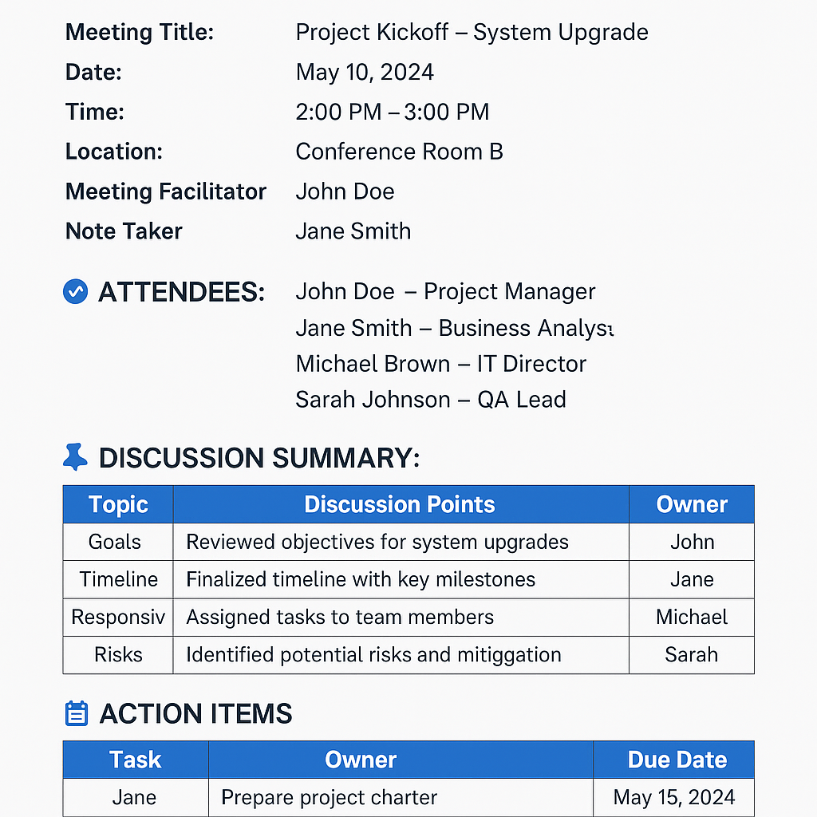**Meeting Minutes document** in a clear, professional format. You can use this for team meetings, stakeholder discussions, or client sync-ups.

[Meeting_Minutes_Template.xlsx](https://1drv.ms/x/c/c4d2bb5cc67aee6c/Ec2kaNs3nSFMoJ45rO1wOy4B9dZGkIVxRYpjsu_tA6hZbA?e=oAzQNs)

**Q13. Change Tracker – Document - – prepare one Sample -**

[Change Request Template.xlsx](https://1drv.ms/x/c/c4d2bb5cc67aee6c/Ec2kaNs3nSFMoJ45rO1wOy4B9dZGkIVxRYpjsu_tA6hZbA?e=J0Ax6W)

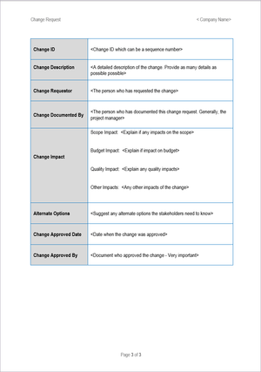

**Q14. Difference between Traditional Development Model and Agile Development Models**

| **Aspect** | **Traditional Development (Waterfall)** | **Agile Development** |
| --- | --- | --- |
| **Approach** | Linear and sequential | Iterative and incremental |
| **Planning** | Entire project is planned upfront | Planning is done at the beginning of each sprint |
| **Flexibility to Changes** | Very low – changes are costly once development starts | Very high – changes can be made even late in development |
| **Customer Involvement** | Minimal – usually only at the beginning and end | Continuous – customer gives feedback in every iteration |
| **Delivery** | Single final product delivered at the end | Working software delivered at the end of each sprint/iteration |
| **Testing** | Happens after development is complete | Testing happens continuously during development |
| **Documentation** | Heavy documentation | Minimal but sufficient documentation |
| **Project Size** | Suitable for small, well-defined projects | Suitable for complex, evolving, and fast-paced projects |
| **Team Collaboration** | Siloed – each team works in separate phases | Collaborative – cross-functional teams work together |

**In Simple Terms:**

* Traditional is like planning an entire trip before leaving home – you don’t change your path once you start.
* Agile is like adjusting your journey as you go based on weather, traffic, or new ideas from your co-travellers.

**15.Explain Brainstorming Technique – Where to use**

Brainstorming is a group creativity technique used to generate a wide range of ideas, solutions, or requirements by encouraging free-thinking and open discussion. It’s typically done in a relaxed environment where judgment is suspended so that participants feel safe to express even unusual or bold ideas.

**Where is Brainstorming Used?**

| **Context** | **Purpose** |
| --- | --- |
| **Requirements Gathering** | To identify what features or needs the users might want in a product |
| **Problem Solving** | To explore possible solutions to a business or technical challenge |
| **Process Improvement** | To find ways to streamline or enhance current workflows |
| **Project Planning** | To list down all potential tasks, risks, or resources |
| **ProductDesign & Innovation** | To come up with creative features or product enhancements |

**Q16. Reports Generated by Accounts Department**

**1.Loan Application Status Report**

|  |  |  |  |  |  |
| --- | --- | --- | --- | --- | --- |
| **Loan Application Status Report** | | | | | |
| **Employe ID** | **Full Name** | **Department** | **Date of Application** | **Requested Amount** | **Status** |
| T2533 | Nallamothu Harish | Marketing | 20-04-2025 | ₹ 20,000.00 | Pending |
| T2546 | Ranga Rao K | Sales | 20-04-2025 | ₹ 17,71,464.00 | Done |
| T4545 | Ramesh K | IT | 20-04-2025 | ₹ 3,27,990.00 | Rejected |
| T2454 | Naresh N | Finance | 20-04-2025 | ₹ 12,16,322.00 | Approved |

**2.** **Loan Disbursement Report**

|  |  |  |  |  |
| --- | --- | --- | --- | --- |
| **Loan Disbursement Report** | | | | |
| **Employe ID** | **Full Name** | **Amount Disbursed** | **Date of Disbursement** | **Mode of Payment** |
| T2533 | Nallamothu Harish | ₹ 20,000.00 | 18-04-2025 | NEFT |
| T2546 | Ranga Rao K | ₹ 19,31,013.00 | 17-04-2025 | NEFT |
| T4545 | Ramesh K | ₹ 11,45,475.00 | 16-04-2025 | NEFT |
| T2454 | Naresh N | ₹ 14,16,945.00 | 15-04-2025 | NEFT |

**3.Loan Repayment Schedule Report**

|  |  |  |  |  |  |
| --- | --- | --- | --- | --- | --- |
| **Loan Repayment Schedule Report** | | | | | |
| **Employe ID** | **Full Name** | **EMI Amount** | **Remaining Balance** | **Next Deduction Date** | **Number of EMIs remaining** |
| T2533 | Nallamothu Harish | ₹ 5,063.00 | ₹ 1,94,937.00 | 20-05-2025 | 40 |
| T2546 | Ranga Rao K | ₹ 6,103.00 | ₹ 3,98,603.00 | 20-05-2025 | 41 |
| T4545 | Ramesh K | ₹ 6,290.00 | ₹ 10,91,719.00 | 20-05-2025 | 42 |
| T2454 | Naresh N | ₹ 5,231.00 | ₹ 19,28,654.00 | 20-05-2025 | 43 |

**4.Outstanding Loan Summary Report**

|  |  |  |  |  |
| --- | --- | --- | --- | --- |
| **Outstanding Loan Summary Report** | | | | |
| **Employe ID** | **Full Name** | **Total Loan Amount** | **Paid Amount** | **Balance Amount** |
| T2533 | Nallamothu Harish | ₹ 2,00,000.00 | ₹ 5,660.00 | ₹ 1,94,340.00 |
| T2546 | Ranga Rao K | ₹ 3,14,192.00 | ₹ 5,190.00 | ₹ 3,09,002.00 |
| T4545 | Ramesh K | ₹ 3,11,566.00 | ₹ 5,206.00 | ₹ 3,06,360.00 |
| T2454 | Naresh N | ₹ 3,53,693.00 | ₹ 5,502.00 | ₹ 3,48,191.00 |

**5.Monthly Salary Deduction Report**

|  |  |  |  |  |
| --- | --- | --- | --- | --- |
| **Monthly Salary Deduction Report** | | | | |
| **Employe ID** | **Full Name** | **Loan ID** | **EMI Amount** | **Deduction Date** |
| T2533 | Nallamothu Harish | 2545 | ₹ 5,154.00 | 20-05-2025 |
| T2546 | Ranga Rao K | 2546 | ₹ 5,341.00 | 21-05-2025 |
| T4545 | Ramesh K | 2547 | ₹ 5,743.00 | 22-05-2025 |
| T2454 | Naresh N | 2548 | ₹ 5,478.00 | 23-05-2025 |

**Q17. Structure of HR Mail (Loan Rejection)**

Subject: Loan Application Status – Rejected

Dear [Employee Name],

Thank you for applying for a loan under the Employees Loan Management System. We regret to inform you that your loan application submitted on [Date] has been rejected.

Reason for Rejection:  
[Insert Reason – e.g., Insufficient salary, outstanding liabilities, ineligible tenure, etc.]

You may reach out to the HR department for further clarification or reapply after fulfilling the eligibility criteria.

Thank you for your understanding.

Regards,  
HR Department  
TTS Company

**Q18. Structure of HR Mail (Loan Approval)**

Subject: Loan Application Status – Approved

Dear [Employee Name],

We are pleased to inform you that your loan application submitted on [Date] under the Employees Loan Management System has been approved.

Loan Details:

* Approved Amount: ₹[Amount]
* EMI Amount: ₹[EMI]
* Repayment Duration: [No. of Months]
* Interest Rate: [Rate]
* First Deduction Date: [Date]
* Deduction Mode: Automatic Salary Deduction

Please review the attached Loan Agreement, Repayment Schedule, and Terms and Conditions. Your loan will be disbursed upon your acceptance and digital signature.

Feel free to contact HR for any queries.

Warm regards,  
HR Department  
TTS Company

**Q19. Sample Report – Loan Applications Received**

|  |  |  |  |  |  |  |  |
| --- | --- | --- | --- | --- | --- | --- | --- |
| **S.No** | **Employee ID** | **Employee Name** | **Department** | **Requested Amount (₹)** | **Date of Application** | **Status** | **Reviewed By** |
| 1 | E1234 | Ananya Sharma | IT | 1,00,000 | 05-Apr-25 | Pending | - |
| 2 | E1267 | Rajiv Mehta | Finance | 2,50,000 | 03-Apr-25 | Approved | A. Kumar |
| 3 | E1288 | Sneha Rao | HR | 80,000 | 06-Apr-25 | Rejected | P. Roy |
| 4 | E1321 | Vikram Desai | Marketing | 1,50,000 | 07-Apr-25 | Approved | M. Gupta |
| 5 | E1355 | Tanya Verma | R&D | 50,000 | 09-Apr-25 | Pending | - |

**Q20. Reporting Tools Used (5 Marks)**

The following reporting tools can be used for generating reports in the Loan Management System:

1. **Power BI** – For interactive dashboards and visual analytics.
2. **Tableau** – For real-time visual reporting and data exploration.
3. **Microsoft Excel** – For basic reporting, analysis, and exporting data.