Mock Question

A company is having manufacturing plants and warehouses in various parts of the country. They manufacture ice-cream and milk products. They want to build software to achieve two goals.
- Manage the inventory
- Quickest delivery to the customers
Assignment 1:
Question 1: Please make a BRD which can be presented to the client along with complete development and resource plan.

Answer:
Project Title: Inventory and Delivery Optimization System (IDOS)
Customer Name: Villa Milk Pvt. Ltd.
Project Version: v1.0
Prepared By: Sramana Bhattacharya
Date: 11/11/2024

1.Document Revisions
Date | Version No. | Author | Document Changes | Reviewer/ Approver
30/07/2024 | 1.0 | Business Analyst | Initial draft | Project Sponsor
15/08/2024 | 1.1 | QA Lead | Review & Feedback | IT Steering Comm.
24/08/2024 | 1.2 | Project Manager | Final Draft for Signoff | Client Representative

2.Approvals
Role | Name | Signature | Date
Project Sponsor | Priya Rao
Client Representative | Vivek Sharma
Project Manager | Shaleen Gupta

3.1. RASCI Chart for This Document
Code | Meaning
R | Responsible – The person(s) who does the work to complete the task
A | Accountable – The one ultimately answerable for the task’s outcome
S | Support – The one who Provide resources or assistance to those responsible
C | Consulted – Person(s) whose input is sought before a decision/action
I | Informed – Person(s) kept up-to-date about progress or decisions

3.2. RASCI matrix
Task/ Deliverables | Client | Sponsor | PM | BA | Dev Team | QA Team | IT Ops | Vendor
Requirement Gathering | C | A | R | R | I | I | I | I
BRD Approval | A | R | C | S | I | I | I | I
System Design | I | C | A | C | R | S | C | S
Development | I | I | C | S | R | S | I | S
Testing & Validation | I | I | C | C | S | R | S | I
Deployment | I | I | A | S | R | S | R | C
Training & Handover | C | I | R | R | S | S | S | I

4.Introduction
The client operates multiple manufacturing plants and warehouses across the country producing ice cream and milk products. Currently, inventory management is done through legacy spreadsheets/manual processes, and customer deliveries are suboptimal, leading to delays, higher costs, and customer dissatisfaction.

4.1. Business Goals
- Enhance real-time inventory visibility across plants and warehouses.
- Enable quickest delivery routes for customers using logistics optimization.
- Improve customer satisfaction & reduce delivery delays.
- Reduce operational costs through efficient supply chain management.

4.2. Business Objectives
- Automate inventory updates and stock tracking.
- Provide centralized dashboards for management.
- Implement AI-based route optimization for faster deliveries.
- Integrate with ERP and warehouse systems.

4.3 Business Rules
- Orders must be fulfilled from the nearest warehouse with sufficient stock.
- Inventory update
- s must reflect in real time.
- Products must adhere to expiry date rules before shipping.
- Delivery partners must follow optimized routing logic.

4.4 Background
The client operates multiple manufacturing plants and warehouses across the country, producing a wide range of ice-cream and milk products. Currently, inventory management is fragmented, with different plants and warehouses relying on manual logs, spreadsheets, and disconnected systems. This often results in challenges such as stockouts, overstocking, delayed deliveries, and lack of real-time visibility into inventory levels.
Customer demand for dairy and frozen products is highly time-sensitive, and any delay in delivery affects product freshness, quality, and customer satisfaction. Moreover, the growing competition in the FMCG and dairy sector requires the client to adopt a technology-driven approach to stay ahead.
To address these challenges, the client seeks to implement a centralized software solution that manages inventory across all locations and ensures the quickest possible delivery to customers through intelligent routing and supply chain optimization.

4.5 Project Objectives
- Implement a centralized inventory management system that provides real-time stock visibility across all plants and warehouses.
- Automate stock tracking and replenishment alerts to minimize shortages and overstocking.
- Develop a route optimization system to ensure the quickest and most cost-effective delivery to customers.
- Provide a unified dashboard for management to track inventory, order fulfilment, and logistics efficiency.
- Integrate with existing ERP/CRM systems to ensure seamless operations and reporting.
- Enhance customer satisfaction by reducing delivery delays and ensuring product quality.
- Support future scalability for expansion into new regions and digital sales channels.

4.6 Project Scope
4.6.1 In-Scope Functionality
- Centralized Inventory Management System
- Stock tracking across plants & warehouses
- Route optimization engine for deliveries
- Integration with ERP / CRM systems
- Real-time dashboards & reporting
- Mobile app for delivery personnel
4.6.2 Out-of-Scope Functionality
- Manufacturing automation systems
- HR and payroll functionalities
- Third-party vendor billing system

5.Assumptions
- Client will provide access to legacy inventory data.
- Delivery partners will adopt the proposed mobile application.
- Sufficient IT infrastructure and internet connectivity at warehouses.

6. Constraints
- Project completion within 6 months.
- Budget capped at $5 million.
- Compliance with FSSAI & food supply chain regulations.

7. Risks
7.1 Technological Risks
- Integration challenges with ERP systems.
- System downtime during migration.
7.2 Skills Risks
- Limited expertise in AI/ML for route optimization.
7.3 Political Risks
- Changes in food transportation policies.
7.4 Business Risks
- High dependency on logistics partners.
7.5 Requirement Risks
- Shifting client priorities during development.
7.6 Other Risks
- Resistance to change from warehouse staff.

8. Business Process Overview
Legacy System (AS-IS)
- Manual inventory tracking via Excel.
- No centralized database.
- Delivery allocation based on manual dispatcher decisions.
Proposed System (TO-BE)
- Centralized cloud-based inventory system.
- AI-powered route optimization.
- Automated stock alerts and expiry tracking.
- Mobile-enabled last-mile delivery tracking.

9. Business Requirements
- System must allow real-time inventory updates.
- Must generate auto-restocking alerts.
- Route optimization must minimize delivery time & cost.
- System must integrate with ERP & CRM.
- Dashboards must provide daily, weekly, monthly reports.
- Mobile app for delivery staff with GPS tracking.

10. Development Plan
- Phase 1 (Month 1-2): Requirement gathering, BRD approval, system design.
- Phase 2 (Month 3-4): Development of inventory management module + integrations.
- Phase 3 (Month 5): Route optimization & mobile app development.
- Phase 4 (Month 6): Testing, training, and deployment.

11. Resource Plan
- Project Manager (1)
- Business Analysts (2)
- Developers (6) – Backend (3), Frontend (2), Mobile (1)
- QA Engineers (3)
- Data Scientist (1) – For route optimization
- IT Infrastructure Lead (1)

12.Appendices
- A. List of Acronyms
- ERP – Enterprise Resource Planning
- CRM – Customer Relationship Management
- GPS – Global Positioning System
- AI – Artificial Intelligence

- B. Glossary of Terms
- Inventory Management: Process of ordering, storing, and using a company’s stock.
- Route Optimization: Process of determining the most cost-efficient delivery route.

- C. Related Documents
- Project Charter
- System Requirement Specification (SRS)
- Test Strategy Document

Question 2: Prepare process flow diagram using your imagination.
Answer:
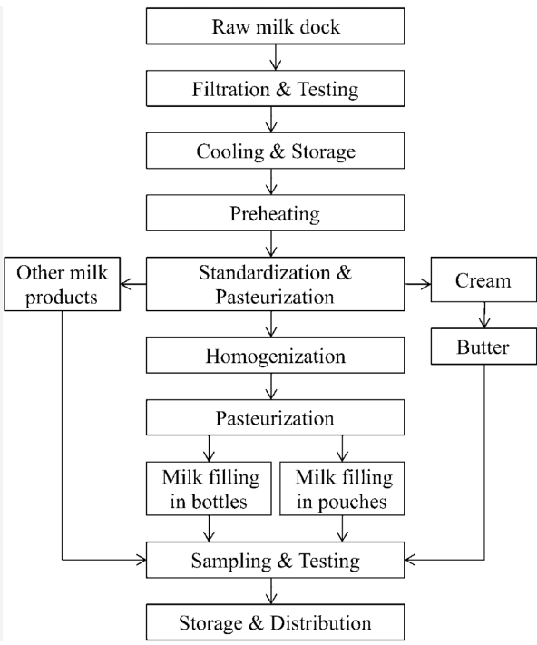

Assignment 2:
Question1: Write an introduction letter to a client introducing yourself as a business analyst in charge of working with the client and his team to start the business understanding process.

Answer:

Subject: Introduction as Business Analyst for Villa Milk
Dear Saroj,
I hope this message finds you well.
My name is Sramana, and I will be working with you as the Business Analyst for the upcoming [Inventory and Delivery Optimization System for Villa Milk. My role will be to act as a bridge between your business team and our development team, ensuring that we capture your requirements accurately and translate them into effective solutions.
Over the coming weeks, I will be engaging with you and your stakeholders to gain a deep understanding of your current processes, challenges, and expectations. This business understanding phase will form the foundation of the project, enabling us to define clear requirements, align priorities, and set realistic objectives for successful delivery.
I am looking forward to collaborating closely with you and your team. Please feel free to share any initial thoughts, concerns, or documentation that you believe will help us get started. I will also be scheduling a kick-off discussion soon to outline the next steps and approach.
Thank you for your time and support. I am confident that together we can build a solution that drives efficiency, accuracy, and customer satisfaction for your business.
Warm regards,
Sramana Bhattacharya
Business Analyst
+91 987654321

Question 2: Prepare a brief BRD and SRS for a project- Horoscope or Ticketing system or online store.

Answer:

Business Requirements Document (BRD)
Project Title: Online Ticketing System
Prepared By: Sramana Bhattacharya – Business Analyst
Date: 24/08/2025
Version: 1.0

1. Background
The client organization needs an online ticketing system to allow customers to easily purchase, manage, and cancel tickets for events, shows, or travel. Currently, the process is either manual or through third-party vendors, leading to higher costs and poor customer experience.

2. Business Goals & Objectives
- Provide a seamless online platform for booking, modifying, and cancelling tickets.
- Reduce manual effort and dependency on third parties.
- Ensure real-time availability of seats and schedules.
- Generate reports for sales, cancellations, and revenue tracking.

3. Project Scope
  - In-Scope
- Online ticket booking (web and mobile).
- Seat selection and availability check.
- Online payments (credit card, debit card, wallet, UPI).
- Ticket cancellation and refund processing.
- Admin portal for event/travel schedule management.
- Reporting and analytics.

  - Out-Scope
- Physical ticket printing.
- Marketing/Promotions module.
- Third-party reseller integrations.

4. Business Rules
- A ticket is confirmed only after successful payment.
- Cancellation charges apply based on event/travel policy.
- Seats once booked cannot be modified but can be cancelled/refunded.

5. Risks & Constraints
- Technological risk: Payment gateway downtime.
- Business risk: High cancellations affecting revenue.
- Constraint: Must comply with local data privacy and payment regulations.

6. High-Level Requirements
- R1: The system must allow users to register/login.
- R2: The system must allow users to search and book available tickets.
- R3: The system must process online payments securely.
- R4: The system must allow cancellations with refund policies.
- R5: The system must provide an admin dashboard for schedule and report management.

Software Requirements Specification (SRS)
Project Title: Online Ticketing System
Prepared By: Sramana Bhattacharya
Date: 26/08/2025
Version: 1.0

1. Functional Requirements
- User Management
- FR1.1: User can register and log in using email/mobile.
- FR1.2: System must validate credentials and provide secure authentication.

- Ticket Booking
- FR2.1: Users can search available events/travel schedules.
- FR2.2: Users can select seats (if applicable).
- FR2.3: System must update seat availability in real time.

- Payment Processing
- FR3.1: System must integrate with multiple payment gateways.
- FR3.2: System must generate a confirmation receipt after payment.

- Ticket Cancellation
- FR4.1: Users can cancel tickets through their account.
- FR4.2: System must apply cancellation policy and process refunds.

- Admin Functions
- FR5.1: Admin can add/update/delete events or schedules.
- FR5.2: Admin can generate reports on sales, cancellations, and revenue.

2. Non- Functional Requirements
- Performance: System must support at least 5,000 concurrent users.
- Availability: 99.9% uptime SLA.
- Security: Must comply with PCI-DSS for payment security and encrypt customer data.
- Scalability: Must support future addition of mobile apps and new event categories.
- Usability: Intuitive UI with multi-language support.

3. Assumptions
- Reliable internet connectivity is available for all users.
- Payment gateway service providers will supply APIs for integration.
- Users will access the system primarily via web browsers and mobile apps.

4. Constraints
- Must be developed and deployed within 6 months.
- Budget is capped at Rs. 2 crores.
- Compliance with regional tax and financial regulations is mandatory.

Question 3: Make an ERD of creating a support ticket/Ticketing life cycle.
Answer:

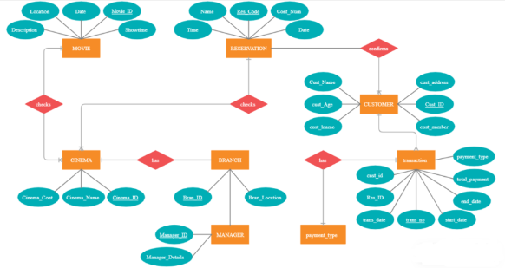

Question 4: User story of shopping from ecommerce.
Answer:
User Story ID: US001
Tasks:3
Priority:1
Value Statement: As a new customer, I want to register and log in securely so that I can access my account and place orders.
BV: 500
CP:8
Acceptance Criteria:
- User can register with email/phone and password.
- System validates credentials and prevents duplicate accounts.
- User receives confirmation (email/SMS).
- Login is successful only with correct credentials.

User Story ID: US002
Tasks:3
Priority:1
Value Statement: As a shopper, I want to search and filter products so that I can quickly find what I need.
BV: 500
CP:8
Acceptance Criteria:
- User can search products by keyword.
- Filters (price range, category, rating) narrow results correctly.
- System displays results within 2 seconds.
- Product details page loads correctly when clicked.

User Story ID: US003
Tasks:3
Priority:2
Value Statement: As a customer, I want to add, remove, and update items in my cart so that I can review before purchase.
BV: 200
CP:5
Acceptance Criteria:
- User can add multiple items to cart.
- User can update quantity or remove items.
- Cart automatically updates total price.
- Cart persists until checkout or manual clearing.

User Story ID: US004
Tasks:4
Priority:1
Value Statement: As a buyer, I want to check out with secure payment options so that I can complete my purchase safely.
BV: 500
CP:13
Acceptance Criteria:
- User can enter shipping details.
- Payment gateway processes transactions securely.
- Order confirmation is displayed and emailed to customer.
- Payment failures show proper error message.

User Story ID: US005
Tasks:3
Priority:3
Value Statement: As a customer, I want to track my orders in real time so that I know when to expect delivery.
BV: 100
CP: 5
Acceptance Criteria:
- User can view current status of orders (Processing, Shipped, Delivered).
- Tracking updates are accurate and real-time.
- Notifications are sent on status changes.
- Delivered orders are marked as completed.

