**Nurturing Process - Capstone Project1 – Part -3/3 V2D2 Aug 2024**

Online Agriculture Products Store

Mr. Henry, after being successful as a businessman and has become one of the wealthiest persons

in the city. Now, Mr. Henry wants to help others to fulfil their dreams. One day, Mr. Henry went to

meet his childhood friends Peter, Kevin and Ben. They live in a remote village and do farming. Mr.

Henry asked his friends if they are facing any difficulties in their day-to-day work.

Peter told Mr. Henry that he is facing difficulties in procuring fertilizers which are very important for

farm. Kevin said that he is also facing the same problem in-case of buying seeds for farming certain

crops. Ben raised his concern on lack of pesticides which could help in greatly reducing pests in

crops.

After listening to all his friends’ problems, Mr. Henry thought that this is a crucial problem faced not

only by his friends but also by so many other farmers. So, Mr. Henry decided to make an online

agriculture product store to facilitate remote area farmers to buy agriculture products. Through this

Online Web / mobile Application, Farmers and Companies (Fertilizers, seeds and pesticides

manufacturing Companies) can communicate directly with each other.

The main purpose to build this online store is to facilitate farmers to buy seeds, pesticides, and

fertilizersfrom anywhere through internet connectivity. Since new users are involved, Application

should be user friendly.

This new application should be able to accept the product (fertilizers, seeds, pesticides) details fromthe

manufacturers and should be able to display them to the Farmers. Farmers will browse throughthese

products and select the products what they need and request to buy them and deliver them to

farmers location.

Mr. Henry has given this project through his Company SOONY. In SOONY Company, Mr Pandu is

Financial Head and Mr Dooku is Project Coordinator. Mr. Henry , Mr Pandu , and Mr Dooku formed

one Committee and gave this project to APT IT SOLUTIONS company for Budget 2 Crores INR and

18 months Duration under CSR initiative. Peter, Kevin and Ben are helping the Committee and can

be considered as Stakeholders share requirements for the Project.

Mr Karthik is the Delivery Head in APT IT SOLUTIONS company and he reached out to Mr Henry

through his connects and Bagged this project. APT IT SOLUTIONS company have Talent pool

Available for this Project. Mr Vandanam is project Manager, Ms. Juhi is Senior Java Developer, Mr

Teyson, Ms Lucie, Mr Tucker, Mr Bravo are Java Developers. Network Admin is Mr Mike and DB

Admin is John. Mr Jason and Ms Alekya are the Tester. And you joined this team as a BA.

Your Team

Project Manager - Mr VandanamSenior

Java Developer - Ms. Juhi

Java Developers - Mr Teyson, Ms Lucie, Mr Tucker, Mr Bravo

Network Admin - Mr Mike

DB Admin - Mr John.

Testers - Mr Jason and Ms Alekya

BA - You

Fertilizers, seeds, pesticides details from the manufacturers and should be able to display them to the

Farmers.

To gather the business requirements from the client, you went to SOONY and met Mr. Henry. When Mr.

Henry was asked about the project and what are they expecting from the project, Mr. Henry stated that he is

expecting to have a login for all its users (fertilizers, seeds, pesticides manufacturers and Farmers) , a

product catalog of fertilizers, seeds, pesticides, a search option to search for products, payment process, and

delivery tracking.

After doing the stakeholder analysis, you have found out that Peter, Kevin, Ben are the key stakeholders and

you have scheduled an appointment to meet them. After meeting with them and trying to gather the

stakeholder requirements, Kevin said that, a Farmer should be able to browse through the products catalog

once they visit the website and need to have a search option so that they can search for any product they

need. Peter said that, if a farmer wants to buy any product or add them to buy-later list, they need to login

first using their email id and password. If it is a new user, then they can create a new account by submitting

their email ID and creating a secure password. Ben added saying that, Farmers needs to have an easy-to-use

payment gateway which should include cash-on-delivery (COD), Credit/Debit card and UPI options so that

the user’s experience should be better. Kevin mentioned that, a user gets an email confirmation regarding

their order status. A delivery tracker to track the whereabouts of their order.

Identify Business Requirements(which includes Stakeholder Requirements)

BR001 – Farmers should be able to search for available products in fertilizers, seeds, pesticides

BR002 – Manufacturers should be able to upload and display their products in the application

Make suitable Assumptions and identify at least 10 Business Requirements.

List your assumptions

Give Priority 1 to 10 numbers ( 1 being low priority – 10 being high priority) to these Requirements

after discussions with the stakeholders

Once the requirements are finalized, as a business analyst, one of the major roles is to act as a

liaison between the client and the project team. To gather the requirements correctly from the

client side and then to deliver those requirements to the project team in a way they understand.

To make the project team understand the requirements, you need to convert those requirements

into UML diagrams and screen mock-ups.

You will draw use case diagram

Prepare use case specs for all use cases

And you will all Activity diagrams required

**Question 1 – Functional Requirements - 15 Marks**

Identify minimum 20 functional requirements

Functional requirement: When an order is fulfilled, the local printer shall print a packing slip.

Non-Functional Requirement: Packing slips shall be printed on both sides of 4”x 6” white paper, the

standard size for packing slips used by local printers.

Answer:

**Functional requirement:** This define the specific behaviours, functions, or operation of a system. They describe what the system should do, outlining the necessary tasks, action or activities it must perform to achieve its objectives.

|  |  |  |  |
| --- | --- | --- | --- |
| **Req ID** | **Req Name** | **Req Description** | **Priority** |
| FR0001 | Farmer Registration | Farmers should be able to register with the application | 8 |
| FR0002 | Farmer Search for Products | Farmers should be able to search for available products in fertilizers, seeds, pesticides | 8 |
| FR0003 | Shopping cart | Should allow farmers after logging in to add the products to the shopping cart (buy now /buy later | 9 |
| FR0004 | Payment Processing Application should be able to manage  multiple payment gateways to facilitate  secure and convenient transactions  Payment Processing | Application should be able to manage multiple payment gateways to facilitate secure and convenient transactions | 10 |
| FR0005 | Order quantity placement | Farmers should be able to place order for specifying quantity for selected address and selected products | 8 |
| FR0006 | Order History | Should allow to view the past history including the orders list, and status of the order | 9 |
| FR0007 | Tracking details Users getting an email confirmation with a  delivery tracker to track the status of the  order in real time  Tracking details | Users getting an email confirmation with a delivery tracker to track the status of the order in real time | 5 |
| FR0008 | Order confirmation | Users should get confirmation details like order quality, colour, delivery timeline on the specified ordered products | 9 |
| FR0009 | Customer service | Should allow customer support to either chat, phone, call option | 9 |
| FR0010 | Inventory control | Should have update on the inventory needed if required | 8 |
| FR0011 | Product reviews | Allow users to provide ratings to the products they have purchased | 10 |
| FR0012 | Return and refund | Policy Should allow user to avail for a refund or a return if the product is damaged or doesn’t meet the criteria | 8 |
| FR0013 | Manufacturer registration | Allow manufacturers to register and login | 9 |
| FR0014 | Product Recommendations | Application should provide personalized product recommendations according to user history and order history | 5 |
| FR0015 | Social Sharing | Application should allow users to share the products socially to anyone on social media platforms | 7 |
| FR0016 | Product Filtering | Should allow users to filter the product according to their needs | 3 |
| FR0017 | Account management | Should allow users to manage their account via/ profile settings, password changes and email preferences | 3 |
| FR0018 | Order confirmation | Should allow users to select the mode of confirmation either via(email/phone number, SMS, what’s app etc) | 8 |
| FR0019 | Manufacturer Product | Listing Should allow manufacturers to able to list their products | 8 |
| FR0020 | Wishlist | Show allows customers to add the products to Wishlist to buy later | 5 |
| FR0021 | Auto order | Should allow users to enable auto order according to the flexibility of time/month or days frequency | 3 |

**Non-Functional requirement:** This describe the qualities and attributes of the system such as speed, security etc, focusing on how the system performs rather than specific behaviours or functions

|  |  |  |  |
| --- | --- | --- | --- |
| NFR0101 | Page Loading Time | Each Page should load within 2 seconds time | 9 |
| NFR0102 | WCAG 2.1. | The system must meet Web Content Accessibility Guidelines WCAG 2.1. | 8 |
| NFR0103 | Internet speed Required internet speed to run the  application  Internet speed | Required internet speed to run the application | application  7  7 |
| NFR0104 | Maintenance | Maintenance of the application | 8 |
| NFR0105 | Compliance | Adherence of law, regulations, industry standards etc. | 8 |

**Question 2–Minimum 5 page designs - 15 Marks**

Make wireframe and prototypes

Answer: The wireframe and prototypes are:

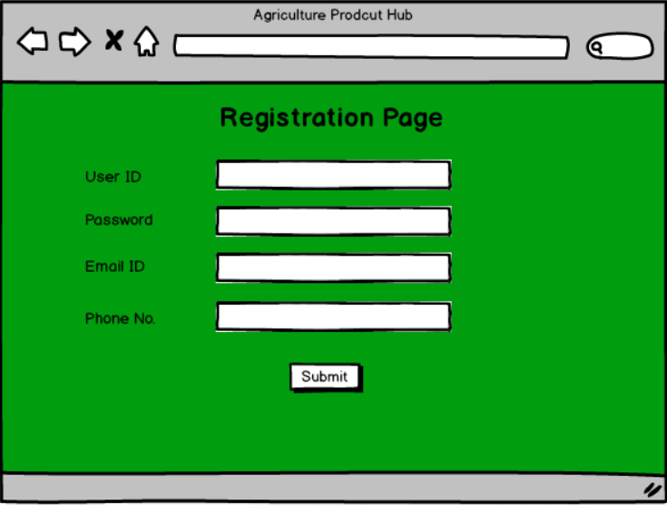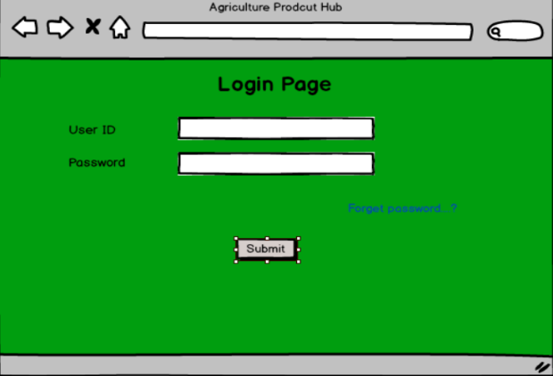

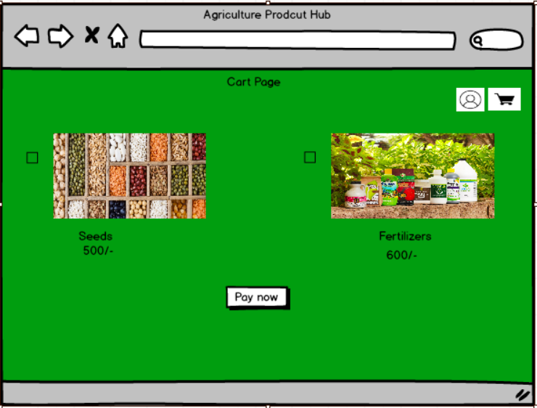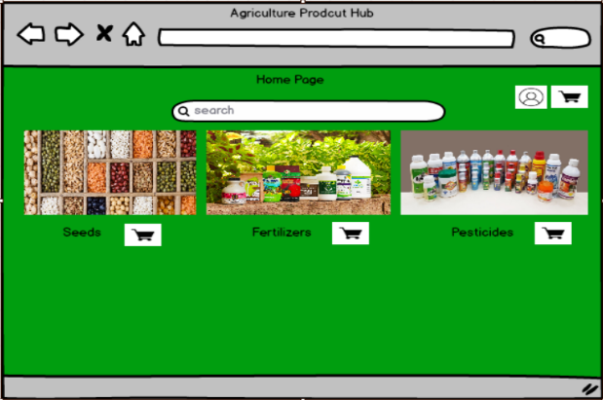

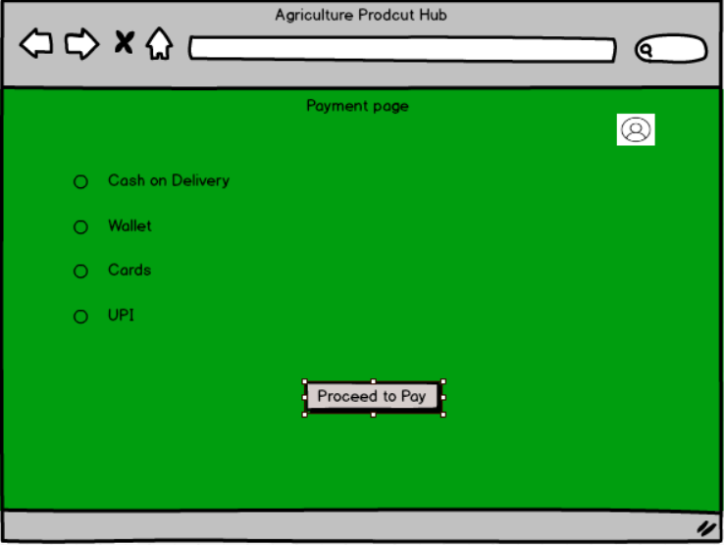

**Question 3 – Tools (Visio, Balsamiq) - 15 Marks**

Make a note of the Tools, which you are using for above concepts.

Answer: Some commonly used tools for the concepts you mentioned:

* Balsamiq: Balsamiq is a popular wireframing tool used for creating low-fidelity prototypes. It focuses on simplicity and sketch-like designs to quickly visualize and communicate design ideas. With its drag-and-drop interface and pre-built UI elements, Balsamiq allows users to rapidly iterate and gather feedback on the basic structure and layout of a digital product.
* Axure: Axure is a powerful prototyping tool that enables the creation of interactive and high-fidelity prototypes. It offers a wide range of dynamic and interactive elements, such as animations, conditional logic, and data-driven interactions. Axure allows designers to simulate user flows and test complex interactions before the actual development phase, aiding in user testing and stakeholder communication.
* Microsoft Visio: Microsoft Visio is a versatile diagramming tool that allows users to create a wide range of diagrams, including flowcharts, organizational charts, and network diagrams. With its extensive library of shapes and customization options, Visio enables users to visually represent complex information and processes. It offers collaboration features, data linking capabilities, and seamless integration with other Microsoft Office applications.

Axure: Axure is a powerful prototyping tool that enables the creation of interactive and high-fidelity

prototypes. It offers a wide range of dynamic and interactive elements, such as animations, conditional

logic, and data-driven interactions. Axure allows designers to simulate user flows and test complex

interactions before the actual development phase, aiding in user testing and stakeholder

communication.

Microsoft Visio: Microsoft Visio is a versatile diagramming tool that allows users to create a wide range

of diagrams, including flowcharts, organizational charts, and network diagrams. With its extensive

library of shapes and customization options, Visio enables users to visually represent complex

information and processes. It offers collaboration features, data linking capabilities, and seamless

integration with other Microsoft Office applications

These tools can assist you in visualizing and prototyping your design concepts effectively. It's important to explore their features and determine which tool best fits your specific needs and preferences.

**Question 4 – RTM - 6 Marks**

A business analyst’s key responsibilities are to keep track of the requirements and make sure that

no requirement is missed.

Mr. Henry and peter have approached you regarding the current status of the project. How will you

tackle this situation?

Answer: RTM: A requirements traceability matrix is a document that demonstrates the relationship between requirements and other artefacts. It is the document to track the requirement throughout the project lifecycle, ensuring that they are met and that no requirement is overlooked.

|  |  |  |  |  |  |  |  |  |  |  |  |  |  |  |
| --- | --- | --- | --- | --- | --- | --- | --- | --- | --- | --- | --- | --- | --- | --- |
| **Req ID** | **Req Name** | **Req Description** | **Design** | **Code** | | **Unit Testing** | | **Component Testing** | | **System Tesing** | | **Integration Testing** | | **UAT** |
| FR0001 | Farmer Registration | Farmers should be able to register with the application | Complete | Complete | | Complete | | Complete | | Complete | | Complete | | In progress |
| FR0002 | Farmer Search for Products | Farmers should be able to search for available products in fertilizers, seeds, pesticides | Complete | Complete | | Complete | | Complete | | In progress | | In progress | | In progress |
| FR0003 | Shopping cart | Should allow farmers after logging in to add the products to the shopping cart (buy now /buy later | Complete | Complete | | Complete | | Complete | | In progress | | In progress | | Complete |
| FR0004 | Payment Processing Application should be able to manage  multiple payment gateways to facilitate  secure and convenient transactions  Payment Processing | Application should be able to manage multiple payment gateways to facilitate secure and convenient transactions | Complete | Complete | | Complete | | Complete | | In progress | | In progress | | In progress |
| FR0005 | Order quantity placement | Farmers should be able to place order for specifying quantity for selected address and selected products | Complete | Complete | | Complete | | Complete | | Complete | | In progress | | In progress |
| FR0006 | Order History | Should allow to view the past history including the orders list, and status of the order | Complete | Complete | | Complete | | Complete | | Complete | | Complete | | Complete |
| FR0007 | Tracking details Users getting an email confirmation with a  delivery tracker to track the status of the  order in real time  Tracking details | Users getting an email confirmation with a delivery tracker to track the status of the order in real time | Complete | Complete | | Complete | | Complete | | In progress | | In progress | | In progress |
| FR0008 | Order confirmation | Users should get confirmation details like order quality, colour, delivery timeline on the specified ordered products | Complete | Complete | | Complete | | Complete | | Complete | | In progress | | In progress |
| FR0009 | Customer service | Should allow customer support to either chat, phone, call option | Complete | Complete | | Complete | | Complete | | In progress | | In progress | | In progress |
| FR0010 | Inventory control | Should have update on the inventory needed if required | Complete | Complete | | Complete | | Complete | | Complete | | In progress | | In progress |
| FR0011 | Product reviews | Allow users to provide ratings to the products they have purchased | Complete | Complete | | Complete | | Complete | | Complete | | In progress | | In progress |
| FR0012 | Return and refund | Policy Should allow user to avail for a refund or a return if the product is damaged or doesn’t meet the criteria | Complete | Complete | | Complete | | Complete | | In progress | | In progress | | In progress |
| FR0013 | Manufacturer registration | Allow manufacturers to register and login | Complete | | Complete | | Complete | Complete | Complete | | Complete | | In progress | |
| FR0014 | Product Recommendations | Application should provide personalized product recommendations according to user history and order history | Complete | | Complete | | Complete | Complete | In progress | | In progress | | In progress | |
| FR0015 | Social Sharing | Application should allow users to share the products socially to anyone on social media platforms | Complete | | Complete | | Complete | Complete | In progress | | In progress | | Complete | |
| FR0016 | Product Filtering | Should allow users to filter the product according to their needs | Complete | | Complete | | Complete | Complete | In progress | | In progress | | In progress | |
| FR0017 | Account management | Should allow users to manage their account via/ profile settings, password changes and email preferences | Complete | | Complete | | Complete | Complete | Complete | | In progress | | In progress | |
| FR0018 | Order confirmation | Should allow users to select the mode of confirmation either via(email/phone number, SMS, what’s app etc) | Complete | | Complete | | Complete | Complete | Complete | | Complete | | Complete | |
| FR0019 | Manufacturer Product | Listing Should allow manufacturers to able to list their products | Complete | | Complete | | Complete | Complete | In progress | | In progress | | In progress | |
| FR0020 | Wishlist | Show allows customers to add the products to Wishlist to buy later | Complete | | Complete | | Complete | Complete | Complete | | In progress | | In progress | |
| FR0021 | Auto order | Should allow users to enable auto order according to the flexibility of time/month or days frequency | Complete | | Complete | | Complete | Complete | In progress | | In progress | | In progress | |

|  |  |  |  |  |  |  |  |  |  |
| --- | --- | --- | --- | --- | --- | --- | --- | --- | --- |
| **Req ID** | **Req Name** | **Req Description** | **Design** | **Code** | **Unit Testing** | **Component Testing** | **System Tesing** | **Integration Testing** | **UAT** |
| NFR0101 | Page Loading Time | Each Page should load within 2 seconds time | Complete | Complete | Complete | Complete | Complete | Complete | In progress |
| NFR0102 | WCAG 2.1. | The system must meet Web Content Accessibility Guidelines WCAG 2.1. | Complete | Complete | Complete | Complete | In progress | In progress | In progress |
| NFR0103 | Internet speed Required internet speed to run the  application  Internet speed | Required internet speed to run the application | Complete | Complete | Complete | Complete | Complete | In progress | In progress |
| NFR0104 | Maintenance | Maintenance of the application | Complete | Complete | Complete | Complete | Complete | In progress | In progress |
| NFR0105 | Compliance | Adherence of law, regulations, industry standards etc. | Complete | Complete | Complete | Complete | In progress | In progress | In progress |

**Question 5 – 10 Test Case Documents - 10 Marks**

Prepare 10 Test Case Documents

Answer: Test Case Documents is a detailed outline used by testers to ensure that a software application or system is working as expected.

|  |  |  |  |  |  |  |  |
| --- | --- | --- | --- | --- | --- | --- | --- |
| **Test Case** | | TC001 | **Test Case Name** | | | New User Registration | |
| **Project ID** | | PRJ001 | **Project Name** | | | Online Agriculture Product Store | |
| **PM ID** | | PM001 | **Tester ID** | | | T001 | |
| **Test Strategy ID** | | TS001 | **Tester Name** | | | Mr John | |
| **Test Plan ID** | | TP001 | **Date of Test** | | | 25/04/2024 | |
| **Test Schedule ID** | | TSCH001 | **Prepared By** | | | BA | |
|  | | | | | | | |
| **Scenario** | | The user enters valid phone number or email id and clicks on the register button. User receives an OTP. User enters the OTP and click on login button. | | | | | |
| **Example** | | Phone number - 9123458765, Email - abc@gmail.com, OTP - 9999 | | | | | |
|  | | | | | | | |
| **Action** | **Input** | | **Expected Output** | **Actual Output** | **Test Browser** | | **Test Result** |
| Enter phone number/e mail id and click on Register. Enter OTP and click on login | Phone number -9123458765, Email [-abc@gmail.com](mailto:-abc@gmail.com), OTP – 9999 | | The user should be able to register and redirected to home page | User successfully logged in and redirected to home page | Internet Explorer | | Pass |

|  |  |  |  |  |  |  |  |
| --- | --- | --- | --- | --- | --- | --- | --- |
| **Test Case** | | TC002 | **Test Case Name** | | | Attempt to login with invalid credentials | |
| **Project ID** | | PRJ001 | **Project Name** | | | Online Agriculture Product Store | |
| **PM ID** | | PM001 | **Tester ID** | | | T002 | |
| **Test Strategy ID** | | TS002 | **Tester Name** | | | Mr John | |
| **Test Plan ID** | | TP001 | **Date of Test** | | | 25/04/2024 | |
| **Test Schedule ID** | | TSCH002 | **Prepared By** | | | BA | |
|  | | | | | | | |
| **Scenario** | | The user enters invalid phone number or email id and clicks on the register button. User receives an OTP. User enters the invalid OTP and click on login button | | | | | |
| **Example** | | Phone number - 1234567890, Email - invalid@gmail.com, OTP - 0000 | | | | | |
|  | | | | | | | |
| **Action** | **Input** | | **Expected Output** | **Actual Output** | **Test Browser** | | **Test Result** |
| Enter phone number/email id and click on Register. Enter invalid OTP and click on login | Phone number -1234567890, Email-invalid@gmail.com, OTP- 0000 | | The system should display an error message -''Invalid phone number/Email'' | Error message was displayed | Internet Explorer | | Pass |

|  |  |  |  |  |  |  |  |
| --- | --- | --- | --- | --- | --- | --- | --- |
| **Test Case** | | TC003 | **Test Case Name** | | | Add product to cart | |
| **Project ID** | | PRJ001 | **Project Name** | | | Online Agriculture Product Store | |
| **PM ID** | | PM001 | **Tester ID** | | | T003 | |
| **Test Strategy ID** | | TS003 | **Tester Name** | | | Mr John | |
| **Test Plan ID** | | TP001 | **Date of Test** | | | 25/04/2024 | |
| **Test Schedule ID** | | TSCH003 | **Prepared By** | | | BA | |
|  | | | | | | | |
| **Scenario** | | The user selects some products and add it to the cart. | | | | | |
| **Example** | | Select Organic Tomato seeds 1 Kg | | | | | |
|  | | | | | | | |
| **Action** | **Input** | | **Expected Output** | **Actual Output** | **Test Browser** | | **Test Result** |
| Click on the product. Select the required quantity and then click on 'Add to Cart' button | Product – Organic Tomato Seeds Quantity - 1 Kg | | The product should be added to the cart with accurate quantity | Product was added to the cart with correct quantity | Chrome | | Pass |

|  |  |  |  |  |  |  |  |
| --- | --- | --- | --- | --- | --- | --- | --- |
| **Test Case** | | TC004 | **Test Case Name** | | | Remove product from cart | |
| **Project ID** | | PRJ001 | **Project Name** | | | Online Agriculture Product Store | |
| **PM ID** | | PM001 | **Tester ID** | | | T004 | |
| **Test Strategy ID** | | TS004 | **Tester Name** | | | Mr John | |
| **Test Plan ID** | | TP001 | **Date of Test** | | | 25/04/2024 | |
| **Test Schedule ID** | | TSCH004 | **Prepared By** | | | BA | |
|  | | | | | | | |
| **Scenario** | | The user removes a product from the cart | | | | | |
| **Example** | | Remove pesticides 2 Ltrs | | | | | |
|  | | | | | | | |
| **Action** | **Input** | | **Expected Output** | **Actual Output** | **Test Browser** | | **Test Result** |
| Select the product in cart. Then click on Remove button | Product - Pesticide  Quantity - 2 Ltrs  Product – Pesticide Quantity - 2 Litres | | The user should be able to remove the product from the cart | User was able to remove the product | Firefox | | Pass |

|  |  |  |  |  |  |  |  |
| --- | --- | --- | --- | --- | --- | --- | --- |
| **Test Case** | | TC005 | **Test Case Name** | | | Search for a product | |
| **Project ID** | | PRJ001 | **Project Name** | | | Online Agriculture Product Store | |
| **PM ID** | | PM001 | **Tester ID** | | | T005 | |
| **Test Strategy ID** | | TS005 | **Tester Name** | | | Mr John | |
| **Test Plan ID** | | TP001 | **Date of Test** | | | 25/04/2024 | |
| **Test Schedule ID** | | TSCH005 | **Prepared By** | | | BA | |
|  | | | | | | | |
| **Scenario** | | The user searches for a specific product | | | | | |
| **Example** | | Search for Cucumber seeds 1 Kg | | | | | |
|  | | | | | | | |
| **Action** | **Input** | | **Expected Output** | **Actual Output** | **Test Browser** | | **Test Result** |
| Type cucumber seeds in product search bar and hit enter | search cucumber seeds1 Kg | | The user should be able to search for 1 Kg Cucumber seeds | User was able to search the product | Internet Explorer | | Pass |

|  |  |  |  |  |  |  |  |
| --- | --- | --- | --- | --- | --- | --- | --- |
| **Test Case** | | TC006 | **Test Case Name** | | | Add product to favourites | |
| **Project ID** | | PRJ001 | **Project Name** | | | Online Agriculture Product Store | |
| **PM ID** | | PM001 | **Tester ID** | | | T006 | |
| **Test Strategy ID** | | TS006 | **Tester Name** | | | Mr John | |
| **Test Plan ID** | | TP001 | **Date of Test** | | | 25/04/2024 | |
| **Test Schedule ID** | | TSCH006 | **Prepared By** | | | BA | |
|  | | | | | | | |
| **Scenario** | | The user adds a product to favourites or wish list | | | | | |
| **Example** | | Add Power Fertiliser to favourites | | | | | |
|  | | | | | | | |
| **Action** | **Input** | | **Expected Output** | **Actual Output** | **Test Browser** | | **Test Result** |
| Find the product and then click on the LOVE symbol | Product – Power Fertiliser | | The user should be able to add the product to Wishlist | Product was successfully added to favourites | Chrome | | Pass |

|  |  |  |  |  |  |  |  |
| --- | --- | --- | --- | --- | --- | --- | --- |
| **Test Case** | | TC007 | **Test Case Name** | | | Update product quantity in cart | |
| **Project ID** | | PRJ001 | **Project Name** | | | Online Agriculture Product Store | |
| **PM ID** | | PM001 | **Tester ID** | | | T007 | |
| **Test Strategy ID** | | TS007 | **Tester Name** | | | Mr John | |
| **Test Plan ID** | | TP001 | **Date of Test** | | | 25/04/2024 | |
| **Test Schedule ID** | | TSCH007 | **Prepared By** | | | BA | |
|  | | | | | | | |
| **Scenario** | | User updates the quantity of the product in cart | | | | | |
| **Example** | | Update quantity of power fertilizer from 2 Kg to 3 Kg | | | | | |
|  | | | | | | | |
| **Action** | **Input** | | **Expected Output** | **Actual Output** | **Test Browser** | | **Test Result** |
| Go to cart and change the quantity of the product from 2Kg to 3 Kg | Product – Power Fertilizer Quantity - 3 Kg | | The user should be able to change the quantity of the product | User was able to change the quantity | Chrome | | Pass |

|  |  |  |  |  |  |  |  |
| --- | --- | --- | --- | --- | --- | --- | --- |
| **Test Case** | | TC008 | **Test Case Name** | | | Display total cost of the products | |
| **Project ID** | | PRJ001 | **Project Name** | | | Online Agriculture Product Store | |
| **PM ID** | | PM001 | **Tester ID** | | | T008 | |
| **Test Strategy ID** | | TS008 | **Tester Name** | | | Mr John | |
| **Test Plan ID** | | TP001 | **Date of Test** | | | 25/04/2024 | |
| **Test Schedule ID** | | TSCH008 | **Prepared By** | | | BA | |
|  | | | | | | | |
| **Scenario** | | The user gets the total cost of the products by clicking the Checkout button | | | | | |
| **Example** | | Calculate cost of 1 Kg Fertilizer & 2 Kg Pesticide | | | | | |
|  | | | | | | | |
| **Action** | **Input** | | **Expected Output** | **Actual Output** | **Test Browser** | | **Test Result** |
| Click on the Checkout button after adding 2products | search cucumber seeds1 Kg Product - Fertiliser and Pesticide Quantity - 1 & 2 Kg | | The system should display the total cost of 2 product | Total cost of the product was displayed including GST | Internet Explorer | | Pass |

|  |  |  |  |  |  |  |  |
| --- | --- | --- | --- | --- | --- | --- | --- |
| **Test Case** | | TC009 | **Test Case Name** | | | Select COD & place order | |
| **Project ID** | | PRJ001 | **Project Name** | | | Online Agriculture Product Store | |
| **PM ID** | | PM001 | **Tester ID** | | | T009 | |
| **Test Strategy ID** | | TS009 | **Tester Name** | | | Mr John | |
| **Test Plan ID** | | TP001 | **Date of Test** | | | 25/04/2024 | |
| **Test Schedule ID** | | TSCH009 | **Prepared By** | | | BA | |
|  | | | | | | | |
| **Scenario** | | Payment mode COD for 1 Kg Fertilizer | | | | | |
| **Example** | | Calculate cost of 1 Kg Fertilizer & 2 Kg Pesticide | | | | | |
|  | | | | | | | |
| **Action** | **Input** | | **Expected Output** | **Actual Output** | **Test Browser** | | **Test Result** |
| On Checkout screen, select COD as mode of payment and then click on the Order button | Payment mode – COD  Product-Fertiliser Quantity - 1 Kg | | The user should be able to place the order selecting COD | Order was successfully placed | Safari | | Pass |

|  |  |  |  |  |  |  |  |
| --- | --- | --- | --- | --- | --- | --- | --- |
| **Test Case** | | TC010 | **Test Case Name** | | | Cancel the existing order | |
| **Project ID** | | PRJ001 | **Project Name** | | | Online Agriculture Product Store | |
| **PM ID** | | PM001 | **Tester ID** | | | T010 | |
| **Test Strategy ID** | | TS010 | **Tester Name** | | | Mr John | |
| **Test Plan ID** | | TP001 | **Date of Test** | | | 25/04/2024 | |
| **Test Schedule ID** | | TSCH010 | **Prepared By** | | | BA | |
|  | | | | | | | |
| **Scenario** | | The user selects the existing order and clicks on cancel button | | | | | |
| **Example** | | Cancel the order for 2 Kg Tomato seeds | | | | | |
|  | | | | | | | |
| **Action** | **Input** | | **Expected Output** | **Actual Output** | **Test Browser** | | **Test Result** |
| Select the live order and then click on Cancel button | Product - Tomato seeds Quantity - 2 Kg | | The user should be able to cancel the order | Order was successfully cancelled | Chrome | | Pass |

**Question 6 – DB Design – 8 Marks**

After the requirements are thoroughly explained to the entire project team by business analyst, the

Database architects have decided to do the database design and also to represent the in-flow and

out-flow of data.

Draw database schema and ER diagram

Answer: Database Schema: it is blueprint that outlines the structure of a database, including its tables, fields, relationships, constraints and other characteristics.

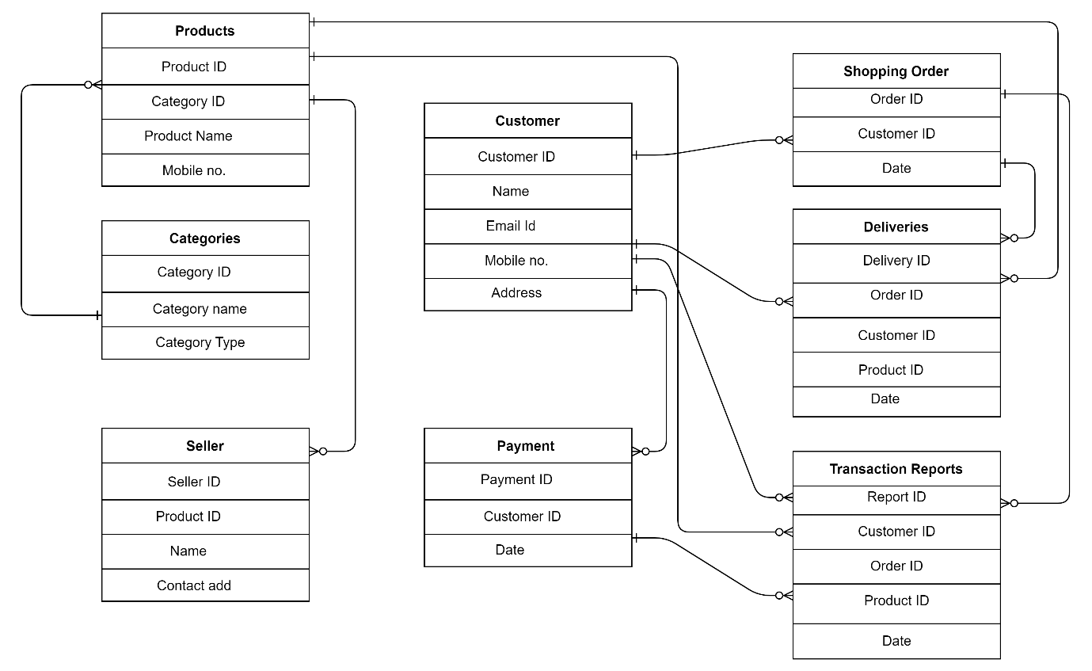

ERD: Entity Relationship diagram is a visual representation of the relationships between entities in a database. It depicts the entities (such as tables), attributes (properties or fields) and relationships between them.

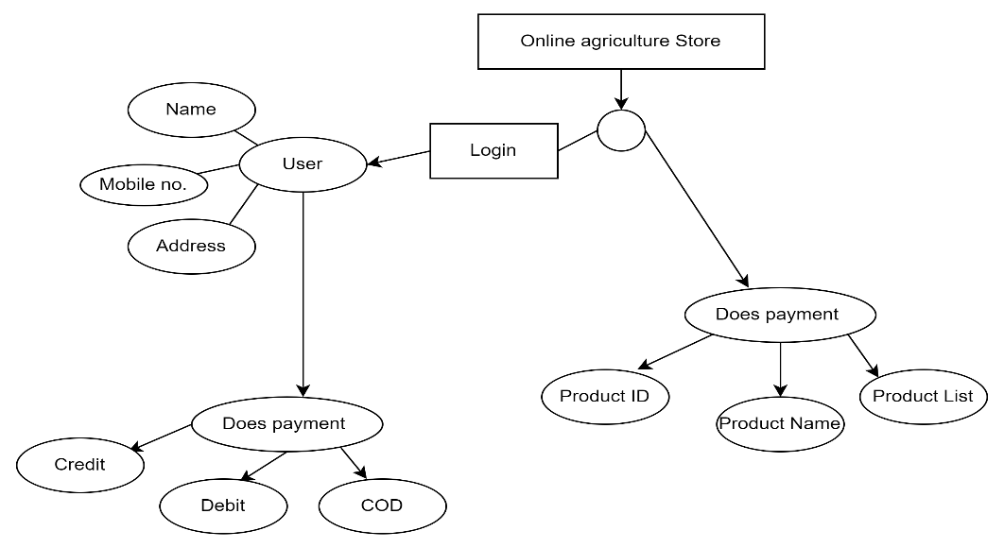

**Question 7 – Data Flow Diagram - 3 Marks**

What is a data flow diagram? Draw a data flow diagram to represent the in-flow and out-flow of

data when a Farmer is placing an order for the product

Answer: A Data Flow Diagram (DFD) is a graphical representation of the flow of data within a system. It visually shows how data moves from one process to another, how it's stored, and where it ends up.

It helps analysts and designers understand the flow of data within a system, identify potential bottlenecks or inefficiencies, and communicate system requirements to stakeholders.

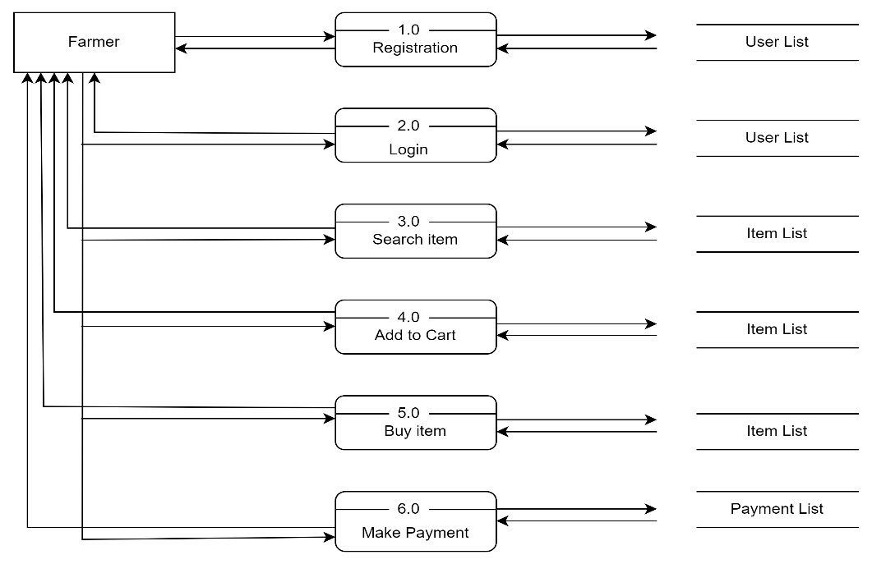

**Question 8 – Change Request - 10 Marks**

Due to change in the Government Taxation structure. we should change the Tax structure

How do you handle change requests in a project?

Answer: A change request is a formal proposal to alter a system, product or project.

Change requests are when a stakeholder, either a client or an internal team or department, requests a change to the processes or deliverables that had already been decided upon in the project scope. However, in this scenario, this change request has come up due to change in the Govt. Taxation structure. As a BA, I would analyse the request and clarify the stakeholders exactly what the request is asking us to do in the Online Agriculture Product Store. In a normal scenario, as a BA, I would first do the Feasibility Test, to check, how feasible it is to change the current ongoing project with the new change request. However, in this case, Feasibility study is not required, as it’s a Govt structure which needs to be updated and followed.

Therefore, as a BA the below steps to change the project as per the client’s requirements:

* Document the Change request.
* Look for any Supporting materials to help in adding this Change.
* Need to assess, whether the Change is an Inside or Outside scope. As it’s an outside scope, the Budget and time will get impacted.
* BA and PM should ensure whether the change is a minor or a major change. Policy changes by Govts a major change request and we need to ensure that the change should be done according to the Govt. instruction.
* Fill the Change request Form (CRL) and get the approval from the Project Manager.
* We also need to ensure that our Team understands the priority of this change request.
* We also need to discuss the change with Change Control Board (CCB) who will recommend the necessary change on the Project.
* Once this change is approved, the project deliverables will need to be updated. This can include plans and schedules, business process documents, and the requirements documents.
* Once these updates have been made, the project manager can communicate the new course of action to everyone who will be impacted. Now you can delegate the necessary tasks to the people in charge of implementing these new changes

**Question 9 – Change Request Vs an Enhancement - 5 Marks**

As the project is in process, Ben and Kevin have contacted you. The reason is to inform you that they want the Farmers to sell their crop yields through this application i.e. Farmers should be able to add their crop yields or products and display to general public and should be able to sell them. They also want to introduce Auction system for their Crop yields. As a BA, what will be your response? Is this a change request or an enhancement???

Answer: The request from Ben and Kevin is an Enhancement request, as they want to add another feature in the Online store which acts as an application upgrade, which will also help the Farmers to sell the yields directly in the online store, apart from buying products. Hence my response would a positive response to them. Therefore, as a BA, I should analyse the request and provide a project plan, requirement, design, a testing plans for this request. I must prepare an enhancement request form and decide how much man-power and man-hours required for this enhancement request

**Question 10 – Estimations - 6 Marks**

Come up with estimations – How many Manhours required

Answer: Manhours Required= Total hours working per day x Total number of members x Total numbers of days worked over the specific period.

Number of Working Hours a day = 8 hours

Number of Resources = 12

Time period provided = 18 months = 547 days = 78 weeks (Including Weekends and Public Holidays)

Assuming Weekends = 156

Assuming Public Holidays = 10

Total = 166

547-166 = 381 working days. Hence, Estimated Manhours = 8 hours * 12 resources * 381 days = 36,576 hours required

**Question 11 – UAT – 6 Marks**

Project has finally completed all the stages i.e., design, development, testing etc. Now, it is the role of a business analyst to contact the client for testing of the final product and have to successfully complete it. How are you going to handle this situation? And once it is done, what will be the process to close the project?

Explain UAT Acceptance process

Answer: UAT is the final stage of the software development lifecycle where the end-users of the system test the product to ensure that it meets their requirements and is ready for deployment. The UAT Acceptance process involves the following steps –

Planning: The business analyst works with the client to plan the UAT phase, including defining the scope,

identifying the test scenarios and cases, and setting the acceptance criteria.

Test Execution: The end-users perform the testing on the software product in a real-world environment

and provide feedback on its usability, functionality, and performance.

Issue Resolution: If any issues are identified during the UAT phase, they are recorded and addressed by

the development team.

Sign-off: Once the UAT is completed successfully, the end-users sign-off on the product, indicating that it

meets their requirements and is ready for deployment. To close the project, the following steps can be

taken: Project Review: The business analyst conducts a project review to ensure that all the

requirements have been met, and the project objectives have been achieved.

Documentation: All project documentation, including requirements documents, design documents, test

cases, and project plans, are reviewed and updated.

Closure Meeting: A

Planning: The business analyst works with the client to plan the UAT phase, including defining the scope, identifying the test scenarios and cases, and setting the acceptance criteria.

Test Execution: The end-users perform the testing on the software product in a real-world environment and provide feedback on its usability, functionality, and performance.

Issue Resolution: If any issues are identified during the UAT phase, they are recorded and addressed by the development team.

Sign-off: Once the UAT is completed successfully, the end-users sign-off on the product, indicating that it meets their requirements and is ready for deployment. To close the project, the following steps can be taken: Project Review: The business analyst conducts a project review to ensure that all the requirements have been met, and the project objectives have been achieved.

Documentation: All project documentation, including requirements documents, design documents, test cases, and project plans, are reviewed and updated.

Closure Meeting: A closure meeting is held with the stakeholders to discuss the success of the project, any lessons learned, and future recommendations.

Project Closure Report: The business analyst prepares a project closure report that includes the project review, documentation updates, closure meeting outcomes, and any final recommendations.

Archiving: The project documentation and artefacts are archived for future reference, and the project team is disbanded.

**Question 12 – Project Closure Document - 6 Marks**.

Explain Project closure document

Answer: A project closure document is a document that summarizes the results of a project. It documents all phases of project management into one report. It includes the team’s accomplishments, lessons learned, and recommendations for improving upon future projects. A project closure document is created at the end of a project

|  |  |  |  |
| --- | --- | --- | --- |
| Sr No. | Point To Include | Details | Reference |
| **1** | **Did the client sign of UAT** |  |  |
|  | Date of sign of: | 25/4/2024 | Business_Scope.docx |
|  | Name of the resource: | Mr Henry |
| **2** | **Objective of the project** |  |  |
|  | User friendliness | Achieved |  |
|  | Customer satisfaction | ROI n 6 months |  |
|  | More sales | Achieved |  |
| **3** | **Functionalities worked on** |  |  |
|  | Secure payment processing | Achieved | FRD.docx |
|  | Categories | Achieved |
| **4** | **Infrastructure** |  |  |
|  | Software installed |  | Procurement.docx |
|  | Server setup |  |
| **5** | **Funding** |  |  |
|  | Amount Sanctioned | 2 crores | FinancialDetails.xlsx |
|  | Amount Used | 2 crores |
| **6** | **Overall project information** |  |  |
|  | Escalations | 12 |  |
|  | Customer satisfaction | High |  |
| **7** | **Value to the organization** |  |  |
|  | Positive/Negative | Company has successfully integrated the project increased turnover by 30% and increased efficiency by20% |  |