**Question 1 – Audits**

**Ans:**

Audit is all about inspection and providing independent opinion about things working in organization. It is a positive aspect for team or organization because it will inspect whether things are going as per stakeholder requirement or company compliance.

Auditing is an independent objective assurance consulting activity which is designed to add values and improve an organization operation. In every organization we have three layers of defence First line, Second Line and third line and internal audit is Third line defence. They are the one directly reports to the Board of Directors. They called as eyes and ear of an organization. They audit all the process like Change Management, data centres, IT, Information Security. They audit all these process audits is not only about checking certification and all main objective is to identify the gaps, identify the risk and proactively inform to the board members

**Internal Audit:**

The purpose of this audit is to evaluate the effectiveness, accuracy, and completeness of the requirement gathering process conducted for the Agriculture E-Commerce Platform. This audit aims to ensure that all stakeholder requirements are identified, documented, and validated in alignment with business objectives and industry best practices.

**Objective of internal Audit:**

1. Ensures reliability of Financial and Management Report
2. Ensures the company is compliance with law and regulation
3. Responsible for safeguard of an assets
4. effectiveness, accuracy, and completeness of the requirement gathering process

**Procedure of an Audit:**

1. In Internal audit there is audit manager who basically plan the audit of the year and release to the audit teams. Audit of the year going to plan by Audit committee or Audit head.
2. Audit team sends an Announcement letter to Audience of the respective team in this it includes Date and Time of an Audit, the Name of the Auditor or Associate Auditor who will be part of the Audit, Scope of the edit.
3. Conduct Pre-Audit meeting and Interview department personal or kick-off meeting auditor gathers relevant information about the Unit. In one audit need to have two Auditors and one Audit manager. In this meeting trying to understand how the operation work in their process and request for Policy, SOP for the necessary Doc.

And cross questions like how many days for Change request or it to approve? Who has sign-off this SOP? 3i checks on RFC? Overall, we are asking for all Applicable law and Regulation, Any Policy Memorandum or directive related to the operation, copy of the Procedure manuals, Organization chart, Department chart, Goals and Objectives

1. Collect documents on EMAIL for Accountability
2. **Audit Plan Memorandum (APM)**

Prepare one Internal Document called Audit Plan Memorandum (APM). This internal to the organization if suppose some committee wants to audit then they will refer this document only. In this Document after understanding entire process I/Auditor will identify the possible risk like suppose during review of SOP, I identified the same person is approving the SOP and closing the tickets then that is risk. In this document explains about audit steps, overall process. In APM, Scope of the process, When team starting field work, when we submitting report, Scope of Audit and List of all possible Risk we have identified

1. **Prepare PreRisk control matrix:**

From APM, auditor will pen down the risk, associated risk and in third column how to conduct an Audit of this controls to identify. Detailed discussion in internal audit team along with Audit Manager and can finalize the Pre-RCM.

1. **Field Work**

Based on Pre-RCM, field work will start based on SOP investigation. For example, In SOP it has mentioned that every RFC need to have six parameters. So that auditor will collect the sample of the RFC.

1. **Pick Sample based on Sea-Saw Sampling technique:**

There could be 10000 or 20000 RFC. From two team member it is not possible to judge so by using Sea-Saw Technique random 100 samples will be going to take place and from 100 if 90 RFC are not as per the SOP then we Flag for identification and pen down. In RFC, there will be recovery plan also included an also need to check whether SOP is basically sign-off by the concerned person during SOP if it is not Sign-Off then this called Lack of Governance.

1. **Preparing Report final Stage of Audit:**

After field work, peer and auditor will discuss about all discussion and create Post-RCM, in this What is the confirm Risk from possible Risk? What audit steps have taken? What is the evidence for that particular control effectiveness?

1. **Creating Draft Audit report:**

Basically, summarize the audit findings, conclusion, recommendation and cross checking with teammates and draft the risk two ways like qualitative and quantitative. Second, we give our recommendations also we need action plan from them in only Action plan area keep read/write option rest of the things are only the Read. First email will be share with the Internal Audit head and audit manager and debate with them. Then only shares the draft report with Auditee because we need their action plan. This are also call evidence paper

1. **Do follow-up meeting**

Once agreed upon the action plan, need to ask timeline for the action plan and need to get follow up whether they closed it or not. Final report will get released by the auditor or by the Auditor Manager. Then finally this going to share to the Process manager counter.

1. **Need Evidence for closing the finding:**

If Auditee confirms the finding has been closed but still need the evidence then only we can flag the finding off in our sheet

|  |  |
| --- | --- |
| Stages | Quarter1 Audit Report(Requirement Gathering Phase) |
| Completed | 10 weeks (Week1 to Week 10) |
| Check List | BRD Template |
|  | Elicitation techniques |
|  | Duplicate requirement report |
|  | Grouping of functionalities/features |
|  | client sign-off |
|  | Email communication To,CC,BCC |

|  |  |
| --- | --- |
| Stages | Quarter 2- Audit Report (Requirement Analysis phase) |
| Completed | 7 weeks (Week 16 to Week 23) |
| Check List | UML Diagram |
|  | Business to Functional requirement mapping |
|  | Client sign-off document |
|  | RTM Document version control |
|  | Email communication To,CC,BCC |

|  |  |
| --- | --- |
| Stages | Quarter 3- Audit Report(Design) |
| Completed | 7 weeks (Week 30 to week 37) |
| Check List |  |
|  | Utilization of tools |
|  | Documented evidence on client communication |
|  | Stakeholder MOM |
|  | Email communication To,CC,BCC |

|  |  |
| --- | --- |
| Stages | Quarter 4- Audit Report(Development) |
| Completed | 20 weeks (Week 40 to week 60) |
| Check List |  |
|  | JAD Session report |
|  | End user manual preparation document |
|  | BA and Developer MOM |
|  | Email communication To, CC, BCC |

|  |  |
| --- | --- |
| Stages | Quarter 5- Audit Report(Testing) |
| Completed | 7 weeks (Week 58 to week 78) |
| Check List |  |
|  | Test Case summary |
|  | Training report to end user |
|  | Lessons learnt Document |
|  | Email communication To, CC, BCC |

**Question 2 – BA Approach Strategy**

**Ans:**

* **What Elicitation Techniques to apply?**

Elicitation is all about getting information from the client about their needs regarding project. Elicitation is technique of bagging requirement from the client but sometimes not sure what exactly he wants so that time without any proper technique we could not proceed. Elicitation is all about by using any of the following technique gather the in-detail input. BA has to decide which is best suitable foe client business requirement elicitation. There are three types basic requirement type

1. Collaborative
2. Research Based
3. Experiments
4. **Document Analysis:**

It is a popular elicitation technique. Document may involve Manual, Reports. It gives information about the current state of the project and current processes it is using so that you can identify gaps in the processes and the solution you need to applied. This method is like resume if records are up to date and verifiable. It is time taking process and faces obstacle if specific document is not available to you but it can give us further details for elicitation.

1. **Focus Groups:**

Focus Groups involved participant discuss one idea for a problem. There will be partial moderator who assist you. You can have preplanned question but it is an open discussion you can determine attitude, idea and methods through this discussion. Knowing our Target users in terms of what is the comfortable way, expectations and all called as **Focus Group**. For Example: For WhatsApp target users are peoples with mobiles.

1. **Interviews**

Interviews generally will be with an individual and planned can build strong relationship with stakeholder. It is systematic approach to posting relevant question related to software development. There are two types of questions

* **Open Ended:** It’s like Fill in the blanks type question. For example: Job interviewer ask tell me about yourself.
* **Closed Ended:** It’s like MCQ type for example: HR asking which city you want as job location

There are two types of interviews as shown below.

**Interviews**

**Structured Interviews**

**Unstructured Interviews**

When gives in input client in meeting regarding requirement then BA only receives input which was unplanned so he didn’t have planned questions to ask called Unstructured Interviews

Once Meeting done with client, BA goes through requirement and ask clients doubt in form of email is called structured interviews.

1. **Observation:**

Stakeholder or user might not know about what’s there value. People act differently when they know they are getting observed. So BA has to take care that he should secretly observing things.

Observation is of two types

1. **Active Observation:**

Active observation means where along with presentation get some comments or answers or feedback in form of communication.

1. **Passive Observation:**

Participants stay silent. There will be no response. Only observation will be done. For example: Recorded videos.

1. **Questionnaires and Surveys:**

To survey large groups of peoples can use Questionnaire. We can get lots of information in short amount of time but prepared remained stakeholders to complete the forms. The questions should be direct. We can ask open ended question where the respondent can write the answer in their own words. It is harder to quantify more answer but we can get more insights

1. **Workshop:**

It is a formal elicitation technique. Bringing stakeholder and user to bring ideas. It is processing driven way to discuss and clarify the idea. Select attendee and recruit scribe to record everything and there will neutralize facilitator to guide and keep on track. Usually, it will be for a day or two.

1. **JAD:**

So many people take a client call is nothing but JAD (Joint Application Development). Whenever there is need to understand the requirements directly from the client so BA will arrange the JAD. Application developed through the JAD has higher satisfaction and a smaller number of errors as user is directly involved in the development process. To avoid Tag-time BA will directly involve client to discuss or clarify the doubts of the development team. This can be weekly once.

1. **Prototyping:**

One of the Experimental elicitation techniques. You create Mock-ups to identify the requirements. You can also try prototype after using other elicitation techniques. Provide demos to the client. It is common for analyst to uncover missing requirements or use Mock-Ups to specify unclear request. It is better way for the client to visualize the system. It is way to affirm ideas and start put them into the reality. It requires time and money because the client can change requirements at any time.

BA will use Wireframing tool for creating Mock-ups. For example: AXURE (Dynamic Representation of screens) and BalsaMique (Static representation of screen)

1. **Brainstorming:**

Brainstorming is a group-oriented elicitation technique used to generate a wide range of ideas quickly, fostering creativity and problem-solving by encouraging participants to freely share their thoughts without immediate judgment.

Here's a breakdown of brainstorming as an elicitation technique:

What it is:

* **Group-based:**

Brainstorming involves a group of people (ideally 5-12) working together to generate ideas.

* **Idea Generation:**

The primary goal is to come up with as many ideas as possible within a set timeframe, focusing on quantity over quality initially.

* **Free Flow of Ideas:**

Participants are encouraged to share their thoughts without being judged or censored, allowing for a free flow of ideas.

* **Facilitated:**

A facilitator guides the brainstorming session, ensuring everyone participates and the discussion stays on track.

**How it works:**

1. **Define the Problem/Topic:** The facilitator clearly states the problem or topic that the group will brainstorm about.
2. **Generate Ideas:** Participants share their ideas, building upon each other's suggestions.
3. **Record Ideas:** A facilitator or designated person records all the ideas generated.
4. **Analyse and Prioritize:** After the brainstorming session, the group can analyse the ideas and prioritize them based on certain criteria.

**Benefits of Brainstorming:**

* **Encourages Creativity:**

By fostering a free-flowing environment, brainstorming can unlock creative solutions and perspectives.

* **Identifies Potential Solutions:**

The large number of ideas generated can lead to the discovery of innovative solutions to problems.

* **Facilitates Collaboration:**

Brainstorming encourages teamwork and collaboration, as participants learn from each other's ideas.

* **Improves Problem-Solving:**

By exploring different perspectives and ideas, brainstorming can lead to more effective problem-solving.

* **How to do stakeholder Analysis?**

The people who are directly or indirectly involve in the process of a software development. Stakeholder exist in both inside or outside of the organization.

**Types of Stakeholders**

1. **Project Stakeholders:**

Our IT team where we are going to service or solution to the client team is nothing but project stakeholders. In Figure mentioned all Project Stakeholder/Internal Stakeholder

1. **Business Stakeholders:**

It involves client-side team members who are actually supporting the business. In Figure mentioned all Business Stakeholder/External Stakeholder

1. **Third Party Stakeholder**

The Team members who are indirectly involves in the project are the Third-party stakeholders

* Auditors: Neither internal or External. Auditing as per guidelines or standards or not. Invested on project at once or phase by phase
* Focus Groups: Finding Target users llike for whatsapp Mobile numbers is the target user
* Manufacturer: Specification of the Software or the Hardware or the product for example: ATM Machine experts
* Outsource: If company don’t have the expertise then company will hire from outside or from vendor for some time also add values in success of the project
* Legal Specialist: Knowing about terms and condition about the project will be specified by the Legal Specialist. Going to protect the project.

1. **Negative Stakeholder**

The people who are always looks for project failure

* Competitor
* Hacker
* Public Opinion

Types of Stakeholder

* Project Manager
* Executive Sponsor
* Business Sponsor
* SPOC
* Operation Team
* Business Owner

Internal/Project Stakeholder

External/Business Stakeholder

* Auditor
* Focus Group
* Manufacturer
* Legal Specialist
* Outsource
* Competitor
* Hacker
* Public opinion

Third Party Stakeholder

Negative Stakeholder

* Project Manager
* Development
* Team
* Business Analyst
* Operation
* Testing Team

**Stakeholder Analysis**

It is nothing but the relationship between needs, Interest and Expert. It can be done by using Stakeholder analysis. Which is internal.

**Stakeholder for AgroTech project:**

Mr Henry - project sponsor

Mr Pandu -financial head

Mr Dooku -Project coordinator

Peter, Kevin, Ben- Key Stakeholders

Mr Karthik- Delivery Head

Mr Vandanam -Project manager

Ms juhli -Senior java Developer

Mr Teyson, Ms Lucie,

Mr Tucker, Mr Bravo -Java Developers

Mr Mike -Network Admin

Mr John -DB

Mr Jason and Ms Alekya -Tester

Sapna – BA

|  |  |  |  |  |  |  |  |  |
| --- | --- | --- | --- | --- | --- | --- | --- | --- |
| Task | Mr Henry- project sponsor | Mr. Karthik-Delivery head | Mr. vandanam-  Project manager | Mrs. Juhili- Senior Java Developer | Mr. Teyson,Ms Lucie Java | Mr.Tucker,Mr.Bravo-Java Developer | Peter, Kevin, Benkeey | Sapna-BA |
| Requirement Gathering |  | A/I |  | A |  |  | C | R |
| Analysis |  | I |  |  |  |  |  | R |
| Development |  | I | C/A | R | R |  |  |  |
| Testing |  | I |  |  |  | R |  |  |
| Implementation |  | I | I |  |  |  |  | R |
| UAT | I | R |  |  |  |  |  | C |

**Roles and responsibilities of the stakeholder**

Client (Mr. Henry): Mr. Henry has initiated the project and he is project Sponsor from company SOONY. As project initiates Project manager (Mr. Vandanam) decides the scope of the project and which models to follow. BA(Sapna) will look after business communication and functionality of the business. So, first BA(Sapna) will write communication mail to the client (Mr. Henry). Client will nominate the SPOC with that BA understand who is admin & sales team i.e., Key Stakeholder (Peter, Kevin & Ben) for sharing project requirement. This is how BA will summarize the stakeholder.

* **What Documents to Write?**

BA has to prepare document by three phases

1. **PreProject**: . After knowing proposal of the client in Business case document BA will try to understand client organization and capabilities, resources, technology Gaps, skillset of the resources, current system, current process every business parameter with the help of RFP & SOW. Here senior BA or Senior business consultant involved in this phase and do following analysis to understand opportunity. So senior BA will research on what was existing challenges and how to overcome. Summary of all these analyses is called Business case document. So, Business case document will help business owner and business sponsor to understand what company is all about and what is the opportunity & challenges company facing. After that can recommend some solution. After bagging project BA will do all following analysis of an organization capabilities and all. Then share with Business owner & Business consultant so they will come to know how we will implement, what are the future project plans, resource allocation, time, budget & quality management. As shown in Figure First column

* EA (Enterprise analysis): First BA will prepare RFP (request For Proposal), RFI (Request For information), SOW (Statement of Work)
* SWOT Analysis

|  |  |  |  |  |  |  |  |
| --- | --- | --- | --- | --- | --- | --- | --- |
| Preproject | | Implementation | | | | Support | |
|  | | **Planning** | | **Implementation** | |  | |
| EA | RFP, RFI, SOW,  Business Case Document | PM & Sr. BA will prepare PBA (Planning Business Analysis) | | **Req. Gathering** | BRD | Enhancement/  Change Management | CR,  CRT |
| SWOT | **Req. Analysis** | FRS,  SRS,  RTM,  SSD |
| RCA | **Design** | HDD, ADD |
| Strategy | **Coding** | LDD, CDD |
| GAP | **Testing** | TCD |
| FS | **Deployment** | User Manual, Training Manual |
| DA |  |  |  |  |

* RCA (Root Cause Analysis),
* Strategy Analysis,
* GAP Analysis,
* Feasibility Study
* Document Analysis: recommended solutions should be Quantitative not only Qualitative. On what basis recommending solution what is the scale or range of rating or ranking

1. **Implementation**

Once solution of the requirement got freeze then implementation phase will start. Before implementation and after solution selection phase there will be Planning phase in which Project manager will prepare project planning, resource allocation efforts estimation Basically He will prepare Gantt Chart in which how many resources requires, and task, what is the start and end date, Manhours. Meanwhile Senior BA will prepare BAP/PBA (Plan Business Analysis) Approach. He will also think whether we need BRD,FRD or other docs or not or he can put it in one. Senior Ba will decide how many document will going to maintain and what strategy going to follow, what are the document either it fully compliant doc or partially, what are the standard documentation need to follow, what procedure to follow for requirement gathering, prioritization this implementation phase. So after planning all this things in PBA by Senior BA the same doc will going to share to the BA. All document has summarized in Figure

Then BA will prepare the document according to the Requirement Gathering, Requirement analysis, Design, coding and Testing. All full forms of Document as

**BRD** (Business Requirement Document), **FSD** (Function Specification Document),**SRS** (Software Requirements Specification), **RTM** (Requirements Traceability Matrix), **SSD** (Software Design Document), **HDD** (High-level Design Document), **ADD** (Application Design Document), **LDD** (Low-level design Document), **CDD** (Customer Due Diligence), **TCD** (Test-case Design Document),User manuals for deployment.

1. **Support**

After implementation might have enhancement or Change management for this need to prepare **CR** document (Change Request) Or

**CR** Tracker (Change Request). If there are any version changes of software then just modified same BRD with Another version.

Note: In Agile methodology there will be zero coding but still for auditing purpose documents are necessary

* **What process to follow to Sign off on the Documents?**

Sign Off to be taken on SRS as this is the primary and important document. Sign off can be taken by using E-mail confirmation from client.

* **How to take Approvals from the Client?**

Establish Formal meeting with the clients to keep them informed and get continuous feedback.

* **When Communication Channels to establish and implement?**

Regular meeting- Weekly status meeting, bi -weekly sprint review and monthly stakeholder updates

* **How to handle Change request?**

Change request Form, Do Impact Analysis, Approvals Process, Documentation

* **How to update the progress of the project to the stakeholder?**

Weekly Status Report, Monthly Review Meeting

* **How to take signoff on the UAT-Client Project Acceptance Form?**

UAT preparation, Conduct UAT, Fix issues, Acceptance form, Final Review Meeting, Obtain Sign-off.

**Question 3 – 3-Tier Architecture?**

**3 Tier Architecture**

In DBMS, the 3-tier architecture is a client-server architecture that separates the user interface, application processing, and data management into three distinct tiers or layers. The 3-tier architecture is widely used in modern web applications and enterprise systems because it offers scalability, flexibility, and security. 3 tier architecture has shown in the Figure 3.1 Here is a brief description of each tier in the 3-tier architecture:

* **Presentation Tier**: The presentation tier is the user interface or client layer of the application. It is responsible for presenting data to the user and receiving input from the user. This tier can be a web browser, mobile app, or desktop application.
* **Application Tier**: The application tier is the middle layer of the 3-tier architecture. It is responsible for processing and managing the business logic of the application. This tier communicates with the presentation tier to receive user input and communicates with the data management tier to retrieve or store data. This tier may include application servers, web servers, or APIs.
* **Data Management Tier**: The data management tier is the bottom layer of the 3-tier architecture. It is responsible for managing and storing data. This tier can include databases, data warehouses, or data lakes. The data management tier communicates with the application tier to receive or store data.

Logical Layer

JDBC/ODBC

Data layer

Database Servers

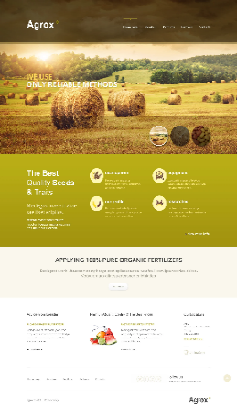

Presentation Layer



[This Photo](https://freepngimg.com/png/21890-smartphone-image) by Unknown Author is licensed under [CC BY-NC](https://creativecommons.org/licenses/by-nc/3.0/)

**Figure 3.1: 3 Tier Architecture**

**Question 4: Write about the approach strategy for framing the question?**

**Ans:**

Business Analyst should keep What points in his/her mind before he frames a Question to ask to the Stakeholder ( 5W 1H – SMART – RACI – 3 Tier Architecture – Use Cases, Use case Specs, Activity Diagrams, Models, Page designs)

* 1. **5W1H Framework:**

“5w1H” is framework used to gather the information from stakeholder and analyse situation by asking following 6 key questions.

**Why** this project was initiated?

**What** is the Product?

**Who** are the benefited from this project?

**When** will the project get initiated?

**Where** did requirement get spotted?

**How** we should be doing this project?

* 1. **SMART technique:**

Simply put, SMART goals are specific, measurable and actionable. By using a series of five benchmarks that comprise the SMART (Specific Measurable Achievable relevant Time-based)method, you’ll be able to create concise goals and action steps that will keep you on track.

**Specific**: Goal should be quantifiable terms by asking following question to self

What do I want to accomplish?

Will achieving this goal have an important impact ?

What action will I need to take?

**Measurable:** This may take the form of tracking the time it takes you to complete an action or meet a milestone.

For example: *"I will distribute a budget report that shows our department’s current expenses in comparison to our allotted annual budget."*

**Achievable:** This aspect of the SMART strategy relates to your goal being achievable. Do you have the resources and time needed to achieve the goal? This may include gathering necessary data, asking team members for help and learning new skills.

**Relevant:** A relevant goal will directly contribute to successful results. Keep in mind that every action you take should move you closer to your goal. In our example, a relevant goal will directly reduce expenses.

**Time-Based:** A time-based goal has a specific time deadline. You’ll want to determine if your goal is a short-term or long-term goal (or a combination of both).

* 1. **UML:** Unified Modelling Language, is a standardized way of diagramming and software system to aid design, development and communication between team member.
  2. **RACI:**
* A RACI matrix is crucial for project success because it clearly defines roles and responsibilities, leading to better communication, accountability, and task completion, ultimately reducing confusion and improving project outcomes
* RACI charts help define and clarify roles and responsibility within a team by outlining who is **R**esponsible, **A**ccountable, **C**onsulted and **I**nformed for each task
* The RACI matrix clarifies responsibilities and ensures that everything the project needs done is assigned someone to do it
  1. **Use Case:**

A Use Case Diagram in [Unified Modelling Language (UML)](https://www.geeksforgeeks.org/unified-modeling-language-uml-introduction/) is a visual representation that illustrates the interactions between users (actors) and a system. It captures the functional requirements of a system, showing how different users engage with various use cases, or specific functionalities, within the system. Use case diagram is a high level diagram

Wireframes: Wireframes are like sample pages.

Prototypes: UI/UX designer will prepare this

* 1. **Use case Specs:**Use case specifications are detailed, textual descriptions of how a system interacts with its users (actors) to achieve a specific goal, outlining the steps, preconditions, postconditions, and alternative scenarios.

Use case specifications are a way to document and understand the functional requirements of a system from the user's perspective.

* 1. **Activity diagram:**

An activity diagram, a type of Unified Modelling Language (UML) behavioural diagram, visually represents the flow of activities and actions within a system or process, emphasizing control flow, decision points, and the sequence of actions.

Before understanding the process need to understand the process. Process of any feature will be going to address by process flow diagram or Activity Diagram.

It is like flow chart. Basically, Flow chart. How System should function in order to achieve business logic, Business functionality and business objectives.

* 1. **Page design:**

Page design id nothing but we call it as prototyping will represent screens, how web should look like & if suppose they want to follow some colour coding. We can represent this diagram with any wireframing tool like Balsamique or any open-source tool like draw.io

Attached some page design sample for this Agrotech project

* + 1. **Mock-up for Login**

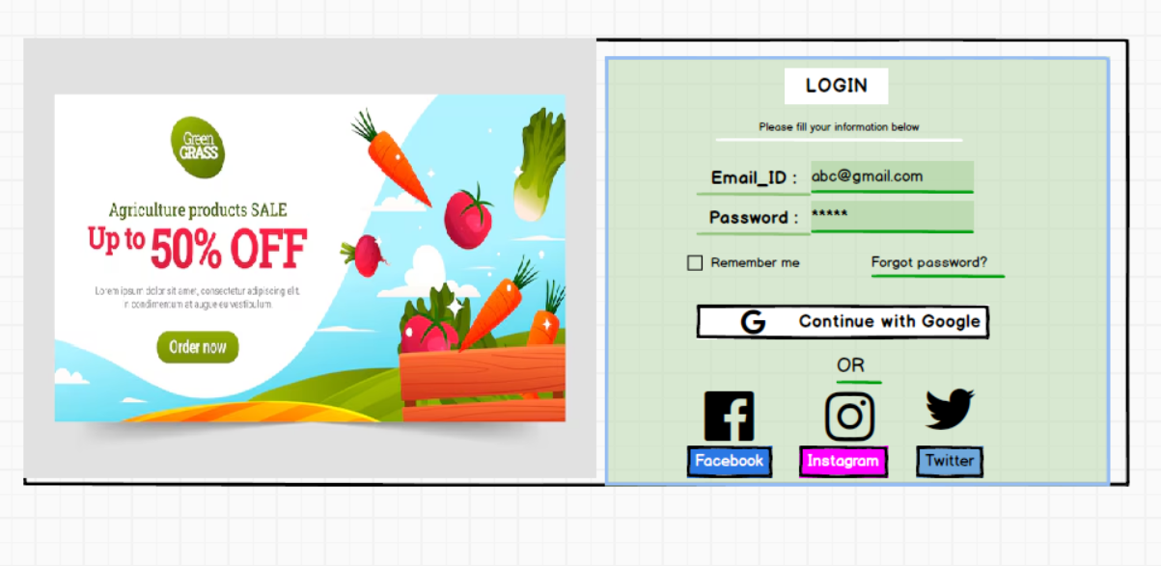

* + 1. **Mock-up for Home Page**

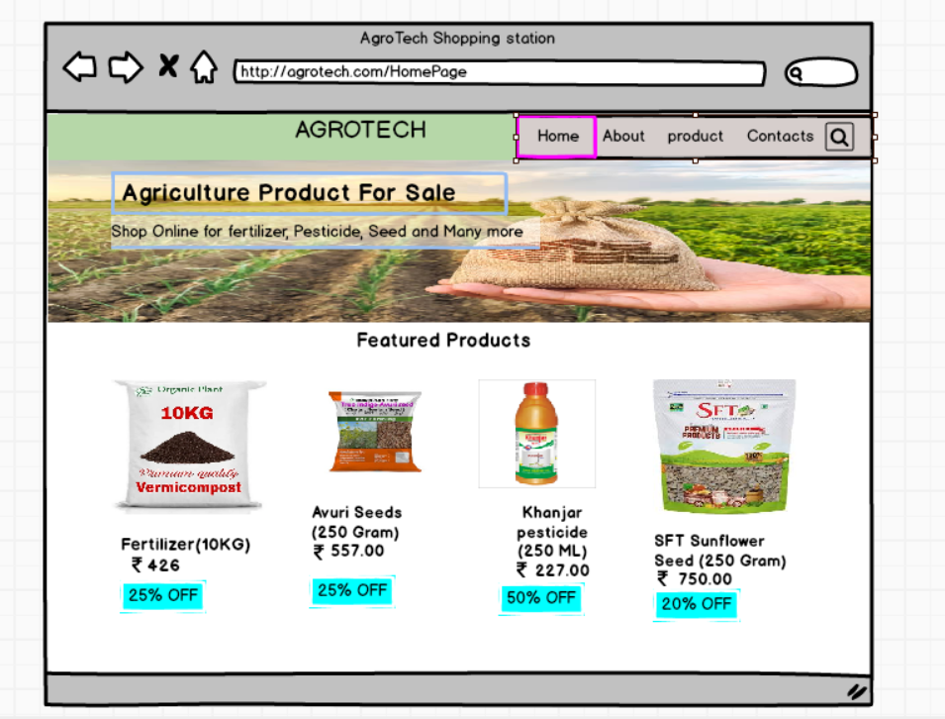

1. **Mock-up for product to add in cart**

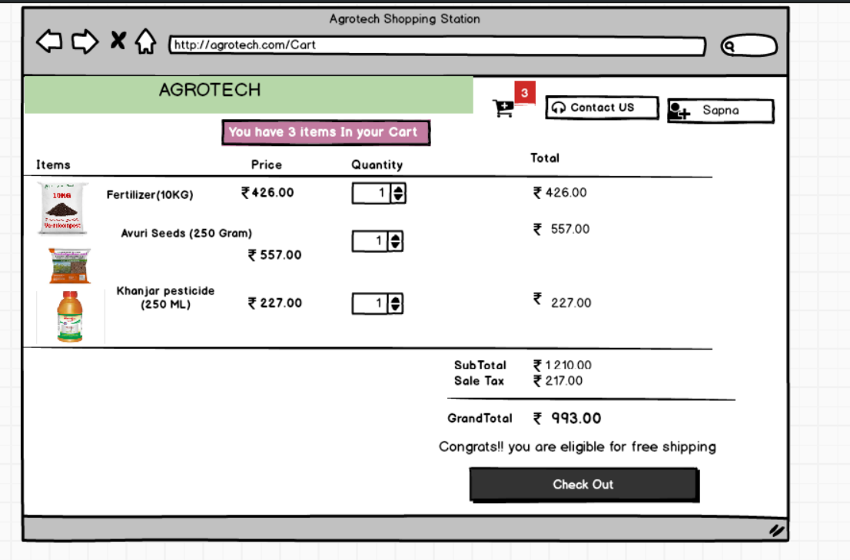

1. **Mock-up for cancel or return the product**

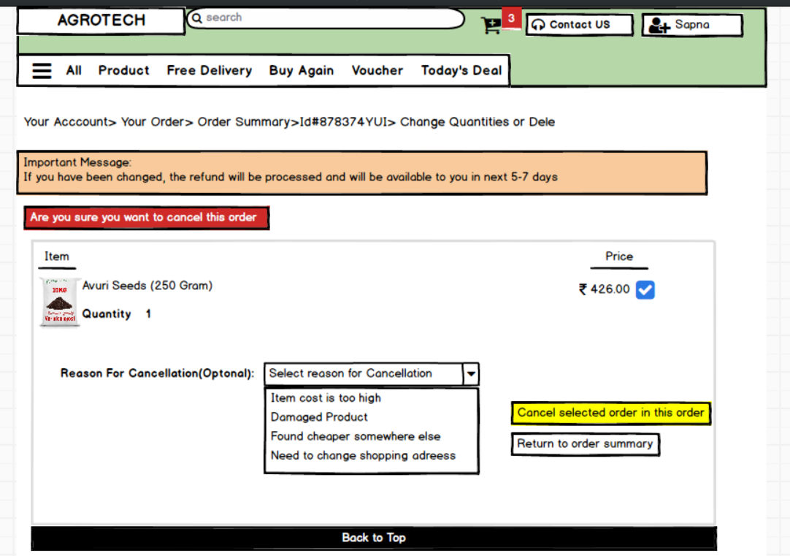

**Question 5: Write about the various elicitation techniques you are learnt in the workshop?**

Elicitation is all about getting information from the client about there needs regarding project. Elicitation is technique of bagging requirement from the client but sometimes not sure what exactly he wants so that time without any proper technique we could not proceed. Elicitation is all about by using any of the following technique gather the in detail input. BA has to decide which is best suitable foe client business requirement elicitation. There are three types basic requirement type

1. Collaborative
2. Research Based
3. Experiments
   1. **Document Analysis:**

It is a popular elicitation technique. Document may involve Manual, Reports. It gives information about the current state of the project and current processes it is using so that you can identify gaps in the processes and the solution you need to applied. This method is like resume if records are up to date and verifiable. It is time taking process and faces obstacle if specific document is not available to you but it can give us further details for elicitation.

* 1. **Focus Groups:**

Focus Groups involved participant discuss one idea for a problem. There will be partial moderator who assist you. You can have preplanned question but it is an open discussion you can determine attitude, idea and methods through this discussion. Knowing our Target users in terms of what is the comfortable way, expectations and all called as Focus Group. For Example: For whatsapp target users are peoples with mobiles.

* 1. **Interviews:** One-on-one or group interviews with stakeholders, end-users, and subject matter experts can provide valuable insights into their needs, expectations, and perspectives.Interviews generally will be with an individual and planned can build strong relationship with stakeholder. It is systematic approach to posting relevant question related to software development. There are two types of questions
* **Open Ended:** Its like Fill in the blanks type question. For example: Job interviewer ask tell me about yourself.
* **Closed Ended:** Its like MCQ type for example: HR asking which city you want as job location

There are two types of interview as shown below.

**Interviews**

**Structured Interviews**

**Unstructured Interviews**

When gives in input client in meeting regarding requirement then BA only receives input which was unplanned so he didn’t have planned questions to ask called Unstructured Interviews

Once Meeting done with client, BA goes through requirement and ask clients doubt in form of email is called structured interviews.

* 1. **Observation:** Observation is a method of gathering information by watching how users interact with a system, process, or product in their natural environment.Stakeholder or user might not know about what’s there value. People act differently when they know they are getting observed. So BA has to take care that he should secretly observing things.

Observation is of two types

* + 1. **Active Observation:** Active observation means where along with presentation get some comments or answers or feedback in form of communication.
    2. **Passive Observation:** Participants stays silent. There will be no response. Only observation will be done. For example: Recorded videos.
  1. **Questionnaires and Surveys:** To survey large groups of peoples can use Questionnaire. We can get lots of information in short amount of time but prepared remained stakeholders to complete the forms. The questions should be direct. We can ask open ended question where the respondent can write the answer in their own words. It is harder to quantify more answer but we can get more insights
  2. **Workshop:** It is a formal elicitation technique. Bringing stakeholder and user to bring ideas. It is processing driven way to discuss and clarify the idea. Select attendee and recruit scribe to record everything and there will neutralize facilitator to guide and keep on track. Usually, it will be for a day or two.
  3. **JAD:** So many people take a client call is nothing but JAD (Joint Application Development). Whenever there is need to understand the requirements directly from the client so BA will arrange the JAD. Application developed through the JAD has higher satisfaction and a smaller number of errors as user is directly involved in the development process. To avoid Tag-time BA will directly involve client to discuss or clarify the doubts of the development team. This can be weekly once.
  4. **Prototyping:** One of the Experimental elicitation techniques. You create Mock-ups to identify the requirements. You can also try prototype after using other elicitation techniques. Provide demos to the client. It is common for analyst to uncover missing requirements or use Mock-Ups to specify unclear request. It is better way for the client to visualize the system. It is way to affirm ideas and start put them into the reality. It requires time and money because the client can change requirements at any time.

BA will use Wireframing tool for creating Mock-ups. For example: AXURE (Dynamic Representation of screens) and BalsaMique (Static representation of screen)

* 1. **Brainstorming:**

Brainstorming is a group-oriented elicitation technique used to generate a wide range of ideas quickly, fostering creativity and problem-solving by encouraging participants to freely share their thoughts without immediate judgment.

Here's a breakdown of brainstorming as an elicitation technique:

What it is:

* **Group-based:** Brainstorming involves a group of people (ideally 5-12) working together to generate ideas.
* **Idea Generation:** The primary goal is to come up with as many ideas as possible within a set timeframe, focusing on quantity over quality initially.
* **Free Flow of Ideas:** Participants are encouraged to share their thoughts without being judged or censored, allowing for a free flow of ideas.
* **Facilitated:** A facilitator guides the brainstorming session, ensuring everyone participates and the discussion stays on track.

**How it works:**

* + 1. **Define the Problem/Topic:** The facilitator clearly states the problem or topic that the group will brainstorm about.
    2. **Generate Ideas:** Participants share their ideas, building upon each other's suggestions.
    3. **Record Ideas:** A facilitator or designated person records all the ideas generated.
    4. **Analyse and Prioritize:** After the brainstorming session, the group can analyse the ideas and prioritize them based on certain criteria.

**Benefits of Brainstorming:**

* **Encourages Creativity:** By fostering a free-flowing environment, brainstorming can unlock creative solutions and perspectives.
* **Identifies Potential Solutions:** The large number of ideas generated can lead to the discovery of innovative solutions to problems.
* **Facilitates Collaboration:** Brainstorming encourages teamwork and collaboration, as participants learn from each other's ideas.
* **Improves Problem-Solving:** By exploring different perspectives and ideas, brainstorming can lead to more effective problem-solving.
  1. **Reverse engineering:**

When we don’t have proper documentation.Reverse engineering, in the context of elicitation, is a method of gathering requirements by examining an existing system or product to understand how it works and what it does. Reverse engineering as an elicitation technique involves analysing an existing system or product to understand its design, functionality, and components, thereby deriving requirements for a new or improved system. It's particularly useful when documentation is lacking or outdated.

**Limitations:**

1. **Time-consuming:** Reverse engineering can be a time-consuming process, especially for complex systems.
2. **Requires expertise:** It may require specialized knowledge and skills.
3. **Ethical and legal considerations:** There can be ethical and legal implications, especially when reverse engineering copyrighted software or products.

**Question 6: Which Elicitation Techniques will you use in this project? Justify your opinion?**

As a business analyst, I will prefer to use Workshop or Brainstorming elicitation techniques are best to use. **Brainstorming** is spontaneous idea of generation many ways or method. It involves a group of individuals focusing on a topic or problem and generating a wide range of ideas, solutions, or potential requirements. **Workshops** facilitated group sessions can facilitate brainstorming, consensus-building, and prioritization of requirements. It is preplanned questions. Bringing stakeholder and user to bring ideas. It is processing driven way to discuss and clarify the idea.

**Question 7: Write 10 Business requirement?**

**Ans:**

Business requirement is the specific needs or condition that a business must meet to achieve its objectives

**Example:**

**BR001- User should be able to search product online**

**BR002- User need to create login and password first**

**BR003- If User is the new user, then he should create login id and password first**

**BR004- Manufacturer or Retailer should be signed user to the website to add there products CatLog.**

**BR005- User can browse many other products as per his convenience**

**BR006- User either can add to Wishlist or if he decides to purchase then he can add to the Cart. Otherwise, he can directly add to the cart**

**BR007- Selection option from the cart should be available or Unselect**

**BR008- Payment gateways options like Cash On Delivery, Via UPI or Net Banking**

**BR009- If it is NET Banking or UPI and if user is new to the website, then for the first time, he has to done KYC of the bank account**

**BR010- User should be able to add Delivery address along with Mobile number which is mandatory**

**BR011- After receiving product if any damages are observed then return of the product should be available**

**BR0012- Acknowledgement of purchased product confirmation via Email or Mobile Number Message**

**BR013- Feedback regarding product from customer should be there but it is optional**

**Question 8: Write 4 assumptions based on the Project?**

Assumption1:

1. **Target Audience**: The project assumes a sufficient and accessible target audience with internet access and purchasing Product online.
2. **Market Demand:** The project assumes there's a demand for the products or services offered online in Rural area, and that customers will be willing to purchase online.
3. **Logistics and Infrastructure:** The project assumes reliable logistics and infrastructure, including efficient delivery services and stable internet access, are available.
4. **Competition:** The project assumes a manageable level of competition from existing e-commerce players.

**Question 9: This project requirement priority**

**Ans**:

|  |  |  |  |
| --- | --- | --- | --- |
| Req-Id | Req_Name | Req_Description | Priority |
|  | Farmer Search for Products | To search for available products in fertilizer, seed and pesticides | 8 |
|  | Manufacturer should be able to add | Manufacturer or Retailer should be signed user to the website to add their products CatLog. | 10 |
|  | Farmer browses through the Products  CatLog | A Farmer should be able to browse through all products and categories | 7 |
|  | Search Bar for website | The website should have search option so that they can search for any product they need | 10 |
|  | Every user should be able to login | Everyone should be able to login to the website as the user | 10 |
|  | Bagging selected product | User either can add to Wishlist or if he decides to purchase then he can add to the Cart. Otherwise, he can directly add to the cart | 9 |
|  | Select or Unselect in Cart | Selection option from the cart should be available or unselect | 6 |
|  | Types of payment options | Payment gateways options like Cash On Delivery, Via UPI or Net Banking | 8 |
|  | KYC for Bank details | If it is NET Banking or UPI and if user is new to the website then for the first time, he has to done KYC of the bank account |  |
|  | Delivery Address | User should be able to add Delivery address along with Mobile number which is mandatory | 7 |
|  | Acknowledgement | Acknowledgement of purchased product confirmation via Email or Mobile Number Message | 6 |
|  | Review or Feedback | Feedback regarding product from customer should be there but it is optional | 6 |

**Question 10. Prepare Use-Case Spec**

A Use Case Diagram in [Unified Modelling Language (UML)](https://www.geeksforgeeks.org/unified-modeling-language-uml-introduction/) is a visual representation that illustrates the interactions between users (actors) and a system. It captures the functional requirements of a system, showing how different users engage with various use cases, or specific functionalities, within the system. Use case diagrams provide a high-level overview of a system’s behaviour, making them useful for stakeholders, developers, and analysts to understand how a system is intended to operate from the user’s perspective, and how different processes relate to one another. They are crucial for defining system scope and requirements.

Use case has following Four Elements:

* + 1. **Actor:** In a use case diagram, an "actor" represents a role that interacts with the system, whether it's a human user, another system, or even a hardware component, and is depicted as a stick figure or a box with the "actor". It can be living or non-living thing.

Actors are of two type

* + - 1. Primary Actor: The actor whoever initiate some action
      2. Secondary Actor: It will response depend upon some instance

Symbol:

* + 1. **System:** In a use case diagram, "System" represents the boundary or scope of the system being modelled, visually depicted as a rectangle encompassing all the use cases and actors within its horizon.

Symbol:

System_name

Features

----

---------

* + 1. **Use Case:** Use cases are created when the requirements of a system need to be captured.it defines the feature of the system. Use case represented by Oval shape.

Symbol:

* + 1. **Lines:** In a use case diagram, lines represent relationships between actors and use cases, or between use cases themselves, and these relationships are categorized as associations, includes, extends, and generalizations.
       1. **Include:** Use case can include another use case. Represents the inclusion of another use case. It should be mandatory. Arrow should be drawn from Base case to Derived case

**For Example: When user buys soda from render machine. He has to put coin inside. Then machine will verify whether the amount is correct or not. Here Verifying amount is derived case and Buying soda is dependent on verify soda so this is base case.**

Money Given

<Include>

* + - 1. **Extend**:Represents the optional behaviour. Arrow drawn from Extension use case to Base use case.

**For Example: For buying soda if value is not correct then it should be return change when value is greater.**

Money Given

<Include>

<Extend>

* + - 1. **Generalization:** It shows the category or type of use case as follows

**For example: Buy Soda can be of type like Coke, Sprite or Fanta**

* **How to draw use case diagram from case study**

1. Write down all sequence of action as follow

**BR001-** User should be able to search product online -- Action

**BR002-** User need to create login and password first -- Action

**BR003-** If User is the new user, then he should create login id and password first-- Action

**BR004-** Manufacturer or Retailer should be signed user to the website to add there products CatLog.-- Action

**BR005-** User can browse many other products as per his convenience-- Action

**BR006-** User either can add to Wishlist or if he decides to purchase then he can add to the Cart. Otherwise, he can directly add to the cart-- Action

**BR007-** Selection option from the cart should be available or Unselect-- Action

**BR008-** Payment gateways options like Cash On Delivery, Via UPI or Net Banking-- Action

**BR009-** If it is NET Banking or UPI and if user is new to the website then for the first time, he has to done KYC of the bank account -- Action

**BR010-** User should be able to add Delivery address along with Mobile number which is mandatory-- Action

**BR011-** After receiving product if any damages are observed then return of the product should be available -- Action

**BR0012**- Acknowledgement of purchased product confirmation via Email or Mobile Number Message—Action

1. Differentiate Information against Action as shown above and highlight in red colour
2. Try to find out which actor performing action which actor it is Primary or Secondary.

Login --- User -🡪Primary Actor

Manufacturer🡪Secondary Actor

Searching Product---- User/farmer --🡪Primary actor

Add to Cart -------------User/Farmer--🡪Primary Actor

Payment-----------------User/Farmer--🡪Primary Actor

Delivery------------------User /farmer-🡪Primary Actor

Acknowledgement-----Server-------🡪Secondary Actor

1. Find Supporting use case and Essential means Base use case
2. Find our actor, use case, system boundary
3. Draw relationship between use case

Website for AgroTech store

Farmer

Manufacturer

Web Server

Email Server

SMS Gateway

<include>

<extend>

<extend>

**Question 11: Prepare Use Case Specs for all use cases**

**Ans:**

Use case specification document is for all the use cases to describe in details action. Use case specifications are detailed, textual descriptions of how a system interacts with its users (actors) to achieve a specific goal, outlining the steps, preconditions, postconditions, and alternative scenarios

1. **Use case Specs for New user Login**

|  |  |  |  |  |
| --- | --- | --- | --- | --- |
| **Use_Case_ID** | New_User_02 | | | |
| **Use_Case_Name** | User is new to the website | | | |
| **Created by** | Sapna k. | **Last updated by** | | Sapna k. |
| **Date created** | 31-03-2025 | | **Last Revision By** | 01-04-2025 |
| **Actor** | Farmer (primary Actor) and Web Server (Secondary actor) | | | |
| **Description** | If user is new to the website, then he can register or sign up to get login credentials. Once he registers, he can get the email verification | | | |
| **Pre-condition** | 1. Active Internet Connection 2. User should have email id | | | |
| **Post Condition** | User will get his credential with message “You are successfully registered” and get Email confirmation for registration. User can be able to login to the website. | | | |
| **Basic Flow of Events** | When user is new to the site he could not do further activities until he registered to the website   1. User will sign up with email id 2. Create his password 3. OTP verification will be done by SMS or via Email 4. Get message “Congrats!! You are successfully registered to our website” | | | |
| **Alternate Flow** | 1. OTP is not going to the number because of range problem then user get message “User Verification Failed” 2. If internet connection is poor then Email verification will get failed then user get message “User Verification Failed” 3. Due to range problem if both verifications get failed then user get message “User Verification Failed” 4. User has given mistakenly wrong or different mobile number which is not linked for OTP 5. If Mail id he has but he forgot his password then user get “verification failed message” | | | |
| **Exceptional flow** | 1. Gmail account is not there 2. Number is out of service | | | |
| **Assumption** | Don’t know how to check OTP on mobile or not aware about Gmail usage because someone else create his Gmail id. | | | |
| **Constraints** | Must and should have mobile number and Gmail id. | | | |
| **Usage** | High | | | |

1. **Use case Specs for Search and Order the Item**

|  |  |  |  |  |
| --- | --- | --- | --- | --- |
| **Use_Case_ID** | Orde_ Items_01 | | | |
| **Use_Case_Name** | User can order item via app | | | |
| **Created by** | Sapna k. | **Last updated by** | | Sapna k. |
| **Date created** | 31-03-2025 | | **Last Revision By** | 01-04-2025 |
| **Actor** | Farmer (Primary Actor) , manufacturer (primary Actor) and Web Server (Secondary actor) | | | |
| **Description** | This use case describes how user can order the product. First he has to add the product to the cart then only he can order. | | | |
| **Pre-condition** | 1. Active Internet Connection 2. User add has to add product into the cart 3. He can Wishlist before ordering | | | |
| **Basic Flow of Events** | 1. User will login into the app 2. Browse with the name of fertilizer or seed 3. He can select the product 4. Wishlist or Direct add product to the Cart | | | |
| **Alternate Flow** | 1. User want to buy product but by mistake if he write wrong product name that may shows product unavailable 2. Even though he write wrong name, there is chances that our search engine can show similar name product with slightly name or content different 3. While browsing if he don’t know the category or exact product name still he can search with the content of the product and purchase | | | |
| **Exceptional flow** | While adding to the cart different pages pops out or While selecting quantity of the product it may give higher number which leads costly product to the farmer. Farmer must add product the cart. | | | |
| **Assumption** | What if user is unaware about adding product to the cart | | | |
| **Constraints** | There should be one or more than one till 25 items user can select for ordering. | | | |
| **Usage** | High | | | |

1. **Use case Specs for Search and Order the Item**

|  |  |  |  |  |
| --- | --- | --- | --- | --- |
| **Use_Case_ID** | Payment_Gateway_03 | | | |
| **Use_Case_Name** | Varieties of Payment option | | | |
| **Created by** | Sapna k. | **Last updated by** | | Sapna k. |
| **Date created** | 31-03-2025 | | **Last Revision By** | 01-04-2025 |
| **Actor** | Farmer (primary Actor)  Web Server (Secondary actor)  Bank server (Secondary Actor) | | | |
| **Description** | When user add product to the card and want to buy then he has three options available   1. Cash On Delivery: No need of Bank details 2. Through UPI: Need Bank details 3. Net Banking: Need bank details or card details   Either of one option from above he can select do payment. | | | |
| **Pre-condition** | 1. Active Internet Connection 2. For NET Banking application, farmer should have the bank account 3. In case of net banking user has to enter his card details. So, user should have card also 4. His reliable Bank account should have net banking option | | | |
| **Post Condition** | User can purchase the product with reliable option. Once the payment done, he will get message “Payment is successful” | | | |
| **Basic Flow of Events** | 1. User will select products to buy from the cart 2. Get three options for payment procedure i.e., Cash on Delivery, Net Banking or UPI 3. Farmer will select reliable option among three 4. Once payment is successful, he will get message “Payment is successful” | | | |
| **Alternate Flow** | 1. User select Cash on delivery option but on the time not having cash to give so product may get return. 2. If user choose net banking option, and he is having card details which he enters already during last payment but at the time payment now his card got expired then he couldn’t do the payment.   Again, he has to do KYC. He gets Message “Payment failed”   1. In case he changed his mobile number or email id which is linked to the bank, in that case also UPI option will get failed and he get message “Payment Failed” | | | |
| **Exceptional flow** | 1. At the time of payment suddenly server get down for website then it will be disaster for farmer. And user will lose interest to buy that product again from online. 2. Not having properad stocks of item | | | |
| **Assumption** | What if user added product to the cart but he is not willing to buy doe to any reason. If internet connection is slow then it will be disaster for user to buy. | | | |
| **Constraints** | The reliable bank account of farmer/user should have Net banking option or UPI option. | | | |
| **Usage** | High | | | |

1. **Use specs for Uploading the product by manufacturer**

|  |  |  |  |  |
| --- | --- | --- | --- | --- |
| **Use_Case_ID** | Upload_Product_03 | | | |
| **Use_Case_Name** | Upload product via app | | | |
| **Created by** | Sapna k. | **Last updated by** | | Sapna k. |
| **Date created** | 31-03-2025 | | **Last Revision By** | 01-04-2025 |
| **Actor** | Manufacturer (primary Actor) and Web Server (Secondary actor) | | | |
| **Description** | This use case describes how manufacturer can list the product , add price and upload on the site so that user can view his products while browsing | | | |
| **Pre-condition** | 1.Active Internet Connection  2.His Product should have his brand name  3.Or if he is retailoring then some identity like scanner or unique id to the product. So, when user select the product, he should get order | | | |
| **Post Condition** | Manufacturer stocks will be visible in online app and user can able to view product with information and add to the cart. Get message payment is successful. Acknowledgment via email or SMS for product delivery | | | |
| **Basic Flow of Events** | 1. Manufacturer will login into the app with his credential  2. Upload the list of items he has one by one  3. Must and should add the price with discounts if he wants | | | |
| **Alternate Flow** | 1. Manufacturer with the same identity or brand name someone else can upload the product and give fake product  2. Retailor also adding same product with same brand can confuse farmer which is the genuine product  3. Sometime due to seasonal huge demand of product stock may go out of the stock. So, Manufacturer should be aware of demanding. | | | |
| **Exceptional flow** | Manufacturer may forget his credential in case someone hacked his id.   1. There may be chances id he adds stocks to the website but on the same time id server get down or DB got refresh there may be chances to lose his stocks from website 2. Product name or description can mismatch | | | |
| **Assumption** | What if user is unaware about adding product to the cart | | | |
| **Constraints** | At a time in one day, he can add 35 products only | | | |
| **Usage** | High | | | |

1. **Use case specs for Cancel or return the item**

|  |  |  |  |  |
| --- | --- | --- | --- | --- |
| **Use_Case_ID** | Cancel or Return Product_03 | | | |
| **Use_Case_Name** | Cancel or Return Product via app | | | |
| **Created by** | Sapna k. | **Last updated by** | | Sapna k. |
| **Date created** | 31-03-2025 | | **Last Revision By** | 01-04-2025 |
| **Actor** | User (primary Actor) and Web Server (Secondary actor) | | | |
| **Description** | This use case describes how user can cancel or return the product via app. | | | |
| **Pre-condition** | 1.Active Internet Connection  2.That product must be his order history  3. Knowledge about steps to return the product | | | |
| **Post Condition** | If user follow the proper steps to return the product, then he will get the date to pick up the order and his product will get return and he will get refund in his account. | | | |
| **Basic Flow of Events** | 1. User will login into the app  2. Go to order history  3. select the item he wants to return  4. Request for Return or Exchange | | | |
| **Alternate Flow** | 1. User should have knowledge on how to return item 2. If that product got out of page from website for any internal reason 3. Order history page is very slow 4. Wrong address for pick up order 5. Wrong item selected or selection option not working 6. All item getting selected for the return 7. Return should be within the 15 days from order received by the user   And suppose user is not returning in the 15 days   1. If user enters wrong web address for website | | | |
| **Exceptional flow** | Manufacturer may forget his credential in case someone hacked his id.   1. Internet is very slow in rural area of user so he couldn’t able to return 2. Page is loading is very slowly 3. Or App or website is under recovery | | | |
| **Assumption** | What if user missed to return the product due to slow connection or poor connection | | | |
| **Constraints** | At a time in one day, he can return 15 products | | | |
| **Usage** | High | | | |

**Question 12 – (minimum 5) Activity Diagrams**

**Ans:**

**Activity Diagram:**

- An activity diagram, a type of behavioural diagram in UML, is used to model the flow of activities and actions within a system or process, showing the sequence of actions, decision points, and parallel or concurrent flows.

-Activity diagram shows actual functional working and system behaviour activity of each functional requirement.

-Before understanding the process need to understand the process.

- Process of any feature will be going to address by process flow diagram or Activity Diagram.

-It is like flow chart. Basically, Flow chart.

-How System should function in order to achieve business logic, Business functionality and business objectives.

**Key element of the Activity Diagram**

* **Activities:** Represent the actions or steps in a process, shown as rounded rectangles.

**Symbol:**

* **Actions:** Represent a single step within an activity.
* **Control Flow:** Arrows that indicate the sequence of activities, showing the order in which actions are performed.

**Symbol :**

* **Initial Node:** A solid circle that marks the start of the activity diagram.

**Symbol:**

* **Final Node:** A circle with a dot inside, indicating the end of the activity.

**Symbol:**

* **Decision Node:** A diamond shape that indicates a point where the flow can branch based on a condition.

**Symbol:**

* **Fork/Join:** Symbols that represent parallel execution of activities.

**Symbol:**

* **Object:** Represents data or resources used in the activities.
* **Partition:** A rectangle that groups related activities or actions, often used for organization or to show different actors or roles.

For below Activity diagram I have used Microsoft Visio.

1. **Activity diagram for LOGIN**

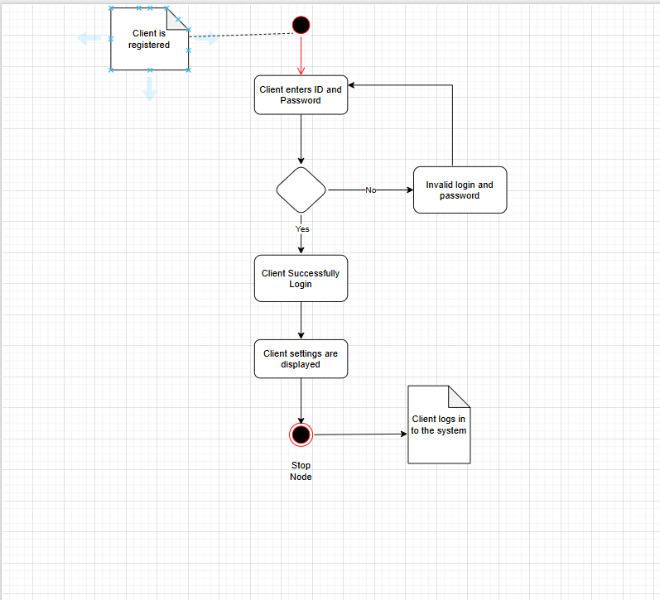

1. **Activity diagram for Search the product**

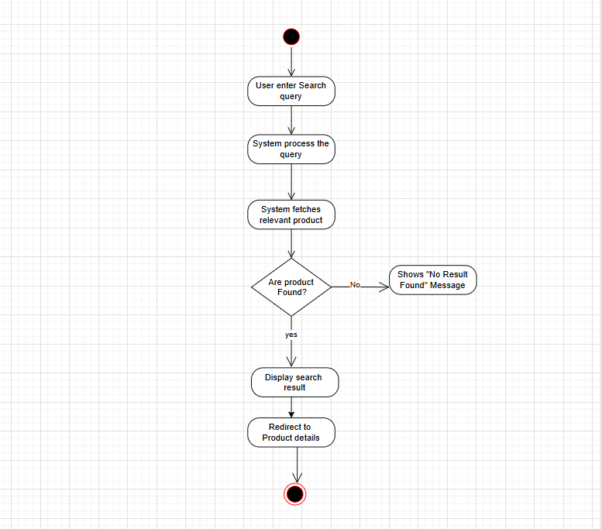

1. **Activity diagram for to Add to Cart**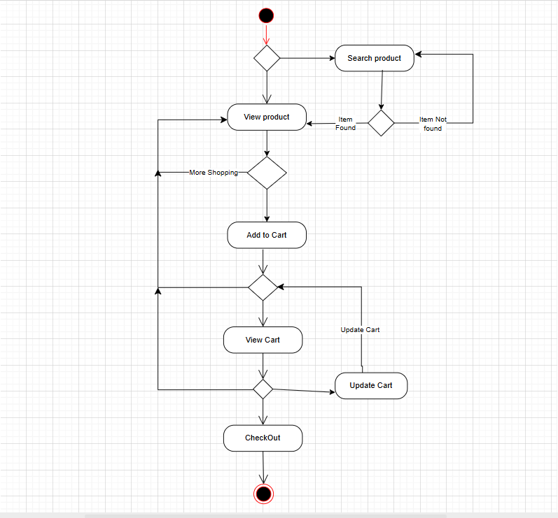
2. **Activity diagram for the Payment Gateway**

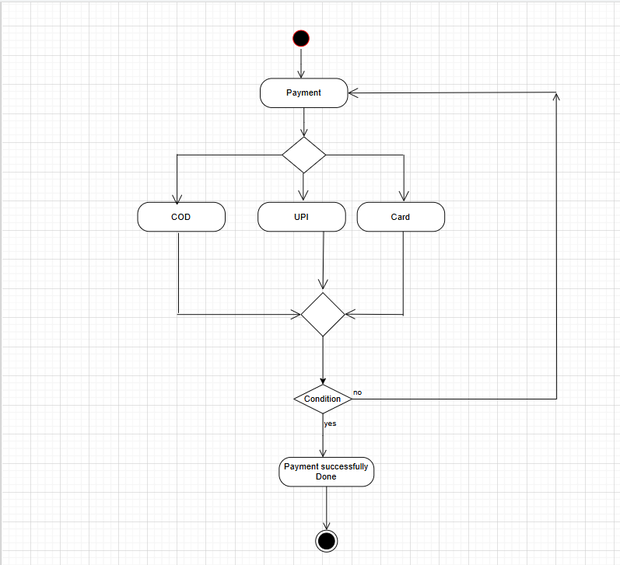

1. **Activity Diagram for the Delivery of the item**

