**Use Case Specification Document**

**1. Use Case Name:**

Automated Retort Sterilization Process

**2. Use Case Description:**

This use case describes the process of automating the sterilization cycles in the retort system, including monitoring, logging, and compliance reporting. It ensures accurate control of temperature, pressure, and time while providing real-time alerts and data traceability.

**3. Actors:**

**Primary Actors**

* + System Operator
  + Quality Assurance Manager

**Secondary Actors**

* + Maintenance Technician
  + Regulatory Auditor

**4. Basic Flow:**

1. The operator logs into the system.
2. The operator selects the batch and initiates the sterilization cycle.
3. The system monitors and controls temperature, pressure, and time in real time.
4. The system logs data and provides updates on the dashboard.
5. On completion, the system notifies the operator and updates batch records.

**5. Alternate Flow:**

**1.** If the operator forgets to select a batch, the system prompts them to do so before proceeding.

**2.** The system allows manual configuration if predefined cycle parameters are missing.

**6. Exceptional Flows:**

**1.**  In case of a sensor failure, the system halts the process and alerts the maintenance technician.

**2.** If the system detects a deviation from set parameters, it triggers an alarm and logs the deviation.

**3.** In case of power failure, the system resumes the cycle from the last logged state after restoration.

**7. Pre-Conditions:**

* The system is operational and connected to all required sensors and devices.
* authenticated and authorized operator can Start the cycle
* Batch information must be entered in the system.

**8. Post-Conditions:**

* Sterilization data is logged and linked to the batch record.
* The system generates a compliance report.
* Notifications are sent to relevant stakeholders.

**9. Assumptions:**

* Operators are trained to use the system.
* The facility has a stable power supply.
* Sensors and devices are regularly calibrated and maintained.

**10. Constraints:**

* Limited system downtime is permissible during maintenance.
* Data storage must comply with regulatory standards.
* Integration with ERP and LIMS must be seamless.

**11. Dependencies:**

* Integration with IoT sensors and hardware.
* Availability of network connectivity.
* Timely response from external systems like ERP or LIMS.

**12. Inputs and Outputs:**

* **Inputs:**
  + Batch ID
  + Sterilization parameters (temperature, pressure, time)
  + Operator credentials
* **Outputs:**
  + Cycle status updates
  + Compliance reports
  + Notifications

**13. Business Rules:**

* Only authorized users can initiate or stop cycles.
* All deviations must be logged with timestamps and reasons.
* Compliance reports must be generated in a predefined format.

**14. Miscellaneous Information:**

* All logged data must be stored securely for at least 5 years.



**Documents 7 – Screens and Pages**

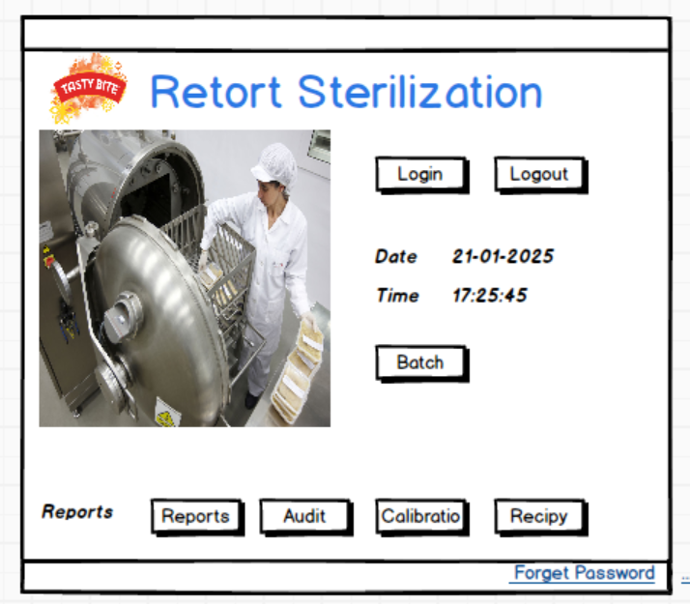

**Document 8- Tools-Visio and Axure and Balsamiq**

Using Microsoft Visio, Balsamiq, and Axure for the first time feels a bit overwhelming, but they are great tools for creating diagrams and wireframes.

* Microsoft Visio is like a digital whiteboard. You can easily drag and drop shapes to create flowcharts, organizational charts, or process diagrams. It’s great for visualizing workflows and processes in detail.
* Balsamiq feels simple and user-friendly. It’s like sketching ideas on paper but digitally. It’s ideal for creating quick wireframes to map out how a screen or website should look without worrying about colors or details.
* Axure is a bit more advanced and is used for building interactive prototypes. You can create clickable designs to show how an application will function. It might take time to learn but is powerful for showing dynamic behavior.

I understood the importance of these tools, they simplify communication between designers, Developers, and stakeholders. It helps stakeholders to get an idea about their application's look and feel and also It gives an idea about the user flow

**Document 9- BA experience**

**My experience as BA in the following phases:**

**1. Requirement gathering:**

* To gather Requirements, We used Observation and interview techniques.
* We also used a document analysis technique for regulatory compliance.
* Then I prepared a prototype and elaborated on how system would look like

**Requirement Analysis**

* In this phase I drew a UML diagram and an Activity diagram, Use case diagram to visually describe the requirements
* The activity diagram helps represent the activities in a more precise manner.
* Use case diagram helped in representing the high-level positive flow of the system and the actors of the system.
* These diagrams then shared with teams
* I started preparation of BRD

**Design**

* From use case diagram we prepared test cases
* We also prepared use case document and shared with client this document includes positive as well as negative flow of system.
* We prepared test data for testing
* Then we prepared RTM and update it to ensure all requirements are met.

**Development**

* Clarifies the queries of development team during coding
* Connected with SME i.e. regulatory experts to clarify queries regarding audit trail and reports

**Testing**

* Participated in functional testing to ensure that all the functions were designed
* Update RTM
* Invite and arrange client for UAT
* Shared test data with client
* Took signoff on UAT by client

**Deployment**

* Schedule activities with client.
* Monitor the system and took feedback.
* Give system information to Business Stakeholders who are going to use the system
* Arrange training session to them.
* Handover user manual of the system to client.