Scrum Foods (Foods Delivery Application)

QUESTION 1: Agile Manifesto
ANS:
Four main values:
- Individuals and interactions over processes and tools.
- Working software over comprehensive documentation.
- Customer collaboration over contract negotiation.
- Responding to change over the following a plan.
Twelve principles:
- Satisfy the customers through early and continuous delivery of valuable software.
- Welcome changing requirements, even late in development. Agile processes harness change for the customer’s competitive advantage.
- Deliver working software frequently, from a couple of weeks to a couple of months, with a preference to the shorter timescale.
- Business people and developers must work together daily throughout the project.
- Build projects around motivated individuals. Give them the environment and support they need and trust them to get the job done.
- The most efficient and effective method of conveying information to and within a development team is face – to – face conversation
- Working software is the primary measure of progress
- Agile processes promote sustainable development. The sponsors, developers and users should be able to maintain a constant pace indefinitely
- Continuous attention to technical excellence and good design enhances agility
- Simplicity—the art of maximizing the amount of work not done—is essential
- The best architectures, requirements and designs emerge from self-organising teams.
- At regular intervals, the team reflects on how to become more effective, then tunes and adjusts its behaviour accordingly.

QUESTION 2: User Stories- Acceptance Criteria BV-CP
ANS:
User stories: It is a short feature description from the user’s perspective. It keeps the focus on user needs instead of technical details. The format for user stories goes like, “As a <User>
I want to <what is the purpose>
so that <what you gain by this story>”
Acceptance criteria: It is a checklist of conditions that must be true for the user story to be considered complete and acceptable.
Complexity Points (CP): The purpose of assigning complexity points is to provide a high-level estimation of the effort or complexity involved in completing a user story or task. CP is estimated by the Scrum Developers, but this need to be done from customer point of view
Business Vale (BV): Business value is how important the user story is to the business. It is a way to prioritize work based on the impact it has on achieving business goal.
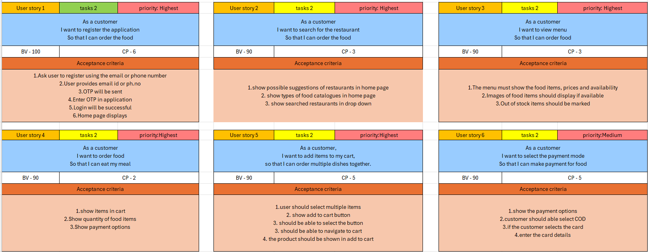
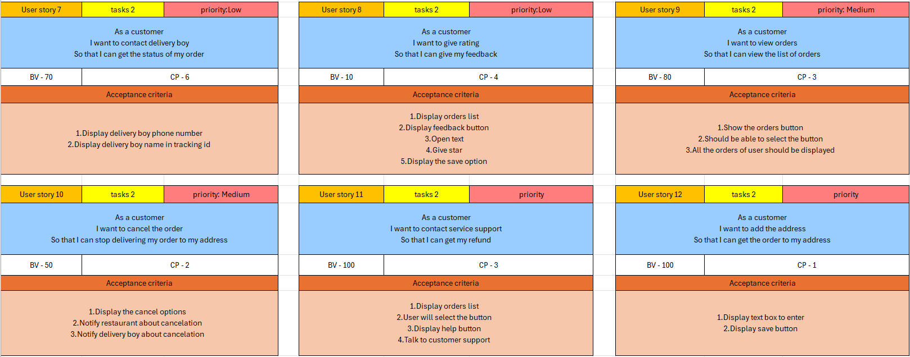
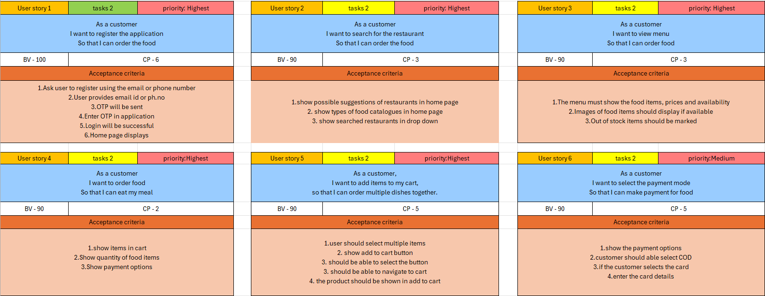
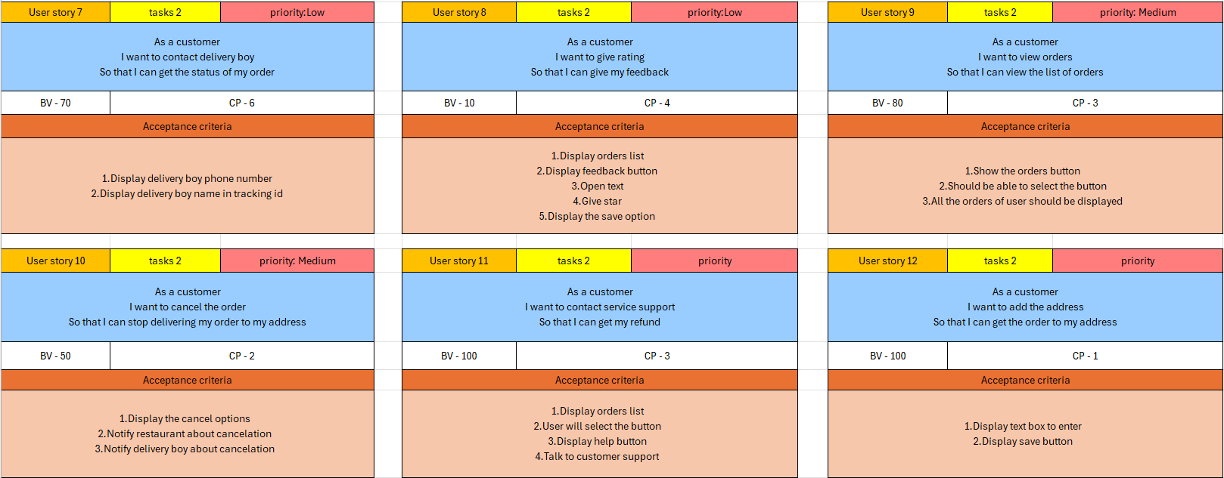
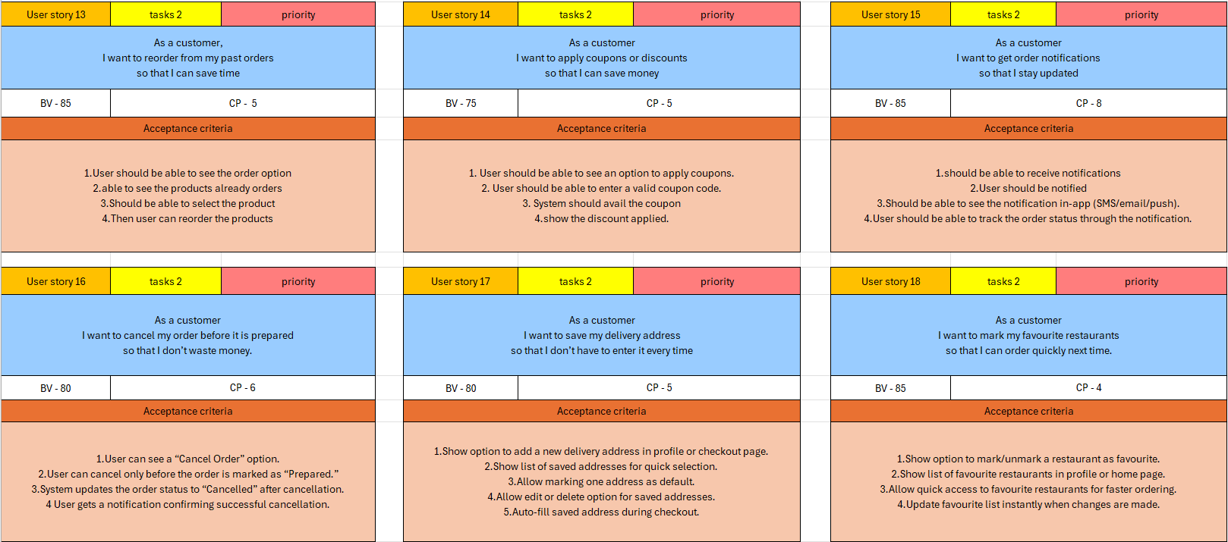
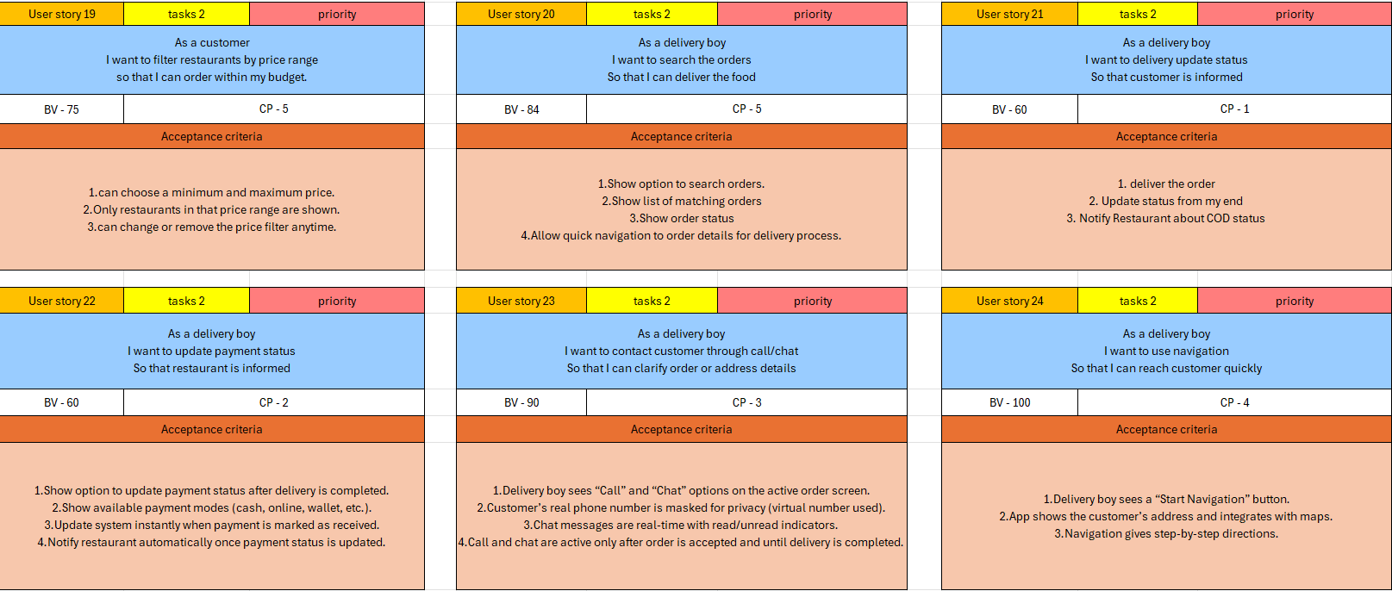
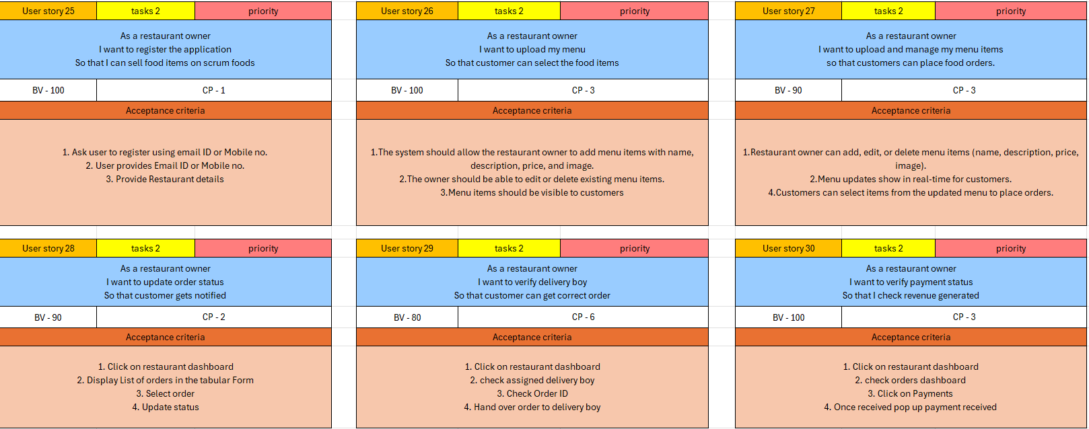
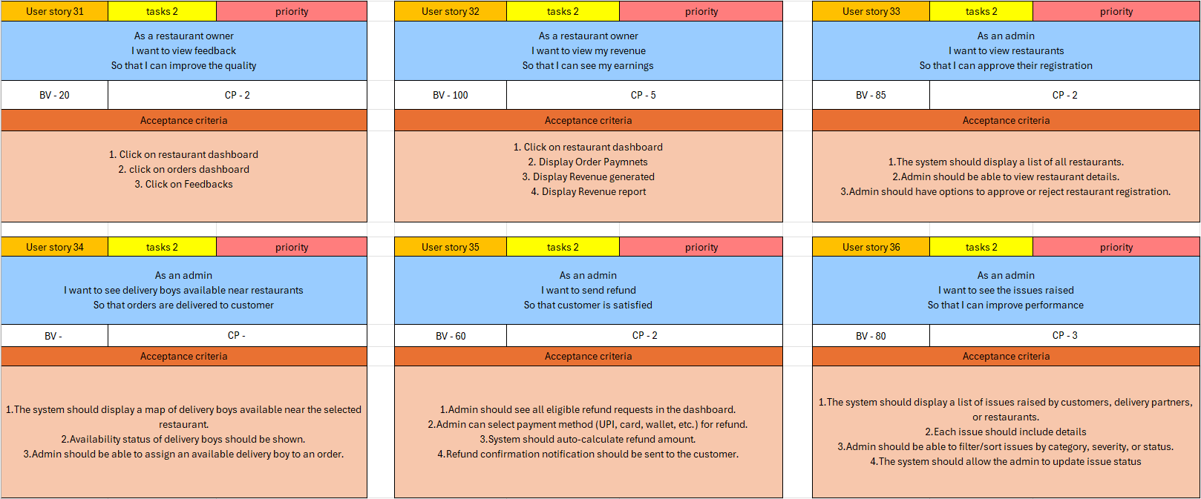
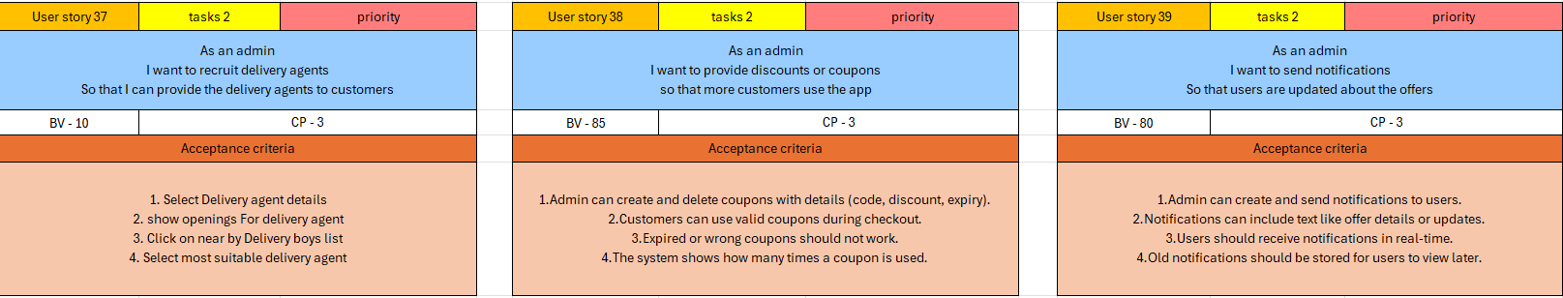
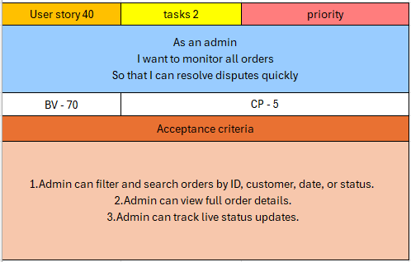
QUESTION 3: What is epic? Write 2 epics
Ans:
An Epic is a big user story that is made up of smaller user stories. Epics help organize and prioritize work in the product backlog.
Epic 1:
Digital Wallet & Multiple Payment Options
As a user, I want to pay using wallet balance, UPI, credit/debit cards, or COD so that I have flexibility in payments.
Acceptance Criteria:
- User can add money to Scrum Foods wallet.
- User can link UPI, credit/debit cards.
- User can select preferred payment option at checkout.
- User can view wallet balance in profile.
Epic 2:
Restaurant Menu Management
As a restaurant owner, I want to add, edit, or remove dishes from my menu so that customers always see updated options.
Acceptance Criteria:
- Restaurant can upload new dishes with price and description.
- Option to edit dish details (price, availability, photo).
- Option to mark a dish “unavailable.”
- Customers see only currently available dishes.
- Admin can review/approve major menu changes.

QUESTION 4: What is the difference between BV and CP
Ans:
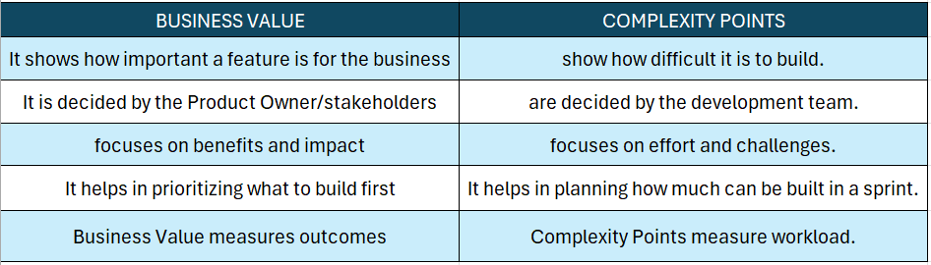

QUESTION 5: Explain Sprint
Ans:
Sprint:
- Sprints have a fixed duration, usually between 1 and 4 weeks. Based on factors like the nature of the project, the organization's preferences, and performance of team the time frame may differ.
- A sprint is a short, time-boxed period in Agile Scrum methodology during which a development team works to complete a specific set of tasks or deliverables.
Sprint Planning:
Sprint Planning takes place at the beginning of the sprint. During this event, the team defines the Sprint Goal, selects items from the Product Backlog to form the Sprint Backlog, breaks those items into smaller tasks, and estimates the effort required (using story points, hours, etc.)
Sprint Execution (Development Work):
- Sprint Execution is the core working phase of the sprint where the Development Team carries out all activities required to deliver the Sprint Goal and create a usable product increment.
- The duration is fixed based on the chosen sprint length (1–4 weeks), and the team collaborates closely throughout this period.
- Scrum Master helps remove obstacles. Product Owner is available for clarifications.
Daily Scrum (Every Day During Sprint):
This happens each day where team will just answer the 3 questions:
- What did u do today?
- What will you do tomorrow?
- Is there any impediments that is slowing or stopping u?
Sprint Review (End of Sprint):
This happens at the end of the sprint where team will demo the completed stories to product owner and get it cleared.
Sprint Retrospective (After Review, Before Next Sprint):
This happens at the end of the spirit where team will answer these 3 questions
- What went will in the sprint?
- What did not go well?
- What are the required areas of improvements in next sprint?
Sprint Backlog
Sprint backlog is a table which is consist of 4 elements PBI, Task, WIP and Done.
PBI - Product backlog items- it has the all the user stories.
Task- The user stories are divided into number of tasks.
WIP- One developer will choose one task and change the status to WIP.
Done- Once the task is completed the developer will change the status from WIP to Done.
Stakeholders Involved in Sprint:
- Development Team:
The individuals who work to create the product increment. They are responsible for turning the Product Backlog items into a potentially shippable product.
- Scrum Master:
A facilitator and servant leader for the Scrum Team. The Scrum Master helps the team understand the requirements and removes impediments.
- Product Owner:
Represents the stakeholders and is responsible for defining and prioritizing the Product Backlog. The Product Owner has the authority to accept or reject work done by the Development Team.
- Customers:
Actual end-users or customers of the product are important stakeholders. Their needs and expectations are important for development process and their feedback during Sprint Reviews is valuable in shaping the product.
- Quality Assurance (QA) Teams:
This team can be involved in testing activities during the Sprint and can provide valuable insights into the product's quality.
Sprint Understanding
According to our project a sprint Duration: 2 Weeks
Scrum Duration: 1 day
PBI: Product Backlog Item
Task: Unit of Work done by 1 Developer in 1 sprint
WIP: Work In Progress
Sprint backlog:
PBI | Tasks | WIP | Done
Payment Feature | 1.User goes to Checkout  2. Selects Payment Method (Card/UPI/Wallet)  3. Enter details & authenticate  4. Show Success/Failure Message | Payment Gateway Integration | Checkout Page completed

QUESTION 6: Explain product backlog and sprint backlog
Ans:
Product Backlog:
Product Backlog is the master list of everything that needs to be built in the product. It contains all Product Backlog Items (PBI).
- A Product Backlog Item (PBI) is simply a feature, bug fix or task from the product backlog.
Example: User login, Payment gateway integration, real-time tracking
- A task is a small piece of work that helps complete PBI. One developer should be able to finish a task within a day.
Example: Create login screen (UI), connect API for login.
- WIP (work in progress) refers to the tasks or PBI currently being worked on. Limiting WIP avoids bottlenecks and improves flow.
Sprint Backlog:
Sprint Backlog is a subset of the Product Backlog selected for a specific sprint (e.g., 2 weeks). It contains PBIs that the team commits to deliver in the sprint. Each PBI is broken into tasks and is owned by scrum team.
QUESTION 7: What is impediments log? Write 2 impediments
Ans:
An Impediments Log is a record maintained in Agile/Scrum projects to track issues, blockers, or obstacles that prevent the team from making progress. It helps the Scrum Master and team ensure impediments are visible, prioritized, and resolved quickly.
Sprint planning is the first event of a sprint. During sprint planning, the team might identify risks, dependencies or knows blockers before starting the sprint. These potential issues can be recorded in the impediments log so that they are monitored from the very start. During the sprint, if new impediments appear, they are also added to the log and handled.
Two Impediments for this project are:
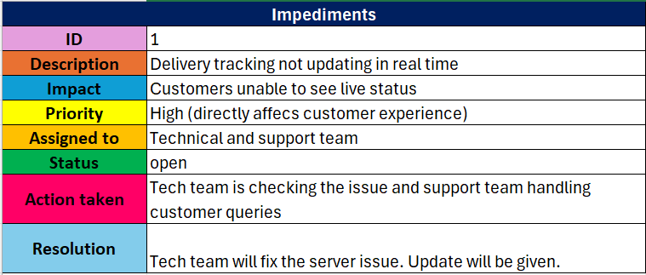

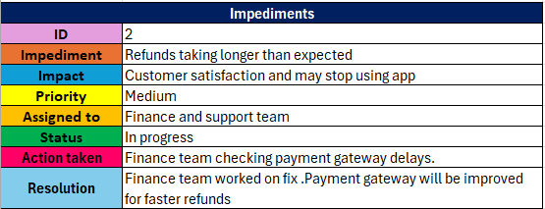

QUESTION 8: Explain velocity of the team
Ans:
Velocity in Scrum is a metric used to measure the average amount of work a Scrum Team can complete in a given Sprint. This is calculated by scrum master during sprint planning meeting. Product Owners and Scrum Masters use velocity as a guide for Sprint Planning.
QUESTION 9: Draw sprint burndown chart and product burndown chart
Ans:
PRODUCT BURNDOWN:
A Product Burn down Chart is a graphical representation that shows the amount of work remaining to be completed in the Product Backlog over a specific time period.
The X-axis represents time, usually divided into Sprint increments or other timeboxes. It provides a timeline showing the progression of the project or Sprint.
The Y-axis represents the amount of work remaining. It could be measured in units such as story points, effort hours, or tasks. The scale reflects the total work that needs to be completed.
SPRINT BURNDOWN:
A Sprint Burndown Chart is a graphical representation of the amount of work remaining in a Sprint over time. It is updated daily to reflect the ongoing progress of the team.
The X-axis represents time, usually in days, throughout the duration of the Sprint. Each day is marked, showing the progression of the Sprint
The Y-axis represents the amount of work remaining to be completed. The units can be story points, hours, or any other measure of effort that the team uses.
Similar to a Product Burn Down Chart, the Sprint Burndown Chart includes an "ideal line" that indicates the anticipated rate at which the team should be completing work if they are progressing at a consistent pace.
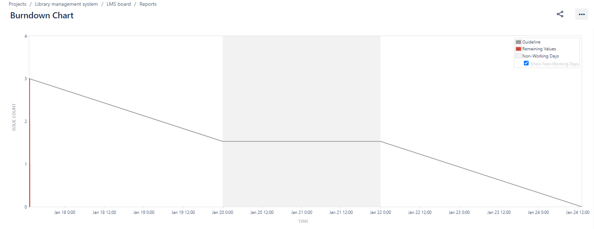
QUESTION 10: Explain about product grooming
Ans:
Product Grooming is a continuous process in Scrum where the Product Owner and the Development Team collaboratively review and update the Product Backlog to ensure it is prioritized, detailed, and ready for future sprints. This activity is critical to maintain a well-organized and actionable backlog that reflects the current business priorities and project goals.

QUESTION 11: Explain the roles of scrum master and product owner
Ans:
Scrum Master
The Scrum Master is like a coach for the Scrum team. They make sure the team follows Scrum rules and practices correctly. The Scrum Master removes obstacles that slow down the team, helps them stay focused on the sprint goal, and ensures smooth communication between members. They also facilitate meetings like Daily Scrum, Sprint Planning, Sprint Review, and Sprint Retrospective. In short, the Scrum Master helps the team work efficiently without directly making product decisions.
Product Owner
The Product Owner is responsible for the product’s vision and ensuring that the team builds what gives the most value to customers and the business. They create and manage the product backlog, prioritize features, and clearly explain requirements to the development team. The Product Owner decides what should be built first based on business goals, customer needs, and market value. In short, the Product Owner represents the voice of the customer and makes sure the product delivers maximum value.

QUESTION 12: Explain all meeting conducted in scrum project
ANS:
- Sprint Planning Meeting:
This happens at the beginning of each sprit and team decides on what they will be delivering in Sprint.
- Purpose: To plan the work for the upcoming sprint.
- Participants: Scrum Master, Product Owner, and the Development Team.
- Agenda: The Product Owner presents the prioritized backlog items, and the Development Team discusses and finalizes the work they can complete in the upcoming sprint
- Daily Standup (Daily Scrum):
This happens each start of day where team will just answer 3 questions:
- Purpose: To provide a daily synchronization and quick status update.
- Participants: Scrum Master, Product Owner (optional observer), and the Development Team.
- Agenda: Each team member answers three questions: What did I do yesterday? What will I do today? Are there any impediments or blockers?
- Sprint Review:
- Purpose: To review and demonstrate the completed work of the sprint.
- Participants: ScrumMaster, Product Owner, Development Team, Stakeholders, and anyone else interested.
- Agenda: The Development Team showcases the completed user stories, and stakeholders provide feedback. The Product Owner reviews and adjusts the product backlog based on the feedback.
- Sprint Retrospective:
- Purpose: To reflect on the sprint and identify areas for improvement.
- Participants: Scrum Master, Product Owner, and the Development Team.
- Agenda: Happens at end of each sprint where the team discusses what went well, what could be improved and identifies action items to enhance the team's performance in the next sprint.
  - What went well in the sprint?
  - What did not go well?
  - What are required areas of improvements in next sprint

QUESTION 13. Explain Sprint Size and Scrum Size
ANS:
Sprint Size
Sprint size refers to the duration of the sprint. A sprint is a time-boxed period during which the development team will work on the user stories which are being assigned to the developers in the sprint backlog. It usually of 1-2 weeks but can be vary depending upon the complexity and size of the project.

Scrum Size
It refers to the no of individuals working in a team including the scrum master and the product owner in which all work together to deliver the project increment. It is usually consists of 5-9 member for the ease of functionality and communication but can vary depending upon the complexity and size of the project.

QUESTION 14: Explain DOR and DOD
Ans:
DOR and DOD are Definition of Ready and Definition of Done which is decided by the product owner. Where DOR is more functional and DOD is Technical
Definition of Ready (DOR):
- This define the criteria that a user story meet before it is considered as ready to be included in a sprint. It ensures that the team has sufficient info and clarity about user story with no misunderstandings and delays during sprint
- User story has clear description including the expected behaviour and functionality
- Acceptance criteria is well defined and agreed by the product owner and development team
- All the designs and wireframes are available in user stories
- User story is sized or estimated in story points
Definition of Done (DOD):
- This is the final stage just before we deliver. DOD is a criteria that a user story must meet to be considered as completed and ready for release.
- It ensures all necessary aspects like quality testing and documentation are addressed.
- The written code is implemented, reviewed and then merged into main code base if all goes well
- User story is thoroughly tested and validated against the criteria. Also automated tests will be in place to make sure there are no regressions when code is added
- User interface and user experience aspects related to user story are implemented and reviewed
- Product owner will be reviewing the user story and accept it if all the criteria is met

QUESTION 15: Explain Prioritization Techniques and MVP
Ans:
Prioritization Techniques: Prioritization is deciding which Product Backlog Items (PBIs) or features to build first, based on business needs, value, and constraints. The Product Owner usually applies these techniques to ensure the most valuable work is done early.
Moscow:
The MoSCoW technique is a prioritization method used in project management and software development to categorize and prioritize requirements or features based on their importance.
- M – Must have
- S – Should have
- C – Could have
- W – Won’t have or would have
The basic steps involved in this prioritization technique is Identification of Requirements, Grouping the requirements, then we reach out to stakeholders to assign priorities to each and every requirement. According to priorities indicate them as Must have, should have, could have, Won’t or would have, then review the prioritized requirements with stake holders and ensure agreement with them.
Essential aspects of Moscow Technique are Stakeholder involvement, Regular reviews and updates, Transparency, Flexibility and Clear Communication
A Minimal Viable Product (MVP) is a version of a new product that includes only the essential features required to meet the needs of early adopters and gather feedback for further development. The primary goal of creating an MVP is to quickly launch a functional version of the product with minimum effort and resources.
QUESTION 16: Difference Between Product Owner and Business Analyst
Ans:
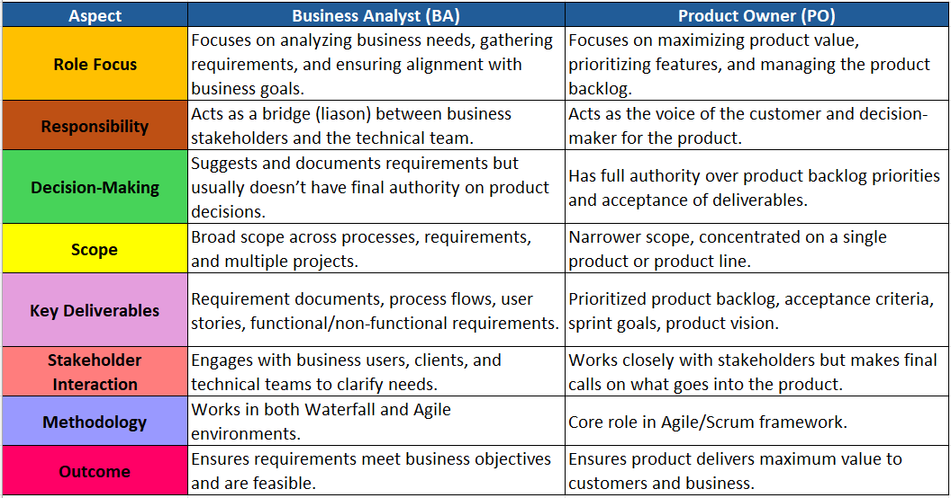

QUESTION 17: Prepare a sample Resume of 3yrs exp Product Owner
ANS.
