**Question 1:**

**Q: 4 Quarterly Audits are planned Q1, Q2, Q3, Q4 for this Project. What is your knowledge on how these Audits will happen for a BA?**

**Answer:** Quarterly audits serve as project health checkpoints. Here's how each quarter aligns with the BA responsibilities:

**Q1 – Planning Audit**

* **Objective:** Evaluate initial project planning and readiness.
* **BA Role Focus:**
  + Confirmation of stakeholder identification and analysis.
  + Verification of elicitation plans and techniques.
  + Review of BA deliverables planning (BRD, FRD, RTM timelines).
  + Communication plan review (frequency, formats, escalation protocols).
* **Outcome:** Green signal to begin requirement elicitation phase.

**Q2 – Requirements Audit**

* **Objective:** Assess progress and quality of gathered requirements.
* **BA Role Focus:**
  + Review of **elicited requirements** and stakeholder sign-offs.
  + Validation of **Use Case Specs**, **Activity Diagrams**, and **RTM mapping**.
  + Assessment of **version control** and **document baselining** practices.
  + Ensure **traceability** from business goals to individual requirements.
* **Outcome:** Approval to transition from analysis to design phase.

**Q3 – Design & Testing Prep Audit**

* **Objective:** Validate transition from analysis to development/testing preparation.
* **BA Role Focus:**
  + Review of **handover of requirements** to developers and testers.
  + Ensure **test case alignment** with requirements.
  + Participation in **reviewing design documents** from a requirements perspective.
  + Verification of **UAT scenarios preparation** and user feedback loops.
* **Outcome:** Confirm system readiness for testing.

**Q4 – Closure & UAT Audit**

* **Objective:** Confirm project closure activities and client acceptance.
* **BA Role Focus:**
  + Validation of **UAT completion** and client sign-off using acceptance forms.
  + Ensure all **change requests** are closed and documented.
  + Archive of BA documentation and final lessons learned.
  + Feedback collection from stakeholders on BA performance.
* **Outcome:** Official project closure from a BA documentation and delivery standpoint.

**Question 2: BA Approach Strategy**

**Answer:** As a Business Analyst, my strategy to effectively deliver this project would follow a structured approach, broken into clear phases:

**1. Understand the Business Need**

* Review the project charter, objectives, and background shared by Mr. Karthik and the committee.
* Identify the key problem statements: difficulties in procuring **fertilizers, seeds, pesticides** by remote farmers.
* Understand stakeholder vision: Providing an **Online Agriculture Products Store** as a CSR initiative under a budget of ₹2 Crores and 18 months.

**2. Stakeholder Identification & Analysis (RACI/ILS)**

* **Responsible:** Me (BA), Developers, Testers
* **Accountable:** Project Manager (Mr. Vandanam)
* **Consulted:** Committee (Mr. Henry, Mr. Pandu, Mr. Dooku), Farmers (Peter, Kevin, Ben)
* **Informed:** All development team members and client side stakeholders

**3. Elicitation Techniques**

* **Workshops & Interviews** with committee and end users (farmers).
* **Observation** to understand current procurement methods in rural areas.
* **Surveys** to collect additional requirements from other potential farmer users.
* **Document Analysis** to study regulatory needs for agri-products.

**4. Documentation**

* BRD (Business Requirements Document)
* FRD (Functional Requirements Document)
* Use Case Specifications
* Process Flow Diagrams
* User Stories (if Agile)
* RTM (Requirement Traceability Matrix)
* SRS (Software Requirements Specification)

**5. Requirement Validation & Sign-Off**

* Organize **walkthroughs** of BRD/FRD with key stakeholders.
* Collect **formal sign-off** from the client (Mr. Henry & Committee) using **Document Sign-Off Templates**.

**6. Communication Channels**

* Weekly project meetings via Zoom/Google Meet
* Project tracking via **JIRA** or **Trello**
* Daily standups with the Dev team
* Shared documentation via **Confluence/SharePoint**
* Stakeholder updates through **monthly reports & demo sessions**

**7. Handling Change Requests**

* Establish a **Change Control Board (CCB)** involving the PM and Committee.
* Evaluate impact on time, cost, and quality before acceptance.
* Maintain **Change Request Log (CRL)**

**8. UAT & Client Sign-Off**

* Define clear **UAT criteria** and scenarios.
* Coordinate with Testers (Mr. Jason & Ms. Alekya) to prepare UAT Test Cases.
* Schedule UAT cycles with stakeholder review.
* Get formal **Client Project Acceptance Form** signed after successful UAT.

**9. Progress Updates**

* Use a **Status Report Template** (weekly).
* Milestone-based dashboards with visual indicators (green/yellow/red).
* Present during steering committee meetings.

**10. Tools & Techniques**

* Modeling Tools: **Visio**
* Requirement Tools: **JIRA**, **Confluence**
* Communication: **Slack**, **Email**, **Google Meet**
* Documentation: **MS Word**, **Excel**, **PowerPoint**

**Question 3: 3-Tier Architecture**

**Answer:** A **3-Tier Architecture** is a widely used software architecture model that separates an application into three logical layers: **Presentation Tier**, **Application (Business Logic) Tier**, and **Data Tier**. This separation improves scalability, maintainability, and flexibility of the application.

**1. Presentation Tier (Client Layer):**

* This is the **front-end** of the application.
* It includes the user interface and handles user interactions.
* In this project, farmers and manufacturers will access the application via a web or mobile interface.
* Technologies: HTML, CSS, JavaScript, Angular, React (for frontend development).

**2. Application Tier (Business Logic Layer):**

* It contains the **core business logic** and processes user requests.
* It acts as a bridge between the presentation layer and the data layer.
* In this project, it will manage login authentication, product catalog search, order placement, and payment processing.
* Technologies: Java (Spring Framework), REST APIs, Controllers, Services.

**3. Data Tier (Database Layer):**

* This layer handles **data storage and retrieval**.
* It communicates with the business logic to store, update, and fetch data from the database.
* In this project, it will store details like user profiles, product information, order history, and payment transactions.
* Technologies: MySQL, Oracle, PostgreSQL.

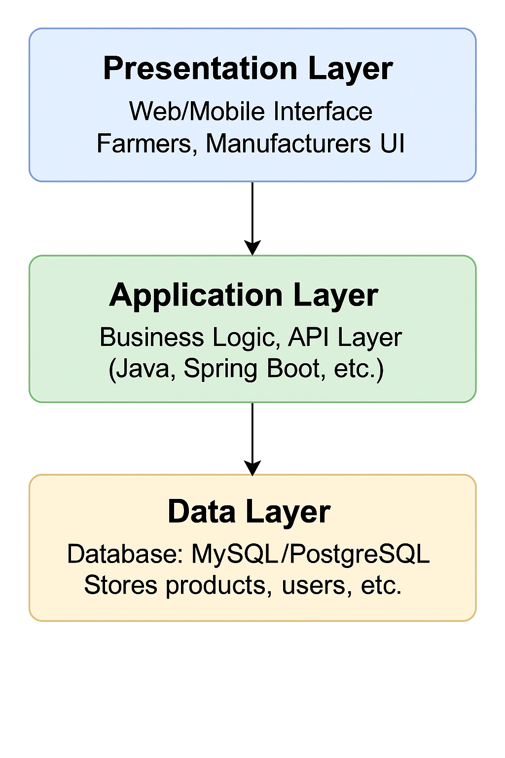

**Question 4: BA Approach Strategy for Framing Questions**

**Answer:** It’s essential to have a structured and strategic approach for framing questions. This ensures clarity, relevance, and depth in understanding business requirements.

**1. 5W1H Approach:**

Use this technique to gather complete context:

* **What** is the problem?
* **Why** is it a problem?
* **When** does it occur?
* **Where** does it occur?
* **Who** are involved or affected?
* **How** is the current process handled?

**2. SMART Criteria for Questions:**

Make sure your questions lead to responses that are:

* **S**pecific – Clear and focused.
* **M**easurable – Can be validated with evidence.
* **A**chievable – Relevant within the scope.
* **R**ealistic – Aligned with business capability.
* **T**ime-bound – Associated with delivery timelines.

**3. RACI Matrix Awareness:**

Understand roles before questioning:

* **Responsible** – Who does the work?
* **Accountable** – Who makes final decisions?
* **Consulted** – Who are the subject matter experts?
* **Informed** – Who needs updates?

This helps tailor your questions appropriately to each stakeholder’s role.

**4. 3-Tier Architecture Knowledge:**

Be prepared to understand and discuss:

* **Presentation Layer** – What user interface requirements exist?
* **Business Logic Layer** – What processes or rules must be handled?
* **Data Layer** – What data is used, where it comes from, and how it's stored?

This enables framing technical and functional questions better.

**5. Use Case and Specification Driven:**

Use cases help in framing scenario-based questions:

* “Can you walk me through how a farmer orders a product?”
* “What happens after a company uploads product details?”

Use Case Specifications support detailed follow-up questions on flows and exceptions.

**6. Activity Diagrams and Models:**

Having a visual understanding of business flows helps you probe gaps or inefficiencies:

* “Is there any manual intervention in this step?”
* “Who initiates this process?”

**7. Page Design / UI Mockups (Optional):**

Early wireframes or mockups help clarify:

* How stakeholders expect the system to look.
* What input fields, buttons, or messages should be on a screen.

**Question 5: Elicitation Techniques**

**Answer:** Elicitation Techniques include:

As a Business Analyst, eliciting accurate, complete, and relevant requirements from stakeholders is a key responsibility. The following techniques, often remembered using the mnemonic **BDRFOWJIPQU**, are commonly used:

**B – Brainstorming**

Used for generating a large number of ideas quickly from stakeholders or subject matter experts (SMEs). Useful in the early stages of requirement gathering and solution design.

**D – Document Analysis**

Involves reviewing existing documentation such as SOPs, user manuals, reports, or previous project specs to understand current processes and gather baseline information.

**R – Reverse Engineering**

Used to analyze an existing system to extract requirements or understand how it functions, particularly when documentation is limited.

**F – Focus Groups**

A moderated discussion with a selected group of stakeholders or end-users to gather opinions, needs, and expectations. It provides qualitative insights.

**O – Observation**

Also known as Job Shadowing. The BA observes users performing their tasks to understand actual workflows, pain points, and system usage in real-time.

**W – Workshops**

Collaborative sessions involving multiple stakeholders to define requirements, resolve conflicts, and make decisions faster. These are highly interactive and productive.

**J – Joint Application Development (JAD) Sessions**

Structured workshops involving business and technical teams that focus on system design and requirement gathering, ensuring consensus and quick validation.

**I – Interface Analysis**

Analyzes how the current system interacts with other systems. Helps define the inputs, outputs, and communication protocols involved in integrations.

**P – Prototyping**

Developing a working or visual mock-up of the system or user interface to gather feedback early and refine requirements iteratively.

**Q – Questionnaire / Surveys**

Useful for collecting responses from a large audience. Helps when direct interaction is not possible or for confirming understanding of requirements.

**U – User Stories / Use Case Development**

Captures the functionality required from the end-user's perspective, structured to support Agile or traditional methodologies.

**Question 6: Project-Specific Elicitation Techniques**

**Answer:** For this project, the following elicitation techniques are most suitable:

**1. Prototyping**

**Justification:**  
Given the multiple user groups (farmers and manufacturers), and their need for specific features like **product search**, **login flow**, **buy-later list**, and **payment/delivery tracking**, creating **low-fidelity wireframes or clickable prototypes** would help stakeholders visualize the system early.  
This reduces ambiguity and allows stakeholders like Mr. Henry, Peter, Kevin, and Ben to give **concrete feedback** on UI/UX expectations.

**2. Use Case Specifications**

**Justification:**  
The requirements involve various system interactions like **product browsing**, **login/signup**, **add-to-cart/buy-later**, **payment**, and **delivery tracking**.  
Documenting **Use Cases** will help define **how each type of user (farmer, manufacturer)** interacts with the system, including **alternate flows** and **exceptions**—making it easier for developers and testers to understand expectations.

**3. Document Analysis**

**Justification:**  
Since Mr. Henry already had a structured idea of what the system should do, reviewing existing **catalogs, login processes, and ordering workflows** (if available from similar existing systems or documentation) can speed up the requirement-gathering process and ensure nothing is overlooked.  
It also ensures consistency with existing business practices.

**4. Brainstorming**

**Justification:**  
With multiple stakeholders involved (Henry, Kevin, Peter, Ben), brainstorming sessions are ideal to bring all ideas to the table.  
These sessions will help uncover:

* Unspoken pain points
* Additional user needs (e.g., **UPI options, delivery confirmation email**)
* Feasible features that can be included in MVP vs future releases

These elicitation techniques—**Prototyping**, **Use Case Specs**, **Document Analysis**, and **Brainstorming**—collectively ensure both **functional and non-functional requirements** are well understood, visualized, and agreed upon by all key stakeholders. This leads to better system design, implementation, and user satisfaction.

**Question 7: 10 Business Requirements**

**Answer: Assumptions:**

Before identifying the requirements, the following assumptions are made:

1. All users (farmers and manufacturers) have basic internet access and mobile devices.
2. The application will support both web and mobile interfaces.
3. Manufacturers are verified vendors onboarded by the admin.
4. Payments will be processed via third-party payment gateways.
5. The application must be available in English and possibly in regional languages.
6. Delivery is handled via third-party logistics services integrated into the platform.
7. User support will be provided via in-app queries or helplines.
8. Farmers may operate in low-bandwidth rural areas, so UI must be lightweight.
9. Admin will manage platform operations including user approvals and product listings.
10. Notifications will be sent via SMS and/or Email for major actions.
11. **Identified Business Requirements:**

|  |  |
| --- | --- |
| **BR ID** | **Business Requirement** |
| **BR1** | The system shall allow farmers to **search** and **filter** agricultural products (fertilizers, seeds, pesticides). |
| **BR2** | The system shall allow **manufacturers to upload, view, and edit** their product listings. |
| **BR3** | The system shall provide **user registration and login** functionality for both farmers and manufacturers. |
| **BR4** | The system shall allow farmers to **add products to cart or wishlist** (buy-later list). |
| **BR5** | The system shall support **multiple payment options** including UPI, Debit/Credit Cards, and Cash on Delivery (COD). |
| **BR6** | The system shall send **order confirmation and delivery tracking** details to farmers via email/SMS. |
| **BR7** | The system shall provide an **admin module** to approve/reject product listings and user accounts. |
| **BR8** | The system shall enable **multilingual support** to accommodate users in regional areas. |
| **BR9** | The system shall allow **farmers to raise support queries** or contact the admin within the application. |
| **BR10** | The system shall provide **role-based dashboards** for farmers, manufacturers, and admins. |

**Question 8: Assumptions**

**Answer:**

1. All users will have access to internet and smartphones.
2. The product will be developed in English.
3. Manufacturers are verified and trusted entities.
4. Payment gateway APIs will be available and integrated.
5. Regulatory compliance for e-commerce is taken care of by the legal team.

**Question 9: Requirement Prioritization**

|  |  |  |  |
| --- | --- | --- | --- |
| **Req ID** | **Req Name** | **Description** | **Priority** |
| BR1 | Farmer Search for Products | Farmers should be able to search for available products | 8 |
| BR2 | Manufacturers upload Products | Manufacturers can upload and display products | 8 |
| BR3 | User Registration/Login | Secure login and sign-up for users | 10 |
| BR4 | Add to Wishlist/Cart | Save products for later or buy now | 9 |
| BR5 | Payment Gateway Integration | Support COD, UPI, Cards | 10 |
| BR6 | Product Catalog | Browsing and filtering of products | 9 |
| BR7 | Email Confirmation | Notify users about orders via email | 8 |
| BR8 | Delivery Tracking | Allow users to track orders | 9 |
| BR9 | Admin Approval Module | Product listing approval workflow | 7 |
| BR10 | Contact Support | Farmer query submission and support | 7 |

**Question 10: Use Case Diagram**

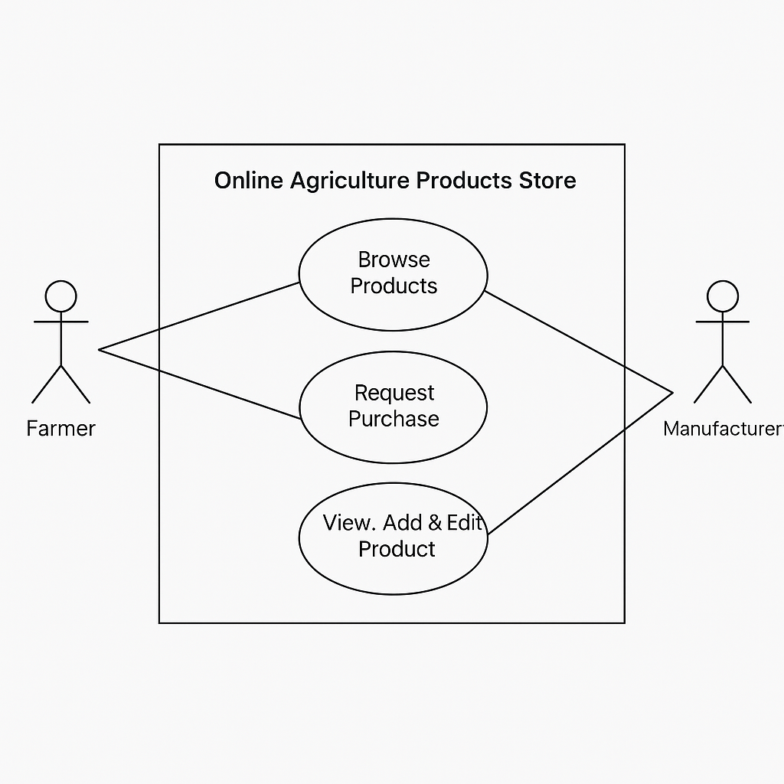

**Question 11: Use Case Specs**

**Answer:** Detailed specs for 5 Use Cases:

1. **Register/Login:**
   * Actor: Farmer/Manufacturer
   * Precondition: User is not logged in
   * Description: Allows user to create a new account or log in to the system
   * Flow: Open form → Enter details → Submit → Login confirmation
2. **Search Products:**
   * Actor: Farmer
   * Precondition: User is logged in
   * Flow: Enter keyword → Filter by type → View results
   * Description: Allows farmers to search and filter agricultural products.
3. **Upload Product:**
   * Actor: Manufacturer
   * Precondition: Manufacturer logged in
   * Description: Enables manufacturers to upload new products with details and images.
   * Flow: Add product → Add images → Submit → Admin approval
4. **Make Payment:**
   * Actor: Farmer
   * Precondition: Products added to cart
   * Description: Allows the farmer to save products to purchase later or add to cart for immediate checkout.
   * Flow: Checkout → Select payment mode → Confirmation
5. **Track Order:**
   * Actor: Farmer
   * Precondition: Order placed
   * Flow: Go to order history → View tracking link/status

**Question 12: Activity Diagram**

