**Document 1- Business case document template**

1. Project Initiation

Why is this project initiated?

This project is initiated to streamline and automate the payment transaction processing system. Currently, payment transactions are received through emails in Excel sheets or PDF documents, leading to several inefficiencies, including:

Manual Processing Delays – Reviewing and processing transactions manually takes time and increases turnaround time.

High Risk of Errors – Manual data entry and validation increase the chances of human errors, resulting in incorrect payments or missing transactions.

Lack of Real-Time Tracking – There is no centralized system to track transaction statuses, approvals, or rejections in real-time.

Compliance & Security Risks – Handling sensitive payment data over emails increases security vulnerabilities and makes it harder to ensure compliance with financial regulations.

Scalability Issues – As transaction volumes grow, the current process becomes increasingly inefficient and difficult to manage.

By developing an automated application, the organization can improve efficiency, accuracy, security, and scalability while reducing operational costs.

2. Current Problems

What are the current problems?

anual email-based processing is inefficient.

Risk of errors in Excel/PDF files.

Lack of real-time tracking and reporting.

Security and compliance concerns.

3. Problem Resolution

With this project, how many problems could be solved?

Automated processing and validation.

Centralized system for transaction tracking.

Reduced human errors and increased efficiency.

Improved compliance and security.

4. Resource Requirements

What are the resources required?

Human Resources: Development team, business analysts, testers, project managers.

Technology: Software framework, database, servers/cloud infrastructure.

Financial Resources: Budget estimation for development, deployment, and maintenance.

5. Organizational Change

How much organizational change is required to adopt this technology?

Changes in job roles and responsibilities.

Employee training and onboarding requirements.

Adoption strategy to ensure a smooth transition.

6. ROI and Time Frame

Time frame to recover ROI?

Cost of development and deployment.

Time and efficiency gains.

Expected cost savings due to automation.

Projected timeline for break-even.

7. Stakeholder Identification

Internal Stakeholders: Finance department, IT team, compliance officers, executive leadership.

External Stakeholders: Banks, payment processors, vendors.

Methods to engage stakeholders: Meetings, surveys, workshops.

**Document 2: BA Strategy**

Requirement Elicitation

Interviews:

One-on-one discussions with stakeholders to gather detailed requirements.

Workshops:

Group sessions to identify business needs and potential solutions.

Surveys & Questionnaires:

Collecting input from a larger audience.

Document Analysis:

Reviewing existing documentation (Excel reports, emails, policies) to understand the current process.

Prototyping:

Creating wireframes/mockups to visualize the solution before development.

Stakeholder Analysis (RACI/ILS)

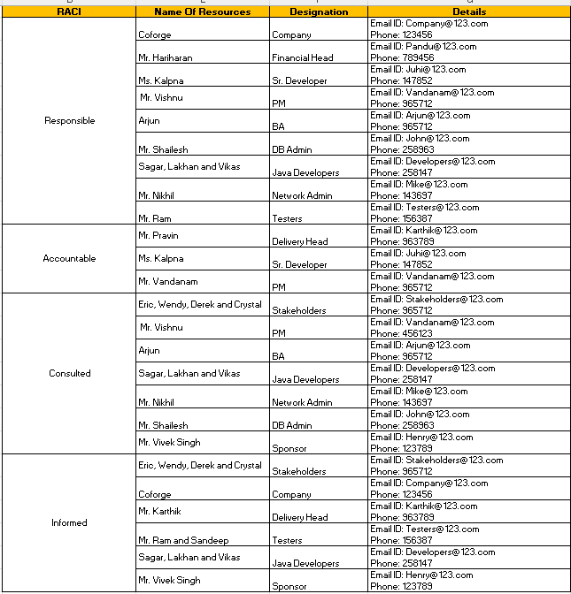

Documents to write:

Business Case Document – Justification of the project initiation.

Business Requirements Document (BRD) – To Capture high-level business needs.

Functional Requirements Specification (FRS) – Details system functionalities.

Process Flows & Use Cases – Defines workflows and user interactions.

Data Flow Diagrams (DFD) – Illustration data movement within the system.

Traceability Matrix – Ensures all requirements are met during development.

User Acceptance Test (UAT) Plan – Defines test scenarios and acceptance criteria.

Document Sign-Off Process

* Documents will be reviewed internally with the project team.
* Formal review sessions will be conducted with stakeholders.
* Any feedback will be incorporated, and the revised document will be sent for approval.
* Sign-off will be obtained via email confirmation or digital signature.

Client Approvals & Communication Plan

* Regular status meetings to present updates and gather feedback.
* Define a structured review timeline for each document.
* Maintain a change request process to address modifications.
* Client approvals will be documented via formal sign-off forms.

Communication Channels

* Meetings: Weekly stand-ups, bi-weekly stakeholder meetings.
* Emails: Official communication and approval tracking.
* Project Management Tools (JIRA, PowerBI, tableau, SQL): Track progress and issues.
* Collaboration Platforms (MS Teams, Slack): Real-time discussions

Change Request Management

* Establish a Change Control Board (CCB) for reviewing and approving changes.
* Use a Change Request Form (CRF) to document requested modifications.
* Evaluate changes for impact on scope, timeline, and budget.
* Obtain necessary approvals before implementing changes.

Project Progress Updates

* Weekly Status Reports to stakeholders.
* Monthly Steering Committee Meetings to discuss project health.
* Risk and Issue Log Updates to track challenges.
* Live Dashboards for real-time tracking (if applicable).

UAT & Client Project Acceptance

* Prepare UAT Test Cases covering all business scenarios.
* Conduct UAT Workshops with key users.
* Capture feedback and log any defects.
* Retest after fixes and obtain final confirmation.

Sign-Off on UAT & Client Project Acceptance

* Prepare a Client Project Acceptance Form summarizing test results.
* Obtain written confirmation (email or document signature) from the client.
* Officially transition to deployment and support phase.

**Document 3- Functional Specifications**

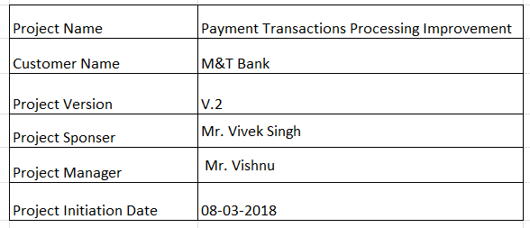

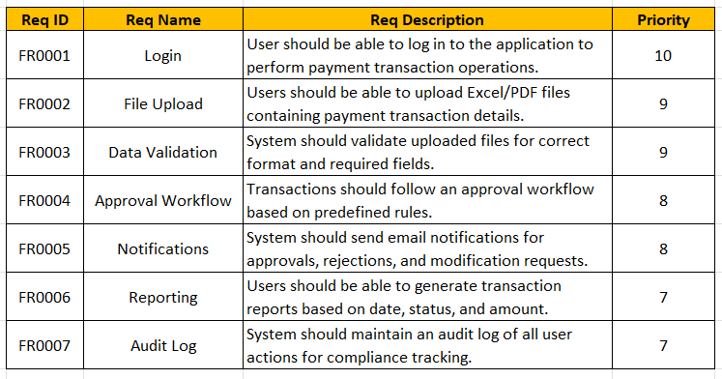

**Document 4- Requirement Traceability Matrix**

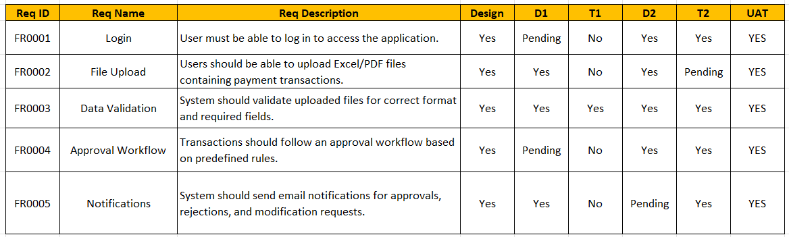

**Document 5- BRD Template**

