**Waterfall Project2 – Part -2/2**

**Document 6- Please prepare a use case diagram, activity diagram and a use case specification document.**

**Use Case Diagram:**

A **Use Case Diagram** represents the functional requirements of a system, including the interactions between different actors and the system. It visually depicts the use cases and the relationships between the actors and the system.

**Key actors involved:**

**Primary Actor**: Loan Applicant, Loan Officer, System

**Secondary Actors**: Bank Manager, Credit Bureau

Here’s an outline of the **Use Case Diagram**

**Actors**:

**Loan Applicant**: Initiates loan application.

**Loan Officer**: Reviews applications and verifies documents.

**Bank Manager**: Approves/Rejects loans based on officer recommendations.

**System**: Calculates credit score, loan eligibility, etc.

**Credit Bureau**: Provides credit score information.

**Use Cases**:

* Apply for Loan
* Review Application
* Approve/Reject Loan
* Check Credit Score
* Verify Documents
* Calculate Loan Terms



**Activity Diagram:**

An **Activity Diagram** shows the sequence of activities involved in a use case and how they are executed. Here’s an outline of the **Activity Diagram** for a loan application process.

**Start**

* Applicant submits loan application
* System checks for missing information

If missing info, notify applicant and wait for submission

If complete, system verifies eligibility

* Loan officer reviews application

If documents or eligibility are incomplete, send back for correction

If complete, request credit score from the credit bureau

* System checks the credit score

If score is low, reject the loan

If score is acceptable, proceed to approval process

* Bank Manager approves or rejects the loan

**End**



**3. Use Case Specification Document:**

Here’s a detailed **Use Case Specification Document** for the loan and credit management system.

**Use Case 1: Apply for Loan**

**Use Case Name**: Apply for Loan

**Use Case Description**: This use case allows a loan applicant to initiate a loan application by providing necessary details like personal information, employment details, requested loan amount, and loan type.

**Actors**:

**Primary Actor**: Loan Applicant

**Secondary Actor**: System (for verifying information)

**Basic Flow**:

* Loan applicant logs into the system.
* Applicant fills out the application form.
* Applicant submits the application.
* System confirms the submission and stores the application details.
* System notifies the applicant that the loan application has been submitted.

**Alternate Flow**:

If required fields are missing or invalid, the system prompts the applicant to fill in missing or correct data.

**Exceptional Flows**:

If the applicant’s session expires during submission, they are logged out, and data is not submitted.

If the system is down, the application cannot be submitted.

**Pre-Conditions**:

The applicant must have an account in the system.

The applicant must be eligible to apply for a loan based on internal criteria (age, income, etc.).

**Post-Conditions**:

The loan application is stored in the system.

The applicant receives confirmation of submission.

**Assumptions**:

The applicant provides accurate information.

The applicant meets the minimum eligibility criteria for applying for a loan.

**Constraints**:

The loan application can only be submitted during business hours.

The applicant’s credit score must be checked before loan approval.

**Dependencies**:

The system depends on the credit bureau to provide an accurate credit score.

The loan officer depends on the system to provide relevant data for review.

**Inputs and Outputs**:

**Inputs**: Loan application details (personal information, loan amount, employment details, etc.)

**Outputs**: A confirmation message, loan application ID.

**Business Rules**:

A loan applicant must meet the minimum age requirement.

The loan amount must not exceed certain thresholds based on the applicant’s income.

**Miscellaneous Information**:

The loan application process will be automated, including eligibility checks.

**Use Case 2: Approve/Reject Loan**

**Use Case Name**: Approve/Reject Loan

**Use Case Description**: This use case involves the loan officer or bank manager reviewing loan applications, making decisions to approve or reject them based on eligibility, credit score, and other factors.

**Actors**:

**Primary Actor**: Loan Officer/Bank Manager

**Secondary Actor**: System (for calculating eligibility, checking credit score)

**Basic Flow**:

* Loan officer reviews loan application.
* Loan officer verifies applicant’s information and credit score.
* Loan officer approves or rejects the loan based on criteria.
* System updates loan status as approved or rejected.
* Applicant is notified of the decision.

**Alternate Flow**:

If additional documentation is required, the officer asks the applicant to provide it.

**Exceptional Flows**:

If the system fails to calculate the loan eligibility or retrieve the credit score, the loan application is placed in pending status.

**Pre-Conditions**:

* The loan application must be complete.
* The credit score must be available.

**Post-Conditions**:

* The loan application status is updated in the system.
* The applicant is notified of the approval/rejection.

**Assumptions**:

* The loan officer has access to all relevant applicant information.
* The credit score is updated in real-time from the credit bureau.

**Constraints**:

Loan approval/rejection must be based on preset business rules.

Only authorized personnel (loan officer, bank manager) can approve or reject loans.

**Dependencies**:

* The system depends on credit information from the credit bureau.
* The loan officer depends on the completeness of the application.

**Inputs and Outputs**:

**Inputs**: Loan application, credit score, applicant’s financial data.

**Outputs**: Loan approval/rejection decision, status update.

**Business Rules**:

* The loan approval process must follow predefined eligibility criteria.
* The loan amount must be within the bank’s lending limits.

**Miscellaneous Information**:

The loan approval/rejection process is automated as much as possible but may involve human intervention for complex cases.

**Document 7- Screens and pages**

Here’s a step-by-step flow for the **Loan Application Process**:

1. **Home Page** → User clicks on **Login**
2. **Login Page** → User enters credentials and clicks **Login**
3. **Dashboard** → User clicks on **Apply for Loan**
4. **Loan Application Page** → User fills out details and submits the application
5. **Loan Application Confirmation Page** → System confirms submission and informs the user of next steps
6. **Loan Officer Review** → System updates the loan status (approved/rejected)
7. **Loan Status Page** → User views the status of their loan application (approved/rejected)
8. If approved, user proceeds to the **Payment Page** to set up repayment.
9. **Logout Page** → User clicks **Log Out** to exit the system.

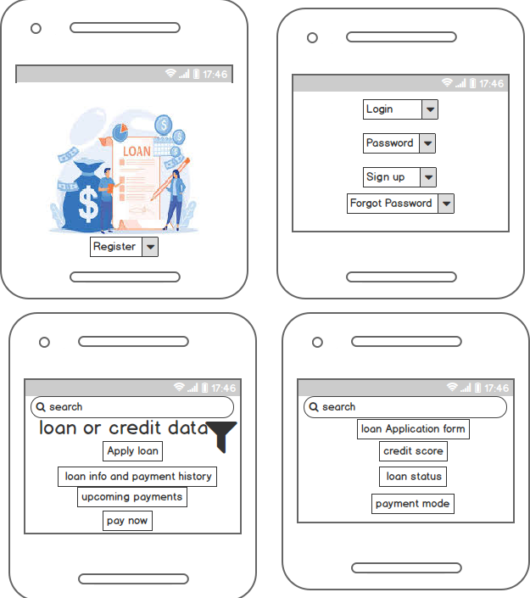

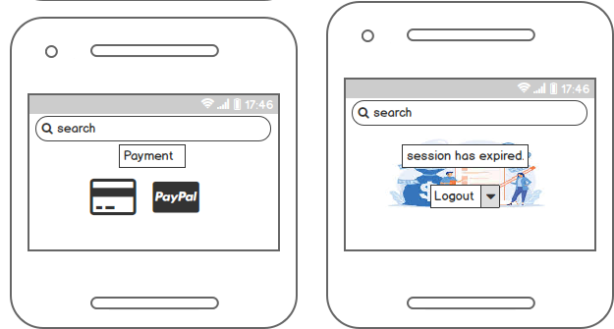

**Creating Mockups in Balsamiq or Axure**

Using **Balsamiq** or **Axure**, you can create the above screens with interactive elements. Below are some basic instructions on how to start with each tool:

**Balsamiq**:

* + Use **widgets** to create form fields, buttons, and navigation bars.
  + Drag and drop UI elements such as text boxes, buttons, and images for the page layout.
  + Use **links** between pages for basic navigation.

**Axure**:

* + Use **dynamic panels** for interactive states (e.g., login status, loan approval).
  + Create **variables** to store user data and simulate login or payment functionality.
  + Use **prototyping** features to make the mockups interactive, allowing you to link different pages and simulate user flow.

These mockups will provide a solid visual foundation for the Loan and Credit Management Analysis system

**Document 8- Tools-Visio and Axure**

**Experience Using Visio and Axure for the Loan and Credit Management Analysis Project**

* In working on the Loan and Credit Management Analysis project, I had the opportunity to use both **Visio** and **Axure** to create visual diagrams and interactive mockups.
* **Visio** proved to be an excellent tool for creating process flow diagrams, data flow diagrams, and organizational charts. Its ease of use and comprehensive set of shapes and templates allowed me to quickly map out processes like the loan application workflow and decision-making steps.
* The drag-and-drop functionality made it efficient to visualize the sequence of activities, interactions between actors, and system components.
* On the other hand, **Axure** provided a more dynamic and interactive experience for creating wireframes and mockups. The ability to create functional prototypes with clickable elements allowed me to simulate user interactions, which was incredibly useful for the Loan Application and Payment pages.
* The tool's dynamic panels and variables enabled me to mimic real user behavior, such as navigating through different states in the application process or viewing loan status updates. The interactivity was key in presenting a realistic user experience to stakeholders and refining the system's flow before implementation.
* Together, **Visio** helped with process modeling and planning, while **Axure** allowed for more in-depth
* Prototyping and user interaction design, both are crucial for visualizing and refining the loan management system’s user interface and flow.

**Document 9- BA experience**

**My experience as BA in following phases:**

**1. Requirement gathering:**

* During the **requirement gathering phase**, we utilized the **MOSCOW technique** (Must have, Should have, Could have, won’t have) to prioritize requirements, ensuring that the most critical aspects were addressed first. However, we faced the challenge of the client being unavailable for a period, so I had to take proactive steps.
* I identified and contacted key points of contact on the client’s side to ensure continuous information flow and promptly gather the necessary details.
* To validate the gathered requirements, I applied the **FURPS technique** (Functionality, Usability, Reliability, Performance, and Supportability) to ensure each requirement was comprehensive, clear, and feasible. I also identified many **duplicated or repeated requirements** that needed to be eliminated immediately to avoid confusion and ensure clarity in the final documentation.
* Prototyping was heavily used to refine and specify the requirements, offering the client a clearer view of how the system would function and ensuring alignment with their expectations.

**2. Requirement Analysis:**

* In the **requirement analysis phase**, I used **UML diagrams** (Unified Modeling Language) to visually describe the system’s requirements. These diagrams helped the development and technical teams understand the system structure and interactions better.
* I also created **Activity Diagrams** to depict the flow of the processes within the loan management system, ensuring that all stakeholders had a visual representation of the process.
* There were instances when team members disagreed with certain diagrams or proposed changes. In such cases, I engaged in discussions, understanding their perspectives, and making necessary modifications to the diagrams based on their valid inputs. The **Business Requirements Specification (BRS)** and **System Requirements Specification (SRS)** documents were prepared at this stage, providing a detailed and organized view of all project requirements.

**3. Design:**

* In the **design phase**, I translated **use case diagrams** into detailed **test cases** to ensure that all functionalities were thoroughly tested. I worked closely with the client to review and validate the design and solution documents.

.

* **Test data** was also prepared for testing, and I ensured the **Requirements Traceability Matrix (RTM)** was regularly updated to track that all requirements were being met. Maintaining the RTM was essential for ensuring traceability and ensuring nothing was missed as the project progressed

**4. Development:**

* During the **development phase**, I organized **Joint Application Development (JAD) sessions** with both the technical team and the client to clarify any queries. These sessions were essential for ensuring the development team fully understood the requirements and design specifications.
* Sometimes, team members didn’t fully agree with certain concepts, or there were instances of non-cooperation. In these situations, I handled the matter delicately, scheduling one-on-one discussions to explain the impact of their actions on the project. I emphasized the importance of collaboration and created a healthy environment within the team to facilitate smoother communication.
* I referred to the **diagrams** and **use cases** to assist the technical team in coding the units, ensuring all requirements were integrated into the system. Regular meetings with the client and technical team helped keep everyone aligned.
* When certain team members could not attend meetings, I recorded the sessions and followed up with them individually to ensure they were informed.

**5. Testing:**

* In the **testing phase**, I used the **use cases** to create comprehensive **test cases**, ensuring both functional and non-functional requirements were tested.
* I performed **high-level testing** to validate the overall system functionality, while **test data** was sourced from the client to ensure the system could handle real-world scenarios.
* I made sure the **RTM** was updated regularly, and I collaborated with the client to obtain **signoff** on the test cases. Once everything was in place, I prepared the client for **User Acceptance Testing (UAT)** by ensuring they understood the testing process and their responsibilities during this phase.

**6. Deployment:**

* In the **deployment phase**, I forwarded the **RTM** to the client, ensuring it was attached to the project closure document for reference. Additionally, I coordinated the preparation and sharing of **end-user manuals** to help users navigate the new system effectively.
* I planned and organized **training sessions** for end users, making sure all candidates attended the training to ensure a smooth transition.
* I closely monitored the training process to address any concerns or questions, helping the client understand how to use the loan and credit management system effectively.

**Conclusion:**

* Throughout the project, I ensured clear and constant communication with both the client and the development team. As a BA, my role was not only to gather and analyze requirements but also to facilitate the development process, ensuring every aspect was documented, tested, and deployed as per the client’s expectations.
* Each phase presented its own set of challenges, but through collaboration, attention to detail, and proactive problem-solving, I helped deliver a robust loan and credit management solution.