**Waterfall Deliverables-DCF**

**Document -1-** Business case document template – 5WIH

* **Why is the project initiated ?**
* To enhance operational efficiency, improve user experience, and ensure regulatory compliance.
* With the increasing complexity of healthcare claims processing, medical underwriting, and risk assessment, a robust system is crucial for integrating patient data, improving decision-making, and reducing fraud.
* Currently, the organization relies on disparate systems that require manual intervention, leading to inefficiencies in claim verification, increased turnaround times, and challenges in maintaining accurate medical records for policyholders.
* **What are the current problems?**
* Data Fragmentation: Medical records of policyholders are stored in multiple systems, leading to inconsistencies, redundancies, and difficulty in accessing patient history during claim verification and underwriting.
* Inefficiencies in Claims Processing: Manual handling of medical records results in increased processing time, higher operational costs, and potential errors in claims assessment.
* Regulatory Compliance Challenges: Compliance with healthcare regulations (such as HIPAA and local data protection laws) is difficult due to the absence of a structured and auditable electronic medical record system.
* Limited Fraud Detection Capabilities: Lack of centralized medical records makes it challenging to detect fraudulent claims, increasing financial risks for the company.
* Challenges in managing Patient's medical records
* Gap between Medical Analyst, Adjuster, Developers, SMEs, QAs.
* Need for data-driven decision making.
* Issues related to data security , privacy, interoperability.
* **With this project how many problems could be solved?**
* An expanded set of online tools designed to allow agents and customers to access information and perform tasks associated with the claims process.
* Focused on a modern claims system implementation and focus on reducing the time and improve the customer experience.
* Customers would be well aware of their claim timelines and who would be handling it.
* Operational Cost Reduction: Automation and digitization of medical records will reduce manual workload, lowering administrative costs and improving overall business efficiency.
* Enhanced Data Accuracy and Integrity
* Improved Regulatory Compliance
* Seamless Interoperability.
* **What are the resources required?**
* Implementing an DCF system in the Health Insurance MNC is a strategic initiative that will address existing challenges while unlocking significant business opportunities.
* As a Business Analyst, the focus will be on requirement gathering, stakeholder alignment, workflow optimization, and system integration to ensure a seamless transition and successful implementation of the new system.
* People : PM ; SME, QA , Developers, BA , Adjustors, AM
* Time- Implementation within 2 months.
* Budget : Hardware, software, training and services not to exceed Rs- 5 lakhs.
* Other : Third party software**.**
* **How much organizational change is required to adopt this technology?**
* Data Quality and availability.
* Ethical and Legal concerns.
* Scalability and performance changes.
* The medical document would be easily accessible to stakeholders for easy processing of analysis and claims process.
* **Time frame to recover ROI?**
* Over a span of 1 year.
* **How to identify Stakeholders?** 
  + Understand the scope of project or organisation
  + Identified the impact areas- Increased TAT, Compromised Productivity, Complex and tedious
  + Brainstorming : Considered knowing the stakeholders and who is affected by influences or is interested in the project.
  + Prioritize stakeholders
  + Validate and update regularly

**Document 2 : BA Strategy**

1. BA Approach strategy

As a BA , I have worked on some elicitation techniques.

Brainstorming and Protypying.

**Prototyping** is a technique that allows to create a simplified or tangible version of system or product and test it with potential users. It can help you elicit and validate requirements , identify gaps and issues, and improve user satisfaction and engagement.

It would help in : visualizing the system ; validate the requirements, helps generating feedbacks, boosts stakeholders participation.

**Brainstorming :** It can be done either individually or in groups. The ideas collected can then be reviewed/analysed and where relevant included within the system requirements. Ideas can come from what users/stakeholders have seen or experienced elsewhere.

1. Elicitation techniques

Requirements Elicitation technique is the process of digging out the information from the stakeholders , it serves the foundation in documenting the requirements.

While working on DCF project we followed : Brainstorming, Document analysis, and observation techniques to understand the requirements and gaps clearly.

1. RACI Matrix.

|  |  |  |  |
| --- | --- | --- | --- |
| RACI | Names of stakeholders | Designation | Remarks |
| Responsible | * Ms Juhi | Senior java developer |  |
| * Mr. Teyson, Mr Tucker   Ms Lucie  Mr Bravo | Java  Developers |  |
| * Mr Jason and Ms Alekya | Tester |  |
| Accountable | * Madhumita | Business analyst |  |
| * Mr Karthik | Delivery Head |  |
| * Mr Vandanam | Project manger |  |
| Consulted | * Ms XYZ | SME |  |
| * John | DB Admin |  |
| * Mr Mike | Network Admin |  |
| Informed | * Mr Henry | Sponsor |  |
| * Mr Pandu | Financial Head |  |
| * Mr Dooku | Project coordinator |  |

1. What communication channels to establish and implement ?

Ensure alignment between developers, testers, project managers, and stakeholders.

* Daily & Regular Updates- via **Microsoft Teams, Zoom**
* **Email Updates & Reports** – via **Outlook, Gmail**
* **Instant Messaging – Microsoft Teams**
* **Requirement Documentation** – via **Confluence, Google Drive, SharePoint**
* **Technical Specs & API Docs** – via **Swagger, GitHub Wiki, Confluence**
* **Meeting Notes & MOMs** – via **OneNote, Google Docs**
* **Agile Task Boards & Traceability**– via**JIRA, Trello**
* **Gantt Chart & Timeline Tracking**– via**MS Project, Smartsheet.**
* **Whiteboarding & Brainstorming – via Miro, MURAL, Microsoft Whiteboard**
* **Surveys & Feedback Collection – via Google Forms, Microsoft Forms**

1. How to handle change requests ?

**Change Request Document**

**Project Name:** DCF

**Change Request Title:**  Show name of assigned performer of the claim task.

**Change Request ID:** CR-2025-001

**Date of Request:** [ 25/02/2025]

**Request Initiator:** [Stakeholder Name or Department]

**Change Summary:** Due to a change in the requirements as gathered from stakeholders through observation, there has to be an option on the web page that shows to whom the claim task has been assigned to avoid duplication of work.

**Proposed Solution :**

* Modify the web page , under the claim task its would be visible whether the task is assigned and display the name of the performer. And if not assigned , displays it as unassigned.
* **Update the database to store all the names of performer with proper IDs.**
* **Revise the UI to display update change.**
* **Updated user guidelines and documentation to reflect the changes.**

**Stakeholders Affected : Adjustors, Medical Analyst, QAs, TL.**

**Change Request Status :**

**PM: Mr Ganesh**

1. How to update the progress of the project to the stakeholders ?

A **Gantt chart** is a great way to visually represent the **integration of DCF (Digital Claim File) with Next Gen using the Waterfall Model**.

|  |  |  |  |  |  |
| --- | --- | --- | --- | --- | --- |
| **Phase** | **Task** | **Start Date** | **End Date** | **Duration** | **Responsibility** |
| **Requirement Analysis** | Gather DCF & Next Gen requirements | Day 1 | Day 10 | 10 days | BA/PM/SME |
|  | Define scope & integration points | Day 5 | Day 15 | 10 days | BA/Architect |
| **System Design** | Design architecture & data mapping | Day 16 | Day 30 | 15 days | Architect/Dev |
|  | Develop API framework | Day 25 | Day 40 | 15 days | Dev Team |
| **Implementation** | Backend & middleware development | Day 41 | Day 70 | 30 days | Dev Team |
|  | Frontend adjustments & UI/UX | Day 50 | Day 80 | 30 days | UI/UX Team |
| **Testing** | Unit testing | Day 81 | Day 90 | 10 days | QA Team |
|  | Integration testing | Day 91 | Day 110 | 20 days | QA Team |
|  | UAT & feedback | Day 111 | Day 130 | 20 days | Users/BA |
| **Deployment** | Final deployment & monitoring | Day 131 | Day 140 | 10 days | DevOps Team |
| **Workflow Traceability** | Implement Agile tracking (JIRA) | Ongoing | Ongoing | Continuous | Scrum Master |
|  | Daily standups & sprint planning | Ongoing | Ongoing | Continuous | Agile Team |

1. How to take signoff on the UAT- Client project acceptance form.

**Project Closure Document:**

**Project Name:**  DCF- Digital Claim File   
**Client:** Allsate   
**Project ID:** DCF-2025  
**Date:** 22/02/2025

The following items have been handed over :

Application Source Code.

Deployment Guides.

User Training Materials.

Maintenance & Support Plan.

|  |  |  |  |
| --- | --- | --- | --- |
| **Name** | **Role** | **Signature** | **Date** |
| Mr. Jagan | Client Representative |  |  |
| Ms. Smita | Financial Head |  |  |
| Mr. DEF | Project coordinator |  |  |
| Madhumita | BA |  |  |
| Mr. KLM | PM |  |  |

**Document 3 – Functional Specifications**

|  |  |
| --- | --- |
| **Project Name** | DCF- Digital Claim File |
| **Customer Name** | Allsate |
| **Project Version** | DCF001 |
| **Project Manger** | ABC |
| **Project Sponsor** | Allsate |
| **Project Initiation date** | 01/10/2024 |

**Functional Requirements Specification**

|  |  |  |
| --- | --- | --- |
| **Requirement ID** | **Requirement**  **description** | **Priority** |
| FR001 | A login for all its users  (Adjusters, QAs, Analyst, Customers) | 1 |
| FR002 | User should be able to create log in with email id and password | 1 |
| FR003 | If user forgets log in id and password , they should be able to retrieve the account with the help of Reporting Manager | 2 |
| FR004 | Users should be able to search the Claimant details and medical records with Claimant ID /Name. | 3 |
| FR005 | Users should be able to browse through and view priority Claimant task based on TAT date | 4 |
| FR006 | Users should be able to find appropriate file with keywords. | 5 |
| FR007 | User must be able to view and share the medical records internally with QAs. | 6 |
| FR008 | The document should be easily downloaded and uploaded, and in editable format. | 4 |
| FR009 | Compliant with HIPPA | 1 |
| FR010 | Push notification from NG | 9 |
| FR011 | The document to be uploaded with a defined name format. | 5 |

**Document-4**

**Requirement Traceability Matrix**

|  |  |  |  |  |  |  |  |  |
| --- | --- | --- | --- | --- | --- | --- | --- | --- |
| **Req ID** | **Req Name** | **Req Description** | **Design** | **D1** | **T1** | **D2** | **T2** | **UAT** |
| FR0001 | Login | A login for all its users  (Adjusters, QAs, Analyst, Customers) | Yes | Completed | Yes | Yes | Yes | Yes |
| FR0002 | Login with ID | User should be able to create log in with email id and password | Yes | Completed | Yes | Yes | Yes | Yes |
| FR0003 | Password  Recovery | If user forgets log in id and password , they should be able to retrieve the account with the help of Reporting Manager | Yes | Completed | Yes | Yes | Yes | Yes |
| FR0004 | Search | Users should be able to search the Claimant details and medical records with Claimant ID /Name. | Yes | Completed | Yes | Yes | Yes | Yes |
| FR0005 | Browse | Users should be able to browse through and view priority Claimant task based on TAT date | Yes | Completed | Yes | Yes | Yes | Yes |
| FR0006 | Find  With  keywords | Users should be able to find appropriate file with keywords. | Yes | Completed | Yes | Yes | Yes | Yes |
| FR0007 | Share | User must be able to view and share the medical records internally with QAs. | Yes | Completed | Yes | Yes | Yes | Yes |
| FR0008 | Download  And upload | The document should be easily downloaded and uploaded, and in editable format. | Yes | Completed | Yes | Yes | Yes | Yes |
| FR0009 | Compliant  standard | Compliant with HIPPA | Yes | Completed | Yes | Yes | Yes | Yes |
| FR0010 | Integrate  With  NG | Push notification from NG | Yes | Completed | Yes | Yes | Yes | Yes |
| FR0011 | Standard  Format  For file  Name. | The document to be uploaded with a defined name format. | Yes | Completed | Yes | Yes | Yes | Yes |

**BRD**

**< DCF-Digital Claim File >**

**< PR002001>**

**< Version-1 >**

**< X…Y…Z >**

**Contents**

1. Document Revisions……………………………………………………………….12
2. Approvals………………………………………………………………12
3. RASCI Chart for This Document................................................................................................13

Codes Used in RASCI ................................................................................13

RASCI Chart...............................................................................................13

1. Introduction...............................................................................................14
2. Business Goals........................................................................................14
   1. Business Objectives……………………………………………………14
   2. Business Rules…………………………………………………………15
   3. Background……………………………………………………………..15
   4. Project objectives……………………………………………………….16
   5. Project Scope ……………………………………………………………16
      1. In Scope Functionality……………………………………………………….16
      2. Out Scope Functionality…………………………………………………………16
3. Assumptions……………………………………………………………….17
4. Constraints………………………………………………………………....17
5. Risks………………………………………………………………………..17

Technological Risks……………………………………………..…………18

Skills Risk………………………………………………………………….18

Business Risk……………………………………………………………18

Requirements Risk………………………………………………………….18

Other Risks………………………………………………………………....19

1. Business Process Overview………………………………………………...20
   1. Legacy System
   2. Proposed Recommendations
2. Business Requirements……………………………………………………21
3. Appendices
   1. List of Acronyms………………………………………………..21
   2. Glossary of terms………………………………………………..22
   3. Related documents………………………………………………22
4. Document Revisions

|  |  |  |  |  |  |
| --- | --- | --- | --- | --- | --- |
| **Version** | **Date** | **Description of Change** | **Author** | **Approved By** | **Comments** |
| 1 | 23/2/2025 | Initial draft of BRD | Ms. Smita | Mr Anil | N/A |
| 1.1 | 24/2/2025 | Added clarification to scope section | Ms. Neha | Mr Anil | Updated to reflect stakeholder feedback |
| 1.2 | 24/02/2025 | Revised requirements for user login | Mr Ajay | Mr Anil | Adjusted after meeting with the development team |
| 1.3 | 24/2/2025 | Fixed errors in financial calculations | Mr Anup | Mr Anil | Corrected after QA review |
| 2 | 25/2/2025 | Final version with all approvals | Mr Sanjay | Mr Anil | Finalized for sign-off |

1. Approvals
2. **Document Review:  
   All stakeholders to review the Integration plan, business requirements, and technical specifications.**
3. **Feedback:  
   Any feedback or concerns will be addressed and the document will be updated accordingly.**
4. **Final Sign-Off:  
   After all feedback is incorporated and any final adjustments are made, the document will be signed off by the relevant stakeholders**

|  |  |  |  |  |
| --- | --- | --- | --- | --- |
| **Name** | **Title** | **Department/Organization** | **Signature** | **Date** |
| Mr Henry | Project Sponsor | Allsaate | [Signature] | 25/0/2024 |
| Mr Vandanam | Project Manager | Allsaate | [Signature] | [25/0/2024 |
| Ms Juhi | IT/Development Lead | Allsaate | [Signature] | [25/0/2024 |
| Mr Vandanam  Madhumita | Business Stakeholder | Allsaate | [Signature] | 25/0/2024 |
| Ms. Neeta | Quality Assurance Lead | Allsaate | [Signature] | 25/0/2024 |

1. RACI Matrix.

|  |  |  |  |
| --- | --- | --- | --- |
| RACI | Names of stakeholders | Designation | Remarks |
| Responsible | * Ms Juhi | Senior java developer/Lead |  |
| * Mr. Teyson, Mr Tucker   Ms Lucie  Mr Bravo | Java  Developers |  |
| * Mr Jason and Ms Alekya | Tester |  |
| Accountable | * Madhumita | Business analyst |  |
| * Mr Karthik | Delivery Head |  |
| * Mr Vandanam | Project manger |  |
| Consulted | * Ms Shela | SME |  |
| * John | DB Admin |  |
| * Mr Mike | Network Admin |  |
| Informed | * Mr Henry | Sponsor |  |
| * Mr Pandu | Financial Head |  |
| * Mr Dooku | Project coordinator |  |

1. Introduction

* To enhance operational efficiency, improve customer experience, and ensure regulatory compliance.
* With the increasing complexity of healthcare claims processing, medical underwriting, and risk assessment, a robust system is crucial for integrating patient data, improving decision-making, and reducing fraud.
* Currently, the organization relies on disparate systems that require manual intervention, leading to inefficiencies in claim verification, increased turnaround times, and challenges in maintaining accurate medical records for policyholders.
* The lack of a centralized digital system has also resulted in fragmented customer data, making it difficult to provide seamless and personalized insurance services.
* An expanded set of online tools designed to allow agents and customers to access information and perform tasks associated with the claims process.
* Focused on a modern claims system implementation and focus on reducing the time and improve the customer experience.

1. Business Goals

5.1 Objectives

* Seamlessly integrate **DCF** with **Next Gen** for smooth data exchange.
* Ensure structured **Waterfall Model** implementation for phased development.

5.2 Business Rules

1. All patient data must be securely encrypted during transmission and storage.
2. Claims must be automatically validated before submission to reduce errors.
3. System access should be role-based, ensuring only authorized personnel can modify or view sensitive data.
4. Claims processing should adhere to regulatory compliance requirements (e.g., HIPAA, GDPR).
5. Duplicate claims should be flagged and reviewed before submission.
6. Real-time notifications should be sent to stakeholders upon claim status updates.
7. All system integrations must support standardized data formats (e.g., HL7, FHIR).
8. Data audits should be conducted periodically to ensure accuracy and security.

5.3 Background

* The project aims to integrate the **Digital Claim File (DCF)** system with **Next Gen** using the **Waterfall Model** to ensure a structured development process.

5.4 Project Objectives

* The purpose of this project is to analyze, select , create and implement a new flatform in a healthcare insurance setting. Its primary purpose is to ensure a structured approach to digitalizing health records while enhancing efficiency, security and accessibility for a smooth settlement of claims.
* Adhere to regulations (HIPAA, GDPR, etc.) for data privacy
* Implement secure access controls and encryption.
* Enable seamless data exchange between healthcare providers
* Integrate with other hospital management systems (HMS).

5.5 Project Scope

5.1 In Scope

* Integration of **DCF and Next Gen** for automated claims processing.
* API development for data exchange.
* Testing & validation to ensure seamless operation.
* Compliance standards will be met.

5.2 Out of Scope

* New feature development for DCF or Next Gen (only integration is covered).
* UI redesign of Next Gen or DCF.
* System migration or major infrastructure changes.
* Frequent change in requirements.
* Third party external support.
* Increasing timelines.

6. Assumptions

* APIs for DCF and Next Gen are available for integration.
* The project follows a **fixed scope under Waterfall**, while **workflow tracking remains Agile**.

7. Constraints

* Data compliance regulations (HIPAA, GDPR) must be strictly followed.
* Limited modifications allowed to existing DCF or Next Gen systems.

1. Risks and Mitigation

* Data Quality and availability.
* Server failure.
* Ethical and Legal concerns.
* Scalability and performance issue.
* The medical document would be easily accessible to stakeholders for easy processing of analysis and claims process.

### ****Technological Risks:****

* **Integration Compatibility:**
  + **Risk:** DCF and NextGen may not be fully compatible, leading to data flow or system integration issues.
  + **Impact:** Delays in the project due to technical rework, data inconsistency, or failure to integrate.
  + **Mitigation:** Thoroughly assess system specifications, APIs, and integration capabilities before project initiation. Conduct detailed testing to ensure compatibility.
* **Data Mapping and Conversion Issues:**
  + **Risk:** Inconsistent data formats or structures between DCF and NextGen can lead to errors or data loss during integration.
  + **Impact:** Incorrect or missing claims data in NextGen, affecting business operations and decision-making.
  + **Mitigation:** Develop a clear data mapping and transformation plan. Implement data validation and cleansing during the integration process.
* **Performance Issues:**
  + **Risk:** The integration could lead to performance degradation in either DCF or NextGen (e.g., slower processing or response times).
  + **Impact:** Reduced user experience and efficiency in claim processing.
  + **Mitigation:** Conduct load testing and performance benchmarking to ensure that both systems can handle the expected volume of claims data.
* **System Downtime During Integration:**
  + **Risk:** The integration process might cause downtime in the system, affecting users’ ability to submit or process claims.
  + **Impact:** Disruption to business operations and potential delays in claim processing.
  + **Mitigation:** Plan for off-peak hours for integration work and ensure proper contingency plans, including rollback strategies.

### ****Skills Risks:****

* **Lack of Expertise in Both Systems:**
  + **Risk:** The team may lack sufficient knowledge of DCF and NextGen, especially regarding their architecture, data structures, and integration requirements.
  + **Impact:** Poor quality of integration, misunderstandings of system functionality, or delays due to rework.
  + **Mitigation:** Ensure the project team includes experts familiar with both DCF and NextGen, or hire external consultants if necessary.
* **Insufficient Training for Users:**
  + **Risk:** Users may not be adequately trained to work with the integrated system, leading to errors in data entry or difficulties in using the new workflow.
  + **Impact:** Decreased productivity and increased risk of mistakes in the claims process.
  + **Mitigation:** Plan for user training and conduct user acceptance testing (UAT) to ensure readiness before full deployment.

### ****Business Risks:****

* **Changing Business Requirements:**
  + **Risk:** Business requirements for the integration may change mid-project due to evolving needs or stakeholder input, affecting scope and timelines.
  + **Impact:** Increased costs, delays, and potential scope creep.
  + **Mitigation:** Clearly define the business requirements at the start of the project, and establish a formal change control process to manage scope changes.
* **Stakeholder Misalignment:**
  + **Risk:** Different business units (e.g., claims, finance, IT) may have conflicting expectations regarding the integration.
  + **Impact:** Delays in decision-making, scope misunderstandings, and delays in achieving business objectives.
  + **Mitigation:** Conduct regular stakeholder meetings to ensure alignment and gather feedback early in the process.
* **Compliance and Regulatory Risks:**
  + **Risk:** The integration might not fully comply with industry regulations (e.g., HIPAA, GDPR) regarding data handling, security, and privacy.
  + **Impact:** Legal penalties, security breaches, or reputational damage.
  + **Mitigation:** Involve compliance and legal teams in the early stages of the project to ensure regulatory requirements are identified and followed throughout.

### ****Requirements Risks:****

* **Unclear Integration Requirements:**
  + **Risk:** The initial business and technical requirements for integrating DCF with NextGen may be vague or incomplete.
  + **Impact:** Misalignment between the final solution and business needs, leading to rework or delays.
  + **Mitigation:** Conduct thorough requirements gathering sessions with all relevant stakeholders, and ensure requirements are well-defined and validated before development begins.
* **Scope Creep:**
  + **Risk:** New requirements or features may be introduced after the project has started, resulting in changes to the scope.
  + **Impact:** Timeline and budget overruns, increased complexity of the project.
  + **Mitigation:** Establish clear project goals and boundaries, and manage scope through a formal change request process.
* **Unclear Data Handling Requirements:**
  + **Risk:** The specific handling of sensitive claim data between DCF and NextGen may not be fully defined, leading to data loss or incorrect processing.
  + **Impact:** Disruptions in claims processing, potential data breaches.
  + **Mitigation:** Clearly define data handling, transformation, and security protocols. Ensure these are part of the integration requirements.

### ****Security Risks:****

* **Data Security and Privacy Concerns:**
  + **Risk:** Sensitive claim data exchanged between DCF and NextGen may be exposed to unauthorized access during integration.
  + **Impact:** Potential data breaches or violations of privacy regulations.
  + **Mitigation:** Implement strong encryption protocols for data in transit and at rest. Ensure the integration adheres to industry security standards.
* **Access Control Issues:**
  + **Risk:** Incorrect user permissions or roles in NextGen after integration could allow unauthorized access to sensitive data.
  + **Impact:** Unauthorized data access, leading to potential fraud or data leakage.
  + **Mitigation:** Define and enforce strict access controls and ensure role-based security is set up correctly in NextGen post-integration.

### ****Operational Risks:****

* **Operational Disruption During Integration:**
  + **Risk:** The integration process could disrupt day-to-day operations, including claim submissions, data processing, or reporting.
  + **Impact:** Delayed claims processing, inefficiencies, or customer dissatisfaction.
  + **Mitigation:** Schedule integration activities during off-peak times, and implement a robust backup and recovery plan.
* **Inadequate Testing:**
  + **Risk:** The integrated solution might not undergo thorough testing across all possible use cases, leading to undiscovered issues in production.
  + **Impact:** Errors in claim processing, delayed resolutions, or system outages post-launch.
  + **Mitigation:** Conduct comprehensive testing, including unit testing, integration testing, and user acceptance testing (UAT), to ensure the solution works as expected.

|  |  |  |  |
| --- | --- | --- | --- |
| **Risk ID** | **Risk Description** | **Impact** | **Mitigation Plan** |
| R-01 | API downtime during integration | High | Implement rollback and failover strategies |
| R-02 | Misalignment between Waterfall & Agile teams | Medium | Set clear roles & responsibilities |
| R-03 | Compliance issues with data sharing | High | Conduct security & legal audits before deployment |

1. Business Process Overview

**Data Collection & Input**

* Patient Claim ID is entered into the system Next Gen.
* With the help of Claimant ID , search on Next Gen then the integration of DCF with Next Gen.
* The Push-notification opens the DCF web page to download the digital claim file.

### ****Claim Generation & Processing****

* System auto-generates claims medical records from DCF.
* Claims are verified for accuracy and compliance.
* Digital Claim files are downloaded and uploaded from DCF.

### ****Submission & Validation****

* Digital claims are submitted on DCF after the work is completed.

**Audit and Reporting**

* System maintains an Audit trail of digital claim files
* Reports are generated by Auditors and QAs using their credentials on NG and DCF.
* The compliance and performance analysis is done.

AS-IS

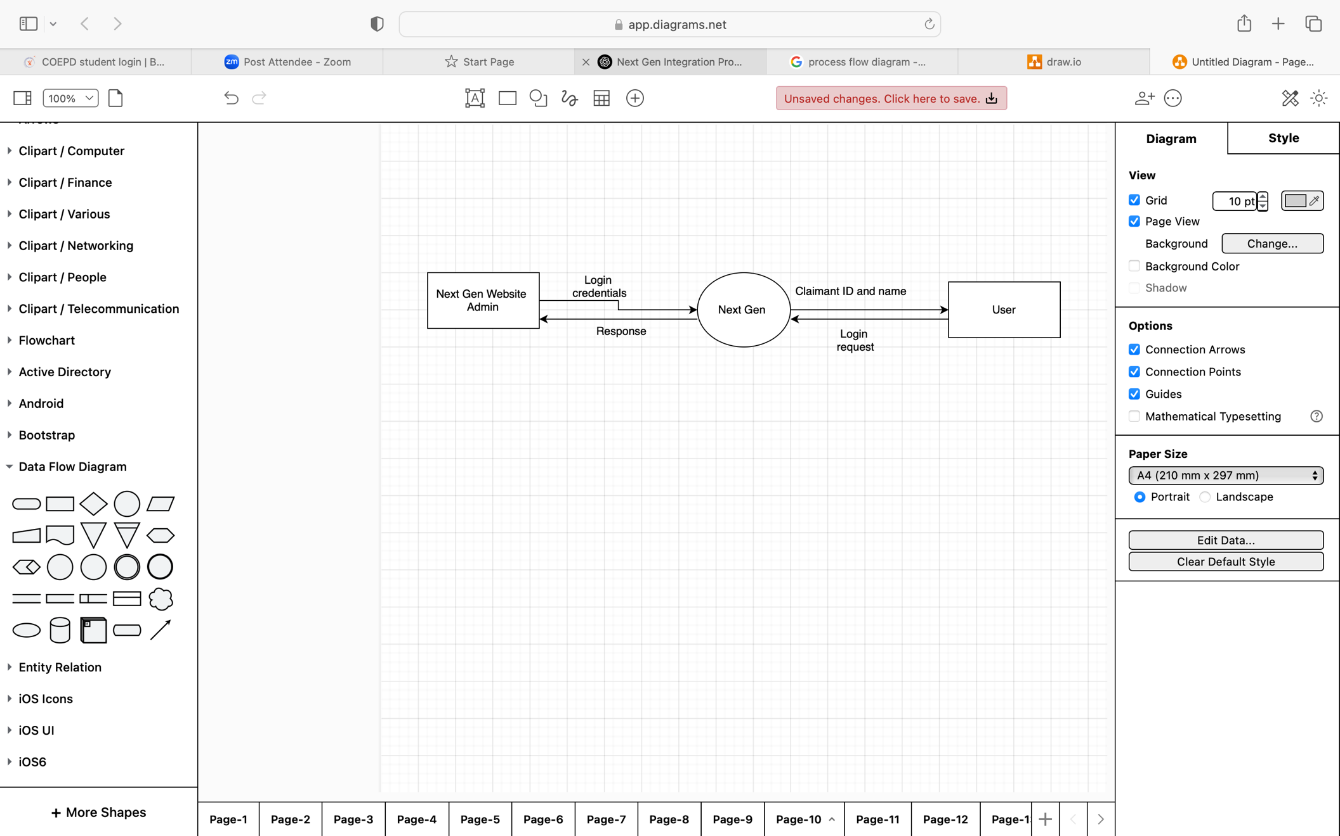

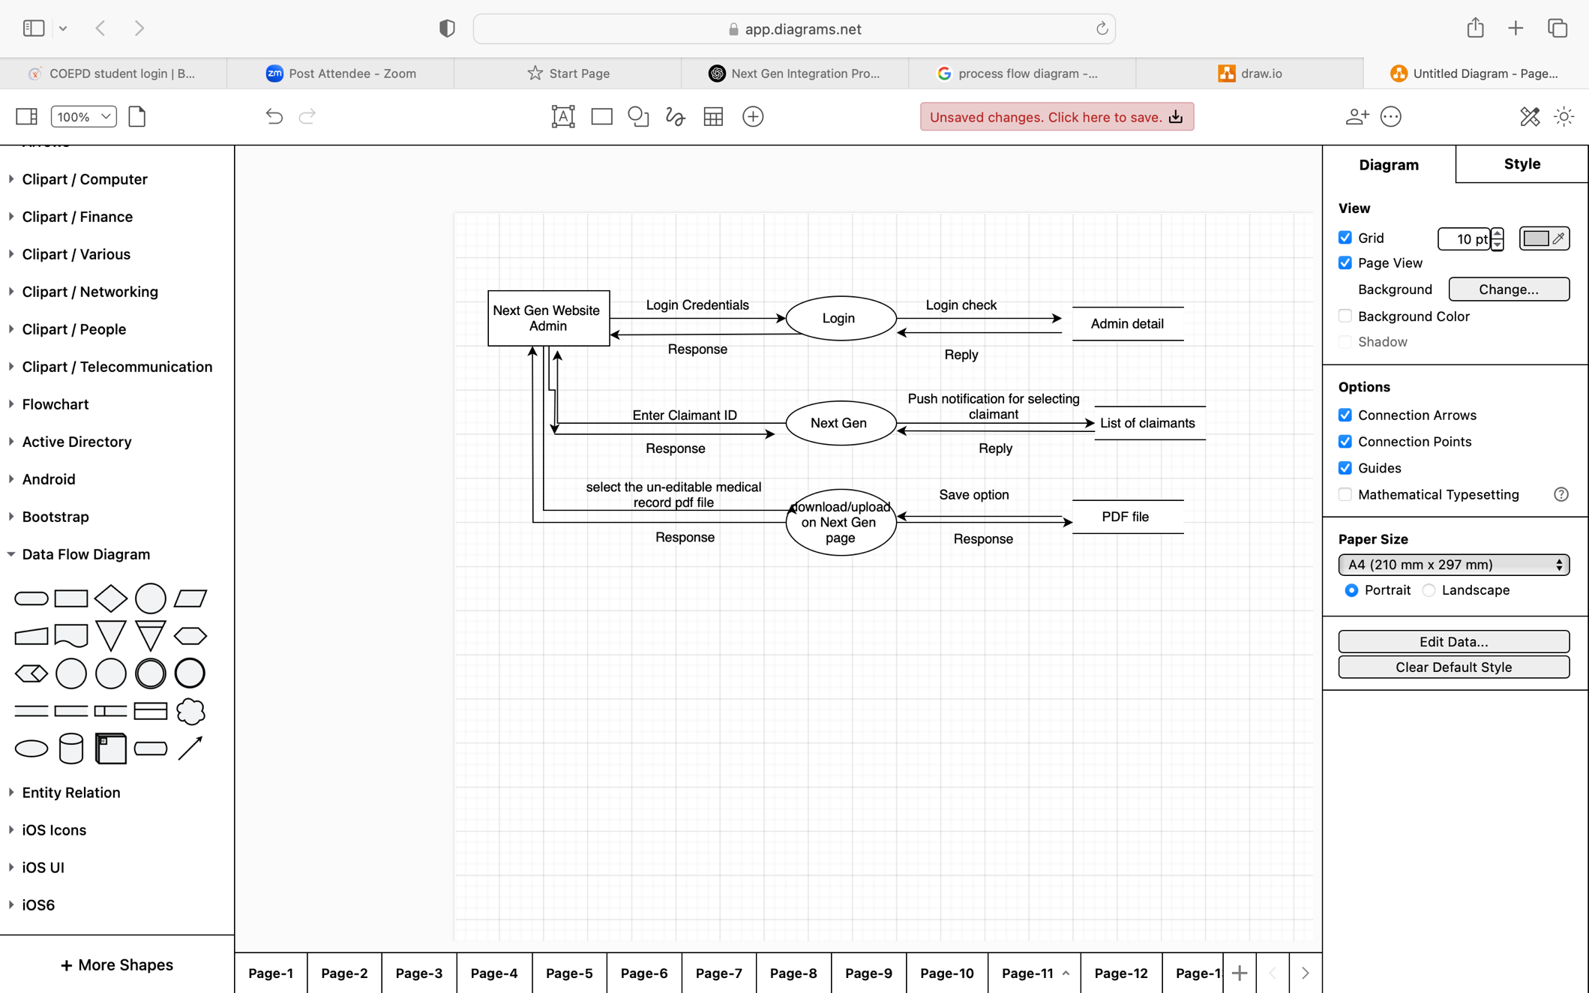

TO-BE

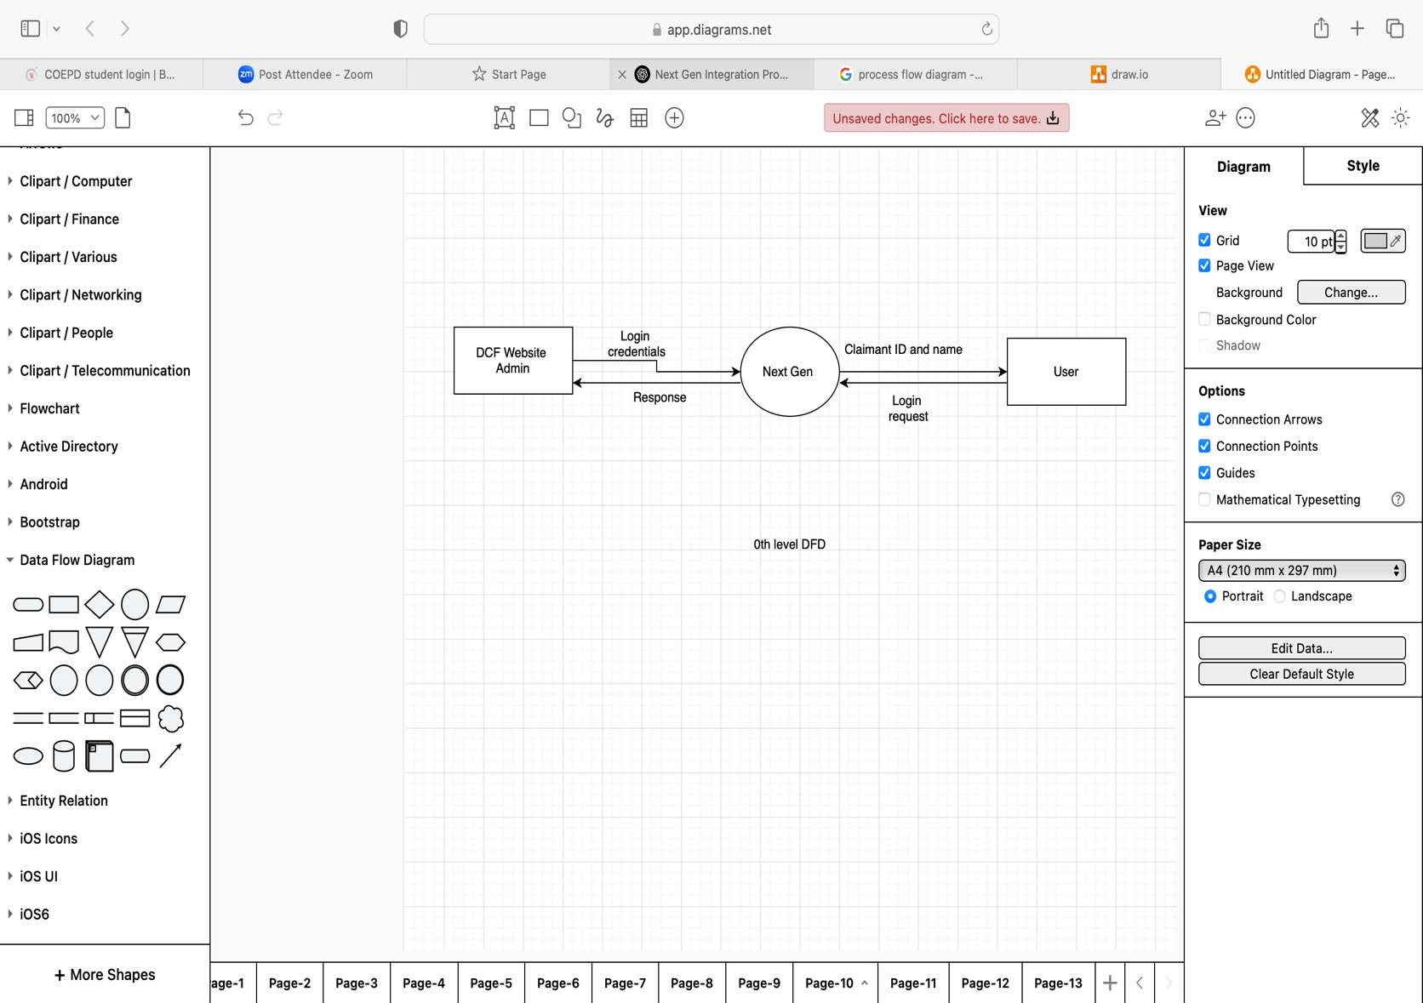

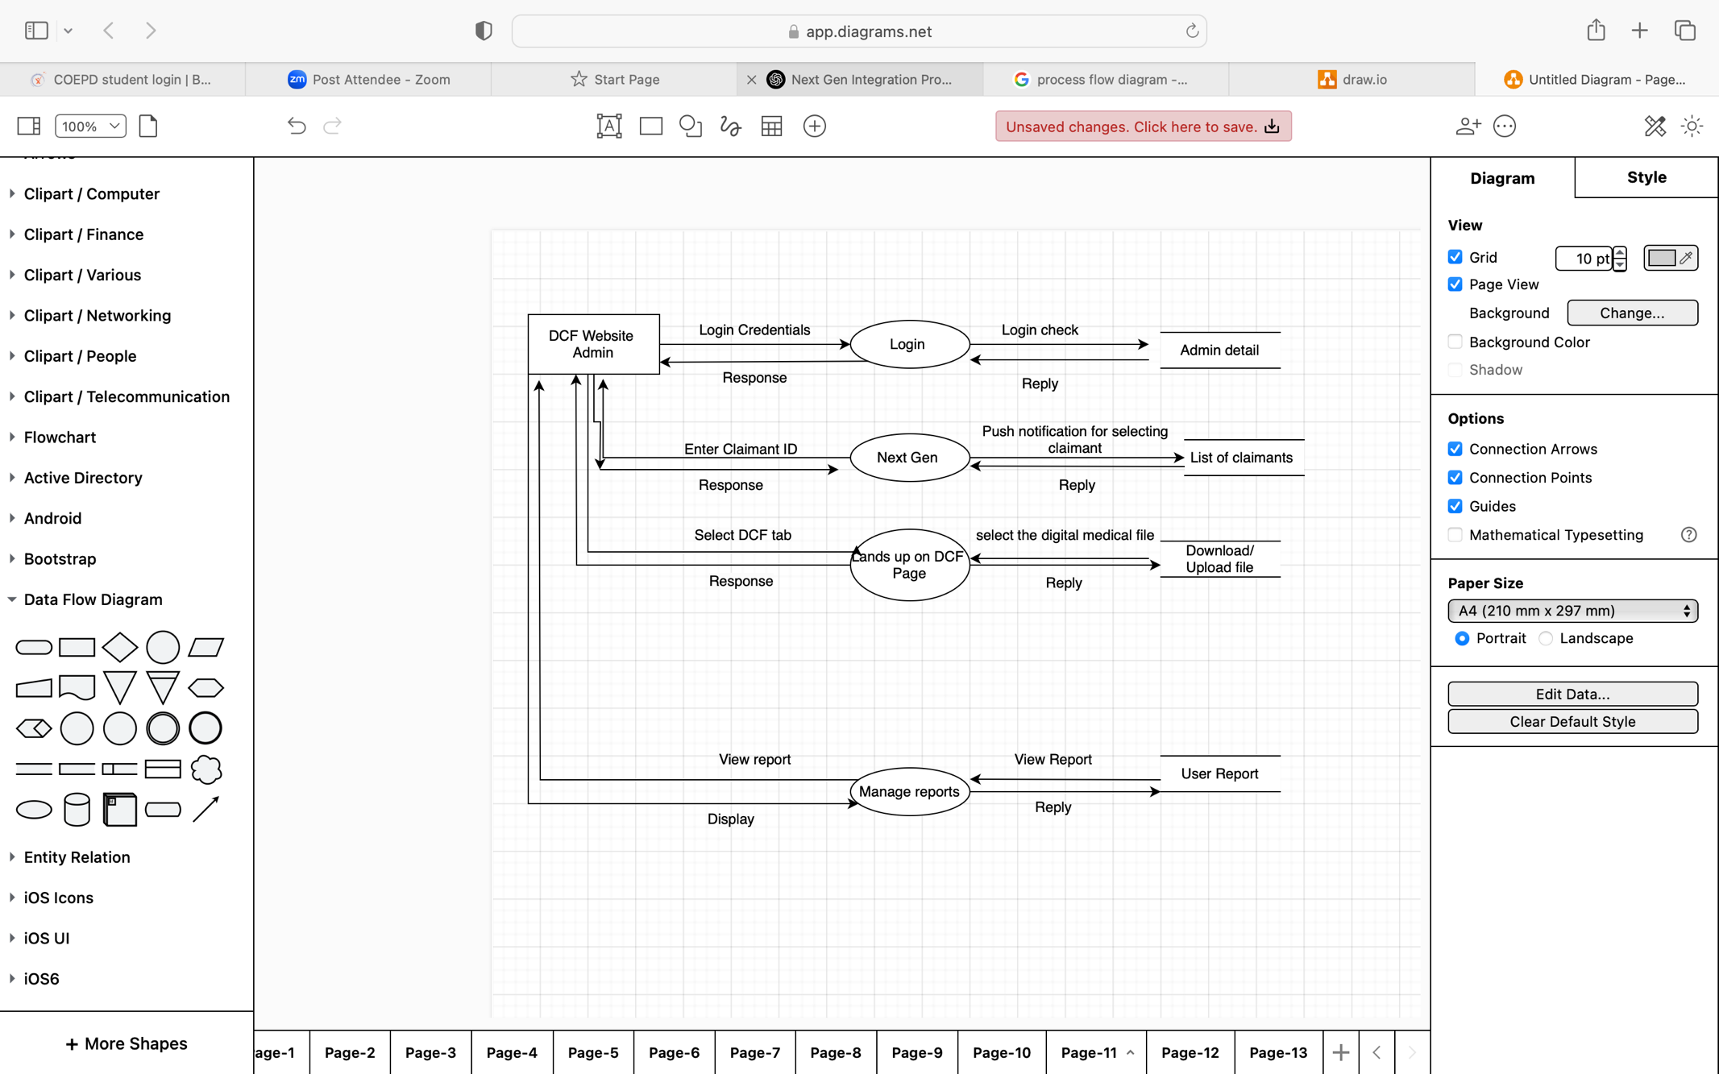

1. Business Requirements

|  |  |  |
| --- | --- | --- |
| BR-01 | Develop REST APIs for DCF and Next Gen integration. | High |
| BR-02 | Implement automated claim validation and processing. | High |
| BR-03 | Establish sprint-based task tracking using Agile tools. | High |
| BR-04 | Enable real-time status tracking via dashboards. | Medium |
| BR-05 | Implement role-based access control for different user levels. | Medium |

1. Appendices
   1. List of Acronyms

DCF- Digital Claim File

NG- Next Generation

HIPAA- Health Insurance Portability and Accountability Act

GDPR- General Data Protection Regulation

BR- Business Requirements

API- Application Programming Interface

UI- User Interface

* 1. Glossary
* In a **Business Requirements Document (BRD)**, **document revisions** refer to the tracking and management of changes made to the document during its lifecycle. These revisions ensure that everyone involved in the project is working with the latest version of the document and that any modifications made are properly documented, understood, and approved.
* **Assumptions :**These are the factors in a project that are considered true without proof.
* An **API (Application Programming Interface)** is a set of rules and protocols that allow different software applications to communicate with each other. APIs define how requests and responses should be structured so that systems can exchange data efficiently and securely.
* **Business Requirements** refer to the high-level needs, goals, and objectives that an organization aims to achieve through a project, system, or process. These requirements define **what** the business wants to accomplish, rather than **how** it will be implemented.
  1. Related Documents

**Handover**

The following items have been handed over to the client:

* Application Source Code.
* Deployment Guides.
* User Training Materials.
* Maintenance & Support Plan.
* FRD
* SRS
* RTM