Capstone Project Prep 3
- Functional Requirements:
Req ID | Req Name | Req Description | Priority
FR 1 | User Registration | Users should be able to create an account by providing basic details such as name, email, phone number and password. | 10
FR2 | Product Catalog | The application should be able to display a comprehensive list of all available products including fertilizers, seeds and pesticides with detailed information. | 10
FR3 | Search Functionality | Users should be able to search for products based on various criteria like name, type, brand, price range, etc. | 9
FR4 | Product Details | Users should be able to view detailed information about each product, including price, quantity, description, images, and reviews. | 9
FR5 | Shopping Cart | Users should be able to add products to their cart and view their cart details, including total price and quantity. | 8
FR6 | Checkout Process | Users should be able to complete the checkout process by providing delivery address, payment details, and confirmation of order. | 8
FR7 | Order Tracking | Users should be able to track their order status, including confirmation, processing, shipping, and delivery. | 7
FR8 | User Profile Managing | Users should be able to manage their profile details such as name, address, phone number, and password. | 7
FR9 | Order History | Users should be able to view their previous order history, including details like order date, order status, and product details. | 6
FR10 | Product Reviews | Users should be able to rate and review products they have purchased, which will be visible to other users. | 6
FR11 | Product Comparison | Users should be able to compare products based on various parameters such as price, quality, and features. | 5
FR12 | Newsletter Subscription | Users should be able to subscribe to the newsletter to receive updates about new products, discounts, and promotions. | 5
FR13 | Wish List | Users should be able to add products to their wish list for future purchase. | 4
FR14 | Product Recommendation | Users should be provided with personalized product recommendations based on their search and purchase history. | 4
FR15 | Multiple Payment Options | Users should be able to pay for their orders through multiple payment options such as credit/debit cards, net banking, and wallets. | 3
FR16 | Order Cancellation | Users should be able to cancel their order and request a refund as per the company's policies. | 3
FR17 | Customer Support | Users should be able to contact customer support for any queries, complaints, or feedback. | 2
FR18 | Mobile App | The application should have a mobile app version for users to access it from their mobile devices. | 2
FR19 | Multilingual Support | The application should support multiple languages for users from different regions. | 1
FR20 | Social Media Sharing | Users should be able to share product details on social media platforms. | 3

- Wireframes & Prototypes

Login Page Search Page
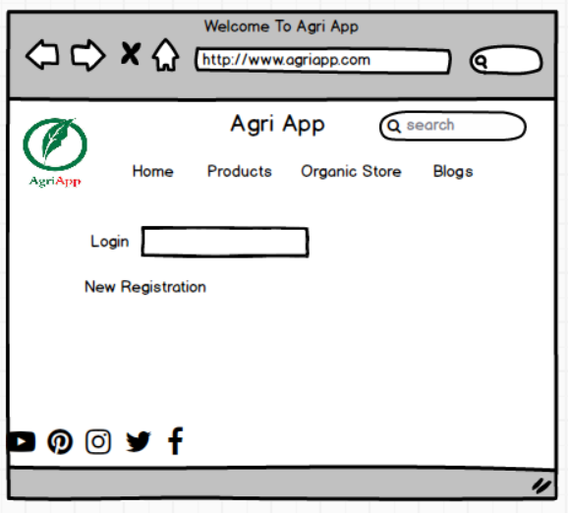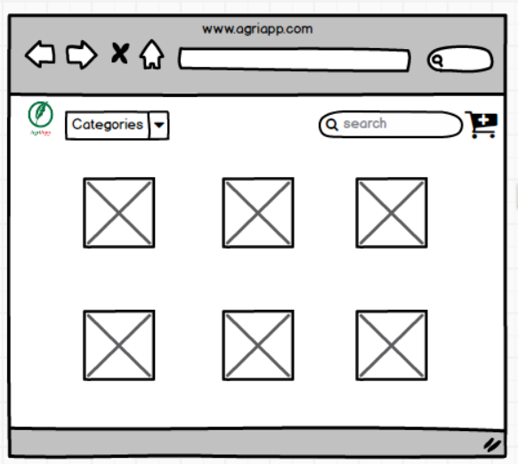

Add to Cart Page Payment Page
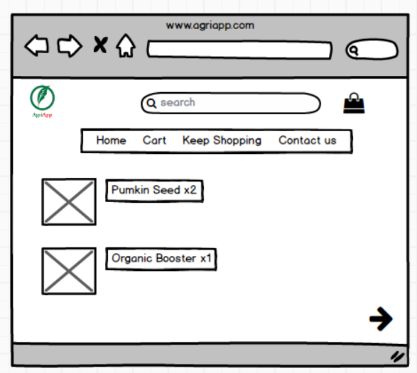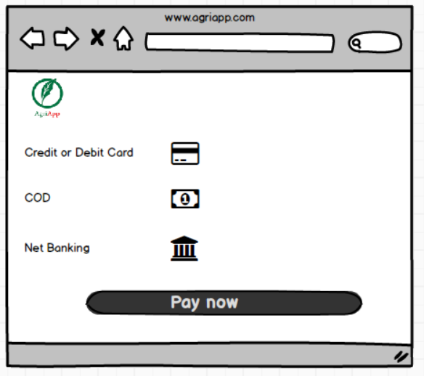

Logout Page
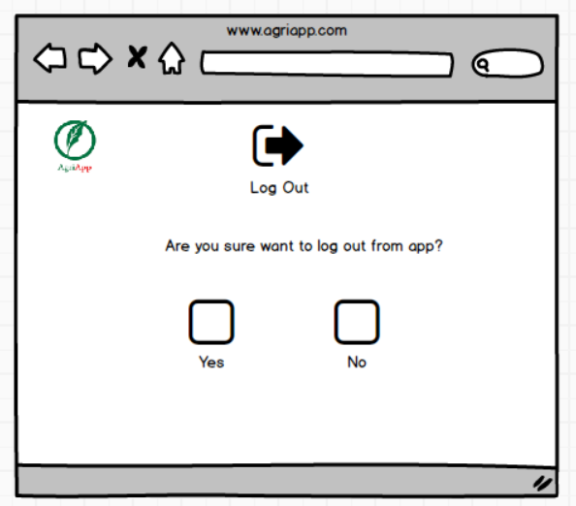

- Tools (Visio, Balsmiq)
- Balsmiq:
Balsamiq is a popular wireframing tool used for creating low-fidelity prototypes. It focuses on simplicity and sketch-like designs to quickly visualize and communicate design ideas. With its drag-and-drop interface and pre-built UI elements, Balsamiq allows users to rapidly iterate and gather feedback on the basic structure and layout of a digital product.

- Microsoft Visio:
Microsoft Visio is a versatile diagramming tool that allows users to create a wide range of diagrams, including flowcharts, organizational charts, and network diagrams. With its extensive library of shapes and customization options, Visio enables users to visually represent complex information and processes. It offers collaboration features, data linking capabilities, and seamless integration with other Microsoft Office applications.
- RTM
RTM requirement traceable Matrix plays a vital role as it showcases the progress and the status of the project; it contains high level documents which shows us the information on the project data.

Req ID | Req Name | Req Description | Design | D1 | T1 | T2 | T3 | T4 | UAT
FR0001 | Farmer Registration | farmers should be able to register with their email id and mobile number | Completed | Yes | Yes | Yes | Yes | Yes | Completed
FR0002 | Login | Farmers should be able to login after registering | Completed | Yes | Yes | Yes | No | No | Pending
FR0003 | Search for products | Farmers should be able to search for required products | Completed | Yes | Yes | Yes | Yes | Yes | Completed
FR0004 | Add to cart | Farmers should be able to add required products to cart | Completed | Yes | Yes | Yes | Yes | No | Pending
FR0005 | View the cart | Farmers should be able to view the cart | Completed | Yes | No | No | No | No | Pending
FR0006 | Completing the order | Farmers should be able to complete the required order | Completed | Yes | Yes | Yes | Yes | Yes | Completed
FR0007 | Payment | Farmers should be able to view the payment options | Completed | Yes | Yes | No | Yes | Yes | Pending
FR0008 | Order confirmation | Farmers should be able to confirm the order | Completed | Yes | Yes | Yes | No | No | Pending
FR0009 | Status of order | Farmers should be able to see the status of order | Completed | Yes | Yes | Yes | Yes | No | Pending
FR0010 | Delivery tracking | Farmers should be able to view delivery tracking | Completed | Yes | Yes | No | No | No | Pending

Req ID | Req Name | Req Description | Design | D1 | T1 | T2 | T3 | T4 | UAT
NFR0101 | Page load time | Each Page should load within 2 seconds time | Yes | Yes | Yes | Yes | Yes | No | Pending
NFR0102 | Description | Description of the products should be mentioned | Yes | Yes | Yes | Yes | Yes | Yes | Completed
NFR0103 | Web Content Accessibility Guidelines | The system must meet Web Content Accessibility Guidelines WCAG 2.1 | Yes | Yes | Yes | Yes | Yes | No | Pending
NFR0104 | Availability | Products need to be available | Yes | Yes | Yes | No | No | No | Pending
NFR0105 | Usability | Products need to be useful | Yes | Yes | Yes | Yes | Yes | Yes | Completed
NFR0106 | Usability | Application should be useful | Yes | Yes | Yes | Yes | Yes | Yes | Completed
NFR0107 | Security | The data of the user need to be secured | Yes | Yes | No | No | No | No | Pending
NFR0108 | Maintainability | Application should be maintained without any bugs | Yes | No | No | No | No | No | Pending
NFR0109 | Performance | Application performance should be fast | Yes | Yes | Yes | Yes | Yes | Yes | Completed
NFR0110 | Capacity | Capacity of the application should be high to store the data | Yes | Yes | Yes | Yes | Yes | Yes | Completed

- Test case documents

- Test case - Login
Test case ID | TC001 | Tested By: | Ajas A
Project Name | Online Agriculture application | Testing date: | 13/06/2024
Document | User login | Test implemented by: | Ajas A
Model | Login | Test implementation date: | 13/06/2024

Scenario: | Website for online shopping for farm products. In that we have login, there we have 4 inputs in which 3 are compulsory & 1 optional. After that results are being shown.

- Pre-condition: User needs to valid username and password to login to the portal
- Post condition: Successfully logged in to the portal
- Dependencies: Internet Connectivity
Input data | - User ID  - Password  - Captcha  - OTP
Expected behaviour | Home page /Pop up error page
Actual Behaviour | Home page /Pop up error page
Comments | Test was successful
Results pass/Fail | Pass

- Test case - New users
Test case ID | TC002 | Tested By: | Ajas A
Project Name | Online Agriculture application | Testing date: | 13/06/2024
Document | New User | Test implemented by: | Ajas A
Model |  | Test implementation date: | 13/06/2024

Scenario: | Website for online shopping for farm products. In this we have new user. There we have 4 compulsory, 1 optional & after that results are being shown.

- Pre-condition: User needs to register with email id and create a secure password.
- Post condition: Successfully created a username and password
- Dependencies: Internet Connectivity
Input data | - Username  - Password set  - Email authentication  - Captcha  - OTP
Expected behaviour | Registered and logged in  home page shows
Actual Behaviour | Home page pops up
Comments | Test was successful
Results pass/Fail | Pass

- Test case – Website ordering
Test case ID | TC003 | Tested By: | Ajas A
Project Name | Online Agriculture application | Testing date: | 13/06/2024
Document | Online ordering | Test implemented by: | Ajas A
Model |  | Test implementation date: | 13/06/2024

Scenario: | Website for online shopping of farm products. In that, we perform website purchasing. So, we have 1 compulsory, 1 optional and after that results are being shown.

- Pre-condition: User needs to login & open & have access to the portal.
- Post condition: Successfully have access to the portal
- Dependencies: Internet connectivity/ valid user name password.
Input data | - Product name  - Product details
Expected behaviour | After login in to the portal user has multiple products to choose
Actual Behaviour | Options to select from the product
Comments | Test was successful
Results pass/Fail | Pass

- Test case – Online product purchase
Test case ID | TC004 | Tested By: | Ajas A
Project Name | Online Agriculture application | Testing date: | 13/06/2024
Document | Online purchasing | Test implemented by: | Ajas A
Model |  | Test implementation date: | 13/06/2024

Scenario: | Website for online shopping of farm products. In that we perform online purchasing. We have 3 inputs and 3 are compulsory and after that results are being shown.

- Pre-condition: User needs to login and open and have access to the portal
- Post condition: Can purchase products online
- Dependencies: Internet Connectivity/ Valid username and password
Input data | - Product name  - Manufacturing code  - Captcha  - Password
Expected behaviour | After login in to the portal user has products/ stocks information
Actual Behaviour | After login in to the portal user has products/ stocks information
Comments | Test was successful
Results pass/Fail | Pass

- Test case – Payment gateway
Test case ID | TC005 | Tested By: | Ajas A
Project Name | Online Agriculture application | Testing date: | 13/06/2024
Document | Online purchasing | Test implemented by: | Ajas A
Model |  | Test implementation date: | 13/06/2024

Scenario: | Website for online shopping of farm products. In that we perform Payment gateway. With 4 inputs and 4 are compulsory, after that results are being shown.

- Pre-condition: User needs to login and select a product and check out using COD/CARD OR UPI
- Post condition: Product ordered
- Dependencies: Internet Connectivity/ Have payment details
Input data | - Username  - Card number  - Expiry  - CVV  - OTP
Expected behaviour | After proceeding to buy the product leads to transaction/payments page
Actual Behaviour | After proceeding to buy the product leads to transaction/payments page
Comments | Test was successful
Results pass/Fail | Pass

- Test case – Browse products
Test case ID | TC006 | Tested By: | Ajas A
Project Name | Online Agriculture application | Testing date: | 13/06/2024
Document | Browse product | Test implemented by: | Ajas A
Model |  | Test implementation date: | 13/06/2024

Scenario: | Website for online shopping of farm products. In that we perform Browse products. With 4 inputs and 4 are compulsory, after that results are being shown.

- Pre-condition: User needs to login & use username & password
- Post condition: User can now be able to browse products
- Dependencies: Internet connectivity
Input data | - Category  - Size  - Price  - Availability
Expected behaviour | After login in to the page, user will have options to browse according to needs.
Actual Behaviour | After login to the page user will have options to browse according to the needs.
Comments | Test was successful
Results pass/Fail | Test pass

- Test case – User experience
Test case ID | TC007 | Tested By: | Ajas A
Project Name | Online Agriculture application | Testing date: | 13/06/2024
Document | User experience | Test implemented by: | Ajas A
Model |  | Test implementation date: | 13/06/2024

Scenario: | Website for online shopping of farm products. In that we perform User Experience, with 4 inputs, where 3 are compulsory and after that results are being shown.

- Pre-condition: User needs to buy a product.
- Post condition: User can now be able to rate the product according to the use.
- Dependencies: Should be a valid customer & bought a product.
Input data | - Name  - Order ID  - Contact number  - Rating
Expected behaviour | After the user buys a product, he can rate the product usage whether the product has met the expectations
Actual Behaviour | After the user buys a product, he can rate the product usage whether the product has met the expectations
Comments | Test was successful
Results pass/Fail | Pass

- Test case – Order cancellation
Test case ID | TC008 | Tested By: | Ajas A
Project Name | Online Agriculture application | Testing date: | 13/06/2024
Document | Order cancellation | Test implemented by: | Ajas A
Model |  | Test implementation date: | 13/06/2024

Scenario: | Website for online shopping of farm products. In that we perform User Experience, there with 3 inputs. After clicking on submit results are being shown.

- Pre-condition: User needs to buy a product or cancel the delivery when the product is (Out for delivery)
- Post condition: User can avail for a return on a replacement/ refund
- Dependencies: Should be a valid customer and bought a product.
Input data | - Name  - Order id/ order details  - Reason to cancel the order.
Expected behaviour | After user bought a product, he can return the product for a replacement or a refund if the user wants.
Actual Behaviour | After user bought a product, he can return the product for a replacement or a refund if the user wants
Comments | Test was successful
Results pass/Fail | Pass

- Test case – Customer service
Test case ID | TC009 | Tested By: | Ajas A
Project Name | Online Agriculture application | Testing date: | 13/06/2024
Document | Customer service | Test implemented by: | Ajas A
Model |  | Test implementation date: | 13/06/2024

Scenario: | Website for online shopping of farm products. In that we perform Customer service, with 3 inputs where 2 are compulsory and 1 is optional. After that results are being shown.

- Pre-condition: User needs to be a registered customer and might or might not buy a product.
- Post condition: User can connect to customer service and enquire about the needs.
- Dependencies: Should be a valid customer
Input data | - Name  - Contact number  - Order id
Expected behaviour | Users must be a registered customer with valid user id and password (Ordered the product or not does not matter)
Actual Behaviour | Users must be a registered customer with valid user id and password (Ordered the product or not does not matter)
Comments | Test was successful
Results pass/Fail | Pass

- Test case – Delivery tracking
Test case ID | TC0010 | Tested By: | Ajas A
Project Name | Online Agriculture application | Testing date: | 13/06/2024
Document | Delivery tracking | Test implemented by: | Ajas A
Model |  | Test implementation date: | 13/06/2024

Scenario: | Website for online shopping of farm products. In that we perform delivery tracking, with 3 inputs where 3 are compulsory and 1 is optional. After that results are being shown.

- Pre-condition: User needs should buy the product
- Post condition: User is shared with the tracking number through which customer can track the product Live.
- Dependencies: Should be a valid customer and should order a product
Input data | - Name  - Order number  - Tracking number
Expected behaviour | User is shared with the tracking number through which customer can track the order live.
Actual Behaviour | User have to place a order for a product & tracking number is shared.
Comments | Test was successful
Results pass/Fail | Pass

- DB Design
Database design has 2 approaches:
- Top to bottom approach
- Bottom to top approach
All tables + entities = DB Schema
DB Schema + ER Diagram = DB Design

Product list
Product Name
Credit
COD
Debit
Does Payment
Mobile No
Address
Name

User
Online Agriculture Store
Login
Products online list
Product ID
ER Diagram – Entities Relationship

DB Schema – with tables & entities:
* Varchar is used when the data to be dealt with is a set of characters on which numerical operations cannot be performed directly whereas int is used when certain numerical are to be performed on it.
* Varchar includes numbers, alphabets as well as special characters whereas int only include numbers.
* For example, varchar: email, int: user_id.

Farmer |  |  | Products |  |  | Manufacturer
Email | Varchar |  | Name | Varchar | Include | Email | Varchar
Password | Varchar |  | Description | Varchar |  | Password | Varchar
Address | Varchar |  | Price | Decimal |  | Manufacturer ID | Int
Farmer ID | Int |  | Manufacturer ID | Int
 |  |  | Product ID | Int
Include
Include
Include

Wishlist |  |  | Orders
Product ID | Int |  | Order ID | Int
Farmer ID | Int |  | Product ID | Int
Wishlist ID | Int |  | Farmer ID | Int
 |  |  | Quantity | Int
 |  |  | Order Date | Date
 |  |  | Order value | Int

- Data flow diagram
A data flow diagram (DFD) is a graphical representation of the flow of data through an information system. It visualizes the processes, data stores, and external entities that interact to produce or consume data. The data flow diagram also provides Information about the outputs and inputs of each entity and the process itself. A dataflow diagram has no control flow, there are no decision rules and no loops.
It uses defined symbols like rectangles, circles, and arrows plus short test labels to show data inputs, outputs, storage points and the routes between each destination.
- External entity – Rectangle
- Data flow – arrow
- Process or bubble – circle (process)
- Data store –Parallel lines (Backend)
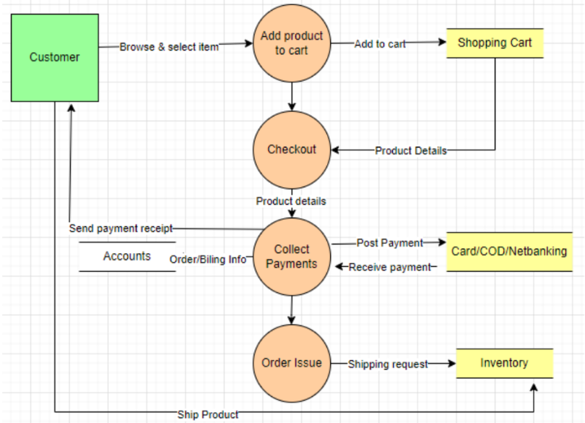

- Change Request
A change request is a formal proposal to modify a project's scope, timeline, requirements, or deliverables due to new circumstances, constraints, or opportunities that arise during development.
Change requests are when a stakeholder, either a client or an internal team or department, requests a change to the processes or deliverables that have already been decided upon in the project scope.
However, in this scenario, this change request has come up due to change in the Govt. Taxation structure. As a BA, I would analyse the request and clarify the stakeholders exactly what the request is asking us to do in the Online Agriculture Product Store. In a normal scenario, as a BA, I would first do the Feasibility Test, to check how feasible it is to change the current ongoing project with the new change request. However, in this case, Feasibility study is not required, as it’s a Govt structure which needs to be updated and followed.
- Identify the scope of the change request and assess its impact on the project.
- Analyze the cost and time required to implement the change request.
- Evaluate the benefits of the change request and its alignment with project goals.
- Prioritize the change request based on its urgency and importance.
- Communicate the change request to all relevant stakeholders, including the client, project manager, development team, and business analyst.
- Update the project plan and documentation to reflect the change request.
- Implement the change request and monitor its impact on the project.
- Conduct testing and quality assurance to ensure the change request has been successfully implemented.
- Obtain approval from the client or other relevant stakeholders before finalizing the change request.
- Communicate the status and impact of the change request to all stakeholders, including any updates to the project plan, timeline, or budget.

- Change Request Vs an Enhancement
A change request is a formal proposal submitted during a project to modify the scope, requirements, timeline, or deliverables. It arises due to unforeseen circumstances like regulatory changes, technical challenges, or new stakeholder demands. Change requests may affect project costs and timelines and require stakeholder approval before implementation.
An enhancement refers to planned improvements to an existing system, product, or process. These involve adding new features, optimizing performance, or refining functionality to better meet user needs or industry standards. Enhancements are usually proactive and aimed at improving value or usability, rather than addressing issues or external changes.

In this project, it sounds like an enhancement request as it involves adding new features to the existing project. As a BA, I would first gather more information from Ben and Kevin about the specific requirements for adding crop yields and implementing an auction system. I would then assess the impact of these changes on the project timeline, budget, and other existing requirements. If the changes are feasible and align with the project goals, I will document the new requirements and update the project plan and relevant stakeholders accordingly.

- Estimations
As per the given case study-
The duration of the project is 18 months
The current team size is around 15
This will come under medium project. As the trained resources are available, trainers are not required. Hence the required man hours will be 15 x 72(no of weeks) x 30(hrs worked per week) = 21,600 hrs/-

- UAT
UAT (User Acceptance Testing) is the final stage of the software development lifecycle where the end-users of the system test the product to ensure that it meets their requirements and is ready for deployment.
User Acceptance Testing (UAT) is a phase in the software development life cycle where the users of the Online Agriculture Product Store participate in validating that if meets their needs. As a BA, I will verify all the validations prior to design the UAT Test cases, which will cover the functionality of the product, system environment, any possible defects which could arise and how to deal with these defects.

The UAT Acceptance process involves the following steps:
- Planning - The business analyst works with the client to plan the UAT phase, including defining the scope, identifying the test scenarios and cases, and setting the acceptance criteria.
- Test Execution - The end-users perform the testing on the software product in a real-world environment and provide feedback on its usability, functionality, and performance.
- Issue Resolution - If any issues are identified during the UAT phase, they are recorded and addressed by the development team.
- Sign-off - Once the UAT is completed successfully, the end-users sign off on the product, indicating that it meets their requirements and is ready for deployment.
To close the project, the following steps can be taken:
- Project Review - The business analyst conducts a project review to ensure that all the requirements have been met, and the project objectives have been achieved.
- Documentation - All project documentation, including requirements documents, design documents, test cases, and project plans, are reviewed and updated.
- Closure Meeting - A closure meeting is held with the stakeholders to discuss the success of the project, any lessons learned, and future recommendations.
- Project Closure Report - The business analyst prepares a project closure report that includes the project review, documentation updates, closure meeting outcomes, and any final recommendations.
- Archiving - The project documentation and artifacts are archived for future reference, and the project team is disbanded.

- Project Closure Document
A project closure document is a document that summarizes the results of a project. It documents all phases of project management into one report. It includes the team’s accomplishments, lessons learned, and recommendations for improving upon future projects. A project closure document is created at the end of a project.
Srl No. | Point To Include | Details | Reference
1 | Did the client sign of UAT
 | Date of sign of: | 4/25/2024 | Business_Scope.docx
 | Name of the resource: | Mr Henry
2 | Objective of the project
 | User friendliness | Achieved
 | Customer satisfaction | ROI in 6 months
 | More sales | Achieved
3 | Functionalities worked on
 | Secure payment processing | Achieved | FRD.docx
 | Categories | Achieved
4 | Infrastructure
 | Software installed |  | Prourement.docx
 | Server setup
5 | Funding
 | Amount Sanctioned | 2 Crore | FinancialDetails.xlsx
 | Amount Used | 2 Crore
6 | Overall project information
 | Escalations | 12
 | Customer satisfaction | High
7 | Value to the organization
 | Positive/Negative | Company has successfully integrated the project increased turnover by 30% and increased efficiency by 20%

