**Assignment-1**

1. **Please make a BRD which can be presented to the client along with complete development and resource plan.**

**I & M Manufacturers**

**PYIMM2025**

**PYIMM2025. V2**

**MANIKANTA**

1. **Document Revisions.**

|  |  |  |
| --- | --- | --- |
| **Date** | **Version number** | **Document changes** |
| 01-01-2024 | 1.0 | Initial draft created, including project objectives, scope, and high-level requirements. |
| 05-01-2024 | 1.1 | Added detailed functional requirements for inventory management module. |
| 10-01-2024 | 1.2 | Defined requirements for the logistics and delivery optimization module. |
| 15-01-2024 | 1.3 | Incorporated non-functional requirements for system performance and security. |
| 18-01-2024 | 1.4 | Updated use cases for inventory tracking and customer order delivery. |
| 21-01-2024 | 1.5 | Added user roles and access level definitions. |
| 27-01-2024 | 1.6 | Revised reporting requirements for warehouse operations and customer delivery metrics. |
| 30-01-2024 | 1.7 | Introduced route optimization requirements for fastest delivery to customers. |
| 31-01-2024 | 1.8 | Enhanced real-time tracking and delivery status notification features. |
| 02-02-2024 | 1.9 | Added requirements for dynamic delivery scheduling based on traffic conditions. |
| 04-02-2024 | 2.0 | Final review and stakeholder approval. |

1. **Approvals:**

|  |  |  |  |  |
| --- | --- | --- | --- | --- |
| **Role** | **Name** | **Title** | **Signature** | **Date** |
| Project sponsor | Rahul | Chief Operations Officer |  |  |
| Business Owner | Aayush | Head of Division |  |  |
| PM | Anurag | Senior Project Manager |  |  |
| Design lead | Sugandha | Senior Design Lead |  |  |
| System Architect | Vijay | Lead System Architect |  |  |
| Development Lead | Brijendra | Software Development Lead |  |  |
| User experience lead | Mehta | Lead UI/UX Designer |  |  |
| Quality Lead | Deepak | QA Lead |  |  |
| Content Lead | Safiq | Content Development Lead |  |  |

1. **RACI matrix:**

The RACI chart identifies the persons who need to be contacted whenever changes are made to this document. RACI stands for responsible, accountable, consulted, and informed. These are the main codes that appear in a RACI chart, used here to describe the roles played by team members and stakeholders in the production of the BRD.

**Stakeholders from Business stakeholders (Client side):** Business owner, Warehouse Manager, Subject Matter expert, Project Sponsor, Delivery personal, and Admin.

**Stakeholders from IT side (Project side):** PM, BA, UI/UX, Developers, Testers, Legal team, Govt. Authority/ Legal compliance team.

|  |  |  |  |  |
| --- | --- | --- | --- | --- |
| **Task** | **Anurag** | **Mehta** | **Praveen** | **Rahul** |
| **Project Ini** | A | C | I | R |
| **Req. gathering** | C | C | C | A |
| **UI/UX design** | C | C | C | A |
| **Development** | I | I | I | I |
| **UAT** | A | C | I | R |
| **Post launch** | I | I | I | I |

1. **Introduction:**
   1. **Business Goals:**

The software solution aims to achieve the following goals:

* **Efficient Inventory Management:** Track raw materials, work-in-progress, and finished goods in real-time across multiple manufacturing plants and warehouses.
* **Quickest Delivery:** Optimize order processing, route planning, and delivery mechanisms to ensure timely deliveries.
  1. **Business objectives:**
* Efficient Inventory Management
* Quickest delivery to the customers
* Enhanced customer experience
* Data driven decision making
* Scalability and Performance
  1. **Business Rules:**
* Inventory levels must be updated in real-time upon receipt, dispatch, or movement of products.
* Minimum stock thresholds must be defined for each product category, triggering automatic replenishment alerts.
* Warehouse stock counts must be reconciled monthly to ensure data accuracy.
* Orders must be dispatched within a predefined timeframe (e.g., within 2 hours of order confirmation).
* Customers must receive automated notifications for order dispatch, delivery status, and estimated delivery time.
  1. **Executive Summary**

The manufacturing company specializes in ice cream and milk products with multiple plants and warehouses across the country. To stay competitive and deliver superior customer service, the company requires a robust software solution to manage inventory efficiently and ensure the quickest delivery of products to customers. This project focuses on developing a comprehensive system that streamlines inventory management, optimizes logistics, and provides actionable insights through advanced reporting tools. The solution will enhance operational efficiency, reduce costs, and improve customer satisfaction.

* 1. **Projects Scope:**

In-Scope

* Comprehensive inventory management for manufacturing plants and warehouses.
* Order processing and management.
* Delivery optimization tools, including route planning and tracking.
* Reporting and analytics dashboards.
* Role-based user access.

Out of Scope

* Integration with third-party payment systems.
* Marketing or customer support features.

1. **Assumptions:**

* All manufacturing plants and warehouses are digitally connected and capable of real-time data synchronization.
* The software solution will integrate seamlessly with existing warehouse management and logistics systems.
* Delivery vehicles will be equipped with GPS tracking devices.
* Adequate staffing will be available for warehouse operations and delivery management.
* Sufficient training will be provided to staff for using the new software system.

1. **Constraints:**

* The system must comply with local and national regulations for food storage and transportation.
* Budget limitations may affect the scope of software features.
* Limited warehouse space may restrict stock levels during peak seasons.

1. **Risks**

* Supply chain disruptions affecting product availability.
* Integration challenges with existing systems.
* Delays in delivery leading to customer dissatisfaction.
* Adverse weather conditions affecting delivery timelines.

1. **Business Process Overview**

|  |  |
| --- | --- |
| **AS-IS** | **TO-BE** |
| Inventory management is conducted manually or through isolated systems without real-time synchronization. | A centralized inventory management system with real-time updates across all manufacturing plants and warehouses. |
| Delivery scheduling is static, often resulting in delays due to unoptimized routes. | Automated replenishment alerts to maintain optimal stock levels. |
| Limited visibility for customers on order status and delivery timelines. | Dynamic delivery scheduling and route optimization based on real-time traffic data. Real time tracking and status. |

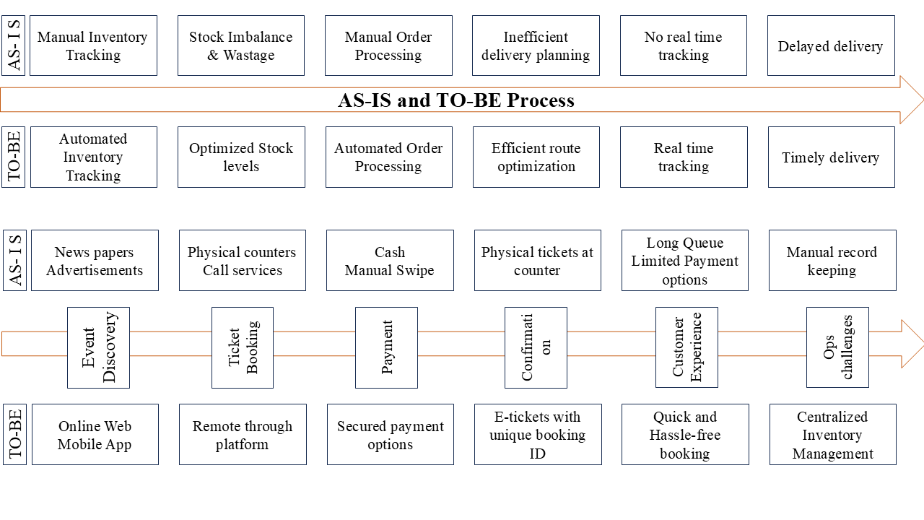

1. **Business Requirements:**

|  |  |  |
| --- | --- | --- |
| **Req ID** | **Requirement Name** | **Requirement Description** |
| BR-001 | Real-Time Inventory Tracking | The system must track inventory levels across manufacturing plants and warehouses in real-time. |
| BR-002 | Automated Stock Alerts | The system should generate automated alerts for stock replenishment when predefined thresholds are met. |
| BR-003 | Inventory Categorization | Support categorization of raw materials, work-in-progress, and finished goods. |
| BR-004 | Batch Tracking | Enable tracking of production batches for quality control and compliance. |
| BR-005 | Warehouse Transfers | Allow inventory transfers between warehouses and manufacturing plants. |
| BR-006 | Barcode/QR Code Integration | Enable barcode or QR code scanning for efficient stock management. |
| BR-007 | Delivery Route Optimization | Optimize delivery routes to minimize transportation time and costs. |
| BR-008 | Real-Time Delivery Tracking | Provide real-time tracking for delivery vehicles. |
| BR-009 | Order Fulfillment | Automate order allocation and prioritization based on stock availability. |
| BR-010 | GPS Integration | Integrate with GPS systems for accurate delivery navigation. |
| BR-011 | Customer Notification System | Send notifications to customers about order status, delivery times, and delays. |
| BR-012 | Reporting and Analytics | Generate reports on inventory trends, delivery performance, and order fulfillment metrics. |
| BR-013 | Role-Based User Access | Implement role-based access control to secure data and restrict access to authorized users. |
| BR-014 | Multi-Warehouse Support | Support multiple warehouses with centralized inventory management. |
| BR-015 | Performance Dashboard | Provide dashboards for warehouse managers and delivery personnel to monitor operations. |
| BR-016 | Order Cancellation and Returns | Allow customers to cancel orders or initiate returns as per defined policies. |
| BR-017 | Demand Forecasting | Analyze historical data to forecast future inventory requirements. |
| BR-018 | Integration with ERP Systems | Allow integration with existing ERP systems for seamless data exchange. |
| BR-019 | Data Backup and Recovery | Ensure automated daily data backups and a disaster recovery plan. |
| BR-020 | Compliance with Industry Standards | Ensure the system complies with data security and operational industry standards. |

**Development and Resource Plan**

**Phase 1: Requirement Gathering and Analysis (2 weeks)**

* Conduct stakeholder interviews to gather requirements.
* Analyze current processes and pain points in inventory and delivery.
* Document functional and non-functional requirements.
* Develop initial wireframes and system workflow diagrams.
* Obtain stakeholder sign-off on requirements.

**Phase 2: System Design (4 weeks)**

* Develop system architecture and define technology stack.
* Create database schema and entity-relationship diagrams.
* Design user interfaces and user experience workflows.
* Prepare detailed design documentation.
* Review and finalize design with stakeholders.

**Phase 3: Development (8 weeks)**

* **Week 1-3:** Development of the Inventory Management Module.
  + Implement stock tracking and replenishment features.
  + Develop inventory transfer functionality.
* **Week 4-5:** Development of the Order Management Module.
  + Build order creation, prioritization, and tracking features.
* **Week 6-8:** Development of the Delivery Optimization Module.
  + Implement route optimization and real-time delivery tracking.
  + Integrate GPS navigation and customer notifications.
  + Conduct code reviews and version control management.

**Phase 4: Testing (4 weeks)**

* **Unit Testing:** Validate individual components.
* **Integration Testing:** Ensure seamless interaction between modules.
* **Performance Testing:** Assess system speed and responsiveness.
* **User Acceptance Testing (UAT):** Engage key stakeholders for validation.
* Address and resolve defects.

**Phase 5: Deployment and Training (2 weeks)**

* Deploy the system to the production environment.
* Conduct training sessions for end-users and administrators.
* Provide user manuals and troubleshooting guides.

**Phase 6: Maintenance (Ongoing)**

* Monitor system performance and resolve issues.
* Release updates and enhancements based on user feedback.
* Provide ongoing technical support.

**Resource Plan:**

|  |  |  |  |
| --- | --- | --- | --- |
| **Resource** | **Role** | **Quantity** | **Duration** |
| Project Manager | Oversee project execution | 1 | Full project duration |
| Business Analyst | Requirement gathering and documentation | 1 | Phase 1 and Phase 2 |
| Developers | Backend and frontend development | 4 | Phase 3 |
| QA Engineers | Testing and quality assurance | 2 | Phase 4 |
| UI/UX Designer | User interface design | 1 | Phase 2 and Phase 3 |
| Deployment Specialist | System deployment | 1 | Phase 5 |
| Trainers | User training | 2 | Phase 5 |

1. **Prepare process flow diagram using your imagination.**

**PROCESS FLOW DIAGRAM**

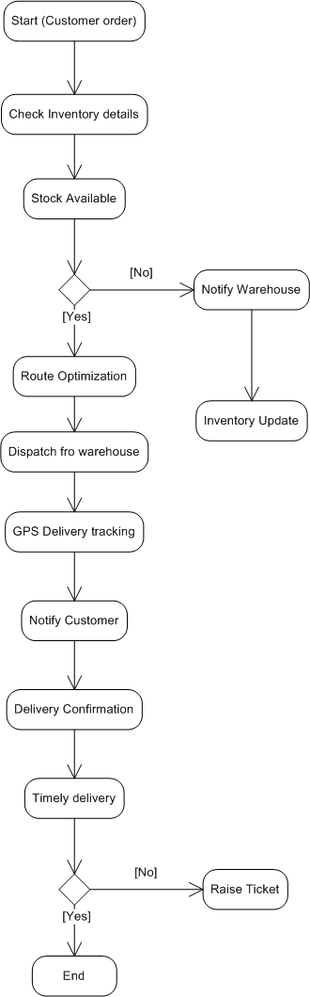

**ASSIGNMENT-2**

**An introduction letter to a client introducing yourself as a business analyst in charge of working with the client and his team to start the business understanding process.**

Dear client,

I hope this letter finds you well.

My name is Manikanta Chikoti, and I am excited to introduce myself as the Business Analyst assigned to collaborate with you and your team on this project.

I bring valuable experience from diverse projects, including:

* **Ecotourism Project (Waterfall Model):** I successfully contributed to a comprehensive platform featuring wildlife information, trekking routes, and adventure tourism experiences by meticulously following structured phases of the Waterfall model.
* **Agricultural Research Portal (Agile Scrum Model):** I played a key role in developing a dynamic portal for agricultural crop research and seed management. Working in iterative sprints, we adapted quickly to changing requirements, ensuring high-quality deliverables.

To begin, I aim to thoroughly understand your current processes, challenges, and aspirations. Together, we will explore your operational workflows, identify key requirements, and map out a strategic plan that aligns with your business objectives. Your insights will be invaluable in ensuring the solution we design is practical, scalable, and optimized for your unique needs. I look forward to discussing your expectations and gathering inputs from your team during our initial meetings.

Please feel free to share your availability for an initial meeting. I am eager to understand your expectations and discuss the best way forward.

Thank you for this opportunity.

Warm Regards,  
Manikanta Chikoti  
Business Analyst  
XYZ Informatics

**Prepare a brief BRD and SRS for a project- Ticketing system**

**BRD and SRS for Ticketing System**

**PY-OLS-2025**

**PY-OLS-2025 V3**

**CHIKOTI MANIKANTA**

**Executive summary:**

This project is to implement a comprehensive solution for development of an online ticketing system. The system will enable customers to seamlessly book tickets for events, travel, movies, and other activities. The goal is to enhance user experience, improve operational efficiency, and increase ticket sales.

* 1. **Document Revisions**

|  |  |  |
| --- | --- | --- |
| **Date** | **Version** | **Document changes** |
| 14-01-2025 | 1.0 | Initial draft created |
| 17-01-2025 | 1.1 | Added business rules and risk details |
| 21-01-2025 | 1.2 | Made changes in the requirement gathering |
| 28-01-2025 | 1.3 | Updated RACI Matrix |
| 31-01-2025 | 1.4 | Changed Use Case Diagram |
| 01-02-2025 | 1.5 | Updated Business Process Overview |

* 1. **Approvals**

|  |  |  |  |  |
| --- | --- | --- | --- | --- |
| **Role** | **Name** | **Title** | **Signature** | **Date** |
| Project sponsor | Saideep | Chief Operations Officer |  |  |
| Business Owner | Satya | Head of Division |  |  |
| PM | Chiranjeevi | Senior Project Manager |  |  |
| Design lead | Amala | Senior Design Lead |  |  |
| System Architect | Weasley | Lead System Architect |  |  |
| Development Lead | Priya | Software Development Lead |  |  |
| User experience lead | Niha | Lead UI/UX Designer |  |  |
| Quality Lead | Deepak | QA Lead |  |  |
| Content Lead | Sunil | Content Development Lead |  |  |

* 1. **RACI Matrix**

|  |  |  |  |  |
| --- | --- | --- | --- | --- |
| **Task** | **Chiranjeevi** | **Priya** | **Niha** | **Saideep** |
| **Project Ini** | A | C | I | R |
| **Req. gathering** | C | C | C | A |
| **UI/UX design** | C | C | C | A |
| **Development** | I | R | I | I |
| **UAT** | A | C | I | R |
| **Deployment** | I | I | I | I |

* 1. **Introduction**
     1. **Business Goals**
* Provide a seamless ticket booking experience for customers.
* Increase ticket sales through an intuitive and user-friendly platform.
* Minimize operational costs by automating ticket management.
* Ensure secure and reliable payment processing.
  + 1. **Business Objectives**
* Develop a user-friendly web and mobile application for ticket booking.
* Enable real-time ticket availability updates.
* Integrate secure payment gateways.
* Implement customer notification systems (email/SMS).
* Provide comprehensive reporting and analytics for business stakeholders.
  + 1. **Business Rules**
* Users must register before booking tickets.
* Payments must be completed within 5 minutes of ticket selection.
* Tickets are non-refundable unless stated otherwise.
* Event organizers can set ticket availability and pricing.
* System must send booking confirmations via email and SMS.
* Customers can view and download e-tickets from their account.
* System must support multiple payment methods (credit card, UPI, wallets).
* User accounts will be locked after five consecutive failed login attempts.
  + 1. **Project Scope**

**In-Scope functionalities:**

* User registration and authentication
* Ticket booking and cancellation
* Real-time ticket availability updates
* Payment gateway integration
* Customer notifications
* Reporting and analytics

**Out-scope functionalities:**

* Physical ticket printing and delivery
* Third-party marketing integrations
* In-house event management
* Hardware procurement and setup
  1. **Assumptions**
* All users have access to the internet.
* Event organizers will provide accurate ticket and event details.
* Payment gateways will be available 24/7.
* Users will maintain accurate contact information.
  1. **Constraints**
* Budget limitations for initial development and deployment.
* The system should be scalable to handle at least 15,000 tickets per day without degradation in performance
* It must comply with applicable data privacy regulations (GDPR, CCPA)
* Integration timelines with third-party payment gateways.
  1. **Risks**
* **Technical Risks:**
  + System downtime affecting ticket sales.
  + Security vulnerabilities in payment processing.
* **Political Risks:**
  + Regulatory changes affecting ticketing operations.
* **Requirements Risks:**
  + Scope creep leading to project delays.
  + Misalignment between business and technical requirements.
* **Business Risks:**
  + Customer dissatisfaction due to system errors.
  + Loss of revenue due to payment failures.
  1. **Business Process Overview**

|  |  |  |
| --- | --- | --- |
| **Task** | **AS-IS** | **TO-BE** |
| **Event Discovery** | Customers rely on newspapers, websites, or physical advertisements to learn about events, travel schedules, or movies | Customers search for events, travel schedules, or movies on the online ticketing platform via web or mobile applications. |
| **Ticket Booking** | Customers physically visit booking counters for tickets or call service providers for reservations. | Customers select events and book tickets directly through the platform.  Real-time availability is displayed to ensure accurate booking information. |
| **Payment Processing** | Payments are made in cash or via manual card swiping at counters.  Third-party systems might handle online payments but lack direct confirmation or refunds. | Secure online payment options, including credit/debit cards, e-wallets, and net banking.  Instant payment confirmation and secure transaction processing. |
| **Ticket Confirmation** | Physical tickets are issued at the counter or sent by email (in cases where third-party systems are used). | E-tickets are generated instantly with a unique booking ID and QR code.  Confirmation is sent via email and SMS notifications. |
| **Customer Experience** | Long queues at booking counters.  Limited payment options and lack of real-time ticket information.  Inefficient cancellation and refund process.  Poor communication for updates on event changes. | Quick and hassle-free ticket booking process.  Real-time updates on event changes, delays, or cancellations. |
| **Operational Challenges** | Manual record-keeping leads to errors.  Difficulty tracking real-time ticket inventory.  High operational costs for maintaining physical booking counters. | Centralized ticket inventory management with automated updates.  Improved reporting and analytics for business insights. |



**Business Requirements:**

|  |  |  |
| --- | --- | --- |
| **Req ID** | **Business Requirement** | **Requirement Description** |
| BR001 | User Registration and Login | Enable user registration and secure login functionality for accessing the platform. |
| BR002 | Event, Movie, and Travel Search | Provide a search feature to help users find events, movies, or travel options easily. |
| BR003 | Real-time Ticket Availability | Display accurate real-time ticket availability for events and travel options. |
| BR004 | Ticket Booking | Allow users to book tickets and receive instant booking confirmation. |
| BR005 | Secure Online Payment | Support secure online payments through multiple payment gateways. |
| BR006 | Ticket Cancellations and Refunds | Enable ticket cancellations and process refund according to the refund policy & rules. |
| BR007 | Unique Booking IDs | Generate unique booking IDs for every successful transaction for better tracking. |
| BR008 | Customer Support | Provide customer support through chat or email to address user queries. |
| BR009 | E-Ticket Download or Print | Allow users to download or print electronic tickets after booking. |
| BR010 | Sales and Trend Analytics | Integrate analytics to track sales performance and market trends. |
| BR011 | Automated Notifications | Send automated notifications for booking confirmations and status updates. |
| BR012 | Loyalty Program | Implement a loyalty program to reward repeat customers. |
| BR013 | Multi-language Support | Provide multi-language functionality to cater to diverse user demographics. |
| BR014 | Event Filtering | Allow users to filter events by location or date for better search precision. |
| BR015 | Mobile App Compatibility | Ensure compatibility for booking through mobile apps across various platforms. |
| BR016 | Personalized Recommendations | Track user activity to provide personalized recommendations for events and services. |
| BR017 | Feedback System | Provide a feedback system for users to rate services and provide comments. |
| BR018 | Role-Based Access Control | Ensure role-based access control for administrators and regular users. |
| BR019 | Sales and Refund Reports | Generate detailed reports on sales performance and refunds for stakeholders. |
| BR020 | Bot Activity Prevention | Implement CAPTCHA functionality to prevent automated bot activities on the platform. |

**SRS Document (Software Requirements Specification):**

1. **Purpose:**

Define the functional and non-functional requirements for the online ticketing system.

1. **Scope:**

The system will support online booking, cancellations, payments, and reporting. This includes functionalities like ticket booking and management, Payment integration, E-ticket management, Booking cancellation and refund, search and filter options, customer support etc.

The system supports scalability, security, and compliance with industry standards, making it suitable for technical support, customer service, and other business functions requiring issue resolutions.

1. **Overview:**

The online ticketing system is a web-based application offering a user-friendly interface accessible across devices. It incorporates modules for:

1. Ticket booking
2. Ticket cancellation & Refund status
3. Agent management
4. Notification system
5. Payment integration
6. Customer support
7. **Software interfaces:**

**Operating systems:**

The system shall be compatible with Windows, Mac OS, and should be accessible on any OS via a browser for a cloud-based deployments

**Web browsers:**

Supports modern web browser like Google Chrome, Mozilla Firefox, Microsoft edge, and Safari etc.,

**Database Management Systems:**

Utilizes RDMS such as MYSQL, cloud-based alternatives like AWS RDS or Azure SQL Database

1. **Hardware Interfaces:**

**Devices:**

Compatible with all desktops, laptops with Windows 7 and above versions, tablets, and smartphones with internet connectivity to access the system.

**Network Infrastructure:**

Requires reliable internet connection with a minimum bandwidth of 10 Mbps for smooth access and operation

**Functional requirements:**

|  |  |  |  |
| --- | --- | --- | --- |
| Req ID | Requirement Name | Requirement Description | Priority |
| FR-001 | User Registration | The system shall allow users to register with an email, phone number, and password. | High |
| FR-002 | User Login | The system shall authenticate users with email and password for secure login. | High |
| FR-003 | Password Recovery | The system shall allow users to recover/reset their password via a secure link. | Medium |
| FR-004 | Event Search | The system shall allow users to search events by category, location, and date. | High |
| FR-005 | Ticket Selection | The system shall enable users to select events, schedules, and seat preferences. | High |
| FR-006 | Real-Time Ticket Availability | The system shall display real-time ticket availability for events. | High |
| FR-007 | Secure Payment Processing | The system shall integrate with payment gateways to process payments securely. | High |
| FR-008 | Payment Confirmation | The system shall provide instant confirmation of successful payments. | High |
| FR-009 | E-Ticket Generation | The system shall generate an e-ticket with a unique ID and QR code upon booking. | High |
| FR-010 | Booking History | The system shall allow users to view their booking history. | Medium |
| FR-011 | Cancellation and Refund | The system shall allow users to cancel tickets and process refunds per event policy. | High |
| FR-012 | Notifications | The system shall send email/SMS notifications for booking confirmation and updates. | High |
| FR-013 | Event Filtering | The system shall allow users to filter events by type, price, and availability. | Medium |
| FR-014 | Admin Event Management | Admins shall be able to create, update, and remove events from the platform. | High |
| FR-015 | Ticket Inventory Management | Admins shall be able to monitor and manage ticket stock for events. | High |
| FR-016 | Reporting and Analytics | The system shall provide reports on ticket sales and user engagement. | Medium |
| FR-017 | Role-Based Access Control | The system shall provide different access levels for admins, support staff, and users. | High |
| FR-018 | QR Code Ticket Validation | The system shall validate tickets at entry points using QR code scanning. | High |
| FR-019 | Customer Support Integration | The system shall provide a helpdesk feature for customer inquiries and complaints. | Medium |
| FR-020 | Multi-Device Compatibility | The system shall support web and mobile platforms for seamless user experience. | High |

**Non-Functional Requirements:**

|  |  |  |
| --- | --- | --- |
| Req ID | Requirement Name | Requirement Description |
| NFR-001 | Performance | The system shall handle up to 10,000 simultaneous users without performance degradation. |
| NFR-002 | Scalability | The system shall be scalable to support a 200% increase in user demand during peak events. |
| NFR-003 | Availability | The system shall maintain 99.9% uptime to ensure continuous service availability. |
| NFR-004 | Security | The system shall protect user data through encryption (SSL/TLS) and comply with GDPR standards. |
| NFR-005 | Usability | The system shall have a user-friendly interface that allows users to book tickets in less than 5 steps. |
| NFR-006 | Maintainability | The system shall be maintainable with clear documentation for future updates and bug fixes. |
| NFR-007 | Response Time | The system shall respond to user requests within 2 seconds for 90% of transactions. |
| NFR-008 | Compatibility | The system shall be compatible with major browsers (Chrome, Firefox, Safari, and Edge) and mobile devices. |
| NFR-009 | Data Backup | The system shall perform automated daily backups to ensure data recovery in case of failure. |
| NFR-010 | Localization | The system shall support multiple languages, including English, Spanish, and French, for international users. |

**ERD of online ticketing system**

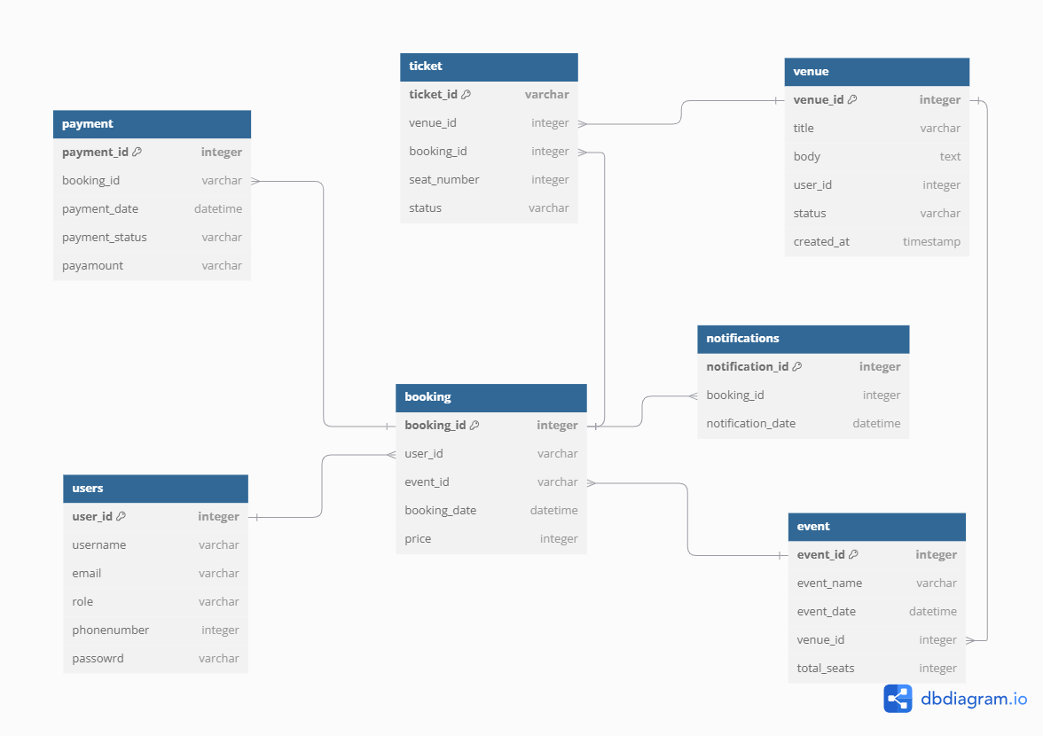

**User stories of shopping from e-commerce:**

|  |  |  |  |  |  |  |  |
| --- | --- | --- | --- | --- | --- | --- | --- |
| Story No | User Story | Tasks | Priority | Value statement | Acceptance criteria | BV | CP |
| 1 | As a user, I want to register an account so that I can save my information for future purchases. | Create registration form; Validate input; Store user data securely | High | Save time for future purchases | User can successfully register with valid details; Error messages for invalid input | 200 | 3 |
| 2 | As a user, I want to log in to my account so that I can access my saved information. | Create login form; Implement authentication | High | Easy access to profile | User can log in with correct credentials | 500 | 3 |
| 3 | As a user, I want to reset my password if I forget it so that I can recover my account. | Build password recovery workflow; Send recovery emails | High | Retain access to account | User receives a recovery email and resets the password | 200 | 5 |
| 4 | As a user, I want to search for products so that I can find what I need easily. | Implement search bar; Optimize query handling | High | Improve product discovery | User can search and receive relevant results | 500 | 8 |
| 5 | As a user, I want to filter search results by price, category, and rating so that I can narrow down options. | Build filtering options; Display filtered results | Medium | Faster decision-making | Filtered results update correctly based on selection | 100 | 5 |
| 6 | As a user, I want to view product details so that I can make an informed purchase. | Create product detail page; Display product specs and images | High | Enable better buying decisions | User can see all product details | 500 | 8 |
| 7 | As a user, I want to add products to my cart so that I can purchase them later. | Build cart logic; Handle item additions | High | Save selected products | User can add and see products in the cart | 500 | 3 |
| 8 | As a user, I want to update item quantities in my cart so that I can modify my purchase. | Implement quantity update feature | Medium | Dynamic cart management | User can update item quantities | 200 | 2 |
| 9 | As a user, I want to remove products from my cart so that I can change my purchase. | Add remove button; Handle UI updates | Medium | Cart flexibility | Items are removed from the cart without errors | 200 | 2 |
| 10 | As a user, I want to view my cart summary so that I can see the total price and items. | Display item list and total price | High | Transparent purchase details | Cart shows correct item count and total | 500 | 3 |
| 11 | As a user, I want to proceed to checkout so that I can complete my purchase. | Build checkout flow; Validate cart state | High | Streamlined purchase process | User moves from cart to payment seamlessly | 500 | 10 |
| 12 | As a user, I want to enter my delivery address during checkout so that I can receive my order. | Create address form; Validate input | High | Ensure correct delivery | User provides address successfully | 500 | 3 |
| 13 | As a user, I want to save my address for future purchases. | Build address book feature | Medium | Faster future checkouts | User saves and retrieves addresses | 200 | 3 |
| 14 | As a user, I want to choose a payment method so that I can pay conveniently. | Display payment options; Integrate payment gateways | High | Convenient payment process | User selects a preferred payment method | 500 | 8 |
| 15 | As a user, I want secure payment processing so that my financial information is protected. | Implement SSL/TLS encryption; PCI DSS compliance | High | Secure transactions | Payments processed without data breaches | 500 | 5 |
| 16 | As a user, I want to receive order confirmation after payment so that I know my order was successful. | Send confirmation email; Display confirmation page | High | Trust and assurance | Confirmation email sent and order ID displayed | 200 | 3 |
| 17 | As a user, I want to track my order status so that I know when it will arrive. | Integrate tracking API; Display status updates | High | Improved customer experience | User sees real-time order status | 200 | 5 |
| 18 | As a user, I want to cancel my order within a certain timeframe so that I can change my decision. | Build order cancellation workflow | Medium | Flexible order management | Order status changes to "Cancelled" | 100 | 3 |
| 19 | As a user, I want to return products if they are defective so that I can get a replacement or refund. | Create return request feature; Handle validations | High | Customer satisfaction | User initiates returns without issues | 200 | 10 |
| 20 | As a user, I want to view my order history so that I can track past purchases. | Build order history page | Medium | Better record-keeping | User views accurate order history | 200 | 3 |
| 21 | As a user, I want personalized product recommendations so that I can discover new products. | Implement recommendation engine | Medium | Boost sales and engagement | Relevant recommendations are displayed | 100 | 10 |
| 22 | As a user, I want to leave product reviews so that I can share my experience. | Build review form; Handle moderation | Medium | Community-driven insights | Reviews are posted successfully | 500 | 8 |
| 23 | As a user, I want to read other users' reviews so that I can make informed decisions. | Display review list | Medium | Social proof | Reviews are displayed with ratings | 200 | 3 |
| 24 | As a user, I want to apply discount codes during checkout so that I can save money. | Validate discount codes; Apply price changes | High | Cost savings | Discount applied correctly | 500 | 8 |
| 25 | As a user, I want to receive notifications about sales and promotions so that I can take advantage of deals. | Build notification system | Medium | Drive sales and engagement | Notifications sent via email/SMS | 200 | 3 |
| 26 | As a user, I want a wish list feature so that I can save products for later. | Build wish list logic; Handle UI updates | Medium | Future purchase intent | User adds and views wish list items | 100 | 5 |
| 27 | As a user, I want to compare products so that I can choose the best option. | Build product comparison tool | Medium | Better decision-making | Accurate comparison displayed | 200 | 5 |
| 28 | As a user, I want a secure user logout option so that my account is protected. | Create logout workflow | High | Account security | User successfully logs out | 500 | 3 |
| 29 | As a user, I want to update my account information so that it remains current. | Build profile update feature | Medium | Accurate user data | Account updates are saved successfully | 200 | 3 |
| 30 | As a user, I want multi-language support so that I can use the platform in my preferred language. | Integrate translation feature | Medium | Broader audience reach | User switches languages without errors | 200 | 8 |
| 31 | As a user, I want product images to zoom so that I can view product details clearly. | Implement zoom feature | Low | Improved visual experience | Image zoom works as expected | 100 | 3 |
| 32 | As a user, I want product categories to be well-organized so that I can find items quickly. | Build category structure | Medium | Improved navigation | Categories are clear and intuitive | 200 | 3 |
| 33 | As a user, I want a chatbot for support so that I can get instant answers. | Build chatbot interface; Integrate AI engine | Medium | Faster support | Chatbot answers user queries correctly | 200 | 8 |
| 34 | As a user, I want order packaging information so that I know how the product is protected. | Display packaging details | Low | Build trust | Packaging information visible | 500 | 2 |
| 35 | As a user, I want to filter products by delivery time so that I can receive them quickly. | Build delivery time filter | Medium | Faster deliveries | Accurate filtering of delivery options | 500 | 5 |
| 36 | As a user, I want gift-wrapping options so that I can send products as gifts. | Build gift-wrapping feature | Low | Customer satisfaction | Gift-wrapping selected during checkout | 200 | 3 |
| 37 | As a user, I want referral rewards so that I can earn discounts by inviting others. | Build referral program logic | Medium | Increase user base | Referral links work correctly | 200 | 5 |
| 38 | As a user, I want customer service contact details so that I can get assistance when needed. | Display contact information | High | Improved support | Contact details are visible and accurate | 200 | 2 |
| 39 | As a user, I want an FAQ section so that I can find answers to common questions. | Build FAQ page | Medium | Reduce support requests | FAQs are accessible and searchable | 500 | 3 |
| 40 | As a user, I want a loyalty points program so that I can earn rewards for frequent purchases. | Build loyalty program feature | Medium | Increase customer retention | Loyalty points are tracked and redeemable | 200 | 8 |