**Online Agriculture Products Store**

Mr. Henry, after being successful as a businessman and has become one of the wealthiest persons in the city. Now, Mr. Henry wants to help others to fulfil their dreams. One day, Mr. Henry went to meet his childhood friends Peter, Kevin and Ben. They live in a remote village and do farming. Mr. Henry asked his friends if they are facing any difficulties in their day-to-day work. Peter told Mr. Henry that he is facing difficulties in procuring fertilizers which are very important for farm. Kevin said that he is also facing the same problem in-case of buying seeds for farming certain crops.

Ben raised his concern on lack of pesticides which could help in greatly reducing pests in crops. After listening to all his friends’ problems, Mr. Henry thought that this is a crucial problem faced not only by his friends but also by so many other farmers. So, Mr. Henry decided to make an online agriculture product store to facilitate remote area farmers to buy agriculture products. Through this Online Web / mobile Application, Farmers and Companies (Fertilizers, seeds and pesticides manufacturing Companies) can communicate directly with each other.

**The main purpose to build this online store is to facilitate farmers to buy seeds, pesticides, and fertilizers from anywhere through internet connectivity**. Since new users are involved, Application should be user friendly. This new application should be able to accept the product (fertilizers, seeds, pesticides) details from the manufacturers and should be able to display them to the Farmers. Farmers will browse through these products and select the products what they need and request to buy them and deliver them to farmers location.

Mr Henry has given this project through his Company SOONY. In SOONY Company, Mr Pandu is Financial Head and Mr Dooku is Project Coordinator. Mr. Henry, Mr Pandu, and Mr Dooku formed one Committee and gave this project to APT IT SOLUTIONS company for Budget 2 Crores INR and 18 months Duration under CSR initiative. Peter, Kevin and Ben are helping the Committee and can be considered as Stakeholders share requirements for the Project.

Mr Karthik is the Delivery Head in APT IT SOLUTIONS company and he reached out to Mr Henry through his connects and bagged this project. APT IT SOLUTIONS company have Talent pool Available for this Project. Mr Vandanam is project Manager, Ms. Juhi is Senior Java Developer, Mr Tayson, Ms Lucie, Mr Tucker, Mr Bravo are Java Developers. Network Admin is Mr Mike and DB Admin is John. Mr Jason and Ms Alekya are the Tester. And you joined this team as a BA.

**Mr Henry** has given this project through his Company **SOONY**

**Following are the Committee members from the company SOONY**

Mr. Pandu -**Financial Head**

Mr. Dooku- **Project Co-ordinator**

**Committee handed over this project to APT IT Solution**

***for Budget 2 Crores INR and 18 months Duration under CSR initiative.***

*Corporate Social Responsibility (CSR) is a business approach where companies give back to society by addressing social, environmental, and economic issues beyond their profit-making activities. CSR initiatives benefit communities, employees, and the environment while enhancing the company's reputation****.***

--------------------------------------------------------------------------------------------------------------------------

**APT IT Solution has following team.**

Mr .Kartik **(Delivery Head)**

Mr. Vandanam **(Project Manager)**

Ms. Juhi **(Sr. JAVA developer)**

Mr. Tayson **(Java Developer 1)**

Mr. Tucker **(Java Developer 2)**

Mr. Bravo **(Java Developer 3)**

Mr. Mike **(Network Admin)**

Mr. John **(DB Admin)**

Mr. Jason **Tester 1**

Mr Alekya **Tester 2**

Mrs. Rashmi Asole **(Business Analyst)**

**Q1 – Business Process Model**

**Identify Business Process Model for Online Agriculture Store – (Goal, Inputs, Resources, Outputs, Activities, Value created to the end Customer)**

**Goal** - To build the web / Mobile application (online store) to facilitate farmers to buy seeds , pesticides, and fertilizers from anywhere through internet connectivity.

**Inputs**- Customer/Farmer’s data and requirements, Search for the specific product, Take product details from manufacturers, Customer location data.

**Resources-** Java developers, testers, DB admin, network admin, IT infrastructure, payment gateway, delivery logistics.

**Output-** Real time availability to all products with smooth transaction, Display all the product details to farmers, Timely delivery to locations.

**Activities-**

* Requirement gathering from stakeholders
* Designing User friendly UX/UI
* Developing Product listing
* Payment Gateway
* Delivery Tracking system
* Testing and deployment
* Training farmers for app usage
* Maintenance After go-live.

**Value -** Customer-centric experience thru online portal, User friendly interface, competitive product prices with easy purchase option. Easy availability of the multiple products at one place.

--------------------------------------------------------------------------------------------------------------------------

**Q2 – SWOT**

**(Mr Karthik is doing SWOT analysis before he accepts this project. What Aspects he Should consider as Strengths, as Weaknesses, as Opportunity and as Threats.)**

**Weakness (internal factors)**

**Strength(internal factors)**

* Digital literacy challenge
* Network connectivity in remote areas
* Logistics management
* Adoption of online platform by farmers
* Solves a Real Problem
* Direct Manufacturer-to-Farmer communication Model
* Easy availability of products on one platform
* CSR Initiative



**Opportunities (External Factors) Factors)**



**Threats (External Factors)**

* Competition from other platforms
* Payment risk and cyber security
* Business Expansion
* Awareness of online platform in farmers.



**Question 3 – Feasibility study**

**Mr Karthik is trying to do feasibility study on doing this project in Technology (Java), Please help him with points (HW SW Trained Resources Budget Time frame) to consider in feasibility Study.**

**Software-**

* Java is a scalable, secure, and platform-independent language.
* Open Source
* Java is widely used for enterprise applications & e-commerce platforms.
* Java has more flexibility across different platforms as well as many cloud platforms.
* Technology Stack (Java-based)
* Database: MySQL
* Cloud Hosting: AWS / Azure
* Payment Gateway like razor pay.
* Security
* Dev-op tools
* Testing tools
* Version control tools like GitHub

**Hardware-**

1. **Server infrastructure**

* Cloud based servers
* Capable to handle more/ high traffic and data storage

1. **Network & Connectivity**

* High-Speed internet for smooth backend operations
* Secure VPN for remote access. (Java-based OpenVPN clients available)

1. **End User Devices**

* Should support low-end smartphones for rural area farmers
* Web and mobile access.

**Experienced Resources are Required Development- IT Team**

* Project Manager
* Backend Development- Java
* Frontend Development- Ui/Ux , Web development
* DBA
* Network Administrator
* Testers
* BA

**Budget (Rs. 2 Crore is allocated)**

* IT Team (Development Cost)-₹75 Lakhs
* Server Infrastructure H/w cost – ₹15 Lakhs
* Cloud services- ₹15 Lakhs
* Any 3rd party Software and Licenses -₹10 Lakhs
* Network and Security service -₹10 Lakhs
* Testing & Maintenance – ₹20 Lakhs
* Training & Support – ₹10 Lakhs (Farmer training & IT support)
* Marketing, Promotions and Farmer Training-₹15 Lakhs
* AMC (annual maintenance) for 03 years - ₹25 Lakhs

**Budget is feasible within ₹2 Crore INR**

**Time Frame (18 Months)**

|  |  |  |  |
| --- | --- | --- | --- |
| |  | | --- | | **Phase** | | **Duration** | **Deliverables** |
| Requirement Gathering & Analysis | 4-6 weeks | SRS and FRD document (freeze sign off) |
| Design UX/UI | 4 weeks | Prototype making and sign off |
| Front end development | 3 Months | Mobile app UI designs final |
| Backend and Database development | 5 Months | Java set up and API configure |
| Testing and integration | 3 Months | application test report |
| Deployment and Go-live (support 01 month) | 2 Months |  |
| Training to farmers | 1 month | Farmer Training |
| Maintenance and support | 1 Months | Maintenance and bug fix |

**Question 4 – Gap Analysis**

**Mr Karthik must submit Gap Analysis to Mr Henry to convince to initiate this project. What points (compare AS-IS existing process with TO-BE future Process) to showcase in the GAP Analysis**

|  |  |  |  |
| --- | --- | --- | --- |
| **Aspect** | **AS-IS – current process** | **To-Be – Future process** | **Gap Analysis** |
| Product Availability | Farmers Facing problem in finding fertilizers, buying seeds and pesticides | Framers can order the specific agriculture product with large availability. | Lack of availability of agriculture products |
| Procurement Process | Farmers must travel for long distance to buy supplies. | Directly purchase from manufacturer via online platform | Time and cost consuming process |
| Supplier Communication | Farmers rely on local sellers for the purchase. | Farmers can communicate directly with manufacturers via online. | Dependency on local sellers increases cost and time. |
| Cost efficiency | High prices due to middlemen and transportation | Reduced cost by eliminating middlemen | Higher cost for the end user(farmers) due to middlemen. |
| Market Reach | Farmers have limited product options based on their location | Farmers can access multiple suppliers and huge product availability online. | Limited options available. |
| Delivery and order Tracking | No tracking-farmers must wait for supplies. | Real time tracking and timely delivery. | Instability in product availability and delivery. |
| Payment Methods | Cast transaction only | Multiple digital payment options (UPI, net banking, mobile wallets). | Limited payment option. Risk in cash handling. |
| Technical support and Assistance | Farmers lack guidance on product usage. | |  | | --- | | Online customer support, FAQs & assistance. | | |  | | --- | | No proper guidance on product selection & usage. | |
| Scalability | Cannot expand beyond local reach. | Can scale to multiple locations. | Geographical limitations in the current system. |
| Business focus | Lack of clear pricing & product details. | Detailed pricing and huge availability of the products | Lack of trust due to hidden costs & misinformation. |

**Question 5 – Risk Analysis**

**List down different risk factors that may be involved (BA Risks And process/Project Risks)**

Risk analysis is the process of identifying, assessing, and prioritizing potential risks that could impact a project’s success. It helps in developing strategies to mitigate, transfer, accept, or avoid risks before they become major issues.

**Internal Risk -**These are risks that arise within the company or project team and can be controlled or managed internally.

* Quality issues
* Lack of Skilled Resources
* Budget
* Delay in Task Completion and Deadlines.
* Communication Gap

**External Risk** These risks arise due to factors beyond the control of the company or project team.

* Market Adoption issue
* Competition from other online platform
* Economic Condition

**BA Risk** These risks are specific to the BA role, impacting requirement gathering and documentation.

* Lack of requirement clarity, stakeholder engagement, and communication.

**Project Based Risk** These are risks associated with the execution, management, and completion of the project.

* Scope Creep – if not finalised properly
* Deployment and maintenance risk
* Testing and quality Assurance issue
* Lack of Post-Implementation Support

**Question 6 – Stakeholder Analysis (RACI Matrix)**

**Perform stakeholder analysis (RACI Matrix) to find out the key stakeholders who can take Decisions and Who are the influencers**

|  |  |
| --- | --- |
| **Role** | **Stakeholder** |
| **Accountable** | Mr. Henry (Sponsor) |
| Mr. Pandu (Finance Head) |
| Mr. Dooku (Project Coordinator) |
| Project Manager (Vandanam) |
| **Responsible** | APT IT solution (Vendor) |
| Mr Karthik (Delivery Head) |
| Developers (Ms. Juhi, Mr. Tayson, Ms. Lucie, Mr. Tucker, Mr. Bravo) |
| Testers (Mr. Jason, Ms. Alekya) |
| Network Admin (Mr. Mike) |
| DB Admin (John) |
| **Consulted** | Farmers (Peter, Kevin, Ben) |
| Mr. Karthik (Delivery Head - Vendor) |
| Senior Developers (Ms. Juhi) |
| Quality Assurance Team |
| **informed** | Farmers (Peter ,Kevin, Ben) |
| Other Farmers |
| Vendors and suppliers |

**Question 7 – Business Case Document – 8**

Help Mr Karthik to prepare a business case document

Following Questions should be included

**1.Why is this project initiated?**

* The project is initiated to address the difficulties faced by farmers in procuring agricultural products due to:
* Limited access to fertilizers, seeds, and pesticides.
* High dependency on intermediaries, leading to increased costs.
* Lack of transparency in pricing and quality of products.
* Limited connectivity between farmers and manufacturers.

**2. What are the Current problems?**

* Lack of Availability: Farmers struggle to procure essential products.
* High Costs: Middlemen increase product prices.
* Limited Choices: Farmers have fewer options due to geographic constraints.
* Delayed Supply Chain: Orders take too long to reach remote areas.
* Digital Literacy Issues: Farmers have limited experience using online platforms**.**

**3. With this project how many current problems get solved?**

* Product Availability: Farmers can purchase fertilizers, seeds, and pesticides anytime.
* Cost Reduction: Direct purchases from manufacturers eliminate middlemen.
* Wide Product Selection: Farmers get access to multiple brands and products.
* Faster Delivery: Improved logistics ensure timely delivery.
* Easy-to-Use Platform: A simple and user-friendly mobile/web app for farmers.

**4. What are the resources required?**

* Human Resources- Developers, Testers, Project Manager, Network Admin, DB Admin, Support Staff
* Technology Resource-JAVA, Database, Mobile and WEB app development.
* Infrastructure – Servers, Database storage, cloud, customer support system.
* Total project Budget – Rs 2 Cr. INR
* Time Frame- 18 Months.

**5. How much organizational change required to adopt this technology?**

* Shift from offline to an online digital marketplace.
* Training farmers to use the platform effectively.
* Implementing secure payment gateways, cloud-based storage, and user-friendly applications.
* Onboarding product manufacturers onto the platform.
* Training Programs will be required to help farmers navigate the online platform.

**6. What is the time frame to recover the ROI?**

|  |  |
| --- | --- |
| **Year 1** | **Initial development and onboarding farmers** |
| **Year 2** | **Adoption and revenue generation from transaction (increase buying items once farmer comfortably start online purchases)** |
| **Year 3** | **Expansion and growing profit (addition of customers/farmers in the system)** |

**7. How to identify the stakeholders?**

* Stakeholders are categorized based on their involvement, roles and experience.
* The RACI Matrix (Responsible, Accountable, Consulted, Informed) helps clarify stakeholder roles in decision-making and execution.

**8. Four SDLC Methodologies –**

*The Committee of Mr. Henry, Mr Pandu, and Mr Dooku and Mr Karthik are having a discussion on Project Development Approach.*

*Mr Karthik explained to Mr. Henry about SDLC. And four methodologies like Sequential Iterative Evolutionary and Agile. Please share your thoughts and clarity on Methodologies.*

**1.Sequential Model-** The Sequential model most commonly known **as waterfall model** also referred as linear sequential life cycle model. It follows a **step-by-step process**, where each phase must be **completed before moving to the next**. At the end of each phase review takes place to determine the project is on right path or not.

|  |  |  |  |
| --- | --- | --- | --- |
| **Stage** | **Description** | **Deliverables** | **Resources Involved** |
| Requirement Gathering | * Collect & document all project requirements. | BRD, FRS | * Business Analyst * Project manager * Client & Stakeholders |
| Requirement Analysis | * Analyse Business needs, * feasibility and constraints | FS.FRS, SSD, SRS, RTM | * Business Analyst * Project manager * Tech Team * Solution Arch * NW Arch * DB Arch |
| System Design | * Create System Architecture * UI/UX Design & Database Model | * SDD- System Design Document * HDD * ADD | * System Architect * UI/UX Designers * Database Designers |
| Development | Developers write code based on the design. | * Source code   API & database integrations   * LDD * CDD | * JAVA Developers * Frontend and backend developers |
| Testing | Identify and fix the Bugs. Ensure the functionality and performance. | * Test Documents * Test cases | Testers |
| Deployment | Release the final product to users. | Live Software  User Manual | * DevOps Engineers * System Admins |
| Maintenance | Fix post-launch issues and provide Updates. | Patches & Updates  Customer support | IT Team |

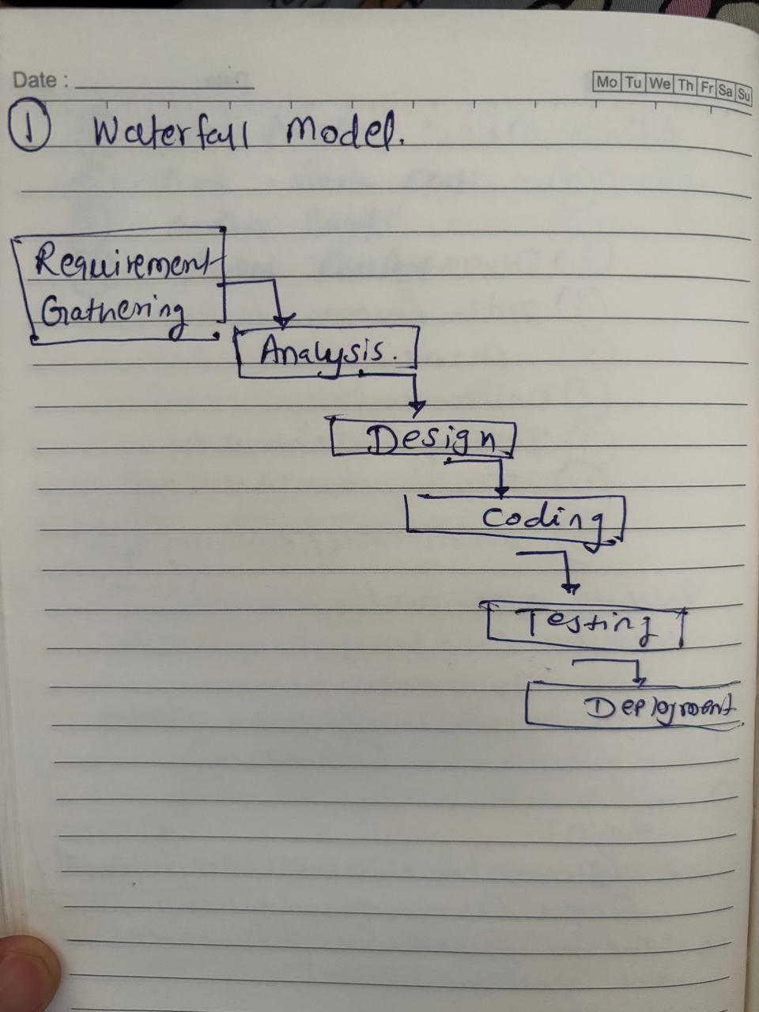

**2.Iterative Model.**

**Iterative RUP (Rational Unified Process) Model**

The Rational Unified Process (RUP) is an iterative and incremental software development framework created by IBM Rational. It follows a structured approach where development is divided into phases and iterations, ensuring gradual improvement in each cycle.

Unlike the traditional iterative model, RUP includes well-defined roles, best practices, and workflows to manage complexity and risks effectively.

**Four project life cycle phases:**

**1.inception:** Agreement among the team and the customer.

**2.ellaboration:** Agreement within the team as to the architecture and design needed todeliver the agreed system behaviour.

**3.Construction :** The iterative implementation of fully functional system**.**

**4. Transition:** Delivery defect correction and tuning to ensure the customer acceptance**. When to Use the RUP Model?**

* For large-scale enterprise projects with evolving requirements.
* When risk management is critical to project success.
* For complex software systems requiring structured development.

**When NOT to Use the RUP Model?**

* For small, short-term projects where Agile or Waterfall is simpler.
* When the team lacks experience in RUP methodologies.
* When rapid development is required without formal documentation.

**RUP Model**

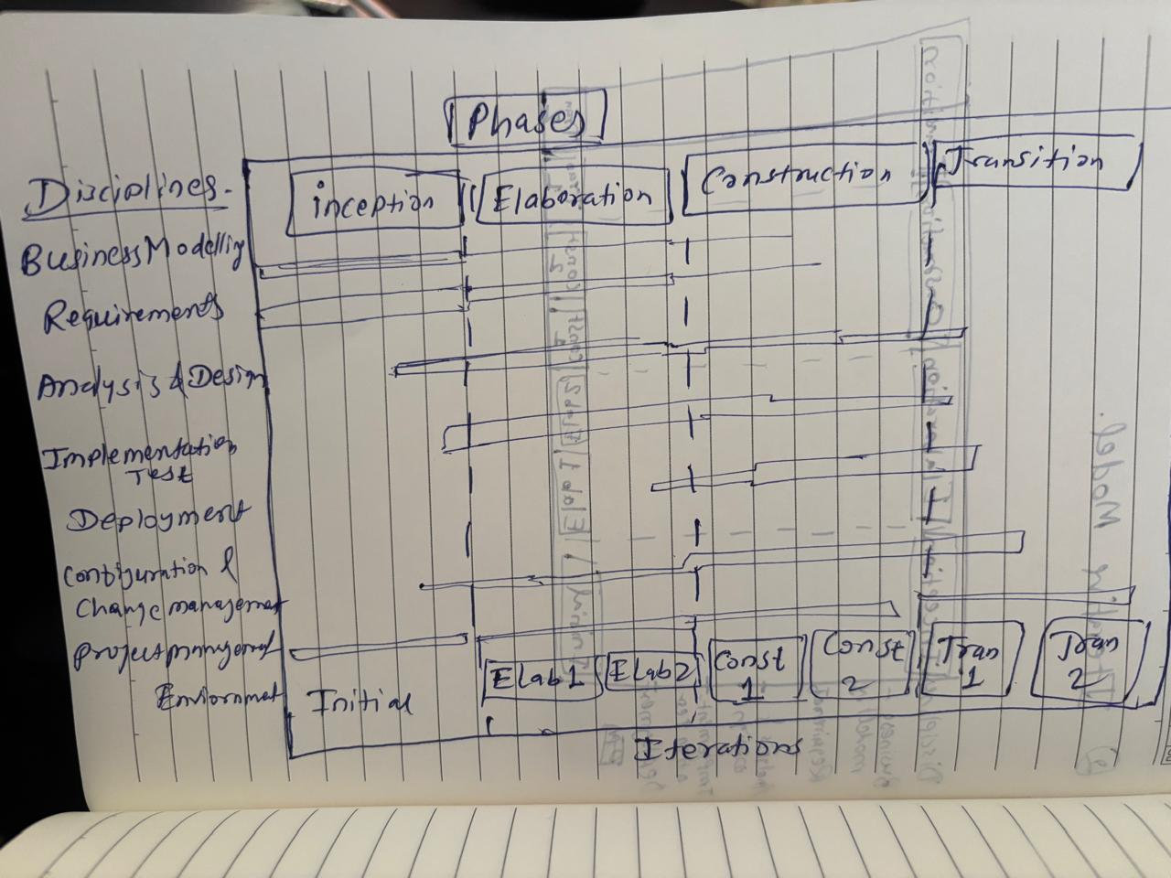

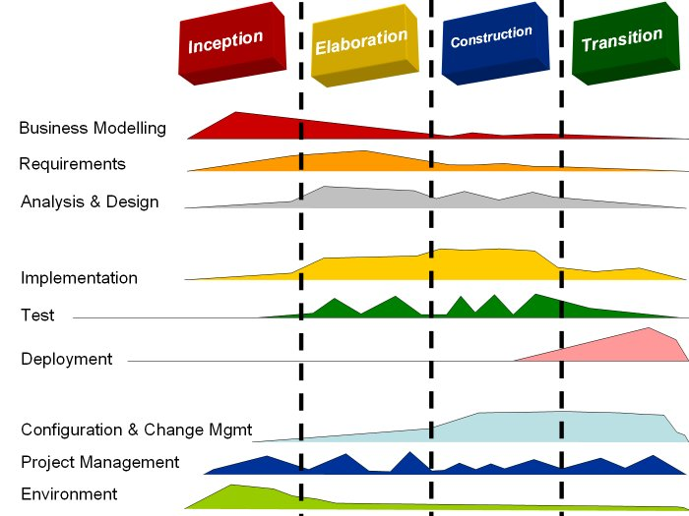

**3.Evolutionary.** **The Spiral Model** - The Spiral Model is an evolutionary software development process that combines iterative development with **risk management**. It was introduced by Barry Boehm and is particularly suited for large, high-risk, and complex projects.

This model consists of multiple spirals (iterations), where each spiral represents a new version of the system with increased functionality. **The focus is on continuous refinement, and risks are assessed in each cycle before progressing further.**

**Key stages of the spiral model.**

The spiral model has 4 key ASPECTS.

|  |  |  |  |
| --- | --- | --- | --- |
| **Phase** | **Description** | **Key deliverables** | **Resources** |
| Planning | Identify objectives, constraints, and risks for the next iteration. | * Feasibility study * Requirement Document | * Business Analyst (BA) * Project Manager * Stakeholders |
| Risk Analysis | Identify, evaluate, and mitigate risks at the start of each cycle. | * Risk management plan | * Risk Analysis * System Architect * Technical Expert |
| Engineering (Development and Testing) | Develop and test the software incrementally. | * Prototype * Source code and test report | * Developers and QA Testers |
| Evaluation and review | Stakeholders review the prototype, provide feedback, and approve further iterations. | * Stakeholder Feedback | * Stakeholder * Client * Business Analyst |

**Characteristics of the Spiral Model**

* Risk-Driven Development: Risks are identified and mitigated early.
* Multiple Iterations: System is developed in cycles, refining each version.
* Stakeholder Involvement: Continuous feedback ensures alignment with user needs.
* Flexible to Changes: Requirements can evolve during development.

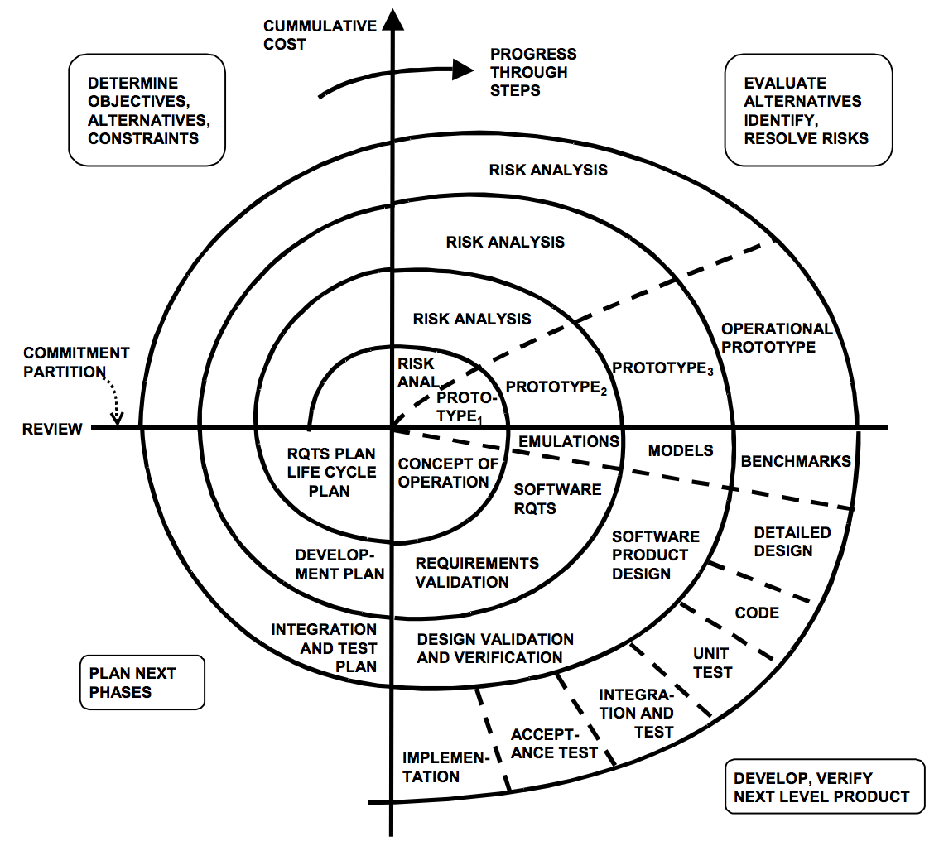

**SPIRAL MODEL**

**--------------------------------------------------------------------------------------------------------------------------**

**4.Agile. - Scrum**

* Agile can be implemented where faster delivery is required.
* No documentation is required.
* The code itself forms as a documentation.

The Agile Model is a flexible, iterative, and collaborative approach to software development that emphasizes customer feedback, rapid delivery, and adaptability to change. Unlike traditional models like Waterfall, Agile delivers software incrementally in small, usable portions called iterations or sprints (typically 1–4 weeks).

* Agile follows the **Agile Manifesto**, which prioritizes:
* **Individuals and interactions** over processes and tools.
* **Working software** over comprehensive documentation.
* **Customer collaboration** over contract negotiation.
* **Responding to change** over following a plan.

**Key Stages of the Agile Model-**

|  |  |  |  |
| --- | --- | --- | --- |
| **Stage** | **Description** | **Key Deliverables** | **Resources Involved** |
| Concept initiation | Define the vision, Business Goals, and initial requirements | * Product backlog * High level requirement | * Product owner * BA * Stakeholders |
| **Sprint Planning** | Prioritize requirements, define sprint goals, and allocate tasks | * Sprint Backlog * Sprint planning | * Scrum Master * Developer * QA Team |
| **Developments(sprints)** | Implement features in (1-4 weeks). | * Working Software Increments * coding | * Developers * UI/UX designers |
| **Testing and QA** | Testing of the features within each sprint | * Test cases * Bug reports * Auto/manual test results | * Testers and Developers |
| **Sprint review and feedback** | Demo of the working product to the stakeholders | * Updated product backlog * feedback | * Product owner * stakeholder |
| **Retrospective and improvement** | Analysis for the next sprint | * Process improvements | * Scrum master * Agile team |

**Agile Frameworks (Popular Agile Methods)**

1.Scrum → Sprint-based development with daily stand-ups & defined roles.  
2. Kanban → Visual task management using boards & continuous flow.  
 3.Lean → Focuses on eliminating waste & improving efficiency.  
4. Extreme Programming (XP) → Emphasizes coding best practices & frequent releases.  
5. SAFe (Scaled Agile Framework) → Scales Agile for large enterprises.

**Conclusion: Choosing the Right SDLC Model**

* Use **Waterfall** when requirements are **clear and fixed**.
* Use **Iterative** when projects need **continuous refinements**.
* Use **Spiral** when projects are **high-risk and need risk management**.
* Use **Agile** when **fast delivery and flexibility** are required.
* 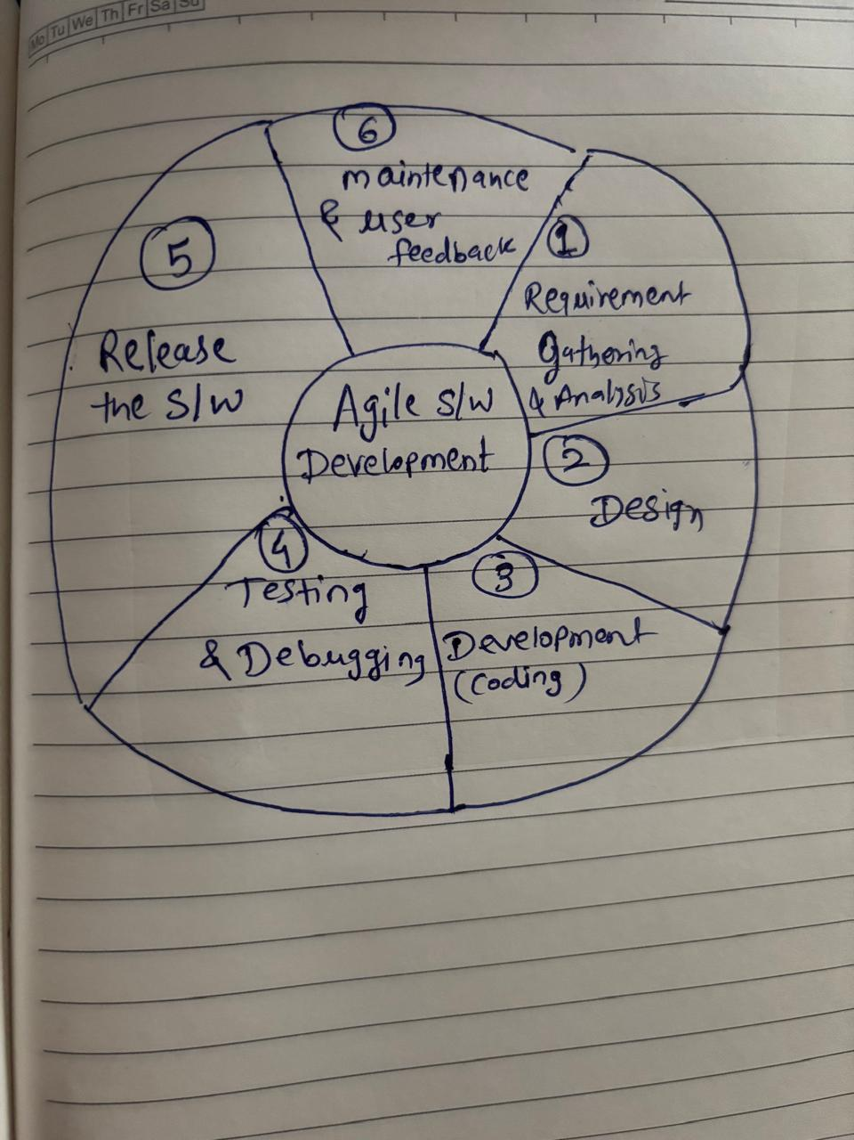

**Agile Model**

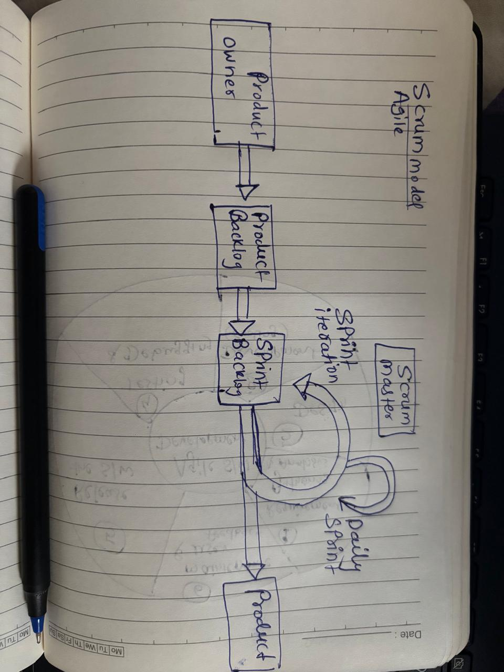

**Scrum Model**

**Question 9 – Waterfall, RUP,Spiral and Scrum Model–**

**SDLC Models**

* **Waterfall**
* **V model**
* **Spiral**
* **Scrum**
* **RUP**

**1.Waterfall Model**

The **Waterfall Model** follows a **linear and structured** process where each phase must be completed before moving to the next.

|  |  |  |
| --- | --- | --- |
| **Phase** | **Description** | **Resources Involved** |
| Requirement Analysis | Gather and document the software requirements. | Business Analyst, Stakeholders, clients |
| System Design | Define Architecture, UI/UX and database | Architect, Designers |
| Implementation | Develop the software | Developers |
| Testing | Software testing | Testers |
| Deployment | Release the software to users | It Team |
| Maintenance | Provide bug fixes and update | Support Team |

**2. V- Model (Verification and Validation Model)**

|  |  |  |  |
| --- | --- | --- | --- |
| **Development Phase** | **Testing(Validation)** | **Description** | **Resources Involved** |
| **Requirement Analysis** | **UAT** | Validate the requirements | **BA, Client, Tester** |
| **System Design** | **System Testing** | Validate the system Function | Architect, QA |
| **High Level Design** | **Integration Testing** | Validate component interaction | Developer ,Tester |
| **Low Level Design** | **Unit testing** | Validate individual module | Developer ,Tester |
| **Implementation** | **Final Testing and Deployment** | Release the system | IT team |

**3**. **Spiral Model- Risk ORIENTED Approach**

|  |  |  |
| --- | --- | --- |
| **Phase** | **Description** | **Resources INVOLVED** |
| **Planning** | Identify project goals, risks, and requirements | BA, Project Manager |
| **Risk Analysis** | Assess risks and define mitigation strategies. | Risk Analyst, BA, Architect |
| **Development** | Build, test, and improve software in loops. | Testers and Developers |
| **Customer Evaluation** | Get user feedback for refinements. | End User |

**4.Scrum Model**

|  |  |  |
| --- | --- | --- |
| **Phase** | **Description** | **Resources involved** |
| Sprint Planning | Define Task for a short iteration. (Sprint) | Scrum Master, Product Owner |
| Development | Implement Selected Features | Developers |
| Daily Stand-ups | Track Progress | Scrum Team |
| Testing and Review | Validate the work and get feedback | QA, Tester |
| Sprint Retrospective | Analyse and improve | IT Team |

**5.(RUP – Rational Unified Process)- Iteration Model**

The **Iterative Model** improves software through **repeated cycles** (iterations), refining the product in every cycle.

|  |  |  |
| --- | --- | --- |
| **Phase** | **Description** | **Resources Involved** |
| Inception | Define Project Goals, feasibility, and risks. | BA, Clients |
| Elaboration | Plan architecture, develop a prototype. | Architects, UX/UI Designers |
| Construction | Code, test, and refine software in iterations. | Developers, Testers |
| Transition | Deploy the product in stages. | IT Team, DevOps |

**Conclusion: Choosing the Right SDLC Model**

**Waterfall** → Best for **stable, well-documented projects**.  
**RUP (Iterative)** → Best for **enterprise systems needing phased improvements**.  
**Spiral** → Best for **high-risk projects requiring risk assessment**.  
**Agile (Scrum/Kanban)** → Best for **fast-paced, customer-driven development**.  
 **V-Model** → Best for **critical, high-quality software projects**.

When the APT IT SOLUTIONS company got the project to make this online agriculture product store, there is a difference of opinion between a couple of SMEs and the project team regarding which methodology would be more suitable for this project. SMEs are stressing on using the V model and the project team is leaning more onto the side of waterfall model. As a business analyst, which methodology do you think would be better for this project.

As a **Business Analyst**, I would evaluate both the **V-Model** and **Waterfall Model** based on the project requirements, risks, and constraints before recommending the best approach. Let's analyse both models:

|  |  |  |
| --- | --- | --- |
| **Aspect** | **V- Model** | **Waterfall Model** |
| Nature | Verification and validation after each model | Linear, phase based |
| Testing | Parallel Testing with development | Testing after development |
| Flexibility | Very low, difficult to accommodate changes | Low but some changes can happen |
| Risk Handling | Low risk due to early stage detection | Higher risk if defects found later |
| Time and cost | Higher cost | Lower cost |
| Best suited for | High-quality, critical projects e.g.- HealthCare, Aerospace | Well-Defined projects with clear scope |

Since the project involves developing a new system from scratch with clear requirements, it is not a safety-critical system like healthcare or aviation, where the V-Model is typically preferred**.**

**Why the Waterfall Model is More Suitable**

* Clear Requirements
* Cost & Time Efficiency
* Easier Vendor Collaboration
* Faster Delivery

**Why Not V-Model?**

* The V-Model is better for critical systems that require heavy validation (e.g., healthcare, automotive).
* This project is not life-critical, so the extensive testing phases of V-Model might slow down development unnecessarily.

**As a Business Analyst, I would explain to convince SME :-**

* The Waterfall model will help meet the fixed timeline and budget more effectively.
* The V-Model is more suitable for high-risk systems, whereas our project focuses on usability and transactions.
* We can still implement strong testing and validation within Waterfall to ensure quality.

**Conclusion: Waterfall is the best choice for delivering a structured, cost-effective, and efficient online agriculture product store.**

**------------------------------------------------------------------------------------------------------------**

**Question 10 – Waterfall Vs V-Model**

**Write down the differences between waterfall model and V model.**

| **Aspect** | **Waterfall model** | **V-model** |
| --- | --- | --- |
| **Cost** | The cost of Waterfall model is low. | V-model is expensive. |
| **Simplicity** | Simplicity of Waterfall model is simple. | Simplicity of V-model is Intermediate. |
| **Flexibility** | Flexibility of Waterfall model is Rigid. | Flexibility of V-model is Little flexible. |
| **Phases** | There is no way to return to the earlier phase. | There is no such constraint in V-model. |
| **Execution Process** | Waterfall model is a sequential execution process. | It is also a sequential execution process. |
| **Linear Movement of Steps** | Waterfall model’s steps move in a linear way. | V-model’s steps don’t move in linear way. |
| **Reusability** | Re-usability of Waterfall model is Limited. | V-model can be Re-use for some extent. |
| **User Involvement** | User involvement in Waterfall model is only in beginning. | User involvement in V-model is also only in beginning. |
| **Testing Activities Start** | In Waterfall model testing activities start after the development activities are over. | In V-model testing activities start with the first stage. |
| **Success Guarantee** | Guarantee of success through Waterfall model is low. | Guarantee of success through V-model is high. |
| **Process** | Waterfall model is a continuous process. | V-model is a simultaneous process. |
| **Defects** | Software made using Waterfall model, the number of defects are less in comparison of software made using V-model. | Software made using V-model, the number of defects are greater in comparison of software made using Waterfall model. |
| **Requirement Specification** | Requirement specification in Waterfall model is necessary in beginning. | Requirement specification in V-model is also necessary in beginning. |
| **Customer Involvement** | Less customer involvement. | More customer involvement as compared to waterfall model. |
| **Testing during Development** | It is not possible to test a software during its development. | There is possibility to test a software during its development. |
| **Identification of Defects** | Identification of defects is done in the testing phase. | Identification of defects can be done from the beginning. |
| **Debugging** | Debugging is done after the last phase. | Debugging can be done in between phases. |
| **Usage** | Waterfall model is less used now-a-days in software engineering. | V-model is widely used in software engineering, healthcare and aerospace. |

**Question 11 – Justify your choice**

**As a BA, state your reason for choosing one model for this project**

As a Business Analyst (BA), I understand that project is depends on the customer requirements, risks, budget, and flexibility. However, based on modern industry trends and best practices, I would recommend **Agile (Scrum) for this project**. Following are the reasons

**Why AGILE is the best choice for this project**

* Flexibility & Adaptability
* Empowered Teams
* Incremental Delivery
* Frequent Deliverables
* Customer collaboration
* Risk Management
* Early Testing and feedback
* Faster Time-to-Market

**Question 12 – Gantt Chart.**

*The Committee of Mr. Henry, Mr Pandu, and Mr Dooku discussed with Mr Karthik and finalised on the V Model approach (RG, RA, Design, D1, T1, D2, T2, D3, T3, D4, T4 and UAT)*

*Mr Vandanam is mapped as a PM to this project. He studies this Project and Prepares a Gantt chart with V Model (RG, RA, Design, D1, T1, D2, T2, D3, T3, D4, T4 and UAT) as development process and the Resources are PM, BA, Java Developers, testers, DB Admin, NW Admin.*

-The **V-Model (Verification & Validation Model)** follows a **phase-wise development and testing approach**, ensuring that each development stage has a corresponding testing phase.

Below is the **Gantt Chart representation** of the project using V-Model stages:

|  |  |  |
| --- | --- | --- |
| **Phase** | **Description** | **Responsible Resources** |
| Requirement Gathering | Collecting requirements from stakeholders (Farmers, Manufacturers, Committee) | BA, PM |
| Requirement Analysis | Analysing functional & technical feasibility | BA,PM , Java Developer |
| Design | System Architecture , DB Design, UI/UX planning | PM, Java Developer, DB admin NW Admin |
| D1-Development Phase 1 | Core module development | Java Developer |
| T1- Testing Phase 1 | Testing D1 Functionalities | Testers |
| D2- Development Phase 2 | Order management, Payment Gateway Integration | Java Developer |
| T2 Testing Phase 2 | Testing D2 Functionalities | Testers |
| D3 Development Phase 3 | Delivery Tracking Notifications | Java Developers |
| T3 Testing Phase 3 | Testing D3 Functions | Testers |
| D4 Development Phase 4 | Final Enhancements | Java Developer |
| T4 Testing Phase 4 | Final Testing and Bug fixes | Testers |
| UAT User Acceptance Testing | End Users(Farmers & Manufacturers test the platform before deployment) | BA , Testers and Stakeholders |

|  |  |  |  |  |
| --- | --- | --- | --- | --- |
| **Phase** | **Start Week** | **End Week** | **Duration (Weeks)** | **Resources** |
| Requirement Gathering | 1 | 3 | 2 | BA |
| Requirement Analysis | 3 | 5 | 2 | BA |
| Design | 5 | 8 | 3 | BA, PM |
| Development 1 | 8 | 11 | 3 | Java Developers |
| Testing 1 | 11 | 12 | 1 | Testers |
| Development 2 | 12 | 15 | 3 | Java Developers |
| Testing 2 | 15 | 16 | 1 | Testers |
| Development 3 | 16 | 19 | 3 | Java Developers |
| Testing 3 | 19 | 20 | 1 | Testers |
| Development 4 | 20 | 24 | 4 | Java Developers |
| Testing 4 | 24 | 27 | 3 | Testers |
| UAT | 27 | 29 | 2 | PM, BA, Testers |

**Gantt Chart Representation**

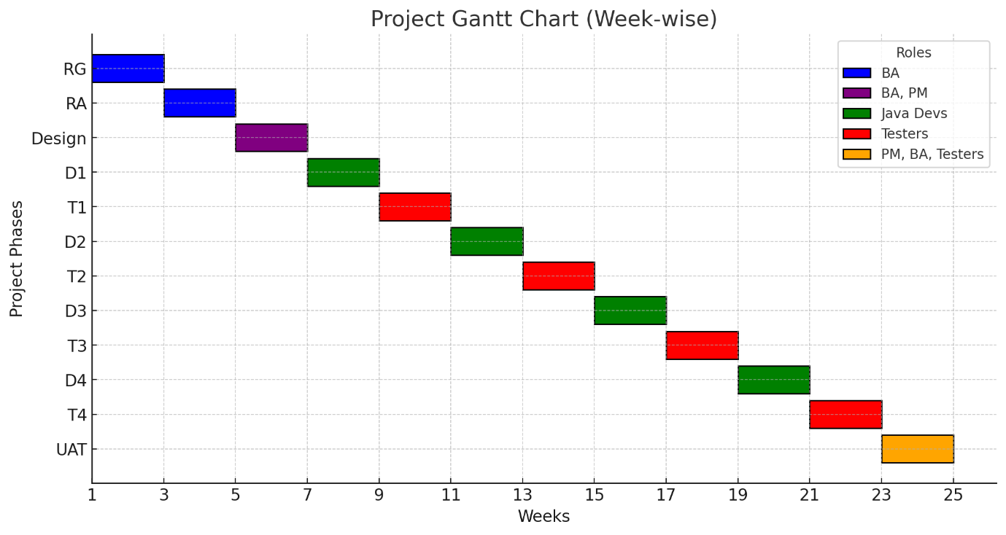*Parallel Testing Approach – Each development phase has a corresponding testing phase (D1 → T1, D2 → T2, etc.), ensuring early defect detection.  
 Structured & Rigid – The V-Model ensures a systematic approach with well-defined milestones. Clearly Assigned Responsibilities – Each phase is handled by the appropriate team members.*

**Conclusion**

**The V-Model is best suited for this project because:**

* It ensures early defect detection, which is important for an e-commerce platform.
* The testing phase runs in parallel with development, avoiding last-minute failures.
* The structured approach ensures the project is completed within the planned 18 months.

**Question 13 – Fixed Bid Vs Billing**

**Explain the difference between Fixed Bid and Billing projects**

|  |  |
| --- | --- |
| **Fixed Bid Model** | **Billing Model** |
| A fixed cost is agreed upon for the entire project, regardless of time or effort. | The client pays based on actual hours worked and resources used. |
| Client knows the exact cost upfront. | Cost varies based on time & effort spent. |
| Projects with well-defined scope and minimal changes. | Projects with changing requirements or evolving scope. |
| Eg - Government projects, infrastructure projects, or small software projects with a clear scope. | Eg- Agile software development, consulting services, R&D projects. |

**Question 14 – Prepare Timesheets of a BA in various stages of SDLC**

* **Design Timesheet of a BA**

**➢ Development Timesheet of a BA**

**➢ Testing Timesheet of a BA**

**➢ UAT Timesheet of a BA**

**➢ Deployment n Implementation Timesheet of a BA**

**-------------------------------------------------------------------------------------------------------------------------**

**1.Requirement Gathering Phase Timesheet**

|  |  |  |  |  |  |
| --- | --- | --- | --- | --- | --- |
| **Sr. No** | **Task** | **Actionable item** | **Start time** | **End time** | **Duration** |
| **1** | Identify the Stakeholder | Engage business owners, SMEs, and tech teams | |  | | --- | | **9:00 AM** |  |  | | --- | |  | | **10:00 AM** | **1 Hrs** |
| **2** | Conduct requirement workshops & interviews | Gather functional & non-functional requirements | **11:00 AM** | **1:00 PM** | **2 Hrs** |
|  | Create Use case & User stories | System interaction and workflows | **2:00 PM** | **4:00 PM** | **2 Hrs** |
| **3** | Getting the inputs for BRD Documents | Capture detailed business needs | **4.30 AM** | **6:00 PM** | **1.5 Hrs** |
| **4** | Conduct feasibility analysis | Evaluate practicality of proposed solution | **9:00 PM** | **11:00 PM** | **2 Hrs** |
| **5** | Perform competitor & market analysis | Gather insights for system enhancement | |  | | --- | | **1130 PM** |  |  | | --- | |  | | **1:00 PM** | **1.5 Hrs** |
| **6** | Obtain requirement sign-offs | Ensure alignment before next phase | **2:30 PM** | **5:00 PM** | **2.5 Hrs** |
|  |  |  |  | **total** | **13.5 hrs** |

**2. Design Phase Timesheet**

|  |  |  |  |  |  |
| --- | --- | --- | --- | --- | --- |
| **Sr. No** | **Task** | **Actionable item** | **Start time** | **End time** | **Duration** |
| **1** | |  | | --- | | Collaborate with UI/UX team | | Review wireframes & suggest improvements | |  | | --- | | **9:00 AM** |  |  | | --- | |  | | **12:00 AM** | **3 Hrs** |
| **2** | Define System Workflows | Ensure workflows meets business needs | **12:30 AM** | **3:30 PM** | **3 Hrs** |
| **3** | Validate functional specifications | Ensure alignment with business needs | **4:00 PM** | **6:30 PM** | **2.5 Hrs** |
| **4** | Update Process flow diagram | Visual representation of the system flow | **9:00 AM** | **12:00 PM** | **3 Hrs** |
| **5** | Conduct design review meet | Gather feedback from stakeholders | **1:00 PM** | **3:00 PM** | **2 Hrs** |
| **6** | Review API and Database Schema | Make sure system design documentation | |  | | --- | | **3:30 PM** |  |  | | --- | |  | | **5:00 PM** | **1.5 Hrs** |
|  |  |  |  | **Total** | **15 Hrs** |

**3. Development Timesheet of a BA**

|  |  |  |  |  |  |
| --- | --- | --- | --- | --- | --- |
| **Sr. No** | **Task** | **Actionable item** | **Start time** | **End time** | **Duration** |
| **1** | Clarification of the Requirements | Answer queries about BRD/FRD | **9:00 AM** | **11:00 AM** | **2 Hrs** |
| **2** | Track Development progress | Make sure implementation aligns with Business goals | **11:30 AM** | **2:30 PM** | **3 Hrs** |
| **3** | Conduct requirement walkthrough | Educate development team on business objectives | **3:00 Pm** | **4:30 PM** | **1.5 Hrs** |
| **4** | Review Prototype | Validate Business functionality | **9 :00 AM** | **12:00 PM** | **3 Hrs** |
| **5** | Participate in sprint review | Provide continuous feedback | **1:00** | **3:00** | **2 Hrs** |
|  |  |  |  | **total** | **11.5 Hrs** |

**4.Testing Phase Timesheet**

|  |  |  |  |  |  |
| --- | --- | --- | --- | --- | --- |
| **Sr. NO** | **Task** | **Actionable Item** | **Start Time** | **End Time** | **Duration** |
| **1** | **Static Testing** | **perform manual or automated reviews of the supporting documents for the software,** | **9:00 AM** | **11:00 AM** | **2 Hrs** |
| **2** | **Unit Testing** | **software undergoes assessments of its specific units, or its functions and procedures. White box testing** | **11:30 AM** | **2:30 PM** | **3 Hrs** |
| **3** | **Integration Testing** | **testing all the units of a program as a group to find issues** | **3:00 Pm** | **4:30 PM** | **1.5 Hrs** |
| **4** | **System Testing** | **the software undergoes its first test as a complete, integrated application to determine how well it carries out its purpose** | **9 :00 AM** | **12:00 PM** | **3 Hrs** |
| **5** | **Acceptance Testing** | **Its purpose is to evaluate the software's readiness for release and practical use. Testers may perform acceptance testing alongside** | **1:00** | **3:00** | **2 Hrs** |
|  |  |  |  | **Total** | **11 Hrs** |

**5.UAT (User Acceptance Testing) Phase Timesheet**

|  |  |  |  |  |  |
| --- | --- | --- | --- | --- | --- |
| **Sr. No** | **Task** | **Actionable item** | **Start time** | **End time** | **Duration** |
| **1** | Conduct UAT planning | Define the criteria | **9:00 AM** | **11:00 AM** | **2HRS** |
| **2** | Create UAT Test document | Define Test scenarios | **11:30 AM** | **2:30 PM** | **3 Hrs** |
| **3** | Assist end users in executing UAT scenarios | Provide support | **3:00 Pm** | **4:30 PM** | **1.5 Hrs** |
| **4** | Gather user feedback | Improvements | **9 :00 AM** | **12:00 PM** | **3 Hrs** |
|  |  |  |  | **Total** | **9.5 Hrs** |

**6. Deployment n Implementation Timesheet of a BA**

|  |  |  |  |  |  |
| --- | --- | --- | --- | --- | --- |
| **Sr. No** | **Task** | **Actionable item** | **Start time** | **End time** | **Duration** |
| **1** | |  | | --- | | deployment planning |  |  | | --- | |  | | Ensure Smooth transition | **9:00 AM** | **11:30 AM** | **2.5 Hrs** |
| **2** | Prepare Training Material | Guide end user | **12:00 PM** | **1:00 PM** | **1 Hrs** |
| **3** | Conduct Training sessions | Educate Users for system use | **3:00 PM** | **5:00 PM** | **2 Hrs** |
| **4** | Monitor deployment progress | Make sure stability after Go-Live | **6:00 PM** | **7:30 PM** | **2.5 Hrs** |
|  |  |  |  | **Total** | **8 Hrs** |

* **Requirement Gathering & Testing Phases →** Highest BA involvement, focusing on documentation, validation, and communication.
* **Development Phase -** BA provides clarifications, tracks progress, and ensures alignment.
* **UAT & Deployment -** BA assists in testing, ensures stakeholder validation, and supports user adoption.

**--------------------------------------------------------------------------------------------------------------------------**