Question 1: Identify minimum 20 functional requirements

|  |  |  |  |
| --- | --- | --- | --- |
| Req ID | Req Name | Req Description | Priority |
| FR001 | User Registration | Users should be able to register for an account by providing their email ID and creating a password | 10 |
| FR002 | Manufacturer Registration | Manufacturers should be able to register and create an account to upload product information | 10 |
| FR003 | User Search for Products | Users should be able to search for available products in fertilizers, seeds, pesticides | 9 |
| FR004 | Product Filtering | Users should be able to filter products by categories such as type (fertilizers, seeds, pesticides), price range, and brand. | 8 |
| FR005 | Product Detail View | Users should be able to view detailed information about a product including description, price, availability, and manufacturer details | 7 |
| FR006 | Add to Cart | Users should be able to add selected products to a shopping cart for purchasing | 6 |
| FR007 | Wishlist Feature | Users should be able to create a wish list to save products for future consideration | 6 |
| FR008 | Checkout Process | There should be a streamlined checkout process for farmers to complete their orders | 7 |
| FR009 | Multiple Payment Option | The application must support various payment methods including Credit/Debit cards, UPI, and Cash on Delivery (COD) | 7 |
| FR010 | Order Confirmation Email | Users should receive an email confirmation with the order details after a successful purchase | 6 |
| FR011 | Order Tracking | Users should be able to track the status of their orders through a delivery tracking feature | 6 |
| FR012 | Help and Support | The application should provide a help section or FAQ for users | 8 |
| FR013 | Feedback and Rating | Users should be able to provide ratings and reviews for the products they purchase | 5 |
| FR014 | Return & Refund Policy | Outline the return and refund policy for customers to ensure a positive customer experience and minimize customer complaint | 8 |
| FR015 | Buy now | On clicking on ‘buy now’, the customer will be redirected to the checkout page :- Payment Gateway | 7 |
| NFR016 | Page Loading Time | The application should respond to user requests within 2 seconds for any action, including loading pages and processing transactions | 10 |
| NFR017 | Usability | The application must have an easy-to-use interface that allows easy navigation | 8 |
| NFR018 | Security | The application must implement data encryption for sensitive information and secure user authentication | 10 |
| NFR019 | Error Handling | The application should provide user-friendly error messages and logging mechanisms for troubleshooting | 8 |
| NFR020 | Accessibility | The system must meet Web Content Accessibility Guidelines WCAG 2.1. | 8 |

Question 2: 5 Page Designs

Login Page

Product Listing Page

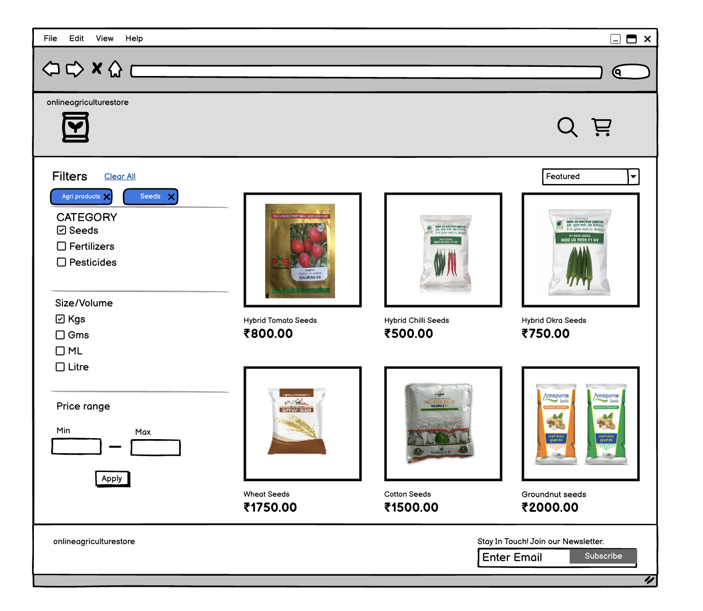

Product Details Page

Payment Page

Checkout Success page

Question 3: Tools

Visio: Microsoft Visio is software for drawing a variety of diagrams. These include flowcharts, org charts, building plans, floor plans, data flow diagrams, process flow diagrams, business process modelling, swim lane diagrams, 3D maps, and many more

.Balsamiq: Balsamiq is a rapid wireframing tool. It creates mock-ups and wireframes for websites, webapps, and desktop software. It allows us to picture ideas and concepts through a simple drag-and-drop interface. The wireframes created using Balsamiq have a hand-drawn style. It focuses on the structure and content of the product rather than visual details.

Axure: Axure is a UX design tool used for creating wireframes and interactive prototypes. Axure is especially useful for designers of desktop and mobile applications, and it is highly regarded among enterprise companies for the high level of functionality and visual detail that can be built into its prototypes.

Question 4: RTM

|  |  |  |  |  |  |  |  |  |  |  |  |  |
| --- | --- | --- | --- | --- | --- | --- | --- | --- | --- | --- | --- | --- |
| Req ID | Req Name | Req Description | Design | D1 | D2 | D3 | D4 | T1 | T2 | T3 | T4 | UAT |
| FR001 | User Registration | Users should be able to register for an account by providing their email ID and creating a password |  |  |  |  |  |  |  | User registration is in T2 phase |  |  |
| FR002 | Manufacturer Registration | Manufacturers should be able to register and create an account to upload product information |  |  |  |  |  |  | Manufacturer registration is in T2 phase |  |  |  |
| FR003 | User Search for Products | Users should be able to search for available products in fertilizers, seeds, pesticides |  |  |  |  |  | User search is in T1 Phase |  |  | Product Filtering is in T4 phase |  |
| FR004 | Product Filtering | Users should be able to filter products by categories such as type (fertilizers, seeds, pesticides), price range, and brand. |  |  |  |  |  |  | Product Detail View is in T2 phase |  |  |  |
| FR005 | Product Detail View | Users should be able to view detailed information about a product including description, price, availability, and manufacturer details |  |  |  |  |  |  |  |  |  |  |
| FR006 | Add to Cart | Users should be able to add selected products to a shopping cart for purchasing |  |  |  |  | Add to Cart is in D4 phase |  |  |  |  |  |
| FR007 | Wishlist Feature | Users should be able to create a Wishlist to save products for future consideration |  |  |  | Wishlist Feature is in D3 phase |  |  |  |  |  |  |
| FR008 | Checkout Process | There should be a streamlined checkout process for farmers to complete their orders |  |  | Checkout Process is in D2 phase |  |  |  |  |  |  |  |
| FR009 | Multiple Payment Option | The application must support various payment methods including Credit/Debit cards, UPI, and Cash on Delivery (COD) |  |  |  |  |  |  |  | Multiple Payment Option is in T3 phase |  |  |
| FR010 | Order Confirmation Email | Users should receive an email confirmation with the order details after a successful purchase |  | Order Confirmation Email is in D1 |  |  |  |  |  |  |  |  |
| FR011 | Order Tracking | Users should be able to track the status of their orders through a delivery tracking feature |  |  |  |  | Order Tracking is in D4 phase |  |  |  |  |  |
| FR012 | Help and Support | The application should provide a help section or FAQ for users |  |  |  |  |  |  |  |  |  | Help and Support is in UAT phase |
| FR013 | Feedback and Rating | Users should be able to provide ratings and reviews for the products they purchase |  |  |  | Feedback and Rating is in D3 phase |  |  |  |  |  |  |
| FR014 | Return & Refund Policy | Outline the return and refund policy for customers to ensure a positive customer experience and minimize customer complaint |  |  |  |  |  | Return & Refund Policy is in T1 phase |  |  |  |  |
| FR015 | Buy now | On clicking on ‘buy now’, the customer will be redirected to the checkout page :- Payment Gateway |  |  |  |  |  |  | Buy now is in T2 phase |  |  |  |
| NFR016 | Page Loading Time | The application should respond to user requests within 2 seconds for any action, including loading pages and processing transactions |  |  |  |  |  |  |  |  |  | Page Loading Time is in UAT phase |
| NFR017 | Usability | The application must have an easy-to-use interface that allows easy navigation |  |  |  |  |  |  |  |  |  | Usability is in UAT phase |
| NFR018 | Security | The application must implement data encryption for sensitive information and secure user authentication |  |  |  |  |  |  |  |  |  | Security is in UAT phase |
| NFR019 | Error Handling | The application should provide user-friendly error messages and logging mechanisms for troubleshooting |  |  |  |  |  |  |  |  |  | Error handling is in UAT phase |
| NFR020 | Accessibility | The system must meet Web Content Accessibility Guidelines WCAG 2.1. |  |  |  |  |  |  | Accessibility is in T2 phase |  |  |  |

Question 5: 10 Test case Documents

|  |  |  |  |  |
| --- | --- | --- | --- | --- |
| Test Case ID | TCOO1 | Test Case  Name | | Login |
| Project ID | 1234 | Project Name | | Online Agriculture Product  Store |
| PM ID | XR-3010087 | PM Name | | Mr Vandanam |
| Test Strategy ID | TS-1222 | Tester ID | | XR-696768 |
| Test Plan ID | TS-1222 | Tester Name | | Miss Alekya |
| Test Schedule ID | TS-1222 | Date of Test | 2-02-2025 | |
| Link to that page |  | | | |
| Input Data | User ID, Password, Captcha, OTP | | | |
| Expected  Behaviour | Home page/ Popup error page | | | |
| Actual Behaviour | Home page/ Popup error page | | | |
| Comments | Test Was Successful | | | |
| Result (Pass/Fail) | Pass | | | |

|  |  |  |  |
| --- | --- | --- | --- |
| Test Case ID | TCOO2 | Test Case  Name | Product Search Functionality |
| Project ID | 1234 | Project Name | Online Agriculture Product  Store |
| PM ID | XR-3010087 | PM Name | Mr Vandanam |
| Test Strategy ID | TS-1222 | Tester ID | XR-696768 |
| Test Plan ID | TS-1222 | Tester Name | Miss Alekya |
| Test Schedule ID | TS-1222 | Date of Test | 3-02-2025 |
| Link to that page |  | | |
| Input Data | Search keyword (e.g., "fertilizer") | | |
| Expected  Behaviour | Relevant products matching the search keyword should be displayed | | |
| Actual Behaviour | Relevant products, including "Organic Fertilizer" and "Chemical Fertilizer," were displayed | | |
| Comments | Search function correctly handles both partial matches and synonyms | | |
| Result (Pass/Fail) | Pass | | |

|  |  |  |  |  |
| --- | --- | --- | --- | --- |
| Test Case ID | TCOO3 | Test Case  Name | | Add Product to Cart |
| Project ID | 1234 | Project Name | | Online Agriculture Product  Store |
| PM ID | XR-3010087 | PM Name | | Mr Vandanam |
| Test Strategy ID | TS-1222 | Tester ID | | XR-696768 |
| Test Plan ID | TS-1222 | Tester Name | | Miss Alekya |
| Test Schedule ID | TS-1222 | Date of Test | 4-02-2025 | |
| Link to that page |  | | | |
| Input Data | Select product (e.g., "Organic Fertilizer"), quantity | | | |
| Expected  Behaviour | Selected product is added to the cart with correct quantity. Confirmation message displayed | | | |
| Actual Behaviour | Product "Organic Fertilizer" was added to the cart with a quantity ; confirmation message displayed | | | |
| Comments | Stock decreased appropriately after addition | | | |
| Result (Pass/Fail) | Pass | | | |

|  |  |  |  |  |
| --- | --- | --- | --- | --- |
| Test Case ID | TCOO4 | Test Case  Name | | Checkout Process |
| Project ID | 1234 | Project Name | | Online Agriculture Product  Store |
| PM ID | XR-3010087 | PM Name | | Mr Vandanam |
| Test Strategy ID | TS-1222 | Tester ID | | XR-696768 |
| Test Plan ID | TS-1222 | Tester Name | | Miss Alekya |
| Test Schedule ID | TS-1222 | Date of Test | 5-02-2025 | |
| Link to that page |  | | | |
| Input Data | Products in cart, delivery address, payment information (e.g., COD | | | |
| Expected  Behaviour | Order is confirmed, and an order summary is displayed | | | |
| Actual Behaviour | Order was confirmed and an order summary was correctly displayed | | | |
| Comments | All totals calculated correctly without any errors | | | |
| Result (Pass/Fail) | Pass | | | |

|  |  |  |  |  |
| --- | --- | --- | --- | --- |
| Test Case ID | TCOO5 | Test Case  Name | | Email Confirmation on Order |
| Project ID | 1234 | Project Name | | Online Agriculture Product  Store |
| PM ID | XR-3010087 | PM Name | | Mr Vandanam |
| Test Strategy ID | TS-1222 | Tester ID | | XR-696768 |
| Test Plan ID | TS-1222 | Tester Name | | Miss Alekya |
| Test Schedule ID | TS-1222 | Date of Test | 6-02-2025 | |
| Link to that page |  | | | |
| Input Data | Valid email address (test@example.com), confirm order placed | | | |
| Expected  Behaviour | Email confirmation regarding order status is sent to the registered email | | | |
| Actual Behaviour | Email confirmation received successfully at [test@example.com](mailto:test@example.com) | | | |
| Comments | Check ensured that the email also arrived in the inbox, not in spam | | | |
| Result (Pass/Fail) | Pass | | | |

|  |  |  |  |  |
| --- | --- | --- | --- | --- |
| Test Case ID | TCOO6 | Test Case  Name | | Delivery Tracking |
| Project ID | 1234 | Project Name | | Online Agriculture Product  Store |
| PM ID | XR-3010087 | PM Name | | Mr Vandanam |
| Test Strategy ID | TS-1222 | Tester ID | | XR-696769 |
| Test Plan ID | TS-1222 | Tester Name | | Mr. Jason |
| Test Schedule ID | TS-1222 | Date of Test | 7-02-2025 | |
| Link to that page |  | | | |
| Input Data | Order ID (12345) | | | |
| Expected  Behaviour | Tracking page shows the current status and location of the order | | | |
| Actual Behaviour | The tracking page displayed the correct status and location information | | | |
| Comments | Invalid order ID prompted proper error handling | | | |
| Result (Pass/Fail) | Pass | | | |

|  |  |  |  |  |
| --- | --- | --- | --- | --- |
| Test Case ID | TCOO7 | Test Case  Name | | User Logout |
| Project ID | 1234 | Project Name | | Online Agriculture Product  Store |
| PM ID | XR-3010087 | PM Name | | Mr Vandanam |
| Test Strategy ID | TS-1222 | Tester ID | | XR-696769 |
| Test Plan ID | TS-1222 | Tester Name | | Mr. Jason |
| Test Schedule ID | TS-1222 | Date of Test | 8-02-2025 | |
| Link to that page |  | | | |
| Input Data | User is logged in | | | |
| Expected  Behaviour | User is successfully logged out and redirected to the homepage | | | |
| Actual Behaviour | User was successfully logged out and redirected to the homepage | | | |
| Comments | Session terminated properly after logout | | | |
| Result (Pass/Fail) | Pass | | | |

|  |  |  |  |  |
| --- | --- | --- | --- | --- |
| Test Case ID | TCOO8 | Test Case  Name | | Password Recovery |
| Project ID | 1234 | Project Name | | Online Agriculture Product  Store |
| PM ID | XR-3010087 | PM Name | | Mr Vandanam |
| Test Strategy ID | TS-1222 | Tester ID | | XR-696769 |
| Test Plan ID | TS-1222 | Tester Name | | Mr. Jason |
| Test Schedule ID | TS-1222 | Date of Test | 8-02-2025 | |
| Link to that page |  | | | |
| Input Data | Registered email address ([test@example.com](mailto:test@example.com)) | | | |
| Expected  Behaviour | User receives an email with a link to reset the password. | | | |
| Actual Behaviour | Password reset email received at [test@example.com](mailto:test@example.com) | | | |
| Comments | The reset link was functional and directed to the password change page | | | |
| Result (Pass/Fail) | Pass | | | |

|  |  |  |  |  |
| --- | --- | --- | --- | --- |
| Test Case ID | TCOO9 | Test Case  Name | | Add Product Review |
| Project ID | 1234 | Project Name | | Online Agriculture Product  Store |
| PM ID | XR-3010087 | PM Name | | Mr Vandanam |
| Test Strategy ID | TS-1222 | Tester ID | | XR-696769 |
| Test Plan ID | TS-1222 | Tester Name | | Mr. Jason |
| Test Schedule ID | TS-1222 | Date of Test | 9-02-2025 | |
| Link to that page |  | | | |
| Input Data | Valid product (Organic Fertilizer), review text ("Excellent product!") | | | |
| Expected  Behaviour | Review is submitted successfully and displayed under product details | | | |
| Actual Behaviour | Review submitted and displayed correctly under the product | | | |
| Comments | User notified of successful submission | | | |
| Result (Pass/Fail) | Pass | | | |

|  |  |  |  |  |
| --- | --- | --- | --- | --- |
| Test Case ID | TCO10 | Test Case  Name | | View Order History |
| Project ID | 1234 | Project Name | | Online Agriculture Product  Store |
| PM ID | XR-3010087 | PM Name | | Mr Vandanam |
| Test Strategy ID | TS-1222 | Tester ID | | XR-696769 |
| Test Plan ID | TS-1222 | Tester Name | | Mr. Jason |
| Test Schedule ID | TS-1222 | Date of Test | 10-02-2025 | |
| Link to that page |  | | | |
| Input Data | User is logged in | | | |
| Expected  Behaviour | User should see a list of past orders under "Order History." | | | |
| Actual Behaviour | All past orders were displayed correctly under the section | | | |
| Comments | Navigation to the order history page was seamless | | | |
| Result (Pass/Fail) | Pass | | | |

Question 6: DB Design