Question 1: Quarterly Audits

Answer 1:

**Quarter 1 Audit Report**

|  |  |
| --- | --- |
| Stage | Requirement Gathering phase |
| Timeline | 10 weeks (week 1 to week 10) |
| Status | Completed |
| Checklist | * BRD Template * Elicitation result report * Duplicate requirement report * Grouping of functionality/ Features-client sign off * Email communication- To , CC, BCC |

**Quarter 2 Audit Report**

|  |  |
| --- | --- |
| Stage | Requirement Analysis phase |
| Timeline | 18 weeks (week 11 to week 29) |
| Status | Completed |
| Checklist | * UML diagram * Business to functional requirements mapping * Client sign off-documents * RTM document version control * Email communication- To , CC, BCC |

**Quarter 3 Audit Report**

|  |  |
| --- | --- |
| Stage | Design phase |
| Timeline | 9 weeks (week 30 to week 38) |
| Status | Completed |
| Checklist | * Utilization of tools * Documented evidences on client communication * Stakeholder MOM * Email communication- To , CC, BCC |

**Quarter 4 Audit Report**

|  |  |
| --- | --- |
| Stage | Developmentphase |
| Timeline | 24 weeks (week 39 to week 62) |
| Status | Completed |
| Checklist | * JAD session report * End user manual preparation document * BA and developer MOM * Email communication-To, CC, BCC |

**Quarter 5 Audit Report**

|  |  |
| --- | --- |
| Stage | Testing phase |
| Timeline | 16 weeks (week 63 to week 78) |
| Status | Completed |
| Checklist | * Meeting with testers to check on possible outcome * Discussion with QA team on the details such as automation code, where to store the automation code and who will need across to it, who’s running the test, writing the test * Meeting with QA team to identify where the test will run * Email communication- To , CC, BCC |

Question 2: BA Approach Strategy

Answer 2:

**What Elicitation Techniques to apply:**

We have many elicitation techniques to apply used to gather requirements. Some of them are: Brainstorming, Document Analysis, Reverse engineering, Focus Groups, Observation, etc.

As a BA I will be using brainstorming Technique,

Brainstorming is an elicitation technique used to generate a large number of ideas or solutions in a short time. It involves a group of people sharing thoughts freely without judgment. The goal is to encourage creativity and explore different perspectives. It is useful in problem-solving, decision-making, and gathering requirements.

**How to do Stakeholder Analysis RACI:**

Stakeholder analysis can be done by using the RACI matrix involves identifying stakeholders and defining their roles and responsibilities within a project. – Identify Stakeholders, Define Roles and Responsibilities, Create the RACI Matrix, Assign RACI Roles.

Stakeholders are:

1. **Project stakeholders**

* Delivery head - Mr. Kartik
* Project manager - Mr. Vandanam
* Development team - Ms. Juhi, Mr. Teyson, Ms. Lucie, Mr. Tucker, Mr. Bravo
* Testing Team- Mr. Jason and Ms. Alekya
* Network Admin - Mr. Mike
* DB Admin - Mr. John
* Business Analyst - Anushk

1. **Business Stakeholders**

* Business sponsor - Mr. Henry
* Farmers - Peter, Kevin and Ben
* Financial Head - Mr. Pandu
* Project Coordinator - Mr. Doku

**What Documents to Write:**

* Scope
* Use case
* Technology specification
* FRD-Functional and Non-functional documents
* BRD
* Project Time line
* Architectural diagrams
* Risks and mitigation plan
* Test case
* Standard Terms and conditions
* Sign off documents

**What process to follow to Sign off on the Documents:**

Project signoff is typical executed during the contact closer phase, the company presents the results of the work done to the client and then, after getting the necessary acceptance from them, should get a client statement to verify that the job was completed.

Such as:-

* Name of the project
* All relevant dates
* Key role in the project
* Project deliverables

Sign Off to be taken on SRS as this is the primary and important document. Sign off can be taken by using E-mail confirmation from Client.

**How to Take Approvals from the Client:**

Whenever we seek approval from a manager or client , we will have to draft a request for an approval letter.

By following These steps we can get approvals efficiently:

* Prepare the Document/Deliverable
* Send a Clear Approval Request via Email
* Follow Up with the Client
* Document the Approval

Write email to addressing the relevant signing stakeholders and reviewers as per below format:-

Dear Henry,

I am sending this request to seek your approval regarding the recent project proposal I mentioned earlier in the meeting.

The team and I have put together a detailed plan that can be found attached to this email. After receiving your proposal, we will commence with the project immediately, you will find this plan beneficial for several reasons for your online agricultural store.

The project will be embedded with all the following milestones with the main aim being towards achieving. I anticipate this project to succeed and effectively brings our aim to reality. The whole team looks forward for your confirmation and working on the project.

**What Communication Channels to establish n implement:**

* In person meeting (Face to Face communication-physical meeting)
* Video conferencing
* Phone calls
* Emails
* Text messages
* Online messaging platform

**How to Handle Change Requests:**

* Change Request Form: Use a Change Request Form (CRF) to document the request.
* Impact Analysis: Assess how the change affects
* Approval Process: Share the impact analysis with key stakeholders.
* Documentation: Update project documents (SRS, design, schedule, etc.).

**How to update the progress of the project to the Stakeholders:**

* Weekly status reports
* Monthly review meetings

**How to take signoff on the UAT- Client Project Acceptance Form**

* UAT Preparation – Prepare test cases and ensure the client has access to the system.
* Conduct UAT – The client tests the system to verify it meets their requirements.
* Fix Issues – Resolve any bugs or feedback from UAT testing.
* Acceptance Form – Share the Client Project Acceptance Form for approval.
* Final Review Meeting – Discuss the UAT results and confirm all requirements are met.
* Obtain Sign-Off – Get the client’s approval via email or a signed form.

Question 3: 3-Tier Architecture

Answer 3: The 3-tier architecture is a way of designing applications by dividing them into three layers, making them more organized, scalable, and secure.

**Application Layer** (Frontend): topmost layer of the architecture, also known as “Presentation Layer -It handles user interface (UI) components such as screens, pages. This is what users see and interact with (e.g., website or mobile app). Examples: Web browsers, mobile apps, UI components

**Business Logic Layer:** middle layer of the architecture, acts as an intermediary between the presentation layer and the data storage layer & layer contains the core logic of the application. Ex: Printer, payment gateways. And Handles the main processing, calculations, and rules of the application. Connects the frontend with the database. Examples: APIs, web servers, business logic.

**Database Layer** (Backend)**:** bottom-most layer of the architecture, responsible for storing and Retrieving data from database or file system. The information is passed back to the logic tier for processing and eventually back to the user. Examples: SQL databases, cloud storage.

Question 4: BA Approach Strategy for Framing Questions

Answer 4:

1. **5W1H:** This 5W1H can help recognize potential issue and possible solution related to the scenario.

**WHY:** Asking “Why” helps understand the root cause of a problem. It identifies what triggered the issue and explains why action is needed. It also justifies using the 5W1H method as the first step in problem-solving.

**WHAT:** The “What” element should clearly explain the situation, the specific problem, or the purpose of using the method. It should also mention the overall goal of the solution, if possible.

**WHO: “**Who” refers to the people involved in a situation or problem. It includes the person who found the issue, the people who can fix it, and those responsible for making sure the solution is implemented.

**WHERE**: This part should clearly mention the exact location or area where the issue exists. It could be a physical place, a specific facility, or even a certain step in a process where a solution needs to be applied.

**WHEN**: This section should include all time-related details about the issue. It should mention important dates, deadlines, timelines, or durations that will help in solving the problem efficiently.

**HOW**: The last element of the method, specifies the step on how the identified plan should be carried out. It should also include all the resources tools, methods, means and even the expenditure needed for the changes to be live.

1. **SMART:** SMART is a goal-setting framework that helps create clear and achievable objectives. It stands for: SMART-Specific, Measurable, Attainable, relevant and Time-bound

**Specific** – Clearly define what you want to achieve.

**Measurable** – Make sure progress can be tracked.

**Attainable** – Set a goal that is realistic and achievable.

**Relevant** – Ensure it aligns with your needs or objectives.

**Time**-**bound** – Set a deadline to complete the goal.

1. **RACI:** It is a model used to define roles and responsibilities in a project or process. It helps clarify who is responsible for what.

**R – Responsible:** The person who does the actual work to complete a task. Example: A developer coding a feature.

**A – Accountable:** The person who ensures the task is completed and takes final ownership. Example: A project manager approving the work.

**C – Consulted:** The person who gives input, advice, or expertise before work is done. Example: A business analyst providing requirements.

**I – Informed:** The person who needs updates about the progress but doesn’t take part in the work. Example: A client who needs status updates.

1. **3 TIER Architecture:** 3-Tier Architecture is a way of designing software applications by dividing them into three separate layers. This makes the application more organized, scalable, and secure.

**Presentation Layer (Frontend):** This is what users see and interact with (e.g., website, mobile app). Examples: Web browsers, mobile apps, UI components.

**Application Layer (Backend/Business Logic):** This processes requests, applies business rules, and connects the frontend to the database. Examples: APIs, servers, programming logic.

**Data Layer (Database/Storage):** This stores and manages data securely.Examples: SQL databases, cloud storage

1. **Use case Specs**

**The (BA) should focus on the primary actor when designing the structured workflow.**

* Who is the primary user? Identify the main user interacting with the system.
* What type of product is needed for the project? Define the specific product requirements.
* Placing an order: The system should support order placement.
* Order confirmation is required: Users must receive confirmation after placing an order.
* Delivery channel & tracking updates: The system should provide delivery options and real-time tracking updates.

1. **Activity Diagram**  in UML is used to model how a system behaves dynamically. To create it, we need to discuss key points with stakeholders, such as:

* What activities will be performed? Identifying the main tasks or processes in the system.
* How do different parts relate functionally? Understanding the connections and interactions between different system components.
* What are the business functions and objectives? Ensuring the system supports business goals and operational needs.

1. **Modeling and page design** are crucial for gathering requirements. A Business Analyst should ask stakeholders:

* How should the system work? (Overall functionality)
* How should the web page look and function? (User interface and experience)
* What actions should users be able to perform? (Functional activities)
* How should payments be processed? (Payment gateway)
* How will complaints and updates be managed? (Support and issue resolution)

Question 5: Elicitation Techniques

Answer 5

**Brainstorming:**

* Brainstorming sessions involve gathering a group of stakeholders to generate ideas, solutions, and requirements collectively.
* It encourages creativity and can be useful for exploring new possibilities.

**Document Analysis:**

* Analyzing existing documents, reports, and documentation related to the project or domain to extract relevant information
* This technique helps in understanding the current state and identifying gaps.

**Focus Groups:**

* Focus groups involve a small, representative group of stakeholders who engage in structured discussions to provide insights, feedback, and requirements.
* It’s useful for gathering diverse perspectives.

**Observation:**

* Directly observing users or stakeholders in their natural environment to understand their behaviors, tasks, and challenges.
* Observations provide valuable context for requirements gathering,

**Interviews**

* Conducting one-on-one or group interviews with stakeholders to ask specific questions and gather detailed information and insights.
* Interviews allow for in-depth exploration of individual perspectives.

**Questionnaires and Surveys:**

* Distributing structured questionnaires or surveys to a larger audience to collect quantitative and qualitative data.
* Questionnaires are useful for gathering input from a broad group of stakeholders.

**Use Cases and Scenarios:**

* Developing use cases and scenarios to describe how users interact with the system and achieve specific goals.
* Use cases help define functional requirements and system behavior.

**Prototyping:**

* Creating mockups or prototypes of the solution to visualize and validate requirements.
* Prototypes help stakeholders better understand the proposed system and provide feedback

Question 6: This project Elicitation Techniques

Answer 6: In the context of the case study, Online Agriculture Products Store, the most suitable elicitation technique to use is **Use Case Specifications** because it effectively outlines how users—such as farmers and agricultural product manufacturers—will interact with the online store system.

**Justification:**

1. Since the platform connects farmers and manufacturing companies, it’s crucial to clearly define how they will interact with the system. Use case specs provide a structured way to map out these interactions.
2. The project is about building a web/mobile application where users can browse, select, and purchase agricultural products. Use case specifications help break down these steps into clear, actionable scenarios.
3. By using this approach, we can capture different user roles, scenarios, and system behaviors in an organized manner, ensuring nothing is overlooked.
4. It also gives a solid framework for understanding how users will navigate the system and what features need to be in place to support their journey.
5. Lastly, use case specs help define system boundaries and anticipate potential challenges, such as exceptions or alternate flows, making the development process smoother.

Question 7: 10 Business Requirements

Answer 7:

**Business Requirements for Buyers**

* **BR001**: User Registration and Login: Farmers should be able to sign up as new users. If they are already registered, they can log in using their username and password.
* **BR002**: Product Search: Farmers should be able to search for products based on categories like pesticides, fertilizers, seeds, and crops.
* **BR003**: Cart Management: Farmers should be able to add items to their cart and also remove items if needed.
* **BR004**: Payment Gateway: Farmers should be able to place an order and make payments using net banking, UPI, wallets, coupons, or cash on delivery (COD).
* **BR005**: Track Delivery: Farmers should be able to track deliveries.
* **BR006:** Upload & Display: Dealers should be able to upload and display their products in the application
* **BR007:** Browse: Customers should be able to browse through the Product Catalogue
* **BR008:** Connect: Dealers should be able to communicate with customers
* **BR009:** Order Confirmation: Customers should get order confirmation once order is successfully placed.
* **BR0010:** User-Friendly Interface: The platform should be easy to use and accessible via both web and mobile applications for convenience.

Question 8: Assumptions

Answer 8:

* **Assumption 1:** Users can login using Facebook, communicate Google account.
* **Assumption 2:** Users should have basic technical knowledge to browse websites or make purchase.
* **Assumption 3:** Due to boom in online shopping trend, customers will prefer online shopping.
* **Assumption 4:** The dealers/traders need to display good quality product in the application to increase their sales.
* **Assumption 5:** Users should have knowledge on agricultural products, its usage and longevity**.**
* **Assumption 6:** Customers should have online accounts for secured payment processing.

Question 9: Give Priority 1 to 10 numbers ( 1 being low priority – 10 being high priority) to these Requirements After discussions with the stakeholders

Answer 9:

|  |  |  |  |
| --- | --- | --- | --- |
| **Requirement ID** | **Requirement Category** | **Requirement Description** | **Priority** |
| **BR001** | User Registration and Login | Farmers should be able to sign up as new users. If they are already registered, they can log in using their username and password | 1 |
| **BR002** | Product Search | Farmers should be able to search for products based on categories like pesticides, fertilizers, seeds, and crops. | 3 |
| **BR003** | Cart Management | Farmers should be able to add items to their cart and also remove items if needed. | 4 |
| **BR004** | Payment Gateway | Farmers should be able to place an order and make payments using net banking, UPI, wallets, coupons, or cash on delivery | 2 |
| **BR005** | Track Delivery | Farmers should be able to track deliveries. | 10 |
| **BR006** | Upload & Display | Dealers should be able to upload and display their products in the application | 8 |
| **BR007** | Browse | Customers should be able to browse through the Product Catalogue | 7 |
| **BR008** | Connect | Dealers should be able to with customers | 9 |
| **BR009** | Order Confirmation | Customers should get order confirmation once order is successfully placed. | 6 |
| **BR0010** | User-Friendly Interface | The platform should be easy to use and accessible via both web and mobile applications for convenience. | 5 |

Question 10: Use case diagram

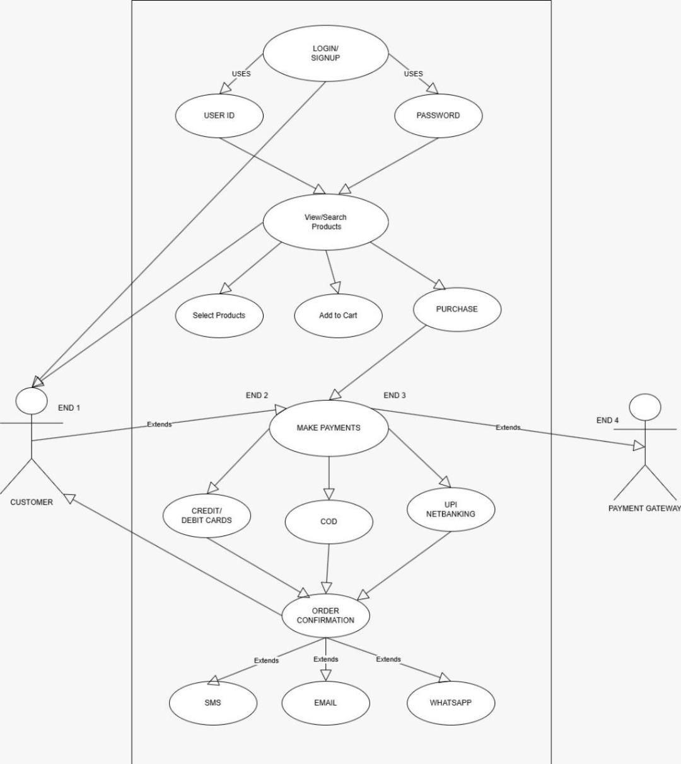Answer 10:

Question 11: Use Case Specs

Answer 11:

|  |  |  |  |
| --- | --- | --- | --- |
| **Use Case ID** | UC001 | | |
| **Use Case Name** | This use case shows How the user can buy Agriculture product from this application | | |
| **Created by** | XYZ. Ltd. | Last Updated by | 29-March-2025 |
| **Date Created** | 28-March-2025 | Last Revision Date | 29-March-2025 |
| **Actor** | Customers/Farmers | | |
| **Description** | Describing how page should respond if there is no internet | | |
| **Pre-condition** | Farmers is having an active internet connection, Valid mobile no., Pincode | | |
| **Post-condition** | **Success** -Farmers can place the order successfully.  **Failure** -Farmers unable to Login/ logs are updates accordingly. | | |
| **Basic Flow** | Step 1: The use case starts when Farmers do the registration with valid email ID and then Login with ID and password.  Step 2: Use case validate the user is performed.  Step 3: Farmers search for desired products and browse the catalogue.  Step 4: Farmers then select desired quantity and no of items.  Step 5: Farmers add product to cart  Step 6: Selecting the complete order button will take the user to the payment page displaying the final amount to pay on the screen.  Step 7: Payment page will show different payment modes available like COD, Debit/credit card, UPI, Net Banking and ask the user to enter correct payment details like pin, CVV, card number  Step 8: Once the payment is done, it will generate a pop-up message whether the payment is successful or not if successful then the real-time order id will be generated  Step 9: Once an order is placed successfully then it will ask the user to go to the order tab to check the dispatch status  Step 10: After the dispatch of the product on the order page it will show shipment tracking details with a link to track the same  Step 11: The farmers receive the placed product. | | |
| **Alternative Flow** | Invalid User, Wrong account ID, Wrong password, No successful authentication Via mobile number or email Id | | |
| **Exceptions** | If internet connection lost during activity, then display “Check your internet connection” | | |
| **Frequency of Use** | High | | |
| **Assumptions** | It is assumed that customer is registered and have basic browsing knowledge of products. | | |

Question 12:

Answer 12:

1. **USER** **REGISTRATION**

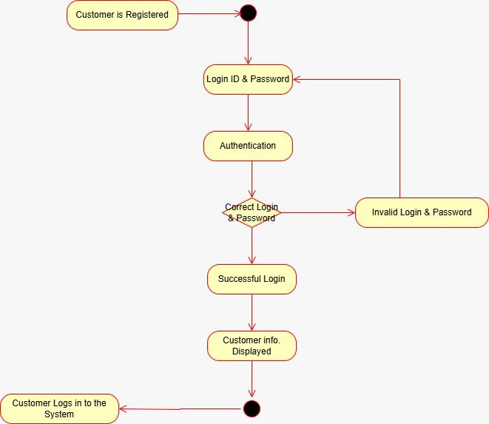

1. **SEARCH** **PRODUCTS**

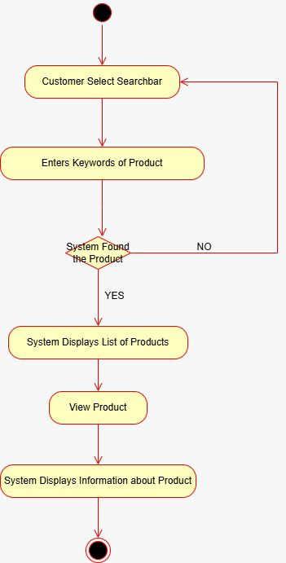

1. **ADD PRODUCTS TO THE CART**

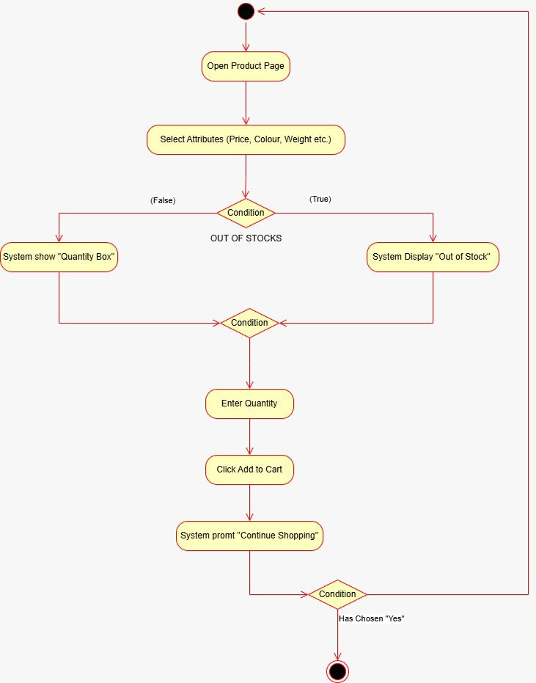

1. **MAKING A PAYMENT**

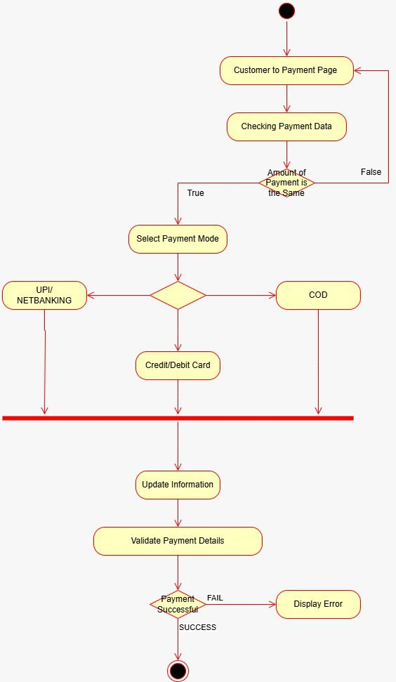

1. **DELIVERY**

