Assignment 1:
A company is having manufacturing plants and warehouses in various parts of the country. They
manufacture ice-cream and milk products. They want to build software to achieve two goals.
• Manage the inventory
• Quickest delivery to the customers
Assignment 1:
- Please make a BRD which can be presented to the client along with complete development and resource plan.
Document 5- BRD Template

Scream Ice Creams
ICE065
Ver 3.01
Dhanoop

Contents

Document Revisions
Date | Version Number | Document Changes
25/4/2025 | 0.1 | Initial Draft

Approvals

Role | Name | Title | Signature | Date
Project Sponsor | Client MD | MD
Business Owner | Danny | IT operations
Project Manager | Vignesh | SPOC and project head
Business analyst | Dhanoop | Lead analyst
System Architect | Sunil | Software Architect
Development Lead | Anil | Lead development
User Experience Lead | chapman | Customer success
Quality Lead | mark | QA
Content Lead | lee | Digital marketing

RACI Chart for This Document
The RACI chart identifies the persons who need to be contacted whenever changes are made to this document. RACI stands for responsible, accountable, consulted, and informed. These are the main codes that appear in a RACI chart, used here to describe the roles played by team members and stakeholders in the production of the BRD. They are adapted from charts used to assign roles and responsibilities during a project.( RACI Can be made for IT side[Project stakeholder] as mentioned above, apart from that Can also Be made for Client side[Business Stakeholder]).
The following describes the full list of codes used in the table:

Codes Used in RACI Chart
* Authorize Has ultimate signing authority for any changes to the document.
R Responsible Responsible for creating this document.
A Accountable Accountable for accuracy of this document
(for example, the project manager)
S Supports Provides supporting services in the production of this document
C Consulted Provides input (such as an interviewee).
I Informed Must be informed of any changes.

RACI Chart
Name | Position | * | R | A | S | C | I
Client MD | MD |  |  |  |  | * | *
Danny | IT operations |  | * | *
Vignesh | SPOC and project head |  | * | *
Dhanoop | Lead business analyst |  |  |  |  | *
Sunil | Software Architect |  | * | *
Anil | Lead development |  | * | *
chapman | Customer success |  |  |  |  | * | *
mark | QA |  |  |  | * |  | *
lee | Digital marketing |  |  |  | * |  | *

*Resources required:- as planned the team is arranged the infra needs to be aligned to host the application. Cloud hosting and managed services

Introduction

Business Goals
[This should describe the organization goals& Organization Need]
Need: As a Ice cream manufacturing firm we need to manage inventory and achieve quick deliveries to customers

Business Objectives
To provide an IT solution for:
List what the functionalities are going to develop in software
- Portal for inwarding finished goods and managing inventory while establishing fefo logic during dispatches
- Delivery lead time to the requirement requests from the customer needs to be improved drastically.

Business Rules
[List Organization Policies, Procedures, and Rules& Regulations]
- Inwarding of finished goods
- Maintaining bin details against the stock
- FEFO logic to be configured to ensure only soon to expire items are dispatched first
- Receive orders from customers and dispatch asap
- Predictive prompt of stock to be maintained to be suggested based on last 2 years sale trends
- Align 3-4 parcel booking or vehicle booking agents to ensure availability

Background
[Provide a brief history of how the project came to be proposed and initiated, including the business issues/problems identified, and expected benefit of implementing the project/developing the product.]
Old stocks were lying while new stocks were coming in and getting dispatched, over a period of time those old stocks were expiring and we had to dispose it off
The customer orders were high and we were facing shortage on stock and also having challenges in shipping the material

Project Objective
[These should describe the overall goal in developing the product, high level descriptions of what the product will do, how they are aligned to business objectives, and the requirements for interaction with other systems]
Manage inventory correctly
Quick deliveries on orders placed

Project Scope
[What we are going to develop in the current project]
A portal to inward finished goods
FEFO logic on existing stock
Quick deliveries on the orders placed, lead time to be reduced

In Scope Functionality
[List what functionalities we are going to do with in the project in bullets]
- Inward of finished goods
- Bin details along with stock and date of manufacture for FEFO
- Customer enquiries and orders filtered based on FIFO to ensure timely dispatches

Out Scope Functionality
[List of functionality what is not included in the current project]
- Stock tracking from manufacturer to end user based on supply chain principles. Liability on the company based on the goods sold and payments yet to come etc data

Assumptions
[List all assumptions requirements are based on]
- We will get to manage inventory well
- We will get the logistics support on time
- We will have enough stocks all time to ship materials as and when we get order

Constraints
[List all Constraints]
- The data that is made available is on a select format as this is a existing product customised to our business requirements, since they work on SAAS model this product cannot be heavily customized
- If inventory is not updated based on the sales real time we will have wrong data
- If stocks are not maintained correctly we may have to delay shipping

Risks
In this section of the BRD, you describe risks. A risk is something that could affect the success or failure of a project. Analyze risks regularly as the project progresses. While you may not be able to avoid every risk, you can limit each risk’s impact on the project by preparing for it beforehand. For each risk, you’ll note the likelihood of its occurrence, the cost to the project if it does occur, and the strategy for handling the risk. Strategies include the following:
- Avoid: Do something to eliminate the risk.
- Mitigate: Do something to reduce damage if risk materializes.
- Transfer: Pass the risk up or out to another entity.
- Accept: Do nothing about the risk. Accept the consequences.

Technological Risks
This subsection of “Risk Analysis” specifies new technology issues that could affect the project.
Software platform Portal i do not see any issue as it is HTML and widely used which works on mongo db

Skills Risks
This subsection of “Risk Analysis” specifies the risk of not getting staff with the required expertise for the project.
Right now we have a good team but going forward this issue will not come up as the management is hands on experts themselves and not dependent

Political Risks
This subsection of “Risk Analysis” identifies political forces that could derail or affect the project.
This occurs if we have many hierarchy within the organization and an external government statuary needs are not met but this is not a issue as we have managements commitment for this project

Business Risks
This subsection of “Risk Analysis” describes the business implications if the project is canceled.
Executives will have an opposition and may work half heartedly for a while after some time they will realise they have to accept and blend with the system

Requirements Risks
This subsection of “Risk Analysis” describes the risk that you have not correctly described the requirements. List areas whose requirements were most likely to have been incorrectly captured.
Elient and myself are actively involved in this project from the beginning and this is our 3rd attempt so requirements are sorted

Other Risks
In this subsection of “Risk Analysis,” document any other risks not covered in the prior subsections.
I don’t foresee anything as such

Business Process Overview
[This describes the overall process flow from each phase]
Attendance will be sent to HR dept for salary calculation
Reimbursement will be sent to accounts dept for disbursement

Legacy System (AS-IS)

[Brief Explanation about the process in legacy system and draw process flow diagrams]
The system we follow now is a crude one with no systems in place and decision making happens on the executive personal intuition

Proposed Recommendations (TO-BE)

[Describe the recommended process and how the proposed system will address the challenges in legacy system]
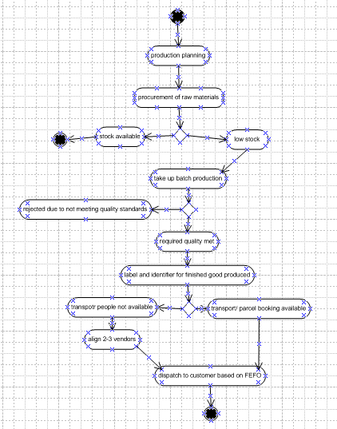
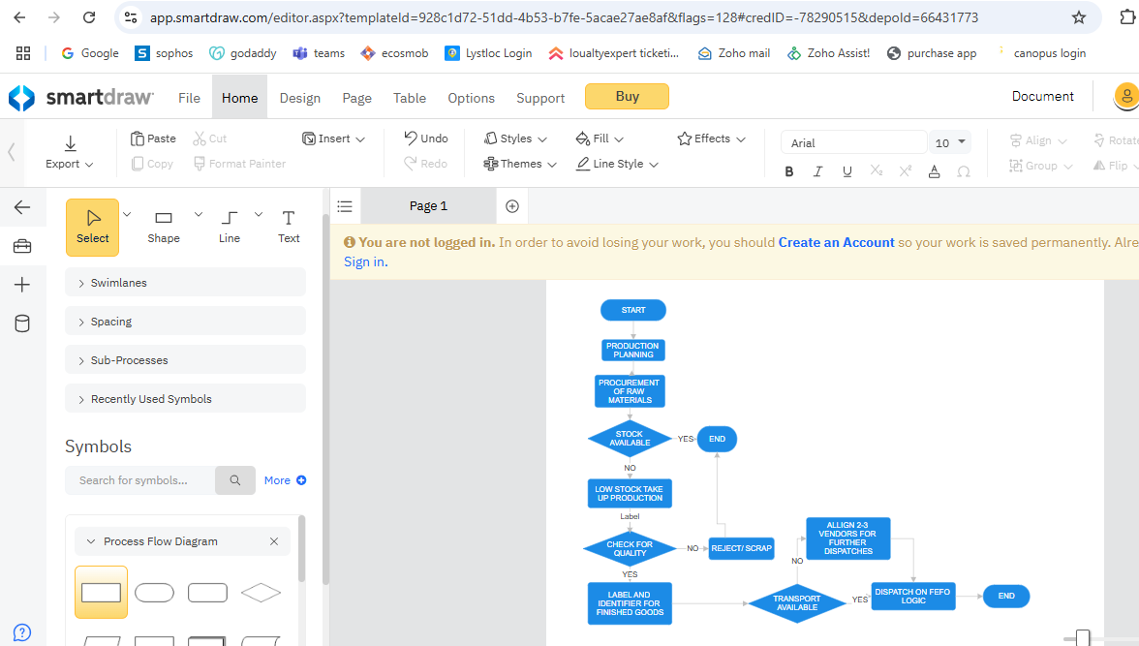

- We are taking up production based on the stocks available and past year consumption trends
- Also we are having 2-3 vendors for transport solutions
- We are also following fefo logic while dispatch so this is the best for inventory management

Business Requirements
[The specific business requirements elicited from stakeholders should be listed, categorized by both priority and area of functionality to smooth the process of reading and tracking them. Include links to use case documentation, and other key reference material as needed to make the requirements as complete and understandable as possible. You may wish to incorporate the functional and non-functional requirements into a traceability matrix that can be followed throughout the project]
Sl No | Req ID | Req Category | Description | Priority
1 | BRQ01 | Portal login | Backend user should be able to login to the portal | 10
2 | BRQ02 | Backend users view and download report | In the portal login all reports viewing and download option is required | 10
3 | BRQ03 | Back end users need to update stock | Inward and sales needs to be updated | 10
4 | BRQ04 | Backend users need to create customers for sales | Add option for adding customers | 10
5 | BRQ05 | Adding of transport agents | Option to add transport agent should be available | 10

Appendices

List of Acronyms
BRD- business requirement document; RTM Requirement traceability matrix
CR Change Request; RACI responsible accountable consulted informed

Glossary of Terms Related Documents
BRD, RTM, CR, RACI

- Prepare process flow diagram using your imagination.

Assignment 2:
- Write an introduction letter to a client introducing yourself as a business analyst in charge of working with the client and his team to start the business understanding process.
I would like to introduce myself Dhanoop Somashekar Business analyst, I am a part of the ongoing project and I am responsible for client interactions. As part of eliciting requirements and understanding business process, I collaborate closely with stakeholders in the client team and development team to ensure the success of our partnership with clients.
I am reaching out with a small request to schedule a short meeting with you to discuss your business process so that we can suggest right solution while ensuring all your requirements and issues are addressed.

To delve deeper into this, could you please share a convenient time for this discussion? I’m sure it’s going to be a value-add for both of us.
- Prepare a brief BRD and SRS for a project- Horoscope or Ticketing system or online store
BRD Template
Ticketing reservation
ICE065
Ver 3.01
Dhanoop

Contents

Document Revisions
Date | Version Number | Document Changes
25/4/2025 | 0.1 | Initial Draft

Approvals

Role | Name | Title | Signature | Date
Project Sponsor | Client MD | MD
Business Owner | Danny | IT operations
Project Manager | Vignesh | SPOC and project head
Business analyst | Dhanoop | Lead analyst
System Architect | Sunil | Software Architect
Development Lead | Anil | Lead development
User Experience Lead | chapman | Customer success
Quality Lead | mark | QA
Content Lead | lee | Digital marketing

RACI Chart for This Document
The RACI chart identifies the persons who need to be contacted whenever changes are made to this document. RACI stands for responsible, accountable, consulted, and informed. These are the main codes that appear in a RACI chart, used here to describe the roles played by team members and stakeholders in the production of the BRD. They are adapted from charts used to assign roles and responsibilities during a project.( RACI Can be made for IT side[Project stakeholder] as mentioned above, apart from that Can also Be made for Client side[Business Stakeholder]).
The following describes the full list of codes used in the table:

Codes Used in RACI Chart
* Authorize Has ultimate signing authority for any changes to the document.
R Responsible Responsible for creating this document.
A Accountable Accountable for accuracy of this document
(for example, the project manager)
S Supports Provides supporting services in the production of this document
C Consulted Provides input (such as an interviewee).
I Informed Must be informed of any changes.

RACI Chart
Name | Position | * | R | A | S | C | I
Client MD | MD |  |  |  |  | * | *
Danny | IT operations |  | * | *
Vignesh | SPOC and project head |  | * | *
Dhanoop | Lead business analyst |  |  |  |  | *
Sunil | Software Architect |  | * | *
Anil | Lead development |  | * | *
chapman | Customer success |  |  |  |  | * | *
mark | QA |  |  |  | * |  | *
lee | Digital marketing |  |  |  | * |  | *

*Resources required:- as planned the team is arranged the infra needs to be aligned to host the application. Cloud hosting and managed services

Introduction

Business Goals
[This should describe the organization goals& Organization Need]
Need: As a Ticketing portal aggregator we need to list all the flights with scheduled timings while also ensuring the seat/class availability for that particular journey

Business Objectives
To provide an IT solution for:
List what the functionalities are going to develop in software
- Listing of flights and seat availability class availability
- Passenger details, booking agent details, Reservation details, airport codes and payments
- Live tracking of booking status and departure status(ontime/delayed).

Business Rules
[List Organization Policies, Procedures, and Rules& Regulations]
- Listing and registering a list of booking agents
- Customer login for displaying details and booking while collecting payments
- Listing of all airports that are being serviced
- Reservation data with booking status based on payment received
- Different types of payment options(upi, card, netbanking, paypal) for online portal
- Flight details ie flight number, journey details, origin, destination, departure time, arrival time.

Background
[Provide a brief history of how the project came to be proposed and initiated, including the business issues/problems identified, and expected benefit of implementing the project/developing the product.]
Existing system is all manual and at times we end up taking excess reservations due to lack of information real time across all agents and reservation counter this issue will be resolved by proposed system
In case of flight rescheduled or cancelled information of the same was not reaching the customers on time
We are also tracking the itinerary of the flight to ensure all the fleet is being uniformly used

Project Objective
[These should describe the overall goal in developing the product, high level descriptions of what the product will do, how they are aligned to business objectives, and the requirements for interaction with other systems]
Ensure full occupancy
Ensure the customers are accessing the right data and booking the flights accordingly to enable confirmed bookings

Project Scope
[What we are going to develop in the current project]
A portal to hold backend operations details for backend users login
And front end users login for listing details of flights available and enabling booking for the users while collecting online payments

In Scope Functionality
[List what functionalities we are going to do with in the project in bullets]
- Listing and registering a list of booking agents
- Customer login for displaying details and booking while collecting payments
- Listing of all airports that are being serviced
- Reservation data with booking status based on payment received
- Different types of payment options(upi, card, netbanking, paypal) for online portal
- Flight details ie flight number, journey details, origin, destination, departure time, arrival time.

Out Scope Functionality
[List of functionality what is not included in the current project]
- Only flight bookings are available for now
- In future we will look at integrating trains and bus bookings

Assumptions
[List all assumptions requirements are based on]
- Booking tickets will become easy
- Occupancy will increase drastically
- Cancellations if any will be reflected on the portal immediately on cancellation to ensure a new booking possibilities are high
- List of flights its schedules and status of the vehicle health all are monitored while ensuring one plane is not over used and all are uniformly used

Constraints
[List all Constraints]
- The portal is custom developed for our business process
- There will be high developmental costs
- Maintenance cost will be high as we will be hosting server in the cloud to ensure everybody is using the same server and we have realtime data

Risks
In this section of the BRD, you describe risks. A risk is something that could affect the success or failure of a project. Analyze risks regularly as the project progresses. While you may not be able to avoid every risk, you can limit each risk’s impact on the project by preparing for it beforehand. For each risk, you’ll note the likelihood of its occurrence, the cost to the project if it does occur, and the strategy for handling the risk. Strategies include the following:
- Avoid: Do something to eliminate the risk.
- Mitigate: Do something to reduce damage if risk materializes.
- Transfer: Pass the risk up or out to another entity.
- Accept: Do nothing about the risk. Accept the consequences.

Technological Risks
This subsection of “Risk Analysis” specifies new technology issues that could affect the project.
Software platform Portal i do not see any issue as it is HTML and widely used which works on mongo db

Skills Risks
This subsection of “Risk Analysis” specifies the risk of not getting staff with the required expertise for the project.
Right now we have a good team but going forward this issue will not come up as the management is hands on experts themselves and not dependent

Political Risks
This subsection of “Risk Analysis” identifies political forces that could derail or affect the project.
This occurs if we have much hierarchy within the organization and external government statuary needs are not met but this is not a issue as we have management’s commitment for this project

Business Risks
This subsection of “Risk Analysis” describes the business implications if the project is canceled.
Executives will have an opposition and may work half heartedly as existing system has many loopholes and it is more helpful for them after some time they will realize they have to accept and blend with the system

Requirements Risks
This subsection of “Risk Analysis” describes the risk that you have not correctly described the requirements. List areas whose requirements were most likely to have been incorrectly captured.
client and myself are actively involved in this project from the beginning and have a good knowledge on the requirement and that option is taken care of

Other Risks
In this subsection of “Risk Analysis,” document any other risks not covered in the prior subsections.
I don’t foresee anything as such

Business Process Overview
[This describes the overall process flow from each phase]
We need to host the flight details along with journey details and occupancy status
Bookings and cancellations real time display will help in better occupancy and reduce operations overhead

Legacy System (AS-IS)

[Brief Explanation about the process in legacy system and draw process flow diagrams]
The system we follow now is a crude one with no systems in place and manual booking will result in either over bookings or vacant seats in terms of cancellations

Proposed Recommendations (TO-BE)

[Describe the recommended process and how the proposed system will address the challenges in legacy system]
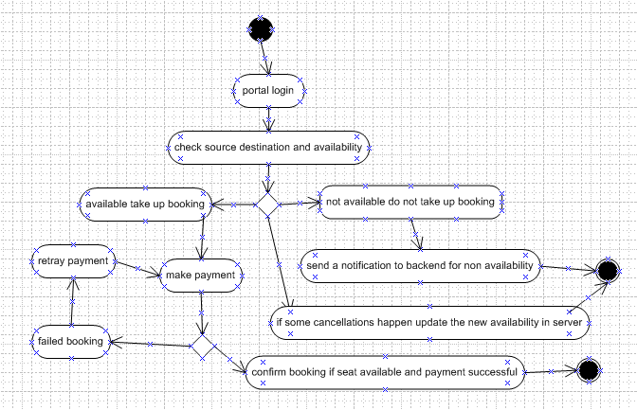
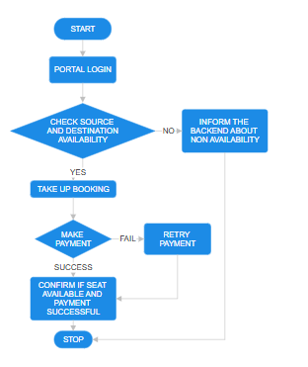
- We are taking up bookings based on seats availability
- Also we are having ticketing agents for ensuring greater footfalls
- We also are ensuring optimum fleet usability

Business Requirements
[The specific business requirements elicited from stakeholders should be listed, categorized by both priority and area of functionality to smooth the process of reading and tracking them. Include links to use case documentation, and other key reference material as needed to make the requirements as complete and understandable as possible. You may wish to incorporate the functional and non-functional requirements into a traceability matrix that can be followed throughout the project]
Sl No | Req ID | Req Category | Description | Priority
1 | BRQ01 | Portal login and account creation | Backend and front end user should be able to login to the portal by creating their account | 10
2 | BRQ02 | Backend users update data | In the portal login we should be able to add flights and seat availability | 10
3 | BRQ03 | Back end users need booking history | Booking history report need to be available for backend users | 10
4 | BRQ04 | Backend users have payment received and refunds data | Report for the payments credit and debit need to be available for audits | 10
5 | BRQ05 | Customer need to see availability | On successful login customer should be able to see date wise trips available and seats available | 10

Appendices

List of Acronyms
BRD- business requirement document; RTM Requirement traceability matrix
CR Change Request; RACI responsible accountable consulted informed

Glossary of Terms Related Documents
BRD, RTM, CR, RACI
SOFTWARE REQUIREMENT SPECIFICATION

Project objective:- The purpose of this document is to build an online ticketing system to manage flights and passengers to ease the flight management.

Project scope:- The purpose of the online flight management system is to ease flight management and to create a convenient and easy-to-use application for passengers, trying to buy airline tickets. The system handles flight management and reservations. Aggregating multiple airlines

Details that is to be collected

Flight details:
It includes the originating flight terminal and destination terminal, along with the stops in between, the number of seats booked/available seats between two destinations etc.

Customer description:
It includes customer code, name, address, and phone number. This information may be used for keeping the records of the customer for any emergency or for any other kind of information.

Reservation description:
It includes customer details, code number, flight number, date of booking, date of travel.

A customer should be able to do below activities

Make a new reservation
One-way
Round-Trip
Multi-city
Flexible Date/time
Confirmation
Cancel an existing reservation

A backend executive must be able to

CUSTOMER related
Get all customers who have seats reserved on a given flight.
Get all flights for a given airport.
View flight schedule.
Get all flights whose arrival and departure times are on time/delayed.
Calculate total sales for a given flight.

ADMINISTRATIVE related
Add/Delete a flight
Add a new airport
Update fare for flights.
• Add a new flight leg instance.
• Update departure/arrival times for flight leg instances.

Operations technical specs
Hosted on cloud resource provided by client
Operating system: Windows.
database: sql+ database
platform: vb.net/Java/PHP

Landscape overview
The server gone live globally through vpn and database stores the data accordingly.
The database becomes a centralized database management

Assumptions
A request for booking/cancellation of a flight from any source to any destination, giving connected flights in case no direct flight between the specified Source-Destination pair exist.
Calculation of high fliers (most frequent fliers) and calculating appropriate reward points for these fliers.

Functional requirements
A global server accessable to all end users
A GUI for all the end users to login and access the data
INTERFACE REQUIREMENTS
USER INTERFACES
Front-end software: Vb.net version
Back-end software: SQL+

Hardware interfaces
Windows.
A browser that supports CGI, HTML & Javascript.

Software interfaces
Software used | Description
Operating system | Windows
Database | we have chosen SQL+ database.

Communication interfaces
This project supports all types of web browsers. We are using simple electronic forms for reservation forms, ticket booking etc.

Req ID | Req Name | Req Description | Priority
FR0001 | customer registration | customer should be able to register in application himself | 9
FR0002 | Flight avaibility search | customer should be able to browse through available trips and connectivity | 8
FR0003 | select desired journey | customer should be able to select the desired Trip | 8
FR0004 | save for later | customer should be able to save the trip for deciding and paying later | 7
FR0005 | buy ticket | customer should be able to buy the ticket and reserve the journey | 8
FR0006 | payment options | credit, debit, netbanking, upi, should be available | 9
FR0007 | cancellation and reschedule option | options for cancellation and reschedule in case of changes in plan for customer | 8
FR0008 | Flight details and updates | Departure date status check and updates in case of change in departure time | 8
FR0009 | invoice download and order history | invoice download and order history for purchases made | 7
FR0010 | payment history | payment history for purchases made | 7
FR0011 | Global server with portal connectivity via URL and mobile application | This helps accessibility for customer due to ease of booking | 8
NFR0101 | customer care numbers | support numbers for clarifications if any | 6
NFR0102 | user manual of portal | portal features and run through | 5
NFR0103 | Safety requirements | Disaster recovery must be implemented in case of a unexpected incident | 7
NFR0104 | offers available during purchase of ticket | offers running at any given point of time | 5
NFR0105 | feedback of the ticket purchased | Over all purchase feedback | 6
NFR0106 | advertisement slider | ads for promotion | 6
NFR0107 | Security requirements | Right cloud partner to be chosen for hosting with policies implemented | 6

AVAILABILITY: The flight should be available on the specified date and specified time as many customers are doing advance reservations.
CORRECTNESS: The flight should reach start from the correct start terminal and should reach the correct destination.
MAINTAINABILITY: The web application must support regular updates to ensure compatibility with the latest web technologies, Bug fixes, and security patches.
USABILITY: The flight schedules should satisfy a maximum number of customers’ needs. The application should be accessible on multiple devices, including desktop and mobile
- Make an ERD of creating a support ticket/Ticketing life cycle.
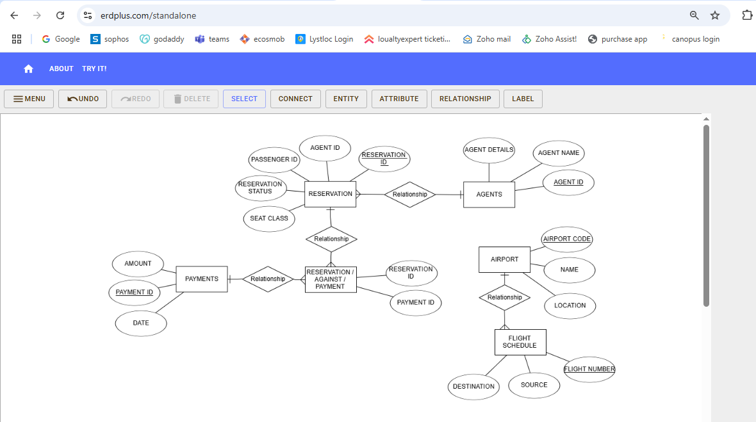

- User story of shopping from ecommerce
User story No: 1 | Tasks: 2 |  | Priority: high
Value statement: As a customer, I want to login to the portal so that I can view the products listed for sale
BV: 100 |  | CP: 2
Acceptance criteria: a text field to be provided for entering user name and password for logging in
User story No: 2 | Tasks: 2 |  | Priority: high
Value statement: As a customer I want to see all the products and filter category so that I can decide on the product
BV: 100 |  | CP: 2
Acceptance criteria: A tab to list all products and a filter to filter products according to category
User story No: 3 | Tasks: 2 |  | Priority: high
Value statement: As a customer I want to add products to cart so that I can review later
BV: 100 |  | CP: 2
Acceptance criteria: Add to cart option and view cart option to see all the products added
User story No: 4 | Tasks: 2 |  | Priority: high
Value statement: As a customer I want to track consignment so that I can have a idea on the delivery date
BV: 100 |  | CP: 2
Acceptance criteria: tab for viewing tracking status of already ordered products with latest update
User story No: 5 | Tasks: 3 |  | Priority: high
Value statement: As a Customer I want to apply for return, refund, or replacement
BV: 100 |  | CP: 2
Acceptance criteria: A tab for Return replacement or refund
User story No: 6 | Tasks: 2 |  | Priority: high
Value statement: As a reseller I want to add products and price to the portal so that customers can see
BV: 100 |  | CP: 2
Acceptance criteria: Tab for uploading products and updating of price
User story No: 7 | Tasks: 2 |  | Priority: high
Value statement: As a reseller I want to update the stocks and availability status for customers to see
BV: 100 |  | CP: 2
Acceptance criteria: a table required for updation of stock quantity and availability
User story No: 8 | Tasks: 2 |  | Priority: high
Value statement: As a customer I want to give ratings and reviews so that it will help other customers
BV: 100 |  | CP: 2
Acceptance criteria: A tab for writing a review and star selection option for giving ratings
User story No: 9 | Tasks: 2 |  | Priority: high
Value statement: As a Aggregator I want to see sales after return window system wide to know commission earned
BV: 100 |  | CP: 2
Acceptance criteria: Tab for report showing sales gone past return window for seeing commission earned
User story No: 10 | Tasks: 2 |  | Priority: high
Value statement: As a aggregator I want to see products arrived for delivery and prioritize earliest orders first
BV: 100 |  | CP: 2
Acceptance criteria: A tab to see all the orders up for delivery and arranged as first ordered out for delivery first
User story No: 11 | Tasks: 2 |  | Priority: high
Value statement: As a reseller I want to add product photos so that customer can decide better
BV: 100 |  | CP: 2
Acceptance criteria: Tab for uploading product photos
User story No: 12 | Tasks: 2 |  | Priority: high
Value statement: As a reseller I want to add variants available like colours and size so that customer can see
BV: 100 |  | CP: 2
Acceptance criteria: a table required for updation of colours and size
User story No: 13 | Tasks: 2 |  | Priority: high
Value statement: As a customer I want create my account for login so that I can login
BV: 100 |  | CP: 2
Acceptance criteria: A tab for creating login
User story No: 14 | Tasks: 2 |  | Priority: high
Value statement: As a Aggregator I want to see return trend of a single customer so that I can analyze
BV: 100 |  | CP: 2
Acceptance criteria: Tab for report showing return trend of a single customer
User story No: 15 | Tasks: 2 |  | Priority: high
Value statement: As a Aggregator I want to see return trend of whole organization so that I can analyze
BV: 100 |  | CP: 2
Acceptance criteria: Tab for report showing return trend of a whole organization

User story No: 16 | Tasks: 2 |  | Priority: high
Value statement: As a Aggregator I want to see purchase trend of whole Market along with competitors so that I can analyze
BV: 100 |  | CP: 2
Acceptance criteria: Tab for report showing market share of the specific industry
User story No: 17 | Tasks: 2 |  | Priority: high
Value statement: As a reseller I want to see feedback on returned and replaced products so that I can analyze
BV: 100 |  | CP: 2
Acceptance criteria: a feedback report of all products sold will help in analysis
User story No: 18 | Tasks: 2 |  | Priority: high
Value statement: As a reseller I want to do SEO and digital marketing so that my products comes first
BV: 100 |  | CP: 2
Acceptance criteria: A tab for running a cron job to ensure product listing is high above the rest
User story No: 19 | Tasks: 2 |  | Priority: high
Value statement: As a Aggregator I want to see other resellers in the marketplace so that I can look for a differentiator for better positioning
BV: 100 |  | CP: 2
Acceptance criteria: Tab for filtering segment and look for other reseller profile
User story No: 20 | Tasks: 2 |  | Priority: high
Value statement: As a reseller I want to know my hero product and products which is not getting sold much
BV: 100 |  | CP: 2
Acceptance criteria: A tab to see product wise sales
User story No: 21 | Tasks: 2 |  | Priority: high
Value statement: As a Aggregator I want to set tier for resellers so that I can fix commission accordingly
BV: 100 |  | CP: 2
Acceptance criteria: Automatic program to push resellers into tier they belong to so that we can fix comission
User story No: 22 | Tasks: 2 |  | Priority: high
Value statement: As a customer I want to see applicable card offers and portal offers
BV: 100 |  | CP: 2
Acceptance criteria: offers tab to list all offers and a filter option to filter out platform offers and card offers
User story No: 23 | Tasks: 2 |  | Priority: high
Value statement: As a aggregator I want to run offers for tier based resellers so that they can sell better
BV: 100 |  | CP: 2
Acceptance criteria: A tab hosting offers and assigning the offers to the respective tier
User story No: 24 | Tasks: 2 |  | Priority: high
Value statement: As a Customer I want to register myself for a wider category of business vertical so that I can increase my earnings
BV: 100 |  | CP: 2
Acceptance criteria: Tab for editing business verticals so that it is sent for acceptance for aggregator
User story No: 25 | Tasks: 2 |  | Priority: high
Value statement: As a reseller I want to add pincodes which I can consider serviceable so that I don’t end up paying more money for freight
BV: 100 |  | CP: 2
Acceptance criteria: A table to set all the pincodes deemed serviceable

