**Question 1-**

**Functional requirements** define the **specific behavior, functions or operation of a system**. They describe **what the system should do**, outlining the necessary task, **actions or activities** it must perform to achieve its objectives.

|  |  |  |
| --- | --- | --- |
| Regd id | Reqd name | Reqd descriptions |
| FR001 | User registration/login | Farmers and manufacturers should be able to register and login using user id and password |
| FR002 | Upload product details catalog | Manufacturer should be able to upload products in product catalog |
| FR003 | Edit/update product details | Manufacturer should be able to edit/update product details in the product catalog |
| FR004 | Browse the product list | Farmers should be able to browse through the product catalog |
| FR005 | Search for products | User should be able to search for products |
| FR006 | Filter products | The systems should allow users to filter product through various criteria |
| FR007 | Add/remove to cart | Farmers should be able to add/remove products to cart to buy later |
| FR008 | Add/ remove to wish list | Farmers should be able to add/remove products to whishlist |
| FR009 | Place order | Farmers should be able to place order for the products |
| FR010 | Cancel order | System should allow option for user to cancel order |
| FR011 | Password recovery | System should allow user to recover password who forgot their user login |
| FR012 | Update profile | System should allow user to update and view their profile details |
| FR013 | Payments | System should allow user payment with different mode ( COD, Cards, UPI) |
| FR014 | Tracking Products | User should be able to track real time delivery |
| FR015 | After cancellation refund | System should be able process cancellation refund |
| FR016 | Mail confirmation | System should send an email confirmation to user after a successful order |
| FR017 | Order history |  |
| FR018 | Update address |  |
| FR019 | Review |  |
| FR020 |  |  |

**Nonfunctional requirement** will describe the **qualities constraint and attributes** of a system focusing on **how the** **system performs** rather than specific behaviors or functions.

|  |  |  |
| --- | --- | --- |
| **Reqd id** | **Reqd name** | **Reqd description** |
| NFR001 | Usability | The application should have an intuitive and use-friendly |
| NFR002 | Performance | The application must load pages within 3 seconds |
| NFR003 | Security | The application must ensure secure user authentication |
| NFR004 | Compatibility | The application should be compatible with major web browsers |
| NFR005 | Response time | The application should respond to user inputs within 2 seconds |
| NF5006 | Availability | The application should maintain an uptime of 99.9% during operational hours to ensure continuous access to farmers and manufacturers. |
|  |  |  |

**Question -2**

Below are the **mockups** and it is as **a visual representation of the application layout**, **structure** and **functionality** to communicate it to the stakeholders, developers or designers. Here, I have used the tool balsamiq to create the mockups

**Home page of Agro application**

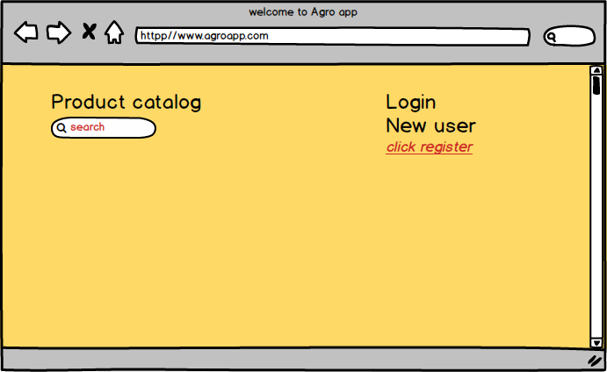

**Sign UP screen**

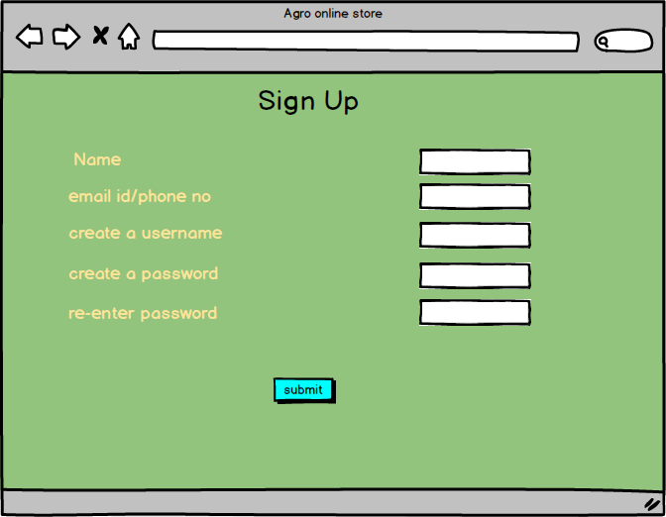

**Log in screen**

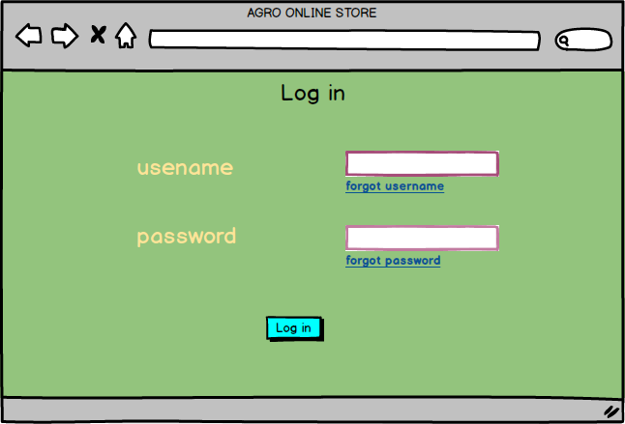

**Product Search page**

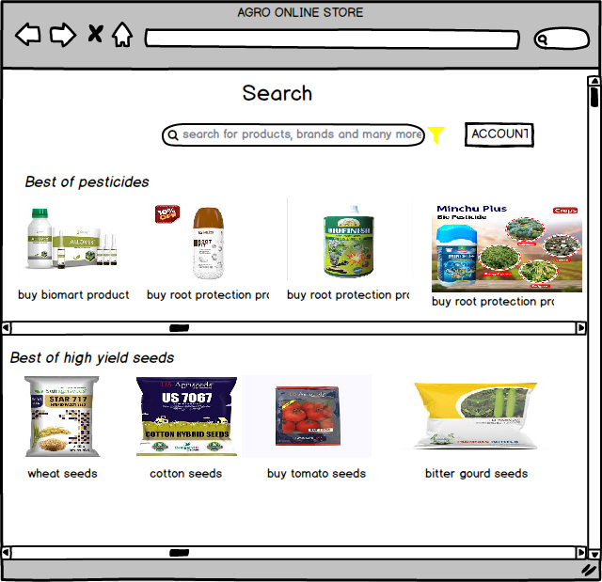

**Payment Page**

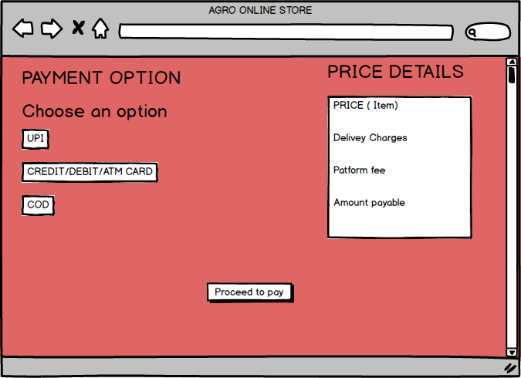

**Question-3**

**Microsoft** Visio- Is a diagramming and vector graphics application used to create **diagrams, flowcharts, and other visual representation of complex information**

**Balsamiq** is a rapid wireframe tool used to **create mockups and prototype of user interfaces**

**Axure** is a more advanced prototyping tool used to create **high-fidelity, interactive wireframes** and **prototypes** for web and mobile application

**Question-4**

**RTM-** Requirement Traceability Matrix is a document or way to **track the requirements throughout** **project life cycle** so that they are met and no requirements are overlooked.

|  |  |  |  |  |  |  |  |  |
| --- | --- | --- | --- | --- | --- | --- | --- | --- |
| Regd id | Reqd name | Reqd descriptions | Design | code | Unit testing | Component testing | System testing | UAT |
| FR001 | User registration/login | Farmers and manufacturers should be able to register and login using user id and password | Completed | completed | completed | completed | in completed | incomplete |
| FR002 | Upload product details catalog | Manufacturer should be able to upload products in product catalog | Completed | Completed | completed | completed | in completed | incomplete |
| FR003 | Edit/update product details | Manufacturer should be able to edit/update product details in the product catalog | Completed | Completed | in completed | incomplete | in completed | incomplete |
| FR004 | Browse the product list | Farmers should be able to browse through the product catalog | Completed | Completed | Completed |  |  |  |
| FR005 | Search for products | User should be able to search for products | Completed | Completed | Completed | Completed | Completed | incomplete |
| FR006 | Filter products | The systems should allow users to filter product through various criteria | Completed | Completed | Completed | incomplete | incomplete | incomplete |
| FR007 | Add/remove to cart | Farmers should be able to add/remove products to cart to buy later | Completed | Completed | Completed | incomplete | incomplete | incomplete |
| FR008 | Add/ remove to wish list | Farmers should be able to add/remove products to whishlist | Completed | Completed | Completed | incomplete | incomplete | incomplete |
| FR009 | Place order | Farmers should be able to place order for the products | Completed | Completed | Completed | incomplete | incomplete | incomplete |
| FR010 | Cancel order | System should allow option for user to cancel order | Completed | Completed | Completed | incomplete | incomplete | incomplete |

**Question-5**

**Test case document**- It is a **detailed outline used by testers** to ensure that a **software application is** **working as expected**.

|  |  |  |  |
| --- | --- | --- | --- |
| Test case id |  | Test Case Name |  |
| Project ID |  | Project Name | Online Agricultural product store |
| PM ID |  | PM Name | Mr Vandanam |
| Test strategy ID |  | Tester ID |  |
| Test Plan ID |  | Tester Name |  |
| Test Schedule ID |  | Date of Test |  |

|  |
| --- |
| Scenario: website/application for online purchase of farming product… In that New User sign up... we have to 5 inputs… 5 compulsory... and after that results are displayed in a tabular way |
| Link to that page |

|  |  |  |  |  |
| --- | --- | --- | --- | --- |
|  | Set 1 |  |  |  |
| Input Data | Create user id  Create password  Re-enter password  Email verification  Mobile no. verification |  |  |  |
| Expected behavior | Sign up done and login page should come |  |  |  |
| Actual behavior | Login page displayed |  |  |  |
| Comments |  |  |  |  |
| Result  Pass/fail | Pass |  |  |  |

|  |  |  |  |
| --- | --- | --- | --- |
| Test case id |  | Test Case Name |  |
| Project ID |  | Project Name | Online Agricultural product store |
| PM ID |  | PM Name | Mr Vandanam |
| Test strategy ID |  | Tester ID |  |
| Test Plan ID |  | Tester Name |  |
| Test Schedule ID |  | Date of Test |  |

|  |
| --- |
| Scenario: website/application for online purchase of farming product… In that existing user log in... we have to 4 inputs… 4 compulsory... and after that results are displayed in a tabular way |
| Link to that page |

|  |  |  |  |  |
| --- | --- | --- | --- | --- |
|  | Set 1 |  |  |  |
| Input Data | Username  Password  Forgot password  Forgot user name |  |  |  |
| Expected behavior | Login done. Home page displayed |  |  |  |
| Actual behavior | Home page displayed |  |  |  |
| Comments |  |  |  |  |
| Result  Pass/fail | pass |  |  |  |

|  |  |  |  |
| --- | --- | --- | --- |
| Test case id |  | Test Case Name |  |
| Project ID |  | Project Name | Online Agricultural product store |
| PM ID |  | PM Name | Mr Vandanam |
| Test strategy ID |  | Tester ID |  |
| Test Plan ID |  | Tester Name |  |
| Test Schedule ID |  | Date of Test |  |

|  |
| --- |
| Scenario: website/application for online purchase of farming product… In that user search for products... we have to 2 inputs… 2 compulsory... and after that results are displayed in a tabular way |
| Link to that page |

|  |  |  |  |  |
| --- | --- | --- | --- | --- |
|  | Set 1 |  |  |  |
| Input Data | Product name  filters |  |  |  |
| Expected behavior | Product option |  |  |  |
| Actual behavior | Different product displayed |  |  |  |
| Comments |  |  |  |  |
| Result  Pass/fail | Pass |  |  |  |

|  |  |  |  |
| --- | --- | --- | --- |
| Test case id |  | Test Case Name |  |
| Project ID |  | Project Name | Online Agricultural product store |
| PM ID |  | PM Name | Mr Vandanam |
| Test strategy ID |  | Tester ID |  |
| Test Plan ID |  | Tester Name |  |
| Test Schedule ID |  | Date of Test |  |

|  |
| --- |
| Scenario: website/application for online purchase of farming product… In that user place order for products... we have to 2 inputs… 2 compulsory... and after that results are displayed in a tabular way |
| Link to that page |

|  |  |  |  |  |
| --- | --- | --- | --- | --- |
|  | Set 1 |  |  |  |
| Input Data | Select product  Place order |  |  |  |
| Expected behavior | Order placed page displayed |  |  |  |
| Actual behavior | As same as expected |  |  |  |
| Comments |  |  |  |  |
| Result  Pass/fail | pass |  |  |  |

|  |  |  |  |
| --- | --- | --- | --- |
| Test case id |  | Test Case Name |  |
| Project ID |  | Project Name | Online Agricultural product store |
| PM ID |  | PM Name | Mr Vandanam |
| Test strategy ID |  | Tester ID |  |
| Test Plan ID |  | Tester Name |  |
| Test Schedule ID |  | Date of Test |  |

|  |
| --- |
| Scenario: website/application for online purchase of farming product… In that use of payment gateway ... we have to 5 inputs… 5 compulsory... and after that results are displayed in a tabular way |
| Link to that page |

|  |  |  |  |  |
| --- | --- | --- | --- | --- |
|  | Set 1 |  |  |  |
| Input Data | Card no  CVV  Name  Expiry  OTP |  |  |  |
| Expected behavior | Transaction page |  |  |  |
| Actual behavior | As expected |  |  |  |
| Comments |  |  |  |  |
| Result  Pass/fail | Pass |  |  |  |

|  |  |  |  |
| --- | --- | --- | --- |
| Test case id |  | Test Case Name |  |
| Project ID |  | Project Name | Online Agricultural product store |
| PM ID |  | PM Name | Mr Vandanam |
| Test strategy ID |  | Tester ID |  |
| Test Plan ID |  | Tester Name |  |
| Test Schedule ID |  | Date of Test |  |

|  |
| --- |
| Scenario: website/application for online purchase of farming product… In that use of add and remove to cart ... we have to 3 inputs… 3 compulsory... and after that results are displayed in a tabular way |
| Link to that page |

|  |  |  |  |  |
| --- | --- | --- | --- | --- |
|  |  |  |  |  |
| Input Data | Select product  Add to cart  Remove from cart |  |  |  |
| Expected behavior | Product displayed on cart icon |  |  |  |
| Actual behavior | As expected |  |  |  |
| Comments |  |  |  |  |
| Result  Pass/fail | Pass |  |  |  |

**Question 6 – DB Design**

**Below is an example of a database schema and an ER diagram. This design captures the core entities and relationships when a Farmer places an order for products provided by Manufacturers.**

|  |  |  |  |  |  |
| --- | --- | --- | --- | --- | --- |
| Farmer table | | | | | |
| Farmer id | name | Email id | password | Contact no | address |

|  |  |  |  |  |  |
| --- | --- | --- | --- | --- | --- |
| Manufacturer table | | | | | |
| Manufacturer id | Manufacturer name | Email id | password | Contact no | address |

|  |  |  |  |  |  |  |
| --- | --- | --- | --- | --- | --- | --- |
| Product table | | | | | | |
| Product id | Manufacturer id | Product name | Product details | Category | Price | Stock |

|  |  |  |  |  |
| --- | --- | --- | --- | --- |
| Order Table | | | | |
| Order id | Farmer id | Order date | Total amount | Payment status |

|  |  |  |  |  |
| --- | --- | --- | --- | --- |
| Order item table | | | | |
| Order item id | Order id | Product id | quantity | price |

|  |  |  |  |  |  |
| --- | --- | --- | --- | --- | --- |
| Payment table | | | | | |
| Payment id | Order id | Payment method | Payment date | amount | Payment status |

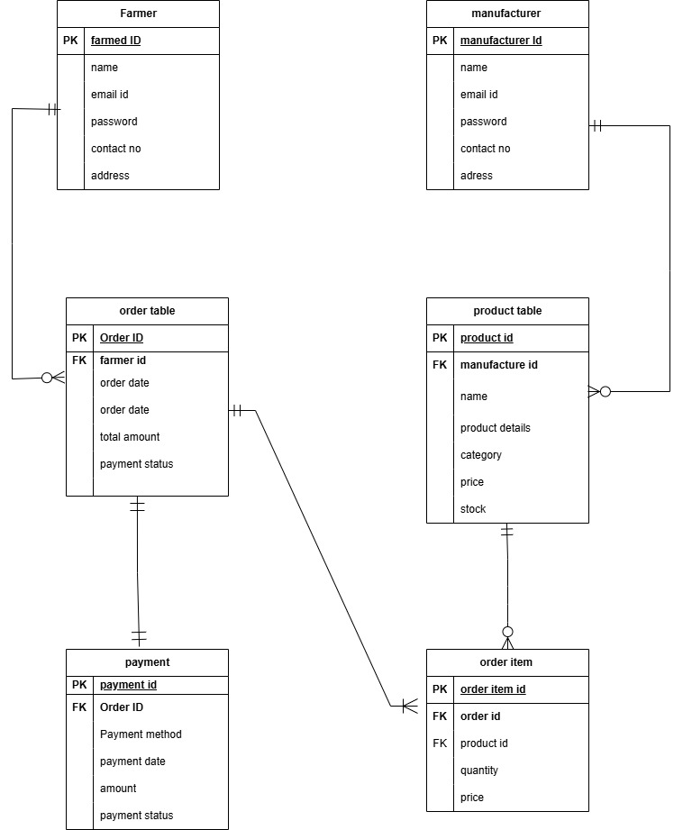

**Question-7**

A data flow diagram is a **graphical representation of the flow of data within a system**. It **visually shows how data moves from one process to another, how it’s stored and where it ends up.**

It helps analysts and designer to understand the flow of data within a system, **identify potential bottlenecks or inefficiencies, and communicate system requirements to stakeholder.**

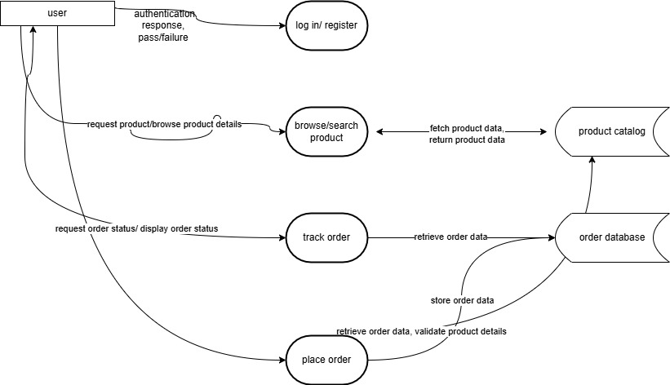

**Question-8**

**Change Request**

Handling change requests effectively is crucial for maintaining project stability while accommodating new requirements. In the case of changing the tax structure due to a government taxation update, here's how I would manage the process:

First, I **need to initiate the change request**, capture the change request details including the reason and **documenting the affected area of the project** and the modification required. Then, scheduling a meeting with the stakeholder, explaining them the changes needs to be done and take their feedbacks and document their expectation.

Secondly, I **need to do an impact analysis** to identify which parts of the system affected eg**-tax calculation, modules, and invoice generation**. Asses how the change **will impact the project schedule and budget, consider any necessary adjustments or additional resources**. Evaluate **risk associated** with **implementing the new tax** structure including potential disruption to current functionalities and compliance.

With all the necessary steps done, **we need to take an approval from the PM and present the change request to Change control board for review.**

Secure formal **sign-off ensuring all stakeholders understand and agree** with the implementation on project scope.

Then we need to implement the changes and communicate the same to all the stakeholders timely to keep them informed

**Question-9**

**Change request vs. Enhancement**

**Change request**- **Introduces entirely new process or features that were not included in the original scope**. It affects system architecture, design, budget, and timelines, requiring re-estimation and potential reprioritization of project deliverables.

Must go through a formal change request management

**Enhancement –** it is an **incremental improvement, enhance existing functionality without fundamentally altering the system’s core design**. Overall there is no significant effect on project scope, budget and timeline.

Presently, the system was **designed for manufacturers to list and sell products**, while farmers primarily purchase them. The request to **allow farmers to list and sell their crop yields, along with an auction system for those yields**, introduces entirely new functionality that wasn't part of our original scope. So, this **could be considered as change request rather than enhancement**

**Questio-10- Estimation of man-hour**

Man hour are the required effort of the resources to complete a project. There are 3 types of projects:

**Smal**l: Up to 500 hours

**Medium**: up to 1000 hours

**Large**: up to 1500 hours

As per the case study, **the duration of the project is 18 months and current size is around 12**. This is will come under **Medium project.**

Total man hours as a whole we required is 700 man hours

Project Manager - Mr Vandanam-100 men hours.

Senior Java Developer - Ms. Juhi-100 men hours.

Java Developers - Mr Teyson, Ms Lucie, Mr Tucker, Mr Bravo-100 men hours.

Network admin - Mr Mike- 50 men hours.

DB Admin - Mr John -50 men hours.

Testers - Mr Jason and Ms Alekya-200 men hours

BA – me-100 men hours

**Question 11 – UAT – 6 Mark**

**UAT-** The main purpose of UAT is to identify end to end business flow. UAT is a critical phase of the software development lifecycle that **validates whether the developed software meets the business requirement and user expectation**

The phases involved in UAT acceptance process

1. **Create a UAT test plan**- The purpose of this is to **establish the overall approach, scope and object**
2. **Identify test scenarios**- **Determine the high-level situations or workflows** that represent real-world business processes to be tested. **Need to review the business requirements, user stories, and use case documents and identify the test scenarios.**

For critical scenarios engage with business users to understand.

Ensure that all key functionalities and user interactions are covered.

1. **Create test case-** Develop detailed, **step-by-step test cases derived from the identified scenarios** that clearly define how the system should behave.
2. **Prepare Test Data- Generate or identify appropriate data that will be used to execute the test cases, ensuring real life stimulation, transaction and process**.

Determine the **type of test data needed** (e.g., user accounts, product details, transaction records).

**Create data that accurately reflects production scenarios.**

Verify that test data covers all edge cases and necessary conditions (e.g., valid and invalid inputs).

Load the test data into the UAT environment, ensuring it mirrors the production environment.

1. **Run the test case- The purpose is to execute the test cases with the intended users to validate that the system meets the defined business requirements.**

**Here,** we need to instruct UAT participants on how to execute the test cases and document outcomes. Monitor the execution process and provide support for any issues encountered. Record test results, logging any defects or deviations from expected outcomes. Organize regular review sessions with stakeholders to discuss progress and prioritize fixes.

1. **Confirm and compliance-** Verify that the system complies with the documented requirements and business rules, and that all critical issues have been resolved.

* Review test results and confirm that all acceptance criteria have been met.
* Validate that all defects identified during testing are addressed and retested.
* Obtain formal sign-off from the business stakeholders on the UAT completion.
* Document the final compliance report, which details the successful testing and approvals.
* Ensure the system is ready for production deployment based on the UAT feedback.

**Question 12- Product closure document**

A Project Closure Document is a formal record created at the end of a **project that summarizes all** **project activities, deliverables, performance metrics, and lessons learned**. It confirms that the project **objectives have been met and serves as an official sign-off for stakeholders**. This document is important because it ensures accountability, provides a clear reference for future projects, and helps in evaluating project success and areas for improvement.

The key components typically include:

* **Executive Summary:** Overview of the project, its objectives, and outcomes.
* **Project Objectives and Deliverables:** Confirmation that all agreed-upon objectives and deliverables have been met.
* **Performance Evaluation:** Analysis of project performance against scope, timeline, cost, and quality benchmarks.
* **Financial Summary:** Final budget, actual expenditures, and explanations for any variances.
* **Lessons Learned:** Insights, successes, challenges, and recommendations for future projects.
* **Stakeholder Sign-Off:** Formal acceptance from key stakeholders.
* **Post-Implementation Support and Handover:** Details regarding ongoing support, maintenance, and documentation archiving.