**Capstone Project1 – Part -2/3**

Question 1 – Audits - 5 Marks 4 Quarterly Audits are planned Q1 , Q2, Q3, Q4 for this Project What is your knowledge on how these Audits will happen for a BA ?

Answer:-

As a Business Analyst (BA), audits in a project like this typically focus on ensuring that the requirements, documentation, and processes align with the project goals and compliance standards. Here’s how the **4 Quarterly Audits (Q1, Q2, Q3, Q4)** will happen from a BA perspective:

**Q1 - Initial Planning & Requirement Validation Audit**

🔹 **Objective**: Ensure that all business requirements are properly documented and approved.  
🔹 **BA Role**:

* Validate the Business Requirements Document (BRD) with stakeholders.
* Ensure that functional and non-functional requirements are well-defined.
* Confirm if Use Cases, Process Flows, and Wireframes (if applicable) are completed.
* Ensure that traceability between business objectives and requirements is established.

**Q2 - Midway Progress & Design Review Audit**

🔹 **Objective**: Evaluate the design phase and check if the development aligns with business needs.  
🔹 **BA Role**:

* Verify if the development team is following the documented requirements.
* Conduct Gap Analysis to identify any missing or incorrect requirements.
* Ensure that requirements are updated as per Change Requests (CRs).
* Work with testers to review test cases against requirements.

**Q3 - UAT Readiness & Compliance Audit**

🔹 **Objective**: Ensure that the system is ready for **User Acceptance Testing (UAT)**.  
🔹 **BA Role**:

* Validate if the developed application meets business needs.
* Support UAT by assisting in test case reviews and user feedback collection.
* Ensure regulatory compliance (if any) for the online store.
* Work on resolving requirement-related defects found in testing.

**Q4 - Final Review & Post-Implementation Audit**

🔹 **Objective**: Ensure that the system is working as expected after deployment.  
🔹 **BA Role**:

* Confirm that all project requirements were met successfully.
* Ensure that all documentation (Requirement Traceability Matrix, Process Flows, etc.) is updated.
* Assist in post-launch feedback collection and issue resolution.
* Conduct lessons learned and retrospective analysis for future improvements.

**Conclusion:**

Each audit ensures that the project stays aligned with business goals. As a BA, your primary focus will be on requirements validation, documentation, gap analysis, and ensuring smooth communication between stakeholders and the development team.

Question 2 – BA Approach Strategy - 6 Marks Before the Project is going to Kick Start, The Committee asked Mr Karthik to submit BA Approach Strategy Write BA Approach strategy (As a business analyst, what are the steps that you would need to follow to complete a project – What Elicitation Techniques to apply, how to do Stakeholder Analysis RACI/ILS, What Documents to Write, What process to follow to Sign off on the Documents, How to take Approvals from the Client, What Communication Channels to establish n implement, How to Handle Change Requests, How to update the progress of the project to the Stakeholders, How to take signoff on the UAT- Client Project Acceptance Form

Answer:-

Here's a structured **BA Approach Strategy** for the Online Agriculture Products Store project:

## **Business Analyst Approach Strategy**

### ****1. Requirement Elicitation & Gathering****

To ensure a comprehensive understanding of the project needs, I will apply multiple elicitation techniques:  
✔ **Interviews** – Conduct structured discussions with stakeholders (Farmers, Manufacturers, Committee Members, and Development Team).  
✔ **Workshops** – Organize requirement workshops with Peter, Kevin, and Ben (Farmers) and the APT IT Solutions team.  
✔ **Surveys & Questionnaires** – Collect feedback from potential users in remote areas.  
✔ **Document Analysis** – Review similar existing platforms for insights.  
✔ **Brainstorming** – Discuss potential features with the development team.

### ****2. Stakeholder Analysis & RACI Matrix****

I will classify stakeholders based on their roles and responsibilities:

| **Stakeholder** | **Role** | **RACI (Responsible, Accountable, Consulted, Informed)** |
| --- | --- | --- |
| Mr. Henry | Sponsor | Accountable |
| Mr. Pandu | Financial Head | Consulted |
| Mr. Dooku | Project Coordinator | Informed |
| Peter, Kevin, Ben | Farmers (End Users) | Consulted |
| Mr. Karthik | Delivery Head | Accountable |
| Mr. Vandanam | Project Manager | Responsible |
| Developers | Tech Team | Responsible |
| Testers | QA Team | Responsible |
| Network Admin | Infrastructure | Responsible |
| DB Admin | Database | Responsible |
| BA (You) | Requirement Owner | Responsible |

### ****3. Documents to Prepare****

As a BA, I will be responsible for preparing the following documents:

✔ **Business Requirement Document (BRD)** – Captures high-level business needs.  
✔ **Functional Requirement Specification (FRS)** – Defines system functionalities.  
✔ **Non-Functional Requirement (NFR) Document** – Covers performance, security, and scalability aspects.  
✔ **Use Case Documents** – Describes user interactions.  
✔ **Process Flow Diagrams & Wireframes** – Visual representation of workflows.  
✔ **Requirement Traceability Matrix (RTM)** – Maps requirements to test cases.  
✔ **Change Request Document (CRD)** – Captures and manages change requests.

**4. Approval & Sign-Off Process**

To finalize and approve project documents, I will follow this process:

**BRD & FRS Approval**:

* Conduct review sessions with stakeholders.
* Revise documents based on feedback.
* Get official sign-off from Mr. Henry & Committee.

**Change Request Handling**:

* Document the change request.
* Analyze impact (Cost, Time, Scope).
* Get approval from Mr. Henry & Project Manager.

**UAT & Client Sign-Off**:

* Work with testers to define UAT scenarios.
* Conduct UAT with farmers & stakeholders.
* Collect feedback and fix issues.
* Obtain final **Client Project Acceptance Form** sign-off.

**5. Communication Plan**

To ensure smooth collaboration, I will establish the following communication channels:

✔ **Daily Stand-up Meetings** – Quick status updates with the project team.  
✔ **Weekly Progress Reports** – Share updates with stakeholders.  
✔ **Monthly Steering Committee Meetings** – Review project milestones.  
✔ **Collaboration Tools** – Use Slack, Microsoft Teams, or Jira for documentation & discussions.  
✔ **Email & Video Conferences** – Regular updates to Mr. Henry and Committee.

**6. Progress Reporting & Updates**

**Status Reports** – Weekly updates to Committee on project milestones.  
 **Risk Register** – Track project risks and mitigation plans.  
 **Sprint Demos** – Demonstrate application progress to stakeholders.

**7. Handling Change Requests**

**Step 1**: Capture Change Request (CR) from stakeholders.  
 **Step 2**: Analyze impact on scope, timeline, and cost.  
 **Step 3**: Get approval from Mr. Henry & Project Manager.  
 **Step 4**: Update RTM & Project Documentation.  
 **Step 5**: Implement & Test the Change.

**Conclusion**

This approach ensures **clear documentation, strong stakeholder collaboration, proper approvals, and effective project tracking.** By following this strategy, we will successfully deliver the Online Agriculture Products Store within the given budget and timeline.

Question 3 – 3-Tier Architecture - 5 Marks Explain and illustrate 3-tier architecture?

Answer:-

**3-Tier Architecture Explanation**

The **3-Tier Architecture** is a client-server software architecture that organizes applications into three logical layers:

1. **Presentation Layer (Client Tier)**
2. **Application Layer (Business Logic Tier)**
3. **Data Layer (Database Tier)**

Each layer is **independent**, making the system scalable, secure, and maintainable.

**Presentation Layer (Client Tier)**

* This is the **front-end** that users interact with (e.g., farmers and manufacturers).
* It includes **Web/Mobile Applications** where users browse products, place orders, and track deliveries.
* Technologies: **HTML, CSS, JavaScript, React, Angular, Mobile Apps (Android/iOS).**

**Example for our Online Agriculture Store:**  
✅ Farmers log in via a web/mobile app to browse products.  
✅ Manufacturers upload fertilizer, seed, and pesticide details.

**Application Layer (Business Logic Tier)**

* This is the **middle layer** that processes requests and executes business logic.
* It communicates between the **Presentation Layer** and the **Database Layer**.
* Technologies: **Java, Spring Boot, .NET, Node.js, APIs.**

**Example for our Online Agriculture Store:**  
✅ Validates user authentication.  
✅ Checks product availability and processes orders.  
✅ Handles payment transactions securely.

**Data Layer (Database Tier)**

* This is the **back-end** where all data is stored and managed.
* It ensures **data consistency, security, and backup**.
* Technologies: **MySQL, PostgreSQL, MongoDB, Oracle.**

**Example for our Online Agriculture Store:**  
✅ Stores product details, orders, and user data.  
✅ Saves payment and transaction records securely.

### ****Advantages of 3-Tier Architecture****

✅ **Scalability** – Each layer can be scaled independently.  
✅ **Security** – Sensitive data is protected in the database layer.  
✅ **Maintainability** – Changes in one layer don’t affect others.  
✅ **Performance** – Faster data retrieval and processing.

Presentation Layer (Web/Mobile App - UI)

Presentation layer

React and Angular

(React, Angular)

Application Layer

Java and Spring

Application Layer (Business Logic - API)

(Java, Spring)

Data Layer

Stores Data

Data Layer (Database - MySQL, MongoDB)

(Stores Data)

Question 4 – BA Approach Strategy for Framing Questions – 10 Marks Business Analyst should keep What points in his/her mind before he frames a Question to ask to the Stakeholder ( 5W 1H – SMART – RACI – 3 Tier Architecture – Use Cases, Use case Specs, Activity Diagrams,Models, Page designs)

Answer:-

As a Business Analyst, asking the **right questions** is **crucial** to gather clear, precise, and actionable requirements from stakeholders. Before framing a question, I will consider the following approaches:

## **The 5W 1H Framework**

Before framing a question, I will ensure it aligns with **5W 1H** (Who, What, When, Where, Why, How):

✔ **Who** – Who are the users (farmers, manufacturers, admin)?  
✔ **What** – What features do they need (ordering, tracking, payment)?  
✔ **When** – When do they expect delivery timelines and updates?  
✔ **Where** – Where will they use the system (web/mobile app)?  
✔ **Why** – Why is this feature needed (business justification)?  
✔ **How** – How will they use it (UI flow, integration with payment)?

**Example Question:**  
"What difficulties do farmers face in ordering fertilizers online?"

## **SMART Framework for Questioning**

Each question should be framed using the **SMART** principle:

✔ **S**pecific – The question should be **clear and detailed**.  
✔ **M**easurable – The answer should provide **quantifiable insights**.  
✔ **A**chievable – The question should be **realistic and relevant** to the project scope.  
✔ **R**elevant – Ensure the question focuses on **business goals**.  
✔ **T**ime-bound – The answer should have a **timeline or deadline** attached.

**Example Question:**  
"By when do you expect the delivery tracking feature to be implemented?"

## **RACI Matrix Consideration**

I will ensure that questions are directed at the **right stakeholders** based on their **RACI** (Responsible, Accountable, Consulted, Informed) roles.

| **Stakeholder** | **Type of Questions to Ask** |
| --- | --- |
| Farmers (End Users) | What challenges do you face in buying seeds/pesticides? |
| Manufacturers | How do you currently distribute your products? |
| Project Manager | What is the expected timeline for development? |
| Developers | What technical limitations should we consider? |
| Testers | What are the key test scenarios for UAT? |

## **3-Tier Architecture-Based Questions**

To ensure technical feasibility, I will frame questions based on the **3-tier architecture**:

✔ **Presentation Layer (UI)** – What fields should be present in the product listing page?  
✔ **Application Layer (Business Logic)** – How should order processing work?  
✔ **Data Layer (Database)** – What kind of reports should be generated for farmers?

## **Use Cases, Use Case Specs, and Activity Diagrams**

Before framing a question, I will ensure I understand:

✔ **Use Cases** – Identify system interactions.  
✔ **Use Case Specifications** – Define preconditions, postconditions, and flows.  
✔ **Activity Diagrams** – Visualize how users will navigate the system.

**Example Question:**  
"Can you walk me through how a farmer will search and place an order for seeds?"

## **Models, Page Designs, and Wireframes**

To avoid miscommunication, I will use:

✔ **Wireframes** – To validate UI designs.  
✔ **Process Models** – To understand workflows.  
✔ **Entity-Relationship Diagrams (ERD)** – To define data relationships.

**Example Question:**  
"Does this wireframe correctly represent how farmers will browse products?"

Before framing a question, a BA should consider **5W 1H, SMART goals, RACI matrix, 3-tier architecture, Use Cases, and Wireframes** to ensure effective communication and accurate requirement gathering.

Question 5 – Elicitation Techniques - 6 Marks As a Business Analyst, What Elicitation Techniques you are aware of? ( BDRFOWJIPQU)

Answer:-

### ****Elicitation Techniques for Business Analysts (BDRFOWJIPQU)****

As a Business Analyst, I use various **elicitation techniques** to gather requirements effectively. Based on the acronym **BDRFOWJIPQU**, here are the techniques:

### ****B – Brainstorming****

✔ Used to generate **new ideas** and **solutions** collaboratively.  
✔ Helps in **identifying innovative features** for the online agriculture store.  
✔ **Example:** Conduct a brainstorming session with farmers & manufacturers to list challenges in the current system.

### ****D – Document Analysis****

✔ Reviewing **existing documents, reports, and policies** to extract relevant information.  
✔ Helps understand **regulatory requirements** and past projects.  
✔ **Example:** Analyzing competitor platforms to gather best practices for the agriculture store.

### ****R – Reverse Engineering****

✔ Used when there is an **existing system**, but documentation is missing.  
✔ Helps **understand system behavior** by analyzing how it works.  
✔ **Example:** If farmers currently use an offline process, reverse engineer it into a digital workflow.

### ****F – Focus Groups****

✔ A **small group of end users (Farmers, Manufacturers)** discuss their expectations.  
✔ Useful for gathering **qualitative feedback** on UI/UX and workflows.  
✔ **Example:** Conduct a focus group to validate the online store's **ordering process** before development.

### ****O – Observation (Job Shadowing)****

✔ Watching users perform tasks in **their real environment**.  
✔ Helps understand **actual pain points** that users might not express.  
✔ **Example:** Observing how farmers currently buy fertilizers to design a user-friendly **order flow**.

### ****W – Workshops****

✔ **Interactive sessions** with stakeholders to define **requirements collaboratively**.  
✔ Helps **clarify conflicts** and **align expectations** early.  
✔ **Example:** Organizing a workshop with **farmers, manufacturers, and developers** to finalize product categories.

### ****J – JAD (Joint Application Development)****

✔ A structured workshop involving **BAs, developers, testers, and stakeholders**.  
✔ Faster decision-making with **real-time collaboration**.  
✔ **Example:** A JAD session to finalize **payment and delivery workflows** in the online store.

### ****I – Interviews****

✔ One-on-one or group discussions with **stakeholders** to gather detailed requirements.  
✔ Helps uncover **hidden expectations and constraints**.  
✔ **Example:** Interviewing **farmers, project managers, and developers** to understand product listing requirements.

### ****P – Prototyping****

✔ Developing **mock-ups or wireframes** to visualize the system before full development.  
✔ Helps stakeholders **validate UI/UX** early.  
✔ **Example:** Creating a prototype for the **checkout process** before finalizing the design.

### ****Q – Questionnaires & Surveys****

✔ **Structured set of questions** to collect feedback from a **large audience**.  
✔ Helps when stakeholders are **geographically distributed**.  
✔ **Example:** Sending a survey to **100+ farmers** to understand their biggest challenges in purchasing agriculture products.

### ****U – Use Cases & Scenarios****

✔ **Use cases define how users will interact** with the system.  
✔ Helps in understanding the **step-by-step process of tasks**.  
✔ **Example:** Creating a **use case diagram** for **placing an order** in the agriculture store.

Using a combination of these elicitation techniques ensures **comprehensive and accurate requirement gathering**

Question 6 – This project Elicitation Techniques - 5 Marks Which Elicitation Techniques can be used in this Project and Justify your selection of Elicitation Techniques? Prototyping Use case Specs Document Analysis Brainstorming

Answer:-

### ****Elicitation Techniques for This Project & Justification****

For this **Online Agriculture Products Store**, I will use the following **elicitation techniques** to gather business and stakeholder requirements effectively:

**Prototyping**

✔ **Why?**

* Mr. Henry and the farmers (stakeholders) may not fully visualize the system just through discussions.
* A **prototype (wireframe or mockup)** helps stakeholders provide **early feedback** before development starts.

✔ **How?**

* Create a **UI prototype** showcasing login screens, product catalogs, search options, payment processes, and order tracking.
* Get approvals from **farmers, manufacturers, and Mr. Henry** before finalizing.

✔ **Example:**

* A wireframe of how farmers will search for products and complete payments.

**Use Case Specifications**

✔ **Why?**

* Defines **step-by-step interactions** between **users (farmers, manufacturers)** and the system.
* Helps developers understand **how each feature will work**.

✔ **How?**

* Create **use case diagrams** for:
  + **Farmer logs in & searches for a product**
  + **Manufacturer uploads product details**
  + **Farmer places an order & makes payment**
  + **Order delivery tracking system**

✔ **Example:**

* **Use Case: Farmer places an order**
  + **Actor:** Farmer
  + **Pre-condition:** User must be logged in
  + **Steps:**
    1. Farmer searches for products
    2. Adds product to cart
    3. Selects payment option (COD, UPI, Debit/Credit)
    4. Confirms order
    5. Receives order confirmation email

**Document Analysis**

✔ **Why?**

* Reviewing **existing reports, agriculture e-commerce platforms, and industry regulations** ensures that our system aligns with **best practices**.
* Helps in understanding **how fertilizers, seeds, and pesticides are currently sold and distributed**.

✔ **How?**

* Study existing **agriculture product websites** and analyze:
  + **How they structure product catalogs**
  + **Their payment & delivery processes**
* Review any **government compliance requirements** for selling fertilizers/pesticides.

✔ **Example:**

* Referencing **Amazon Agriculture, BigHaat, and AgroStar** to identify how products are categorized and delivered.

**Brainstorming**

✔ **Why?**

* Engages key stakeholders (Peter, Kevin, Ben, Mr. Henry) in generating **requirements & solutions**.
* Ensures **farmers and manufacturers’ pain points are directly addressed**.

✔ **How?**

* Conduct **brainstorming sessions** with **farmers & manufacturers** to:
  + **Identify must-have features** (search bar, login, payment options, order tracking).
  + **List additional features** (discount coupons, farmer support chat).

✔ **Example:**

* In a session with farmers, **Kevin suggested a search option**, Peter recommended **login for order tracking**, and Ben requested **multiple payment options**.

**Business Requirements (Stakeholder Requirements)**

| **ID** | **Business Requirement** | **Stakeholder** |
| --- | --- | --- |
| **BR001** | Farmers should be able to **search for available products** in fertilizers, seeds, pesticides. | Kevin |
| **BR002** | Manufacturers should be able to **upload and display their products** in the application. | Mr. Henry, Manufacturers |
| **BR003** | Farmers must **log in** to add products to the cart or buy later. | Peter |
| **BR004** | The system should provide **multiple payment options (COD, UPI, Credit/Debit Card).** | Ben |
| **BR005** | Farmers should receive **email confirmation regarding order status.** | Kevin |
| **BR006** | A **delivery tracking system** should be available. | Kevin |

**Final Justification**

* **Prototyping** → Helps visualize UI/UX before development.
* **Use Case Specs** → Defines interactions between users and the system.
* **Document Analysis** → Ensures alignment with industry best practices.
* **Brainstorming** → Directly gathers stakeholder needs.

These techniques ensure a **structured, clear, and stakeholder-approved requirement gathering process**.

Question 7 – 10 Business Requirements- 10 Marks Make suitable Assumptions and identify at least 10 Business Requirements.

Answer:

Based on the case study and some reasonable assumptions, here are **10 key business requirements (BRs):**

**User & Authentication Requirements**

✅ **BR001 – User Login & Registration:**

* The system should allow **farmers and manufacturers** to create an account using **email and password**.
* A **forgot password** and **OTP-based verification** should be included.

✅ **BR002 – User Role Management:**

* There should be **two types of users**:
  1. **Farmers** (who can browse and buy products)
  2. **Manufacturers** (who can list and manage products)
* Admin should be able to **approve or suspend accounts**.

**Product & Search Requirements**

✅ **BR003 – Product Catalog for Fertilizers, Seeds & Pesticides:**

* Manufacturers should be able to **upload product details** including:
  + Name, Description, Price, Stock Availability, Expiry Date, Image.
* Farmers should be able to browse products by **category, brand, and price range**.

✅ **BR004 – Search & Filters:**

* The system should provide a **search bar** where farmers can **search products by name, category, or brand**.
* Filters should allow sorting by **price, ratings, and availability**.

**Order & Payment Requirements**

✅ **BR005 – Shopping Cart & Wishlist:**

* Farmers should be able to **add products to the cart** and modify quantities.
* A **"Buy Later" wishlist** option should be available.

✅ **BR006 – Secure Payment Gateway:**

* The system should support multiple payment options:
  + **UPI, Credit/Debit Card, Net Banking, and Cash-on-Delivery (COD).**
* A **secure encryption method (SSL)** should be used for transactions.

✅ **BR007 – Order Confirmation & Invoice:**

* Once a farmer places an order, they should receive an **email confirmation** with:
  + Order summary, Invoice, Estimated delivery date, Tracking link.

**Delivery & Tracking Requirements**

✅ **BR008 – Delivery Tracking System:**

* Farmers should be able to **track their orders** via a **real-time tracking system**.
* Notifications should be sent for **order dispatched, out for delivery, and delivered** status.

**Customer Support & Feedback Requirements**

✅ **BR009 – Customer Support Chat & Helpdesk:**

* The system should have a **chat support feature** where farmers can ask for help.
* A **helpdesk system** should allow users to raise complaints about:
  + **Payment issues, Order delivery delays, or Product returns.**

✅ **BR010 – Product Reviews & Ratings:**

* Farmers should be able to **rate and review** purchased products.
* Ratings should be **visible to other farmers** to help in decision-making.

These **10 business requirements** ensure the **online agriculture store** is **user-friendly, efficient, and secure** for both **farmers and manufacturers**.

Question 8 –Assumptions- 5 Marks List your assumptions

Answer:-

**1. User & Access Assumptions**

✅ The platform will have **two main user roles**:

* **Farmers** (who will browse and buy products).
* **Manufacturers** (who will list and manage their products).

✅ Farmers and manufacturers **must register and log in** before making any transactions.

✅ **Admin approval is required** before a manufacturer can start selling products.

### ****2. Product & Inventory Assumptions****

✅ Manufacturers can list **fertilizers, seeds, and pesticides** with details such as **price, availability, and images**.

✅ There will be a **stock management system** to prevent orders for out-of-stock products.

✅ Product information, including **expiry dates and certifications**, will be displayed to maintain quality standards.

**3. Payment & Order Processing Assumptions**

✅ The platform will support multiple **payment methods**:

* **UPI, Credit/Debit Cards, Net Banking, and Cash-on-Delivery (COD).**

✅ Farmers will receive an **email confirmation** after placing an order, including an **invoice and estimated delivery date**.

✅ There will be a **return and refund policy** for damaged or incorrect products.

### ****4. Delivery & Logistics Assumptions****

✅ A **real-time order tracking system** will be integrated into the platform.

✅ Orders will be delivered **within 3–7 business days**, depending on location.

✅ A **third-party logistics provider (e.g., local delivery companies)** will handle deliveries.

✅ Farmers in **remote areas** may face longer delivery times due to limited connectivity.

### ****5. Security & Compliance Assumptions****

✅ The system will follow **standard security measures (SSL encryption, OTP verification)** to protect user data.

✅ Government regulations regarding **fertilizers and pesticides sales** will be followed.

✅ Data privacy policies will ensure that **farmers’ and manufacturers’ personal information** is protected.

These assumptions help **define project scope, expectations, and limitations** before development.

Question 9 – This project Requirements Priority - 8 Marks Give Priority 1 to 10 numbers ( 1 being low priority – 10 being high priority) to these Requirements after discussions with the stakeholders. Once the requirements are finalized, as a business analyst, one of the major roles is to act as a liaison between the client and the project team. To gather the requirements correctly from the client side and then to deliver those requirements to the project team in a way they understand. To make the project team understand the requirements, you need to convert those requirements into UML diagrams and screen mock-ups.

Answer:-

**Requirements Prioritization for the Online Agriculture Products Store**

After discussing with stakeholders, the priority levels (1 = Low, 10 = High) for each requirement are assigned based on **business value, urgency, and technical feasibility**.

| **Req ID** | **Requirement Name** | **Requirement Description** | **Priority (1-10)** |
| --- | --- | --- | --- |
| **BR001** | **Farmer Search for Products** | Farmers should be able to search for available products in fertilizers, seeds, pesticides. | **8** |
| **BR002** | **Manufacturers Upload Their Products** | Manufacturers should be able to upload and display their products in the application. | **8** |
| **BR003** | **User Login & Registration** | Farmers and manufacturers should be able to register, log in, and manage their accounts. | **10** |
| **BR004** | **Shopping Cart & Wishlist** | Farmers should be able to add products to a cart and save items for later purchase. | **7** |
| **BR005** | **Secure Payment Gateway** | The system should support multiple payment options (UPI, Credit/Debit, COD). | **9** |
| **BR006** | **Order Confirmation & Invoice** | Farmers should receive an order confirmation with an invoice after purchase. | **8** |
| **BR007** | **Delivery Tracking System** | Farmers should be able to track their order status in real time. | **7** |
| **BR008** | **Customer Support Chat & Helpdesk** | The platform should provide customer support for queries and complaints. | **5** |
| **BR009** | **Product Reviews & Ratings** | Farmers should be able to rate and review purchased products. | **6** |
| **BR010** | **Admin Role for Managing Users & Content** | Admin should be able to approve, suspend users, and manage content. | **9** |

**Justification for Prioritization:**

* **Login & Registration (BR003) – High Priority (10):** Without authentication, no one can use the system.
* **Payment Gateway (BR005) – High Priority (9):** Without a secure payment system, transactions cannot occur.
* **Search (BR001) & Product Upload (BR002) – High Priority (8):** Core features enabling farmers to find and purchase products.
* **Delivery Tracking (BR007) – Medium Priority (7):** Helps farmers track orders but can be introduced after core features.
* **Customer Support (BR008) – Lower Priority (5):** Not critical for initial launch but improves user experience.

Question 10 – Use Case Diagram - 10 Marks Draw use case diagram

Answer:

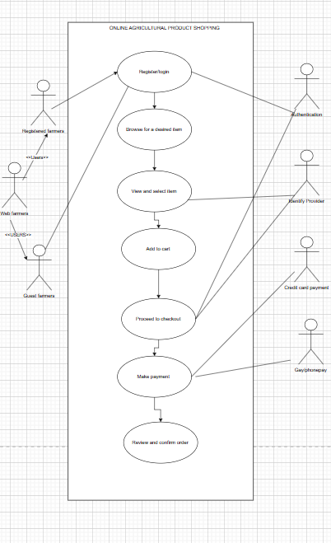

Question 11 – (minimum 5) Use Case Specs - 15 Marks Prepare use case specs for all use cases

Answer:-

### ****Use Case Specifications for the Online Agriculture Products Store****

A **Use Case Specification** (Use Case Document) provides **detailed descriptions** of system interactions. Here are **5 essential use cases** with their specifications.

## **Use Case 1: User Login & Registration**

### ****Use Case ID:**** UC001

**Actors:** Farmer, Manufacturer  
**Preconditions:**

* The user must have a valid email ID to register.  
  **Basic Flow:**

1. The user selects **"Register"** or **"Login"** on the homepage.
2. If registering, the user enters details (Name, Email, Password) and submits.
3. If logging in, the user enters email & password.
4. The system validates credentials.
5. If successful, the user is redirected to the dashboard.  
   **Alternate Flow:**

* If invalid credentials are entered, the system shows an error message.  
  **Postconditions:**
* The user is successfully authenticated and can access the system.

## **Use Case 2: Search for Products**

### ****Use Case ID:**** UC002

**Actors:** Farmer  
**Preconditions:**

* The system must have listed products (fertilizers, seeds, pesticides).  
  **Basic Flow:**

1. The farmer enters a **search term** (e.g., “organic fertilizer”) in the search bar.
2. The system fetches **matching products** from the database.
3. The farmer views search results.
4. The farmer selects a product for more details.  
   **Alternate Flow:**

* If no matching product is found, a **"No results found"** message is displayed.  
  **Postconditions:**
* The user can either purchase a product or refine their search.

## **Use Case 3: Add to Cart & Checkout**

### ****Use Case ID:**** UC003

**Actors:** Farmer  
**Preconditions:**

* The user must be logged in.
* The selected product must be in stock.  
  **Basic Flow:**

1. The farmer clicks **“Add to Cart”** on a product page.
2. The system updates the shopping cart.
3. The farmer clicks **"Proceed to Checkout"**.
4. The system calculates the total cost and applies discounts (if any).
5. The user selects a **payment method** (COD, UPI, Card).
6. The system processes payment and confirms the order.
7. The user receives an **order confirmation email**.  
   **Alternate Flow:**

* If the item is out of stock, the user is notified.  
  **Postconditions:**
* The order is placed, and delivery tracking is enabled.

## **Use Case 4: Manufacturer Uploads Products**

### ****Use Case ID:**** UC004

**Actors:** Manufacturer  
**Preconditions:**

* The manufacturer must be logged in.  
  **Basic Flow:**

1. The manufacturer clicks **"Add Product"** on the dashboard.
2. The manufacturer fills in product details (name, description, price, stock, image).
3. The system **validates** and **stores** the product information.
4. The product appears in the **public product catalog**.  
   **Alternate Flow:**

* If mandatory fields are missing, an error message is shown.  
  **Postconditions:**
* The product is available for farmers to purchase.

## **Use Case 5: Order Tracking**

### ****Use Case ID:**** UC005

**Actors:** Farmer  
**Preconditions:**

* The user must have placed an order.  
  **Basic Flow:**

1. The farmer clicks **"Track My Order"** on the dashboard.
2. The system fetches the **order status** from the database.
3. The order status is displayed (e.g., **"Shipped," "Out for Delivery"**).
4. The farmer receives an **email update**.  
   **Alternate Flow:**

* If the order is delayed, the estimated delivery time is updated.  
  **Postconditions:**
* The farmer can track their order’s location and status.

Question 12 – (minimum 5) Activity Diagrams - 15 Marks Activity diagrams

Answer:

* 1. Farmer Purchasing with payment option

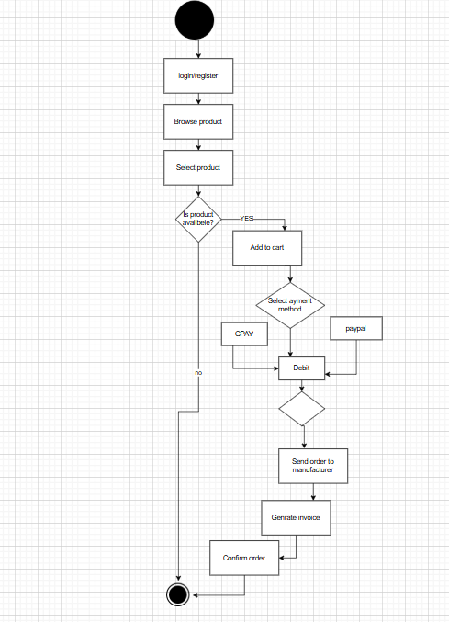

* 1. Manufacturer upload product

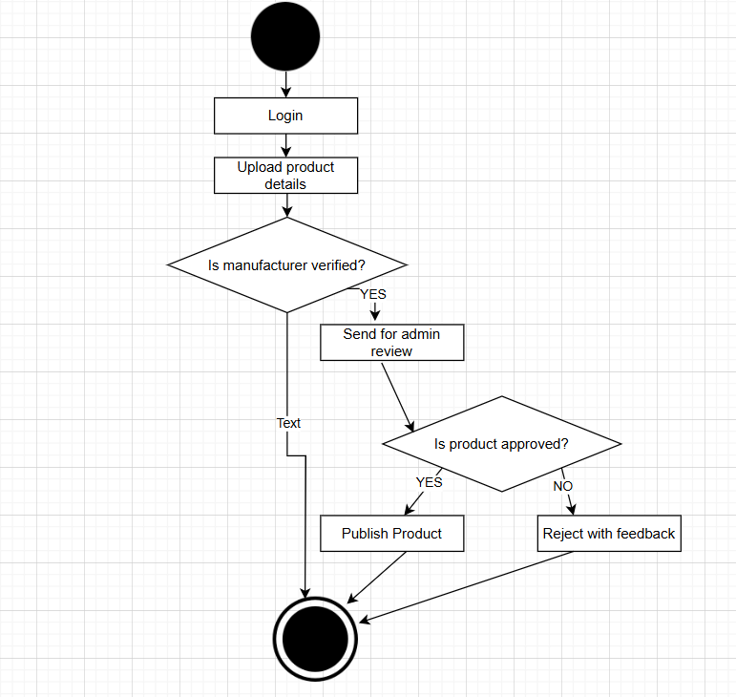

* 1. Farmer Login and Registration

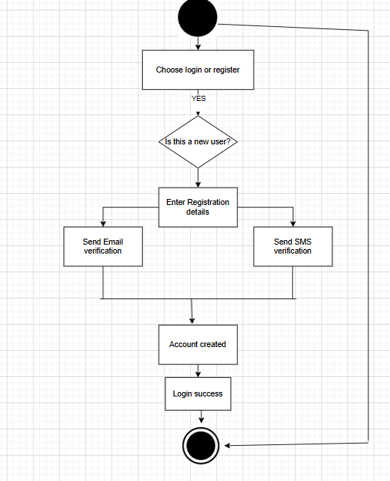

* 1. Admin Managing users

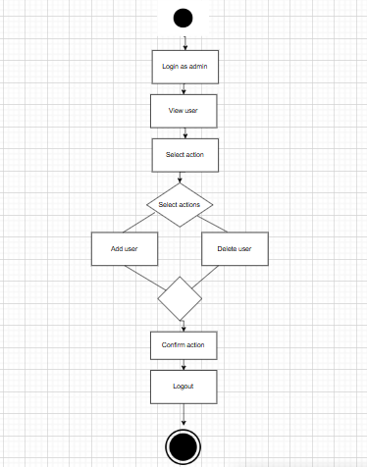

* 1. Order Tracking and Feedback

