**Question 1 – Functional Requirements**

**Identify minimum 20 functional requirements**

**Example:**

**Functional requirement: When an order is fulfilled, the local printer shall print a packing slip.**

**Non-Functional Requirement: Packing slips shall be printed on both sides of 4”x 6” white paper, the standard size for packing slips used by local printers.**

**Answer:**

|  |  |  |  |
| --- | --- | --- | --- |
| **Req ID** | **Req Name** | **Req Description** | **Priority** |
| FR0001 | Registration | Allow customer to do Registration. | 10 |
| FR0002 | Login | Allow customer to do Login. | 10 |
| FR0003 | Sign In | Allow customer to sign In. | 9 |
| FR0004 | Search | Allow customer to Search Product. | 7 |
| FR0005 | Browse | Allow Customer to Browse the Product. | 7 |
| FR0006 | Buy Later List | Allow Customer to add product in buy later list. | 3 |
| FR0007 | Remove from Buy Later List | Allow customer to remove product from Buy later List. | 2 |
| FR0008 | Filter | Allow customer to apply Filter to while searching the product. | 2 |
| FR0009 | Cancel order | Allow customer to Cancel the order. | 9 |
| FR0010 | Payment Option | Allow customer to do the payment. | 9 |
| FR0011 | Delivery Tracker | Allow customer to track the delivered Product. | 5 |
| FR0012 | History | Allow customer to See the History of Purchased items. | 2 |
| FR0013 | Accounts | Allow customer to view his Profile. | 4 |
| NFR0101 | Page Loading Time | Each Page should load within 2 seconds time | 9 |
| NFR0102 | WCAG 2.1. | The system must meet Web Content Accessibility Guidelines WCAG 2.1. | 8 |

**Question 2–Minimum 5page designs**

**Make wireframe and prototypes**

**Answer:**

**Wireframe for First Page**

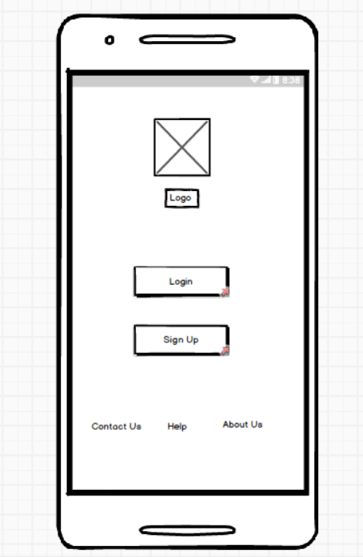

**Wireframe For Login:**

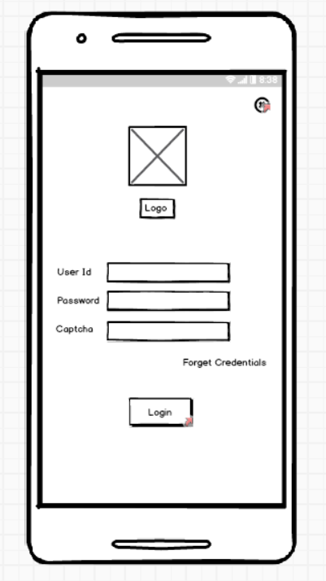

**Wireframe for Sign Up Page:**

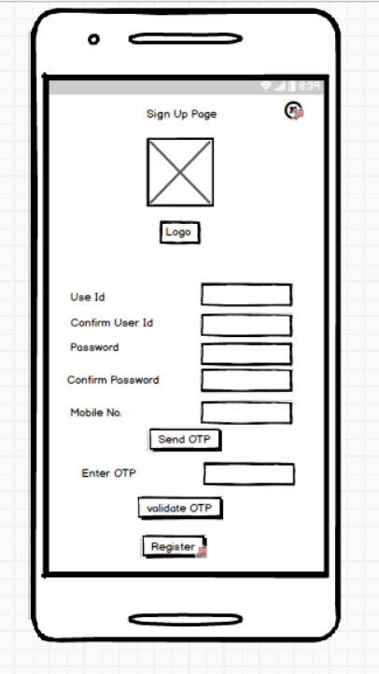

**Wireframe for Home Page:**

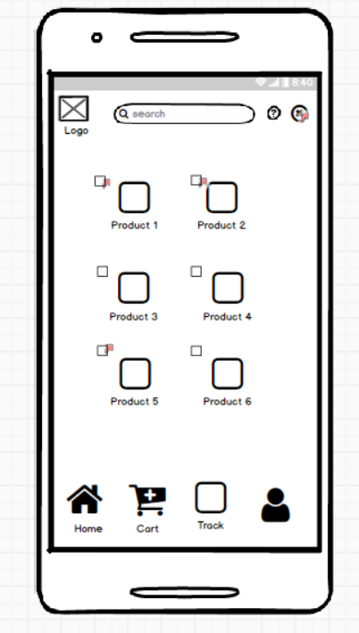

**Wireframe For Order Confirmation:**

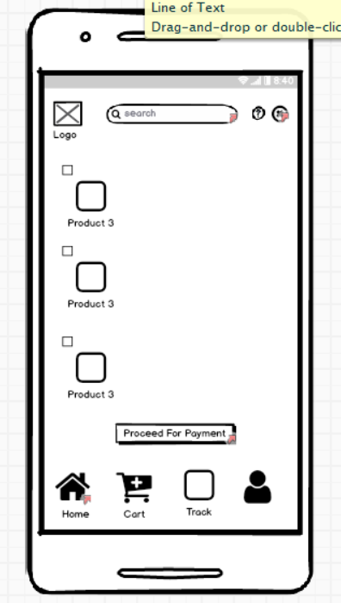

**Wireframe for Payment:**

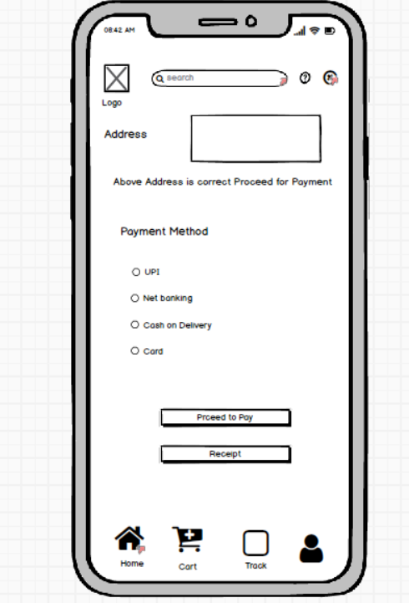

**Question 3 – Tools (Visio, Balsamiq)**

**Make a note of the Tools, which you are using for above concepts.**

**Answer:**

1. **Balsmiq:**

-It is a type of wire framing tool.

-It is a low fidelity wire framing UI or UX design.

-Can be best used for quick UI sketches.

-It can be used on the platforms like the web and desktop.

1. **MS Visio:**

-It is a type of diagramming and vector graphics tool.

-It is medium fidelity in drawing Flow Charts, Network Diagrams.

-Best to draw flowcharts and network diagrams.

-It can be used on the platforms like the web and the desktop.

1. **Axure RP:**

-It is UI or UX prototyping or wire framing tool.

-Has High fidelity interactive prototypes and wireframes.

-Best to draw interactive UI and Wireframes.

-It is used on platforms like Windows and Mac.

**Question 4 – RTM**

**A business analyst’s key responsibilities are to keep track of the requirements and make sure that no requirement is missed.** **Mr. Henry and Peter have approached you regarding the current status of the project. How will you tackle this situation?**

**Answer:**

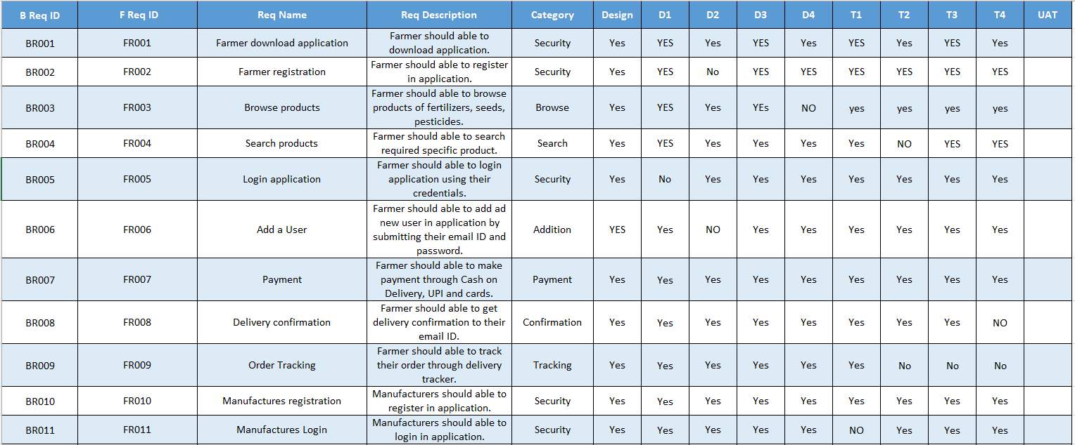

**Question 5 – 10 Test Case Documents**

**Prepare 10 Test Case Documents**

**Answer:**

|  |  |  |  |  |  |
| --- | --- | --- | --- | --- | --- |
| **Test Case** | TS_001 | **Test Case Name** | Login | | |
| **Project ID** | PR_001 | **Project Name** | Online Agriculture Product Store | | |
| **PM ID** | PM1234 | **Tester ID** | T1234 | | |
| **Test Strategy ID** | TC_001 | **Tester Name** | ABC | | |
| **Test Plan ID** | TP_001 | **Date of Test** | 30-06-2025 | | |
| **Test Schedule ID** | TSCH_001 | | | | |
| **Scenario** | The user enters valid login credentials | | | | |
| **Example** | User Id: [abc@com.co](mailto:abc@com.co) PWD: abc@123 | | | | |
| **Action** | **Inputs** | **Expected Output** | **Actual Output** | **Test Browser** | **Test Result** |
| Enter the user Id and Password and click on login | User Id: abc@com.co  PWD: abc@123 | User successfully login. | User successfully login. | Chrome | Pass |

|  |  |  |  |  |  |
| --- | --- | --- | --- | --- | --- |
| **Test Case** | TS_002 | **Test Case Name** | Login | | |
| **Project ID** | PR_001 | **Project Name** | Online Agriculture Product Store | | |
| **PM ID** | PM1234 | **Tester ID** | T1234 | | |
| **Test Strategy ID** | TC_001 | **Tester Name** | ABC | | |
| **Test Plan ID** | TP_002 | **Date of Test** | 30-06-2025 | | |
| **Test Schedule ID** | TSCH_001 | | | | |
| **Scenario** | The user enters Invalid User Id and Valid Password | | | | |
| **Example** | User Id: [abc@com.co](mailto:abc@com.co) PWD: abc@123 | | | | |
| **Action** | **Inputs** | **Expected Output** | **Actual Output** | **Test Browser** | **Test Result** |
| Enter the Invalid user Id and valid Password and click on login. | User Id : xyz@com.co  PWD: abc@123 | Error message pops up. | Error message pops up. | Chrome | Pass |

|  |  |  |  |  |  |
| --- | --- | --- | --- | --- | --- |
| **Test Case** | TS_003 | **Test Case Name** | Login | | |
| **Project ID** | PR_001 | **Project Name** | Online Agriculture Product Store | | |
| **PM ID** | PM1234 | **Tester ID** | T1234 | | |
| **Test Strategy ID** | TC_003 | **Tester Name** | ABC | | |
| **Test Plan ID** | TP_001 | **Date of Test** | 30-06-2025 | | |
| **Test Schedule ID** | TSCH_001 | | | | |
| **Scenario** | The user enters valid user Id and Invalid Password | | | | |
| **Example** | User Id: [abc@com.co](mailto:abc@com.co) PWD: abc@123 | | | | |
| **Action** | **Inputs** | **Expected Output** | **Actual Output** | **Test Browser** | **Test Result** |
| Enter the Valid user Id and Invalid Password and click on login | User Id : abc@com.co  PWD: xyz@123 | Error message pops up. | Error message pops up. | Chrome | Pass |

|  |  |  |  |  |  |
| --- | --- | --- | --- | --- | --- |
| **Test Case** | TS_004 | **Test Case Name** | Login | | |
| **Project ID** | PR_001 | **Project Name** | Online Agriculture Product Store | | |
| **PM ID** | PM1234 | **Tester ID** | T1234 | | |
| **Test Strategy ID** | TC_004 | **Tester Name** | ABC | | |
| **Test Plan ID** | TP_001 | **Date of Test** | 30-06-2025 | | |
| **Test Schedule ID** | TSCH_001 | | | | |
| **Scenario** | The user enters Invalid login credentials. | | | | |
| **Example** | User Id: [abc@com.co](mailto:abc@com.co) PWD: abc@123 | | | | |
| **Action** | **Inputs** | **Expected Output** | **Actual Output** | **Test Browser** | **Test Result** |
| Enter the invalid user Id and invalid Password and click on login | User Id : xyz@com.co  PWD: xyz@123 | Error message pops up. | Error message pops up. | Chrome | Pass |

|  |  |  |  |  |  |
| --- | --- | --- | --- | --- | --- |
| **Test Case** | TS_005 | **Test Case Name** | Payment | | |
| **Project ID** | PR_001 | **Project Name** | Online Agriculture Product Store | | |
| **PM ID** | PM1234 | **Tester ID** | T1234 | | |
| **Test Strategy ID** | TC_001 | **Tester Name** | ABC | | |
| **Test Plan ID** | TP_005 | **Date of Test** | 30-06-2025 | | |
| **Test Schedule ID** | TSCH_001 | | | | |
| **Scenario** | The user enters valid Payment credentials | | | | |
| **Example** | UPI ID: abc@okhdfcbank UPI Pin:1234 | | | | |
| **Action** | **Inputs** | **Expected Output** | **Actual Output** | **Test Browser** | **Test Result** |
| Enter the Valid UPI Id and Valid UPI pin click Payment. | UPI ID: abc@okhdfcbank UPI Pin:1234 | Payment successful message. | Payment successful message. | Chrome | Pass |

|  |  |  |  |  |  |
| --- | --- | --- | --- | --- | --- |
| **Test Case** | TS_006 | **Test Case Name** | Payment | | |
| **Project ID** | PR_001 | **Project Name** | Online Agriculture Product Store | | |
| **PM ID** | PM1234 | **Tester ID** | T1234 | | |
| **Test Strategy ID** | TC_001 | **Tester Name** | ABC | | |
| **Test Plan ID** | TP_006 | **Date of Test** | 30-06-2025 | | |
| **Test Schedule ID** | TSCH_001 | | | | |
| **Scenario** | The user enters Invalid UPI Id and valid UPI pin | | | | |
| **Example** | UPI ID: abc@okhdfcbank UPI Pin:1234 | | | | |
| **Action** | **Inputs** | **Expected Output** | **Actual Output** | **Test Browser** | **Test Result** |
| Enter the Invalid UPI Id and Valid UPI pin click Payment. | UPI ID: xyz@okhdfcbank UPI Pin:1234 | Payment Falied. | Payment Falied. | Chrome | Pass |

|  |  |  |  |  |  |
| --- | --- | --- | --- | --- | --- |
| **Test Case** | TS_007 | **Test Case Name** | Payment | | |
| **Project ID** | PR_001 | **Project Name** | Online Agriculture Product Store | | |
| **PM ID** | PM1234 | **Tester ID** | T1234 | | |
| **Test Strategy ID** | TC_001 | **Tester Name** | ABC | | |
| **Test Plan ID** | TP_007 | **Date of Test** | 30-06-2025 | | |
| **Test Schedule ID** | TSCH_001 | | | | |
| **Scenario** | The user enters valid UPI Id and Invalid UPI pin | | | | |
| **Example** | UPI ID: abc@okhdfcbank UPI Pin:1234 | | | | |
| **Action** | **Inputs** | **Expected Output** | **Actual Output** | **Test Browser** | **Test Result** |
| Enter the valid UPI Id and Invalid UPI pin click Payment. | UPI ID: abc@okhdfcbank UPI Pin:4567 | Payment Falied. | Payment Falied. | Chrome | Pass |

|  |  |  |  |  |  |
| --- | --- | --- | --- | --- | --- |
| **Test Case** | TS_008 | **Test Case Name** | Payment | | |
| **Project ID** | PR_001 | **Project Name** | Online Agriculture Product Store | | |
| **PM ID** | PM1234 | **Tester ID** | T1234 | | |
| **Test Strategy ID** | TC_001 | **Tester Name** | ABC | | |
| **Test Plan ID** | TP_008 | **Date of Test** | 30-06-2025 | | |
| **Test Schedule ID** | TSCH_001 | | | | |
| **Scenario** | The user enters valid card credentials | | | | |
| **Example** |  | | | | |
| **Action** | **Inputs** | **Expected Output** | **Actual Output** | **Test Browser** | **Test Result** |
| Enter the user Id and Password and click on login | User Id : abc@com.co  PWD: abc@123 | User successfully login. | User successfully login. | Chrome | Pass |

|  |  |  |  |  |  |
| --- | --- | --- | --- | --- | --- |
| **Test Case** | TS_001 | **Test Case Name** | Login | | |
| **Project ID** | PR_001 | **Project Name** | Online Agriculture Product Store | | |
| **PM ID** | PM1234 | **Tester ID** | T1234 | | |
| **Test Strategy ID** | TC_001 | **Tester Name** | ABC | | |
| **Test Plan ID** | TP_001 | **Date of Test** | 30-06-2025 | | |
| **Test Schedule ID** | TSCH_001 | | | | |
| **Scenario** | The user enters valid login credentials | | | | |
| **Example** |  | | | | |
| **Action** | **Inputs** | **Expected Output** | **Actual Output** | **Test Browser** | **Test Result** |
| Enter the user Id and Password and click on login | User Id : abc@com.co  PWD: abc@123 | User successfully login. | User successfully login. | Chrome | Pass |

|  |  |  |  |  |  |
| --- | --- | --- | --- | --- | --- |
| **Test Case** | TS_001 | **Test Case Name** | Login | | |
| **Project ID** | PR_001 | **Project Name** | Online Agriculture Product Store | | |
| **PM ID** | PM1234 | **Tester ID** | T1234 | | |
| **Test Strategy ID** | TC_001 | **Tester Name** | ABC | | |
| **Test Plan ID** | TP_001 | **Date of Test** | 30-06-2025 | | |
| **Test Schedule ID** | TSCH_001 | | | | |
| **Scenario** | The user enters valid login credentials | | | | |
| **Example** |  | | | | |
| **Action** | **Inputs** | **Expected Output** | **Actual Output** | **Test Browser** | **Test Result** |
| Enter the user Id and Password and click on login | User Id : abc@com.co  PWD: abc@123 | User successfully login. | User successfully login. | Chrome | Pass |

**Question 6 – DB Design**

**After the requirements are thoroughly explained to the entire project team by business analyst, the Database architects have decided to do the database design and also to represent the in-flow and out-flow of data.**

**Draw database schema and ER diagram**

**Answer:**

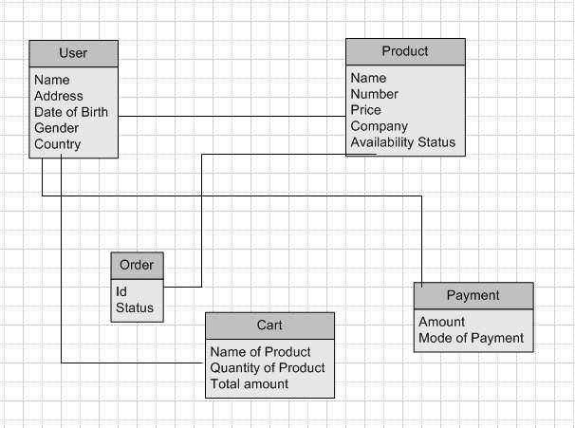

**Question 7 – Data Flow Diagram**

**What is a data flow diagram? Draw a data flow diagram to represent the in-flow and out-flow of data when a Farmer is placing an order for the product.**

**Answer:**

* Data Flow Diagram is a Graphical View of how data is processed in a system in terms of Input and Output.

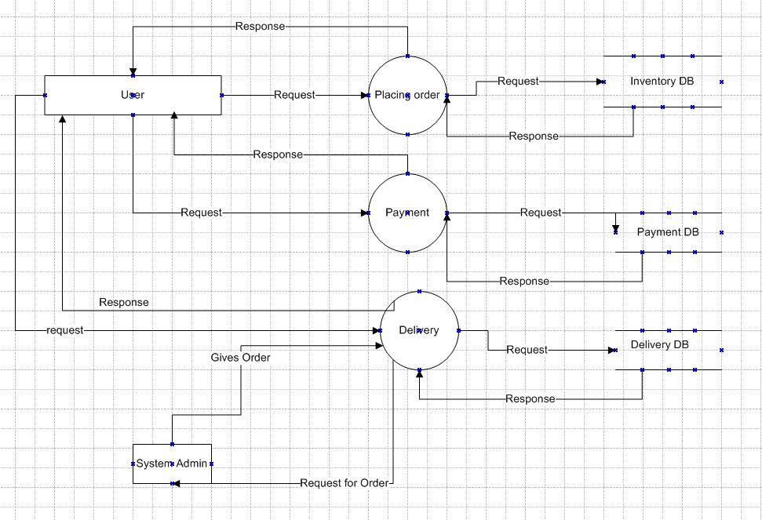

**Question 8 – Change Request**

**Due to change in the Government Taxation structure. We should change the Tax structure How do you handle change requests in a project?**

**Answer:**

* BA should always be prepared for change requests and their management. This change request is regarding Government Taxation, initially the BA documents the change request.
* BA performs a Feasibility study to accept the change request. The BA will analyse the change request of Taxation.
* After approval for the project manager BA needs to move further in analysing the change request.
* The BA will help the stakeholders to understand, the impact change request will have on the organisation.
* Successful change efforts necessitate the BA to articulate a realistic or convincing vision that appeals to both internal and external stakeholders.

**Question 9 – Change Request Vs an Enhancement**

**As the project is in process, Ben and Kevin have contacted you. The reason is to inform you that they want the Farmers to sell their crop yields through this application i.e. Farmers should be able to add their crop yields or products and display to general public and should be able to sell them. They also want to introduce Auction system for their Crop yields. As a BA, what will be your response?**

**Is this a change request or an enhancement???**

**Answer:**

* Enhancement refers to improvements made to an existing system.
* This will be considered as enhancement in the Project.
* As we are adding new Functionalities in the App to meet user Demands.
* Adding these three functionalities will improve Usability.

**Question 10 – Estimations**

**Come up with estimations – How many Manhours required**

**Answer:**

Total Budget: 2 Cr

Total Period: 18 Months

Resources: 11

* 40Hrs of work / Week by each individual.
* Per week work by 11 Resources is 440Hrs.

**Question 11 – UAT**

**Project has finally completed all the stages i.e., design, development, testing etc. Now, it is the role of a business analyst to contact the client for testing of the final product and have to successfully complete it. How are you going to handle this situation? And once it is done, what will be the process to close the project?**

**Explain UAT Acceptance process.**

**Answer:**

**Planning:**

* In this step, Blueprints are made to implement UAT testing for every feature that needs to be tested and minimum standards for accepting the test.

**Designing:**

* Here the test cases are designed to hide all the possibilities of software packages in a realworld environment.

**UAT Testers:**

* A testing team consists of a end user that meet the criteria for implementing testing. The end user must have expertise in subject matter and the ability to report the problems.

**Bug Fixing:**

* Whatever bugs are found in the UAT testing, the development team should work on them and make it software error free.

**Sign Off:**

* After removing all the bugs, the testing team indicates acceptance of the completion of the bugs. In this phase, all the stakeholders come to a conclusion that the software is ready to GO LIVE and sign it off.

**Question 12 – Project Closure Document**

**Explain Project closure document.**

**Answer:**

|  |  |  |  |
| --- | --- | --- | --- |
| **Sr.No.** | **Points To Include** | **Details** | **Reference Link** |
| **1.** | **Did the client Sign Off on the UAT Testing** | |  |
|  | Date of sign off: |  |
|  | Name of the resourse: |  |
| **2.** | **Objectives of the Project** | |
|  | User friendliness: | Achieved |  |
|  | Customer satisfaction: | Achieved |  |
|  | Misc: | Achieved |  |
| **3.** | **Functionalities worked on** |  |  |
|  | Secure payment Processing | Achieved |  |
|  | Categories | Achieved |  |
| **4.** | **Infrastructure** |  |  |
|  | Software Installed | Achieved |  |
|  | Laptops Purchased | Achieved |  |
| **5.** | **Funding** |  |  |
|  | Amount Approved | Rs. 2 Cr |
|  | Amount Used | Rs. 1.85 Cr |
| **6.** | **Overall project Information** |  |  |
|  | Escalations |  |  |
|  | Customer Satisfaction | High |  |
| **7.** | **Value to company** |  |  |
|  |  | -Trained Employees  -Increased Clients |  |