**MOCK 4**

A company is having manufacturing plants and warehouses in various parts of the country. They manufacture ice-cream and milk products. They want to build software to achieve two goals.

• Manage the inventory

• Quickest delivery to the customers

Assignment 1 –

**1) Please make a BRD which can be presented to the client along with complete development and resource plan.**

**Business Requirement Document**

**Inventory Management and Delivery System for Ice-Cream and Milk Products**

**Version – 1.0**

**Author – Janhavi Karia**

Contents

1. Document Revisions

2. Approvals

3. RACI Chart for This Document

RACI Chart

4. Introduction

4.1. Business Goals

4.2. Business Objectives

4.3. Business Rules

4.4. Background

4.5. Project Objective

4.6. Project Scope

4.6.1. In Scope Functionality

4.6.2. Out Scope Functionality

5. Assumptions

6. Constraints

7. Risks

Technological Risks

Skills Risks

Political Risks

Business Risks

Requirements Risks

Other Risks

8. Business Process Overview

8.1. Legacy System (AS-IS)

8.2. Proposed Recommendations (TO-BE)

9. Business Requirements

10. Development And Resource Plan…………………………………………………………………………………………

**1. Document Revisions**

|  |  |  |
| --- | --- | --- |
| **Date** | **Version Number** | **Document Changes** |
| 15/02/2025 | 0.1 | Initial Draft |

**2.Approvals**

|  |  |  |  |  |
| --- | --- | --- | --- | --- |
| **Role** | **Name** | **Title** | **Signature** | **Date** |
| Project Sponsor | John Doe | Chief Operating Officer |  | 16/02/2025 |
| Business Owner | Sarah Smith | Head of Operations |  | 16/02/2025 |
| Project Manager | Michael Brown | Project Manager |  | 16/02/2025 |
| System Architect | Emily Davis | System Architect |  | 16/02/2025 |
| Development Lead | Alex Johnson | Lead Developer |  | 16/02/2025 |
| User Experience Lead | Rachel Green | UX Lead |  | 16/02/2025 |
| Quality Lead | Liam White | QA Lead |  | 16/02/2025 |

**3. RACI Chart for This Document**

* **( * )Authorize** - Has ultimate signing authority for any changes to the document.
* **(R)Responsible** - Responsible for creating this document.
* **Accountable** - Accountable for accuracy of this document (for example, the project manager)
* **(S) Supports** - Provides supporting services in the production of this document
* **(C ) Consulted -** Provides input (such as an interviewee).
* **( I ) Informed** - Must be informed of any changes.

|  |  |  |  |  |  |  |  |
| --- | --- | --- | --- | --- | --- | --- | --- |
| **Name** | **Position** | **\*** | **R** | **A** | **S** | **C** | **I** |
| Jhanvi [BA] | Business Analyst |  | ✔ | ✔ |  |  | ✔ |
| John Doe | COO | ✔ |  |  |  | ✔ | ✔ |
| Sarah Smith | Head of Operations |  |  | ✔ | ✔ |  | ✔ |
| Michael Brown | Project Manager |  | ✔ | ✔ | ✔ | ✔ | ✔ |
| Emily Davis | System Architect |  |  |  | ✔ | ✔ | ✔ |
| Alex Johnson | Lead Developer |  |  |  | ✔ | ✔ | ✔ |
| Rachel Green | UX Lead |  |  |  | ✔ | ✔ | ✔ |
| Liam White | QA Lead |  |  |  | ✔ | ✔ | ✔ |

### **4. Introduction**

#### 4.1. Business Goals

The **Inventory Management and Delivery System** aims to:

* Streamline inventory management across manufacturing plants and warehouses.
* Ensure the quickest delivery of ice-cream and milk products to customers.
* Reduce manual errors and improve operational efficiency.
* Provide real-time visibility into inventory levels and delivery statuses

#### 4.2. Business Objectives

To achieve the business goals, the system will:

* **Track Inventory**: Monitor stock levels of raw materials and finished products in real-time.
* **Automate Reordering**: Generate automatic reorder alerts for low stock items.
* **Optimize Delivery Routes**: Use route optimization algorithms to ensure quick delivery.
* **Provide Real-Time Updates**: Offer real-time updates on inventory and delivery statuses to stakeholders.
* **Integrate with ERP Systems**: Seamlessly integrate with existing ERP systems for data consistency.
* **Order Assignment Automation**: Assign deliveries to the nearest warehouse.

#### 4.3. Business Rules

#### Only authorized personnel can update inventory levels.

#### Delivery routes must be optimized for fuel efficiency and time.

#### The system must comply with data security regulations.

#### Different user roles (e.g., Admin, Warehouse Manager, Delivery Personnel) will have specific access rights.

* The system must ensure FIFO (First In, First Out) for perishable goods.

#### 4.4. Background

#### Currently, the company relies on manual processes for inventory management and delivery scheduling. This leads to inefficiencies, delays, and errors. The new system will automate these processes, providing real-time visibility and improving overall efficiency.

#### 4.5. Project Objective

#### Automate inventory tracking and reordering processes.

#### Optimize delivery routes to ensure quickest delivery.

#### Provide real-time updates to stakeholders.

#### Integrate with existing ERP systems for seamless data flow.

#### 4.6. Project Scope

##### 4.6.1. In Scope Functionality

* **Inventory Management**: Track raw materials and finished products across all locations.
* **Reordering System**: Automatically generate reorder alerts for low stock items.
* **Delivery Optimization**: Use algorithms to optimize delivery routes.
* **Real-Time Updates**: Provide real-time updates on inventory and delivery statuses.
* **User Roles**: Define and manage user roles and access rights

##### 4.6.2. Out of Scope Functionality

### **Marketing Automation**: Generating promotional offers or campaigns**.**

### **Customer Loyalty Programs: Managing customer rewards or loyalty points.**

### **5. Assumptions**

### The system will integrate with existing ERP systems.

### The system will support real-time data synchronization.

### The system will be accessible via desktop and mobile devices.

### **6.Constraints**

* Limited resources may restrict feature scope and third-party integration costs.
* Limited availability of skilled resources for technical and integration tasks.
* Challenges in scalability, integration with legacy systems, and third-party API limitations.
* Strict compliance requirements for food safety regulations.

### **7. Risks**

#### Technological Risks

#### Difficulty in integrating with legacy systems or third-party APIs.

#### Skills Risks

* Users may require training to use the new system effectively.

**Operational Risks**

* Delays due to unexpected supply chain disruptions.

#### Business Risks

#### Delays in delivery optimization could impact customer satisfaction.

#### Requirements Risks

* The system must provide accurate real-time updates to ensure efficient operations
* Increased operational costs due to unoptimized inventory management.

#### Other Risks

* Data breaches or unauthorized access to inventory and customer data.

### **8. Business Process Overview**

#### 8.1. Legacy System (AS-IS)

* Inventory is managed manually using spreadsheets, leading to errors and inefficiencies.
* Orders are assigned manually, causing delivery delays.
* Delivery tracking is unreliable, leading to customer dissatisfaction.

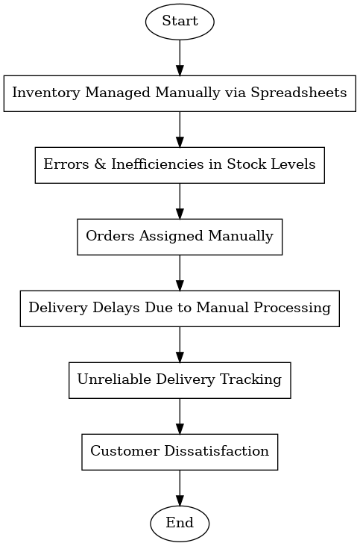

#### 8.2. Proposed Recommendations (TO-BE)

#### Automated Inventory Management: The system will track stock levels in real time, preventing shortages and overstocking.

#### AI-Driven Order Processing: Orders will be automatically assigned to the nearest warehouse to optimize delivery speed.

#### Route Optimization & Tracking: AI-based routing will minimize delivery times and provide real-time tracking for customers and administrators.

#### Seamless Integration: The system will integrate with third-party logistics for last-mile delivery.

#### 

# **9. Business Requirements –**

|  |  |  |  |
| --- | --- | --- | --- |
| **Sr. No** | **Business Requirement** | **Functionality** | **Priority** |
| 1 | System should track inventory levels in real-time. | Inventory Management | High |
| 2 | System should generate automatic reorder alerts. | Inventory Management | High |
| 3 | System should optimize delivery routes. | Delivery Optimization | High |
| 4 | System should provide real-time updates to stakeholders. | Real-Time Updates | High |
| 5 | System should integrate with existing ERP systems. | Integration | High |
| 6 | System should define and manage user roles and access. | User Management | Medium |
| 7 | System should be accessible via desktop and mobile devices | Accessibility | Medium |

**10. Development and Resource Plan**

**10.1 Project Timeline**

The project will be divided into 5 phases, with an estimated total duration of 6 months.

|  |  |  |  |  |
| --- | --- | --- | --- | --- |
| **Phase** | **Activities** | **Duration** | **Start Date** | **End Date** |
| **Phase 1: Requirements Gathering** | -Conduct stakeholder interviews -Finalize BRD - Sign-off on requirements | 2 weeks | 15/02/25 | 28/02/25 |
| **Phase 2: Design** | - Create system architecture - Design UI/UX - Finalize technical specifications | 4 weeks | 1/03/25 | 28/03/25 |
| **Phase 3: Development** | - Develop inventory management module - Develop delivery optimization module - Integrate with ERP systems | 10 weeks | 29/03/25 | 06/06/25 |
| **Phase 4: Testing** | - Unit testing - Integration testing - User acceptance testing (UAT) | 4 weeks | 07/06/25 | 05/07/25 |
| **Phase 5: Deployment** | - Deploy system to production - Train end-users - Go-live and support | 2 weeks | 06/07/25 | 19/07/25 |

**10.2 Resource Plan**

**The following resources will be required to complete the project:**

**10.2.1 Human Resources**

|  |  |  |
| --- | --- | --- |
| **Role** | **Number of Resources** | **Responsibilities** |
| Project Manager | 1 | Oversee project execution, manage timelines, and coordinate between teams. |
| Business Analyst | 1 | Gather requirements, create BRD, and act as a bridge between stakeholders and dev. |
| System Architect | 1 | Design system architecture and ensure scalability and integration. |
| UI/UX Designer | 1 | Design user interfaces and ensure a seamless user experience. |
| Developers | 4 | Develop inventory and delivery modules, integrate with ERP systems. |
| QA Testers | 2 | Conduct testing (unit, integration, UAT) and report bugs. |
| DevOps Engineer | 1 | Manage deployment, CI/CD pipelines, and server configurations. |
| Trainers | 2 | Train end-users on how to use the system. |

**10.2.2 Tools and Technologies**

|  |  |
| --- | --- |
| **Tool/Technology** | **Purpose** |
| Programming Languages | Java, Python, or Node.js for backend development. |
| Frontend Framework | React.js or Angular for UI development. |
| Database | MySQL or PostgreSQL for inventory and delivery data storage. |
| ERP Integration | SAP or Oracle ERP for seamless data flow. |
| Route Optimization | Google Maps API or custom algorithms for delivery route optimization. |
| Testing Tools | Selenium, JUnit, or Postman for testing. |
| Project Management | JIRA or Trello for task tracking and project management. |
| Version Control | Git (GitHub/GitLab) for code versioning. |

**10.2.3. Cost Estimation**

**The estimated cost for the project is broken down as follows:**

|  |  |  |
| --- | --- | --- |
| **Category** | **Estimated Cost** | **Remarks** |
| Human Resources | $150,000 | **Based on 6 months of work for the team.** |
| Tools and Licenses | $20,000 | **Includes software licenses, APIs, and third-party tools.** |
| Infrastructure | $30,000 | **Servers, cloud hosting, and storage costs.** |
| Training | $10,000 | **End-user training and workshops.** |
| Contingency | $20,000 | **Buffer for unforeseen expenses.** |
| Total | $230,000 |  |

**10.2.4. Key Deliverables**

|  |  |
| --- | --- |
| **Deliverable** | **Description** |
| BRD and SRS | Business Requirements Document and Software Requirements Specification. |
| System Design Document | Detailed architecture and design of the system. |
| Inventory Management Module | Fully functional inventory tracking and reordering system. |
| Delivery Optimization Module | Route optimization and real-time delivery tracking. |
| Integrated ERP System | Seamless integration with existing ERP systems. |
| Test Reports | Unit, integration, and UAT test reports. |
| User Training Manual | Documentation and training materials for end-users. |
| Deployed System | Fully functional system deployed to production. |

**2) Prepare process flow diagram using your imagination.**



**Assignment 2**

**1) Write an introduction letter to a client introducing yourself as a business analyst in charge of working with the client and his team to start the business understanding process.**

Subject: Introduction – Business Analyst for Inventory Management and Delivery System

Dear Sarah Smith,

I hope you are doing well. I’d like to take a moment to introduce myself as the **Business Analyst** assigned to your project, Inventory Management and Delivery System. My primary role is to collaborate with you and your team to facilitate the **business understanding process**, ensuring that we align project objectives with your business needs and deliver the best possible outcomes.

To achieve this, I will be focusing on the following key areas:

* **Understanding your business goals, challenges, and expectations** to ensure that the project delivers real value.
* **Gathering and documenting business requirements** through discussions, workshops, and research to create a clear roadmap for development.
* **Bridging communication between stakeholders and the development team**, ensuring that all requirements are accurately translated into functional solutions while keeping you informed throughout the process.
* **Identifying potential risks and opportunities** to help optimize the solution and enhance business efficiency.

I would love to schedule an **initial discussion** at your convenience to better understand your priorities and expectations. Please let me know a time that works best for you. I look forward to working together and ensuring the successful execution of this project.

Best regards,  
Janhavi Karia  
Business Analyst  
COEPD InfoTech

**2) Prepare a brief BRD and SRS for a project- Movie Ticketing system**

**Business Requirement Document**

**Movie Ticketing system**

**Version – 1.0**

**Author – Janhavi Karia**

Contents

1. Document Revisions

2. Approvals

3. RACI Chart for This Document

RACI Chart

4. Introduction

4.1. Business Goals

4.2. Business Objectives

4.3. Business Rules

4.4. Background

4.5. Project Objective

4.6. Project Scope

4.6.1. In Scope Functionality

4.6.2. Out Scope Functionality

5. Assumptions

6. Constraints

7. Risks

Technological Risks

Skills Risks

Political Risks

Business Risks

Requirements Risks

Other Risks

8. Business Process Overview

8.1. Legacy System (AS-IS)

8.2. Proposed Recommendations (TO-BE)

9. Business Requirements

**1. Document Revisions**

|  |  |  |
| --- | --- | --- |
| **Date** | **Version Number** | **Document Changes** |
| 15/02/2025 | 0.1 | Initial Draft |

**2.Approvals**

|  |  |  |  |  |
| --- | --- | --- | --- | --- |
| **Role** | **Name** | **Title** | **Signature** | **Date** |
| Project Sponsor | John Doe | Chief Operating Officer |  | 16/02/2025 |
| Business Owner | Sarah Smith | Head of Operations |  | 16/02/2025 |
| Project Manager | Michael Brown | Project Manager |  | 16/02/2025 |
| System Architect | Emily Davis | System Architect |  | 16/02/2025 |
| Development Lead | Alex Johnson | Lead Developer |  | 16/02/2025 |
| User Experience Lead | Rachel Green | UX Lead |  | 16/02/2025 |
| Quality Lead | Liam White | QA Lead |  | 16/02/2025 |

**3. RACI Chart for This Document**

* **( * )Authorize** - Has ultimate signing authority for any changes to the document.
* **(R)Responsible** - Responsible for creating this document.
* **Accountable** - Accountable for accuracy of this document (for example, the project manager)
* **(S) Supports** - Provides supporting services in the production of this document
* **(C ) Consulted -** Provides input (such as an interviewee).
* **( I ) Informed** - Must be informed of any changes.

|  |  |  |  |  |  |  |  |
| --- | --- | --- | --- | --- | --- | --- | --- |
| **Name** | **Position** | **\*** | **R** | **A** | **S** | **C** | **I** |
| Jhanvi [BA] | Business Analyst |  | ✔ | ✔ |  |  | ✔ |
| John Doe | COO | ✔ |  |  |  | ✔ | ✔ |
| Sarah Smith | Head of Operations |  |  | ✔ | ✔ |  | ✔ |
| Michael Brown | Project Manager |  | ✔ | ✔ | ✔ | ✔ | ✔ |
| Emily Davis | System Architect |  |  |  | ✔ | ✔ | ✔ |
| Alex Johnson | Lead Developer |  |  |  | ✔ | ✔ | ✔ |
| Rachel Green | UX Lead |  |  |  | ✔ | ✔ | ✔ |
| Liam White | QA Lead |  |  |  | ✔ | ✔ | ✔ |

### **4. Introduction**

#### 4.1. Business Goals

The goal of this project is to develop an **Online Movie Ticketing System** that allows the company to:

* **Enable seamless ticket booking** for customers through an intuitive online platform.
* **Enhance theater management** by automating seat allocation and revenue tracking.
* **Improve customer engagement** through loyalty programs and personalized recommendations.
* **Optimize pricing and sales** using real-time analytics and demand-based dynamic pricing.

#### 4.2. Business Objectives

#### Real-time Ticket Booking: Customers can browse movies, select seats, and complete transactions securely.

#### Efficient Theater Management: Automate seat allocation and prevent overbooking.

#### Payment Integration: Support multiple payment methods with fraud prevention.

#### Customer Loyalty & Engagement: Implement personalized recommendations and promotional offers.

#### Reporting & Analytics: Generate insights into sales trends, peak booking times, and customer preferences.

#### 4.3. Business Rules

#### Customers can only book seats for available showtimes.

#### Online payments must be processed securely with encryption.

#### Movie schedules are managed by theater admins.

#### Dynamic pricing is applied based on demand and time slots.

#### Refunds and rescheduling requests must be processed per company policy.

#### 4.4. Background

#### Currently, customers must visit the theater or call customer service to book tickets. This manual process is time-consuming and prone to errors. The new system will automate ticket booking, provide real-time seat availability, and offer a more convenient experience for customers.

#### 4.5. Project Objective

#### Automate ticket booking and reservation management.

#### Provide real-time updates on movie schedules and seat availability.

#### Integrate multiple payment options for seamless transactions.

#### Enhance customer experience through personalized recommendations.

#### 4.6. Project Scope

##### 4.6.1. In Scope Functionality

* Online movie search, seat selection, and ticket booking.
* Integration with payment gateways for seamless transactions.
* Real-time seat availability tracking and automated updates.
* Mobile app and web-based platform support.
* Admin panel for theater managers to update movie schedules and pricing.
* Customer notifications via email/SMS for booking confirmation.
* Loyalty program and personalized movie recommendations.
* Reporting dashboard for revenue tracking and analytics.

##### 4.6.2. Out of Scope Functionality

* Third-party advertising integration.
* In-app food ordering and delivery inside theaters (Future phase consideration).

### **5. Assumptions**

### The system will handle high traffic, especially during peak hours.

### Secure payment processing will be implemented with industry-standard encryption.

### Customers will have stable internet access for seamless booking.

### **6.Constraints**

### Budget limitations may impact feature expansion.

### System must integrate with existing theater management software.

### Compliance with regional regulations on digital transactions and refunds.

### **7. Risks**

#### Technological Risks

* System crashes due to high traffic.

#### Security Risks

* Payment fraud or data breaches.

**Operational Risks**

* Errors in seat allocation causing overbooking.

#### Business Risks

* Poor adoption due to lack of user-friendly design.

#### Other Risks

#### None

### **8. Business Process Overview**

#### 8.1. Legacy System (AS-IS)

* Customers must visit the theater or call to book tickets.
* Manual seat allocation sometimes leads to double booking.
* No centralized database for tracking customer preferences.
* Limited insights into peak booking times and sales trends.

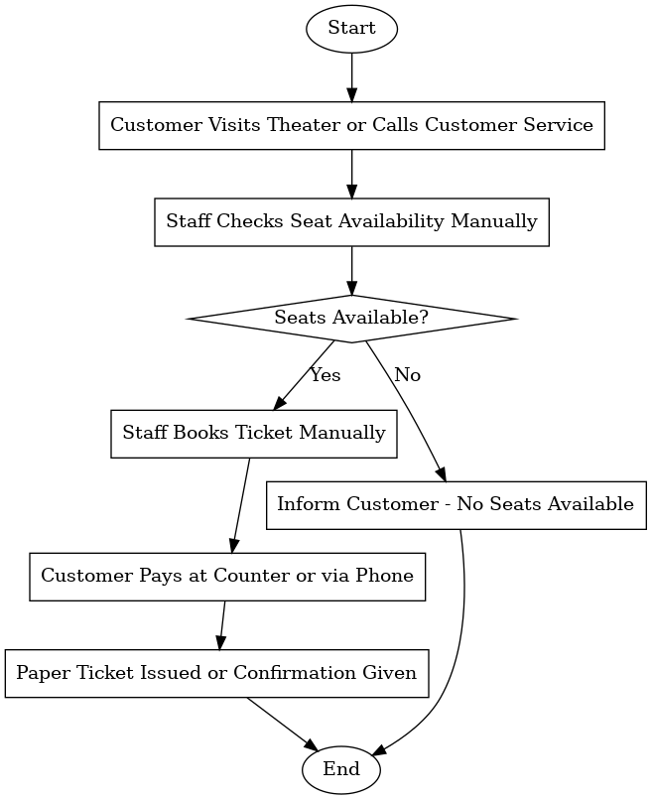

#### 8.2. Proposed Recommendations (TO-BE)

* Customers book tickets online with a real-time seat selection feature.
* Automated seat management ensures accurate availability.
* Theater admins can dynamically adjust pricing based on demand.
* Personalized recommendations improve customer engagement.
* Secure digital payments and instant ticket delivery via email/SMS.

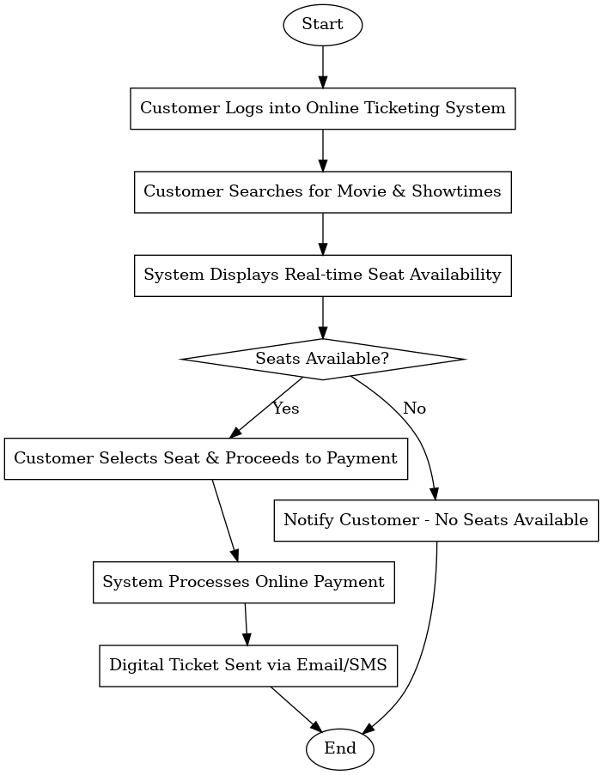

# **9. Business Requirements –**

|  |  |  |
| --- | --- | --- |
| ID | Requirement | Priority |
| BR1 | System must allow users to browse and book tickets online. | High |
| BR2 | Real-time seat availability updates must be shown to customers. | High |
| BR3 | Secure payment processing with multiple options. | High |
| BR4 | Customers must receive instant confirmation via SMS/Email. | High |
| BR5 | Theater admins must be able to manage movie schedules. | High |
| BR6 | Dynamic pricing based on demand must be implemented. | Medium |
| BR7 | Customer loyalty programs must be supported. | Medium |
| BR8 | Sales and booking analytics should be available for business insights. | Medium |

**Software Requirements Specification (SRS) -**

**Version 1.0**  
**Author:** Jhanvi

**1. Introduction**

The purpose of this document is to define the **Software Requirements Specification (SRS)** for the **Online Movie Ticketing System**. This system will provide a seamless and efficient way for customers to browse, book, and manage movie tickets online while ensuring smooth operations for theater administrators. The system will include web and mobile-based platforms with real-time updates on movie schedules and seat availability.

**2. Business Goals**

The primary goals of the **Online Movie Ticketing System** are:

1. **Enable seamless movie ticket booking** through an intuitive online platform.
2. **Automate theater management processes** such as seat allocation and schedule updates.
3. **Enhance customer engagement** with loyalty programs, personalized recommendations, and notifications.
4. **Provide data-driven insights** through sales analytics, customer behavior analysis, and performance reporting.

**3. Business Objectives**

* Ensure **real-time seat availability tracking** to prevent overbooking.
* Implement **secure payment gateways** for hassle-free transactions.
* Provide **multiple access platforms** (web and mobile applications).
* Offer **personalized movie recommendations** based on customer preferences.
* Automate **refund and rescheduling policies** in line with company guidelines.
* Generate **real-time reports and analytics** to help business decision-making.

**4. In-Scope Functionality**

* Online movie search and browsing.
* Seat selection based on availability.
* Secure online payment integration.
* Automated ticket booking confirmation via email/SMS.
* Theater schedule and seat management for admins.
* Dynamic pricing based on demand.
* Customer loyalty programs and promotional offers.
* AI-driven movie recommendations.
* Mobile app and web platform support.
* Real-time booking status tracking.

**5. Out-of-Scope Functionality**

* Physical ticket printing services.
* In-app food ordering and delivery inside theaters.
* Third-party advertisement integration.
* Virtual reality-based movie previews.
* Multi-language voice assistant support.

**6. Assumptions**

* Users will have stable internet access for seamless booking.
* The system will support both Android and iOS platforms.
* Secure payment processing with encryption will be implemented.
* The system will handle peak booking periods without performance issues.
* Customers will provide valid credentials for authentication.

**7. System Requirements**

**7.1 Functional Requirements**

1. The system shall allow users to **search for movies** based on title, genre, and location.
2. The system shall display **real-time seat availability** for each show.
3. The system shall allow users to **select and book seats** from an interactive seating chart.
4. The system shall integrate with **secure payment gateways** for online transactions.
5. The system shall **generate a digital ticket** and send it via email/SMS.
6. The system shall allow **customers to cancel or reschedule tickets** based on company policy.
7. The system shall provide **dynamic pricing options** based on demand.
8. The system shall support **customer login and account management**.
9. The system shall track **customer booking history** and suggest personalized recommendations.
10. The system shall allow **theater admins to manage movie schedules and pricing**.
11. The system shall notify users via **push notifications and emails** about upcoming shows and offers.
12. The system shall allow **loyalty rewards** and discount codes for customers.
13. The system shall generate **real-time revenue reports** for theater management.
14. The system shall support **multi-device compatibility** (desktop, mobile, and tablets).
15. The system shall log all **transactions and user activities** for auditing.
16. The system shall have a **role-based access control system** for different user levels.
17. The system shall support **integration with third-party analytics tools**.
18. The system shall allow customers to **rate and review movies** after watching.
19. The system shall have a **fail-safe mechanism** for preventing duplicate bookings.
20. The system shall have **auto-scaling capabilities** to handle peak booking periods.

**7.2 External Interface Requirements**

* **User Interfaces:** The system shall provide an intuitive interface with structured navigation, accessible screen layouts, and clear content presentation to enhance usability.
* **Hardware Interfaces:** The system shall support various device types such as desktops, mobile phones, and tablets, ensuring compatibility with different operating systems and screen resolutions.
* **Software Interfaces:** The system shall integrate with external software components such as payment gateways, database management systems, and analytics tools.
* **Communication Interfaces:** The system shall support automated email notifications, SMS alerts, and customer support chat functions to facilitate communication between users and administrators.

**7.3 Non-Functional Requirements**

1. The system shall have **99.9% uptime** to ensure continuous availability.
2. The system shall be **scalable** to support multiple theaters across different locations.
3. The system shall have an intuitive **user interface** for a seamless experience.
4. The system shall ensure **data privacy and compliance** with security standards.
5. The system shall process at least **1000 concurrent bookings** without performance degradation.

**8. Conclusion**

This SRS document defines the essential business and system requirements for the **Online Movie Ticketing System**. By implementing this solution, the company aims to enhance customer convenience, optimize theater management, and improve overall business efficiency. Further refinements and detailed design specifications will be developed during the implementation phase.

**3) Make an ERD of creating a Ticketing life cycle.**

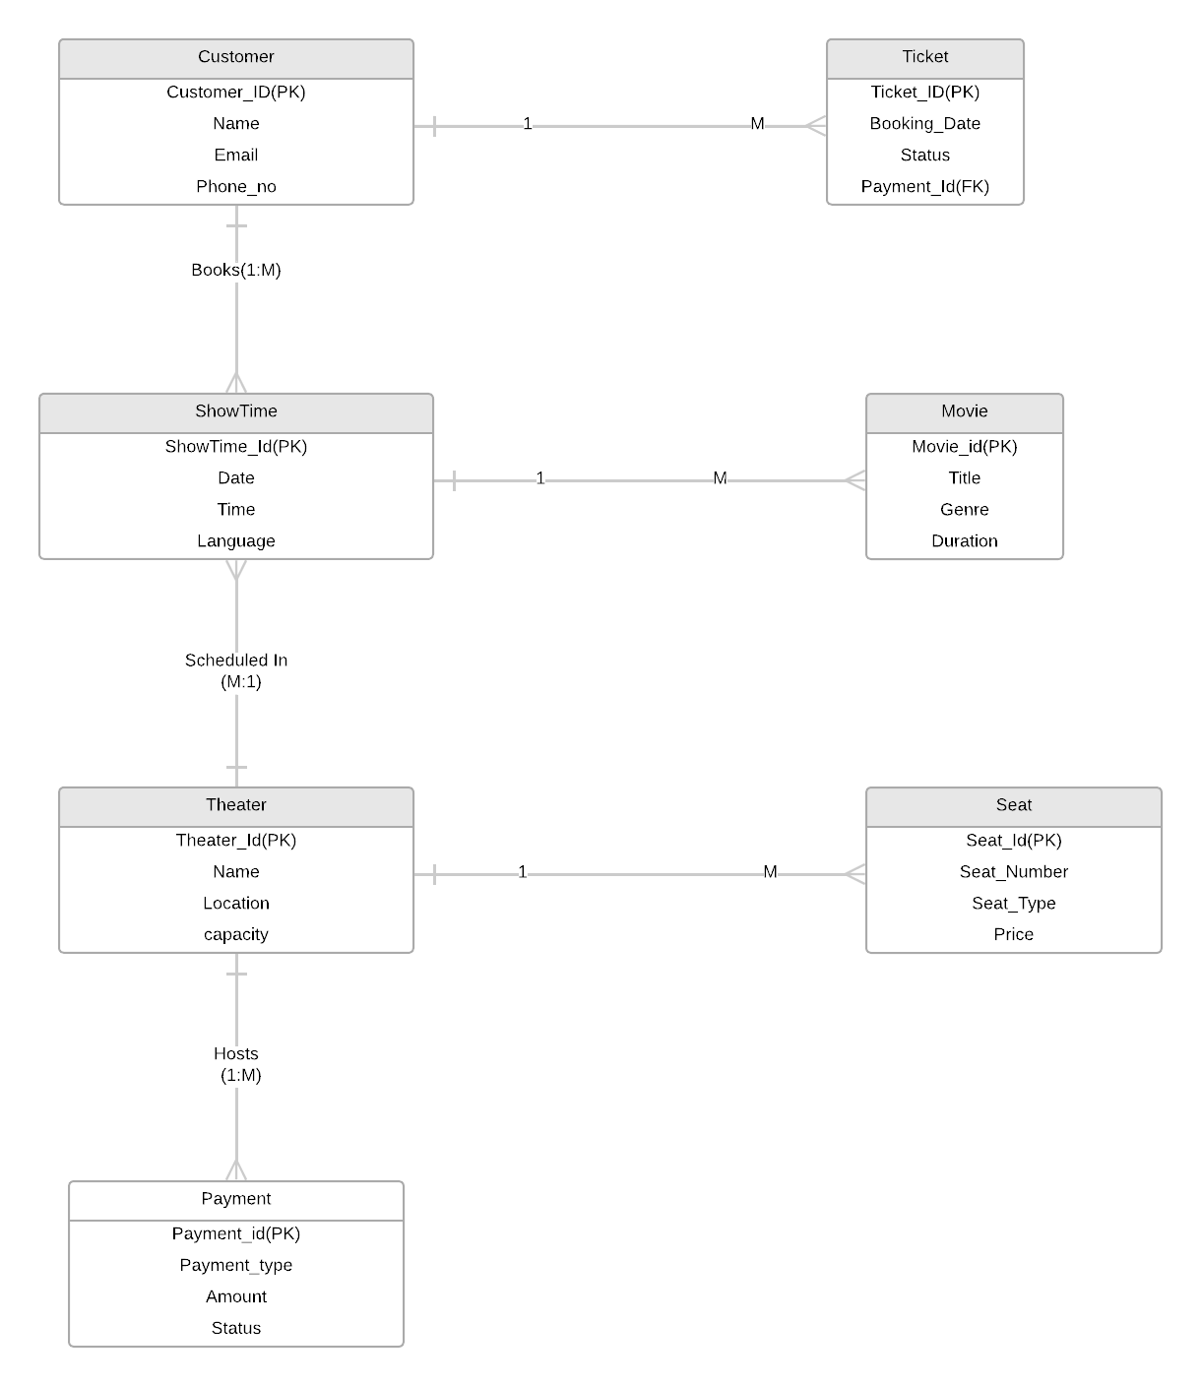

**4) User story of shopping from ecommerce.**

|  |  |  |  |
| --- | --- | --- | --- |
| User Story No – 1 | Task - 2 | | Priority- High |
| **As a user, I want to create an account using my email or social media account, so that I can access and shop on the platform.** | | | |
| BV – 500 | | CP - 2 | |
| Acceptance Criteria –   * User is able to register with email or social media login. * Account is created successfully, and confirmation email is sent.. | | | |

|  |  |  |  |
| --- | --- | --- | --- |
| User Story No – 2 | Task - 2 | | Priority- High |
| **As a user… I want to securely log in using my credentials or social media accounts so that I can access my personal dashboard and make purchases.** | | | |
| BV – 500 | | CP - 2 | |
| Acceptance Criteria –   * User can log in using email/password or social media login. * Login error message is shown in case of incorrect credentials. | | | |

|  |  |  |  |
| --- | --- | --- | --- |
| User Story No – 3 | Task - 4 | | Priority- High |
| **As a user… I want to search for products across different categories so that I can find the exact product I am looking for quickly.** | | | |
| BV – 200 | | CP - 2 | |
| Acceptance Criteria –   * Search bar is present on the homepage and easily accessible. * Products are displayed according to search query. | | | |

|  |  |  |  |
| --- | --- | --- | --- |
| User Story No – 4 | Task - 4 | | Priority- Medium |
| **As a user, I want to filter products by category like clothing, home decor, or skincare so that I can quickly browse through relevant products.** | | | |
| BV – 100 | | CP - 2 | |
| Acceptance Criteria –   * Categories are listed clearly. * Products are filtered based on selected category. | | | |

|  |  |  |  |
| --- | --- | --- | --- |
| User Story No – 5 | Task - 3 | | Priority- High |
| **As a user, I want to view detailed information for each product so that I can decide if it suits my needs.** | | | |
| BV – 200 | | CP – 3 | |
| Acceptance Criteria –   * Product page shows detailed descriptions, images, and price. * Availability status (in stock/out of stock) is shown. | | | |

|  |  |  |  |
| --- | --- | --- | --- |
| User Story No – 6 | Task - 4 | | Priority- High |
| **As a user, I want to place an order for the product I’ve selected so that I can purchase and receive it at my desired address.** | | | |
| BV – 200 | | CP - 3 | |
| Acceptance Criteria –   * Add to cart functionality is available. * Order is successfully placed with a confirmation email. | | | |

|  |  |  |  |
| --- | --- | --- | --- |
| User Story No – 7 | Task - 5 | | Priority- High |
| **As a user, I want to pay using my preferred method (credit/debit, UPI, e-wallets, COD) so that I can complete my purchase easily.** | | | |
| BV – 500 | | CP - 5 | |
| Acceptance Criteria –   * Multiple payment options are available during checkout. * Transaction is successful, and order confirmation is sent. | | | |

|  |  |  |  |
| --- | --- | --- | --- |
| User Story No – 8 | Task - 3 | | Priority- High |
| **As a user, I want to track my order after it’s placed so that I can know when to expect delivery** | | | |
| BV – 200 | | CP - | |
| Acceptance Criteria –   * Tracking information is updated in real-time. * User receives notifications for order status changes. | | | |

|  |  |  |  |
| --- | --- | --- | --- |
| User Story No – 9 | Task - 4 | | Priority- High |
| **As a user, I want to cancel my order before it’s shipped so that I am not charged for an order I no longer want** | | | |
| BV – 100 | | CP - 2 | |
| Acceptance Criteria –   * Option to cancel the order before dispatch is available. * Confirmation email is sent once the order is canceled. | | | |

|  |  |  |  |
| --- | --- | --- | --- |
| User Story No – 10 | Task - 2 | | Priority- Medium |
| **As a user, I want to give feedback and rate the products I bought so that I can share my experience and help other customers.** | | | |
| BV – 50 | | CP - 1 | |
| Acceptance Criteria –   * Option to leave feedback and rating is available on the product page. * Ratings and feedback are displayed publicly after submission. | | | |

|  |  |  |  |
| --- | --- | --- | --- |
| User Story No – 11 | Task - 2 | | Priority- Low |
| **As a user, I want to log out securely from my account so that no one can misuse my personal information.** | | | |
| BV – 50 | | CP - 1 | |
| Acceptance Criteria –   * Logout button is easily visible and accessible. * User is logged out and redirected to the homepage. | | | |

|  |  |  |  |
| --- | --- | --- | --- |
| User Story No – 12 | Task - 3 | | Priority- High |
| **As a business owner… I want to view sales, revenue, and performance metrics so that I can monitor and optimize my business operations.** | | | |
| BV – 200 | | CP - 3 | |
| Acceptance Criteria –   * Dashboard shows sales, revenue, and key metrics. * Data is updated in real-time. | | | |

|  |  |  |  |
| --- | --- | --- | --- |
| User Story No – 13 | Task - 4 | | Priority- High |
| **As a business owner… I want to add, update, or delete products so that I can maintain an up-to-date product catalog.** | | | |
| BV – 200 | | CP - 3 | |
| Acceptance Criteria –   * Products can be added, updated, or deleted. * Changes are reflected in the product catalog. | | | |

|  |  |  |  |
| --- | --- | --- | --- |
| User Story No – 14 | Task - 3 | | Priority- Medium |
| **As a business owner… I want to view a history of all orders placed by customers so that I can analyze trends and make business decisions.** | | | |
| BV – 100 | | CP - 3 | |
| Acceptance Criteria –   * Order history is displayed with order date, customer details, and status. * Data can be filtered by date range and customer. | | | |

|  |  |  |  |
| --- | --- | --- | --- |
| User Story No – 15 | Task - 3 | | Priority- Medium |
| **As a business owner… I want to create and manage discount codes for products so that I can offer promotions to customers.** | | | |
| BV – 100 | | CP - 2 | |
| Acceptance Criteria –   * Discount codes can be created, applied, and tracked. * Discounts are applied correctly during checkout. | | | |

|  |  |  |  |
| --- | --- | --- | --- |
| User Story No – 16 | Task - 3 | | Priority- High |
| **As a delivery partner… I want to see all the orders assigned to me so that I can track and manage deliveries efficiently.** | | | |
| BV – 200 | | CP - | |
| Acceptance Criteria –   * Dashboard shows list of assigned orders. * Status of each order can be updated. | | | |

|  |  |  |  |
| --- | --- | --- | --- |
| User Story No – 17 | Task - 3 | | Priority- High |
| **As a delivery partner… I want to update the status of deliveries (e.g., picked up, in transit, delivered) so that the customer and business owner are informed in real time.** | | | |
| BV – 200 | | CP - 3 | |
| Acceptance Criteria –   * Delivery status can be updated in real-time. * Customer and business owner are notified of status changes. | | | |

|  |  |  |  |
| --- | --- | --- | --- |
| User Story No – 18 | Task - 3 | | Priority- High |
| **As a retail manager… I want to view product sales data so that I can manage inventory and track product performance.** | | | |
| BV – 100 | | CP - 2 | |
| Acceptance Criteria –   * Sales data is displayed for each product. * Data can be filtered by date and product category. | | | |

|  |  |  |  |
| --- | --- | --- | --- |
| User Story No – 19 | Task - 2 | | Priority- High |
| **As a retail manager… I want to update product inventory levels so that I can manage stock and ensure products are available.** | | | |
| BV – 100 | | CP - 2 | |
| Acceptance Criteria –   * Inventory levels can be updated for each product. * Changes are reflected in the product catalog. | | | |

|  |  |  |  |
| --- | --- | --- | --- |
| User Story No – 20 | Task - 5 | | Priority- High |
| **As a retail manager… I want to view and manage all customer orders so that I can ensure timely fulfillment and delivery.** | | | |
| BV – 200 | | CP - 3 | |
| Acceptance Criteria –   * Orders are listed by status (pending, in process, delivered). * Orders can be updated or canceled if needed | | | |

|  |  |  |  |
| --- | --- | --- | --- |
| User Story No – 21 | Task - 4 | | Priority- Medium |
| **As a retail manager… I want to generate sales and inventory reports so that I can make informed decisions about stock and sales strategies.** | | | |
| BV – 200 | | CP - 3 | |
| Acceptance Criteria –   * Reports can be generated for sales, inventory, and customer behavior. * Reports are downloadable and shareable. | | | |

|  |  |  |  |
| --- | --- | --- | --- |
| User Story No – 22 | Task - 3 | | Priority- High |
| **As a user… I want to view my past orders so that I can reorder items or track delivery status.** | | | |
| BV – 100 | | CP - 2 | |
| Acceptance Criteria –   * Order history is accessible from the user profile. * Past orders are displayed with status and details. | | | |

|  |  |  |  |
| --- | --- | --- | --- |
| User Story No – 23 | Task - 2 | | Priority- Low |
| **As a user… I want to update my profile information so that my delivery details are accurate and up-to-date.** | | | |
| BV – 50 | | CP - 1 | |
| Acceptance Criteria –   * User can update name, email, phone, and address. * Changes are saved and reflected on the profile. | | | |

|  |  |  |  |
| --- | --- | --- | --- |
| User Story No – 24 | Task - 3 | | Priority- High |
| **As a business owner… I want to manage users (e.g., staff, partners) so that I can control access to various business functionalities.** | | | |
| BV – 200 | | CP - 3 | |
| Acceptance Criteria –   * Users can be added, updated, or removed. * Roles and permissions are set for each user | | | |

|  |  |  |  |
| --- | --- | --- | --- |
| User Story No – 25 | Task - 2 | | Priority- High |
| **As a delivery partner… I want to mark an order as delivered so that the system reflects the current status and the customer is notified.** | | | |
| BV – 100 | | CP - 2 | |
| Acceptance Criteria –   * Delivery can be marked as completed. * Customer receives notification about the delivery status. | | | |

|  |  |  |  |
| --- | --- | --- | --- |
| User Story No – 26 | Task - 3 | | Priority- Medium |
| **As a retail manager… I want to view order details, including items, customer information, and delivery address so that I can process orders efficiently.** | | | |
| BV – 100 | | CP - 2 | |
| Acceptance Criteria –   * Order details include product information, customer address, and contact. * Order history is updated with statuses. | | | |

|  |  |  |  |
| --- | --- | --- | --- |
| User Story No – 27 | Task - 2 | | Priority- Medium |
| **As a user… I want to request support through live chat or email so that I can get assistance with my issues.** | | | |
| BV – 100 | | CP - 1 | |
| Acceptance Criteria –   * Live chat or email support is available for customers. * A confirmation message is sent acknowledging the request | | | |

|  |  |  |  |
| --- | --- | --- | --- |
| User Story No – 28 | Task - 2 | | Priority- High |
| **As a user… I want to track my order in real-time so that I can know the current status and estimated delivery time.** | | | |
| BV – 200 | | CP - 3 | |
| Acceptance Criteria –   * The order status is updated in real-time. * Tracking information includes location, time, and delivery updates. | | | |

|  |  |  |  |
| --- | --- | --- | --- |
| User Story No – 29 | Task - 2 | | Priority- Medium |
| **As a user… I want to cancel my order before it is processed or delivered so that I am not charged for an unwanted order.** | | | |
| BV – 100 | | CP - 2 | |
| Acceptance Criteria –   * Cancellation option is available before the order is dispatched. * Confirmation of cancellation is sent to the user. | | | |

|  |  |  |  |
| --- | --- | --- | --- |
| User Story No – 30 | Task - 2 | | Priority- Low |
| **As a user… I want to provide feedback and rate my order so that I can share my experience and help improve the service.** | | | |
| BV – 50 | | CP - 1 | |
| Acceptance Criteria –   * Users can rate products or services from 1 to 5 stars. * Feedback text is optional and submitted with ratings. | | | |

|  |  |  |  |
| --- | --- | --- | --- |
| User Story No – 31 | Task - 4 | | Priority- Medium |
| **As a business owner… I want to create, update, or remove product categories so that the product catalog is well-organized.** | | | |
| BV – 100 | | CP - 2 | |
| Acceptance Criteria –   * Categories can be added, updated, or removed. * Products are categorized accordingly. | | | |

|  |  |  |  |
| --- | --- | --- | --- |
| User Story No – 32 | Task - 2 | | Priority- High |
| **As a business owner… I want to analyze sales performance across different categories and time periods so that I can make data-driven decisions..** | | | |
| BV – 200 | | CP - 3 | |
| Acceptance Criteria –   * Sales analytics include total sales, category performance, and time-based reports. * Reports can be exported in CSV or PDF formats. | | | |

|  |  |  |  |
| --- | --- | --- | --- |
| User Story No – 33 | Task - 3 | | Priority- Medium |
| **As a delivery partner… I want to assign myself to orders so that I can manage my deliveries independently.** | | | |
| BV – 100 | | CP – 2 | |
| Acceptance Criteria –   * Available orders are listed with details. * Delivery partners can select and assign themselves to orders.. | | | |

|  |  |  |  |
| --- | --- | --- | --- |
| User Story No – 34 | Task - 2 | | Priority- High |
| **As a delivery partner… I want to mark an order as picked up so that the system reflects the current status of the order.** | | | |
| BV – 100 | | CP - 2 | |
| Acceptance Criteria –   * Delivery status is updated to "Picked Up." * Customer is notified of the status change. | | | |

|  |  |  |  |
| --- | --- | --- | --- |
| User Story No – 35 | Task - 2 | | Priority- Medium |
| **As a retail manager… I want to view the inventory status of each product so that I can manage stock levels effectively.** | | | |
| BV – 100 | | CP - 2 | |
| Acceptance Criteria –   * Inventory levels are displayed for each product. * The status is updated in real-time. | | | |

|  |  |  |  |
| --- | --- | --- | --- |
| User Story No – 36 | Task - 2 | | Priority- Medium |
| **As a retail manager… I want to process returns and exchanges for customers so that I can maintain customer satisfaction and manage product quality.** | | | |
| BV – 100 | | CP - 2 | |
| Acceptance Criteria –   * Return and exchange requests can be approved or denied. * Return and exchange policies are visible to customers. | | | |

|  |  |  |  |
| --- | --- | --- | --- |
| User Story No – 37 | Task - 3 | | Priority- Low |
| **As a user… I want to view recommended products based on my browsing and purchase history so that I can discover new products that match my preferences.** | | | |
| BV – 50 | | CP - 1 | |
| Acceptance Criteria –   * Product recommendations are displayed on the homepage or product page. * Recommendations are based on previous browsing and purchase behavior. | | | |

|  |  |  |  |
| --- | --- | --- | --- |
| User Story No – 38 | Task - 2 | | Priority- Medium |
| **As a business owner… I want to define shipping options (e.g., standard, express) so that customers have various delivery choices.** | | | |
| BV – 100 | | CP - 2 | |
| Acceptance Criteria –   * Shipping options can be added, updated, or removed. * Options are available for customers during checkout. | | | |

|  |  |  |  |
| --- | --- | --- | --- |
| User Story No – 39 | Task - 2 | | Priority- Medium |
| **As a business owner… I want to view detailed customer data (e.g., purchase history, preferences) so that I can tailor promotions and services.** | | | |
| BV – 200 | | CP - 3 | |
| Acceptance Criteria –   * Customer data can be accessed and filtered by various criteria. * Data is secure and complies with privacy regulations. | | | |

|  |  |  |  |
| --- | --- | --- | --- |
| User Story No – 40 | Task - 2 | | Priority- High |
| **As a delivery partner… I want to view my delivery route and directions so that I can deliver products efficiently and on time.** | | | |
| BV – 200 | | CP - 3 | |
| Acceptance Criteria –   * The delivery route is displayed with optimized directions. * Real-time traffic data is integrated into the route. | | | |

|  |  |  |  |
| --- | --- | --- | --- |
| User Story No – 41 | Task - 2 | | Priority- Medium |
| **As a retail manager… I want to track product performance metrics (e.g., sales, returns, stock-outs) so that I can make informed decisions about inventory and pricing.** | | | |
| BV – 100 | | CP - 2 | |
| Acceptance Criteria –   * Metrics like sales and returns are displayed for each product. * Product performance data is updated in real-time. | | | |

|  |  |  |  |
| --- | --- | --- | --- |
| User Story No – 42 | Task - 2 | | Priority- Low |
| **As a user… I want to log out of the application securely so that my account information is protected.** | | | |
| BV – 50 | | CP - 1 | |
| Acceptance Criteria –   * A logout option is available in the user profile menu. * The user is securely logged out, and session data is cleared. | | | |