**Assignment 1**

**#1 Please make a BRD which can be presented to the client along with complete development and resource plan.**

**Business Requirement Document –** It is a blue print of the total project. It keeps the alignment of the project and that every stakeholder is on one boat. We will take approval from the stakeholders for BRD. It gives total a to z clarity in the project.

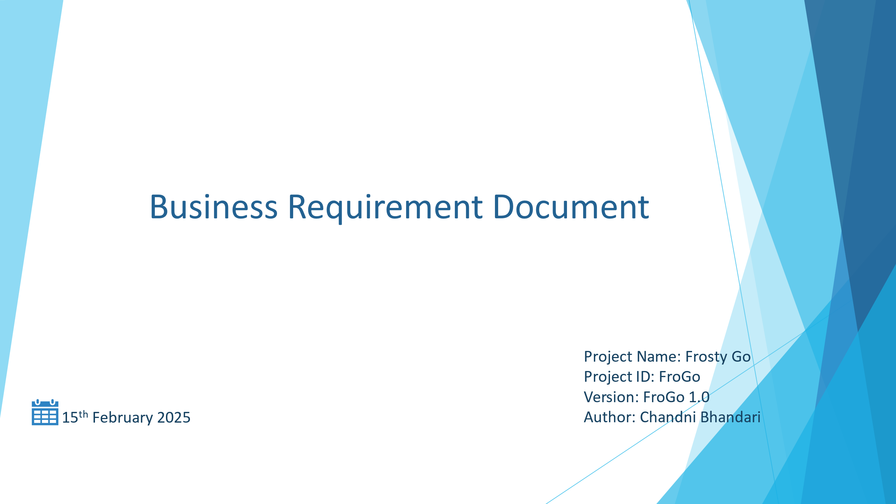

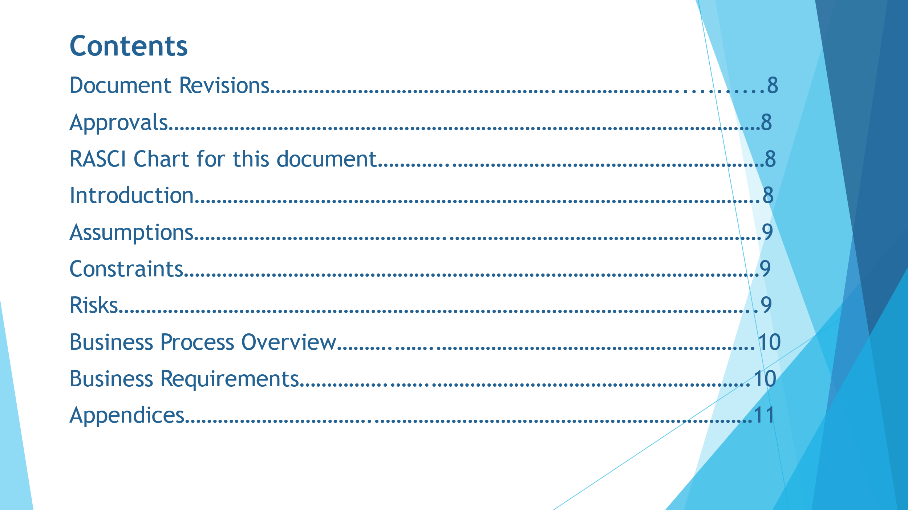

1. **Document Revisions**

| Date | Version Number | Document Changes |
| --- | --- | --- |
| 15/02/2025 | 1.0 | Initial Draft |
|  |  |  |
|  |  |  |

**2. Approvals**

| **Role** | **Name** | **Title** | **Signature** | **Date** |
| --- | --- | --- | --- | --- |
| Project Sponsor | Frosty Go |  |  | 15/02/2025 |
| Business Owner | Vikas Jaiswal |  |  |  |
| Project Manager | Mayank Lodha |  |  |  |
| System Architect | Mike |  |  |  |
| Development Lead | Juhi Singh |  |  |  |
| User Experience Lead | Ankit Jain |  |  |  |
| Quality Lead | Gayatri Kulkarni |  |  |  |
| Content Lead | Nikhil Anupare |  |  |  |

1. **RASCI Chart for this document**

The RACI chart identifies the persons who need to be contacted whenever changes are made to this document. RACI stands for responsible, accountable, consulted, and informed. These are the main codes that appear in a RACI chart, used here to describe the roles played by team members and stakeholders in the production of the BRD. They are adapted from charts used to assign roles and responsibilities during a project.

The following describes the full list of codes used in the table:

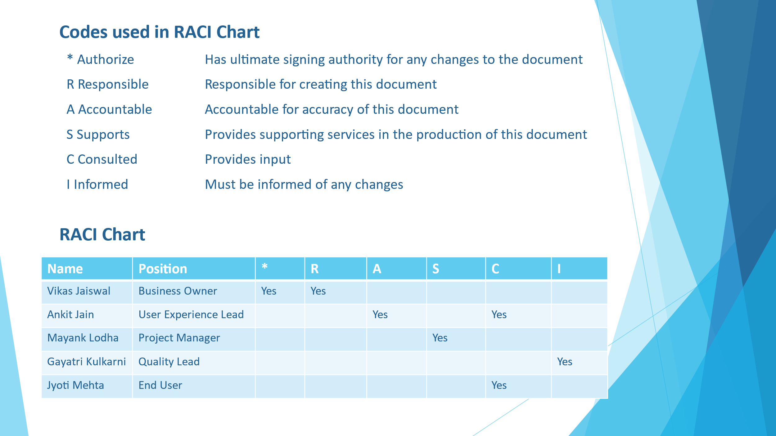

1. **INTRODUCTION**
   1. **Business Goals:** To develop a software to manage the inventory and fastest delivery of the products to the customers. This software will keep a track of all the inventory and help in making faster deliveries.
   2. **Business Objectives:**

* To provide an IT solution for streamlining and automating the entire inventory management and seamless delivery experience ensuring efficiency, accuracy, compliance and customer satisfaction.
* To develop an application for android and iOS and a web page.
* To develop inventory management system for automated orders.
* To develop a dedicated unit for assistance to the customers.
  1. **Business Rules**: Ensure fresh and fast delivery of premium dairy and ice cream products through efficient inventory management and optimized logistics.
  2. **Background:** Currently Frosty Go is keeping a manual track of all the inventories resulting in delayed delivery to the customers. Also, timely orders cannot be placed due to manual tracking.
  3. **Project Objective:** Develop an intelligent software solution to efficiently manage inventory and optimize delivery logistics, ensuring the freshest dairy and ice cream products reach customers in the shortest time possible.
  4. **Project Scope:** The project aims to develop an integrated software solution for managing inventory and optimizing delivery logistics to ensure fresh and timely distribution of ice cream and dairy products.
     1. **In Scope Functionality:**
* Inventory management
* Order and Delivery management
* Customer management
* Reporting and analytics
* System Integration
  + 1. **Out Scope Functionality:**
* Manufacturing process automation.
* Direct customer deliveries (if handled by third-party delivery services).
* International logistics (initially focused on national operations).
* Retail store inventory management (focused on warehouses & distribution centres).

1. **ASSUMPTIONS**

* The company has multiple manufacturing plants and warehouses across the country.
* Warehouses will act as distribution centres, not retail stores.
* Orders can be fulfilled from the nearest warehouse based on stock availability.
* The company operates in a single country (international expansion is not in scope for now).
* Real-time tracking of raw materials and finished goods is required.
* All products follow FIFO (First In, First Out) to minimize waste.
* System will auto-generate restocking alerts based on demand and stock levels.

1. **CONSTRAINTS**

* Challenges in designing a system capable of handling future international deliveries as well traffic without significant reengineering
* Adhering to regulatory requirements that may vary across regions and jurisdictions
* High costs associated with advanced features and third-party integrations
* Budget constraints as SME or Developers may quit and replacement will be required with the same skill set.

1. **RISKS:** A riskis something that could affect the success or failure of a project.
   1. **Technological Risk:** Disruptions in order processing & tracking, data security breach, scalability issues, delayed deliveries
   2. **Political Risk:** Frequent changes in taxation and compliance requirements can disrupt the functionality and require costly updates or reconfigurations.
   3. **Business Risk:**

* The initial cost of developing and customizing the software may exceed budgeted limits affecting the company’s financial stability
* If the software does not deliver expected efficiency, cost savings or revenue growth, it could result in financial losses
* Overstocking and stockouts
  1. **Requirement Risk:** Requirements gathering was not done properly due to stakeholders are not fully aware about the requirements
  2. **BA Risk:**
* Unable to understand the requirements
* Proper documentation not done
* Lack of knowledge of IT domain
* Communication gap between the stakeholders
  1. **Project Risk:**
* Employees struggle to use the system
* Inventory errors and product wastage
* Delivery Delays Due to Weather or Traffic
* Payment failures and order cancellations
* Customer service issues
  1. **Other Risk:** Access needs to be given with expectation that the customer information is secure and there will be no theft of information.

1. **BUSINESS PROCESS OVERVIEW**
   1. **Legacy System (AS-IS):**

* Inventory is tracked manually or using spreadsheets.
* Limited automation leads to stock discrepancies.
* Expiry date management is inefficient, leading to wastage.
* Restocking is done manually based on past trends.
* No real-time demand prediction, leading to overstocking or stockouts.
* Customers place orders via phone, email, or sales representatives.
* Orders are manually entered into a basic system or spreadsheet.
* Deliveries are scheduled manually, with no AI-based route optimization.
* Drivers rely on experience or static maps, leading to delays.
* Temperature-sensitive products are transported, but monitoring is manual.
* Any temperature breaches are identified too late, leading to spoilage.
* Customers do not receive live tracking of their orders.
* Delays often lead to customer complaints and dissatisfaction.
  1. **Proposed Recommendations (TO-BE):**
* A centralized inventory management system (IMS) tracks stock in real-time across all warehouses.
* RFID/barcode scanning ensures accurate stock updates.
* Expiry dates are auto-monitored, and FIFO (First In, First Out) is strictly followed.
* The system automatically suggests purchase orders for raw materials before stockouts occur.
* Alerts notify warehouse managers when stock levels fall below the threshold.
* Customers place orders via a mobile app, website, or integrated sales system.
* Orders are instantly validated and assigned to the nearest warehouse with stock availability.
* The system generates invoices automatically and sends them via email or SMS.
* Multiple payment options (UPI, credit/debit cards, wallets, COD) are available.
* Payment confirmation is real-time, reducing processing delays.

**#2 Prepare process flow diagram using your imagination.**

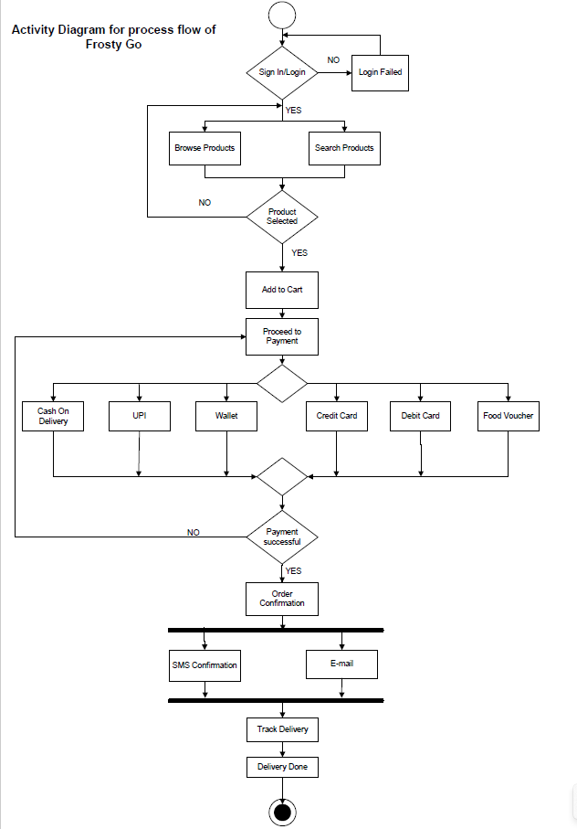

**Assignment 2**

**#1 Write an introduction letter to a client introducing yourself as a business analyst in charge of working with the client and his team to start the business understanding process.**

**Subject:** Introduction as Your Business Analyst for the Business Understanding Process

Dear Frosty Go,

I hope this email finds you well. My name is Chandni Bhandari, and I am pleased to introduce myself as the Business Analyst assigned to work with you and your team as we embark on this exciting journey together.

As part of my role, I will be working closely with you to understand your business objectives, challenges, and requirements to ensure we develop a solution that aligns perfectly with your vision. Our initial focus will be on conducting a comprehensive business understanding process, which includes:

* Gathering key insights into your current operations and pain points.
* Identifying and defining business needs and process improvements.
* Collaborating with stakeholders to ensure alignment between business goals and technology solutions.
* Laying the foundation for a structured and efficient project roadmap.

I look forward to building a strong partnership with you and your team. Please let me know a convenient time when we can schedule our first discussion. In the meantime, feel free to reach out if you have any questions or specific points you would like to address.

I am excited to get started and look forward to working with you!

Best regards,  
Chandni Bhandari  
Business Analyst  
XYZ Limited

**#2 Prepare a brief BRD and SRS for a project- Ticketing system.**

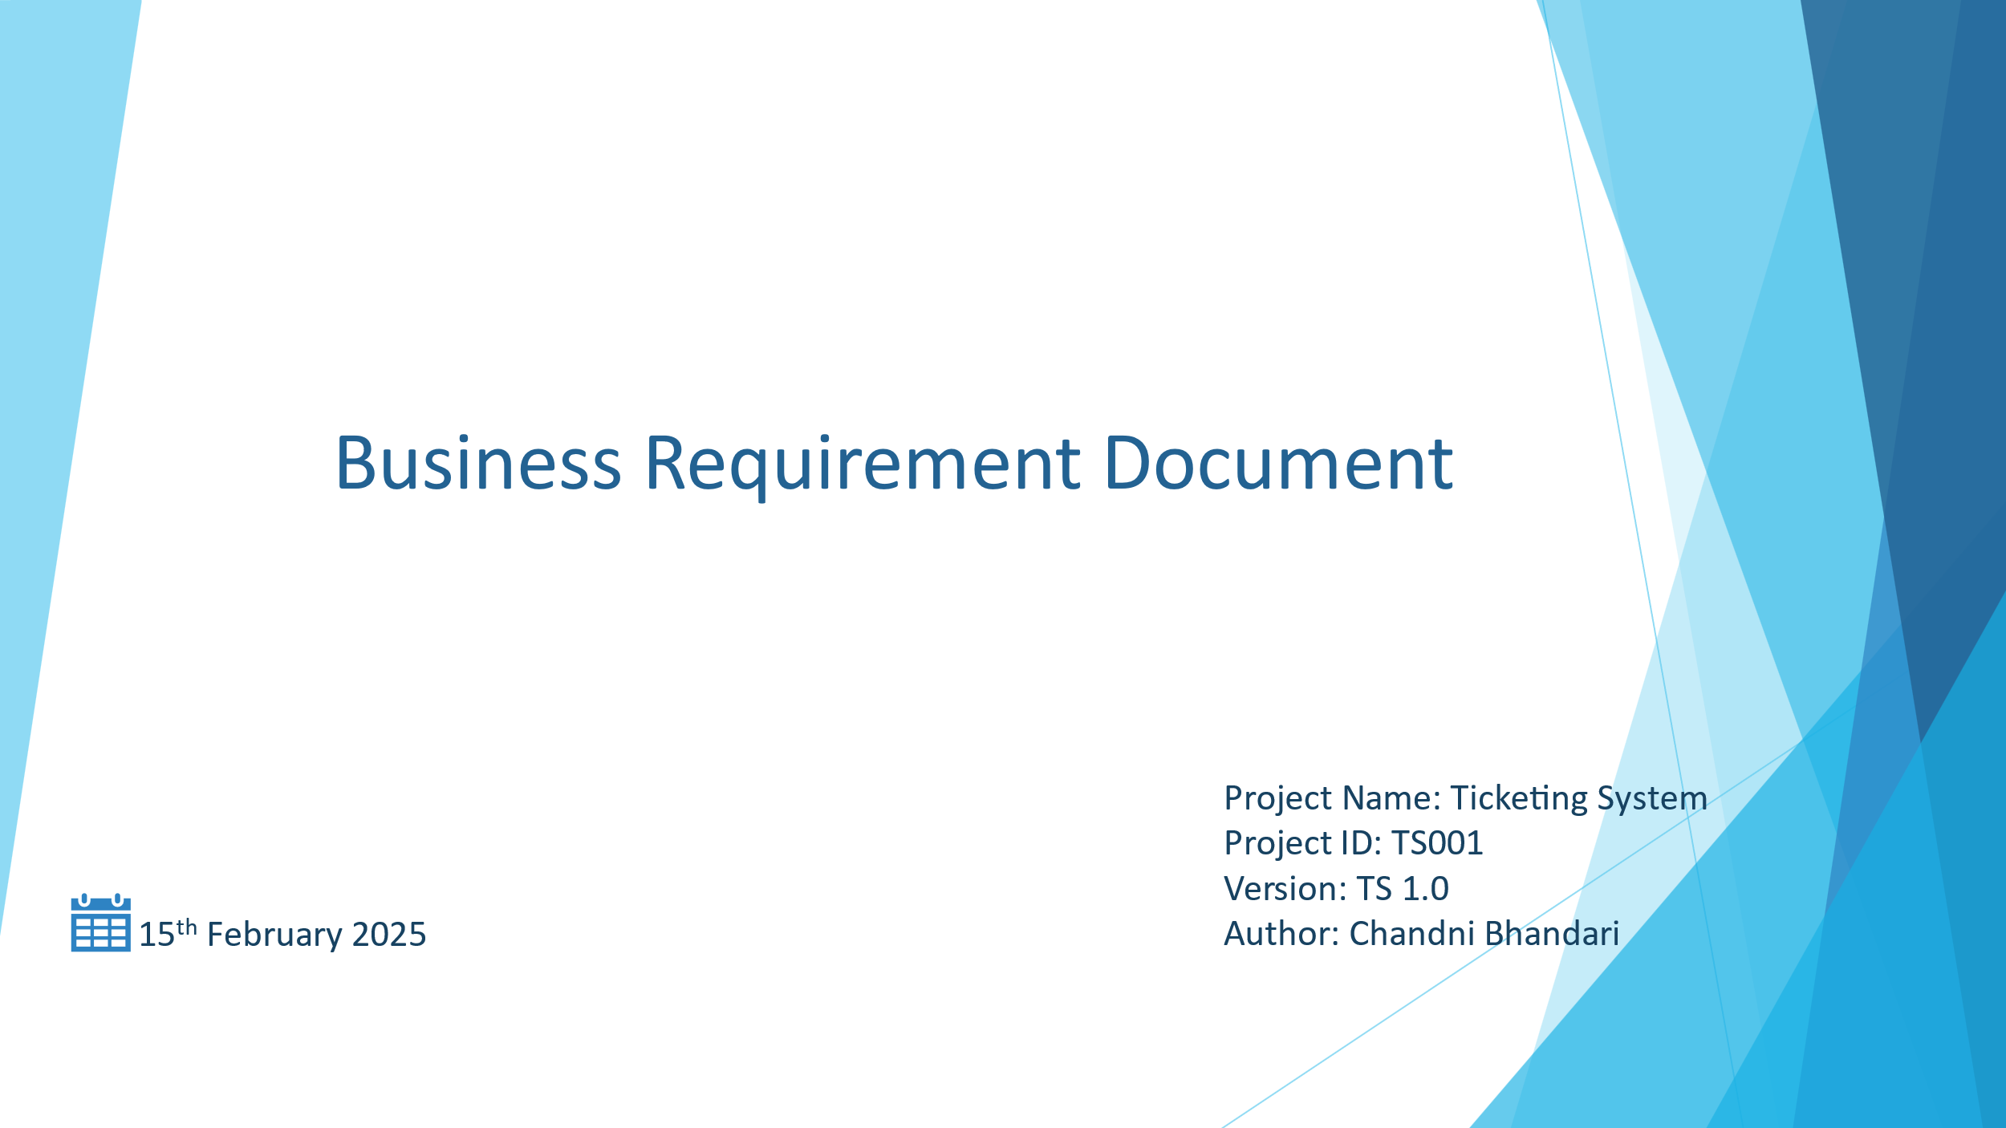



1. **Document Revisions**

| Date | Version Number | Document Changes |
| --- | --- | --- |
| 15/02/2025 | 1.0 | Initial Draft |
|  |  |  |
|  |  |  |

**2. Approvals**

| **Role** | **Name** | **Title** | **Signature** | **Date** |
| --- | --- | --- | --- | --- |
| Project Sponsor | Ticketing System |  |  | 15/02/2025 |
| Business Owner | Vikas Jaiswal |  |  |  |
| Project Manager | Mayank Lodha |  |  |  |
| System Architect | Mike |  |  |  |
| Development Lead | Juhi Singh |  |  |  |
| User Experience Lead | Ankit Jain |  |  |  |
| Quality Lead | Gayatri Kulkarni |  |  |  |
| Content Lead | Nikhil Anupare |  |  |  |

1. **RASCI Chart for this document**

The RACI chart identifies the persons who need to be contacted whenever changes are made to this document. RACI stands for responsible, accountable, consulted, and informed. These are the main codes that appear in a RACI chart, used here to describe the roles played by team members and stakeholders in the production of the BRD. They are adapted from charts used to assign roles and responsibilities during a project.

The following describes the full list of codes used in the table:



1. **INTRODUCTION**
   1. **Business Goals:**
   * Improve customer satisfaction by ensuring faster response and resolution times.
   * Automate ticket management to reduce manual efforts and operational costs.
   * Provide real-time tracking and notifications for transparency and accountability.
   * Enhance reporting and analytics to improve decision-making.
   * Ensure scalability and security to support growing business needs.
   1. **Business Objectives:** The primary objective of this project is to develop a Ticketing System that enables users to create, track, and manage tickets efficiently. This system will enhance customer support, improve response times, and streamline communication between customers and support teams.
   2. **Business Rules**:

* Customers can only update or add comments to tickets they have submitted.
* High-priority tickets must be escalated automatically if not resolved within a specified timeframe.
* Only administrators have the authority to delete tickets or modify system settings.
* System notifications must be sent to customers and agents upon ticket status updates.
* Service Level Agreements (SLAs) must be enforced, ensuring timely resolution of tickets.
  1. **Background:** Many organizations struggle with managing customer inquiries and internal support requests due to a lack of a centralized system. This leads to delayed responses, unresolved issues, and poor tracking mechanisms. To address these challenges, the proposed Ticketing System will provide a streamlined, automated, and transparent approach to managing tickets, ensuring better issue resolution and customer service.

* 1. **Project Objective:** The objective of this project is to design and implement a comprehensive Ticketing System that enhances issue tracking, automates ticket management, and improves response efficiency.
  2. **Project Scope:** The Ticketing System will be designed to support organizations in handling customer inquiries, IT support requests, and internal issue tracking. 
     1. **In Scope Functionality:**
* Development of a web-based ticketing platform accessible to customers, support agents, and administrators.
* Ticket lifecycle management including creation, assignment, tracking, and closure.
* Automated workflows for ticket prioritization, assignment, and escalation.
* Role-based access control to ensure security and restricted access.
* Integration with email and SMS notifications to inform users of ticket updates.
* Comprehensive reporting and analytics
* Multi-channel support, including web, email, and chatbot-based ticket submission.
* Cloud-based hosting for scalability and availability.
  + 1. **Out Scope Functionality:**
* Development of a mobile application (to be considered in future phases).
* AI-driven predictive analytics and chatbots (future enhancements).
* Integration with third-party CRM or ERP systems (unless explicitly requested by stakeholders).
* Support for multiple languages beyond English in the initial release.

1. **ASSUMPTIONS**

* Users have basic knowledge of using a web application.
* The system will be hosted on a cloud platform.
* The system will integrate with existing email and communication tools.

1. **CONSTRAINTS**

* The initial version will only support English language.
* The system must comply with data security and privacy regulations.

1. **RISKS:** A riskis something that could affect the success or failure of a project.
   1. **Technological Risk:** Disruptions in order processing & tracking, data security breach, scalability issues, delayed deliveries
   2. **Political Risk:** Frequent changes in taxation and compliance requirements can disrupt the functionality and require costly updates or reconfigurations.
   3. **Business Risk:**

* The initial cost of developing and customizing the software may exceed budgeted limits affecting the company’s financial stability
* If the software does not deliver expected efficiency, cost savings or revenue growth, it could result in financial losses
  1. **Requirement Risk:** Requirements gathering was not done properly due to stakeholders are not fully aware about the requirements
  2. **BA Risk:**
* Unable to understand the requirements
* Proper documentation not done
* Lack of knowledge of IT domain
* Communication gap between the stakeholders
  1. **Project Risk:**
* Employees struggle to use the system
* Slow response times can affect user experience
* Unforeseen expenses may exceed budget
* Payment failures and order cancellations
* Customer service issues
  1. **Other Risk:** Access needs to be given with expectation that the customer information is secure and there will be no theft of information.

1. **BUSINESS PROCESS OVERVIEW**
   1. **Legacy System (AS-IS):**

* Email-based communication, where customers and employees report issues via email, leading to unstructured tracking and delays.
* Manual assignment of tickets, resulting in inefficiencies and lack of accountability.
* Spreadsheets for tracking, which lacks real-time updates and automation.
* No automated escalation process, causing SLA breaches and unresolved issues.
* Limited reporting and analytics, making it difficult to track trends, measure performance, and improve service levels.
  1. **Proposed Recommendations (TO-BE):**
* Provide a centralized web-based platform for ticket submission, tracking, and resolution.
* Implement automated ticket assignment based on predefined rules.
* Enable real-time notifications via email and SMS for better communication.
* Introduce service-level agreements (SLAs) to ensure timely resolution.
* Offer role-based access control for better security and data protection.
* Provide advanced reporting and analytics to track performance metrics and customer satisfaction.

**#3 Make an ERD of creating a support ticket/Ticketing life cycle.**

**ER Diagram:** An entity-relationship diagram is a visual representation of the relationships between entities in a database. It shows the entities (tables), attributes (fields) and relationship between them.

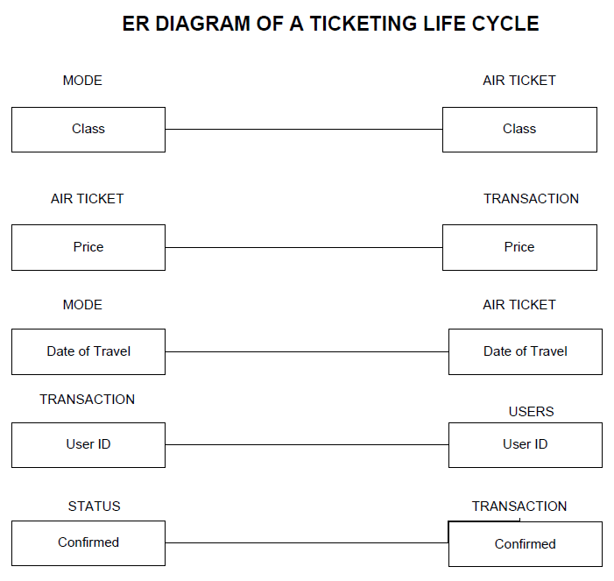

**#4 User story of shopping from ecommerce.**

| User Story No. 1 | Tasks: 4 | Priority: Highest | User Story No. 2 | Tasks: 4 | Priority: Highest | User Story No. 3 | Tasks: 5 | Priority: Highest | User Story No. 4 | Tasks: 2 | Priority: Low | User Story No. 5 | Tasks: 2 | Priority: Low |
| --- | --- | --- | --- | --- | --- | --- | --- | --- | --- | --- | --- | --- | --- | --- |
| AS A NEW USER I WANT TO REGISTER AN ACCOUNT SO THAT I CAN START SHOPPING | | | AS A RETURNING USER I WANT TO LOG IN USING MY EMAIL AND PASSWORD SO THAT I CAN ACCESS MY ACCOUNT | | | AS A USER I WANT TO RESET MY PASSWORD  SO THAT I CAN RESET IN CASE I FORGET IT | | | AS A CUSTOMER  I WANT TO CHECK LIVE LOCATION OF DELIVERY BOY SO THAT I CAN TRACK MY ORDER | | | AS A USER I WANT TO UPDATE MY PROFILE INFORMATION SO THAT I CAN KEEP MY DETAILS ACCURATE | | |
|  |
|  |
| BV: 500 | | CP: 02 | BV: 500 | | CP: 02 | BV: 500 | | CP: 02 | BV: 50 | | CP: 01 | BV: 50 | | CP: 01 |  |
| ACCEPTANCE CRITERIA Registration screen Text boxes for username, password, Mobile No, Email, Address. Click on register now Send registration successful notification to the user | | | ACCEPTANCE CRITERIA Login screen Text boxes for username and password Click on Login | | | ACCEPTANCE CRITERIA Login screen Text boxes for forget password Click on set new password Click on confirm password Click on save | | | ACCEPTANCE CRITERIA Click on my orders show pending orders Show track my order | | | ACCEPTANCE CRITERIA Login screen Text boxes for username and password Click on my profile Click on edit Show save and update button | | |  |
|  |
|  |
|  |
|  |
|  |  |  |  |  |  |  |  |  |  |  |  |  |  |  |  |
| User Story No. 6 | Tasks: 4 | Priority: Highest | User Story No. 7 | Tasks: 5 | Priority: Medium | User Story No. 8 | Tasks: 4 | Priority: Highest | User Story No. 9 | Tasks: 5 | Priority: Highest | User Story No. 10 | Tasks: 4 | Priority: Medium |  |
| AS A DELIVERY BOY I WANT TO REGISTER TO THE BUSINESS SO THAT I CAN WORK FOR THEM | | | AS A DELIVERY BOY I WANT TO HAVE A LOGIN TO APP SO THAT I CAN GIVE FEEDBACK OF CUSTOMERS | | | AS A DELIVERY BOY I WANT TO HAVE THE ACCESS OF LOCATION OF CUSTOMER SO THAT I CAN DELIVER THE ORDER | | | AS A DELIVERY BOY I WANT TO KNOW THE PAYMENT RATE  SO THAT I CAN GET THE COMMISSION ON ORDERS DELIVERED SUCCESSFULLY | | | AS A DELIVERY BOY I WANT TO HAVE A LOGIN TO APP SO THAT I CAN CHECK MY CUSTOMER RATING | | |  |
|  |
|  |
| BV: 500 | | CP: 02 | BV: 100 | | CP: 01 | BV: 500 | | CP: 02 | BV: 500 | | CP: 02 | BV: 100 | | CP: 01 |  |
| ACCEPTANCE CRITERIA Registration screen Text boxes for username, password, Mobile No, Email, ID Proof, Address. Click on register now Send registration successful notification to the user | | | ACCEPTANCE CRITERIA Login screen Text boxes for username and password Click on completed deliveries Click on rate the customer Select the stars and write comments (optional) | | | ACCEPTANCE CRITERIA Login screen Text boxes for username and password Click on pending deliveries Click on location of pending delivery | | | ACCEPTANCE CRITERIA Login screen Text boxes for username and password Click on my profile Click on my deliveries Click on my earnings | | | ACCEPTANCE CRITERIA Login screen Text boxes for username and password Click on my profile Click on my ratings | | |  |
|  |
|  |
|  |
|  |
|  |  |  |  |  |  |  |  |  |  |  |  |  |  |  |  |
| User Story No. 11 | Tasks: 2 | Priority: Medium | User Story No. 12 | Tasks: 2 | Priority: Medium | User Story No. 13 | Tasks: 2 | Priority: Low | User Story No. 14 | Tasks: 2 | Priority: Low | User Story No. 15 | Tasks: 2 | Priority: Low |  |
| AS A USER I WANT TO ADD ITEMS TO MY SHOPPING CART SO THAT I CAN PURCHASE MULTIPLE PRODUCTS | | | AS A CUSTOMER I WANT TO HAVE OPTION TO CHOOSE LANGUAGE SO THAT I CAN SELECT MY PREFERRED LANGUAGE | | | AS A CUSTOMER I WANT TO VIEW THE PRICE SO THAT I CAN ORDER | | | AS A CUSTOMER I WANT TO VIEW THE PRODUCT RATINGS SO THAT I CAN ORDER | | | AS A CUSTOMER  I WANT TO SEE THE RECOMMENDATIONS  SO THAT I CAN PLACE THE ORDERS | | |  |
|  |
|  |
| BV: 100 | | CP: 01 | BV: 100 | | CP: 01 | BV: 50 | | CP: 01 | BV: 50 | | CP: 01 | BV: 50 | | CP: 01 |  |
| ACCEPTANCE CRITERIA Show add to cart for each product Show continue shopping | | | ACCEPTANCE CRITERIA Show option of choose your language List various languages available Show select button | | | ACCEPTANCE CRITERIA List of sellers delivering Price of each items reflecting along with name Button of add to cart | | | ACCEPTANCE CRITERIA List of sellers delivering Search tab for searching products by name Rating of each product reflecting along with name Button of order now | | | ACCEPTANCE CRITERIA List of similar products delivering Separate list showing recommended for you | | |  |
|  |
|  |
|  |
|  |
|  |  |  |  |  |  |  |  |  |  |  |  |  |  |  |  |
| User Story No. 16 | Tasks: 2 | Priority: Low | User Story No. 17 | Tasks: 2 | Priority: Highest | User Story No. 18 | Tasks: 2 | Priority: Highest | User Story No. 19 | Tasks: 2 | Priority: Medium | User Story No. 20 | Tasks: 2 | Priority: Medium |  |
| AS A CUSTOMER  I WANT TO HAVE A FILTER SO THAT I CAN SELECT THE TYPE | | | AS A USER I WANT TO ADD OR SELECT MY SHIPPING ADDRESS SO THAT I CAN RECEIVE MY ORDER AT THE CORRECT LOCATION | | | AS A CUSTOMER I WANT TO CHECK THE PAYMENT OPTIONS SO THAT I CAN MAKE THE PAYMENT OF MY CHOICE | | | AS A USER I WANT TO APPLY DISCOUNT CODES OR COUPONS SO THAT I CAN GET DISCOUNTS ON MY PURCHASE | | | AS A USER I WANT TO REVIEW MY ORDER SUMMARY BEFORE MAKING PAYMENT SO THAT I CAN ENSURE ACCURACY | | |  |
|  |
|  |
| BV: 50 | | CP: 01 | BV: 500 | | CP: 02 | BV: 500 | | CP: 03 | BV: 100 | | CP: 01 | BV: 100 | | CP: 01 |  |
| ACCEPTANCE CRITERIA List of sellers delivering Filter on top to select the products by type, price, delivery time and rating | | | ACCEPTANCE CRITERIA My profile tab add new address tab Fields of flat no, floor no, building name, landmark, pin code and save as Add address Send notification for address added | | | ACCEPTANCE CRITERIA All the selected items reflecting in Cart Show eligible offers Show compete breakup of price Button showing proceed for payment Show various payment options like Credit/Debit Card, UPI, Wallets and COD. | | | ACCEPTANCE CRITERIA Show my cart Show all the products  Show applicable discount coupons Show final price after discount Show proceed to payment | | | ACCEPTANCE CRITERIA Show my cart Show all the products  Show final price after discount Show proceed to payment | | |  |
|  |
|  |
|  |
|  |
|  |  |  |  |  |  |  |  |  |  |  |  |  |  |  |  |
| User Story No. 21 | Tasks: 2 | Priority: Highest | User Story No. 22 | Tasks: 2 | Priority: High | User Story No. 23 | Tasks: 2 | Priority: Highest | User Story No. 24 | Tasks: 2 | Priority: Medium | User Story No. 25 | Tasks: 2 | Priority: High |  |
| AS AN ADMIN I WANT TO VIEW THE PERFORMANCE OF DELIVERY BOY  SO THAT I CAN MAKE THE PAYMENTS | | | AS A CUSTOMER I WANT TO KNOW ABOUT THE APP SO THAT I CAN VIEW THE LICENSE, REGISTRATION, T&C AND VERSION OF THE APP | | | AS AN ADMIN I WANT TO VIEW THE SELLERS  SO THAT I CAN APPROVE THEIR REGISTRATION | | | AS A USER, I WANT TO REORDER A PREVIOUSLY PURCHASED ITEM SO THAT I CAN BUY IT AGAIN EASILY | | | AS A CUSTOMER I WANT TO CONTACT CUSTOMER ADMIN SO THAT I CAN GET A REPLACEMENT | | |  |
|  |
|  |
| BV: 500 | | CP: 02 | BV: 200 | | CP: 02 | BV: 500 | | CP: 02 | BV: 100 | | CP: 01 | BV: 200 | | CP: 02 |  |
| ACCEPTANCE CRITERIA List of all the delivery agents and their orders Show paid and unpaid bills Show net payable of each delivery agent Show release payment button | | | ACCEPTANCE CRITERIA Show about button List varios options like view license, Terms & Conditions, registration and version | | | ACCEPTANCE CRITERIA List of all the pending registerations of sellers Show the products of the sellers Show button of Approve and Reject | | | ACCEPTANCE CRITERIA Click on my profile Click on previous ordders Show order again for each product Show add to cart | | | ACCEPTANCE CRITERIA Click on my profile Click on contact us Click on select order Show chat with us or contact us option | | |  |
|  |
|  |
|  |
|  |
|  |  |  |  |  |  |  |  |  |  |  |  |  |  |  |  |
| User Story No. 26 | Tasks: 2 | Priority: Highest | User Story No. 27 | Tasks: 2 | Priority: High | User Story No. 28 | Tasks: 2 | Priority: Low | User Story No. 29 | Tasks: 2 | Priority: High | User Story No. 30 | Tasks: 2 | Priority: Highest |  |
| AS AN ADMIN I WANT TO VIEW THE ORDERS DELIVERED BY THE SELLERS SO THAT I CAN MAKE THE PAYMENTS | | | AS A CUSTOMER I WANT TO CONTACT CUSTOMER ADMIN SO THAT I CAN REGISTER A COMPLAINT | | | AS A USER, I WANT TO CANCEL MY ORDER BEFORE IT SHIPS SO THAT I CAN AVOID UNWANTED PURCHASES | | | AS A USER, I WANT TO REQUEST A RETURN OR REPLACEMENT FOR A DAMAGED ITEM SO THAT I CAN GET A REFUND OR EXCHANGE | | | AS A USER, I WANT TO RECEIVE NOTIFICATIONS ABOUT MY RETURN STATUS SO THAT I STAY UPDATED ON THE PROCESS | | |  |
|  |
|  |
| BV: 500 | | CP: 02 | BV: 200 | | CP: 02 | BV: 50 | | CP: 01 | BV: 200 | | CP: 02 | BV: 500 | | CP: 02 |  |
| ACCEPTANCE CRITERIA List of all the sellers and their orders Show paid and unpaid bills Show net payable of each seller Show release payment button | | | ACCEPTANCE CRITERIA Click on my profile Click on contact us Click on select order Show chat with us or contact us option | | | ACCEPTANCE CRITERIA Click on my profile Click on my orders Show cancel order Show radio buttons for reason of cancellation Show refund mode (if any) Click on confirm | | | ACCEPTANCE CRITERIA Click on my profile Click on contact us Click on select order Show chat with us or contact us option | | | ACCEPTANCE CRITERIA Click on my profile Click on my orders Show returned order Show status of the return | | |  |
|  |
|  |
|  |
|  |
|  |  |  |  |  |  |  |  |  |  |  |  |  |  |  |  |
| User Story No. 31 | Tasks: 2 | Priority: Highest | User Story No. 32 | Tasks: 2 | Priority: Low | User Story No. 33 | Tasks: 2 | Priority: Low | User Story No. 34 | Tasks: 2 | Priority: Low | User Story No. 35 | Tasks: 2 | Priority: Highest |  |
| AS AN ADMIN I WANT TO CHECK THE COMPLAINTS OF DELIVERY BOY SO THAT I CAN TERMINATE THE DELIVERY BOY | | | AS A USER I WANT TO RATE AND WRITE A REVIEW FOR A PRODUCT SO THAT I CAN HELP OTHERS MAKE INFORMED DECISIONS | | | AS A USER, I WANT TO UPLOAD IMAGES OR VIDEOS IN MY REVIEW SO THAT I CAN PROVIDE VISUAL PROOF OF MY EXPERIENCE | | | AS A CUSTOMER I WANT TO CHECK CONTACT NUMBER OF DELIVERY BOY SO THAT I CAN CONTACT DELIVERY BOY FOR THE STATUS | | | AS AN ADMIN I WANT TO CHECK THE COMPLAINTS OF CUSTOMERS SO THAT I CAN BLOCK THE CUSTOMER | | |  |
|  |
|  |
| BV: 500 | | CP: 02 | BV: 50 | | CP: 01 | BV: 50 | | CP: 01 | BV: 50 | | CP: 01 | BV: 500 | | CP: 02 |  |
| ACCEPTANCE CRITERIA List of all the delivery agents and their orders Show ratings of delivery agents Show complaints Show action button | | | ACCEPTANCE CRITERIA Click on my profile Click on my orders Show rate your order, rate delivery agent, add comments (optional) | | | ACCEPTANCE CRITERIA Click on my profile Click on my orders Show upload images or videos Show radio buttons for experience (poor, average, good, excellent) Show add comments (optional) | | | ACCEPTANCE CRITERIA Click on my orders show pending orders Show contact delivery agent Show call button | | | ACCEPTANCE CRITERIA List of all the customers and their orders Show ratings of customers Show complaints Show action button | | |  |
|  |
|  |
|  |
|  |
|  |  |  |  |  |  |  |  |  |  |  |  |  |  |  |  |
| User Story No. 36 | Tasks: 2 | Priority: Medium | User Story No. 37 | Tasks: 2 | Priority: Highest | User Story No. 38 | Tasks: 2 | Priority: High | User Story No. 39 | Tasks: 2 | Priority: Medium | User Story No. 40 | Tasks: 2 | Priority: Medium |  |
| AS A USER, I WANT TO RECEIVE NOTIFICATIONS FOR DISCOUNTS AND NEW ARRIVALS SO THAT I STAY UPDATED ON OFFERS | | | AS AN ADMIN I WANT TO CHECK THE COMPLAINTS OF SELLERS SO THAT I CAN CANCEL THEIR REGISTRATION | | | AS A BUSINESS OWNER I WANT TO VIEW THE REVENUE REPORT SO THAT I CAN CHECK THE PROFITABILITY OF THE BUSINESS | | | AS A CUSTOMER I WANT TO HAVE A PURCHASE OPTION SO THAT I CAN PURCHASE THE GIFT CARDS | | | AS A CUSTOMER I WANT TO HAVE A CODE FIELD SO THAT I CAN ADD THE GIFT CARDS | | |  |
|  |
|  |
| BV: 100 | | CP: 01 | BV: 500 | | CP: 02 | BV: 200 | | CP: 03 | BV: 100 | | CP: 01 | BV: 100 | | CP: 01 |  |
| ACCEPTANCE CRITERIA Offers reflecting on the home page Further details of bank offers and restaurant offers Show offer code when an offer is selected | | | ACCEPTANCE CRITERIA List of all the restaurants and their orders Show ratings of restaurants Show complaints Show action button | | | ACCEPTANCE CRITERIA View list of all the restaurants View earnings of each restaurant Download in excel or PDF | | | ACCEPTANCE CRITERIA My profile tab Show my wallet Show purchase new gift card Show buy now tab Show various payment options like Credit/Debit Card, UPI and Wallets | | | ACCEPTANCE CRITERIA My profile tab Show my wallet Add new gift card field Show add gift card | | |  |
|  |
|  |
|  |
|  |