**Document 1- Business case document template**

➢ Why is this project initiated?

To develop HDFC FUND Flow application for HDFC Mutual Fund.

➢ What are the current problems?

Company is currently using third party application called Cams 360 where it can see its investors details and transaction details.

Company has to pay for each login made by the employee.

Company is planning to develop its own internal system for employee so they can track the transaction details.

➢ With this project how many problems could be solved?

* Reduction in Third Party Relaibility - Currently company is using registrar website and is reliable on third party for there data . this will help in reduction In third party reliability.
* Role Based Access Control – Allows employees to access only necessary information to effectively perform the job duties. Increase in dta security and integrity.
* Overall Cost reduction – helps in reduction of the cost that we pay the third party on per user basis.
* Data Security- Helps to keep clients data private. Restrict access through role based access control.

➢ What are the resources required?

People - Project team members from Client community and It’s

Time – Implementation in 12 months.

Budget – Hardware, Software, training and services not in excess of 2 cr.

Others – Third Party software evaluation site visits, Dataquest reports – not to exceed Rs 50Lakhs.

➢ How much organizational change is required to adopt this technology?

Organization needs to hire product team of team lead and 5 product managers for training and monitoring by end users.

➢ Time frame to recover ROI?

It will take 1 year and 6 months to recover the ROI.

➢ How to identify Stakeholders?

A stakeholder analysis is a process of identifying stakeholders before the project begins;grouping them according to their levels of participation, interest, and influence in the project; and determining how best to involve and communicate each of these stakeholder groups throughout. We can do this by using RACI Matrix.

**Document 2: BA Strategy.**

Write BA approach Strategy.

Answer –

1. **Elicitation Techniques** – Elicitation is the process of discovering requirements or business needs. It is important to use a very rigorous process to do elicitation because so often stakeholder do not have a direct view of the problem. There are several elicitation techniques. For his case we will use brain storming technique interview and workshop.
2. **Stakeholder Analysis** – A stakeholder analysis is a process of identifying people before the project begin; grouping them according to their level of participation, interest, and influence in the project and determine how best to involve and communicate each of these stakeholder groups throughout. we can do this by Using RACI matrix.
3. **Preparation of business Requirement document –** 
   1. Executive summary – a concise description of what the BRD contains. A reader should understand the purpose of the document and its key conclusion after reading this short summary.
   2. Project overview and objective –This is the largest section with the most details about the project. Some suggested subsections include overall goals, ways the project supports larger strategic objectives, operational and market business drivers, details about the project background a full list of stakeholders etc.
   3. Business requirements – Covers desired outcomes of the project in detail. Some organization use the SMART system to effectively communicate client and market expectation, make sure to order your goals according to their urgency.
   4. Project scope- Explains, in clear terms which individual or department is responsible for achieving which outcomes. Every goal and / or outcome must be assigned to ‘Somebody’
   5. Glossary – This Section is a reference point for readers who may not be familiar with industry –specific terminologies.
4. **Signing off the document -** Once the Business Requirement Document is completed by Business Analyst, he will have to sign of the Document. Sign of means he will take approval for BRD.
5. **Approval from the Client-** After every stage the BA should approve the Document fromClient (e.g., Once FRD is prepared, it should be approved from client or once the designing isdone, the same should be approved by client)
6. **Communication Channels to implement –** Below Channel of communication can be used
   1. In-person.
   2. Documents.
   3. Emails.
   4. Instant messaging platforms.
   5. Videoconference.
   6. Phone calls.
   7. Social media.
7. **Handling Change Request-**Understand the reason for the change. Ensure that you understand why the change is needed.
   1. Understand the impact of the change.
   2. Understand the effort required to implement the change.
   3. Ensure that the change request follows the predetermined approval process
8. **Updating on Progress of Project-** Business analyst should also update the client what isthe current progress on the project.
9. **Signing of on the UAT-** Business Analyst will take a formal sign of after UAT showing that the customer agrees that they have tested the solution and agreed that it is bug free and ready for deployment.

**Document 3 Functional Specialization**-

|  |  |
| --- | --- |
| Project name | HDFC Fund Flow |
| Customer name | HDFC Mutual Fund |
| Project Version | HFF_V.1.1.2 |
| Project Sponsor | Mr. N Murthy Marketing Head HDFC Mutual Fund. |
| Project Manager | N Natrajan |
| Project Initiation date | 28/02/2025 |

**Functional Requirement Specifications :**

|  |  |  |  |
| --- | --- | --- | --- |
| **Req ID** | **Req Name** | **Req Description** | **Priority** |
| FR0001 | Login | Sales Employee- Can login using unique ID and Password after this System shall show his/her Profile  Operations Employee - Can login using unique ID and Password after this System shall show his/her Profile  Admin – Can Login Using unique ID and Password after this system shall show a profile with links to maintain the website  Authoriser - Can login using unique ID and Password after this System shall show his/her Profile | 9 |
| FR0002 | Registration | All the user have to mail the credentials to the admin after verification the id will be created | 8 |
| FR003 | Investors Module | Sales and Operation employee – Can view Investment history or can search for a particular investment . can also look for the mode of investment through any advisor or direct it bill be directly visible next to investment tab as arn code and Distributors name | 8 |
| FR004 | Download Investors Statement. | Sales and Operation employee – Can download statement of investors after viewing the profile for that investor. | 6 |
| FR005 | Distributors module | Operation and sales employee can look for distributor history after search via pan , Arn Code, mobile number or name. He can look for basic details and fund diversification where the distributor has done his business. | 7 |
| FR006 | Distributors Payout Structure | Operation and sales employee – after entering distributor details employee can look for distributor details he can look for brokerage paid and details of brokerage. | 5 |
| FR007 | Updation of any details | Operation Employee- if there is any change in details due to the request from investors or distributors regarding there details. | 7 |
| FR008 | Tracking Query | Sales and operation staff can track query that Is created. | 5 |
| FR009 | Create Query | Operation staff can be create query if there is any wrong details updated in the system. | 6 |

**Document 4- Requirement Traceability Matrix**

|  |  |  |  |  |  |  |  |  |
| --- | --- | --- | --- | --- | --- | --- | --- | --- |
| **Req Id** | **Req Name** | **Req Description** | **Design** | **D1** | **T1** | **D2** | **T2** | **UAT** |
| FR0001 | Login | Sales Employee- Can login using unique ID and Password after this System shall show his/her Profile  Operations Employee - Can login using unique ID and Password after this System shall show his/her Profile  Admin – Can Login Using unique ID and Password after this system shall show a profile with links to maintain the website  Authoriser - Can login using unique ID and Password after this System shall show his/her Profile | Yes | Yes | Yes | Yes | Yes | Yes |
| FR0002 | Registration | All the user have to mail the credentials to the admin after verification the id will be created | Yes | Yes | No | No | No | Pending |
| FR003 | Investors Module | Sales and Operation employee – Can view Investment history or can search for a particular investment . can also look for the mode of investment through any advisor or direct it bill be directly visible next to investment tab as arn code and Distributors name | Yes | Yes | Yes | Yes | No | Pending |
| FR004 | Download Investors Statement. | Sales and Operation employee – Can download statement of investors after viewing the profile for that investor. | Yes | Yes | Yes | No | No | Pending |
| FR005 | Distributors module | Operation and sales employee can look for distributor history after search via pan , Arn Code, mobile number or name. He can look for basic details and fund diversification where the distributor has done his business. | Yes | Yes | Yes | No | No | Pending |
| FR006 | Distributors Payout Structure | Operation and sales employee – after entering distributor details employee can look for distributor details he can look for brokerage paid and details of brokerage. | Yes | Yes | No | NO | No | Pending |
| FR007 | Updation of any details | Operation Employee- if there is any change in details due to the request from investors or distributors regarding there details. | Yes | Yes | Yes | Yes | No | Pending |
| FR008 | Tracking Query | Sales and operation staff can track query that Is created. | Yes | Yes | Yes | Yes | No | Pending |
| FR009 | Create Query | Operation staff can be create query if there is any wrong details updated in the system. | Yes | Yes | Yes | Yes | No | Pending |

**Document 5- BRD Template**

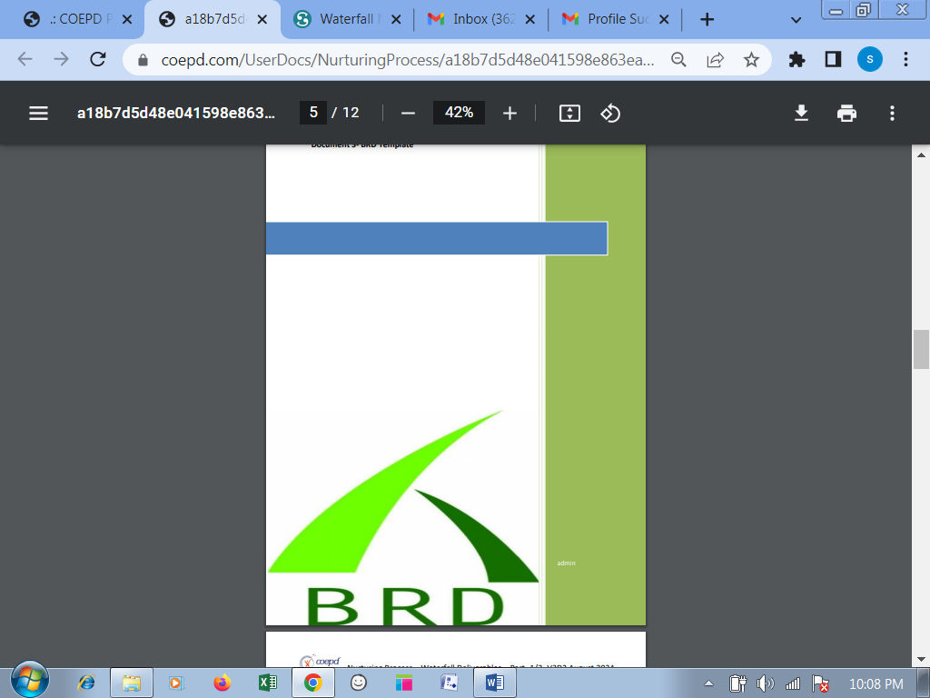

**<HDFC Fundflow>**

**<HFF24022025>**

**<HFF_V.1.1.2>**

**<Shubham Baheti>**

Contents

1. Document Revisions.............................................................................................................8

2. Approvals.............................................................................................................................8

3. RASCI Chart for This Document ............................................................................................8

Codes Used in RASCI Chart...................................................................................................9

RASCI Chart..........................................................................................................................9

4. Introduction.........................................................................................................................9

4.1.Business Goals ..............................................................................................................9

4.2. Business Objectives.......................................................................................................9

4.3. Business Rules.............................................................................................................10

4.4.Background.................................................................................................................10

4.5.Project Objective.........................................................................................................10

4.6. Project Scope ..............................................................................................................10

4.6.1. In Scope Functionality ..........................................................................................10

4.6.2. Out Scope Functionality .......................................................................................10

5. Assumptions ......................................................................................................................10

6.Constraints.........................................................................................................................10

7.Risks...................................................................................................................................10

Technological Risks................................................................................................................11

Skills Risks..............................................................................................................................11

Political Risks.........................................................................................................................11

Business Risks........................................................................................................................11

Requirements Risks ...............................................................................................................11

Other Risks............................................................................................................................11

8. Business Process Overview ................................................................................................11

8.1. Legacy System (AS-IS) ..................................................................................................11

8.2. Proposed Recommendations (TO-BE) .........................................................................11

9. Business Requirements......................................................................................................11

10. Appendices.....................................................................................................................12

10.1. List of Acronyms......................................................................................................12

10.2. Glossary of Terms....................................................................................................12

10.3. Related Documents.................................................................................................12

**1. Document Revisions**

|  |  |  |
| --- | --- | --- |
| **Date** | **Version Number** | **Document Changes** |
| 24/02/2025 | 1.0.1 | Initial Draft |
| 03/03/2025 | 1.0.2 | Requirements obtained |
| 08/03/2025 | 1.0.3 | BRD Approved |
| 12/03/2025 | 1.0.4 | BRD and Use case diagram shared |
| 15/03/2025 | 1.0.5 | Activity Diagram |
| 20/03/2025 | 1.1.1 | Prototype approved and added |
| 31/03/2025 | 1.1.2 | Final Draft |

**2. Approvals**

|  |  |  |  |  |
| --- | --- | --- | --- | --- |
| Role | Name | Title | Signature | Date |
| Project Sponsor | Chetan | HDFC Mutual Fund |  | 28/2/2025 |
| Business Owner | Krishna | Senior Manager |  | 01/03/2025 |
| Project Manager | Ram | Asst VP |  | 01/03/2025 |
| System Architect | Pushkar | Senior Manager |  | 04/03/2025 |
| Development Lead | Aniket | Senior Manager |  | 04/03/2025 |
| User Experience Lead | Abhishek | Senior Managre |  | 04/03/2025 |
| Quality Lead | Yash | Senior Manager |  | 04/03/2025 |
| Content Lead | Sarvesh | Senior Manager |  | 04/03/2025 |

**3. RACI Chart for This Document**

The RACI chart identifies the persons who need to be contacted whenever changes are made to this document. RACI stands for responsible, accountable, consulted, and informed. These are the main codes that appear in a RACI chart, used here to describe the roles played by team members and stakeholders in the production of the BRD. They are adapted from charts used to assign roles and responsibilities during a project. (RACI Can be made for IT side [Project stakeholder] as mentioned above, apart from that Can also Be made for Client side[Business Stakeholder]).

The following describes the full list of codes used in the table:

Codes Used in RACI Chart

* Authorize Has ultimate signing authority for any changes to the document.

R Responsible Responsible for creating this document.

A Accountable Accountable for accuracy of this document (for example, the project manager)

S Supports Provides supporting services in the production of this document

C Consulted Provides input (such as an interviewee).

I Informed Must be informed of any changes.

RACI Chart

|  |  |  |  |  |  |  |  |
| --- | --- | --- | --- | --- | --- | --- | --- |
| Name | Position | * | R | A | S | C | I |
| Project Sponsorer | HDFC Mutual fund |  |  |  |  |  | I |
| Business Owner | Krishna |  | R |  | S |  |  |
| Project Manager | Shubham |  | R |  |  | C | I |
| System Architect | Pushkar |  |  |  |  | C |  |
| Development Lead | Aniket |  | R | A |  |  |  |

**4. Introduction**

**4.1. Business Goals**

The purpose of this project is to develop hdfc fund flow, so that:

* There is less dependence on third party application for investors data.
* User should be able to maintain centralized data of investors, distributors, internal office operations and updating if any.

**4.2. Business Objectives**

* To design the hdfc fund flow for smooth transactions.
* To reduce cost for third party application.
* To get details and updating on demand.
* Make operation smooth flow and data accessible to everyone.
* Increase data smoothness and ease and fast flow of data.

**4.3. Business rules**

HDFC fund flow is to store data and updating of data by officers.

**4.4 Background –**

* Currently HDFC mutual fund is using Cams 360 for its operations and looking for any query regarding investors and distributors. The problem is the company is using third party application where the company has to pay on user basis. Many times user also face the problems regarding server issue where website didn’t work.
* HFF will help us overcome all these problem because now user will be able to use internal application were various un wanted things will be removed and user can look into valuation and guide the investors or distributors.

**4.5 Project Objectives –**

The application helps in easing the back office work and increasing the internal system reliability. Application can align special tabs depending on seniority and reliability of the personal. The objective of the application is to provide smooth flow to the employees so that the transaction is smooth and there is less need for correction/revalidation. The application will help reduce the cost by 30%.

**4.6 Project scope-**

To develop application for HDFC MF for viewing of customers and distributors data and processing any updating.

**4.6.1 In Scope Functionality.**

* User should be able to log in
* User should be able to enter data to search for details
* User should be able to update and submit any updating.
* User should be able to look for details of partner.
* User should be able to directly share the statements to investor and distributors

**4.6.2 Out Scope Functionality.**

**5 . Assumption**

* System is wirelessly networked with an encryption.
* System is only accessibility within the Mutual Fund website only.
* Database is Password Protected.
* Should be use less Ram and processing power.
* Each user should have individual ID and Password.
* Only administrator can access the whole System.

**6.Constraints**

* Each user must have a valid user id and password
* Server must be running from system to function.
* User must log in to system to access any record.
* Only the Administrator can delete records.

**7. Risks**

In this section of the BRD, you describe risks. A risk is something that could affect the success or failure of a project. Analyze risks regularly as the project progresses. While you may not be able to avoid every risk, you can limit each risk’s impact on the project by preparing for it beforehand. For each risk, you’ll note the likelihood of its occurrence, the cost to the project if it does occur, and the strategy for handling the risk. Strategies include the following:

* Avoid: Do something to eliminate the risk.
* Mitigate: Do something to reduce damage if risk materializes.
* Transfer: Pass the risk up or out to another entity.
* Accept: Do nothing about the risk. Accept the consequences.

**Technological risk**

There must be a data backup at least in two instances in order to manage the data corruption. Size of the database should be enough to hold all the Investors data.

**Skills Risks**

Mainly for mis-communication between the stakeholders.

Every Business Analyst should full fill the client needs

As a BA, should update the knowledge day by day.

**Political Risks**

Political risk analysis is defined as the systematic means of assessing and managing the political risks of foreign investment or international business. The scope of political risk can be quite broad. In capital market theory, for example, political risk is often defined as unsystematic risk or all non-business risk.

Political risk is the risk an investment's returns could suffer as a result of political changes or instability in a country. Instability affecting investment returns could stem from a change in government, legislative bodies, other foreign policymakers or military control.

1.Insure your business. Political risk insurance protects investors, Financial institutions and international companies in case of events promoting Financial loss. ...

2.Have a plan B for your supply chain. ...

3.Practice politically savvy banking. ...

4.Get advice from locals

**Business Risk**

1.Hold a kick-of meeting with key stakeholders to meet each other, understand business objectives, and discuss the plan for the first two weeks.

2.Hold a kick-of meeting with the full team to orient them to the work we are doing.

3.Define team roles.

**Requirement Risks**

It must be written in an understandable way. Otherwise, we need to face the problem in Stake holders and project team side. Requirements risk is the potential for losses due to a project's requirements themselves or the requirements management process. Such risks are closely tied to the quality of requirements in that low quality requirements represent a risk to the project.

**8. Business Process Overview**

To develop HDFC Fund Flow, we need to create login page first to enter user credentials, after login various tabs to be displayed where user can select the tab he looks for. After selecting Investors tab when details are submitted, Investor profile should be displayed. Then Employee can look for investor details.

**8.1 Legacy system (As is process)**

Currently HDFC mutual fund is using Cams 360 for its operations and looking for any query regarding investors and distributors. The problem is the company is using third party application where the company has to pay on user basis. Many times user also face the problems regarding server issue where website didn’t work.

8.2 Proposed Recommendation (To be)

In the Proposed solution we are developing an application naming HDFC Fund Flow. HFF will help us overcome all these problem because now user will be able to use internal application were various un wanted things will be removed and user can look into valuation and guide the investors or distributors.

**9. Business Requirements –**

(The specific business requirements elicited from stakeholders should be listed, categorized by both priority and area of functionality to smooth the process of reading and tracking them. Include links to use case documentation, and other key reference material as needed to make the requirements as complete and understandable as possible. You may wish to incorporate the functional and non-functional requirements into a traceability matrix that can be followed throughout the project)

|  |  |  |  |
| --- | --- | --- | --- |
| BR | Required Item | Applicable Roles | Description |
| BR001 | Registration of Employee | Admin | The Registration shall capture the employees official Details. |
| BR002 | Investor Details | Sales or Operation Employee | Look for investor details by entering any of the following details folio no.,bank account number,pan number, mobile number , name. |
| BR003 | Distributor Details | Sales or Operation Employee | Look for distributors details by entering ARN Number, Pan number mobile number or name. |
| BR004 | Brokerage paid | Sales or Operation Employee | Look for the accounts Tab after entering distributors details tab. |
| BR005 | View Query | Sales or Operation Employee | Look for the Contact tab after entering investor details tab. |
| BR006 | Updating information | Operation Employee | Raise service request in updation tab and set priority. |
| BR007 | Raising Query | Operation Employee | Raise service request in query tab and upload relevant document |

|  |  |
| --- | --- |
| Stakeholder | Requirement |
| Operation Employee | 1. Personal Login. 2. Look for details 3. Create Query 4. Update information 5. Look for progress 6. Download statement |
| Sales Employee | 1. Personal Login 2. Look for details 3. Look for query progress 4. Download statement |
| Admin | 1. Personal login 2. Create employee new user id 3. Maintain Updating details. |
| Authorizer | 1. Personal Login 2. Look for query 3. Investor or distributor details 4. Authorize query. |

1. **Appendices**

**10.1 List of Acronyms**

HFF –HDFC Fund Flow

NAV –Net Asset Value

SIP – Systematic Investment Plan

SWP- Systematic Withdrawal Plan

STP - Systematic Transfer plan

Om- Monthly

DZ – Business Days

OQ- Quarterly

AUM –Asset under Management

NFO- New fund offer

IDCW – Income Distribution cum Capital withdrawal

LTCG – Long term capital gains

STCG – Short term capital gains.

**10.2 Glossary of Terms**

• HDFC Fund Flow - A system that manages total data and work flow of investors and distributors

• CAMS – Registrar of HDFC Mutual fund. Every back office operation and data storage is done by this company.

• Investor Detail Tab- The part of the HFF that deals with storing and managing investors data.

• Distributor Details - The part of the HFF that deals with storing and managing Distributors data.

• Statement details – The part deals with statement of the investement done by investor and current valuation.

• Query Raising – in this the operation employee can raise the query.

• Updation of details – Operation employee can update the details if any is wrongly updated.

**10.3 Related Documents –**

**Project Proposal:** Outlines the purpose, scope, objectives, and anticipated benefits of the HFF project.

**Project Charter:** Defines the roles and responsibilities of project team members, stakeholders, and project manager.

**Project Plan:** Details the timeline, milestones, and tasks for each phase of the HFF project.

**Requirements Document:** Describes the functional and non-functional requirements of the HFF, including user stories and use cases.

**System Design Document:** Outlines the architecture and design of the HFF, including database design, user interface design, and system flow.

**Technical Specification Document:** Provides detailed technical specifications for the development team, including technologies, frameworks, and tools to be used.

**Testing Plan:** Describes the testing strategy, including unit testing, integration testing, and user acceptance testing.

**User Manual:** Guides end-users on how to use the HFF, including system navigation, data entry, and common tasks.

**Training Manual:** If training is required, provides detailed instructions for training staff on using the HFF.

**Risk Management Plan:** Identifies potential risks to the project and outlines strategies for risk mitigation.

**Change Control Document:** Describes the process for making changes to the project plan or requirements and how changes will be evaluated and approved.

**Deployment Plan:** Outlines the steps and procedures for deploying the HFF in a live environment.

**Maintenance and Support Plan:** Describes how ongoing maintenance and support for the HFF will be handled after deployment.

**Security Policy:** Outlines security measures and protocols to protect sensitive patient data.

**Data Backup and Recovery Plan:** Describes how data will be regularly backed up and the procedures for data recovery in case of system failure.

**Documentation for APIs and Integrations:** If the HFF integrates with other systems, provide documentation on how these integrations work.