**4 BA Mock - Case study**

A company is having manufacturing plants and warehouses in various parts of the country. They manufacture ice-cream and milk products. They want to build software to achieve two goals.

- Manage the inventory

- Quickest delivery to the customers

Assignment 1

1. Please make a BRD which can be presented to the client along with complete development and resource plan.

2. Prepare process flow diagram using your imagination.

*1. Business Requirement Document*

***Inventory Management and Delivery Optimization System***

***IMDOS-2025***

***Version 1.0***

***Business Analyst***

Contents

1. Document Revisions.............................................................................................................2

2. Approvals...........................................................................................................................2-3

3. RASCI Chart for This Document ............................................................................................3

Codes Used in RASCI Chart...................................................................................................3

RASCI Chart..........................................................................................................................3

4. Introduction.........................................................................................................................3

4.1. Business Goals ..............................................................................................................3-4

4.2. Business Objectives.......................................................................................................4

4.3. Business Rules.............................................................................................................4

4.4. Background.................................................................................................................4-5

4.5. Project Objective.........................................................................................................5

4.6. Project Scope ..............................................................................................................5

4.6.1. In Scope Functionality ..........................................................................................5-6

4.6.2. Out Scope Functionality .......................................................................................6

5. Assumptions ......................................................................................................................6

6. Constraints.........................................................................................................................6

7. Risks...................................................................................................................................7

Technological Risks................................................................................................................7

Skills Risks..............................................................................................................................7

Political Risks.........................................................................................................................7

Business Risks........................................................................................................................7

Requirements Risks ...............................................................................................................7-8

Other Risks............................................................................................................................8

8. Business Process Overview ................................................................................................8

8.1. Legacy System (AS-IS) ..................................................................................................8-10

8.2. Proposed Recommendations (TO-BE) ........................................................................10-12

9. Business Requirements..................................................................................................12-13

10. Appendices.....................................................................................................................13

10.1. List of Acronyms......................................................................................................14

10.2. Glossary of Terms....................................................................................................14

10.3. Related Documents ..................................................................................................14

1. Document Revisions

|  |  |  |
| --- | --- | --- |
| **Date** | **Version Number** | **Document Changes** |
|  |  |  |
| 25-04-2025 | 0.1 | Initial Draft |
|  |  |  |

2. Approvals

|  |  |  |  |  |
| --- | --- | --- | --- | --- |
| **Role** | **Name** | **Title** | **Signature** | **Date** |
| Project Sponsor |  |  |  |  |
| Business Owner |  |  |  |  |
| Project Manager |  |  |  |  |
| System Architect |  |  |  |  |
| Development Lead |  |  |  |  |
| User Experience Lead |  |  |  |  |
| Quality Lead |  |  |  |  |
| Content Lead |  |  |  |  |

3. RACI Chart

Codes Used in RACI Chart

|  |  |  |
| --- | --- | --- |
| **Code** | **Term** | **Description** |
| **\*** | Authorize | Has ultimate signing authority for any changes to the document |
| **R** | Responsible | Responsible for creating this document |
| **A** | Accountable | Accountable for accuracy of this document |
| **S** | Supports | Provides supporting services in the production of this document |
| **C** | Consulted | Provides input |
| **I** | Informed | Must be informed of any changes |

RACI Chart

|  |  |  |  |  |  |  |  |
| --- | --- | --- | --- | --- | --- | --- | --- |
| **Name** | **Position** | **\*** | **R** | **A** | **S** | **C** | **I** |
|  | CEO | * |  |  |  | C | I |
|  | COO | * |  |  |  | C | I |
|  | Project Manager |  |  | A | S | C | I |
|  | Business Analyst |  | R |  | S | C | I |
|  | System Architect |  |  |  | S | C | I |
|  | Logistics Manager |  |  |  |  | C | I |
|  | Warehouse Manager |  |  |  |  | C | I |
|  | IT Manager |  |  |  | S | C | I |

4. Introduction

The document outlines the specifications for a comprehensive software solution for a dairy products company that operates multiple manufacturing plants and warehouses nationwide. The solution aims to address the challenges in inventory management and delivery optimization for perishable ice cream and milk products.

*4.1. Business Goals*

The organization aims to:

- Become the leading dairy products provider in the country with the freshest products and fastest delivery

- Reduce operational costs by optimizing inventory and logistics operations

- Minimize wastage of perishable products

- Improve customer satisfaction through reliable and quick deliveries

- Increase market share by 15% within the next fiscal year

*4.2. Business Objectives*

To provide an IT solution for:

- Real-time inventory management across all manufacturing plants and warehouses

- Tracking of perishable goods with expiration date monitoring

- Automated reordering systems based on configurable thresholds

- Demand forecasting based on historical data and regional preferences

- Intelligent route optimization for product delivery

- Order management with prioritization capabilities

- Real-time delivery tracking for customers and internal stakeholders

- Mobile applications for delivery personnel and warehouse managers

- Comprehensive reporting and analytics dashboard

*4.3. Business Rules*

- All products must have expiration dates tracked and managed

- FIFO (First In, First Out) inventory management must be implemented for all perishable goods

- Products with less than 3 days to expiration must be flagged for priority sale/distribution

- Delivery routes must be optimized based on distance, traffic conditions, and delivery windows

- Orders from premium customers must be prioritized

- Cold chain requirements must be maintained throughout the logistics process

- Deliveries must be scheduled within agreed time windows with customers

- Proof of delivery must be captured for all orders

*4.4. Background*

The dairy products company has been experiencing challenges with inventory management and delivery efficiency. As a producer of perishable ice cream and milk products, the company faces significant losses due to product expiration and inefficient distribution networks. The company currently uses manual processes and disconnected systems to manage inventory and plan deliveries, resulting in stockouts, overstocking, and delays in customer deliveries. These challenges have led to increased operational costs and reduced customer satisfaction.

The company's leadership has identified technology as a key enabler to address these challenges and has initiated this project to develop an integrated software solution for inventory management and delivery optimization.

*4.5. Project Objective*

The primary objectives of this project are to:

- Develop an integrated system that provides real-time visibility of inventory across all facilities

- Implement automated inventory management capabilities for perishable products

- Create an intelligent delivery system that optimizes routes and ensures timely delivery

- Provide analytical insights for demand forecasting and operational optimization

- Improve customer satisfaction through reliable and quick deliveries

- Reduce operational costs related to inventory management and logistics

*4.6. Project Scope*

*4.6.1. In Scope Functionality*

- Real-time inventory tracking system for all manufacturing plants and warehouses

- Perishable goods management with expiration date tracking

- Demand forecasting and automated reordering system

- Route optimization algorithm considering distance, traffic, and delivery windows

- Order management system with prioritization capabilities

- GPS integration for real-time vehicle tracking

- Customer notification system for delivery status

- Mobile application for delivery personnel

- Admin dashboard for inventory and delivery management

- Reporting and analytics functionality

- Integration with existing ERP system

- User management with role-based access control

*4.6.2. Out of Scope Functionality*

- Point of Sale (POS) system for retail outlets

- Accounting and financial management

- Human resource management

- Manufacturing process automation

- Supplier relationship management

- Raw material procurement system

- Customer relationship management beyond delivery notifications

- Marketing and promotion management

- Website and e-commerce platform development

5. Assumptions

- The company has reliable internet connectivity at all manufacturing plants and warehouses

- All delivery vehicles have GPS capabilities or will be equipped with GPS devices

- The existing ERP system has APIs for integration

- The company has or will implement barcode/RFID infrastructure for inventory tracking

- Staff will be available for training on the new system

- Mobile devices will be provided to delivery personnel

- The company has standard operating procedures for inventory management and delivery processes

6. Constraints

- The system must be implemented without disrupting ongoing business operations

- The implementation must be completed within 6 months to address urgent business needs

- The system must comply with food safety regulations and cold chain requirements

- Budget constraints as per approved project funding

- Integration with legacy systems may present technical challenges

- Limited IT resources within the organization for ongoing support

- Varying levels of technical proficiency among end users

7. Risks

*Technological Risks*

- Integration complexity with existing ERP system may cause delays

- Real-time data synchronization across multiple locations may face technical challenges

- Mobile application performance in areas with poor connectivity

- GPS accuracy issues in certain geographical areas

*Mitigation Strategy*: Conduct thorough system analysis during initial phase, implement offline capabilities for mobile app, use multiple location tracking technologies.

*Skills Risks*

- Lack of specialized resources for route optimization algorithm development

- Limited expertise in cold chain logistics systems

- Shortage of mobile application developers with logistics expertise

*Mitigation Strategy*: Engage specialized consultants, provide targeted training, partner with technology vendors with industry expertise.

*Political Risks*

- Resistance from regional managers fearing loss of autonomy

- Union concerns about tracking of delivery personnel

- Interdepartmental conflicts between logistics and warehouse operations

*Mitigation Strategy*: Early stakeholder engagement, clear communication about benefits, involve representatives from all departments in requirements gathering.

*Business Risks*

- Disruption to business operations during implementation

- Inadequate user adoption affecting return on investment

- Inaccurate data migration affecting inventory records

*Mitigation Strategy*: Phased implementation approach, comprehensive training program, rigorous data validation.

*Requirements Risks*

- Incomplete understanding of complex logistics processes

- Changing requirements due to evolving business needs

- Overambitious scope leading to project delays

*Mitigation Strategy*: Involve domain experts in requirements validation, implement change management process, prioritize requirements based on business value.

*Other Risks*

- Seasonal peak periods affecting implementation timeline

- External factors like weather affecting delivery optimization testing

- Regulatory changes in food safety affecting system requirements

*Mitigation Strategy*: Plan implementation during off-peak seasons, develop contingency plans for external factors, monitor regulatory developments.

8. Business Process Overview

*8.1. Legacy System (AS-IS)*

The current inventory management and delivery process is largely manual with minimal system support. Inventory is tracked through spreadsheets and periodic physical counts, leading to discrepancies and lack of real-time visibility. The delivery planning is done manually by logistics coordinators based on their experience and knowledge of routes, without systematic optimization.

Current process flow:

1. Manufacturing plants produce goods based on historical orders

2. Products are transferred to warehouses based on estimated demand

3. Inventory is counted manually at regular intervals

4. Orders are received via phone, email, or sales representatives

5. Logistics coordinators assign orders to delivery vehicles based on geographical zones

6. Delivery personnel receive printed delivery schedules and route information

7. Deliveries are made with paper-based proof of delivery

8. Delivery status is updated manually at the end of each day

9. Inventory is adjusted based on delivery reports

10. Product wastage due to expiration is recorded manually

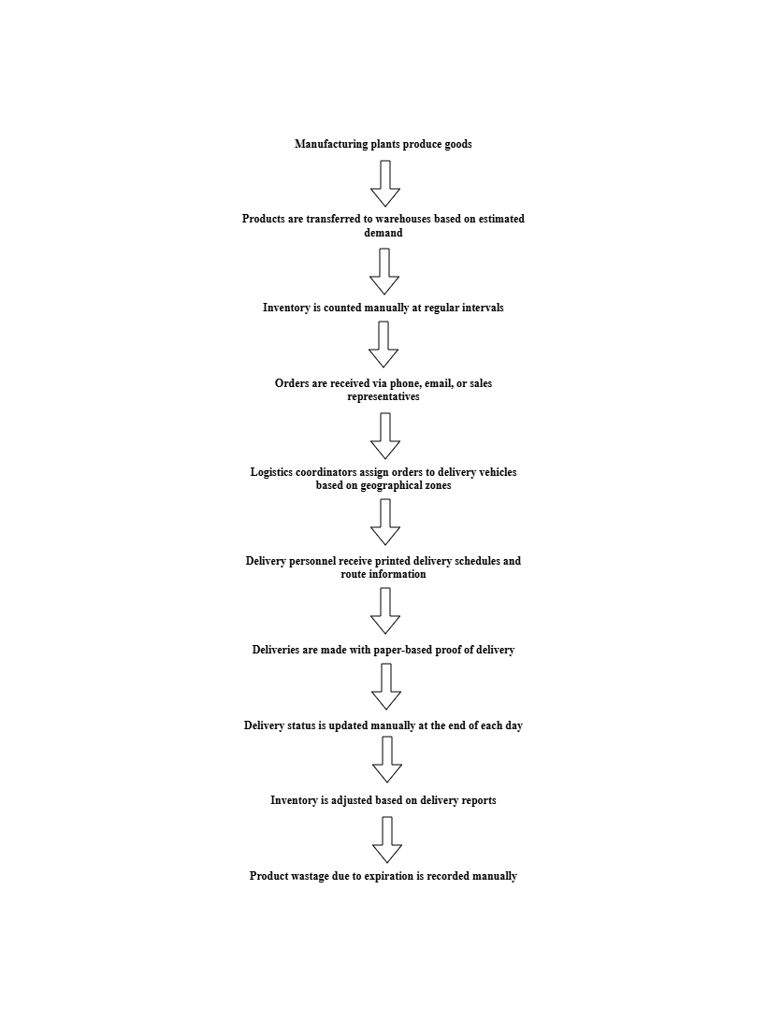

Challenges with the current process include:

- Lack of real-time inventory visibility

- High product wastage due to expiration

- Inefficient delivery routes leading to higher fuel costs and delivery times

- Limited ability to respond to urgent customer requests

- Manual order processing prone to errors

- No real-time delivery tracking for customers

- Disconnected systems requiring duplicate data entry

*8.2. Proposed Recommendations (TO-BE)*

The proposed system will digitize and automate the inventory management and delivery processes, providing real-time visibility and intelligent optimization.

Proposed process flow:

1. Manufacturing plants update production quantities in real-time to the central system

2. System continuously monitors inventory levels across all locations

3. Automated alerts trigger reordering or redistribution of inventory based on demand patterns

4. Orders are received through digital channels and automatically entered into the system

5. System prioritizes orders based on customer type, order value, and delivery urgency

6. Route optimization algorithm generates efficient delivery schedules considering multiple factors

7. Delivery personnel receive optimized routes through mobile application

8. Real-time GPS tracking provides visibility of delivery progress

9. Customers receive automated notifications about delivery status

10. Digital proof of delivery is captured through the mobile application

11. Inventory is automatically adjusted upon delivery confirmation

12. System proactively identifies products approaching expiration for targeted sales actions

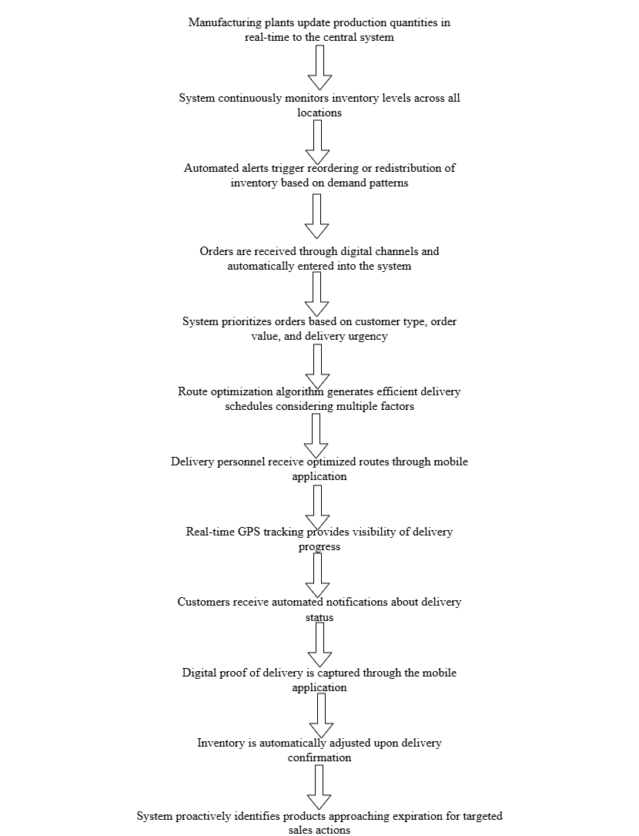

Benefits of the proposed system:

- Real-time inventory visibility across all locations

- Reduced product wastage through better expiration management

- Optimized delivery routes leading to fuel savings and faster deliveries

- Improved customer satisfaction through reliable and traceable deliveries

- Reduced manual effort and error potential

- Data-driven decision making through analytics and reporting

9. Business Requirements

*Functional Requirements*

|  |  |  |  |
| --- | --- | --- | --- |
| **Req ID** | **Req Name** | **Req Description** | **Priority** |
| FR001 | User Authentication | System shall provide secure login functionality with role-based access control | High |
| FR002 | Batch Tracking | System shall track manufacturing date, expiration date, and batch information for all products | High |
| FR003 | Order Management | System shall process and prioritize customer orders | High |
| FR004 | GPS Tracking | System shall enable real-time tracking of delivery vehicles | High |
| FR005 | Load Planning | System shall optimize vehicle loading based on route and product requirements | Medium |
| FR006 | Dashboard | System shall provide customizable dashboard with key metrics | Medium |
| FR007 | Cost Analysis | System shall calculate and report on transportation and inventory holding costs | Low |
| FR008 | Email Integration | System shall send notifications and reports via email | Low |
| FR009 | Export Capabilities | System shall allow exporting reports in multiple formats (PDF, Excel, CSV) | Low |
| FR010 | Route Optimization | System shall calculate optimal delivery routes considering distance, traffic, and delivery windows | High |
| FR011 | Barcode Integration | System shall support barcode/RFID scanning for inventory updates | High |
| FR012 | Inventory Transfers | System shall manage and track transfers between locations | Medium |
| FR013 | Automated Reordering | System shall generate purchase orders based on predefined inventory thresholds | Medium |
| FR014 | Raw Material Management | System shall track raw material inventory for manufacturing plants | Medium |
| FR015 | Wastage Tracking | System shall record and categorize product wastage with reason codes | Low |
| FR016 | ERP Integration | System shall integrate with existing ERP system for master data and financial transactions | High |
| FR017 | Supplier Portal | System shall integrate with supplier portals for order placement and tracking | Medium |
| FR018 | Mobile Applications | System shall provide mobile applications for warehouse staff and delivery personnel | Medium |
| FR019 | Wastage Analysis | System shall provide reports on product wastage and associated costs | Low |
| FR020 | Demand Forecasting | System shall analyse historical data to forecast future demand | Medium |

*Non-Functional Requirements*

|  |  |  |  |
| --- | --- | --- | --- |
| **Req ID** | **Req Name** | **Req Description** | **Priority** |
| NF001 | Response Time | System shall respond to user queries within 2 seconds under normal load | High |
| NF002 | Concurrent Users | System shall support at least 500 concurrent users without performance degradation | Medium |
| NF003 | Mobile Performance | Mobile applications shall function efficiently on devices with minimum specifications | Medium |
| NF004 | Reporting Speed | Reports shall be generated within 5 seconds for standard reports and 30 seconds for complex reports | Medium |
| NF005 | Audit Trail | System shall maintain comprehensive audit logs of all transactions | Medium |
| NF006 | Password Policy | System shall enforce strong password policies | Medium |
| NF007 | Backup | System shall perform automated daily backups of all data | High |
| NF008 | Availability | System shall be available 99.9% of the time during operational hours | High |
| NF009 | Offline Capability | Mobile applications shall function with limited capabilities in offline mode | Medium |
| NF010 | Fault Tolerance | System shall handle unexpected errors gracefully | Medium |

10. Appendices

*10.1. List of Acronyms*

- BRD: Business Requirements Document

- ERP: Enterprise Resource Planning

- FIFO: First In, First Out

- GPS: Global Positioning System

- KPI: Key Performance Indicator

- POS: Point of Sale

- RFID: Radio-Frequency Identification

- SKU: Stock Keeping Unit

*10.2. Glossary of Terms*

- Cold Chain: A temperature-controlled supply chain for perishable products

- Delivery Window: A specific timeframe during which a delivery is scheduled to arrive

- Geofencing: Virtual perimeter for a real-world geographic area

- Inventory Turnover: A ratio showing how many times inventory is sold and replaced in a period

- Route Optimization: Process of determining the most efficient routes for multiple deliveries

- Stock Variance: Difference between recorded inventory and actual physical count

*10.3. Related Documents*

- Project Charter

- System Architecture Document

- Functional Specifications Document

- Requirements Traceability Matrix

- Data Flow Diagrams

- User Interface Mock-ups

*2. Process flow Diagram*

Process Description-

- Manufacturing Phase: -

Raw Material Receipt: Milk and other ingredients arrive at plants

Quality Check: Inspection of incoming materials

Production Planning: Scheduling based on demand forecasts and inventory levels

Manufacturing Process: Production of ice cream and dairy products

Quality Control: Ensuring products meet standards

Packaging: Products are packaged for distribution

Finished Product Storage: Products enter temperature-controlled storage

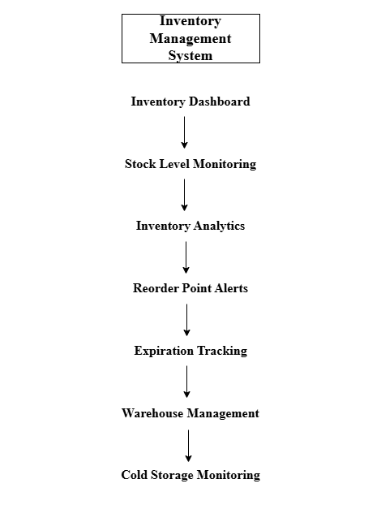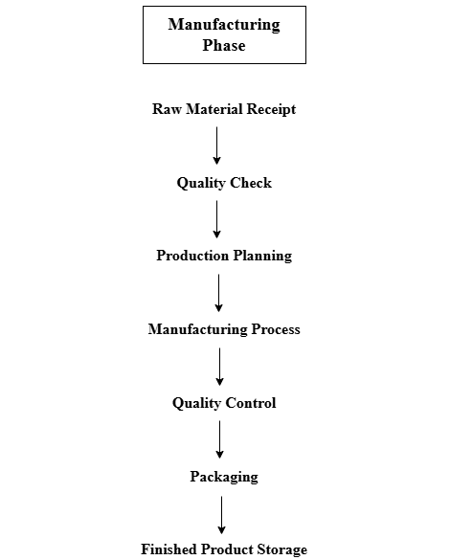

- Inventory Management System: -

Inventory Dashboard: Central view of all inventory across locations

Stock Level Monitoring: Real-time tracking of product quantities

Inventory Analytics: Demand patterns, seasonal trends analysis

Reorder Point Alerts: Automated notifications when stock is low

Expiration Tracking: Critical for dairy products with limited shelf life

Warehouse Management: Optimizing storage space and organization

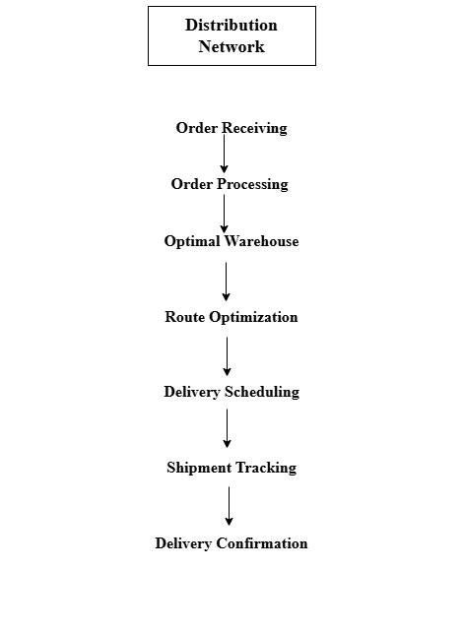Cold Storage Monitoring: Temperature tracking for quality assurance

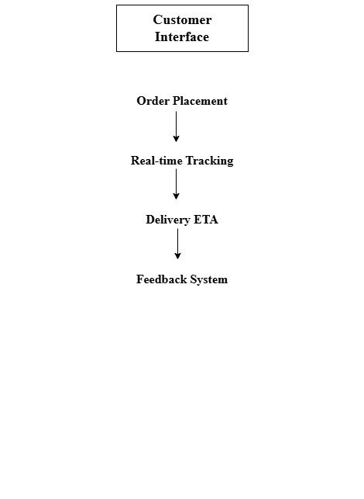

- Distribution Network: -

Order Receiving: Customer orders enter the system

Order Processing: Validation and preparation

Optimal Warehouse Selection: Choosing the closest warehouse with available stock

Route Optimization: Calculating fastest delivery routes

Delivery Scheduling: Organizing deliveries by zones and time windows

Shipment Tracking: Real-time location tracking of delivery vehicles

Delivery Confirmation: Proof of delivery and feedback collection

- Customer Interface: -

Order Placement: Online ordering system

Real-time Tracking: Customers can track their order status

Delivery ETA: Accurate estimated arrival times

Feedback System: Post-delivery quality and service feedback

Assignment 2:

1. Write an introduction letter to a client introducing yourself as a business analyst in charge of working with the client and his team to start the business understanding process.

2. Prepare a brief BRD and SRS for a project- Horoscope or Ticketing system or online store.

3. Make an ERD of creating a support ticket/Ticketing life cycle.

4. User story of shopping from ecommerce.

*1. Introduction Letter*

Dear [Client Name],

Hope you are doing well. I am writing to introduce myself as the Business Analyst assigned to collaborate with you and your team on the ice cream and dairy products supply chain management project. My name is Neha Ravikant Ninave, and I will be your primary point of contact throughout our business understanding process.

Having reviewed the initial project requirements regarding inventory management and delivery optimization, I'm eager to dive deeper into your specific business needs and operational challenges. My role will be to bridge the gap between your business requirements and our technical implementation, ensuring that the final solution truly addresses your company's objectives.

I'd like to propose an initial meeting next week to begin our collaboration. During this session, we can:

* Discuss your current manufacturing and distribution processes in detail
* Identify key pain points in your existing inventory and delivery systems
* Understand your business priorities and success metrics
* Outline a roadmap for our continued collaboration

My approach is highly collaborative, and I believe that the most successful solutions emerge when we combine your industry expertise with our technical capabilities. To make the most of our partnership, I encourage open communication and welcome any questions or concerns you may have throughout this process.

Please let me know if the proposed meeting timeframe works for you, and if there are specific team members you'd like to include. I'm flexible and can adjust to accommodate your schedule.

I look forward to working with you and contributing to the success of your business.

Best regards,

Neha Ravikant Ninave,

Business Analyst,

Company Name

Contact Information

*2. BRD and SRS for Online Store*

*Business Requirement Document*

***Online Store Project***

***OS-2025***

***Version 1.0***

***Business Analyst***

Contents

1. Document Revisions............................................................................................................19

2. Approvals............................................................................................................................19

3. RASCI Chart for This Document ..........................................................................................19

Codes Used in RASCI Chart...................................................................................................19

RASCI Chart..........................................................................................................................19

4. Introduction........................................................................................................................19

4.1. Business Goals ............................................................................................................19-20

4.2. Business Objectives.......................................................................................................20

4.3. Business Rules.............................................................................................................20

4.4. Background.................................................................................................................20

4.5. Project Objective.........................................................................................................21

4.6. Project Scope ..............................................................................................................21

4.6.1. In Scope Functionality ..........................................................................................21

4.6.2. Out Scope Functionality .......................................................................................21

5. Assumptions .................................................................................................................21-22

6. Constraints.........................................................................................................................22

7. Risks...................................................................................................................................22

Technological Risks................................................................................................................22

Skills Risks..............................................................................................................................22

Political Risks......................................................................................................................22-23

Business Risks........................................................................................................................23

Requirements Risks ...............................................................................................................23

Other Risks............................................................................................................................23

8. Business Process Overview ................................................................................................23

8.1. Legacy System (AS-IS) .................................................................................................23-24

8.2. Proposed Recommendations (TO-BE) ........................................................................24-25

9. Business Requirements..................................................................................................25-26

10. Appendices.....................................................................................................................26

10.1. List of Acronyms......................................................................................................26

10.2. Glossary of Terms....................................................................................................26-27

10.3. Related Documents ..................................................................................................27

*1. Document Revisions*

|  |  |  |
| --- | --- | --- |
| **Date** | **Version Number** | **Document Changes** |
| 27/04/2025 | 0.1 | Initial Draft |

*2. Approvals*

|  |  |  |  |  |
| --- | --- | --- | --- | --- |
| **Role** | **Name** | **Title** | **Signature** | **Date** |
| Project Sponsor |  |  |  |  |
| Business Owner |  |  |  |  |
| Project Manager |  |  |  |  |
| System Architect |  |  |  |  |
| Development Lead |  |  |  |  |
| User Experience Lead |  |  |  |  |
| Quality Lead |  |  |  |  |
| Content Lead |  |  |  |  |

*3. RACI Chart*

Codes Used in RACI Chart

|  |  |  |
| --- | --- | --- |
| **Code** | **Term** | **Description** |
| **\*** | Authorize | Has ultimate signing authority for any changes to the document |
| **R** | Responsible | Responsible for creating this document |
| **A** | Accountable | Accountable for accuracy of this document |
| **S** | Supports | Provides supporting services in the production of this document |
| **C** | Consulted | Provides input |
| **I** | Informed | Must be informed of any changes |

RACI Chart

|  |  |  |  |  |  |  |  |
| --- | --- | --- | --- | --- | --- | --- | --- |
| **Name** | **Position** | **\*** | **R** | **A** | **S** | **C** | **I** |
|  | Business Analyst |  | R |  |  |  |  |
|  | Project Manager |  |  | A |  |  |  |
|  | Business Owner | * |  |  |  | C | I |
|  | Development Lead |  |  |  | S | C | I |
|  | UX Designer |  |  |  | S | C | I |
|  | QA Lead |  |  |  |  | C | I |

*4. Introduction*

4.1. Business Goals

The organization aims to establish a strong online presence and expand its retail operations into the digital marketplace. The primary goal is to increase market share, improve customer reach, and establish a competitive position in the e-commerce sector while maintaining brand identity and quality of service.

Need:

* To compete effectively in the growing digital retail space
* To provide customers with convenient 24/7 shopping options
* To expand beyond geographical limitations of physical stores

4.2. Business Objectives

To provide an IT solution for:

- Online product catalogue management and presentation

- Secure customer account management

- Streamlined order processing and payment handling

- Inventory synchronization across online and physical channels

- Customer relationship management

- Data analytics and reporting for business intelligence

4.3. Business Rules

- All customer data must be handled in compliance with data protection regulations

- Returns and refunds must be processed within 7 business days

- Product pricing updates must be approved by department managers

- Order confirmation emails must be sent within 5 minutes of purchase

- Credit card information must not be stored on company servers

- Inventory counts must be updated in real-time across all sales channels

- Customer accounts inactive for more than 24 months must be archived

4.4. Background

The company currently operates through brick-and-mortar retail locations and has experienced increasing customer demand for online shopping options. Market research indicates that competitors with omnichannel retail strategies are capturing market share. The COVID-19 pandemic further accelerated the shift toward online shopping, creating urgency for this digital transformation initiative. Initial customer surveys indicate strong interest in an online store that maintains the brand experience and quality service the company is known for.

4.5. Project Objective

The primary objective of this project is to develop a scalable, user-friendly online store that seamlessly integrates with existing business operations. The platform will provide customers with an engaging shopping experience while giving the business tools to manage products, track orders, and analyse sales data. The system will connect with the existing inventory management system to ensure accurate product availability information across all sales channels.

4.6. Project Scope

*4.6.1. In Scope Functionality*

* Responsive website with mobile optimization
* User registration and account management
* Product catalogue with search and filtering capabilities
* Shopping cart and checkout process
* Multiple payment gateway integration
* Order management and tracking
* Admin dashboard for product and order management
* Basic reporting and analytics
* Email notification system
* Customer reviews and ratings
* Wish list functionality
* Integration with existing inventory management system

*4.6.2. Out of Scope Functionality*

* Mobile application development
* Advanced AI-powered product recommendations
* Customer loyalty program
* Social media shopping integration
* In-store kiosk integration
* Subscription-based product offerings
* Third-party marketplace functionality
* Augmented reality product visualization
* Voice commerce capabilities
* International shipping and multi-currency support

5. Assumptions

* The existing product database is complete and accurate
* IT infrastructure can support the additional load of online operations
* Staff will be available for training on the new system
* Third-party payment processors will meet security compliance requirements
* Marketing team will manage content creation for the online store
* Legal team has reviewed and approved all terms of service and privacy policies
* Current customer data can be migrated to the new system
* Product images of sufficient quality are available for all items

6. Constraints

* The project must be completed within 6 months to launch before holiday season
* Budget limitation of $150,000 for initial development and launch
* Integration with legacy inventory system must be maintained
* Compliance with industry-specific regulations and data protection laws
* Limited IT resources available for implementation and support
* The system must work with existing hardware and network infrastructure
* Third-party integrations limited to approved vendors

7. Risks

*Technological Risks*

* Integration with legacy inventory system may present compatibility challenges
* Server capacity might be insufficient during peak shopping periods
* Payment gateway integration could face security vulnerabilities
* Browser compatibility issues might impact user experience

Mitigation Strategy: Conduct thorough integration testing early in development; implement load balancing; select established payment providers with strong security records; test across multiple browsers and devices.

*Skills Risks*

* Limited in-house expertise in e-commerce platform development
* Insufficient UX design resources for optimal customer experience
* Lack of experience with real-time inventory synchronization

Mitigation Strategy: Hire specialized contractors for key development areas; provide targeted training; partner with UX design specialists; allocate time for knowledge transfer.

*Political Risks*

* Resistance from retail store managers concerned about competition from online channel
* Disagreement among departments regarding feature priorities

Mitigation Strategy: Include store managers in planning process; clearly communicate how online and physical channels complement each other; establish clear prioritization criteria.

*Business Risks*

* Online store may not generate expected ROI in projected timeframe
* Competition may launch similar offerings before project completion
* Customer adoption rate may be slower than anticipated

Mitigation Strategy: Develop phased rollout strategy; monitor competitor activity; create compelling adoption incentives for customers.

*Requirements Risks*

* User needs may not be accurately captured in initial requirements
* Scope creep could derail project timeline and budget

Mitigation Strategy: Conduct user testing throughout development; implement strict change management process; maintain clear documentation of requirements.

8. Business Process Overview

*8.1. Legacy System (AS-IS)*

Currently, the company manages sales exclusively through physical retail locations. Inventory is tracked using an on-premises management system, with daily manual reconciliation between stores. Customers must visit stores during business hours to browse products and make purchases. Order fulfilment and customer service are handled in-person by store staff. Reporting is done manually at the end of each month, making it difficult to respond quickly to market trends.

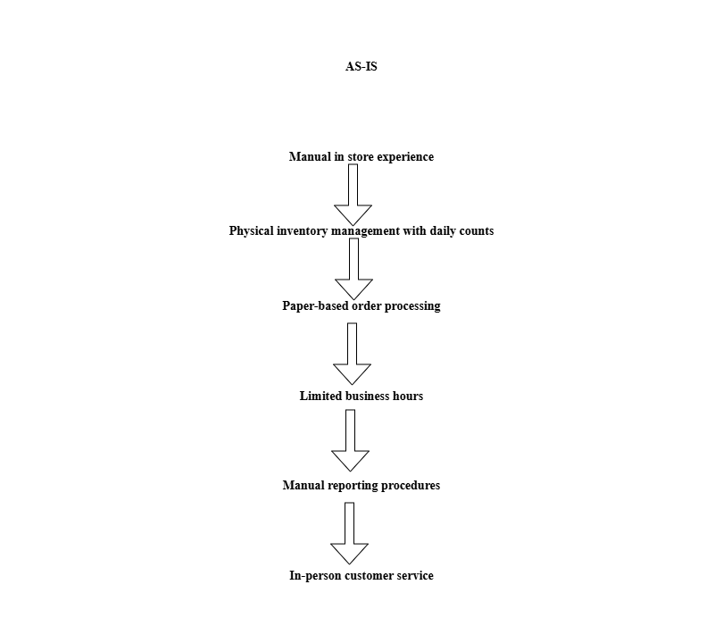

Key challenges in the current system include:

* Limited Customer Reach
* Inefficient Inventory Management
* Operational Inefficiencies
* Suboptimal Customer Experience
* Scalability Constraints

*8.2. Proposed Recommendations (TO-BE)*

The proposed online store will provide a 24/7 digital sales channel integrated with existing operations. Customers will be able to browse the complete product catalogue, create accounts, place orders, and track deliveries online. The system will synchronize inventory data in real-time between online and physical locations, preventing overselling. Order management will be automated with notifications to relevant departments. The admin dashboard will provide real-time analytics and reporting to enable data-driven decision making.

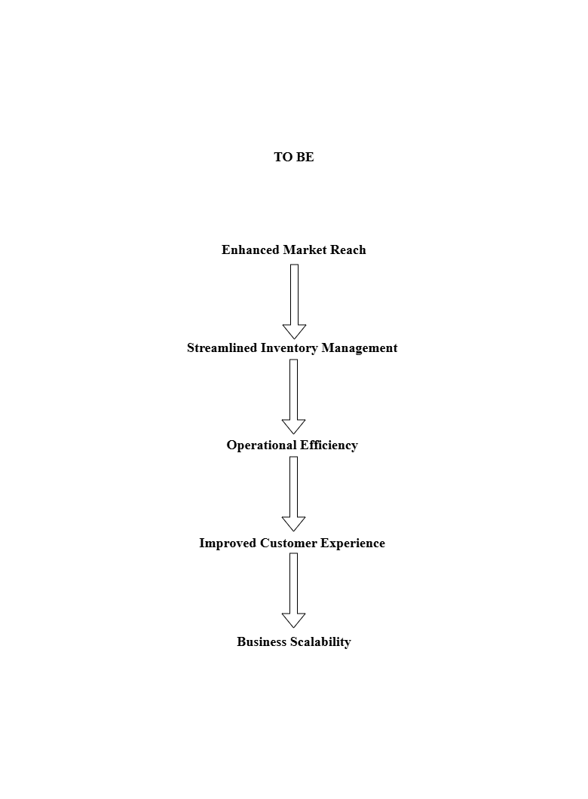

Key improvements in the proposed system:

* Enhanced Market Reach
* Streamlined Inventory Management
* Operational Efficiency
* Improved Customer Experience
* Business Scalability

9. Business Requirements

*Functional Requirements*

|  |  |  |  |
| --- | --- | --- | --- |
| **Req ID** | **Req Name** | **Req Description** | **Priority** |
| FR001 | User Registration | System shall allow users to create accounts using email and password | High |
| FR002 | User Authentication | System shall support secure login/logout functionality | High |
| FR003 | Password Recovery | System shall provide password reset functionality via email | Medium |
| FR004 | Profile Management | System shall allow users to view and update their profile information | Medium |
| FR005 | Address Management | System shall store and manage multiple shipping addresses per user | Medium |
| FR006 | Order History | System shall maintain and display complete order history for each user | Medium |
| FR007 | Product Display | System shall show product listings with images, descriptions, and prices | High |
| FR008 | Product Categorization | System shall organize products in hierarchical categories | High |
| FR009 | Product Search | System shall provide keyword-based product search functionality | High |
| FR010 | Product Filtering | System shall allow filtering products by category, price, and attributes | Medium |
| FR011 | Inventory Status | System shall display real-time product availability status | High |
| FR012 | Product Variants | System shall support product variations (size, colour, etc.) | Medium |
| FR013 | Product Management | System shall allow administrators to add, edit, and remove products | High |
| FR014 | Shopping Cart | System shall provide functionality to add/remove items from cart | High |
| FR015 | Order Calculation | System shall calculate order totals including tax and shipping costs | High |
| FR016 | Discount Application | System shall support applying discount/promo codes to orders | Medium |
| FR017 | Wish List | System shall allow users to save items to a wish list for future purchase | Low |
| FR018 | Product Recommendations | System shall display related or recommended products | Low |
| FR019 | Reviews Display | System shall show product ratings and customer reviews | Medium |
| FR020 | Review Submission | System shall allow authenticated users to submit product reviews | Medium |

*Non-Functional Requirements*

|  |  |  |  |
| --- | --- | --- | --- |
| **Req ID** | **Req Name** | **Req Description** | **Priority** |
| NF001 | User Concurrency | System shall support at least 500 concurrent users | High |
| NF002 | Pay Load Speed | Page load time shall not exceed 3 seconds under normal conditions | High |
| NF003 | Search Performance | Search queries shall return results in less than 2 seconds | Medium |
| NF004 | Transaction Speed | System shall process payment transactions in less than 5 seconds | High |
| NF005 | Database Capacity | Database shall handle at least 10,000 products without performance degradation | Medium |
| NF006 | Password Security | All user passwords shall be stored with strong encryption | High |
| NF007 | Data Encryption | System shall implement HTTPS for all data transmission | High |
| NF008 | Payment Compliance | System shall comply with PCI DSS for payment processing | High |
| NF009 | Session Timeout | User sessions shall timeout after 30 minutes of inactivity | Medium |
| NF010 | Account Security | System shall lock accounts after 5 failed login attempts | Medium |

10. Appendices

*10.1. List of Acronyms*

BRD: Business Requirements Document

ROI: Return on Investment

PCI DSS: Payment Card Industry Data Security Standard

WCAG: Web Content Accessibility Guidelines

UX: User Experience

API: Application Programming Interface

*10.2. Glossary of Terms*

Shopping Cart: Virtual container for items selected for purchase

Payment Gateway: Service that authorizes credit card payments

Inventory Synchronization: Process of updating stock levels across all channels

Admin Dashboard: Web interface for managing the online store

Responsive Design: Website design that adapts to different screen sizes

User Session: Period of user interaction with the website

*10.3. Related Documents*

Functional Specifications Document

Technical Architecture Document

User Experience Design Guidelines

Data Migration Plan

Testing Strategy Document

Implementation Roadmap

*SRS DOCUMENT*

**Software Requirements Specification**

**E-Commerce Online Store**

**Date: May, 01 2025**

Acceptance:

____________________________________________

Client Authorized Representative

Record of Revisions

|  |  |  |  |  |  |  |  |
| --- | --- | --- | --- | --- | --- | --- | --- |
| Version | Date of Release/ Revision | Prepared/ Revised By | Reviewed By | | Approved By | | Reasons for revisions |
|  | | | Name | Date | Name | Date |  |
| 1.0 | May, 01 2025 |  |  | |  | | Initial Document |

Table of Contents

1.0 Introduction

1.1 Overview

1.2 Acronyms and definitions

1.3 Operational Requirements

1.4 References

1.5 Design and Implementation Constraints

1.6 Assumed Factors That Could Affect the Requirements

2.0 System Overview

2.1 Current System

2.2 Proposed System

2.3 Benefits of the Proposed System

3.0 UI Requirements

3.1 Project contents

4.0 Other Parameters

4.1 Acceptance

1.0 Introduction

*1.1 Overview*

This Software Requirements Specification (SRS) document outlines the requirements for developing an Online Store e-commerce platform. The system will provide customers with the ability to browse products, create accounts, place orders, and make secure payments online. It will also provide administrators with tools to manage inventory, process orders, and analyse sales data.

*1.2 Acronyms and definitions*

|  |  |
| --- | --- |
| Term | Description |
|  |  |
| SRS | Software Requirements Specification |
| UI | User Interface |
| API | Application Programming Interface |
| CMS | Content Management System |
| DBMS | Database Management System |
| SSL | Secure Sockets Layer |
| PCI DSS | Payment Card Industry Data Security Standard |
| CRUD | Create, Read, Update, Delete |
| SKU | Stock Keeping Unit |
| SEO | Search Engine Optimization |
| B2C | Business to Consumer |

*1.3 Operational Requirements*

*1.3.1 Software Requirements*

- Web server: Apache/Nginx

- Programming languages: JavaScript, TypeScript, Python

- Frontend framework: React.js

- Backend framework: Node.js/Express or Django

- Database: MySQL or PostgreSQL

- Payment gateway integration: Stripe/PayPal

- Cloud services: AWS/Azure/Google Cloud

- Containerization: Docker

- Version control: Git

- CI/CD: Jenkins/GitHub Actions

- Analytics: Google Analytics

*1.3.2 Hardware Requirements*

- Web servers: Minimum 4GB RAM, 2 CPU cores

- Database servers: Minimum 8GB RAM, 4 CPU cores

- Storage: Minimum 100GB SSD storage (scalable)

- Network: Reliable internet connection with minimum 100Mbps

- Backup systems: Daily automated backups

- Development hardware: Standard development workstations with minimum 16GB RAM

*1.4 References*

- Project Proposal Document

- Industry e-commerce standards

- PCI DSS compliance documentation

- Modern web development best practices

- WCAG 2.1 accessibility guidelines

*1.5 Design and Implementation Constraints*

- The system must be built with responsive design principles to ensure compatibility across various devices and screen sizes.

- All payment processing must comply with PCI DSS requirements.

- Development must follow security best practices to protect customer data.

- The application must be compatible with major browsers (Chrome, Firefox, Safari, Edge).

- User authentication and authorization must implement industry-standard security measures.

- Third-party APIs must be evaluated for reliability, performance, and security.

- The system should be designed for scalability to handle increased traffic during peak sales periods.

- The platform must comply with relevant data protection regulations (GDPR, CCPA, etc.).

*1.6 Assumed Factors That Could Affect the Requirements Stated In the SRS*

- Changes in payment gateway API specifications

- Updates to browser standards and technologies

- Changes in data protection regulations

- Evolving security threats requiring additional countermeasures

- Scaling requirements based on actual user adoption

- Third-party service availability and reliability

- Integration with external inventory or ERP systems

- Future expansion to additional markets requiring localization

2.0 System Overview

*2.1 Current System*

Currently, the business operates through physical stores and limited online presence through social media channels. The ordering process is manual, requiring customers to send messages or make phone calls to place orders. Inventory management is handled through spreadsheets, and there is no integrated system for tracking sales, managing customer relationships, or processing online payments securely.

*2.2 Proposed System*

The proposed Online Store will be a comprehensive e-commerce platform with the following key components:

1. Customer-Facing Frontend

- Responsive design for desktop and mobile devices

- Product catalog with advanced search and filtering capabilities

- User account management system

- Shopping cart and checkout process

- Secure payment processing

- Order tracking functionality

- Product reviews and ratings

- Wishlist feature

2. Admin Dashboard

- Inventory management system

- Order processing workflows

- Customer management

- Content management for product information

- Sales and analytics reporting

- Discount and promotion management

- User role management

3. Backend Systems

- RESTful API for frontend-backend communication

- Database architecture for product, user, and order data

- Payment processing integration

- Shipping provider integration

- Email notification system

- Data backup and recovery systems

- Security infrastructure

*2.3 Benefits of the Proposed System*

- Expanded market reach beyond physical store locations

- 24/7 availability for customers to browse and purchase products

- Automated inventory management reducing manual workload

- Enhanced customer experience with personalized recommendations

- Detailed analytics to inform business decisions

- Scalable platform to support business growth

- Reduced operational costs compared to physical-only retail

- Improved customer relationship management

- Streamlined order fulfilment process

- Ability to rapidly adjust to market demands and promotions

3.0 UI Requirements

*3.1 Project contents*

The Online Store consists of the following key modules:

A. Customer Portal

1. Homepage

- Featured products section

- New arrivals section

- Promotions banner

- Category navigation

- Search functionality

2. Product Catalogue

- Product listing with filtering options

- Product categories and subcategories

- Sort by price, popularity, ratings

- Product cards with images, prices, and quick-view options

3. Product Detail Page

- Multiple product images/gallery

- Detailed product description

- Pricing information

- Availability status

- Add to cart button

- Quantity selection

- Size/variant selection (if applicable)

- Related products section

- Customer reviews and ratings

- Share on social media options

4. Shopping Cart

- Product list with images and details

- Quantity adjustment

- Remove item functionality

- Price subtotal calculation

- Apply coupon/discount code field

- Shipping cost estimate

- Proceed to checkout button

5. Checkout Process

- Shipping address input/selection

- Billing address input/selection

- Shipping method selection

- Payment method selection

- Order summary

- Terms and conditions acceptance

- Place order button

6. User Account

- Registration and login forms

- Profile management

- Address book

- Order history

- Order tracking

- Wishlist management

- Payment methods management

- Password reset functionality

B. Admin Dashboard

1. Orders Management

- Order listing with filtering options

- Order details view

- Order status updates

- Order processing workflows

- Invoice generation and printing

2. Product Management

- Product CRUD operations

- Category management

- Inventory tracking

- Price management

- Product image management

- SEO metadata management

- Product import/export functionality

3. Customer Management

- Customer listing with search and filtering

- Customer profile details

- Purchase history

- Customer segmentation

- Communication tools

4. Content Management

- Home page banner management

- Static page editor

- Blog/article management

- SEO settings

5. Reporting and Analytics

- Sales reports

- Customer acquisition metrics

- Inventory reports

- Best selling products

- Abandoned cart analysis

- Revenue and profit tracking

- Export functionality for reports

6. System Settings

- User role and permission management

- Payment gateway configuration

- Shipping method configuration

- Tax settings

- Email template management

- General store settings

4.0 Other Parameters

*4.1 Acceptance*

The client will review and accept the application on receiving the following deliverables:

1. Fully functional online store with all specified features

2. Comprehensive test reports demonstrating all requirements have been met

3. Source code with documentation

4. User manuals for both customer-facing and admin interfaces

5. Installation and configuration guides

6. Deployment documentation

7. API documentation for third-party integrations

8. Performance test results demonstrating the system meets load requirements

9. Security audit report

10. Training materials for admin users

*Acceptance Criteria:*

- All critical and high-priority features function as specified

- The system performs within agreed response time parameters under expected load

- The application passes security vulnerability testing

- The system complies with applicable regulations for e-commerce and data protection

- The application is compatible with specified browsers and devices

- Documentation is complete and accurate

---

Client Authorized Representative:

________________________________________________

[Name and Signature]

*3. ERD*

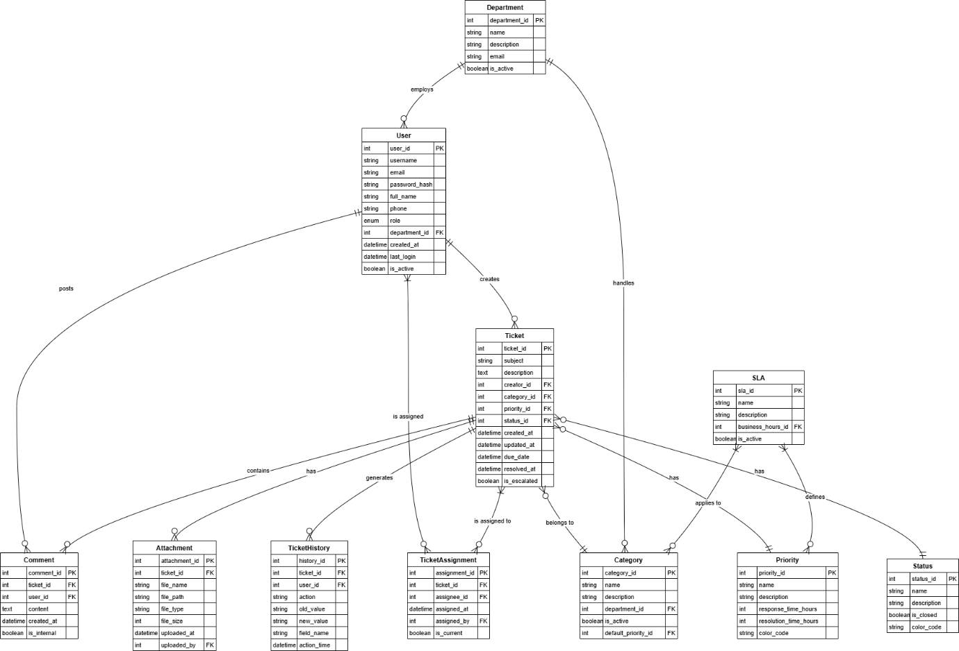

*4. User story of shopping from ecommerce*

|  |  |  |  |
| --- | --- | --- | --- |
| User Story No. 1 | Tasks: 3 | | Priority: High |
| AS A CUSTOMER  I WANT TO BROWSE PRODUCTS BY CATEGORY  SO THAT I CAN EASILY FIND ITEMS I'M INTERESTED IN | | | |
| BV: 500 | | CP: 5 | |
| ACCEPTANCE CRITERIA:  VIEW MAIN PRODUCT CATEGORIES ON HOMEPAGE  NAVIGATE THROUGH SUBCATEGORIES  FILTER PRODUCTS BY ATTRIBUTES (SIZE, COLOR, PRICE)  SORT PRODUCTS BY RELEVANCE, PRICE, OR RATING  SEE PRODUCT THUMBNAILS WITH BASIC INFORMATION  RESPONSIVE DESIGN WORKS ON MOBILE DEVICES | | | |

|  |  |  |  |
| --- | --- | --- | --- |
| User Story No. 2 | Tasks: 3 | | Priority: High |
| AS A CUSTOMER  I WANT TO VIEW DETAILED PRODUCT INFORMATION  SO THAT I CAN MAKE INFORMED PURCHASING DECISIONS | | | |
| BV: 500 | | CP: 3 | |
| ACCEPTANCE CRITERIA:  SEE MULTIPLE PRODUCT IMAGES  READ COMPLETE PRODUCT DESCRIPTIONS  VIEW TECHNICAL SPECIFICATIONS  SEE PRICING INFORMATION AND DISCOUNTS  CHECK PRODUCT AVAILABILITY  VIEW CUSTOMER REVIEWS AND RATINGS  SEE RELATED OR COMPLEMENTARY PRODUCTS | | | |

|  |  |  |  |
| --- | --- | --- | --- |
| User Story No. 3 | Tasks: 4 | | Priority: High |
| AS A CUSTOMER  I WANT TO CREATE AN ACCOUNT  SO THAT I CAN TRACK ORDERS AND SAVE MY INFORMATION | | | |
| BV: 500 | | CP: 5 | |
| ACCEPTANCE CRITERIA:  REGISTER WITH EMAIL OR SOCIAL MEDIA ACCOUNTS  RECEIVE CONFIRMATION EMAIL  VERIFY EMAIL ADDRESS  CREATE AND RESET PASSWORD  VIEW AND EDIT PROFILE INFORMATION  MANAGE COMMUNICATION PREFERENCES  DELETE ACCOUNT IF NEEDED | | | |

|  |  |  |  |
| --- | --- | --- | --- |
| User Story No. 4 | Tasks: 3 | | Priority: High |
| AS A CUSTOMER  I WANT TO ADD ITEMS TO CART  SO THAT I CAN PURCHASE MULTIPLE ITEMS AT ONCE | | | |
| BV: 500 | | CP: 3 | |
| ACCEPTANCE CRITERIA:  ADD PRODUCTS TO CART FROM PRODUCT PAGE  SELECT PRODUCT VARIATIONS (SIZE, COLOR)  SPECIFY QUANTITY  SEE CONFIRMATION OF ADDED ITEM  VIEW CART SUMMARY WITH TOTAL ITEMS  CART PERSISTS BETWEEN SESSIONS  ADD TO CART WITHOUT PAGE RELOAD | | | |

|  |  |  |  |
| --- | --- | --- | --- |
| User Story No. 5 | Tasks: 5 | | Priority: High |
| AS A CUSTOMER  I WANT TO CHECKOUT AND PAY FOR MY ORDER  SO THAT I CAN COMPLETE MY PURCHASE SECURELY | | | |
| BV: 500 | | CP: 8 | |
| ACCEPTANCE CRITERIA:  REVIEW CART CONTENTS BEFORE CHECKOUT  ENTER SHIPPING AND BILLING INFORMATION  SAVE ADDRESSES FOR FUTURE ORDERS  SELECT SHIPPING METHOD  CHOOSE FROM MULTIPLE PAYMENT OPTIONS  RECEIVE ORDER CONFIRMATION  VIEW ORDER SUMMARY WITH ALL COSTS  SECURE PAYMENT PROCESSING | | | |

|  |  |  |  |
| --- | --- | --- | --- |
| User Story No. 6 | Tasks: 3 | | Priority: Medium |
| AS A CUSTOMER  I WANT TO SEARCH FOR SPECIFIC PRODUCTS  SO THAT I CAN QUICKLY FIND WHAT I'M LOOKING FOR | | | |
| BV: 200 | | CP: 5 | |
| ACCEPTANCE CRITERIA:  SEARCH BAR ACCESSIBLE FROM ALL PAGES  SEARCH BY KEYWORDS, PRODUCT NAMES, OR SKU  SEE AUTOCOMPLETE SUGGESTIONS  VIEW SEARCH RESULTS WITH FILTERING OPTIONS  SORT SEARCH RESULTS BY RELEVANCE  HANDLE MISSPELLINGS AND SYNONYMS  DISPLAY "NO RESULTS" WITH ALTERNATIVES | | | |

|  |  |  |  |
| --- | --- | --- | --- |
| User Story No. 7 | Tasks: 2 | | Priority: Medium |
| AS A CUSTOMER  I WANT TO TRACK MY ORDER STATUS  SO THAT I KNOW WHEN MY PURCHASE WILL ARRIVE | | | |
| BV: 200 | | CP: 3 | |
| ACCEPTANCE CRITERIA:  VIEW ORDER HISTORY IN MY ACCOUNT  SEE DETAILED ORDER STATUS  RECEIVE EMAIL NOTIFICATIONS FOR STATUS CHANGES  TRACK PACKAGE WITH SHIPPING CARRIER  VIEW ESTIMATED DELIVERY DATE  CONTACT SUPPORT ABOUT ORDER ISSUES | | | |

|  |  |  |  |
| --- | --- | --- | --- |
| User Story No. 8 | Tasks: 2 | | Priority: Medium |
| AS A CUSTOMER  I WANT TO SAVE ITEMS TO A WISHLIST  SO THAT I CAN REMEMBER PRODUCTS FOR FUTURE PURCHASE | | | |
| BV: 200 | | CP: 3 | |
| ACCEPTANCE CRITERIA:  ADD ITEMS TO WISHLIST FROM PRODUCT PAGES  VIEW AND MANAGE WISHLIST IN MY ACCOUNT  MOVE ITEMS FROM WISHLIST TO CART  SHARE WISHLIST WITH OTHERS  RECEIVE NOTIFICATIONS FOR PRICE DROPS  ORGANIZE ITEMS INTO MULTIPLE WISHLISTS | | | |

|  |  |  |  |
| --- | --- | --- | --- |
| User Story No. 9 | Tasks: 3 | | Priority: Medium |
| AS A CUSTOMER  I WANT TO LEAVE PRODUCT REVIEWS  SO THAT I CAN SHARE MY EXPERIENCE WITH OTHER SHOPPERS | | | |
| BV: 200 | | CP: 4 | |
| ACCEPTANCE CRITERIA:  WRITE REVIEWS FOR PURCHASED PRODUCTS  RATE PRODUCTS WITH STAR RATING  UPLOAD PHOTOS WITH REVIEWS  EDIT OR DELETE MY REVIEWS  FLAG INAPPROPRIATE REVIEWS  SORT AND FILTER REVIEWS BY RATING OR DATE  RECEIVE POINTS OR REWARDS FOR HELPFUL REVIEWS | | | |

|  |  |  |  |
| --- | --- | --- | --- |
| User Story No. 10 | Tasks: 2 | | Priority: Low |
| AS A CUSTOMER  I WANT TO APPLY PROMOTIONAL CODES  SO THAT I CAN RECEIVE DISCOUNTS ON MY PURCHASE | | | |
| BV: 200 | | CP: 2 | |
| ACCEPTANCE CRITERIA:  ENTER PROMO CODE DURING CHECKOUT  SEE DISCOUNT APPLIED IMMEDIATELY  RECEIVE ERROR MESSAGE FOR INVALID CODES  COMBINE PROMOTIONAL OFFERS WHEN ALLOWED  VIEW TERMS AND CONDITIONS OF PROMOTIONS  SEE EXPIRATION DATE OF PROMO CODE | | | |

|  |  |  |  |
| --- | --- | --- | --- |
| User Story No. 11 | Tasks: 3 | | Priority: Low |
| AS A CUSTOMER  I WANT TO RETURN OR EXCHANGE PRODUCTS  SO THAT I CAN RESOLVE ISSUES WITH MY PURCHASE | | | |
| BV: 200 | | CP: 5 | |
| ACCEPTANCE CRITERIA:  INITIATE RETURN FROM ORDER HISTORY  SPECIFY REASON FOR RETURN  PRINT RETURN SHIPPING LABEL  TRACK RETURN STATUS  RECEIVE REFUND CONFIRMATION  REQUEST EXCHANGE INSTEAD OF REFUND  VIEW RETURN POLICY INFORMATION | | | |

|  |  |  |  |
| --- | --- | --- | --- |
| User Story No. 12 | Tasks: 2 | | Priority: Low |
| AS A CUSTOMER  I WANT TO CONTACT CUSTOMER SUPPORT  SO THAT I CAN GET HELP WITH QUESTIONS OR ISSUES | | | |
| BV: 200 | | CP: 3 | |
| ACCEPTANCE CRITERIA:  ACCESS CONTACT INFORMATION EASILY  USE LIVE CHAT SUPPORT  SUBMIT SUPPORT TICKET  VIEW FAQ AND HELP ARTICLES  RECEIVE TIMELY EMAIL RESPONSES  RATE SUPPORT EXPERIENCE | | | |

|  |  |  |  |
| --- | --- | --- | --- |
| User Story No. 13 | Tasks: 3 | | Priority: High |
| AS AN ADMINISTRATOR  I WANT TO MANAGE PRODUCT INVENTORY  SO THAT I CAN KEEP PRODUCT INFORMATION ACCURATE | | | |
| BV: 500 | | CP: 8 | |
| ACCEPTANCE CRITERIA:  ADD NEW PRODUCTS WITH ALL DETAILS  EDIT EXISTING PRODUCT INFORMATION  MANAGE PRODUCT CATEGORIES  UPDATE STOCK LEVELS  SET PRICING AND DISCOUNTS  UPLOAD MULTIPLE PRODUCT IMAGES  BULK IMPORT/EXPORT PRODUCT DATA  MARK PRODUCTS AS FEATURED OR ON SALE | | | |

|  |  |  |  |
| --- | --- | --- | --- |
| User Story No. 14 | Tasks: 3 | | Priority: High |
| AS AN ADMINISTRATOR  I WANT TO PROCESS CUSTOMER ORDERS  SO THAT I CAN FULFILL PURCHASES EFFICIENTLY | | | |
| BV: 500 | | CP: 5 | |
| ACCEPTANCE CRITERIA:  VIEW ALL INCOMING ORDERS  FILTER ORDERS BY STATUS OR DATE  UPDATE ORDER STATUS  GENERATE PACKING SLIPS AND INVOICES  PROCESS REFUNDS WHEN NEEDED  CANCEL ORDERS WHEN REQUESTED  SEND ORDER STATUS UPDATES TO CUSTOMERS | | | |

|  |  |  |  |
| --- | --- | --- | --- |
| User Story No. 15 | Tasks: 2 | | Priority: High |
| AS AN ADMINISTRATOR  I WANT TO VIEW SALES REPORTS AND ANALYTICS  SO THAT I CAN MAKE INFORMED BUSINESS DECISIONS | | | |
| BV: 500 | | CP: 6 | |
| ACCEPTANCE CRITERIA:  VIEW SALES DATA BY TIME PERIOD  ANALYZE REVENUE BY PRODUCT CATEGORY  TRACK CONVERSION RATES  IDENTIFY TOP-SELLING PRODUCTS  MONITOR CUSTOMER ACQUISITION COSTS  EXPORT REPORTS IN VARIOUS FORMATS  VISUALIZE DATA WITH CHARTS AND GRAPHS  SCHEDULE AUTOMATED REPORT DELIVERY | | | |

|  |  |  |  |
| --- | --- | --- | --- |
| User Story No. 16 | Tasks: 3 | | Priority: Medium |
| AS AN ADMINISTRATOR  I WANT TO MANAGE USER ACCOUNTS  SO THAT I CAN ASSIST CUSTOMERS AND CONTROL ACCESS | | | |
| BV: 200 | | CP: 4 | |
| ACCEPTANCE CRITERIA:  VIEW ALL REGISTERED USERS  SEARCH FOR SPECIFIC USERS  EDIT USER INFORMATION WHEN NEEDED  RESET USER PASSWORDS  DISABLE OR DELETE ACCOUNTS  ASSIGN USER ROLES AND PERMISSIONS  TRACK USER ACTIVITY LOGS | | | |

|  |  |  |  |
| --- | --- | --- | --- |
| User Story No. 17 | Tasks: 2 | | Priority: Medium |
| AS AN ADMINISTRATOR  I WANT TO MANAGE PROMOTIONAL CAMPAIGNS  SO THAT I CAN INCREASE SALES AND CUSTOMER ENGAGEMENT | | | |
| BV: 200 | | CP: 5 | |
| ACCEPTANCE CRITERIA:  CREATE TIME-LIMITED PROMOTIONS  GENERATE PROMO CODES  SET DISCOUNT AMOUNTS OR PERCENTAGES  APPLY PROMOTIONS TO SPECIFIC PRODUCTS  SCHEDULE PROMOTIONS IN ADVANCE  TRACK PROMOTION EFFECTIVENESS  SEND PROMOTIONAL EMAILS | | | |

|  |  |  |  |
| --- | --- | --- | --- |
| User Story No. 18 | Tasks: 2 | | Priority: Medium |
| AS AN ADMINISTRATOR  I WANT TO MANAGE CONTENT AND MARKETING  SO THAT I CAN KEEP THE STORE CURRENT AND ATTRACTIVE | | | |
| BV: 200 | | CP: 4 | |
| ACCEPTANCE CRITERIA:  UPDATE HOMEPAGE BANNERS AND FEATURED ITEMS  MANAGE PRODUCT RECOMMENDATIONS  CREATE AND EDIT PAGE CONTENT  PUBLISH BLOG POSTS AND ANNOUNCEMENTS  OPTIMIZE CONTENT FOR SEO  SCHEDULE CONTENT PUBLICATION  PREVIEW CHANGES BEFORE PUBLISHING | | | |

|  |  |  |  |
| --- | --- | --- | --- |
| User Story No. 19 | Tasks: 3 | | Priority: Medium |
| AS AN ADMINISTRATOR  I WANT TO CONFIGURE SHIPPING OPTIONS  SO THAT I CAN PROVIDE ACCURATE SHIPPING COSTS | | | |
| BV: 200 | | CP: 5 | |
| ACCEPTANCE CRITERIA:  SET UP MULTIPLE SHIPPING METHODS  CONFIGURE SHIPPING RATES BY WEIGHT OR PRICE  DEFINE SHIPPING ZONES  SET FREE SHIPPING THRESHOLDS  INTEGRATE WITH SHIPPING CARRIERS  GENERATE SHIPPING LABELS  TRACK SHIPPED PACKAGES | | | |

|  |  |  |  |
| --- | --- | --- | --- |
| User Story No. 20 | Tasks: 2 | | Priority: Low |
| AS AN ADMINISTRATOR  I WANT TO MODERATE CUSTOMER REVIEWS  SO THAT I CAN MAINTAIN QUALITY CONTENT | | | |
| BV: 200 | | CP: 3 | |
| ACCEPTANCE CRITERIA:  VIEW ALL SUBMITTED REVIEWS  APPROVE OR REJECT PENDING REVIEWS  EDIT REVIEW CONTENT IF NEEDED  RESPOND TO CUSTOMER REVIEWS  FLAG INAPPROPRIATE CONTENT  FEATURE HELPFUL REVIEWS  SET AUTOMATED REVIEW RULES | | | |

|  |  |  |  |
| --- | --- | --- | --- |
| User Story No. 21 | Tasks: 3 | | Priority: Low |
| AS AN ADMINISTRATOR  I WANT TO MANAGE PAYMENT GATEWAYS  SO THAT I CAN OFFER SECURE PAYMENT OPTIONS | | | |
| BV: 500 | | CP: 7 | |
| ACCEPTANCE CRITERIA:  CONFIGURE MULTIPLE PAYMENT METHODS  SET PAYMENT PROCESSING FEES  VIEW TRANSACTION HISTORY  PROCESS REFUNDS  ENSURE PCI COMPLIANCE  HANDLE PAYMENT ERRORS  GENERATE FINANCIAL REPORTS | | | |

|  |  |  |  |
| --- | --- | --- | --- |
| User Story No. 22 | Tasks: 2 | | Priority: Low |
| AS AN ADMINISTRATOR  I WANT TO MANAGE CUSTOMER SUPPORT REQUESTS  SO THAT I CAN PROVIDE TIMELY ASSISTANCE | | | |
| BV: 200 | | CP: 4 | |
| ACCEPTANCE CRITERIA:  VIEW ALL SUPPORT TICKETS  ASSIGN TICKETS TO SUPPORT STAFF  TRACK TICKET STATUS AND RESOLUTION TIME  RESPOND TO CUSTOMER INQUIRIES  ACCESS CUSTOMER PURCHASE HISTORY  CREATE KNOWLEDGE BASE ARTICLES  MEASURE CUSTOMER SATISFACTION | | | |

|  |  |  |  |
| --- | --- | --- | --- |
| User Story No. 23 | Tasks: 4 | | Priority: Medium |
| AS A MOBILE USER  I WANT TO SHOP USING A DEDICATED MOBILE APP  SO THAT I CAN PURCHASE PRODUCTS ON THE GO | | | |
| BV: 500 | | CP: 8 | |
| ACCEPTANCE CRITERIA:  BROWSE PRODUCTS WITH MOBILE-OPTIMIZED INTERFACE  USE TOUCH GESTURES FOR NAVIGATION  SCAN BARCODES TO FIND PRODUCTS  SAVE PAYMENT METHODS SECURELY  RECEIVE PUSH NOTIFICATIONS  USE BIOMETRIC AUTHENTICATION  ACCESS ORDER HISTORY OFFLINE  SYNCHRONIZE CART BETWEEN APP AND WEBSITE | | | |

|  |  |  |  |
| --- | --- | --- | --- |
| User Story No. 24 | Tasks: 2 | | Priority: Low |
| AS A MOBILE USER  I WANT TO USE AUGMENTED REALITY TO PREVIEW PRODUCTS  SO THAT I CAN VISUALIZE ITEMS BEFORE PURCHASING | | | |
| BV: 200 | | CP: 13 | |
| ACCEPTANCE CRITERIA:  VIEW PRODUCTS IN AR USING CAMERA  PLACE VIRTUAL PRODUCTS IN REAL ENVIRONMENT  ADJUST PRODUCT SIZE AND ORIENTATION  TAKE SCREENSHOTS OF AR PREVIEW  SHARE AR PREVIEWS WITH OTHERS  COMPATIBLE WITH MAJOR AR FRAMEWORKS  FALLBACK OPTION FOR UNSUPPORTED DEVICES | | | |

|  |  |  |  |
| --- | --- | --- | --- |
| User Story No. 25 | Tasks: 3 | | Priority: Medium |
| AS A CUSTOMER  I WANT TO RECEIVE PERSONALIZED PRODUCT RECOMMENDATIONS  SO THAT I CAN DISCOVER RELEVANT ITEMS | | | |
| BV: 200 | | CP: 8 | |
| ACCEPTANCE CRITERIA:  RECEIVE RECOMMENDATIONS BASED ON BROWSING HISTORY  SEE SUGGESTIONS BASED ON PAST PURCHASES  VIEW "FREQUENTLY BOUGHT TOGETHER" ITEMS  GET RECOMMENDATIONS BY SIMILAR CUSTOMER PREFERENCES  OPT IN/OUT OF PERSONALIZED RECOMMENDATIONS  RATE RECOMMENDATION RELEVANCE  RECOMMENDATIONS ADAPT TO CHANGING PREFERENCES | | | |