Document 1: Definition of Done (DoD) – RISX FACS Project:
Ans :
In the Agile development of Risx FACS—a US healthcare insurance software with modules like Medicare Screen, Note Index, MC Search, and E-Bill—the team uses a Definition of Done (DoD) to ensure each user story meets quality and functional standards before being marked as complete.
This ensures consistent delivery of value across clinical coding, claims processing, and billing modules while meeting compliance and audit expectations.

Purpose:
To establish a clear, measurable checklist that confirms a user story, sprint, or release is:
- Functionally complete
- Tested for quality
- Approved by stakeholders
- Properly documented

Applies To:
- User Stories (e.g., “Add ICD-10 validation to Medicare Screen”)
- Sprints (e.g., “Note Index Enhancements Sprint 3”)
- Releases (e.g., “E-Bill module for CPT/HCPCS Phase 1”)
DoD Checklist for Risx FACS:
# | Activity
1 | Functional code implemented (e.g., code added for ICD or CPT check)
2 | User story assumptions validated (e.g., note types like 010, 019 show correctly)
3 | Code compiles and builds without errors
4 | Unit tests written and passed for backend logic (e.g., check if CPT is valid)
5 | Feature deployed to QA environment identical to production
6 | UI/UX validated across supported browsers (e.g., Note index view tested in Chrome, Firefox)
7 | Feature reviewed by UX/Design (where applicable)
8 | QA testing completed using real claim data scenarios
9 | Acceptance Criteria verified (e.g., shows error if wrong ICD code entered)
10 | Product Owner (US-based RM) approval received
11 | Refactoring completed for any code smells or duplication
12 | Configuration and build updates documented (e.g., added new billing step)
13 | User manuals or Excel tracking sheets updated (e.g., claim record updated)
14 | Peer Code Review completed by dev/auditor team
Document 2- Product Vision :
Ans :
Scrum Project Name:
RISX FACS – Claim Coding & Analysis Platform
Venue:
[Online- MS Teams]
Date:
[30th July 2025 ]
Start time: 10:00 AM IST
End time: 12:30 PM IST
Duration: [2 hours 30 minutes]
Client:
[The Hartford – US Workers’ Compensation Division]
Stakeholder List:
- Business Analyst
- Product Owner
- Scrum Master
- Development Team
- RM (Resolution Manager)
- Coders & Auditors
- QA Team
- End Users (US Insurance Claim Processors)

Vision :
To build a complete software that helps process and code US healthcare insurance claims easily and accurately.
The goal is to bring all tools (Med Screen, E-Bill, Note Index, etc.) into one single system to reduce manual work, save time, and improve claim accuracy.

Target Group :
Market Segment:
- US Healthcare Insurance
- Workers’ Compensation and Liability Claims
- Medical Coding Services
Target Users / Customers:
- US-based Resolution Managers (RMs)
- Coders & Auditors (Offshore teams)
- Claim Process Analysts
- Insurance Providers & Claim Adjusters

Needs :
Problem Solved:
- Claim info is spread across many tools.
- Manual coding, tracking, and queries waste time and cause errors.
- Timesheet tracking is unreliable.
Benefits Provided:
- One platform for coding, reviewing notes, raising queries, and submitting claims.
- Better speed, accuracy, and tracking of compensable body parts (POB).
- In-built query system, smart timesheet, and structured workflow.

Product :
What Product Is It?
- A web-based claim processing and coding software for US healthcare claims.
What Makes It Special?
- Combines Med Screen, E-Bill, MC Search, Note Index, and Excel into one system.
- Uses filters and note categories (001 to 020) for easy POB confirmation.
- Automates reports, timesheet entries, and code tracking.
Is It Feasible to Develop?
- Yes. The process is known, domain expertise is available, and Agile methodology supports step-by-step delivery.

Value :
How Will It Benefit the Company?
- Saves time and improves claim quality.
- Reduces manual errors and email communication.
- Speeds up offshore–onshore collaboration.
Business Goals:
- Increase claim throughput and reduce rework.
- Build trust with US clients through faster delivery and better tracking.
- Ensure HIPAA-compliant secure data handling.
Business Model:
- Software-as-a-Service (SaaS) model for internal use and client services.
- Can scale to other insurance processes in future.
Document 3: User stories :
User Story – 1: View and Analyze Claim Notes
User Story : US-001 | Tasks: |  | Priority : High
  Display all note types (001 to 020) with filters, show basic claim description, and highlight relevant content.
As a user (medical coder),
I want to view and filter different types of claim notes (e.g., Comp Note 010, POA 019, Medical Note 002, etc.),
so that I can quickly identify compensable body parts and confirm claim details.
BV : 500 |  | CP : 13
- Acceptance Criteria :
- User can view all claim notes from 001 to 020.
- Basic claim info like Date of Injury, Name, Type of Claim is visible on screen.
- Notes can be filtered by type (e.g., Medical, Legal, Investigation).
- Matching body part info is highlighted based on note content.

User Story – 2: Enter Codes in Medicare Screen
User Story : US-002 | Tasks: 2  Add/search ICD-9/10, CPT, HCPCS codes in Med Screen; save with shortcut (Ctrl+S). |  | Priority : High
As a coder,
I want to search and add diagnosis and procedure codes easily into the Med Screen,
so that I can ensure correct code entry for each claim.
BV : 500 |  | CP : 13
Acceptance Criteria :
- User can search for ICD, CPT, or HCPCS codes.
- Codes can be added and saved using Ctrl+S.
- System checks for duplicates and confirms successful entry.
- Codes are linked to claim ID.

User Story – 3: Record Claim Data in Excel Tracker
User Story : | Tasks: 2  Maintain coding log per claim ID, add source note details. date. |  | Priority : Medium
  US-003
As a coder,
I want to record all codes added along with reference note, date and claim ID in Excel,
so that I can dispatch a weekly report to the onshore team with full traceability.
BV : 200 |  | CP : 8
Acceptance Criteria :
- Excel sheet has columns for Claim ID, codes, reference note, date and POB.
- Weekly export and dispatch to RM is supported.
- Audit trail is maintained for each claim.

User Story – 4: Raise Queries to RM
User Story : | Tasks: 2  Create email template, link query to claim ID, auto-fill basic info mismatch reason |  | Priority : Medium
  US-004
As a coder,
I want to raise a query to the Resolution Manager when the claim info doesn’t match,
so that I can clarify data and avoid incorrect coding.
BV : 200 |  | CP : 8
Acceptance Criteria :
- Query form is auto-filled with claim ID and mismatch details.
- Email is generated with proper template.
- RM contact details are auto-fetched from the system.
- Query status is tracked in system.

User Story – 5: Auto-Track Time Per Claim
User Story : | Tasks: 2 |  | Priority : High
  US-005
  Auto-calculate time per claim, link with user ID and shift. Replace manual timesheet.
As a user,
I want the system to auto-track the time I spend per claim,
so that I can avoid manual timesheet entry and get accurate productivity data.
BV : 500 |  | CP : 13
Acceptance Criteria :
- Timer starts when claim is opened.
- Time auto-saved when claim is completed.
- Users can view daily, weekly work hours.
- Timesheet report is generated without manual entry.

Document 4: Agile PO Experience :

Product Owner Role Overview
The Product Owner (PO) leads the product with a clear vision based on domain knowledge, user needs, and market trends.

PO Responsibilities in the Project
- Market Analysis
  - Understand customer needs and demand in the US insurance domain.
  - Study if similar products already exist in the market.
- Enterprise Analysis
  - Check if this product is a good opportunity for the company.
  - Validate the feasibility and business value of the product.
- Product Vision and Roadmap
  - Define the product's goal based on market and user needs.
  - Prepare a timeline with key features and delivery milestones.
- Managing Product Features
  - Work with stakeholders to understand and set feature priorities.
  - Focus on high-value features that provide better ROI.
- Product Backlog Management
  - Prioritize user stories and tasks for development.
  - Update the backlog as per changing needs and stakeholder input.
- Sprint & Iteration Progress
  - Monitor sprint progress and make adjustments if required.
  - Work with the Business Analyst during sprint reviews and retrospectives.

Sprint Meeting Experience
From this project, I gained experience in handling these Agile meetings:
- Sprint Planning – Plan stories and tasks for the sprint.
- Daily Scrum – Track daily progress and roadblocks.
- Sprint Review – Review completed work with the team and stakeholders.
- Sprint Retrospective – Discuss what went well and what can be improved.
- Backlog Refinement – Keep the backlog updated with relevant, prioritized items.

User Stories Creation – Key Elements
In this project, I created user stories with these details:
- Story No.
- Tasks
- Priority (High, Medium, Low)
- Acceptance Criteria (Conditions to consider the story complete)
- BV (Business Value) – Importance of the story to business
- CP (Complexity Points) – Effort required to complete

PO as a Bridge Between Teams
- The Product Owner connects business stakeholders and Scrum teams.
- Shares updates with stakeholders and gathers feedback.
- Works closely with developers, testers, and analysts to ensure the product meets expectations.

Outcome
Through this experience, I learned how to manage product development effectively in Agile, define a clear vision, set priorities, and ensure successful delivery of each sprint goal.
Document 5: Product and sprint backlog and product and sprint burndown charts
Ans :

Product Backlog

User Story ID | User Story | Tasks | Priority | Business Value (BV) | Complexity Point (CP) | Sprint
US-001 | As a medical coder, I want to view and filter different types of claim notes (e.g., 010 Comp, 019 POA, 002 Medical) so that I can quickly identify compensable body parts and confirm claim details. | 1. Display all notes (001–020)2. Show basic claim info (DOI, name, type)3. Add filters for note types4. Highlight matching body parts in note | High | 500 | 13 | Sprint 1
US-002 | As a coder, I want to search and add ICD, CPT, HCPCS codes in the Med Screen so that I can ensure correct code entry for each claim. | 1. Enable code search feature2. Allow save using Ctrl+S3. Link codes to Claim ID 4. Validate duplicates before save | High | 500 | 13 | Sprint 1
US-003 | As a coder, I want to record all codes along with reference notes, date, and Claim ID in Excel so that I can generate weekly reports with traceability. | 1. Design Excel with required columns 2. Support weekly export 3. Maintain audit log per claim | Medium | 200 | 8 | Sprint 2
US-004 | As a coder, I want to raise a query to RM when claim info doesn’t match, so that I can clarify data and avoid incorrect coding. | 1. Auto-fill query form with mismatch info 2. Generate email using template 3. Fetch RM contact from database 4. Track query status in system | Medium | 200 | 8 | Sprint 2
US-005 | As a user, I want the system to auto-track time spent per claim so that I can eliminate manual timesheets and get accurate productivity reports. | 1. Start timer on claim open 2. Auto-save time on submission 3. View daily/weekly log s4. Link user ID and shift | High | 500 | 13 | Sprint 2

Sprint Backlog (Sprint 1 Example)

User Story ID | User Story | Tasks | Owner | Status | Estimated Effort (hrs)
US-001 | View and Analyze Claim Notes | 1. Display notes 001–020. 2.Show basic claim info 3. Add filters4. Highlight body part info | Developer 1 | To Do | 12
US-002 | Enter Codes in Medicare Screen | 1. Enable ICD/CPT/HCPCS search 2. Add/save codes with Ctrl+S 3. Link to claim ID 4. Check duplicates | Developer 2 | To Do | 12
US-003 | Record Claim Data in Excel Tracker | 1. Create Excel format 2. Weekly export 3. Audit log per claim | Developer 3 | To Do | 10
US-004 | Raise Queries to RM | 1. Create auto-filled query form 2. Generate email 3. Fetch RM contact 4. Track status | Developer 4 | To Do | 8
US-005 | Auto-Track Time Per Claim | 1. Start/stop timer 2. Link with user ID & shift 3. Generate timesheet report | Developer 5 | To Do | 10

Burndown Charts

Product Burndown Chart
• Shows total work remaining (in story points or hours) for the entire product across all sprints.
• Tracks progress from project start to final sprint.
• Helps monitor if product will be delivered on time.

Sprint Burndown Chart
• Tracks tasks completed daily within a single sprint.
• Y-axis: Remaining effort (hours or story points)
• X-axis: Days in the sprint
• Ideal line shows perfect progress; actual line shows real team performance.

Sprint burndown chart

Sprint – burndown – story point

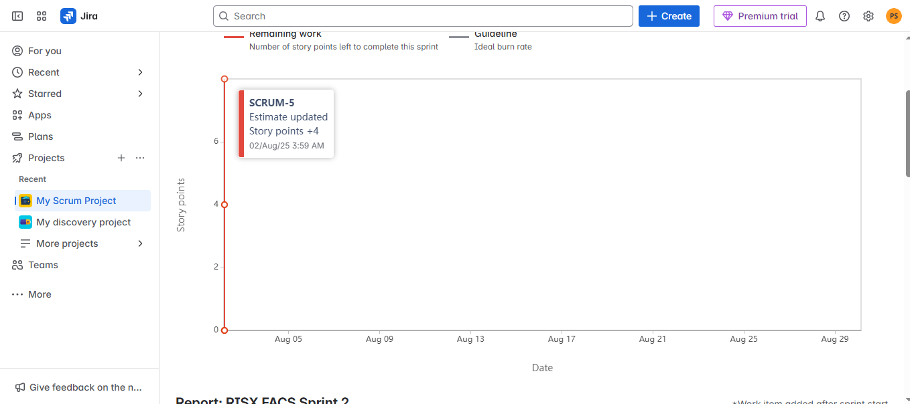

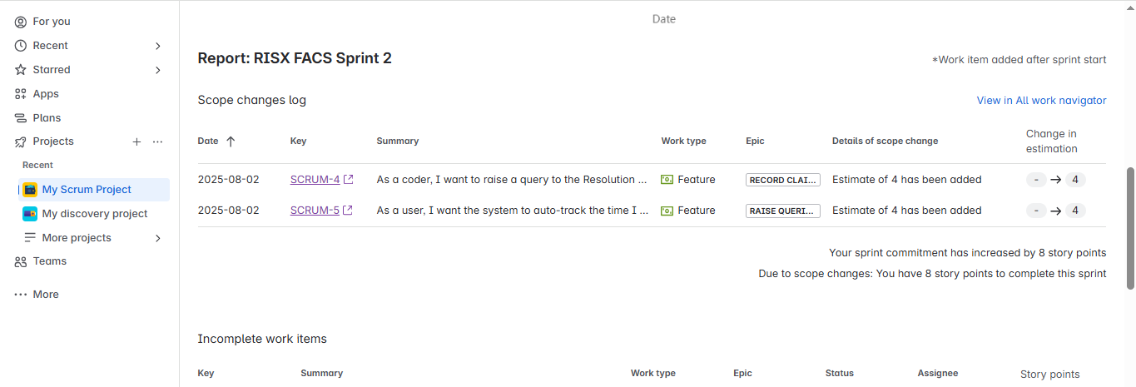

Sprint 2 – Work item count
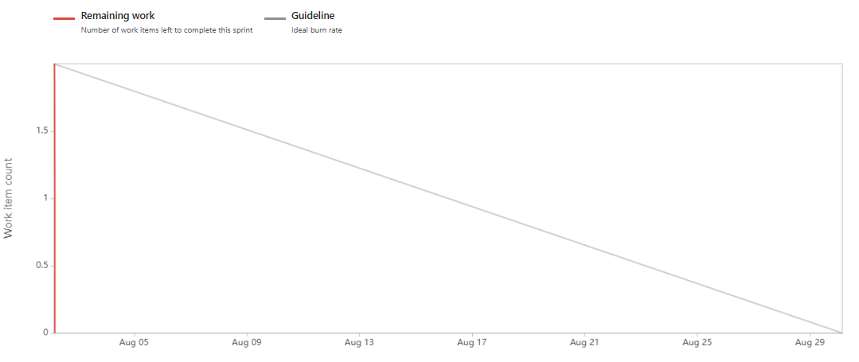

Document 6: Sprint meetings
Ans:
Meeting Type 1: Sprint Planning meeting
Field | Details
Meeting Type | Sprint Planning Meeting
Date | 01/08/2025
Time | 10:00 AM – 11:30 AM IST
Location | Microsoft Teams (Virtual Meeting)
Prepared By | Pradnya(Business Analyst)
Attendees | Product Owner, Scrum Master, Business Analyst, Scrum Developers (5)

Agenda Topics :
Topic | Presenter | Time Allotted
Overview of project & product vision | Product Owner | 10 mins
Discuss Sprint Goal | Scrum Master | 10 mins
Review product backlog items | Business Analyst | 15 mins
Prioritize user stories | Product Owner | 10 mins
Estimate stories using Planning Poker | Developers | 20 mins
Finalize sprint

Other Information : Sprint 1 focuses on integrating Medicare Screen, Note Index, and Excel tracker functionality. User stories 1–5 will be taken up.
Field | Details
Observers | QA Lead (for early clarification), IT Infra Support
Resources | JIRA board, Product Backlog document, Use Case diagrams, Excel tracker samples, Reference claim data
Special Notes | Ensure each story has clearly defined acceptance criteria. Track dependencies on RM for claim info validation. Sprint review planned on 08/08/2025.

Meeting Type 2: Sprint review meeting
Field | Details
Meeting Type | Sprint Review Meeting
Date | 08/08/2025
Time | 3:00 PM – 4:00 PM IST
Location | Zoom – Virtual Meeting Room
Prepared By | Sanjeevani
Attendees | Product Owner, Scrum Master, Scrum Team, QA, RM (Resolution Manager), Client Stakeholder
Sprint Status | Sprint 1 completed successfully. User Stories 1–5 developed and tested.
Things to Demo | • Medicare Screen code entry flow • Note Index integration with claim tracking • Excel auto-population logic • RM email trigger for mismatched data • Auto-timesheet logging
Quick Updates | Minor bugs in Note Index resolved RM interaction module feedback positive
What’s Next | Begin Sprint 2: Focus on E-Bill integration, basic claim description auto-fill, and UI enhancements.

Meeting Type 3: Sprint retrospective meeting :
Field | Details
Date | 08/09/2025
Time | 3:30 PM – 4:15 PM IST
Location | Zoom – Virtual Meeting Room
Prepared By | Sanjeevani
Attendees | Product Owner, Scrum Master, Scrum Team (Developers & QA), BA, RM
Agenda | Discuss Sprint 1 outcomes, team feedback, areas to improve
What Went Well | ✔ Smooth team collaboration ✔ User Story delivery on time ✔ Client appreciated note integration
What Didn’t Go Well | ✘ Manual timesheet logging delayed testing ✘ RM response delays ✘ Some unclear claim data from Excel
Questions | • Can timesheet be fully automated? • Should RM communication be built as in-app feature?
Reference | Jira Board – Sprint 1, RISX FACS Project Repo, Meeting Notes Doc 6

Meeting Type 4: Daily Stand-up meeting :
Question | Name / Role | Monday | Tuesday | Wednesday | Thursday | Friday | Saturday | Sunday
What did you do yesterday? | Developer 1 | Finalized Note Index logic | Implemented code entry UI | Integrated RM query function | Built validation for codes | Unit tested Med Screen module | - | -
 | Developer 2 | Set up claim tracker format | Added Excel export feature | Connected Med Screen to backend | Refined data mapping logic | Internal QA testing | - | -
 | Developer 3 | Designed E-Bill UI | Connected E-Bill data layer | Created claim filter module | Tested search in MC Search | Documented sprint progress | - | -
What will you do today? | Developer 1 | Test code submission flow | Start RM reply display module | Finalize POA note integration | Review & fix comp note issues | Sprint review preparation | - | -
 | Developer 2 | Work on summary report | Add success/error messages | Implement Excel claim log | Sprint retrospective inputs | Update user story tracker | - | -
 | Developer 3 | Optimize E-Bill performance | Link CPT/HCPCS with Med Screen | Clean up UI for MC Search | Work on missing note alerts | Upload to staging environment | - | -
What is blocking your progress? | Developer 1 | None | Waiting for PO feedback | Delay in comp note review | Clarification from BA pending | None | - | -
 | Developer 2 | API issue with Excel export | Network lag | Delay in testing environment | Minor data mismatch | None | - | -
 | Developer 3 | Waiting for E-Bill data sheet | UX review delay | Need clarification on filters | Code merge pending | None | - | -

