CAPSTONE PROJECT 4 ANSWER SHEET

**Que 1. Write Agile Manifesto**

**Ans:** Agile Manifesto includes 4 Values and 12 Principles Four Main Values:

1. Individual and interaction over processes and tools
2. Working software over comprehensive documentation
3. Customer collaboration over contract negotiation
4. Responding to change over following a plan Twelve Principles of Agile Software:
   1. Satisfy the customer through early and continuous delivery of valuable software
   2. Welcome changing requirements, even late in development. Agile processes harness

change for the customer’s competitive advantage.

* 1. Deliver working software frequently, from a couple of weeks to a couple of months, with a preference to the shorter timescale.
  2. Business people and developers must work together daily throughout the project.
  3. Build projects around motivated individuals. Give them the environment and support they need and trust them to get the job done.
  4. The most efficient and effective method of conveying information to and within a development team is face to face conversation.
  5. Working software is the primary measure of progress.
  6. Agile processes promote sustainable development. The sponsor, developers and users should be able to maintain a constant pace indefinitely.
  7. Continuous attention to technical excellence and good design enhances agility.
  8. Simplicity-the art of maximizing the amount of work not done- is essential.
  9. The best architectures, requirements, and designs emerge from self-organizing team.
  10. At regular intervals, the team reflects on how to become more effective, then tunes and adjusts its behavior accordingly.

**Que 2 User Stories- Acceptance Criteria-BV-CP**

**Ans:** A user story is the smallest unit of work in an agile framework. Below are a few user stories.

|  |  |  |  |
| --- | --- | --- | --- |
| User Story: 1 | Task: 1 | | Priority: Lowest |
| As a customer, I want to register So that  I can register myself in the system. | | | |
| BV (Business Value): 50 | | CP (Complexity Point): 3 | |
| Acceptance Criteria Register screen  Text box to enter details such as Name, contact number, Email address. Once details are entered application should share an OTP.  After submitting the OTP, a pop up should be displayed to confirm registration.  Application should send a notification to the email address and phone number for successful  registration. | | | |

|  |  |  |  |
| --- | --- | --- | --- |
| User Story: 2 | Task: 1 | | Priority: Highest |
| As a customer, I want to Login  So that  I can order the food. | | | |
| BV (Business Value): 500 | | CP (Complexity Point): 8 | |
| Acceptance Criteria Login screen  Text box to enter details, if entered details are correct customer should be able to login to his  account. | | | |

|  |  |  |  |
| --- | --- | --- | --- |
| User Story: 3 | Task: 1 | | Priority: Lowest |
| As a customer, I want to  Search and view restaurants So that  I can check the top restaurants. | | | |
| BV (Business Value): 20 | | CP (Complexity Point): 13 | |

Acceptance Criteria Search screen

Text box to enter location and veg/nonveg preference.

After entering the above details, the application should display the list of restaurants available in that location.

|  |  |  |  |
| --- | --- | --- | --- |
| User Story: 4 | Task: 1 | | Priority: Lowest |
| As a customer, I want to  View restaurant menu So that  I can order the food. | | | |
| BV (Business Value): 100 | | CP (Complexity Point): 8 | |
| Acceptance Criteria  After a customer has selected any restaurant, the application should show if the restaurant is open/closed.  It should also display a list of menus.  After selecting the menu, the application should display their price, image, ratings,  veg/nonveg categories and a small description of the item. | | | |

|  |  |  |  |
| --- | --- | --- | --- |
| User Story: 5 | Task: 1 | | Priority: Highest |
| As a customer, I want to Order food So that  I can have delivery of food to my desired location. | | | |
| BV (Business Value): 100 | | CP (Complexity Point): 8 | |
| Acceptance Criteria  Customers need to click on add to cart from the list of menus.  Then the customer needs to click on my cart and check the details such as items added to cart, quantity, price, delivery address and payment mode.  Application should also show text field for adding any delivery instructions. | | | |

|  |  |  |
| --- | --- | --- |
| User Story: 6 | Task: 1 | Priority: Highest |

|  |  |
| --- | --- |
| As a customer, I want to payment So that  I can place orders successfully. | |
| BV (Business Value): 500 | CP (Complexity Point): 21 |
| Acceptance Criteria Payment screen  Application should display modes of payment available.  If customers select card/ net banking / UPI/ Wallet then the application should take the customer to the screen to enter details such as card details, CVV number, card expiry date, UPI ID, etc.  Application should share a OTP to confirm the payment and place order. | |

|  |  |  |  |
| --- | --- | --- | --- |
| User Story: 7 | Task: 1 | | Priority: Lowest |
| As a customer, I want to  Track the order So that  I will know the time required to have the delivery. | | | |
| BV (Business Value): 50 | | CP (Complexity Point): 2 | |
| Acceptance Criteria Order details screen  Application should share a tracking link to the phone number or email address if the customer has requested for the link.  Customer can also view the status of the order through the application. | | | |

|  |  |  |  |
| --- | --- | --- | --- |
| User Story: 8 | Task: 1 | | Priority: Lowest |
| As a customer, I want to  Give feedback and rating So that  I can put forth my opinion and overall experience. | | | |
| BV (Business Value): 100 | | CP (Complexity Point): 1 | |
| Acceptance Criteria Feedback screen  Once the order delivery is completed the feedback option should be available. Few questions such as  1. Was the delivery made on time? | | | |

1. Was the delivery boy professional?
2. Ratings from 0-10, 10 being highest and 0 being lowest. Text box for customers to provide any additional feedback.

|  |  |  |  |
| --- | --- | --- | --- |
| User Story: 9 | Task: 1 | | Priority: Lowest |
| As a customer, I want to  Logout from the application So that  I am secure and nobody misuses my user account. | | | |
| BV (Business Value): 10 | | CP (Complexity Point): 5 | |
| Acceptance Criteria Logout screen  Customer should click on logout option so that he can successfully log out of the application.  Pop up to confirm if the customer wants to log out. | | | |

|  |  |  |  |
| --- | --- | --- | --- |
| User Story: 10 | Task: 1 | | Priority: Lowest |
| As a  Delivery boy, I want to Register  So that  I can register to the application as a delivery boy | | | |
| BV (Business Value): 10 | | CP (Complexity Point): 1 | |
| Acceptance Criteria Register screen  Text box to enter details like mobile number, email address, Name, Address and type of account  Application should share an OTP.  After entering valid OTP, pop up to confirm the registration. Email should be shared for successful login. | | | |

|  |  |  |
| --- | --- | --- |
| User Story: 11 | Task: 2 | Priority: Lowest |
| As a  Delivery boy, I want to Login  So that | | |

|  |  |
| --- | --- |
| I can check the schedule. | |
| BV (Business Value): 10 | CP (Complexity Point): 2 |
| Acceptance Criteria Login screen  Application should display login screen with text box where delivery boy can enter his login credentials.  After validating the credentials, the delivery boy can login to the application. | |

|  |  |  |  |
| --- | --- | --- | --- |
| User Story: 12 | Task: 1 | | Priority: Lowest |
| As a  Delivery boy, I want to  View the order list So that  I can deliver the food to the respective location. | | | |
| BV (Business Value): 20 | | CP (Complexity Point): 13 | |
| Acceptance Criteria  The home page should have a button to view the list of orders.  The order should consist of details such as customer name, phone number, payment mode and pickup and drop location.  Once the order is completed it should be moved from pending state to complete. | | | |

|  |  |  |  |
| --- | --- | --- | --- |
| User Story: 13 | Task: 1 | | Priority: Highest |
| As a  Delivery boy, I want to  Check order delivery and pickup So that  I can complete the delivery in time. | | | |
| BV (Business Value): 20 | | CP (Complexity Point): 13 | |
| Acceptance Criteria Order detail screen  The delivery boy should click on the order from the list so that he can check the delivery pickup.  Application should display the order details with pickup and delivery point, customer contact  details, payment mode. | | | |

|  |  |  |
| --- | --- | --- |
| User Story: 14 | Task: 1 | Priority: Lowest |
| As a  Delivery boy,  I want to | | |

|  |  |
| --- | --- |
| Select and accept order So that  I can work smoothly. | |
| BV (Business Value): 10 | CP (Complexity Point): 5 |
| Acceptance Criteria  Once the delivery boy has the order in his order list, there should be a Yes/No button to accept or reject the order. | |

|  |  |  |  |
| --- | --- | --- | --- |
| User Story: 15 | Task: 1 | | Priority: Highest |
| As a  Delivery boy, I want to  Check the payment mode selected by the customer So that  I can hand over the delivery after the payment is made. | | | |
| BV (Business Value): 500 | | CP (Complexity Point): 21 | |
| Acceptance Criteria  Order details should consist of the payment mode selected by the customer. If the payment  is already made, then the order details should have the transaction ID, amount paid. | | | |

|  |  |  |  |
| --- | --- | --- | --- |
| User Story: 16 | Task: 1 | | Priority: Lowest |
| As a  Delivery boy, I want to  View Deliveries report and revenue generated So that  I can check the total deliveries completed in month and check the salary | | | |
| BV (Business Value): 20 | | CP (Complexity Point): 13 | |
| Acceptance Criteria  Application should maintain daily record of the orders completed. At the end of the month the total number of orders with the customer feedback should be displayed.  The delivery boy needs to click on the report to check this daily target and performance. | | | |

|  |  |  |
| --- | --- | --- |
| User Story: 17 | Task: 1 | Priority: Lowest |
| As a  Delivery boy, I want to  View Feedback  So that | | |

|  |  |
| --- | --- |
| I can check and work on the feedback given. | |
| BV (Business Value): 10 | CP (Complexity Point): 8 |
| Acceptance Criteria  From the order that is moved to complete state will have a button to view feedback.  If the customer has shared the feedback the delivery boy should receive notification in the  application. | |

|  |  |  |  |
| --- | --- | --- | --- |
| User Story: 18 | Task: 1 | | Priority: Lowest |
| As a  Delivery boy, I want to  Logout from the application So that  I am secure and there is no misuse made from my account. | | | |
| BV (Business Value): 50 | | CP (Complexity Point): 13 | |
| Acceptance Criteria Logout screen  The delivery boy should have a logout option, once he clicks on the button a pop up should  appear to confirm logout. | | | |

|  |  |  |  |
| --- | --- | --- | --- |
| User Story: 19 | Task: 1 | | Priority: Highest |
| As a Restaurant, I want to Register  So that  I can register my restaurant in the application | | | |
| BV (Business Value): 100 | | CP (Complexity Point): 8 | |
| Acceptance Criteria Register screen  Text box to enter details like mobile number, email address, Name, Address and type of account.  OTP should be shared by email/phone number.  After submitting valid OTP, notification for successful registration. | | | |

|  |  |  |
| --- | --- | --- |
| User Story: 20 | Task: 1 | Priority: Highest |
| As a Restaurant, I want to Login  So that | | |

|  |  |
| --- | --- |
| I can add my restaurant in the application. | |
| BV (Business Value):2100 | CP (Complexity Point): 21 |
| Acceptance Criteria Login screen  Text box to enter the credentials. Once logged in, a restaurant owner should select whether he wants to register his restaurant or login as a customer.  OTP should be shared for login to the registered email and phone number. | |

|  |  |  |  |
| --- | --- | --- | --- |
| User Story: 21 | Task: 1 | | Priority: Highest |
| As a Restaurant, I want to View orders So that  I can prepare the order and send it for delivery. | | | |
| BV (Business Value): 500 | | CP (Complexity Point): 21 | |
| Acceptance Criteria  The restaurant profile should have a button to view the latest orders placed for his restaurant.  The order details should consist of the customer's name, quantity, item and amount. | | | |

|  |  |  |  |
| --- | --- | --- | --- |
| User Story: 22 | Task: 1 | | Priority: Lowest |
| As a Restaurant, I want to  View feedback So that  I can improve and see if customer satisfaction is achieved. | | | |
| BV (Business Value): 20 | | CP (Complexity Point): 5 | |
| Acceptance Criteria Feedback screen.  The restaurant profile should have a button to view the customer feedback. | | | |

|  |  |  |
| --- | --- | --- |
| User Story: 23 | Task: 1 | Priority: Highest |

|  |  |
| --- | --- |
| As a Restaurant, I want to  View payment option selected by the customer So that  I can check if the order is paid or not and maintain records. | |
| BV (Business Value): 200 | CP (Complexity Point): 13 |
| Acceptance Criteria Order details screen  The application should display the details regarding the payment, if the payment is prepaid it  should share the transaction ID as well. | |

|  |  |  |  |
| --- | --- | --- | --- |
| User Story: 24 | Task: 1 | | Priority: Lowest |
| As a Restaurant, I want to  Logout from the application So that  I am secure and nobody misuses my user account. | | | |
| BV (Business Value): 10 | | CP (Complexity Point): 8 | |
| Acceptance Criteria  Logout screen with logout button. Pop up to confirm logout from the application. | | | |

|  |  |  |  |
| --- | --- | --- | --- |
| User Story: 25 | Task: 1 | | Priority: Lowest |
| As a  Regional Admin, I want to Register  So that  I can register myself in the application | | | |
| BV (Business Value): 10 | | CP (Complexity Point): 8 | |
| Acceptance Criteria Register screen  Text box to enter details like mobile number, email address, Name, Address and type of account.  OTP should be shared to the email/phone as per customer request. After submitting the valid OTP, regional admin can login.  Notification for successful login. | | | |

|  |  |  |  |
| --- | --- | --- | --- |
| User Story: 26 | Task: 1 | | Priority: Highest |
| As a  Regional Admin, I want to  Login So that  I can check the records of restaurants and customers. | | | |
| BV (Business Value): 100 | | CP (Complexity Point): 13 | |
| Acceptance Criteria Login screen  Text box to enter the credentials. | | | |

|  |  |  |  |
| --- | --- | --- | --- |
| User Story: 27 | Task: 1 | | Priority: Highest |
| As a  Regional Admin, I want to  View feedback So that  I can check which restaurants are not meeting the parameter. | | | |
| BV (Business Value): 50 | | CP (Complexity Point): 21 | |
| Acceptance Criteria Feedback list screen  Regional Admin should have a check box to view positive and negative feedback. Feedback should have date, order number, restaurant name, delivery boy details. | | | |

|  |  |  |  |
| --- | --- | --- | --- |
| User Story: 28 | Task: 1 | | Priority: Lowest |
| As a  Regional Admin, I want to  Check the details of the restaurants and delivery boys So that  I can manage regional restaurants and delivery boys. | | | |
| BV (Business Value): 50 | | CP (Complexity Point): 21 | |
| Acceptance Criteria  Restaurant and delivery boy should submit their details to the regional admin through the application.  Regional admin should have button in the menu where all the restaurant and delivery boy details are saved.  Regional Admin should have the access the check the details, records and feedback/ratings | | | |

|  |  |  |  |
| --- | --- | --- | --- |
| User Story: 29 | Task: 1 | | Priority: Lowest |
| As a  Regional admin, I want to  View regional revenue So that  I will know if there is profit or loss made monthly | | | |
| BV (Business Value): 20 | | CP (Complexity Point): 8 | |
| Acceptance Criteria Revenue screen  Regional admin should have button to view report where all orders details with price, date,  time, location and restaurant details should be mentioned | | | |

|  |  |  |  |
| --- | --- | --- | --- |
| User Story: 30 | Task: 1 | | Priority: Lowest |
| As a  Regional admin, I want to  Logout from the application So that  I am secure and nobody misuses my user account. | | | |
| BV (Business Value): 20 | | CP (Complexity Point): 8 | |
| Acceptance Criteria Logout screen  Regional admin should have a logout button to logout from the application. Before logging  out there should be a pop up to confirm. | | | |

|  |  |  |  |
| --- | --- | --- | --- |
| User Story: 31 | Task: 1 | | Priority: Highest |
| As a  Business owner, I want to  Login So that  I can check all the transactions, records, details. | | | |
| BV (Business Value): 100 | | CP (Complexity Point): 13 | |
| Acceptance Criteria Login screen  Text box to enter details and login when details are validated.  OTP should be shared to the registered email address/ phone number as per customer request.  Once the OTP entered is valid, the business owner can login to his account. | | | |

|  |  |  |  |
| --- | --- | --- | --- |
| User Story: 32 | Task: 1 | | Priority: Highest |
| As a  Business owner, I want to Register  So that  I can register myself in the application | | | |
| BV (Business Value): 10 | | CP (Complexity Point): 13 | |
| Acceptance Criteria Register screen  Text box to enter details like mobile number, email address, Name, Address and type of  account | | | |

|  |  |  |  |
| --- | --- | --- | --- |
| User Story: 33 | Task: 1 | | Priority: Lowest |
| As a  Business Owner, I want to  Logout So that  I can logout of the application successfully | | | |
| BV (Business Value): 10 | | CP (Complexity Point): 2 | |
| Acceptance Criteria Logout screen  Option to logout of the application, before logging out the admin there should be a pop to  confirm if the Business Owner wants to logout or not. | | | |

|  |  |  |  |
| --- | --- | --- | --- |
| User Story: 34 | Task: 1 | | Priority: Lowest |
| As a Admin,  I want to Register So that  I can register myself as the admin in the application | | | |
| BV (Business Value): 200 | | CP (Complexity Point): 5 | |
| Acceptance Criteria Register screen  Text box to enter details like mobile number, email address, Name, Address and type of  account | | | |

|  |  |  |  |
| --- | --- | --- | --- |
| User Story: 35 | Task: 1 | | Priority: Lowest |
| As a Admin,  I want to Login  So that  I can login successfully to the application | | | |
| BV (Business Value): 50 | | CP (Complexity Point): 5 | |
| Acceptance Criteria Login screen  Text box to enter details like mobile number, email address, password. After validating the  details admin can login in | | | |

|  |  |  |  |
| --- | --- | --- | --- |
| User Story: 36 | Task: 1 | | Priority: Lowest |
| As a Admin,  I want to  Check details regarding regional admin So that  I can manage regional admin | | | |
| BV (Business Value): 10 | | CP (Complexity Point): 3 | |
| Acceptance Criteria Regional admin screen  The application should have a button to display regional admin details so that the admin can track the working of the regional admin, assign them task/tickets to work to resolve the  complaints. | | | |

|  |  |  |  |
| --- | --- | --- | --- |
| User Story: 37 | Task: 1 | | Priority: Highest |
| As a Admin,  I want to  Check customer feedback So that  I can work on customer satisfaction. | | | |
| BV (Business Value): 50 | | CP (Complexity Point): 21 | |
| Acceptance Criteria Customer feedback screen  Admin account should have a button to check and view the feedback.  To view the report the admin should select the check box if he wants to view positive or  negative feedback. | | | |

|  |  |  |  |
| --- | --- | --- | --- |
| User Story: 38 | Task: 1 | | Priority: Lowest |
| As a Admin,  I want to  Check delivery partner staff So that  I can track the staff working. | | | |
| BV (Business Value): 20 | | CP (Complexity Point): 8 | |
| Acceptance Criteria Delivery staff details screen.  The application should display the delivery staff details, their working hours and days, and  the total order completed per day. | | | |

|  |  |  |  |
| --- | --- | --- | --- |
| User Story: 39 | Task: 1 | | Priority: Lowest |
| As a Admin,  I want to  Check the issues reported by the restaurants, delivery boy and customers. So that  I can have more smooth working and 100% customer satisfaction. | | | |
| BV (Business Value): 50 | | CP (Complexity Point): 5 | |
| Acceptance Criteria Issue/complaints reported screen  The application should display the complaint/issue reported by restaurants, customer and  delivery boy with their ticket number, date and order number. | | | |

|  |  |  |  |
| --- | --- | --- | --- |
| User Story: 40 | Task: 1 | | Priority: Highest |
| As a Admin,  I want to Logout So that  I can logout of the application successfully | | | |
| BV (Business Value): 20 | | CP (Complexity Point): 13 | |
| Acceptance Criteria Logout screen  Option to logout of the application, before logging out the admin there should be a pop to  confirm if the admin wants to logout or not. | | | |

**Que 3 What is epic? Write 2 epics**

**Ans:** An epic is a set of related user stories. They are also considered a “really big user story”

|  |  |  |  |  |
| --- | --- | --- | --- | --- |
| **Epic** | **User story** | | | **Acceptance Criteria (AC)** |
| Epic 1 | User story 1 | As a customer I want to Login  So that  I can check restaurants | BV:100 CP:40 | Login screen with text boxes to enter username, password. |
| User story 2 | As a customer I want to  Check restaurant menu So that  I can order food | BV:50 CP:8 | Details with available restaurant's menu with price, images, short summary about the item. |
| User story 3 | As a customer I want to  Make payment So that  I can place order | BV:500 CP:100 | Different options to make payment such as COD, card payment, UPI, etc. Once the payment mode is selected and  done, order will be confirmed |
| User story 4 | As a customer I want to  Track my order So that  I can know how much time it  will take to deliver the order | BV:50 CP:20 | Order details page with details and a tracking link that will be updated automatically, customer can also have an option to get updates to the  phone number. |
| Epic 2 | User story 1 | As a Restaurant I want to  Login So that  I can today's order | BV:50 CP:13 | Login screen with text boxes to enter username, password. |
| User story 2 | As a Restaurant I want to  Assign order to a chef So that  I can complete the order in  given time | BV:200 CP:40 | Notification sent to the restaurant when an order is placed, with the quantity, item, location, payment mode. |
| User story 3 | As a Restaurant I want to  Check the feedback of the customer after order completion  So that | BV:20 CP:13 | Restaurants should have a report after the order is completed. Both positive and negative feedback should be shared with the restaurant. |

|  |  |  |  |  |
| --- | --- | --- | --- | --- |
|  |  | I can work on the area of  opportunities |  |  |
| User story 4 | As a Restaurant I want to  Add my restaurant special dishes to the application So that  I can engage more customer | BV:10 CP:8 | Restaurant profile screen should have an option to add items and should have mandate field to add the price, images and short information on the dish |

**Que 4 What is the difference between BV and CP**

**Ans :** BV(Business Value) & CP (Complexity Point)

|  |  |  |
| --- | --- | --- |
|  | **BV (business value)** | **(Complexity Point)** |
| 1. | BV is given by the respected stakeholder; how important the user  story is for the stakeholder | CP is given by the developer; how complex the user story is to develop. |
| 2. | BV is given by the currency note method | CP is given by the poker card method |

**Que 5 Explain about Sprint**

**Ans:** Sprint

Sprint is a list of prioritized user stories. From the product backlog the important user stories are prioritized and are put in the sprint backlog and are termed as tasks. Once the tasks are confirmed then we start a sprint. We can add n numbers of user story before starting the sprint. We cannot add a new user story if a sprint has started, as that will change the sprint goal. We can run multiple sprints. Say for example a sprint is running for 2 weeks, we will have a standup meeting for 15 minutes to discuss the task performed yesterday, what tasks will be done today and tomorrow. Also checking if there are impediments or dependency blocking the team to take it forward are carried in the standup meeting or scrum meeting carried daily. If there are any unfinished user stories left by the end of the sprint, we will add those back to the product backlog. Again, there will be a refinement meeting and again a new sprint will begin. At the end of the sprint, we will have a review meeting and retrospective meeting. Review will have what went wrong and what went right in the sprint. Retrospective meetings will have

lessons learnt from all sprints and will be used for upcoming sprints. This process will continue till we deploy the product to the client.

**Who conducts the sprint?**

Sprint planning is a collaborative effort involving a ScrumMaster, who facilitates the meeting, a Product Owner, who clarifies the details of the product backlog items and their respective acceptance criteria, and the Entire Agile Team, who define the work and effort necessary to meet their sprint commitment

**Que 6 Explain Product backlog and sprint back log.**

**Ans:** Product Backlog: Product backlog is all stories, all requirements.

Once the product vision and goal of the project is defined it goes to the next level in the scrum. All the requirements are put into the document called product backlog. So basically, product backlog is nothing but the requirements of the project that a business analyst has gathered through different elicitation techniques. Product backlog is a document that has a complete list of the requirements.

Once the requirements are gathered and documented, those requirements need to be refined or cleaned. For this purpose, a meeting is arranged known as product grooming session or product refinement session. Here the stakeholder, product owner (BA) will have a collaborative session and clean the product backlog. Product backlog is very important in scrum project, it is like an RTM that is submitted in the waterfall model.

Once the product backlog is done, the scrum team will come together and discuss the sprints. The team will sort, validate and prioritize the requirement.

Before starting a sprint, the sprint planning will be done. The scrum team will have a discussion on the velocity, what user story must be prepared, development team size, etc. And important features will go in the Sprint backlog. Sprint backlog consists of tasks, tasks are nothing but the user stories. Sprint backlogs are a collection of user stories that needs to be worked in a sprint. Sprint backlog is a subset of product backlog. Once a sprint has started, we cannot add new user story to the sprint otherwise the goal of the sprint will change. We can have multiple sprints running at the same time parallelly.

**Que 7 What is impediments log? write 2 impediments.**

**Ans:** Impediments are a blocker or a dependency stopping the team from taking forward. impediment log is used to record, track and resolve a list of obstacles, challenges that delay the team's performance

|  |  |  |  |  |  |
| --- | --- | --- | --- | --- | --- |
| **Summary** | **Description** | **Priority** | **Responsible person** | **Status** | **Reported date** |
| Server Downtime | Development and testing are delayed due to intermittent server outages. | High | Mr. SSSS | Open | IT team to investigate and resolve the issue. |
| Missing Key Resource | A team member responsible for integration testing is on unexpected leave. | Medium | Mr. ABCD | Open | Reassign tasks to another team member. |

**Que 8 Explain Velocity of the Team**

**Ans:** Velocity means how many complexity points are covered in this sprint. Velocity is calculated by the scrum master. The scrum master checks how many hours the development team has spent on the sprint. There are n number of sprints running parallel, so the combination of the total amount of time spent by the developers on the sprints is the velocity.

**Que 9 Draw Sprint Burn Charts and Product Burn Down Charts**.

**Ans:** Sprint Burn Chart

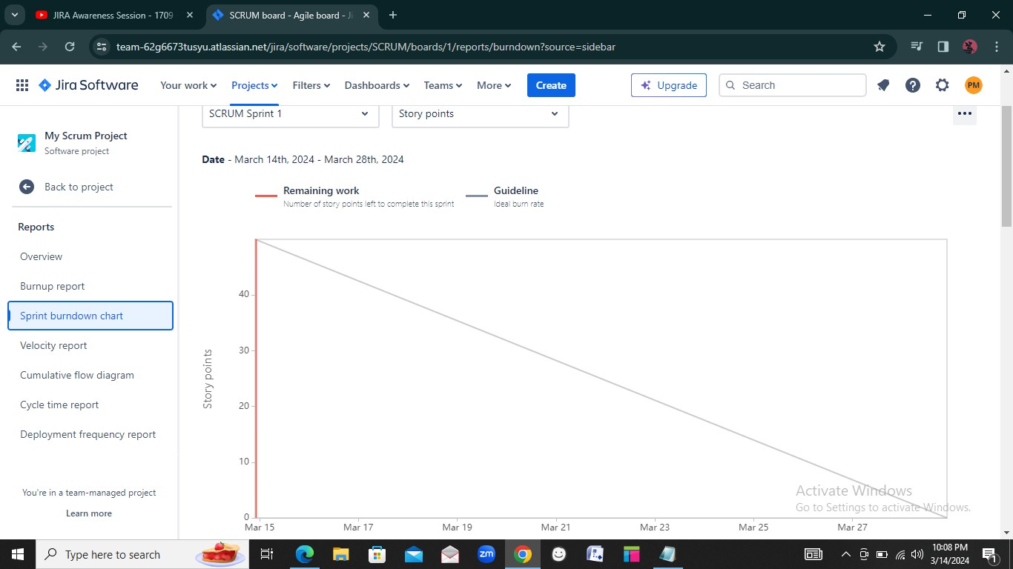

Checked the Jira online lecture session, as we are using the trial version there is no option in reports for Product burn down chart. Below is the image for Burnup reports

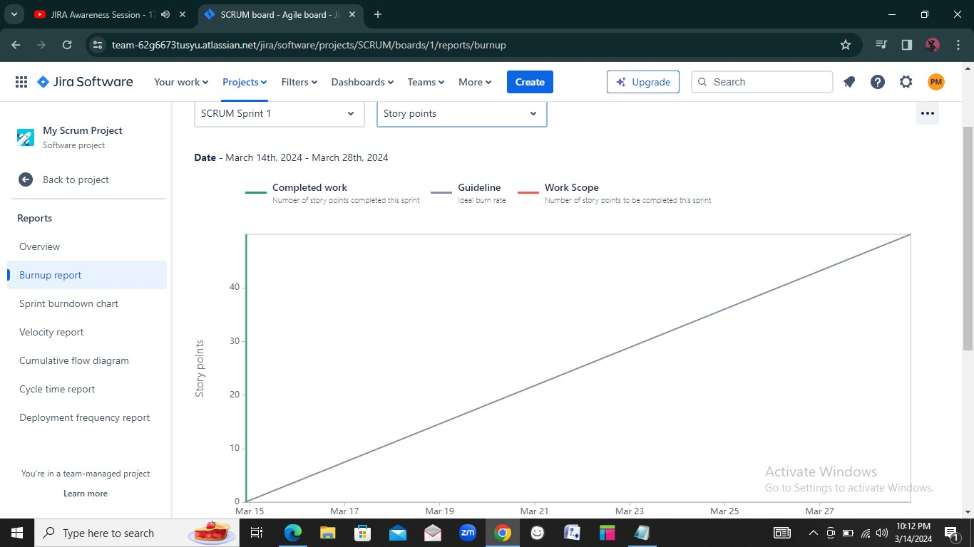

**Que 10 Explain about Product Grooming**

**Ans:** BA gathers all requirements and document them. The document where the requirements are listed is known as product backlog. Once the documentation is done the requirements need to be cleaned or refined. For this purpose, a meeting is arranged and that is known as product grooming session. Refining product backlog is known as Product grooming.

**Ques 11 Explain the roles of Scrum Master and Product Owner**

**Ans:**

Scrum master is like a facilitator, he will coordinate with the meetings, make sure project is going according to the deadlines. Scrum master will manage the scrum process not development. Scrum master ensures if all team member follows the practice described in a scrum

A product owner is someone who has 100% understanding regarding the requirements. Product owner will prioritize and define the product backlog. The product owner is responsible for understanding the project needs and translating those to the scrum master. The product owner is also responsible for developing and communicating a product goal.

**Que 12 Explain all Meetings Conducted in Scrum Project.**

**Ans:**

**Sprint Planning Meeting:**

Sprint planning is a collaborative effort involving a ScrumMaster, who facilitates the meeting, a Product Owner, who clarifies the details of the product backlog items and their respective acceptance criteria, and the Entire Scrum Team, who define the work and effort necessary to meet their sprint commitment. Before starting a sprint, the sprint planning will be done. The scrum team will have a discussion on the velocity, what user story must be prepared, development team size, etc.

**Daily Scrum:**

Daily scrums are quick meetings held each day at the same time for members of the product development team working on a particular sprint. It is a 15-minute meeting. Each member of the daily scrum should answer the following three questions: "What did you do yesterday?", "What will you do today?" and "Are you facing any challenges or dependency". The scrum meeting involves the entire Scrum team attending (developers, product owner, and Scrum Master).

**Sprint Review:**

A sprint review is a meeting held at the end of a sprint, during which the team shows what goals are achieved and the stakeholder provides their feedback. Review will have what went wrong and what went right in the sprint. During a sprint review, the entire development team, the scrum master, the product owner, and the key stakeholders are present.

**Sprint Retrospective:**

Retrospective meetings will have lessons learnt from all sprints and will be used for upcoming sprints. This meeting will have questions such as What went well? What didn't go well? What did we learn? The sprint retrospective team usually includes all development team members, the Scrum Master, and the product owner

**Product Backlog refinement:**

All the requirements in the form of user stories in the product backlog are discussed and the user stories are prioritized, clean and validated. After refinement the user stories are moved to the sprint backlog which will be developed in the sprint by the developers. Backlog refinement meetings are run by the product owner. In addition to the product owner, the meetings are attended by product managers, the scrum master, and at least one representative from the development team.

**Que 13 Explain Sprint Size and Scrum Size**

**Ans:** Sprints in Scrum can be as long as you want; however, it's most common for sprint length to be between 1 and 4 weeks.

Scrum size as per the case study product vision document is 8 members. Product owner and scrum master will not be included as they will not be implementing the sprint backlog items.

**Que 14 Explain DOR and DOD**

**Ans:**

**DOR:** A Definition of Ready (DoR) allows you to evaluate work before your team starts on it. It defines a task, user story, or story point for your team. If you use a Scrum approach, the DoR means you can take immediate action. DOR has single user story; entire epic will not have DOR. Single user story in epic can go in DOR.

**DOD:** The Definition of Done (DoD) includes the conditions and criteria that a software solution or feature must meet to be accepted by the customer. When something is done – this means

that it can be released without any further work or testing. Entire epic can have DOD and can go in development.

**Que 15 Explain Prioritization Techniques and MVP**

**Ans:** In sprint planning meeting the prioritization of user story is done.

**MoSCoW**: It is a prioritization technique used in business analysis and software development to reach a common understanding with stakeholders on the importance they place on the delivery of each requirement also known as MoSCoW prioritization.

The MoSCoW method can help. MoSCoW stands for Must, Should, Could and Would. M: Must have this requirement to meet the business needs

S: Should have this requirement, if possible, but project success does not rely on it. C: Could have this requirement if it does not affect anything else in the project.

W: Would like to have this requirement later, but it won't be delivered this time

**MVP**: MVP is defined as the version of a new product which allows a team to collect the maximum amount of validated learning about customers with the least effort. An MVP is a concept from scrum that refers to a product that has just enough features to satisfy the needs of early customers and, more importantly, give them something to provide feedback on to shape the future of the product. Chunk of the product that we can show to the customer as working.

**Que 16 Difference between Business Analyst n Product Owner**

**Ans:**

|  |  |  |
| --- | --- | --- |
|  | **Business Analyst** | **Product Owner** |
| 1. | They gather requirements for developing the product through different elicitation  techniques | The product owner gives the requirement to develop the product. |
| 2. | Their goal is to achieve technically correct  product | Their goal is that the product sells well |
| 3. | They make sure the technical side of the  product works fine | They make sure the product performs well  in the market. |

**Que 17 Prepare a sample Resume of 3yrs exp Product Owner**

**Ans:**

