**Document 6**

**Use case Diagram: It is a tool that helps to understand how actor interacts with system to achieve a particular goal or objective.**

Actor : Customer

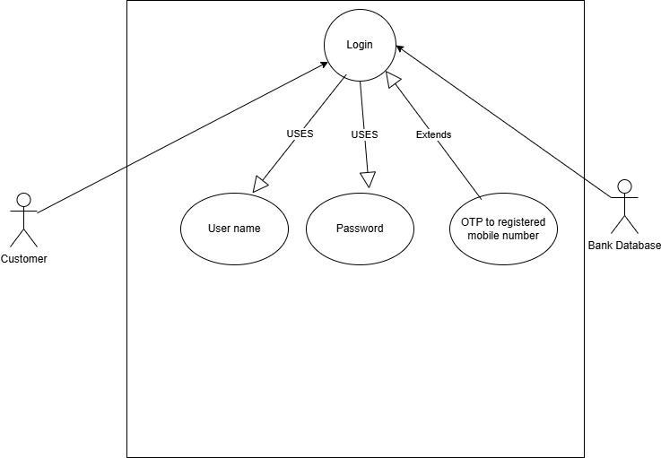

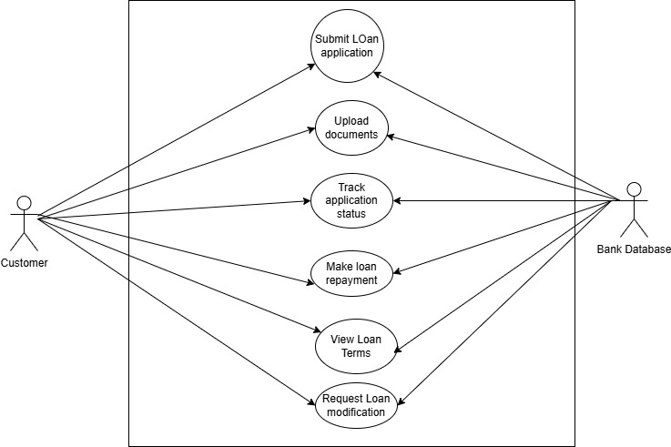

Actor : Loan officer

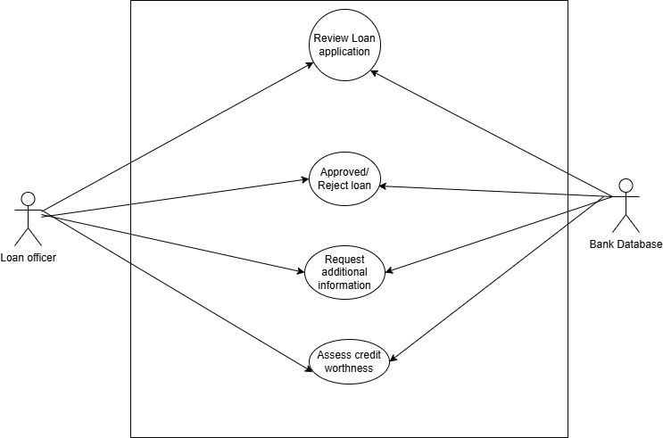

Actor : Admin

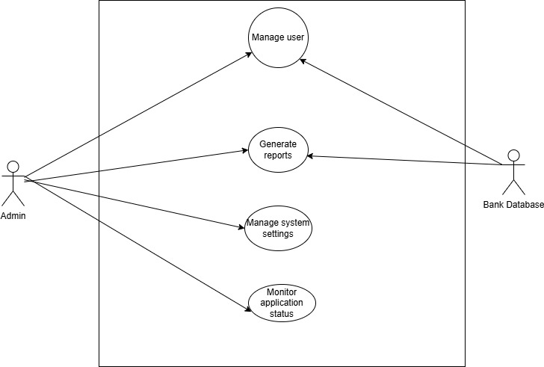

Activity Diagram (Customer Loan application and getting loan)

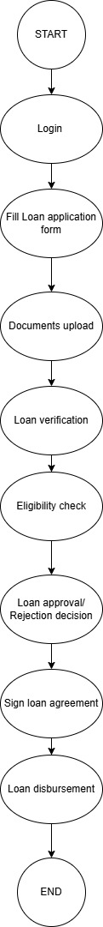

Activity Diagram(Customer loan repayment)

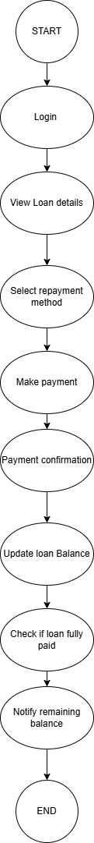

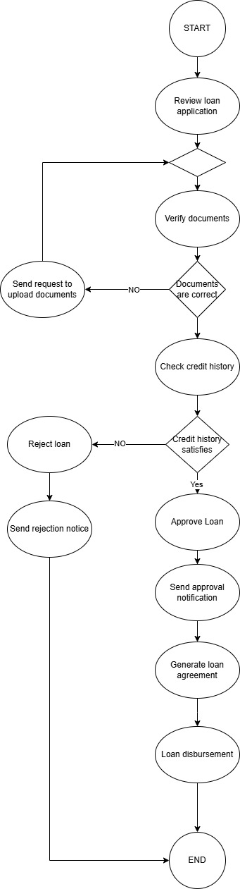

Use Case Specifications:

|  |  |
| --- | --- |
| Use case ID | 1 |
| Use case Name | **Create and Submit Loan application** |
| Actors | Customer |
| Description | The customer provides all information to apply for loan and submit application |
| Pre condition | Customer with valid bank account |
| Post conditioon | A loan application is created and saved in the system |
| Basic flow | The customer access the loan application form Enters all required details Submits the loan application  Application stored in Database |
| Alternate flow | The customer starts filling the application and decides to do it later, the system saves it as draft. |
| Exceptions | If required fields are empty, the system prompts to fill the details |
| Assumptions | The customer has a valid account All information required is available to the customer |
| Limitations | The application should be in prescribed length The system must comply with legal requirements for collecting personal data |

|  |  |
| --- | --- |
| Use case ID | 2 |
| Use case Name | **Upload Documents** |
| Actors | Customer |
| Description | The customer submits required documents( income proof, identity proof) |
| Pre condition | The customer is in the process of applying the loan |
| Post conditioon | Documents are uploaded and verified by the system |
| Basic flow | The customer uplosds the required documents The system verifies the documents The system successfully stores the documents |
| Alternate flow | The customer uploads documents in unsupported format |
| Exceptions | Document fails in verification , customer should upload different document |
| Assumptions | The customer has all the documents ready |
| Limitations | The file upload should be limited The system must ensure documents must be stored safely. |

|  |  |
| --- | --- |
| Use case ID | 3 |
| Use case Name | **Review loan application** |
| Actors | Loan officer |
| Description | The loan officer reviews the loan application and submitted documents |
| Pre condition | A loan application is submitted by a customer |
| Post conditioon | The loan officer has reviewed the application |
| Basic flow | The Loan officer has viewed the application  Checked all necessary parameters  Given necessary inputs |
| Alternate flow | The customer uploads documents in unsupported format |
| Exceptions | Document fails in verification , customer should upload different document |
| Assumptions | The Loan officer has documents and data uploaded by customer |
| Limitations | The file upload should be limited The system must ensure documents must be stored safely. |

|  |  |
| --- | --- |
| Use case ID | 4 |
| Use case Name | **Approve loan** |
| Actors | Loan officer |
| Description | The loan officer approves the loan after reviewing all necessary documents and applicants creditworthiness |
| Pre condition | The loan application has been reviewed |
| Post conditioon | The loan is approved and disbursement is triggered |
| Basic flow | The loan officer receives the application and decides to approve it The system notifies the customer of loan application The system proceeds to loan disbursement |
| Alternate flow | The loan officer may approve with special conditions(eg. Lower loan amount) |
| Exceptions | If the system fails to send notification, the customer has to be informed through call |
| Assumptions | The customer meets the loan approval criteria The loan officer has sufficient authority to approve loans |
| Limitations | The file upload should be limited The system must ensure documents must be stored safely. |

|  |  |
| --- | --- |
| Use case ID | 5 |
| Use case Name | **Generate reports** |
| Actors | Admin |
| Description | The loan officer approves the loan after reviewing all necessary documents and applicants creditworthiness |
| Pre condition | The loan application has been reviewed |
| Post conditioon | The loan is approved and disbursement is triggered |
| Basic flow | The admin selects the report parameters The system generates the reports based on selected parameters |
| Alternate flow | The admin may filter reports by specific parameters like time periods or loan types |
| Exceptions | If the report fails to gemerate due to system issue, the admin is notified and prompted to try again |
| Assumptions | The admin has permission to access generate reports The system maintain historical loan data |
| Limitations | The report generation should comply with data privacy regulations |

|  |  |
| --- | --- |
| Use case ID | 6 |
| Use case Name | **Make loan repayment** |
| Actors | Customer |
| Description | The customer should be able to repay the loan amount |
| Pre condition | The customer with loan taken and repayment date has arrived |
| Post conditioon | The loan is repayed by customer |
| Basic flow | The customer selects the loan he is repaying  It displys with total amount along with interest The customer clicks on repay Amount debits from customer account |
| Alternate flow | The customer should follow repayment terms ( term payment, single payment) |
| Exceptions | If the amount in account is not enoufgh to repay the loan |
| Assumptions | The customer has enoufgh amount in his account and he obeys all loan repayment conditions |
| Limitations | It should comply with repayment terms |

|  |  |
| --- | --- |
| Use case ID | 8 |
| Use case Name | **Request additional information** |
| Actors | Loan officer |
| Description | The loan officer should be able to request for required additional information |
| Pre condition | The loan officer should be able to request for required additional information |
| Post condition | Additional information is requested by loan officer |
| Basic flow | The Loan officer opens and checks all documents The loan officer may require additional information He will mention in comment box Send notification to customer to upload asked information documents |
| Alternate flow | Customer should upload only asked additional information |
| Exceptions | If the additional information request tab is not visible for loan officer he has to do on call |
| Assumptions | Loan officer should have accesses to send request for additional information |
| Limitations | Additional information should be within loan norms |

Screens and Pages:

Login, forgot password and submitting data by customer for perday loan

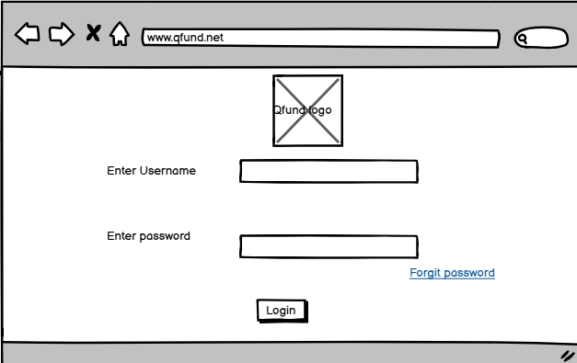

Forgot password

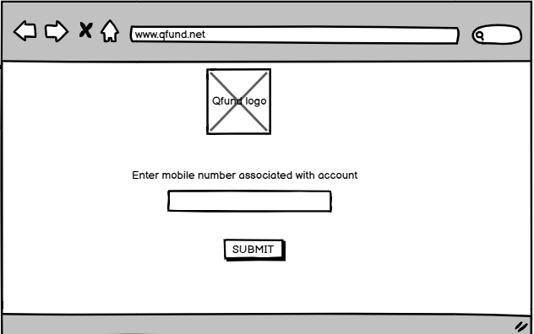

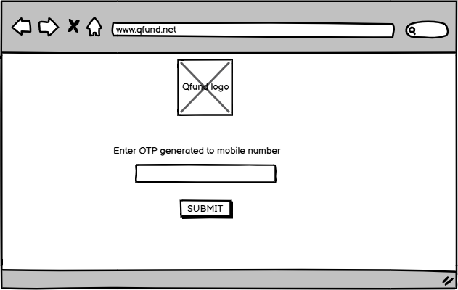

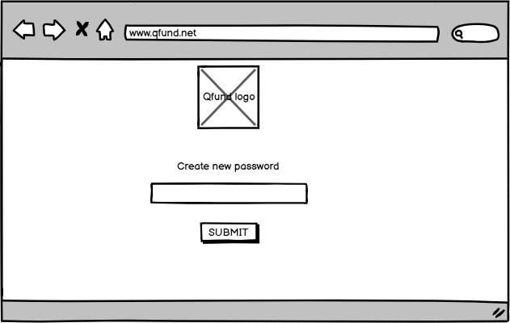

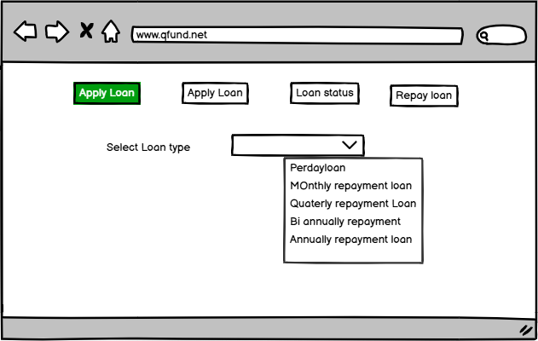

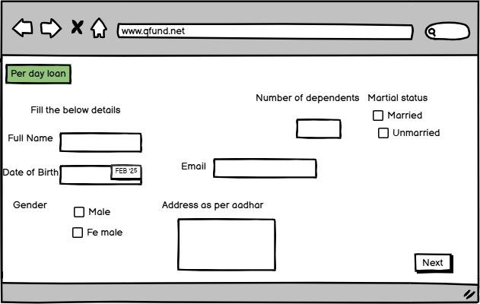

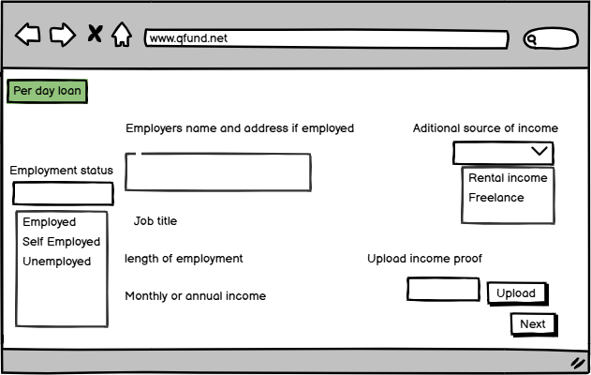

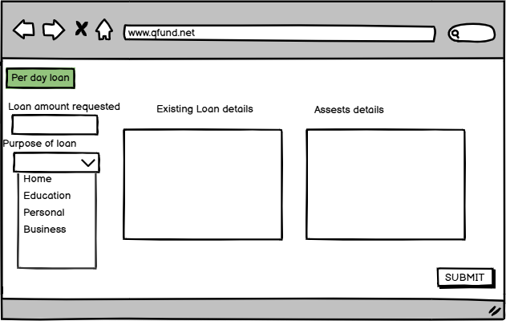

Tools Visio and Balsamiq

MS Visio

Microsoft Visio is a diagramming and vector graphics application used for creating a variety of visual representations, including flowcharts, organizational charts, network diagrams, and floor plans. It is part of the Microsoft Office suite and offers a wide range of templates and shapes that cater to different diagram types. Visio allows users to integrate data from external sources, enabling dynamic diagrams that reflect real-time information. With features for collaboration, custom shapes, and seamless integration with other Microsoft Office tools, Visio is commonly used in business process mapping, IT infrastructure design, and organizational planning. It is available as both a desktop application and a web-based version.

Here are some key uses of MS Visio for a Business Analyst:

**1. Business Process Modeling:**

* Visio allows Business Analysts to create **business process diagrams** such as flowcharts and process maps. This helps in visualizing and analyzing current workflows and identifying areas for improvement or optimization.
* **BPMN (Business Process Model and Notation)** diagrams can be created to standardize process flows and communicate complex processes clearly to stakeholders.

**2. Requirement Visualization:**

* Business Analysts can use Visio to **map out system requirements** visually. Diagrams can help communicate complex technical requirements in a more digestible format for both technical teams and non-technical stakeholders.
* It also aids in illustrating data flows, use case diagrams, and system architectures.

**3. Data Flow Diagrams (DFD):**

* Visio is an excellent tool for creating **Data Flow Diagrams** to show how information moves through a system. This helps the analyst in understanding the system's processes and ensures that data is processed efficiently.

**4. Entity-Relationship Diagrams (ERD):**

* Business Analysts often use **ERDs** to illustrate relationships between data entities in a database. This helps in designing and understanding the database structure during system development or upgrades.

**5. Use Case Diagrams:**

* Visio helps in creating **use case diagrams** that depict the interactions between users (actors) and the system. This visual representation helps in gathering and validating system requirements.

**6. Workflow Automation:**

* For automating business processes, Business Analysts can design workflow diagrams that can be used for system or software development to improve efficiency and decision-making.

**7. Decision Trees and Logic Diagrams:**

* Visio is useful for creating **decision trees**, which help Business Analysts visualize different decision outcomes based on certain conditions, aiding in better business decision-making.

**8. Project Planning and Roadmaps:**

* Business Analysts can use Visio to create project timelines, roadmaps, and Gantt charts to track the progress of projects, making it easier to communicate timelines with stakeholders.

**9. Stakeholder Mapping:**

* Visio can be used to create **stakeholder analysis diagrams** that visually represent key stakeholders and their influence on a project, which helps in aligning strategies and expectations.

**10. Communication and Reporting:**

* As a visualization tool, Visio helps Business Analysts present complex data and findings in a more understandable way, making reports and presentations more effective.

**Balsamiq**

**Balsamiq** is a popular wireframing tool used for creating low-fidelity, hand-drawn style mockups of web and mobile applications. It helps designers, developers, and business analysts quickly sketch and visualize user interfaces (UI) before committing to detailed designs. Balsamiq focuses on rapid prototyping, allowing users to focus on layout, functionality, and user flow rather than fine design details.

Here are some key uses of Balsamiq for a Business Analyst:

### 1. ****Wireframing and Prototyping****:

* Business Analysts can create **low-fidelity wireframes** to illustrate the basic layout and functionality of user interfaces (UI). This helps in visualizing the user experience (UX) early on and gathering feedback from stakeholders before diving into detailed design work.

### 2. ****Gathering Requirements****:

* Balsamiq allows Business Analysts to visually capture and present requirements. By creating wireframes, they can demonstrate how a system or application will work, facilitating clearer discussions and helping stakeholders express their needs.

### 3. ****User Flow Visualization****:

* Business Analysts can use Balsamiq to map out **user flows** and the interactions users will have with the system. This is useful for understanding the user journey, identifying potential usability issues, and ensuring the design meets business goals.

### 4. ****Facilitating Stakeholder Collaboration****:

* Creating wireframes in Balsamiq enables better collaboration with **clients, stakeholders, and development teams**. Since Balsamiq offers easy-to-understand, sketch-like visuals, stakeholders can provide feedback quickly, helping to refine requirements and features.

### 5. ****Concept Validation****:

* Before the design phase, Business Analysts can use Balsamiq to create rapid prototypes to **validate concepts** with stakeholders. This allows for quick iterations based on feedback, ensuring that the final design aligns with business needs.

### 6. ****Documenting Functional Specifications****:

* Balsamiq wireframes can serve as a visual complement to functional specifications documents. Business Analysts can use the wireframes to clarify system behaviors, interactions, and layout expectations, making it easier for development teams to understand requirements.

### 7. ****Usability Testing****:

* Balsamiq helps in conducting **early usability testing**. Business Analysts can present the wireframes to real users or stakeholders, collect feedback on usability, and make necessary adjustments early in the process.

### 8. ****Presenting Ideas to Clients****:

* For Business Analysts, Balsamiq is a great tool to present **concepts** and ideas to clients in a simple, non-technical manner. This fosters better communication and understanding of the intended user interface without overwhelming the client with complex designs.

### 9. ****Project Planning and Scoping****:

* Wireframes created in Balsamiq help in defining **project scope** by visualizing the structure and functionality of a product. This can help in planning timelines, resource allocation, and ensuring that business goals are met.

### 10. ****Supporting Agile Development****:

* In Agile environments, Business Analysts can quickly iterate on wireframes during sprint planning, allowing the team to adapt to changing requirements and make informed decisions during the development process.

**My experience as BA in following phases Requirement gathering, requirement analysis, desiging, development, testing, deployment**

### ****Requirement Gathering****:

### ****Experience****: During this phase, I worked closely with stakeholders, end-users, and project sponsors to gather both functional and non-functional requirements. I conducted interviews, surveys, workshops, and brainstorming sessions to ensure I captured a comprehensive set of requirements.

### ****Requirement Analysis****:

### ****Experience****: After gathering requirements, I performed a thorough analysis to ensure they were clear, complete, and aligned with business objectives. I worked with stakeholders to refine requirements and resolve ambiguities. I also identified gaps, overlaps, and inconsistencies in the requirements.

### ****Designing****:

### ****Experience****: In this phase, I worked with UI/UX designers and system architects to translate the business requirements into functional designs. I helped create wireframes and prototypes (using tools like Balsamiq and Visio) to give stakeholders a clear vision of how the system would look and function.

### ****Development****:

### ****Experience****: During the development phase, I acted as the bridge between the business and the technical teams. I clarified requirements, resolved any misunderstandings, and made sure the product developed aligned with the business needs. I also tracked progress and kept stakeholders informed of any risks or delays.

### ****Testing****:

### ****Experience****: In the testing phase, I collaborated closely with QA teams to create test cases based on business requirements and user stories. I helped ensure that the system met the business needs through functional, integration, and user acceptance testing (UAT).

### ****Deployment****:

### ****Experience****: During the deployment phase, I facilitated communication between technical teams and business stakeholders to ensure a smooth go-live. I ensured that the system was ready for release and worked with users to ensure they were trained and prepared for the new system.