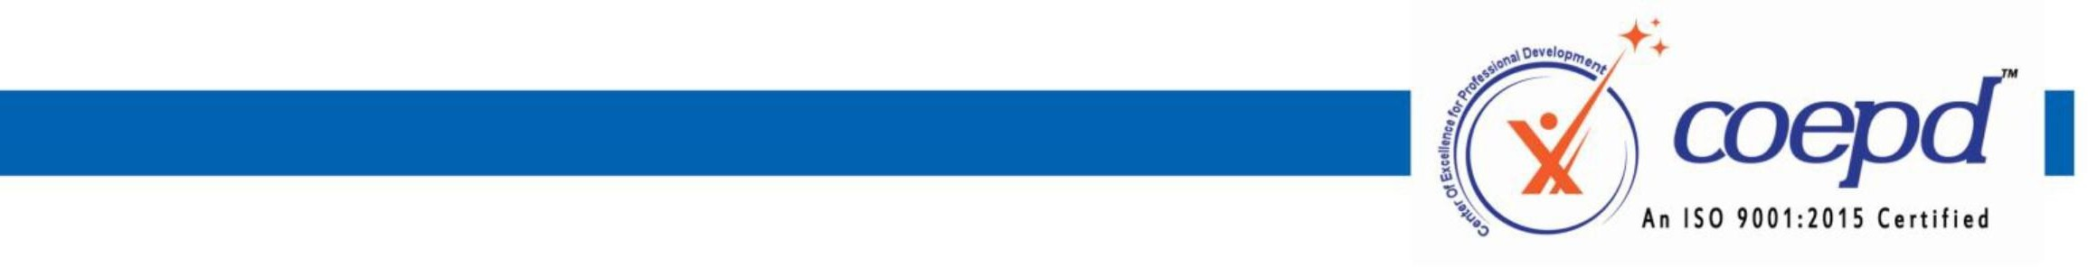

Requesting For Tools Installation

I Harsh Kirtikumar Gupta , enrolled for Business Analyst Training with COEPD, hereby voluntarily declare that, I completed BA Workshop sessions. I request COEPD to support me in installing the tools in my system.

I understood that,

1. Tools Installation will done only one time through Coepd portal. In case of losing application from system, Coepd is not responsible for re-installation.
2. Tools installation support is complementary to the training
3. COEPD is not liable for any damages caused during the installation process
4. These Tools are Trail Versions and works during the trial period only.
5. COEPD will install the tools only in the OS supported by Microsoft, and will not be responsible for the other OS’s like MAC, Linux etc.,
6. Aspirant should buy the actual license after the expiry of trail period.

Signature of the student: 

Name of the Student: **Harsh Gupta**

Batch Start date:

**FEB 2025**

Request Date:**09/04/2025**



3rd Floor, Sahiti Arcade, Beside S.R. Nagar Police Station, S.R. Nagar, Hyderabad - 500038 [www.coepd.com](http://www.coepd.com/) [info@coepd.com](mailto:info@coepd.com)