**Assignment 1:**

1. **Prepare BRD**

**Business Requirements Document (BRD)**

**1. Document Revisions**

|  |  |  |  |
| --- | --- | --- | --- |
| **Version** | **Date** | **Description** | **Author** |
| 1 | 27-01-2025 | Initial Draft | Nirvikar Naik |
| 1.1 | 28-01-2025 | Updated Scope and Risks | Nirvikar Naik |

**2. Approvals**

|  |  |  |  |
| --- | --- | --- | --- |
| **Name** | **Role** | **Date** | **Signature** |
| A1 Dairy | Project Sponsor | 27-01-2025 |  |
| Nirvikar Naik | Business Analyst | 27-01-2025 |  |
| Sushant Kumar | Project Manager | 27-01-2025 |  |

**3. RASCI Chart for This Document** **Codes Used in RASCI Chart:**

* R: Responsible
* A: Accountable
* S: Supportive
* C: Consulted
* I: Informed

**RASCI Chart:**

|  |  |  |  |  |  |
| --- | --- | --- | --- | --- | --- |
| **Task** | **Client** | **BA** | **PM** | **Dev Team** | **QA Team** |
| Requirement Gathering | A | R | S | C | I |
| Document Preparation | I | R | A | S | I |
| Scope Approval | A | R | C | I | I |
| Development | C | I | R | A | S |
| Testing | I | I | S | C | A |

**4. Introduction**

**4.1. Business Goals**

* Optimize inventory management across manufacturing plants and warehouses.
* Ensure the fastest possible delivery to customers.

**4.2. Business Objectives**

* Provide real-time visibility into inventory levels.
* Automate inventory replenishment processes.
* Enable route optimization for delivery logistics.
* Improve overall operational efficiency.

**4.3. Business Rules**

* Inventory levels must not drop below safety stock thresholds.
* Orders must be fulfilled within defined service-level agreements (SLAs).
* Delivery routes should prioritize cost and time efficiency.

**4.4. Background** Currently, the company relies on legacy systems for inventory tracking and delivery coordination. These systems are manual and lack integration, leading to inefficiencies and delays.

**4.5. Project Objective** Develop an integrated software solution that manages inventory efficiently and optimizes delivery operations.

**4.6. Project Scope** **4.6.1. In Scope Functionality:**

* Inventory tracking and monitoring.
* Automated reorder alerts.
* Delivery route optimization.
* Real-time reporting and analytics.

**4.6.2. Out Scope Functionality:**

* Manufacturing process automation.
* Customer-facing applications.

**5. Assumptions**

* The company has reliable internet connectivity at all locations.
* All stakeholders are available for requirement elicitation.
* Existing data can be migrated to the new system.

**6. Constraints**

* Limited budget and timeline for development.
* Dependence on third-party delivery partners.
* Compatibility with legacy systems.

**7. Risks**

**Technological Risks:**

* Integration challenges with legacy systems.

**Skills Risks:**

* Limited in-house expertise on new technologies.

**Political Risks:**

* Resistance to change from end-users.

**Business Risks:**

* Potential downtime during the transition.

**Requirements Risks:**

* Evolving scope due to additional stakeholder needs.

**Other Risks:**

* Vendor delays for third-party tools or APIs.

**8. Business Process Overview**

**8.1. Legacy System (AS-IS):** Manual tracking of inventory and static delivery schedules cause inefficiencies and delays.

**8.2. Proposed Recommendations (TO-BE):** Implement a centralized inventory system and an AI-driven delivery optimization module.

**9. Business Requirements**

|  |  |  |
| --- | --- | --- |
| **ID** | **Requirement Description** | **Priority** |
| BR1 | Develop a dashboard for real-time inventory visibility. | High |
| BR2 | Enable automated alerts for low inventory levels. | High |
| BR3 | Implement delivery route optimization algorithms. | Medium |
| BR4 | Provide reporting tools for inventory and delivery. | Medium |
| BR5 | Integrate the system with legacy data sources. | High |

**10. Appendices**

**10.1. List of Acronyms:**

* SLA: Service Level Agreement
* API: Application Programming Interface
* AI: Artificial Intelligence

**10.2. Glossary of Terms:**

* Inventory Management: The process of overseeing and controlling stock levels.
* Route Optimization: The process of determining the most efficient delivery routes.

**10.3. Related Documents:**

* Project Proposal for Integrated Inventory Management and Delivery Optimization.

**Process Flow Diagram**

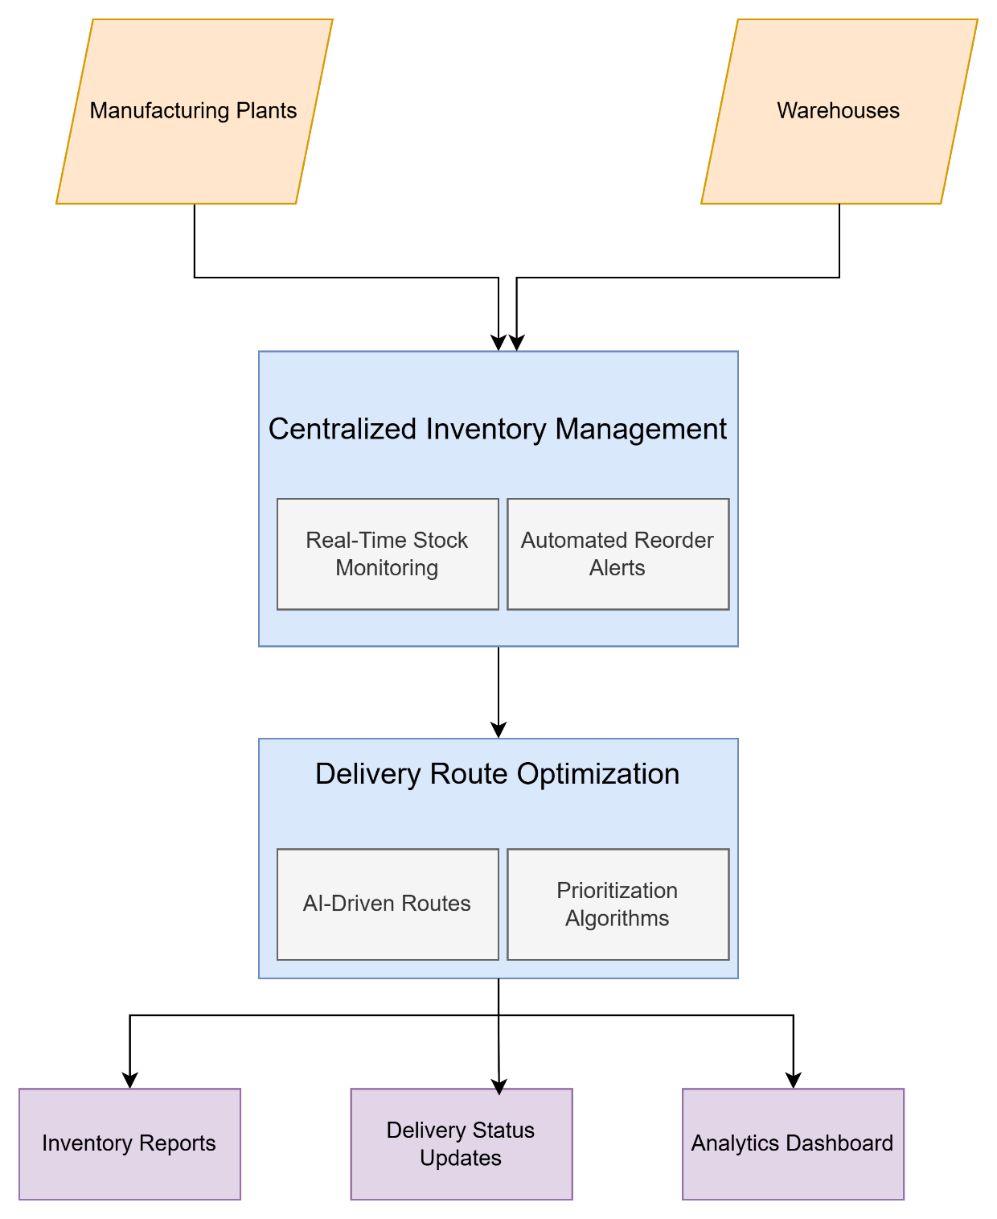

**Assignment 2**

1. Write an introduction letter to a client introducing yourself as a business analyst in charge of working with the client and his team to start the business understanding process

Dear Mr. Sandeep Bhopatkar,

**Subject: Introduction as Your Dedicated Business Analyst**

I hope this message finds you well. My name is Nirvikar Naik, and I am a Business Analyst at ICICI Bank Ltd. I am delighted to introduce myself as your dedicated point of contact for the upcoming project focused on Inventory Management and Quick Delivery System.

My role in this collaboration is to work closely with you and your team to understand your business objectives, identify key challenges, and translate them into actionable requirements that align with your vision. With a comprehensive understanding of the end-to-end project lifecycle, I will ensure that we prioritize clear communication, efficient processes, and the delivery of high-quality solutions tailored to your needs.

**How I Can Support You:**

* **Requirements Gathering:** Conduct detailed discussions to understand your current workflows, pain points, and desired outcomes.
* **Stakeholder Collaboration:** Facilitate seamless communication between your team and our technical experts.
* **Documentation:** Prepare structured documentation such as Business Requirements Documents (BRDs), System Requirements Specifications (SRS), and process diagrams to maintain clarity and alignment.
* **Solution Design:** Work with the development team to ensure the proposed solution is practical, scalable, and meets your expectations.
* **Continuous Engagement:** Provide regular updates, address queries, and adapt to any evolving requirements to ensure the project remains on track.

I look forward to scheduling an initial meeting to discuss your vision, priorities, and key expectations for the project. In the meantime, please feel free to reach out to me via email at nirvikarnaik@gmail.com or call me directly at +91 7774078756.

Thank you for entrusting us with this exciting opportunity. I am confident that, together, we can achieve remarkable results.

Warm regards,

**Nirvikar Naik**  
Business Analyst  
ICICI Bank Ltd  
nirvikarnaik@gmail.com | 7774078756

1. Prepare a brief BRD and SRS for a project- Horoscope or Ticketing system or online store

**1. Document Revisions**

|  |  |  |  |
| --- | --- | --- | --- |
| **Version** | **Date** | **Description** | **Author** |
| 1 | 27-01-2025 | Initial Draft | Nirvikar Naik |
| 1.1 | 28-01-2025 | Incorporated Client Feedback | Nirvikar Naik |

**2. Approvals**

|  |  |  |  |
| --- | --- | --- | --- |
| **Role** | **Name** | **Date** | **Signature** |
| Project Sponsor | Book my Show | 27-01-2025 |  |
| Business Analyst | Nirvikar Naik | 27-01-2025 |  |
| Project Manager | Sushant Kumar | 27-01-2025 |  |

**3. RASCI Chart for This Document**

**Codes Used in RASCI Chart**

* **R**: Responsible
* **A**: Accountable
* **S**: Supportive
* **C**: Consulted
* **I**: Informed

**RASCI Chart**

|  |  |  |  |  |  |
| --- | --- | --- | --- | --- | --- |
| **Task** | **BA** | **PM** | **Sponsor** | **Dev Team** | **QA Team** |
| Gather Requirements | R | A | C | S | I |
| Finalize Business Goals | C | R | A | I | I |
| Review BRD | R | C | A | I | I |
| Approve BRD | I | A | R | I | I |
| Implementation | I | A | I | R | S |

**4. Introduction**

**4.1. Business Goals**

To develop an online ticketing system that provides a seamless experience for users to book, manage, and access event or travel tickets while ensuring scalability and operational efficiency.

**4.2. Business Objectives**

* Enable users to search, book, and purchase tickets online.
* Provide real-time updates on ticket availability.
* Offer a secure and user-friendly payment gateway.
* Generate automated notifications and ticket confirmations.

**4.3. Business Rules**

* Users must register an account to purchase tickets.
* Tickets are issued on a first-come, first-served basis.
* Payments are processed only through approved gateways.
* Refunds are initiated based on cancellation policies.

**4.4. Background**

Currently, ticket booking is managed through manual processes or third-party vendors, leading to inefficiencies and delays. The new system aims to centralize and streamline the process, improving user satisfaction and reducing operational overhead.

**4.5. Project Objective**

To build a robust, scalable online ticketing system capable of managing high transaction volumes while providing a seamless user experience.

**4.6. Project Scope**

**4.6.1. In Scope Functionality**

* User registration and login
* Ticket search and booking
* Payment gateway integration
* Notifications (email/SMS)
* Admin panel for ticket management

**4.6.2. Out Scope Functionality**

* In-person ticket booking
* Integration with third-party promotional systems

**5. Assumptions**

* Internet connectivity will be available at all times.
* Users will have access to standard devices like smartphones or computers.
* Third-party payment gateways will provide APIs for integration.

**6. Constraints**

* The system must comply with local data protection and payment security regulations.
* Initial deployment limited to selected geographies.

**7. Risks**

**Technological Risks**

* Integration challenges with payment gateways.

**Skills Risks**

* Limited expertise in real-time system scalability.

**Political Risks**

* Regulatory changes affecting ticket sales.

**Business Risks**

* Delayed adoption by target users.

**Requirements Risks**

* Ambiguity in user requirements during development.

**Other Risks**

* Dependency on third-party SMS/email services.

**8. Business Process Overview**

**8.1. Legacy System (AS-IS)**

The current manual ticket booking process involves physical counters or third-party vendors, causing delays and inefficiencies.

**8.2. Proposed Recommendations (TO-BE)**

A web-based system enabling users to book tickets online, view availability in real time, and manage their bookings.

**9. Business Requirements**

* A user-friendly interface for ticket search and booking.
* Real-time ticket availability updates.
* Secure payment gateway integration.
* Automated ticket confirmation notifications.
* Comprehensive admin panel for monitoring and managing operations.

**10. Appendices**

**10.1. List of Acronyms**

| **Acronym** | **Description** |
| --- | --- |
| API | Application Programming Interface |
| BA | Business Analyst |
| PM | Project Manager |

**10.2. Glossary of Terms**

* **User**: An individual accessing the system to book tickets.
* **Admin**: System administrator managing operations.

**10.3. Related Documents**

* System Requirements Specification (SRS)
* User Acceptance Test (UAT) Plan

**System Requirements Specification (SRS)**

|  |  |  |  |  |  |  |  |
| --- | --- | --- | --- | --- | --- | --- | --- |
| **Version** | **Date of Release / Revision** | **Prepared / Revised By** | **Reviewed By** | | **Approved By** | | **Reasons for revisions** |
| **Name** | **Date** | **Name** | **Date** |
| **1.0** | **22/01/2025** | **Nirvikar Naik** | **Sushant Kumar** | **25/01/2025** | **Manish Chopra** | **28/01/2025** |  |
|  |  |  |  |  |  |  |  |
|  |  |  |  |  |  |  |  |

**1.0 Introduction**

**1.1 Overview**

The Online Ticketing System (OTS) is designed to enable users to search, book, and manage tickets for events or travel. The system will provide a user-friendly interface, real-time ticket availability updates, secure payment processing, and automated notifications. This document outlines the functional and non-functional requirements for the development and implementation of the system.

**1.2 Acronyms and Definitions**

|  |  |
| --- | --- |
| **Acronym** | **Definition** |
| OTS | Online Ticketing System |
| API | Application Programming Interface |
| UAT | User Acceptance Testing |
| UI | User Interface |

**1.3 Operational Requirements**

* System availability: 24/7 with a 99.9% uptime.
* Concurrent user handling capacity: 10,000 users.
* Integration with third-party payment gateways.

**1.4 References**

* Requirement Gathering Document
* Industry Standards for Data Security

**1.5 Design and Implementation Constraints**

* The system must adhere to data protection regulations such as GDPR.
* Development is limited to a timeline of 6 months.
* Deployment will be restricted to English language support initially.

**1.6 Assumed Factors That Could Affect the Requirements Stated In the SRS**

* Changes in regulatory requirements.
* Unavailability of third-party service APIs.
* Unforeseen technological challenges during implementation.

**2.0 System Overview**

**2.1 Current System**

The current process involves manual or third-party-managed ticketing, resulting in inefficiencies, limited scalability, and lack of real-time updates.

**2.2 Proposed System**

The proposed OTS will:

* Allow users to search and book tickets seamlessly.
* Provide real-time ticket availability updates.
* Include an admin panel for ticket management.
* Automate notifications for ticket confirmations and updates.

**2.3 Benefits of the Proposed System**

* Enhanced user experience through a streamlined booking process.
* Increased operational efficiency with automated workflows.
* Improved revenue through scalable ticketing operations.

**3.0 UI Requirements**

**3.1 Project Contents**

The user interface will include the following components:

* **User Dashboard**: Displays upcoming bookings and recommendations.
* **Search Module**: Allows users to search for events or travel options.
* **Booking Page**: Provides ticket selection, pricing, and payment options.
* **Admin Panel**: Facilitates ticket management, availability updates, and reporting.

**4.0 Other Parameters**

**4.1 Acceptance**

The system will be deemed acceptable upon meeting the following criteria:

* Successful completion of UAT with at least 95% test case pass rate.
* Compliance with data security and payment standards.
* Delivery of agreed-upon functionalities within the project timeline.

1. Make an ERD of creating a support ticket/Ticketing life cycle

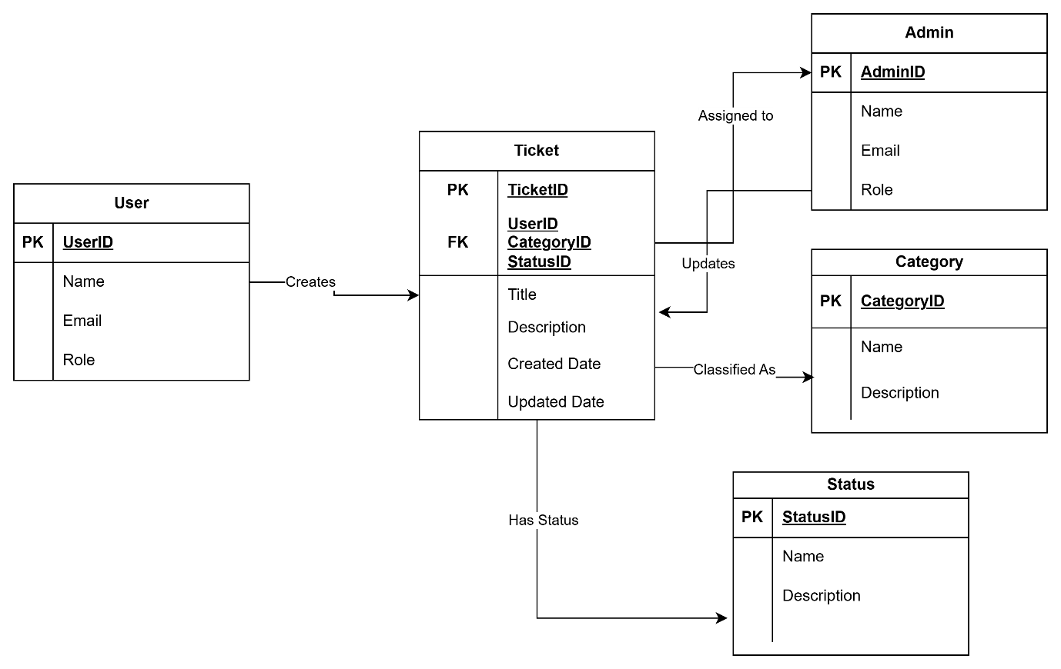

1. User story of shopping from ecommerce

|  |  |  |  |  |  |  |
| --- | --- | --- | --- | --- | --- | --- |
| **User Story No** | **Tasks** | **Priority** | **Value Statement** | **BV** | **CP** | **Acceptance Criteria** |
| 1 | Login, Search, Add to Cart | High | As a customer, I want to log in to my account, so that I can access my previous orders and personalized recommendations. | High | Medium | - User can log in with email/password. |
| - Confirmation message upon successful login. |
| - Personalized homepage shown. |
| 2 | Search, Browse, Filter | High | As a customer, I want to search for products using keywords, so that I can quickly find the items I need. | High | Medium | - Search bar available. |
| - Results filtered by keywords. |
| - Results shown in list format. |
| 3 | Filter, Browse, Sort | Medium | As a customer, I want to filter products by category, price, and ratings, so that I can narrow down my choices to find the best product. | Medium | Medium | - Filters visible on product page. |
| - Multiple filters applied. |
| - Page updates with filtered products. |
| 4 | View Product Details, Add to Cart | High | As a customer, I want to view detailed information about a product, so that I can make an informed purchasing decision. | High | Medium | - Product page shows images, description, and specs. |
| - Sizes/colors available. |
| - Add to Cart button present. |
| 5 | Add to Cart, View Cart | High | As a customer, I want to add products to my cart, so that I can review and purchase them later. | High | Medium | - Products added to cart when clicked. |
| - Cart displays total items/price. |
| - Cart is viewable at any time. |
| 6 | Cart Management, Remove Item | Medium | As a customer, I want to remove products from my cart, so that I can manage my selected items easily. | Medium | Medium | - Remove icon beside each item. |
| - Removing an item updates cart total. |
| - Can add item back later. |
| 7 | Apply Promo Code | Medium | As a customer, I want to apply promo codes during checkout, so that I can get discounts on my purchase. | Medium | High | - Promo code field at checkout. |
| - Promo code is validated and discount applied. |
| - Error message for invalid codes. |
| 8 | Choose Payment Method, Pay | High | As a customer, I want to choose from multiple payment options, so that I can pay in the most convenient way for me. | High | High | - Payment options available (credit card, PayPal, etc.). |
| - Payment details entered securely. |
| - Payment confirmation received. |
| 9 | View Order Summary | Medium | As a customer, I want to view a detailed order summary before completing my purchase, so that I can confirm the details of my order. | Medium | Medium | - Order summary shows items, price, address, and payment. |
| - User can edit shipping address before confirming. |
| - User can edit payment method. |
| 10 | Track Order, View Status | High | As a customer, I want to track my order status, so that I can know when to expect my delivery. | High | Medium | - Tracking info visible on order confirmation page. |
| - Track progress (shipped, in transit, delivered). |
| - Link redirects to delivery service's website. |
| 11 | Review Product | Medium | As a customer, I want to leave a product review, so that I can share my experience and help others make informed decisions. | Medium | Low | - Review form on product page. |
| - Rating system (1-5 stars). |
| - Review visible after moderation. |
| 12 | View Wishlist, Add Items | Low | As a customer, I want to add products to a wishlist, so that I can save items I’m interested in for later. | Low | Medium | - Products can be added to wishlist. |
| - User can view wishlist from profile. |
| - Wishlist items can be added to cart. |
| 13 | Register Account | High | As a new customer, I want to create an account, so that I can save my shipping details, order history, and track future purchases. | High | Medium | - Registration form for details (email, password, address). |
| - Confirmation email sent. |
| - User can log in immediately after creation. |
| 14 | Update Profile | Medium | As a customer, I want to update my profile information, so that I can keep my contact details up to date. | Medium | Low | - Customer can update email, phone, and address. |
| - Changes reflected immediately. |
| - Confirmation message after update. |
| 15 | View Recommended Products | Medium | As a customer, I want to see personalized product recommendations, so that I can discover new items based on my preferences and past purchases. | Medium | Low | - Recommendations displayed on homepage/product pages. |
| - Based on history and preferences. |
| - View more items in suggested categories. |
| 16 | Add to Cart from Wishlist | Medium | As a customer, I want to add products from my wishlist to my cart, so that I can easily purchase saved items. | Medium | Medium | - Products can be added from wishlist to cart. |
| - Cart updates with added items. |
| - Wishlist icon visible on cart page. |
| 17 | View Recent Searches | Low | As a customer, I want to view my recent searches, so that I can quickly revisit products I have already searched for. | Low | Low | - Recent search history displayed under search bar. |
| - User can click on past searches to view them again. |
| 18 | Use Voice Search | Medium | As a customer, I want to use voice search, so that I can find products faster without typing. | Medium | Medium | - Voice search icon available. |
| - User can speak keywords, and results are filtered accordingly. |
| 19 | View Product Ratings | High | As a customer, I want to view product ratings, so that I can choose the highest-rated products based on customer feedback. | High | Medium | - Product ratings shown clearly on the product page. |
| - Users can see the total number of reviews and average rating. |
| 20 | Compare Products | Medium | As a customer, I want to compare multiple products side by side, so that I can make an informed purchasing decision. | Medium | Medium | - "Compare" button visible on product pages. |
| - Comparison table shows features, prices, and ratings side by side. |
| 21 | Request Product Availability | Low | As a customer, I want to request product availability notifications, so that I can be alerted when out-of-stock products are available again. | Low | Low | - "Notify me when available" option is visible on product page. |
| - Customer receives an email notification when the product is back in stock. |
| 22 | Save Payment Information | Medium | As a customer, I want to save my payment details for future purchases, so that I can checkout faster without re-entering my information. | Medium | High | - User can save payment methods for future use. |
| - Saved payment methods are displayed on checkout page. |
| - User can delete saved payment info. |
| 23 | Share Product with Friends | Low | As a customer, I want to share product details with friends via social media or email, so that I can get feedback on products before purchasing. | Low | Low | - Social media and email sharing buttons visible on product pages. |
| - User can share product link to contacts easily. |
| 24 | View Product Videos | Medium | As a customer, I want to view product videos, so that I can better understand how the product works or looks. | Medium | Medium | - Product page contains video demonstrations. |
| - Videos are of high quality and load quickly. |
| 25 | Request Gift Wrapping | Low | As a customer, I want to request gift wrapping for my order, so that I can send the product directly as a gift. | Low | Low | - "Gift Wrapping" option available at checkout. |
| - User can select gift wrap style. |
| - Extra charges for gift wrapping are added to the order. |
| 26 | Filter by Brand | Medium | As a customer, I want to filter products by brand, so that I can quickly find items from my favorite brands. | Medium | Medium | - Filter option available by brand name. |
| - Products update based on brand selected. |
| 27 | View Customer Support Contact | Low | As a customer, I want to view customer support contact details, so that I can reach out for assistance if needed. | Low | Low | - Contact details for support are clearly visible. |
| - Options for live chat, email, and phone support are provided. |
| 28 | Reorder Previous Purchase | Medium | As a customer, I want to reorder products I’ve previously purchased, so that I can easily repurchase without searching again. | Medium | Medium | - Reorder button available in order history. |
| - Previous items are added to the cart instantly when clicked. |
| 29 | Enable Multi-Currency Support | High | As a customer, I want to see product prices in my local currency, so that I can understand the cost better. | High | Medium | - Currency selector available on the website. |
| - Prices are updated in the selected currency. |
| 30 | Subscribe to Newsletter | Low | As a customer, I want to subscribe to the newsletter, so that I can stay informed about new products and discounts. | Low | Low | - Subscription form visible on homepage or product pages. |
| - User can receive confirmation email after subscribing. |
| 31 | Save Product for Later | Medium | As a customer, I want to save products for later purchase, so that I can buy them when I’m ready. | Medium | Medium | - "Save for Later" button available on cart page. |
| - Saved items are stored in a separate section of the cart. |
| 32 | View Shipping Costs | Medium | As a customer, I want to see the shipping costs before checkout, so that I can avoid unexpected costs. | Medium | Medium | - Shipping cost estimator available based on location. |
| - Costs shown before final checkout. |
| 33 | Offer Product Customization | Low | As a customer, I want to customize certain products (e.g., engravings), so that I can personalize my purchase. | Low | Low | - Customization options available on product page. |
| - Confirmation of customization shown before checkout. |
| 34 | Save Cart for Later | Medium | As a customer, I want to save my cart for future purchase, so that I can easily access it later and complete my purchase. | Medium | Low | - "Save Cart" option available. |
| - Saved carts can be viewed when logged in. |
| 35 | Request Return | High | As a customer, I want to request a return for an item, so that I can return products that do not meet my expectations. | High | Medium | - "Request Return" button visible in order history. |
| - Customer can select return reason and method. |
| - Return request confirmation is sent. |
| 36 | Receive Order Updates | High | As a customer, I want to receive order status updates via email or SMS, so that I can be informed about my order’s progress. | High | Medium | - Customer receives updates for key order milestones (shipped, in transit, delivered). |
| - Update preferences are customizable. |
| 37 | Apply Multiple Coupons | Medium | As a customer, I want to apply multiple coupons to my order, so that I can maximize discounts on my purchase. | Medium | High | - System allows stacking of coupons. |
| - User can enter multiple codes during checkout. |
| - Final price updates with all applied discounts. |
| 38 | Set Price Alerts | Medium | As a customer, I want to set price alerts for certain products, so that I can buy them when the price drops. | Medium | Medium | - Price alert option available on product page. |
| - Customer receives email or app notification when price drops. |
| 39 | View Store Locations | Low | As a customer, I want to view physical store locations, so that I can visit in person if I prefer to shop offline. | Low | Low | - Store locator tool available on the website. |
| - Customers can find nearest store based on zip code or city. |
| 40 | Subscribe for Early Access | Low | As a customer, I want to subscribe for early access to new product launches, so that I can get exclusive access to products before they sell out. | Low | Low | - "Early Access" subscription option visible on product launch page. |
| - Customers receive early notifications about upcoming products. |