Question: 1 - Audits

Quarterly Audit - 1
Audit Phase | Requirement Gathering
Completed | - weeks (Week 1-10)
Checklist | - Stakeholder interviews conducted  - Project vision and goals clarified  - Constraints and dependencies identified  - Initial feedback from farmers and companies collected

Quarterly Audit – 2
Audit Phase | Requirement Analysis
Completed | 7 Weeks (week 16-23)
Checklist | - Functional and non-functional requirement drafted  - Use cases and user stories developed  - Prioritization of requirements completed  - Data flow and process diagrams prepared

Quarterly Audit – 3
Audit Phase | Design & Development
Completed | 14 weeks (week 30-43)
Checklist | - Solution architecture documented  - User interface mockups reviewed  - Initial development deliverables mapped to requirement  - Performance and scalability considerations addressed

Quarterly Audit – 4
Audit Phase | Testing & Deployment
Completed | 14 weeks (week 58-71)
Checklist | - Test planning and test cases validated  - User acceptance criteria assessed  - End user training materials reviewed  - Go-live readiness and support documentation prepared

Question: 2 - BA Approach Strategy

1. Elicitation Techniques to apply
- Interviews: Conduct detailed interviews with stakeholders (farmers, manufacturers, project sponsor, committee) to understand pain points and expectations.
- Workshops & Focus Groups: Organize group workshops for collaborating on requirements and validating use cases.
- Surveys/Questionnaires: Circulate surveys to capture input from remote users (farmers, company representatives).
- Observation: Observe users’ current processes for buying/selling agriculture products to identify functional gaps and improvement areas.

2. Stakeholder Analysis & RACI/ILS
- Stakeholder identification: List all stakeholders (Project Sponsor, Product Owner, PM, Java Develops, Testers, Network Admin, DB Admin, End Users).
- RACI Matrix: Clearly define who is Responsible (R), Accountable (A), Consulted (C), Informed (I) for each deliverable and project task.
- Influence/Interest Mapping: identify high-influence stakeholders and keep them engaged with regular updates.

3. Document Preparation
- Business Requirements Document (BRD): Capture high-level business needs and goals.
- Functional Specification Document (FSD): Detail functional and Non-functional requirements.
- User Cases/User Stories: Map user scenarios and test cases.
- Change Request Log: Track changes requested and implemented.

4. Sign-off and Approval Process
- Circulate Documents for Review: After document preparation, circulate to all relevant stakeholders (as per RACI).
- Review Meetings: Organize meetings to review, clarify, and resolve queries.
- Document Approvals: Obtain written/email approval from clients for each key deliverable (BRD, FSD, UAT plan).
- Track Approvals: Maintain a traceable log of sign-offs and feedback (including date and approval method).

5. Communication Channels to Establish
- Email: For all formal communications, document sharing, and sign-off tracking.
- Project Management Tools: For task tracking, defect logging, and status reporting.
- Chat Platforms: For quick clarifications and daily updates.
- Meetings: Schedule weekly/bi-weekly meetings for progress review and ad hoc discussions as needed.
6. Change Request handling
- Submit Requests: Change request form submitted via email or ticketing tool by stakeholders.
- Impact Assessment: Review impact on scope, time, cost, and quality.
- Approval Workflow: Obtain required approvals (based on RACI).
- Documentation: Update all related project documentation to reflect approved changes.
7. Project Progress updates to Stakeholders
- Periodic Status Reports: Share weekly/bi-weekly reports summarizing completed, ongoing, and upcoming tasks, risks, and issues.
- Dashboards: Use project management tools to provide real-time visibility.
- Review Meetings: Hold regular project review meetings with key stakeholders.
8. Sign-off on UAT and Project Closure
- UAT Plan: Prepare and get client approval for UAT strategy, scenarios, and criteria.
- Facilitate UAT: Support end users/testers during execution, document any issues, and track to closure.
- Collect Acceptance: Secure formal sign-off from the client on the UAT Test Results and Client Project Acceptance Form.

Question: 3 – 3 Tier Architecture
- Application Layar
- Role: This is the topmost layer-the user interface. It allows users to interact with the application.
- Components: Web browsers, mobile apps, desktop clients.
- Function: Displays information to users and captures user inputs.
2. Business Logic Layer
- Role: This is the middle tier where business rules and logic are implemented.
- Components: Application server, backend code, API/server logic.
- Function: Processes user inputs from the presentation layer, makes decisions, calculations, and coordinates data movement between presentation and data layers.

3. Database Layer
- Role: The bottom tier responsible for data storage and management.
- Components: Database server, relational (SQL) or non-relational (NoSQL) databases.
- Function: Stores, retrieves, and manages application data.

Question: 4 – Write about the approach strategy for framing
- 5W 1H Technique
- Who: Who is involved or impacted?
- What: What is the issue, requirement, or process?
- When: When does the situation occur (timing, frequency)
- Where: Where does it happen within the process or system
- Why: Why is this needed or important
- How: How is it currently handled or expected to be handled

- SMART Criteria
- Specific: is the question focused and detailed
- Measurable: Can the response be quantified or validated
- Achievable: Is what I’m asking practical and attainable
- Relevant: Is it aligned with project objectives and stakeholder concerns
- Time-bound: Does it address timeline or deadlines

- RACI Metrix Consideration
- Clarify Roles: Understand who is Responsible, Accountable, Consulted, and Informed for the subject in question.
- Direct to Right Person: Ensure to question is addressed to the stakeholder who has authority or information.

- Reference 3-Tier Architecture
- Application Layer
- Business Logic Layer
- Data Layer

- Use Case & Use Case Specifications
- Frame questions to certify real-world scenarios of system usage.
- Primary and alternate flows
- Preconditions and postconditions
- Actor interactions
- Activity Diagrams and Models
- Use diagrams or models to visualize workflows or processes.
- Ask questions that clarify steps, decision points, and handoffs, in process flows.

- Page Design/User Interface
- When relevant, use prototypes or page layouts to ask about user expectations, required fields, and actions.
- Verify design preference and useability requirements.

Question: 5 – BDRFOWJIPQU
B – Brainstorming
D – Document Analysis
R – Reverse Engineering
F – Focus Groups
O – Observation
W – Workshops
J – Joint Application Development
I – Interviews
P – Prototyping
Q – Questionaries/Surveys
U – Use case Specification

Question: 6 – elicitation Techniques
Prototyping: Helps stakeholders visualize key features like product catalog, search, and login, making requirements clearer.
Use Case Specifications: Defines step-by-step user interactions such as searching products or uploading details, ensuring all scenarios are covered.
Document Analysis: Reviews current documents and similar systems for Ideas and avoids missing important requirements.
Brainstorming: Encourages new ideas and solutions from stakeholders for better features.

Question: 7 - 10 Business Requirements
BR001 – If the user is new then he should create account with Login ID and Password.
BR002 – User should be able to search product online via website and mobile app.
BR003 – User should be able to order products online.
BR004 – User can buy products for other farms
BR005 – User can track their orders online via app or website
BR006 – User can create alert for they product which is not available
BR007 – User should compare the products by their choice (Price, Quantity, Quality and Destines)
BR008 - The details of the manufacture should be visible to the user
BR009 – User can buy multiple products at a time.
BR010 – Feedback should be collected from the user after each order delivery.

Question: 8 - List the assumption
1. Users have internet access and digital devices.
2. Product information entered is accurate and updated.
3. Payment are processed through secure gateways.
4. Users must register and verify accounts.
5. Delivery is available in all service regions.

Question: 9 – This project requirements priority
Req ID | Req Name | Req Description | priority
BR001 | User Account Creation | If the user is new then he should create account with Login ID and Password. | 1
BR002 | Online Product Search | Use should be able to search product online via website and mobile | 3
BR003 | Online Product Ordering | User should be able to order product online. | 4
BR004 | Buy for other farms | User can buy product for other farms | 2
BR005 | Order Tracking | User can track their orders online via app or website | 9
BR006 | Product Availability Alert | User can create alert for their product which is not available | 6
BR007 | Product Comparison | User should compare the products by their choice | 5
BR008 | Manufacturing Details Visibility | The details of the manufacturer should be visible to the user | 8
BR009 | Bulk Product Purchase | Iser can buy multiple products at a time | 7
BR010 | User Feedback Collection | Feedback should be collected from the user after each order delivery | 10

Question: 10 – User Case Diagram
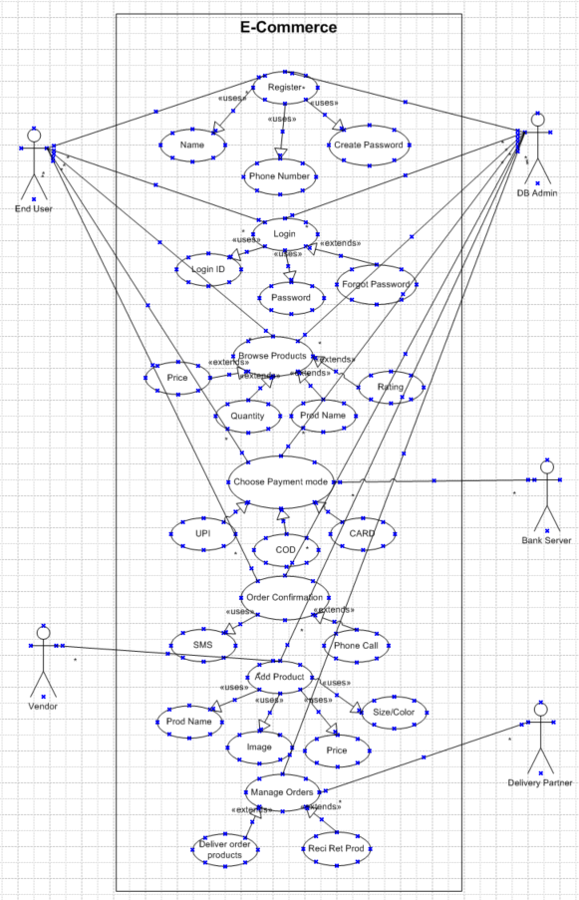

Question: 11 – Use Case Specs
Use Case ID | UC001
Use Case Name | Registration of customer is required to access the app
Created By | Mr. Iftikhaar | Last Updated By | August 5th 2025
Date Created | October 5th 2024 | Last Revision Date | July 28th 2025
Actor | Customer, DB Admin
Description | This use case describes how user can register in an app
Pre-Condition | User should have mobile number
Post-Condition | Successfully receiving the conformation of the registration
Normal Flow or events/Basic Flow/Happy Path | Step 1: System should navigate to a page where there are two option Login, Sign in.  Step 2: User will click sign in option.  Step 3: System should direct the user to the sign in page. Where the user should enter the details.  Step 4: The user should enter information like mobile number and name Step 5: System should generate OTP and send it to the given mobile number  Step 6: The user should enter the OTP to verify the mobile number  Step 7: System should direct the user to create a password. Password should be 8 characters long, with 1 capital letter, 1 number and 1 unique character  Step 8: The user should click on “Register” to confirm the Registration
Alternative Flow | At Step 2: If the user is not able to find the sign in option, then he can request for a call from customer service  At Step 4: If the user is not able to fill the information, then he can request for a call from customer service.  At Step 5: If the OTP is not generated then the customer can change the mobile number or request a call from the customer service  At step 7: If the user has not entered the correct characters password, then the user should be asked to re-enter the password based on the specified characters.
Exceptions | If internet connectivity lost while doing this use case, system displays “check with your internet connectivity”
Frequency of Use | Moderate
Assumptions | It is assumed that customer has the mobile knowledge

User Case ID | UC002
Use Case Name | Login through the application or website
Created By | Mr. Iftikhaar | Last Updated By | August 6th 2025
Date Created | October 5th 2024 | Last Revision Date | August 4th 2025
Actor | Customer, DB Admin
Description | This use case describes how user can login in an app
Pre-Condition | User should have registered in the application
Post-Condition | User can browse through the application
Normal Flow or events/Basic flow Happy Path | Step 1: System should navigate to a page where there are two options “Login” and “Register”.  Step 2: User will click “Login” option.  Step 3: System should direct the user to the login page where there are 2 entries mobile number and password/ forgot password. Where the user should enter the credentials.  Step 4: The User should enter the mobile number for login ID and Password.  Step 5: the user should click “Login” to login successfully.
Alternative Flow | At Step 2: If the user is not able to find the login option, then he can request for a call from customer service.  At step 3: If the user is not able to get the login page, he can request for a call from customer care.  At Step 4: If the user is not able to login, then the system will redirect to “forgot password” page.  At step 5: If the user is not able to click the login option the he can request for a call from customer service.
Exceptions | If the internet connectivity lost while doing this use case, system displays “check with your internet connectivity”
Frequency of Use | High
Assumptions | It is assumed that customer has the mobile knowledge

User Case ID | UC003
Use Case Name | Book a product in the application
Created By | Mr. Iftikhaar | Last Updated By | August 5th 2025
Date Created | October 5th 2024 | Last Revision Date | July 28th 2025
Actor | Customer and DB Admin
Description | This use case describes how user can book a product in app
Pre-Condition | User should have been registered into the application
Post-Condition | Successfully received confirmation of the Product
Normal Flow or events/Basic flow Happy Path | Step 1: The user logs in, clicks on the search  Step 2: System navigates to a new page where the user should enter some information  Step 3: The user should enter information like product name, quantity, and pin code etc.  Step 4: System navigates to a page where it displays multiple options to select from  Step 5: user selects the products and also selects the payment method and click on “Select”  Step 6: System will navigate to a page where the user can view all the details of the purchase  Step 7: The user should click on “Make payment” to confirm the purchase  Step 8: System navigates to a new page where a confirmation is viewed with the receipt where the user can select “Email a copy”  Step 9: Basic flow ends here
Alternative Flow | At Step 2: If the user as not able to login, then the system will redirect to the “Forgot username/password” page.  At Step 3: If the user is not able to get the right information, he can request for a call from customer care.  At Step 4: If the user is not able to get the right information, he can request for a call from customer care.  At Step 5: If the user is not able to get the right information, he can request for a call from customer care.  At Step 6: If the user is not able to get the right information, he can request for a call from customer care.  At Step 8: If the user’s payment did not go through, the system should send an alert message to the customer that the payment failed and asks for another mode of payment.
Exceptions | If the internet connectivity lost while doing that use case, system displays “check with your internet connectivity”
Frequency of Use | High
Assumptions | It is assumed that the customer is registered  It is assumed that customer has computer knowledge.

User Case ID | UC004
Use Case Name | Vendor can manage orders in the application
Created By | Mr. Iftikhaar | Last Updated By | August 5th 2025
Date Created | October 5th 2024 | Last Revision Date | July 28th 2025
Actor | Vendor, DB Admin
Description | Vendors/Admins manage orders, mark delivered/returned.
Pre-Condition | Actor must be registered and logged in.
Post-Condition | Orders updated as delivered or returned.
Normal Flow or events/Basic flow Happy Path | Step 1: Actor logs in, click on “manage Orders”  Step 2: System navigates to a new page where the actor can see the new, past orders,  Step 3: the actor can click any of the option in new order like, ready for delivery, product dispatch etc. or actor can click any option in past order like, returned order, late for delivery  Step 4: Actor will click new orders and marks for delivery  Step 5: user will check if there is any order is returned  Step 6: Basic flow ends here
Alternative Flow | At step 1: If the actor as not able to login, then the system will redirect to the “Forgot username/password” page.  At step 2: If the actor is not able to get the right information, he can request for a call from customer care.  At step 3: If the actor is not able to get the right information, he can request for a call from customer care.  At step 4: If the actor is not able to get the right information, he can request for a call from customer care.  At step 5: Actor can call the user for understand the return of order
Exceptions | If the internet connectivity lost while doing that use case, system displays “check with your internet connectivity”
Frequency of Use | Moderate
Assumptions | Vendor knows order management

User Case ID | UC005
Use Case Name | Customer can choose payment mode for their purchase
Created By | Mr. Iftikhaar | Last Updated By | August 9th 2025
Date Created | October 5th 2025 | Last Revision Date | August 6th 2025
Actor | Customer, DB Admin
Description | This use case describes how customers select their preferred payment mode during checkout.
Pre-Condition | Customer should be registered and logged in; product should be in the cart.
Post-Condition | Payment mode is selected, order proceeds for payment and confirmation.
Normal Flow or events/Basic flow Happy Path | Step 1: User should login, click on search  Step 2: System navigates to a new page where the user should enter some information  Step 3: The user should enter information like product name, quantity, and pin code etc.  Step 4: the user should add their product in the cart.  Step 5: User should click “checkout” option.  Step 6: system will navigate to the payment page. Where the user should select their desire payment mode like, UPI, COD and Card etc.  Step 7: system will verify selection and processes order.  Step 8: Basic flow ends here
Alternative Flow | At Step 1: If the user as not able to login, then the system will redirect to the “Forgot username/password” page.  At step 2: If the actor is not able to get the right information, he can request for a call from customer care.  At step 3: If the actor is not able to get the right information, he can request for a call from customer care.  At step 4: If payment options not visible, customer can request for a call from customer care.  At Step 5: If payment option fails, the prompt can choose another method or contact customer care.
Exceptions | If the internet connectivity is lost, system displays “check with your internet connectivity”
Frequency of Use | High
Assumptions | Customer is registered, understands online payment process.

Question: 12- Prepare 5 Activity Diagrams
1. Activity Diagram: Register Process
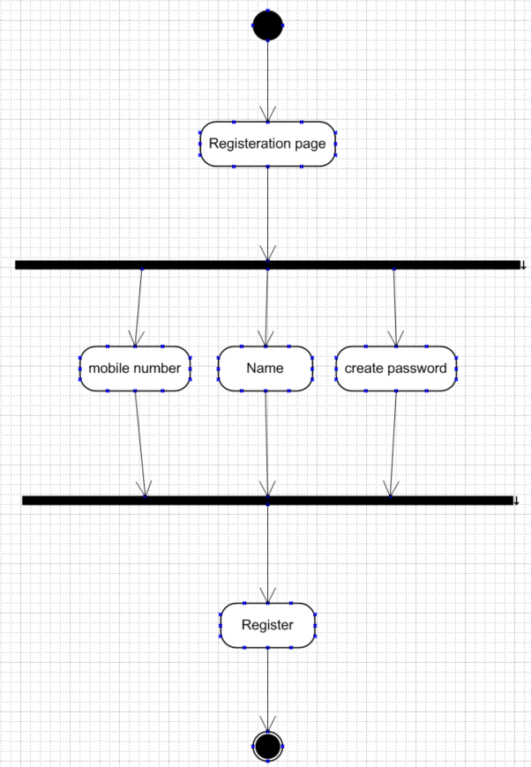

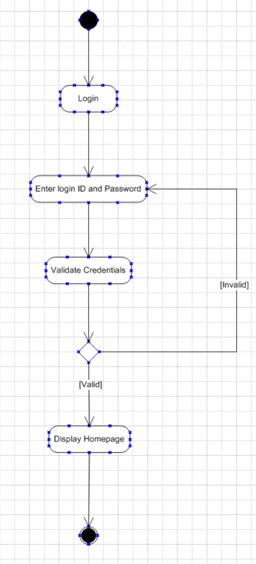
2. Activity Diagram: Login Process

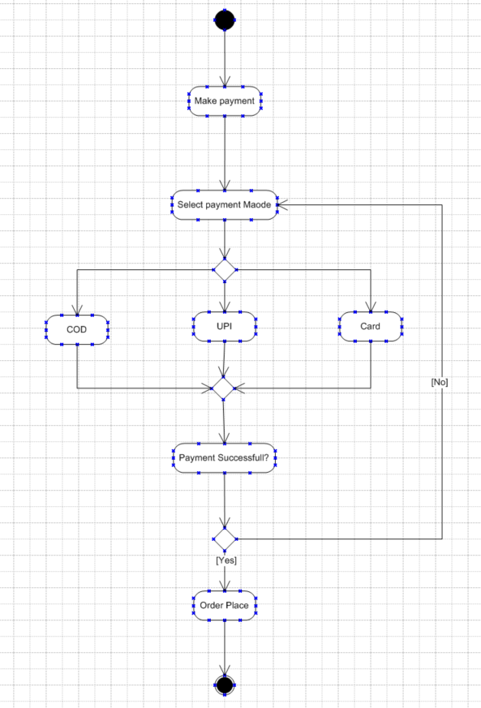
3. Activity Diagram: Payment Process

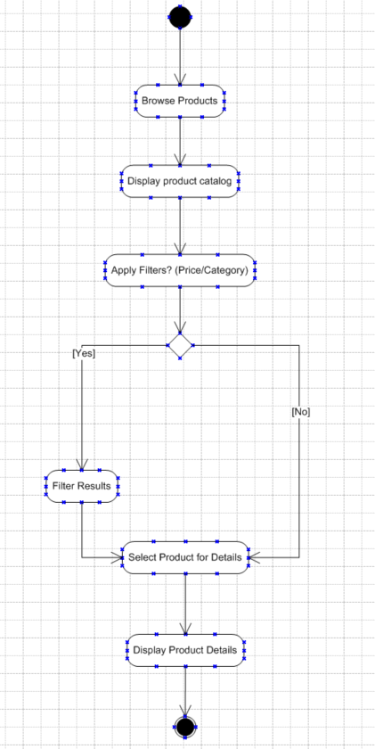
4. Activity Diagram:

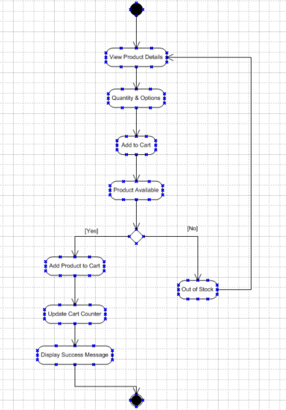
5.

