Capstone Project 1
  - Part 2/3

  - Author: Ameya Mahajan (ameya_mahajan@yahoo.com)
  - Version: 0.1
Date: 04/04/2025

Contents
1. Audits 3
2. BA Approach Strategy 5
3. 3-tier architecture 9
4. BA Approach Strategy for framing questions 10
5. Elicitation Techniques 11
6. Elicitation Techniques (This project) 12
7. 10 Business Requirements 13
8. Assumptions 14
9. This project requirements priority 14
10. Draw use case diagram 16
11. Use case specs 17
12. Activity diagrams 24

Audits
ANS:
Stage | Requirement Gathering Phase
Completed | 10 weeks (Week 1 to week 10)
Checklist | BRD Template
 | Elicitation Results Report (from eleciting information about requirements from stakeholders such as Mr. Henry's friends (farmers)
 | Grouping of functionalities/features - client signoff
 | Email communication - To, cc, bcc

Stage | Requirement Analysis Phase
Completed | 19 weeks (Week 11 to week 29)
Checklist | UML Diagrams
 | Business to functional requirements mapping
 | Client sign-off
 | RTM document version control
 | Email communication - To, cc, bcc

Stage | Design Phase
Completed | 10 weeks (Week 30 to week 40)
Checklist | Utilization of tools
 | Solution/Design Document
 | Documented Evidence on client communication
 | Stakeholder MoM
 | Email communication - To, cc, bcc

Stage | Development Phase
Completed | 10 weeks (Week 41 to week 75)
Checklist | JAD Session Report
 | End user manual preparation (farmers are end users)
 | BA and developer MOM
 | RTM document version control
 | Email communication - To, cc, bcc

Stage | Testing Phase
Completed | 33 weeks (Week 45 to week 78)
Checklist | Test case summary
 | Training report to end users (farmers)
 | Lessons learnt document
 | Email communication - To, cc, bcc

BA Approach Strategy
ANS:
What Elicitation Techniques to apply?
Requirements elicitation is the process of digging out the information from the stakeholders. Requirements elicitation serves the foundation in documenting the requirements. In case of the online agriculture store some of the below elicitation techniques can be used to elicit the requirements:
- Observation: Observing the farmers, or Mr. Henry’s friends, can provide information about their existing agriculture product ordering process. This can be particularly helpful since the farmers may themselves not know what they expect from the application.
- Interviews: Interviews with farmers, especially friends of Mr. Henry, are important in creating a good online agriculture store application. It can help in understanding the expectations and goals of stakeholders.
How to do Stakeholder Analysis?
The stakeholders analysis is done by identifying stakeholders, in this case study the major stakeholder are:
- Mr. Henry and his team
- The end users – friends of Mr. Henry and other farmers living in remote areas
- APT IT SOLUTIONS team – who will be developing the application
Post identifying the stakeholders, stakeholders listing document and stakeholder’s summary can be prepared.
RACI Matrix and the ILS Matrix are two effective tools for analyzing the individuals or groups that can influence or are affected by the online agriculture store project.
- RACI Matrix clarifies stakeholder roles and responsibilities by categorizing them as:
  - Responsible (R): Individuals who perform the task.
  - Accountable (A): The person ultimately answerable for the task’s completion.
  - Consulted (C): Those whose opinions are sought; they provide input before the task is completed.
  - Informed (I): Individuals who are kept updated on progress or decisions.
- The ILS matrix is another tool to analyze stakeholder engagement levels:
  - Interested (I): Stakeholders who have an interest in the project but are not actively involved.
  - Leading (L): Stakeholders who play a leading role in driving the project forward.
  - Supporting (S): Stakeholders who provide support to the project, such as resources or assistance.
What documents to write?
The documents the Business Analyst (BA) has to write are:
- Business Case Document
- Stakeholders Documents
- Business Requirement Document (BRD)
- Functional Requirement Specification (FRS)
- Use case Description Document – Use case specs
- Test Case Document
- User Manual
- Change Tracker (RT)
- Change Request Log
- Requirements Traceability Matrix (RTM)
These documents help in executing the development of the online agriculture store.
What process to follow to sign off on the documents?
As a BA, securing formal approval or “sign-off” on project documents such as the BRD, is essential to ensure all stakeholders agree on the project’s scope and requirements.
To facilitate an effective sign-off process, the following steps can be taken:
- Ensure the stakeholder in the project (online agriculture store), that is Mr. Henry, APT IT SOLUTIONS technical team, the end users (farmers), have clearly understood the document. The BA can discuss the document in detail, address questions, and clarify doubts.
- Involving stakeholders of the online agriculture store project throughout the document development process can help in building trust and ensure the inputs of farmers (end users) and other stakeholders are considered.
- Clearly communicating the purpose of the documents, the approval process with the stakeholders can help in ensuring transparency.
- Allocating sufficient time for stakeholders to review the document avoids rushing the process and avoid future misunderstandings.
- It is important to address the feedback promptly.
- Keeping communication clear through the process would help in keeping the stakeholders engaged and informed.
How to take Approvals from the Client?
To facilitate an effective approval process, the following steps can be considered:
- Familiriazing with Mr. Henry’s company SOONY’s approval process can help in identifying key decision makers and understanding their criteria for approval.
- Developing a structure approval workflow: submission, review, feedback incorporation, and final approval, ensures accountability and transparency.
- Keeping detailed records of all communication channels and approvals provides reference for future stages of project and resolves any disputes.
What Communication Channels to establish n implement?
For the online agriculture store project, the following communication channels can be implemented:
- Email: With Mr. Henry’s team for formal communication, detailed information, and documentation. It can be also used for internal communication withing APT IT SOLUTIONS.
- Meetings: This can be used for discussions, brainstorming sessions, and decision making. Useful for communicating with end users (farmers) and for internal communication withing APT IT SOLUTIONS.

How to Handle Change Requests
Change requests in the online agriculture store project can be handled in the following manner:
- Collect the required detailed information about the change to understand its purpose and scope.
- Analyze how the change would impact the project scope timeline, and resources.
- Present the change request and its impact analysis to decision makers for evaluation and authorization.
- If approved, coordinate the execution of the change and inform all stakeholders about the updates.
- Revise the project documents to update the change.
How to update the progress of the project to the Stakeholders
The update of the progress of the project to the Stakeholders can be done on a regular basis by the business analyst. The BA can provide regular status reports to Mr. Henry and his team by highlighting key milestones, current progress, upcoming tasks, and any issues or risks. Appropriate communication channels, such as emails, meetings, and dashboards to Mr. Henry and the APT IT Solution technical team and the end users (farmers) can be established to provide relevant and timely information to the stakeholders.
How to take signoff on the UAT- Client Project Acceptance Form:
The following steps can be taken by a BA to obtain sign off on the UAT-client project acceptance form:
- Prepare test cases from use cases or assist test manager
- Perform high level testing
- Prepare Mr. Henry and his team, and also the end users (farmers) for UAT
- Provide test data to the stakeholders
- Take signoff from Mr Henry’s team through the established communication channels.

3-tier architecture
ANS:
A 3-tier architecture is a software design pattern that divides the application into three distinct layers:
- Application Layer: Graphical user interfaces like screens and pages of the online agriculture store application, validation s on pages, organization specific business logic will be on the application layer.
- Business Logic Layer: All reusable components (logic pertaining to industry), freuqntly changing components, governing body rules and regulations, compliances will belong to the business logic layers. For the online agriculture store application it will be about logic and rules such as those for payment gateways.
- Data Layer: This layer is responsible for managing data storage and retrieval. This data for the online agriculture store application will be about the farmers and agriculture product manufacturing companies and their products.
Data Layer – Database components connecting to database. Example: farmers data such as name and address, order history
Business Logic Layer – All re-usable components, such as governing body rules and regulations, compliances, payment gateways
Application Layer – Screens, pages, such as farmer login screen, product info screen

BA Approach Strategy for framing questions
ANS:
- While asking questions, BA should probe into 5W, 1H of that concept (Why, What, Who, Where, When, and How) and confirm the requirement is SMART (Specific, Measurable, Attainable, Realistic, Traceable/Time Bound).
What does the farmer want to order from the application?
- Identify the right stakeholders, such as farmers (end users), the APT IT SOLUTIONS development team, through RACI matrix
- Understand the base version of an IT applications.
- Refer to the 3 tier architecture:
  - Application layer – the question can be like how many logins for the farmer are required, how many users will using the application.
  - Business logic layers – the question can be about third party plug-ins like payment gateway options for farmers.
  - Database layers- Questions about database components such as asking what all data needs to stored in the online agriculture store application.
- UML diagrams such as use case diagram, use case spec, and activity diagram are used for specifying, visualizing, constructing , and documenting software systems. It simplifies the software design.
- Models such as Domain model, conceptual model, ER diagram.
- Screen and pages can be designed once the functional requirements are freezed.
Any information gathered should fit into any of the sections of 3-tier, UML, model, & page designs.

Elicitation Techniques
ANS:
Brainstorming: It is most effective with groups of 8-12 people and should be performed in relaxed environment. The ideas collected can then be reviewed/analyzed and where relevant included within the system requirements. Ideas can come from what users/stakeholders have seen experienced elsewhere.
Document Analysis; Read a document (any text) and understand about the project, process or product. It can be BRD, features document, interface details, user manuals, and software vendor manuals.
Reverse Engineering: Understanding the functionality and behaviour of existing system by trial n error basis.
Focus Groups: A focus group is a means to elicit ideas and attitudes about a specific product, service or opportunity in an interactive group environment. The participants share their impressions, preferences and needs, guided by a moderator.
Observation: Observing, shadowing users or even doing part of their job, can provide information of existing processes, inputs and outputs.
Workshop: Workshops can comprise 6-10 or more users/stakeholders, working together to identify requirements. Workshops tend to be of a defined duration, rather than outcome and may need to be briefly repeated in order to clarify or obtain further details.
Joint Application Development (JAD): JAD is an extended, facilitated workshop. It involves collaboration between stakeholders and systems analysts to identify needs or requirements in a concentrated focused effort.
Interview: An interview is a systematic approach to elicit information from a person or group of people in an informal or formal setting by talking to the person – the interview, asking relevant questions and documenting the responses. (This section considers business analyst in the role of interviewer).
Prototyping: Screen mockups can support the requirements gathering process when introduced at the right time, but if introduced too early they can become problematic.
Questionnaire (Survey): It is most suitable approach for getting information from large number of stakeholders. Survey form is designed just like a feedback from, where multiple choice questions will be there and answers will be like ratings.
Use Case Specs: It is a valuable technique for BAs to elicit, analyze, and document functional requirements by detailing how users (actors) interact with a system to achieve specific goals.

Elicitation Techniques (This project)
ANS:
For this online agriculture store project prototyping and brainstorming can be selected for eliciting requirements:
- Prototyping: Since Mr. Henry and his friends (end users and farmers) have placed emphasis on display fertilizers, seeds, pesticides, details from manufacturers and display them to farmers. Prototyping can help farmers to visualize the functionality of the application. They can give inputs of what details and how they want to de displayed.
- Brainstorming: Brainstorming can be used as there are multiple stakeholders who will be sharing requirements, that is Kevin, Peter, and Ben. Brainstorming with them in a group, if possible with more farmers, can generate ideas which can then be analyzed/reviewd and relevant ones can be included for the application. Brainstorming can come up with very innovative ideas and requirements.

10 Business Requirements
ANS:
BR001 – Farmers should be able to search for available products in fertilizers, seeds, pesticides
BR002 – Manufacturers should be able to upload and display their products in the application
BR003 – Login option should be available to all users (farmers and agricultural product manufacturers)
BR004 – New user can create new a/c by using email and secure password
BR005 – Customers should be able to do payment processing including cash-on-deliver (COD), credit/debit card, and UPI options
BR006 – Farmers should be able to track delivery
BR007 – Farmers should be able to buy the product or add it in buy-later list
BR008 – Agriculture manufacturers should be able to communicate with farmers
BR009 – Farmers should be able to give and read the reviews/ratings of the product
BR010 – Farmers should be able to sort products in ascending/descending order in terms or price and ratings

Assumptions
ANS:
Assumption 1: A user can login using email id/password., or through Facebook or Google account.
Assumption 2: A user has knowledge and requires various agriculture products, such as fertilizers, pesticides, and seeds.
Assumption 3: Shopping for agriculture products online is increasing. The farmers are looking to shop the products online.
Assumption 4: Many/most agriculture product manufacturers are willing to sell their products online.
Assumption 5: The customers have online bank accounts for secured payment processing

This project requirements priority
ANS:
Req ID | Req Name | Req Description | Priority
BR001 | Farmer Search  for Products | Farmers should be able to search for available  products in fertilizers, seeds, pesticides | 9
BR002 | Manufacturers  upload their  Products | Manufacturers should be able to upload and display  their products in the application | 9
BR003 | Login option for all users | Login option should be available to all users (farmers and agricultural product manufacturers) | 7
BR004 | New user registration | New user can create new a/c by using email and secure password | 7
BR005 | Payment Processing | Customers should be able to do payment processing including cash-on-deliver (COD), credit/debit card, and UPI options | 8
BR006 | Delivery tracking | Farmers should be able to track delivery | 6
BR007 | Buy/add to list | Farmers should be able to buy the product or add it in buy-later list | 7
BR008 | Chat option | Agriculture manufacturers should be able to communicate with farmers | 1
BR009 | Product review | Agriculture manufacturers should be able to communicate with farmers | 3
BR010 | Product sorting | Farmers should be able to sort products in ascending/descending order in terms or price and ratings | 4

Draw use case diagram
ANS:
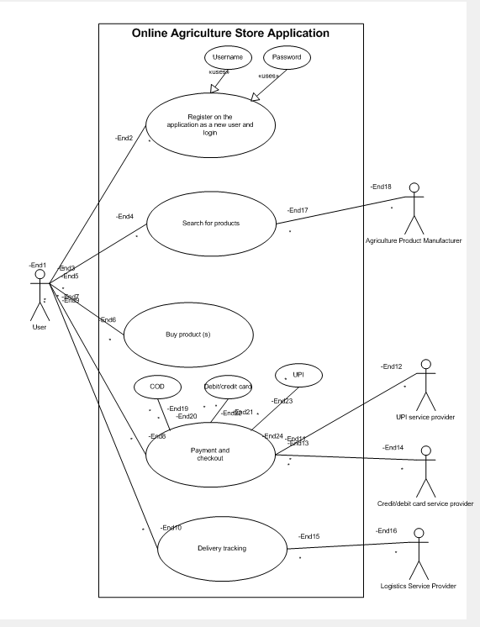

Use case specs
ANS:
Use Case ID | UC-001
Use Case Name | Registration
Description | New user can create new a/c by using email and secure password
Actors | Farmer, Agriculture Product Manufacturers
Pre-condition | 1) Active internet connection  2) Browser compatible
Post-condition | User is registered and email verified and can login
Basic Flow | 1) User enters registration details, such as username, address, email ID, password  2) Email sent for verification  3) User verfifies email
Alternate Flow | 1) User enter invalid email or password not meeting criteria  2) Verification email not received
Exceptions | If internet connectivity lost during this use case, application displays "check with your internet connectivity"
Frequency of Use | Medium
Assumptions | User has basic computer knowledge and knows english

Use Case ID | UC-002
Use Case Name | Login
Description | Login option should be available to all users (farmers and agricultural product manufacturers)
Actors | Farmer, Agriculture Product Manufacturers
Pre-condition | 1) Active internet connection  2) Browser compatible  3) User has registered
Post-condition | Home page of actor should be displayed
Basic Flow | 1) User enters username and password  2) User clicks login  3) User enter the home page
Alternate Flow | 1) Username is incorrect  2) Password is incorrect  3) Both username and password are incorrect
Exceptions | 1) If internet connectivity lost during this use case, application displays "check with your internet connectivity"  2) Forgot username and/or password
Frequency of Use | High
Assumptions | User has basic computer knowledge and knows english

Use Case ID | UC-003
Use Case Name | View/search agriculture products
Description | Farmers should be able to search for available  products in fertilizers, seeds, pesticides
Actors | Farmer, Agriculture Product Manufacturers
Pre-condition | 1) Active internet connection  2) Browser compatible  3) User has registered and logged-in  4) Agriculture product manufacturer has has uploaded and displayed products and data
Post-condition | User (Farmer) can view the products and are able to buy or buy later
Basic Flow | 1) User enters username and password  2) User clicks login  3) User enter the home page  4) User searches specific product such as "fertilizer"  5) Specific products are displayed with information  6) User proceeds to buy or adds to buy later option
Alternate Flow | 1) Product data unavailable/not uploaded  2) Out of stock/price not mentioned
Exceptions | 1) If internet connectivity lost during this use case, application displays "check with your internet connectivity"  2) If product is not found, display "No results"
Frequency of Use | High
Assumptions | User has basic computer knowledge and knows english

Use Case ID | UC-004
Use Case Name | Payment
Description | Customers should be able to do payment processing including cash-on-deliver (COD), credit/debit card, and UPI options
Actors | Farmer, Payment service providers
Pre-condition | 1) Active internet connection  2) Browser compatible  3) User has registered and logged-in  4) Agriculture product manufacturer has has uploaded and displayed products and data  5) Farmer has selected product(s) for buying and added to cart
Post-condition | User (Farmer) selects payment method, completes paymenet, order is placed, receives confirmation email
Basic Flow | 1) User enters username and password  2) User clicks login  3) User enter the home page  4) User searches specific product such as "fertilizer"  5) Specific products are displayed with information  6) User proceeds to buy  7) User selects COD/Credit/debit card/UPI as payment option  8) User completes payment and order is placed
Alternate Flow | 1) Bank server is down/no response  2) Insufficient funds in particular payment method  3) Payment not completed/quit
Exceptions | If internet connectivity lost during this use case, application displays "check with your internet connectivity"
Frequency of Use | Medium to High
Assumptions | User has basic computer knowledge and knows english  User has online bank account

Use Case ID | UC-005
Use Case Name | Delivery tracking
Description | Farmers should be able to track delivery
Actors | Farmer, Logistics service providers
Pre-condition | 1) Active internet connection  2) Browser compatible  3) User has registered and logged-in  4) Agriculture product manufacturer has has uploaded and displayed products and data  5) Farmer has completed payment and placed an order
Post-condition | Farmer is able to view the estmated delivery date and current status
Basic Flow | 1) User enters username and password  2) User clicks login  3) User enter the home page  4) User checks placed order  5) User checks the delivery status
Alternate Flow | 1) Order not displayed  2) Delivery status not updated/unavailable
Exceptions | If internet connectivity lost during this use case, application displays "check with your internet connectivity"
Frequency of Use | Medium
Assumptions | User has basic computer knowledge and knows english

Activity diagrams
ANS: 1) Regstration
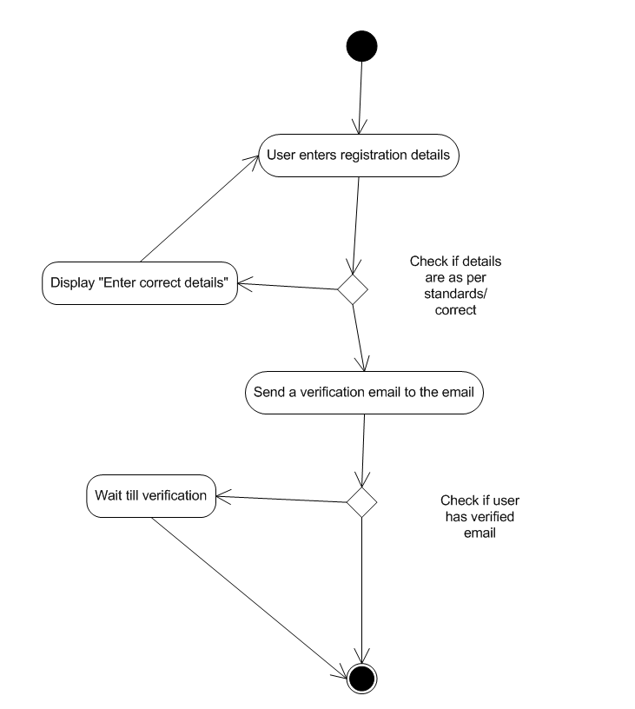

Login
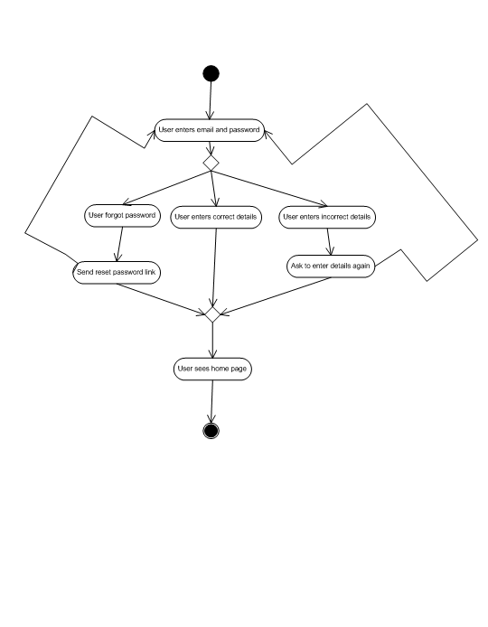

Product search
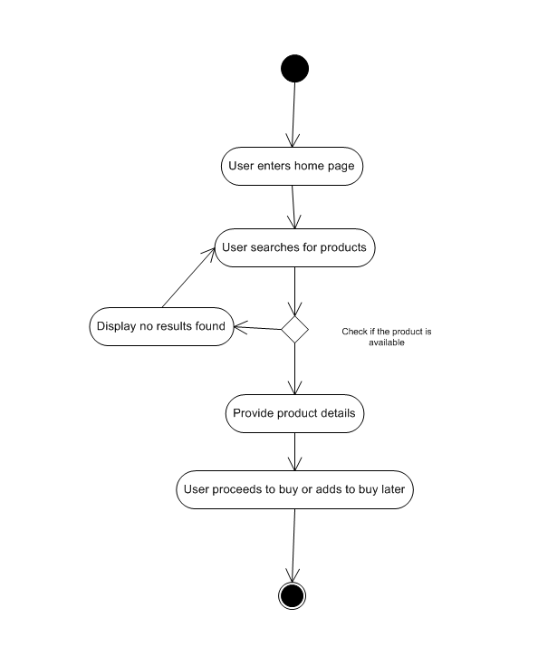

Payment Processing
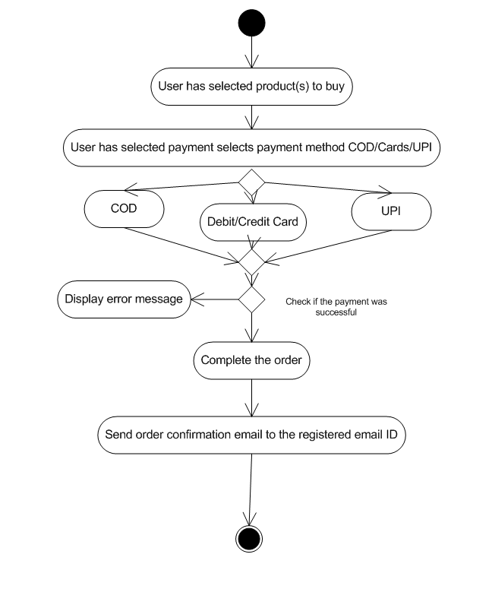

Delivery Tracking
