Q1. 4 Quarterly Audits are planned Q1 , Q2, Q3, Q4 for this Project What is your knowledge on how these Audits will happen for a BA ?

Stage Quarter 1 Audit Report (Requirement gathering phase)

Completed 10Weeks(1 to 10weeks)

Checklist BRD Template

Elicitation results report

Duplicate requirement report

Grouping of functionalities/ features

Client signoff

Email communication- To,CC,BCC

Stage Quarter 2 Audit Report ( Requirement Analysis Phase)

Completed 11Weeks(11 to 23weeks)

Checklist UML diagrams

Business to functional requirements mapping

Client signoff documents

RTM document version control

Email communication- To,CC,BCC

Stage Quarter 3 Audit Report( Design )

Completed 6 Weeks(24 to 29weeks)

Checklist Utilization of tools

Documented evidence on client communication

Stakeholder MOM

Email communication- To,CC,BCC

Stage Quarter 4 Audit Report(Development and design)

Completed 46 Weeks(30 to 76weeks)

Checklist JAD session report

End user manual preparation document

BA and developer MOM

Email communication- To, CC ,BCC

Test case summary

Training report to end users

Lessons learnt document

Email communication-To,CC,BCC

Q2. Before the Project is going to Kick Start, The Committee asked Mr Karthik to submit BA Approach Strategy

Write BA Approach strategy (As a business analyst, what are the steps that you would need to follow to complete a project – What Elicitation Techniques to apply, how to do Stakeholder Analysis RACI/ILS, What Documents to Write, What process to follow to Sign off on the Documents, How to take Approvals from the Client, What Communication Channels to establish n implement, How to Handle Change Requests, How to update the progress of the project to the Stakeholders, How to take signoff on the UAT- Client Project Acceptance Form )

Technical Team have assembled to discuss on the Project approach and have finalised to follow 3-tier architecture for this project.

**What elicitation techniques to apply –** We have many elicitation techniques to used to gather requirements. Some of them are brainstorming, Document analysis, reverse engineering, focus groups, Observation, etc

**How** **to** **do** **stakeholders** **analysis** - Stakeholder analysis can be done using RACI matrix involves identifying stakeholders and defining their roles and responsibilities within a project. Identify stakeholders, Define Roles and Responsibilites, create the RACI Matrix, Assign RACI Roles.

**What document to write -**BRD ,FRD, usecase documentation, Test case documents and etc

**What process to follow to signoff -** Sign off can be taken on SRS as this is primary and important document. Sign off can be taken by using E-mail confirmation from client.

**How to take approvals from client-**Establish a formal meeting with the clients to keep them informed and get continuous feedback.

**What communication channels to establish and implement-** Regular meetings, weekly status meetings, bi-weekly sprint reviews, and monthly stakeholder updates

**How** **to** **handle** **change** **request-** Change request form , Do impact analysis, Approval process, Documentation.

**How to update progress of the project to the stakeholders-** Weekly status report, Monthly Review meetings.

**How to take sign off on UAT (Client Project Acceptance Form**)**-**  UAT preparation, conduct UAT, Fix issues, Acceptance form, Final review Meeting, Obtain Sign-off.

Q3.Explain and illustrate 3-tier architecture?

1. **Presentation Layer (UI Layer)**:

* **Role:** The topmost layer, responsible for the user interface and user interaction.
* **Technologies:** HTML, CSS, JavaScript, Angular, React.
* **Example:** A web page displaying product details and receiving user inputs.

2. **Business Logic Layer (Application Layer)**:

* **Role:** The middle layer, responsible for implementing business rules and processing data.
* **Technologies:** Java, Python, C#, Node.js, .NET.
* **Example:** Validating a user's login credentials or calculating discounts on products.

**3.Data Layer (Database Layer)**:

* **Role:** The bottom layer, responsible for data storage, retrieval, and management.
* **Technologies:** MySQL, PostgreSQL, MongoDB, Oracle DB.
* **Example:** Storing and retrieving user information or product catalog data.

Data Base layer(Data Base server SQL, NoSQL Databases)

Business logic (Web Server, API, Application Logic)

Presentation layer(Web Browser, Mobile App Interface)

Q4. Business Analyst should keep What points in his/her mind before he frames a Question to ask to the Stakeholder

( 5W 1H – SMART – RACI – 3 Tier Architecture – Use Cases, Use case Specs, Activity Diagrams,Models, Page designs)

* The 5W1H framework is a tool for gathering inform is action and understanding a situation by answering questions about who, what, when, where, why, and how.

**5W1H (Who, What, When, Where, Why, How):**

* **Who**: Identify all stakeholders involved (Mr. Henry, Peter, Kevin, Ben, SOONY Committee, APT IT Solutions team).
* **What**: Understand the core objectives (online platform for agricultural products).
* **When**: Clarify the timeline (18 months).
* **Where**: Target audience location (remote villages).
* **Why**: Ensure clarity on the problem being solved (supply issues for farmers).
* **How**: Identify how the platform will work (product listing, purchasing, delivery).
* The SMART technique can help in creating question:

(Specific, Measurable, Attainable, Relevant, and Time Bond)

**SMART (Specific, Measurable, Achievable, Relevant, Time-bound):**

* **Specific**: Clearly defined objective to create a web and mobile platform for agricultural product purchase.
* **Measurable**: Completion within 18 months with a 2 Crores INR budget.
* **Achievable**: Skilled resources available.
* **Relevant**: Solves a critical problem for farmers.
* **Time-bound**: 18-month deadline set.
* RACI Chart helps and clarify roles and responsibilities within a team by outlining who is responsible, accountable, consulted, and informed for each task.

**RACI (Responsible, Accountable, Consulted, Informed):**

* **Responsible**: APT IT Solutions team (Project Manager, Developers, Testers).
* **Accountable**: Project Committee (Mr. Henry, Mr. Pandu, Mr. Dooku).
* **Consulted**: Stakeholders (Peter, Kevin, Ben).
* **Informed**: Farmers, Manufacturers, Company SOONY.
* **3-Tier Architecture**
* **Presentation Layer**: Web/Mobile UI for product browsing and purchasing.
* **Business Logic Layer**: Order management, payment processing, and validation.
* **Data Layer**: Centralized database for storing product and order information.
* **Use Cases and Use Case Specifications:**
* **Use Case Example**: "Place an Order for Fertilizers."
  + **Actors**: Farmer, Manufacturer, System.
  + **Precondition**: Farmer must be registered.
  + **Steps**: Login → Browse Products → Add to Cart → Confirm Order → Notify Manufacturer.
  + **Post-condition**: Order confirmation notification.
* **Activity Diagrams (Example):**
* **Order Flow**: Farmer Logs In → Searches Product → Adds to Cart → Confirms Payment → Order Sent to Manufacturer → Order Delivered.
* **Models (ERD, Class Diagrams):**
* **ER Diagram Components**: Farmer, Manufacturer, Product, Order, Payment, Delivery.
* **Class Diagram**: Farmer, Product, Order, Payment with their attributes and methods
* **Page Designs:**
* **Homepage**: Simple login/register and product categories.
* **Product Listing Page**: Filters for product type and availability.
* **Checkout Page**: Payment methods and delivery details.

UML, or Unified Modeling Language, is a standardized way of diagramming and modeling software systems to aid in design, development, and communication between team members.

Q5. As a Business Analyst, What Elicitation Techniques you are aware of?

**B – Brainstorming**

* **Description:** Group activity to generate ideas and solutions.

**D – Document Analysis**

* **Description:** Reviewing existing documents to gather historical data and requirements.

**R – Reverse Engineering**

* **Description:** Analyzing an existing system to derive requirements for a new system.

**F – Focus Groups**

* **Description:** Engaging a small group of stakeholders to gather feedback and insights.

**O – Observation (Job Shadowing)**

* **Description:** Observing stakeholders in their work environment.

**W – Workshops (Joint Application Development - JAD)**

* **Description:** Interactive sessions with multiple stakeholders to gather collective input.

**J – Joint Application Development (JAD)**

* **Description:** Collaborative workshops for gathering requirements and refining solutions.

**I – Interviews**

* **Description:** One-on-one or group meetings to gather information.

**P – Prototyping**

* **Description:** Creating mockups or wireframes for early validation.

**Q – Questionnaires and Surveys**

* **Description:** Structured questions distributed to a broader audience.

**U – User Stories**

* **Description:** Capturing requirements from an end-user perspective.

**Q6**. Which Elicitation Techniques can be used in this Project and Justify your selection of Elicitation Techniques?

Prototyping

Use case Specs

Document Analysis

Brainstorming

**1. Document Analysis**

* **Justification:**

Since this project involves displaying details about fertilizers, seeds, and pesticides, as well as handling orders and deliveries, it would be beneficial to analyze any existing documents related to these **products, including brochures, catalogs, or technical specifications from manufacturers. Document analysis would help ensure that all relevant data is included in the product catalog,** that product information is accurate, and that you comply with any legal or business standards. It would also provide insights into the necessary fields for the database (e.g., product name, description, price, and availability).

**2. Prototyping**

* **Justification:** Prototyping is useful in situations where the **client has a general idea of what they want** but may not be able to articulate all the details. Given the specifics mentioned in the project requirements (like the **login functionality**, product catalog, search functionality, payment methods, etc.), building a prototype could help the stakeholders, including Mr. Henry, Peter, Kevin, and Ben, visualize the system. This would allow for more detailed feedback on the features, flow, and user interface of the platform. **For example, creating a mock-up of the login process, product catalog, or payment gateway would help** stakeholders clarify expectations and provide direct feedback, enabling iterative development.

**3.Brainstorming**

* **Justification:** Brainstorming can be particularly useful during stakeholder meetings to explore a variety of ideas and solutions for features such as the search option, payment methods, and delivery tracking. It encourages collaboration and can surface innovative solutions or additional requirements that may not have been initially considered**. For example, when Kevin suggested a search option, brainstorming could help define the search parameters, filters, and user experience.** Likewise, when discussing payment options and delivery tracking, brainstorming can **identify potential obstacles or additional functionality that could improve user satisfaction**.

**4. Use Case Specifications**

* **Justification** :Use case specifications are essential for understanding the **functional requirements of the system**. This technique would help in clearly defining how different users (Farmers, Manufacturers, Admins, etc.) interact with the system. Based on the meeting with the stakeholders, it's evident that there are various user roles and actions (e.g., creating accounts, logging in, searching products, adding to the buy-later list, making payments, tracking delivery**). By developing detailed use cases, you can capture these requirements in a structured way, ensuring that all expected user interactions are accounted for and clearly documented.**

**Conclusion:**

The selected elicitation techniques ensure **comprehensive requirement gathering** by addressing both **functional needs** (like login, product catalog) and **non-functional needs** (like usability and performance).

Identify Business Requirements (which includes Stakeholder Requirements)

Q7. Identified Business Requirements (BR):

Business requirements are the specific needs or conditions that a businees must meet to achieve its objectives.

* BR001: Farmers should be able to search for available products in fertilizers, seeds, and pesticides.
* BR002: Manufacturers should be able to upload and display their products on the application.
* BR003: Farmers should be able to create accounts and log in using their email and secure passwords.
* BR004: The system should offer multiple payment options**: COD, Credit/Debit Card, UPI**.
* BR005: Farmers should receive an **email confirmation** about their order status.
* BR006**:** The platform should provide **delivery tracking** features for farmers.
* BR007: Product Comparison
* BR008: Order Confirmation and Notifications
* BR009: Customer support Integration
* BR0010: Multi-Language Support

Q8. List the Assumptions

**User Locations:**

* The platform will primarily serve **rural and remote areas** with internet access.
* **Multiple language support** will be essential for better accessibility.

**Order Management:**

* Farmers can place orders directly through the platform.
* A **unique order ID** will be generated for every order.
* Real-time **order tracking** will be available for placed orders.

**Payment Gateway:**

* The platform will support **COD, UPI, and Credit/Debit cards** as standard payment options.
* All transactions will be **securely encrypted**.

**CSR Initiative:**

* The project is part of a **CSR (Corporate Social Responsibility)** initiative and aims to **empower rural farmers**.

**Regulatory Compliance:**

* The platform will comply with **Indian agricultural e-commerce laws**.
* GST (Goods and Services Tax) compliance for all products sold.

Q.9 – This project Requirements Priority

|  |  |  |  |
| --- | --- | --- | --- |
| **Req ID** | **Req Name** | **Req Description** | **Priority** |
| **BR001** | Farmer Search for Products | Farmers should be able to search for available products in fertilizers, seeds, pesticides. | **8** |
| **BR002** | Manufacturer Product Upload | Manufacturers should be able to upload and display their products in the application. | **8** |
| **BR003** | User Account Management | Farmers and Manufacturers should be able to register, login, and manage their accounts. | **10** |
| **BR004** | Product Comparison Feature | Farmers should be able to compare multiple products before making a purchase. | **5** |
| **BR005** | Secure Payment Gateway | The platform should support secure payment methods like COD, UPI, and Credit/Debit Cards. | **10** |
| **BR006** | Order Management & Tracking | Farmers should be able to place orders and track the delivery status in real-time. | **9** |
| **BR007** | Notifications & Confirmation | Automated notifications for order confirmation, payment status, and delivery updates. | **7** |
| **BR008** | Multi-Language Support | The platform should support multiple languages for better accessibility. | **6** |
| **BR009** | Reporting & Analytics | Generate sales and purchase reports for both farmers and manufacturers. | **5** |
| **BR010** | Customer Support Integration | A helpdesk feature should be available for technical issues and product inquiries. | **7** |

**✅ Justification for Priority Levels:**

1. **BR003 (User Account Management)** and **BR005 (Secure Payment Gateway)** were given the highest priority (**10**) as they are essential for system functionality and security.
2. **BR001 (Search)** and **BR002 (Product Upload)** were also marked as high priority (**8**) since they directly impact core functionality.
3. **BR006 (Order Management & Tracking)** received a priority of **9** due to its critical role in user satisfaction.
4. **Lower priorities** were assigned to features like **Product Comparison (5)** and **Analytics (5)** as they are enhancements rather than core system requirements.

Q.10 Draw use case diagram

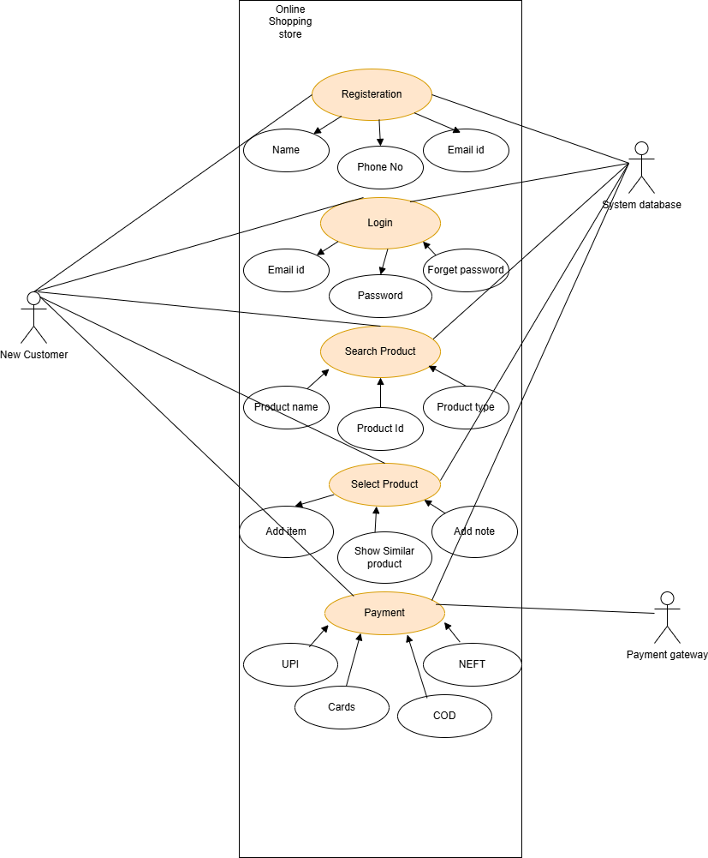

|  |  |  |  |
| --- | --- | --- | --- |
|  |  |  |  |

Q11. Prepare use case specs for all use cases

|  |
| --- |
| **Use Case ID**: UC001 **Use Case Name**: User Registration **Created By**: [Mr.ABC] **Date Created**: [12/12/2024] **Actor**: New User (Farmer/Manufacturer) |
| **Description**: New users register for an account on the platform. |
| **Preconditions**: |
| 1. User has access to the platform. |
| **Postconditions**: |
| 1. The user is successfully registered and can log in. |
| **Normal Flow of Events**: |
| 1. User clicks on the "Register" button. |
| 1. User fills in required details (name, email, password, etc.). |
| 1. System validates and saves the information. |
| 1. User receives a confirmation email. |
| **Alternative Flow**: |
| 1. If email verification fails, the user cannot log in until the email is verified. |
| **Exceptions**: |
| 1. System errors prevent registration from being completed. |
| **Frequency of Use**: High |
| **Assumptions**: |
| 1. Users have valid email addresses. |
| 1. Password requirements are clearly defined. |

|  |
| --- |
| **Use Case ID**: UC002 **Use Case Name**: User Login |
| **Created By**: [Mr.ABC] **Date Created**: [20/12/2024] **Primary Actor**: Farmer, Manufacturer (Seeds, Fertilizers, Pesticides) |
| **Description**: New users login for purchasing products on the platform |
| **Preconditions**: |
| * User has registered on the platform previously. |
| **Postconditions**: |
| * User is successfully logged in to the platform. |
| * User’s session is maintained for subsequent actions. |
| **Main Flow**: |
| 1. User navigates to the login page. |
| 1. User enters email address and password. |
| 1. System validates the credentials against the stored data. |
| 1. If valid, system creates a session for the user and redirects to the homepage or dashboard. |
| 1. User can access the product catalog and other features. |
| **Alternative Flow(s)**: |
| * **Invalid credentials**: If the user enters incorrect details, an error message is shown, and the user is prompted to retry. |
| * **Forgot password**: If the user selects the "Forgot password" link, they can reset the password via email. |
| **Exceptions**: |
| * User enters incorrect credentials multiple times. |
| **Frequency of use:** High |
| **Assumptions**:   * The user knows their username and password. * The user has access to their email or phone if two-factor authentication is required. * The system has internet access and is operational for authentication. |
|  |
|  |

|  |
| --- |
| **Use Case ID**: UC003 **Use Case Name**: Farmer Searches for Products **Created By**: [MR.ABC] **Date Created**: [20/12/2024] **Actor**: Farmer |
| **Description**: Farmers search for available products (fertilizers, seeds, pesticides) to fulfill their farming needs. |
| **Preconditions**: |
| 1. Farmer has successfully logged into the system. |
| 1. The system contains product details uploaded by manufacturers. |
| **Postconditions**: |
| 1. The farmer can view the search results based on their query. |
| 1. The system displays available products that match the search criteria. |
| **Normal Flow of Events**: |
| 1. Farmer enters search criteria into the search bar. |
| 1. The system processes the search query. |
| 1. Matching products are displayed to the farmer. |
| **Alternative Flow**: |
| 1. If no products match the search criteria, the system displays a "No Results Found" message with suggestions for related searches. |
| **Exceptions**: |
| 1. If the system is down, the farmer is notified with an error message. |
| **Frequency of Use**: High |
| **Assumptions**: |
| 1. Farmers have basic knowledge of how to use the search functionality. |
| 1. The database is updated with product details. |

|  |
| --- |
| **Use Case ID**: UC004 **Use Case Name**: Farmer select a Product for Purchase **Created By**: [MR.ABC] **Date Created**: [22/12/2024] |
| **Primary Actor**: Farmer |
| **Description**: Farmers select for products (fertilizers, seeds, pesticides) to fulfill their farming needs. |
| **Preconditions**: |
| * User is logged in or browsing as a guest. |
| * User has searched or browsed through the product catalog. |
| **Postconditions**: |
| * The selected product is added to the shopping cart or wishlist. |
| **Main Flow**: |
| 1. User clicks on a product from the search results or catalog. |
| 1. System displays detailed product information (price, description, availability). |
| 1. User clicks "Add to Cart" or "Add to Wishlist". |
| 1. The product is added to the user’s shopping cart or wishlist. |
| 1. User can proceed to checkout or continue browsing. |
| **Alternative Flow(s)**: |
| * **Out of stock**: If the product is unavailable, the system notifies the user and provides alternatives if applicable. |
| **Exceptions**: |
| * Product added to the cart but becomes unavailable before checkout. * **System Error:** If the system encounters an error during checkout (e.g., database issue or payment gateway error), the farmer is notified of the issue and asked to try again later. |
| **Frequency of use** :High |
| **Assumptions:**   * The platform maintains accurate stock levels and product details. * The farmer has a valid form of payment (credit/debit card, mobile payment, etc.). |

|  |
| --- |
| **Use Case ID**: UC005 **Use Case Name**: Payment for Products |
| **Created By**: [MR.ABC] **Date Created**: [26/12/2024] |
| **Primary Actor**: Farmer |
| **Description:**  Farmers search for available payment options for purchasing (fertilizers, seeds, pesticides) to fulfill their farming needs |
| **Preconditions**: |
| * User has selected products and added them to the shopping cart. |
| **Postconditions**: |
| * Payment is processed, and the order is confirmed. |
| * User receives an email confirmation with order details. |
| **Main Flow**: |
| 1. User navigates to the cart and clicks "Proceed to Checkout". |
| 1. User selects a payment method (COD, Credit/Debit Card, UPI). |
| 1. System presents the payment gateway for the chosen payment method. |
| 1. User enters payment details and confirms the payment. |
| 1. System processes the payment. |
| 1. If successful, the order is confirmed, and a confirmation email is sent to the user. |
| 1. User is provided with an order tracking number. |
| **Alternative Flow(s)**: |
| * **Payment failed**: If the payment fails (e.g., due to insufficient funds or connectivity), the system notifies the user and prompts them to try again or choose a different payment method. |
| * **COD selected**: If COD is selected, no immediate payment is required. The system confirms the order and generates a delivery tracking number. |
| **Exceptions**: |
| * **Payment Gateway Unavailable:** If the payment gateway is unavailable due to maintenance or other issues, the system informs the farmer and asks them to retry later. * **Invalid Payment Information:** If the system detects invalid payment information (e.g., expired card, incorrect details), it prompts the farmer to re-enter the information. |
| **Frequency of use**: High |
| **Assumptions:**   * The farmer has sufficient funds in the account or an active balance in their payment method. |
| * The platform supports multiple payment methods (e.g., credit card, debit card, mobile payment). |

Q12. (minimum 5) Activity Diagrams

1.User Registration

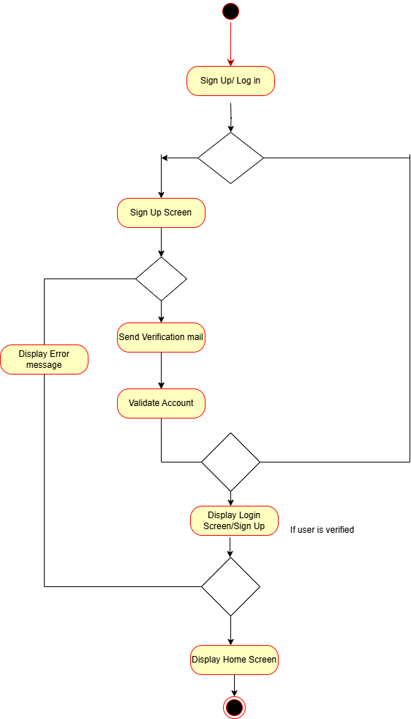

2.Order delivery

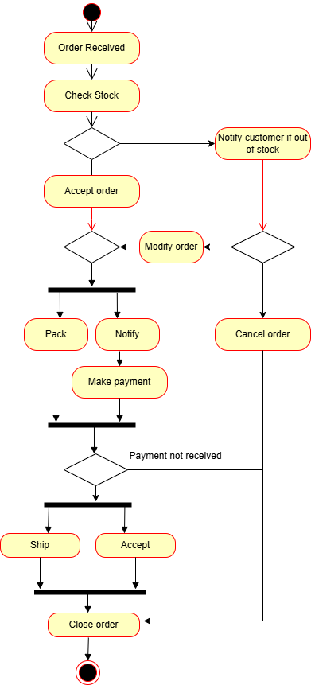

3. Farmers Product purchase

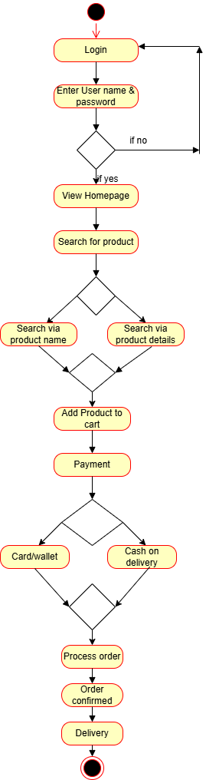

4. Payment activity diagram

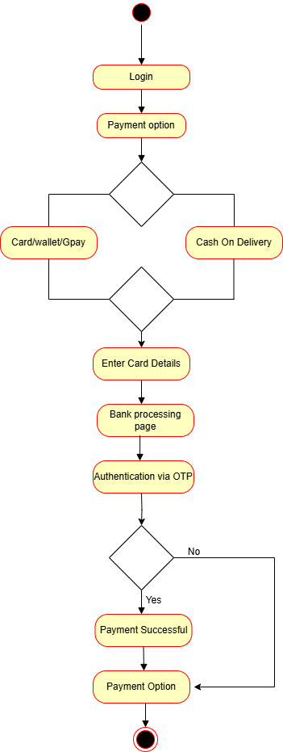

5.Search for the products

