**Assignment: 1  
__________________________________________________________________________________**

**A company is having manufacturing plants and warehouses in various parts of the country. They manufacture ice-cream and milk products. They want to build software to achieve two goals.**

**• Manage the inventory**

**• Quickest delivery to the customers**

**__________________________________________________________________________________**

**Q1.** **Please make a BRD which can be presented to the client along with complete development and resource plan.  
  
Business Requirements Document (BRD)**  
**Project Name:** Inventory Management & Delivery Optimization System  
**Client:** YUGMA LLC  
**Date:** 17/03/2025  
**Prepared by:** Vivek Kumar

**1. Introduction**

**1.1 Purpose**

The purpose of this document is to outline the business requirements for developing an integrated software solution to manage inventory and optimize the delivery of ice cream and milk products. The system will enable the company to efficiently track inventory levels and ensure the quickest delivery to customers across different locations.

**1.2 Project Scope**

This project aims to develop an end-to-end system that covers:

* Real-time inventory management for manufacturing plants and warehouses.
* Route optimization for the fastest delivery to customers.
* Order management, tracking, and fulfilment.
* Reporting and analytics for inventory and logistics performance.

**1.3 Objectives**

* Reduce inventory shortages and overstocking.
* Enhance operational efficiency in manufacturing and warehousing.
* Ensure timely delivery of products to customers.
* Improve overall customer satisfaction.

**2. Business Requirements**

**2.1 Functional Requirements**

1. **Inventory Management:**
   * Track stock levels at manufacturing plants and warehouses.
   * Automated alerts for restocking and expiration dates.
   * Integration with production systems.
2. **Order Processing:**
   * Customers can place orders via web/mobile.
   * Automated order routing to the nearest warehouse.
   * Order confirmation and tracking notifications.
3. **Delivery Optimization:**
   * AI-based route optimization for the quickest delivery.
   * Real-time tracking of delivery vehicles.
   * Integration with third-party logistics partners.
4. **Reporting & Analytics:**
   * Inventory turnover reports.
   * Sales and demand forecasting.
   * Delivery performance analytics.

**2.2 Non-Functional Requirements**

* High system availability (99.9% uptime).
* Secure access control and data encryption.
* Scalable architecture to support business growth.

**3. Development & Resource Plan**

**3.1 Development Phases**

1. **Requirement Gathering & Analysis** (Weeks 1-3)
   * Stakeholder interviews.
   * Process mapping.
2. **System Design** (Weeks 4-6)
   * Architecture and database design.
   * UI/UX wireframing.
3. **Development** (Weeks 7-14)
   * Backend and frontend implementation.
   * API integrations.
4. **Testing & Quality Assurance** (Weeks 15-17)
   * Unit and integration testing.
   * User acceptance testing (UAT).
5. **Deployment & Training** (Weeks 18-20)
   * System deployment.
   * Employee training and documentation.

**3.2 Resource Allocation**

|  |  |  |
| --- | --- | --- |
| **Role** | **Responsibilities** | **No. of Resources** |
| **Business Analyst** | **Requirement gathering, documentation** | **1** |
| **Project Manager** | **Planning, coordination, risk management** | **1** |
| **UI/UX Designer** | **Wireframing, UI design** | **1** |
| **Backend Developer** | **API, database, server-side logic** | **2** |
| **Frontend Developer** | **User interface development** | **2** |

**3.3 Technology Stack**

* **Frontend:** React.js/Angular
* **Backend:** Node.js/Django/Java Spring Boot
* **Database:** PostgreSQL/MySQL
* **Cloud:** AWS/Azure/GCP
* **Mobile App:** Flutter/React Native (if applicable)

**3.4 Risks & Mitigation Strategies**

| **Risk** | **Mitigation Strategy** |
| --- | --- |
| Scope Creep | Define clear project requirements upfront. |
| Data Security | Implement encryption and access controls. |
| System Downtime | Use cloud redundancy and backup strategies. |
| Integration Issues | Plan API design carefully and test early. |

**4. Conclusion**

The proposed Inventory Management & Delivery Optimization System will enhance the efficiency of the company’s operations, ensuring effective inventory management and timely product deliveries. By leveraging modern technology and best practices, the system will drive operational excellence and improve customer satisfaction.

**Approval:**  
Satyajit Pawar  
MD/CEO  
17/03/2025

**Q2. Prepare process flow diagram using your imagination.  
  
Ans:**   
  
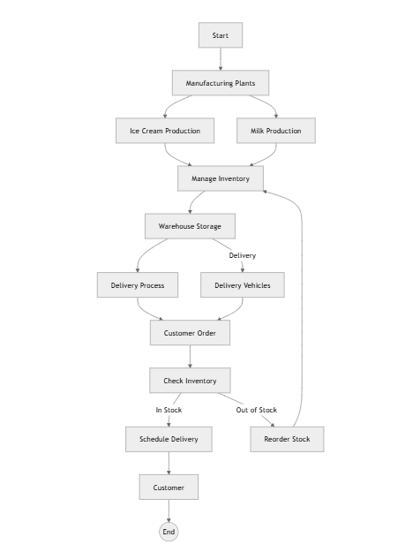

**Assignment 2:  
  
  
Q1.Write an introduction letter to a client introducing yourself as a business analyst in charge of working with the client and his team to start the business understanding process.  
  
Ans:  
Subject: Introduction – Business Analyst for Your Project**

Dear **Atul Raj**,

I hope this email finds you well. My name is **Vivek Kumar**, and I am a Business Analyst assigned to work with you and your team on **EMR Upgrade Project**. I am excited about the opportunity to collaborate and support you in achieving your business objectives.

My primary role is to understand your business needs, gather requirements, and ensure that the proposed solution aligns with your goals. Over the coming weeks, I will be working closely with you to analyze your current processes, identify opportunities for improvement, and document key business requirements that will drive the success of this project.

To kick things off, I would love to schedule an initial discussion to understand your expectations, key pain points, and any specific requirements you have in mind. Please let me know a convenient time for us to connect.

Looking forward to working with you and your team.

Best regards,  
Vivek Kumar  
Business Analyst  
YUGMA LLC  
+91 7220085921

**Q2.** **Prepare a brief BRD and SRS for a project- Horoscope or Ticketing system or online store.  
Ans:**

**Business Requirements Document (BRD)**

**Project Name:** Ticketing System **Client:** YUGMA LLC **Prepared by:** Vivek Kumar **Date:** 17/03/2025

**1. Introduction**

The Ticketing System is designed to streamline issue tracking and resolution for [Company Name]. It will enable users to raise tickets, track progress, and facilitate seamless communication between support teams and customers.

**2. Business Objectives**

* Improve customer support efficiency.
* Automate ticket categorization and assignment.
* Enable real-time tracking and reporting.
* Enhance team collaboration and response time.

**3. Functional Requirements**

1. User Management – Roles for customers, agents, and admins.
2. Ticket Creation – Users can submit tickets via web, mobile, or email.
3. Ticket Assignment & Prioritization – Automatic or manual assignment based on category and urgency.
4. Status Tracking – Ticket status updates (Open, In Progress, Resolved, Closed).
5. Notifications & Alerts – Email/SMS updates on ticket status changes.
6. Reporting & Analytics – Dashboard for tracking resolution times, agent performance, and issue trends.

**4. Non-Functional Requirements**

* Scalability: Handle increasing ticket volumes.
* Security: User authentication and role-based access.
* Availability: 99.9% uptime for uninterrupted support.

**5. Assumptions & Constraints**

* Users must have an account to submit and track tickets.
* System will integrate with third-party tools (e.g., email, chatbots).

**Software Requirements Specification (SRS)**

**Project Name: Ticketing System  
Version: 1.0  
Date: 17/03/2025  
Prepared by: Vivek Kumar**

**1. Introduction**

**1.1 Purpose:**The Ticketing System will facilitate issue tracking, improve customer support efficiency, and enable seamless communication between users and support agents.

**1.2 Scope:**

* Multi-channel ticket submission.
* Automated workflow for ticket assignment and prioritization.
* Real-time tracking and reporting.

**2. System Features**

**2.1 User Authentication & Roles:**

* Users (customers, agents, admins) must log in to access the system.

**2.2 Ticket Management:**

* Users create and submit tickets with issue details.
* Tickets assigned automatically based on priority and category.

**2.3 Communication & Notifications:**

* Email/SMS alerts for status updates.
* In-app messaging for agent-customer interactions.

**2.4 Reporting & Analytics:**

* View performance metrics and issue resolution statistics.
* Exportable reports for management review.

**3. External Interfaces**

* Email Integration: Auto-ticket creation from support emails.
* Chatbot API: Automated responses for common queries.

**4. Performance Requirements**

* System should process 1000+ tickets per hour without delays.

**5. Security & Compliance**

* Role-based access control.
* Data encryption for ticket details and user communications.

**Q3.** **Make an ERD of creating a support ticket/Ticketing life cycle.  
  
  
  
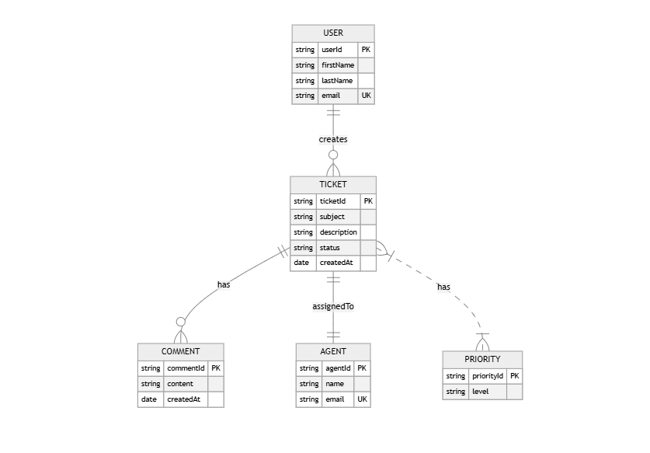  
  
__________________________________________________________________________________**

**Q4.** **User story of shopping from ecommerce.  
  
Ans:**

|  |  |  |  |
| --- | --- | --- | --- |
| User Story No: 01 | Tasks: 01 | | Priority: High |
| **As a** Customer  **I want to** Browse and purchase products  **So that** I can shop online | | | |
| BV: 100 | | CP: 5 | |
| ACCEPTANCE CRITERIA  Proper registration, browsing, checkout, and tracking features available | | | |

|  |  |  |  |
| --- | --- | --- | --- |
| User Story No: 02 | Tasks: 2 | | Priority: Medium |
| **As a** Delivery Boy  **I want to** Register and accept delivery orders  **So that** I can deliver food orders | | | |
| BV: 200 | | CP: 3 | |
| Proper registration, browsing, checkout, and tracking features available | | | |

|  |  |  |  |
| --- | --- | --- | --- |
| User Story No: 03 | Tasks: 1 | | Priority: Low |
| **As a** Customer  **I want to** Browse and purchase products  **So that** I can shop online | | | |
| BV: 500 | | CP: 1 | |
| Proper registration, browsing, checkout, and tracking features available | | | |

|  |  |  |  |
| --- | --- | --- | --- |
| User Story No: 04 | Tasks: 2 | | Priority: Medium |
| **As a** Delivery Boy  **I want to** Register and accept delivery orders  **So that** I can deliver food orders | | | |
| BV: 100 | | CP: 1 | |
| Proper registration, browsing, checkout, and tracking features available | | | |

|  |  |  |  |
| --- | --- | --- | --- |
| User Story No: 05 | Tasks: 1 | | Priority: High |
| **As a** Customer  **I want to** Browse and purchase products  **So that** I can shop online | | | |
| BV: 100 | | CP: 5 | |
| Proper registration, browsing, checkout, and tracking features available | | | |

|  |  |  |  |
| --- | --- | --- | --- |
| User Story No: 06 | Tasks: 1 | | Priority: Low |
| **As a** Delivery Boy  **I want to** Register and accept delivery orders  **So that** I can deliver food orders | | | |
| BV: 200 | | CP: 3 | |
| Proper registration, browsing, checkout, and tracking features available | | | |

|  |  |  |  |
| --- | --- | --- | --- |
| User Story No: 07 | Tasks: 1 | | Priority: Medium |
| **As a** Customer  **I want to** Browse and purchase products  **So that** I can shop online | | | |
| BV: 200 | | CP: 1 | |
| Proper registration, browsing, checkout, and tracking features available | | | |

|  |  |  |  |
| --- | --- | --- | --- |
| User Story No: 08 | Tasks: 1 | | Priority: High |
| **As a** Delivery Boy  **I want to** Register and accept delivery orders  **So that** I can deliver food orders | | | |
| BV: 500 | | CP: 5 | |
| Proper registration, browsing, checkout, and tracking features available | | | |

|  |  |  |  |
| --- | --- | --- | --- |
| User Story No: 09 | Tasks: 2 | | Priority: Low |
| **As a** Customer  **I want to** Browse and purchase products  **So that** I can shop online | | | |
| BV: 500 | | CP: 5 | |
| Proper registration, browsing, checkout, and tracking features available | | | |

|  |  |  |  |
| --- | --- | --- | --- |
| User Story No: 10 | Tasks: 2 | | Priority: Medium |
| **As a** Delivery Boy  **I want to** Register and accept delivery orders  **So that** I can deliver food orders | | | |
| BV: 200 | | CP: 3 | |
| Proper registration, browsing, checkout, and tracking features available | | | |

|  |  |  |  |
| --- | --- | --- | --- |
| User Story No: 11 | Tasks: 1 | | Priority: High |
| **As a** Customer  **I want to** Browse and purchase products  **So that** I can shop online | | | |
| BV: 200 | | CP: 3 | |
| Proper registration, browsing, checkout, and tracking features available | | | |

|  |  |  |  |
| --- | --- | --- | --- |
| User Story No: 12 | Tasks: 1 | | Priority: Low |
| **As a** Delivery Boy  **I want to** Register and accept delivery orders  **So that** I can deliver food orders | | | |
| BV: 100 | | CP: 1 | |
| Proper registration, browsing, checkout, and tracking features available | | | |

|  |  |  |  |
| --- | --- | --- | --- |
| User Story No: 13 | Tasks: 1 | | Priority: Medium |
| **As a** Customer  **I want to** Browse and purchase products  **So that** I can shop online | | | |
| BV: 100 | | CP: 1 | |
| Proper registration, browsing, checkout, and tracking features available | | | |

|  |  |  |  |
| --- | --- | --- | --- |
| User Story No: 14 | Tasks: 2 | | Priority: High |
| **As a** Delivery Boy  **I want to** Register and accept delivery orders  **So that** I can deliver food orders | | | |
| BV: 100 | | CP: 3 | |
| Proper registration, browsing, checkout, and tracking features available | | | |

|  |  |  |  |
| --- | --- | --- | --- |
| User Story No: 15 | Tasks: 2 | | Priority: Medium |
| **As a** Customer  **I want to** Browse and purchase products  **So that** I can shop online | | | |
| BV: 100 | | CP: 5 | |
| Proper registration, browsing, checkout, and tracking features available | | | |

|  |  |  |  |
| --- | --- | --- | --- |
| User Story No: 16 | Tasks: 2 | | Priority: Low |
| **As a** Delivery Boy  **I want to** Register and accept delivery orders  **So that** I can deliver food orders | | | |
| BV: 500 | | CP: 5 | |
| Proper registration, browsing, checkout, and tracking features available | | | |

|  |  |  |  |
| --- | --- | --- | --- |
| User Story No: 17 | Tasks: 1 | | Priority: High |
| **As a** Customer  **I want to** Browse and purchase products  **So that** I can shop online | | | |
| BV: 500 | | CP: 3 | |
| Proper registration, browsing, checkout, and tracking features available | | | |

|  |  |  |  |
| --- | --- | --- | --- |
| User Story No: 18 | Tasks: 1 | | Priority: Medium |
| **As a** Delivery Boy  **I want to** Register and accept delivery orders  **So that** I can deliver food orders | | | |
| BV: 200 | | CP: 1 | |
| Proper registration, browsing, checkout, and tracking features available | | | |

|  |  |  |  |
| --- | --- | --- | --- |
| User Story No: 19 | Tasks: 1 | | Priority: Medium |
| **As a** Customer  **I want to** Browse and purchase products  **So that** I can shop online | | | |
| BV: 200 | | CP: 3 | |
| Proper registration, browsing, checkout, and tracking features available | | | |

|  |  |  |  |
| --- | --- | --- | --- |
| User Story No: 20 | Tasks: 1 | | Priority: High |
| **As a** Delivery Boy  **I want to** Register and accept delivery orders  **So that** I can deliver food orders | | | |
| BV: 200 | | CP: 1 | |
| Proper registration, browsing, checkout, and tracking features available | | | |