Document 6: Use Case Diagram, Activity Diagram & Use Case Specification
- Use Case Specification Document:
Use Case Name: Submit & Track Monthly Financial Data
Use Case Description: Allows department users to enter, validate, and submit monthly revenue and expenditure data to the centralized tracker for review and approval.
Actors:
Primary: Department User
Secondary: Finance Approver, System
Basic Flow:
- User logs into the application.
- User navigates to the monthly entry page.
- User fills in revenue and expenditure fields.
- User submits the data.
- System validates and forwards to approver.
- Approver reviews and approves/rejects.
Alternate Flow:
- If data is incomplete, the system prompts to correct it before submission.
- Approver may request resubmission with comments.
Exceptional Flows:
- System timeout or server error on submission.
- Unauthorized access attempt.
Preconditions:
- User must be registered and authenticated.
Postconditions:
- Data is submitted and routed for approval.
Assumptions:
- Users understand input formats.
Constraints:
- Monthly data must be submitted before the 3rd working day.
Dependencies:
- Department master data and financial year configuration.
Inputs and Outputs:
- Input: Revenue and expense data.
- Output: Status messages, approval alerts.
Business Rules:
- No field should be left blank.
- Approved records are locked for editing.
Miscellaneous Information:
- Future enhancement: Upload CSV functionality.

  - USE CASE DIAGRAM

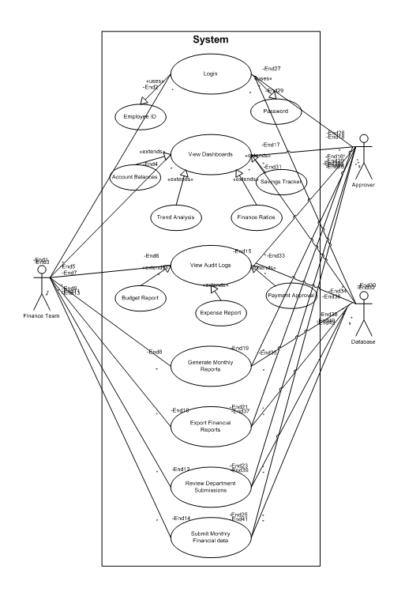

  - ACTIVITY DIAGRAM
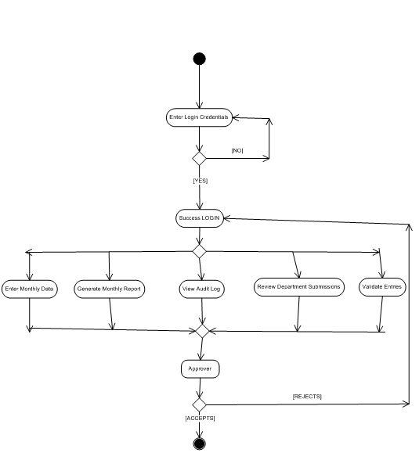

Document 7: Screens and Pages
Tools Used: Axure RP, Balsamiq
- Login Page: Username, Password, Role Selection
- Dashboard: View status of current and past entries, notifications

Given Below are the Login and Dashboard pages of the financial Tracker application:

  - LOGIN PAGE
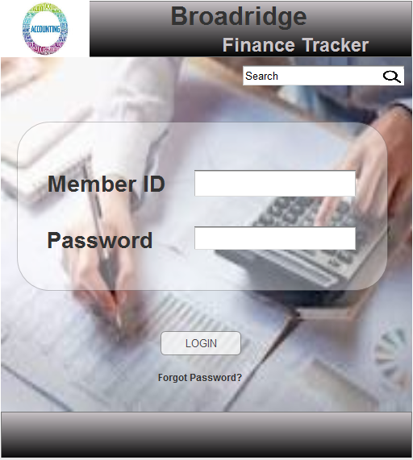

  - DASHBOARD PAGE
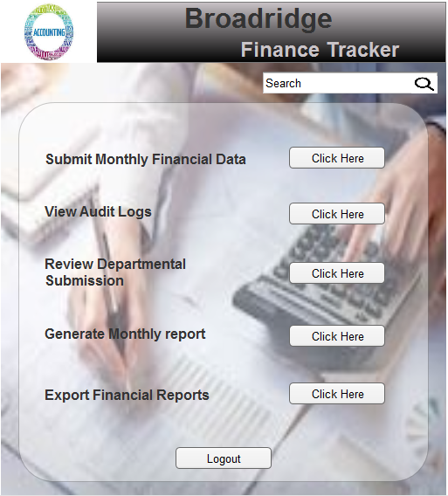

Document 8: Tools – Visio and Axure
Visio: Using Visio, I created flowcharts and system interaction diagrams that helped align the development team on the system logic and approval flows. The clean representation of swimlane diagrams in Visio enabled clear role-based process mapping.
Axure RP was used to design wireframes and interactive prototypes. I used dynamic panels to simulate field-level validations and conditional display messages. These prototypes were shared with stakeholders for early feedback, significantly improving requirement clarity.

Document 9: My Experience as BA in Following Phases
1. Requirement Gathering:
- Used MoSCoW prioritization.
- Addressed client unavailability by identifying alternate stakeholders.
- Applied FURPS to validate completeness.
- Eliminated duplicates and clarified ambiguous items.
- Used low-fidelity prototyping to finalize ambiguous inputs.
2. Requirement Analysis:
- Created use case diagrams, activity flows using UML.
- Reviewed visuals with the team for consensus.
- Created BRS and SRS.
3. Design:
- Prepared and reviewed test cases from use cases.
- Confirmed solution design via client calls.
- Covered edge cases through negative scenarios.
- Maintained and updated RTM throughout.
4. Development:
- Led JAD sessions to clarify requirements.
- Managed team dynamics through 1:1s with hesitant members.
- Supported tech teams with continuous clarifications.
- Documented and recorded all meetings for accountability.
5. Testing:
- Prepared test cases and coordinated test data.
- Performed high-level validation before UAT.
- Managed UAT coordination and defect resolution.
6. Deployment:
- Shared RTM with closure documents.
- Coordinated end-user documentation.
- Planned training sessions and ensured attendance.

