# **Agile document model**

**Document 1: Definition of Done**

As Per Agile Extension to the BABOK® Guide v2, Definition of Done **is a technique where the team agrees on, and prominently displays, a list of criteria which must be met before a backlog item is considered done.**

* That is the team has to create a well-defined, unambiguous, measurable, agreed-upon, and shared Definition of Done between all team members.
* The best form of Definition of Done representation is a checklist of activities that has to demonstrate the agreed value and quality of a user story. So, this checklist should include:
* acceptance criteria (to satisfy customer requirements for a product)
* quality criteria (to satisfy quality requirements for a product)
* *Definition of Done may be defined for different levels of project work*. For example, in Agile / Scrum framework these levels of work could be user story, sprint, and release.

Checklist for DOD:

• Produced code for presumed functionalities

• Assumptions of User Story met

• Project builds without errors

• Unit tests written and passing

• Project deployed on the test environment identical to production platform

• Tests on devices/browsers listed in the project assumptions passed

• Feature ok-ed by UX designer

• QA performed & issues resolved

• Feature is tested against acceptance criteria

• Feature ok-ed by Product Owner

• Refactoring completed

• Any configuration or build changes documented

• Documentation updated

• Peer Code Review performed

Document 2- **Product Vision Document**

| **Scrum Project** | **Lead Management System (LMS) Implementation** | |
| --- | --- | --- |
| **Name** | ABW Digital Marketing Services - LMS | |
| **Venue** | Pune / Virtual Meetings | |
| **Date** | 15 Jan 2019 | |
| **Start Time** | 10:00:00 | |
| **End Time** | 17:00:00 | |
| **Duration** | 2 weeks | |
| **Client** | ABW Digital Marketing Services | |
| **Stakeholder List** | CEO: Rajesh Sharma | |
|  | Marketing Head: Priya Mehta | |
|  | Sales Manager: Amit Verma | |
|  | Finance Team: Neha Iyer | |
|  | IT Department: Vikram Rao | | |
| **Scrum Team** | **Name** | |
| **Scrum Master** | Anjali Deshmukh | |
| **Product Owner** | Shubham Pawar | |
| **Scrum Developer 1** | Sandeep Yadav | |
| **Scrum Developer 2** | Arjun Menon | |
| **Scrum Developer 3** | Rohit Patel | |
| **Scrum Developer 4** | | Kavita Joshi |
| **Scrum Developer 5** | | |  |  | | --- | --- | |  | Manish Gupta | |

| **Target Group** | **Needs** | **Product** | **Value** |
| --- | --- | --- | --- |
| **Digital marketing agencies and businesses** looking for automated lead management.  **Users:** Sales teams, marketing professionals, and business executives. | **Solves inefficiencies** in manual lead tracking and follow-ups.   **Provides AI-powered** assistance for real-time client interactions.   **Automates invoice reminders** to reduce payment delays. | **Lead Management System (LMS)** with AI chatbot, CRM, automated billing, and multilingual support.  **Key Features:** Real-time AI responses, automated workflows, and cloud scalability.  **Feasibility:** Fully scalable with cloud-based architecture. | **Boosts client retention and conversion rates.** **Reduces manual workload** for employees.  **Business Model:** SaaS-based pricing with flexible subscription tiers. |

**Document 3**: **User Stories for ABW Digital Marketing Services - Lead Management System (LMS)**

|  |  |  |  |
| --- | --- | --- | --- |
| **User Story 1** | **Tasks:** Develop AI chatbot for client inquiries | | **Priority:** High |
| **Value Statement:**  As a client,  I want to interact with an AI chatbot,  so that I can get instant responses to my inquiries without waiting for human support | | | |
| **BV:** 200 | | **CP:** 100 | |
| **Acceptance Criteria:**  The AI chatbot should be available 24/7.  It should provide predefined answers based on common inquiries.  It should escalate queries to human agents if not resolved. | | | |

|  |  |  |  |
| --- | --- | --- | --- |
| **User Story 2** | **Tasks:** Integrate CRM for lead tracking | | **Priority:** High |
| **Value Statement:**  As a sales representative,  I want to track leads in a CRM,  so that I can follow up efficiently and increase conversion rates. | | | |
| **BV:** 500 | | **CP:** 40 | |
| **Acceptance Criteria:**  The CRM should capture client details and inquiry history.  It should allow sales representatives to update lead status.  The system should generate reports on lead conversion rates. | | | |

|  |  |  |  |
| --- | --- | --- | --- |
| **User Story 3** | **Tasks:** Implement automated invoice reminders | | **Priority:** High |
| **Value Statement:**  As a finance team member,  I want automated payment reminders,  so that clients are notified about pending invoices without manual follow-ups | | | |
| **BV:** 200 | | **CP:** 40 | |
| **Acceptance Criteria:**  System should send reminders via email/SMS before the due date.  Reminders should be customizable based on client type.  Users should receive a final overdue notification | | | |

|  |  |  |  |
| --- | --- | --- | --- |
| **User Story 4** | **Tasks:** Enable multi-language support | | **Priority:** Medium |
| **Value Statement:**  As a non-English-speaking client  , I want the website to support multiple languages,  so that I can understand and interact with the system easily. | | | |
| **BV:** 100 | | **CP:** 40 | |
| **Acceptance Criteria:**  Users should be able to select a preferred language.  Key pages and chatbot responses should be available in multiple languages.  Language preferences should be saved for returning users. | | | |

|  |  |  |  |
| --- | --- | --- | --- |
| **User Story 5** | **Tasks:** Implement user authentication | | **Priority:** High |
| **Value Statement:**  As a system user,  I want to log in securely  so that I can access my personalized dashboard and services | | | |
| **BV:** 500 | | **CP:** 20 | |
| **Acceptance Criteria:**  Users must log in using a secure authentication method.  Password encryption must be enabled.  Multi-factor authentication should be available. | | | |

|  |  |  |  |
| --- | --- | --- | --- |
| **User Story 6** | **Tasks:** Allow lead import/export functionality | | **Priority:** Medium |
| **Value Statement:**  As a sales executive,  I want to import and export lead data,  so that I can migrate and share data easily | | | |
| **BV:** 100 | | **CP:** 13 | |
| **Acceptance Criteria:**  Users should be able to upload CSV files to import leads.  System should validate data before importing.  Users should be able to export filtered lead data as reports | | | |

|  |  |  |  |
| --- | --- | --- | --- |
| **User Story 7** | **Tasks:** Develop lead scoring system | | **Priority:** High |
| **Value Statement:**  As a sales manager,  I want to prioritize leads based on scores  , so that I can focus on the most valuable prospects | | | |
| **BV:** 200 | | **CP:** 40 | |
| **Acceptance Criteria:**  Leads should be scored based on engagement and conversion likelihood.  High-priority leads should be highlighted in the CRM.  The system should recommend actions based on lead scores. | | | |

|  |  |  |  |
| --- | --- | --- | --- |
| **User Story 8** | **Tasks:** Implement analytics dashboard | | **Priority:** HIgh |
| **Value Statement:**  As a business owner,  I want a dashboard with insights,  so that I can make data-driven decisions. | | | |
| **BV:** 500 | | **CP:** 100 | |
| **Acceptance Criteria:**  Dashboard should display key metrics like lead conversion and revenue trends.  Users should be able to apply filters and view reports.  Data should be updated in real-time. | | | |

|  |  |  |  |
| --- | --- | --- | --- |
| **User Story 9** | **Tasks:** Enable email marketing integration | | **Priority:** Medium |
| **Value Statement:**  As a marketing manager  , I want to send automated emails  , so that I can engage leads efficiently | | | |
| **BV:** 500 | | **CP:** 40 | |
| **Acceptance Criteria:**  System should integrate with email marketing tools like MailChimp.  Users should be able to create email campaigns.  Automated follow-up emails should be triggered based on lead actions. | | | |

|  |  |  |  |
| --- | --- | --- | --- |
| **User Story 10** | **Tasks:** Implement mobile-friendly interface | | **Priority:** High |
| **Value Statement:**  As a client,  I want to access the system on my mobile device,  so that I can manage inquiries on the go | | | |
| **BV:** 200 | | **CP:** 5 | |
| **Acceptance Criteria:**  The system should be fully responsive on mobile devices.  Users should have the same functionalities as on desktop.  Mobile UI should be optimized for speed and usability. | | | |

|  |  |  |  |
| --- | --- | --- | --- |
| **User Story 11** | **Tasks:** Implement customer feedback system | | **Priority:** Medium, |
| **Value Statement:**  As a business owner,  I want to collect customer feedback,  So that I can improve services based on user experiences. | | | |
| **BV:** 50 | | **CP:** 5 | |
| **Acceptance Criteria:**  Clients should be able to leave feedback after interactions.  Feedback should be categorized and stored in the database.  Admin should be able to view and analyze feedback reports. | | | |

|  |  |  |  |
| --- | --- | --- | --- |
| **User Story 12** | **Tasks:** Enable automated report generation | | **Priority:** Medium, |
| **Value Statement:**  As a manager,  I want automated reports,  So that I can track business performance without manual effort. | | | |
| **BV:** 200 | | **CP:** 8 | |
| **Acceptance Criteria:**  Reports should be generated on a scheduled basis.  Users should be able to download reports in PDF/Excel.  Reports should include lead performance, sales data, and customer engagement metrics. | | | |

Document 4: Agile PO Experience

**Product Owner Responsibilities and Learnings from the Project**

**Role of the Product Owner (PO) in a Project:** The Product Owner is responsible for defining the product vision, ensuring it meets market needs, and managing the product backlog to align with business goals. The PO serves as a bridge between stakeholders and the development team.

### **Responsibilities of the Product Owner:**

1. **Market Analysis**
   * Analyzing market needs and demand.
   * Researching similar products available in the market.
2. **Enterprise Analysis**
   * Conducting due diligence on market opportunities.
3. **Product Vision and Roadmap**
   * Defining the product vision based on market and business needs.
   * Developing a product roadmap outlining high-level features and timeline.
4. **Managing Product Features**
   * Balancing stakeholder expectations and prioritizing requirements.
   * Prioritizing epics, user stories, and features based on business value and ROI.
5. **Managing Product Backlog**
   * Prioritizing user stories effectively.
   * Adjusting priorities based on changing stakeholder needs.
   * Planning and maintaining epics.
6. **Managing Overall Iteration Progress**
   * Reviewing sprint progress.
   * Reprioritizing sprints and epics as needed.
   * Conducting sprint retrospectives with the Business Analyst.

### **Learnings from the Project:**

Through this project, I have gained experience in managing various Agile meetings and backlog refinement. Below are the key takeaways:

1. **Handling Sprint Meetings:**
   * **Sprint Planning Meeting** – Defining sprint goals and backlog items.
   * **Daily Scrum Meeting** – Discussing progress, blockers, and plans.
   * **Sprint Review Meeting** – Showcasing completed work to stakeholders.
   * **Sprint Retrospective Meeting** – Identifying areas for improvement.
   * **Backlog Refinement Meeting** – Continuously updating and prioritizing backlog items.
2. **Creating User Stories:**
   * User stories should include:
     + Story number
     + Tasks
     + Priority
     + Acceptance criteria
     + Business Value (BV) & Complexity Points (CP)

### **Role of the Product Owner in Scrum:**

In Scrum, the Product Owner acts as a **liaison between stakeholders and the development team**. The PO ensures that all areas of the business stay informed about the project's progress and collaborates closely with the Scrum team to refine backlog items and deliver a valuable product.

The Product Owner defines the **product vision and key features**, then breaks them down into product backlog items for iterative development within Agile sprints. This ensures that the product evolves according to user needs and business priorities.

Document 5: Product and sprint backlog and product and sprint burndown charts Product backlog:

Product backlog:

| **User Story ID** | **User Story** | **Task** | **Priority** | **BV** | **CP** | **Sprint** |
| --- | --- | --- | --- | --- | --- | --- |
| **US001** | AI Chatbot for Client Inquiries | Develop AI chatbot | High | 200 | 100 | Sprint 1 |
| **US002** | CRM Lead Tracking Integration | Set up CRM, connect with database | High | 500 | 40 | Sprint 1 |
| **US003** | Automated Invoice Reminders | Implement email notifications for payments | High | 200 | 40 | Sprint 2 |
| **US004** | Multi-Language Support | Add language options, test translations | Medium | 100 | 40 | Sprint 2 |
| **US005** | User Authentication System | Implement login, encrypt passwords | High | 500 | 20 | Sprint 1 |
| **US006** | Lead Import/Export Functionality | CSV upload/download, validation | Medium | 100 | 13 | Sprint 3 |
| **US007** | Lead Scoring System | Develop scoring model, implement UI | Medium | 200 | 40 | Sprint 3 |
| **US008** | Analytics Dashboard | Display reports, implement filters | High | 500 | 100 | Sprint 4 |
| **US009** | Email Marketing Integration | Connect MailChimp API, create templates | Medium | 500 | 40 | Sprint 4 |
| **US010** | Mobile-Friendly Interface | Optimize UI for mobile devices | High | 200 | 13 | Sprint 5 |
| **US011** | Customer Feedback System | Implement rating & review system | Medium | 50 | 13 | Sprint 5 |
| **US012** | Automated Report Generation | Schedule and export reports | Medium | 200 | 20 | Sprint 6 |

Sprint backlog:

| **User Story ID** | **User Story** | **Tasks** | **Owner** | **Status** | **Estimated Effort** |
| --- | --- | --- | --- | --- | --- |
| **US001** | AI Chatbot for Client Inquiries | Develop AI chatbot | Developer 1 | In Progress | 10 days |
| **US002** | CRM Lead Tracking Integration | Set up CRM, connect with database | Developer 2 | To Do | 8 days |
| **US003** | Automated Invoice Reminders | Implement email notifications for payments | Developer 3 | In Progress | 6 days |
| **US004** | Multi-Language Support | Add language options, test translations | Developer 4 | To Do | 7 days |
| **US005** | User Authentication System | Implement login, encrypt passwords | Developer 1 | In Progress | 9 days |
| **US006** | Lead Import/Export Functionality | CSV upload/download, validation | Developer 2 | To Do | 5 days |
| **US007** | Lead Scoring System | Develop scoring model, implement UI | Developer 3 | In Progress | 8 days |
| **US008** | Analytics Dashboard | Display reports, implement filters | Developer 4 | To Do | 10 days |
| **US009** | Email Marketing Integration | Connect MailChimp API, create templates | Developer 5 | In Progress | 7 days |
| **US010** | Mobile-Friendly Interface | Optimize UI for mobile devices | Developer 1 | To Do | 6 days |
| **US011** | Customer Feedback System | Implement rating & review system | Developer 2 | In Progress | 5 days |
| **US012** | Automated Report Generation | Schedule and export reports | Developer 3 | To Do | 6 days |

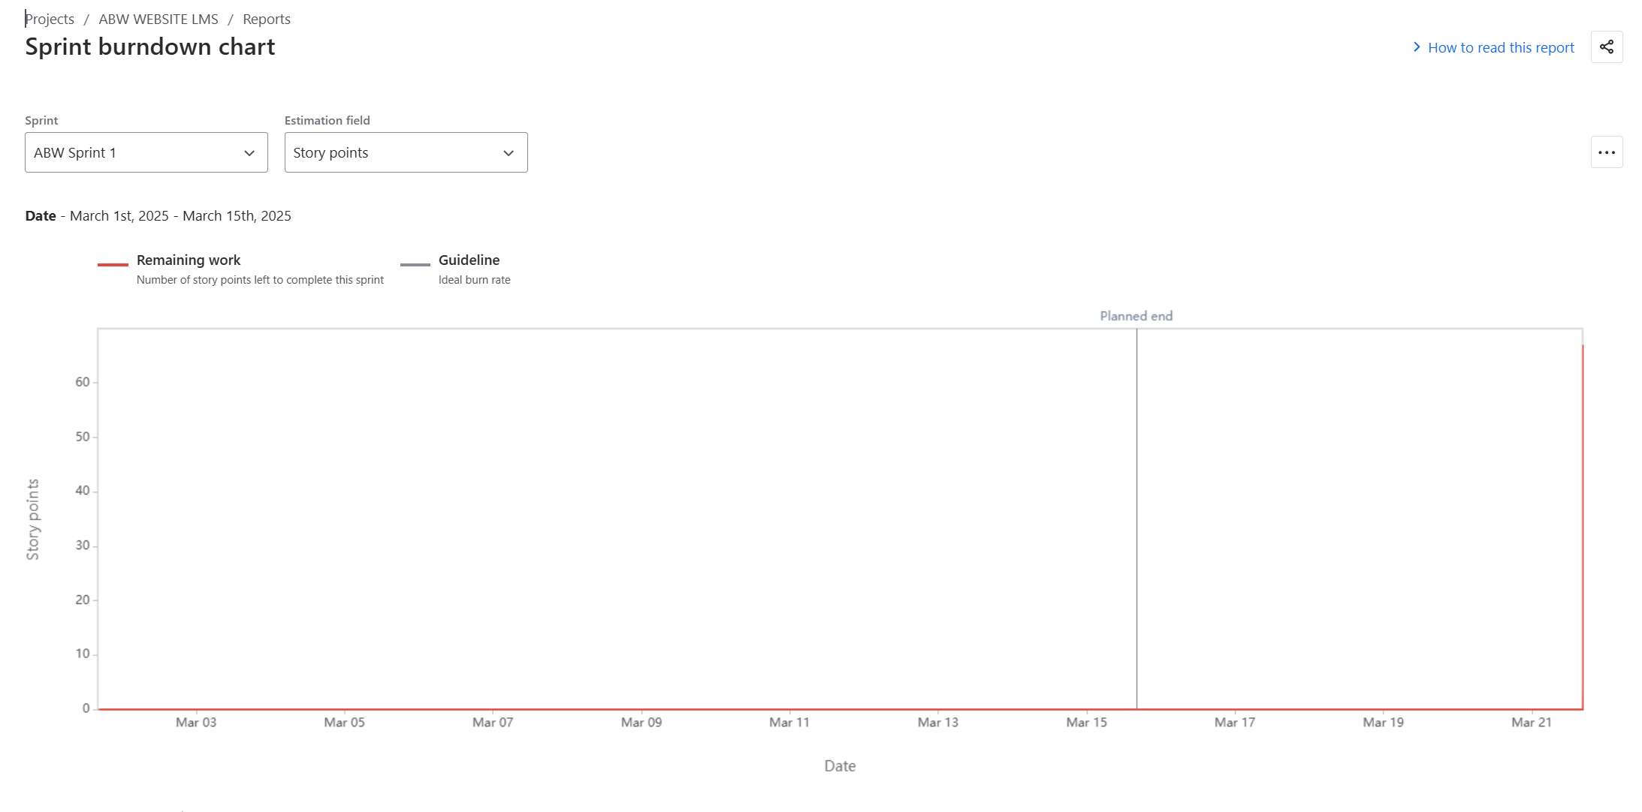 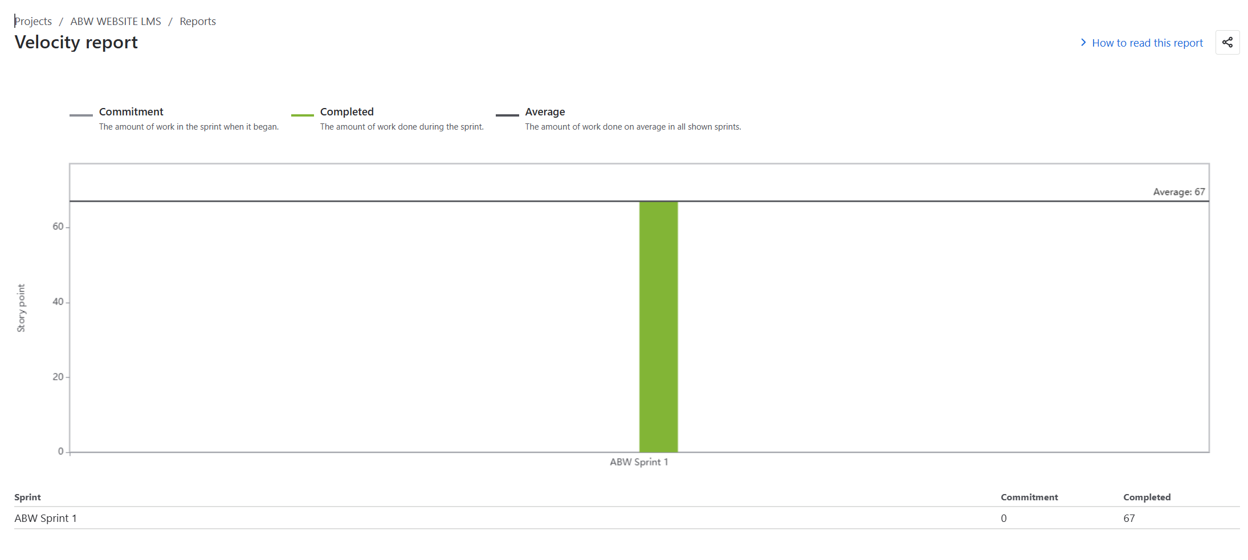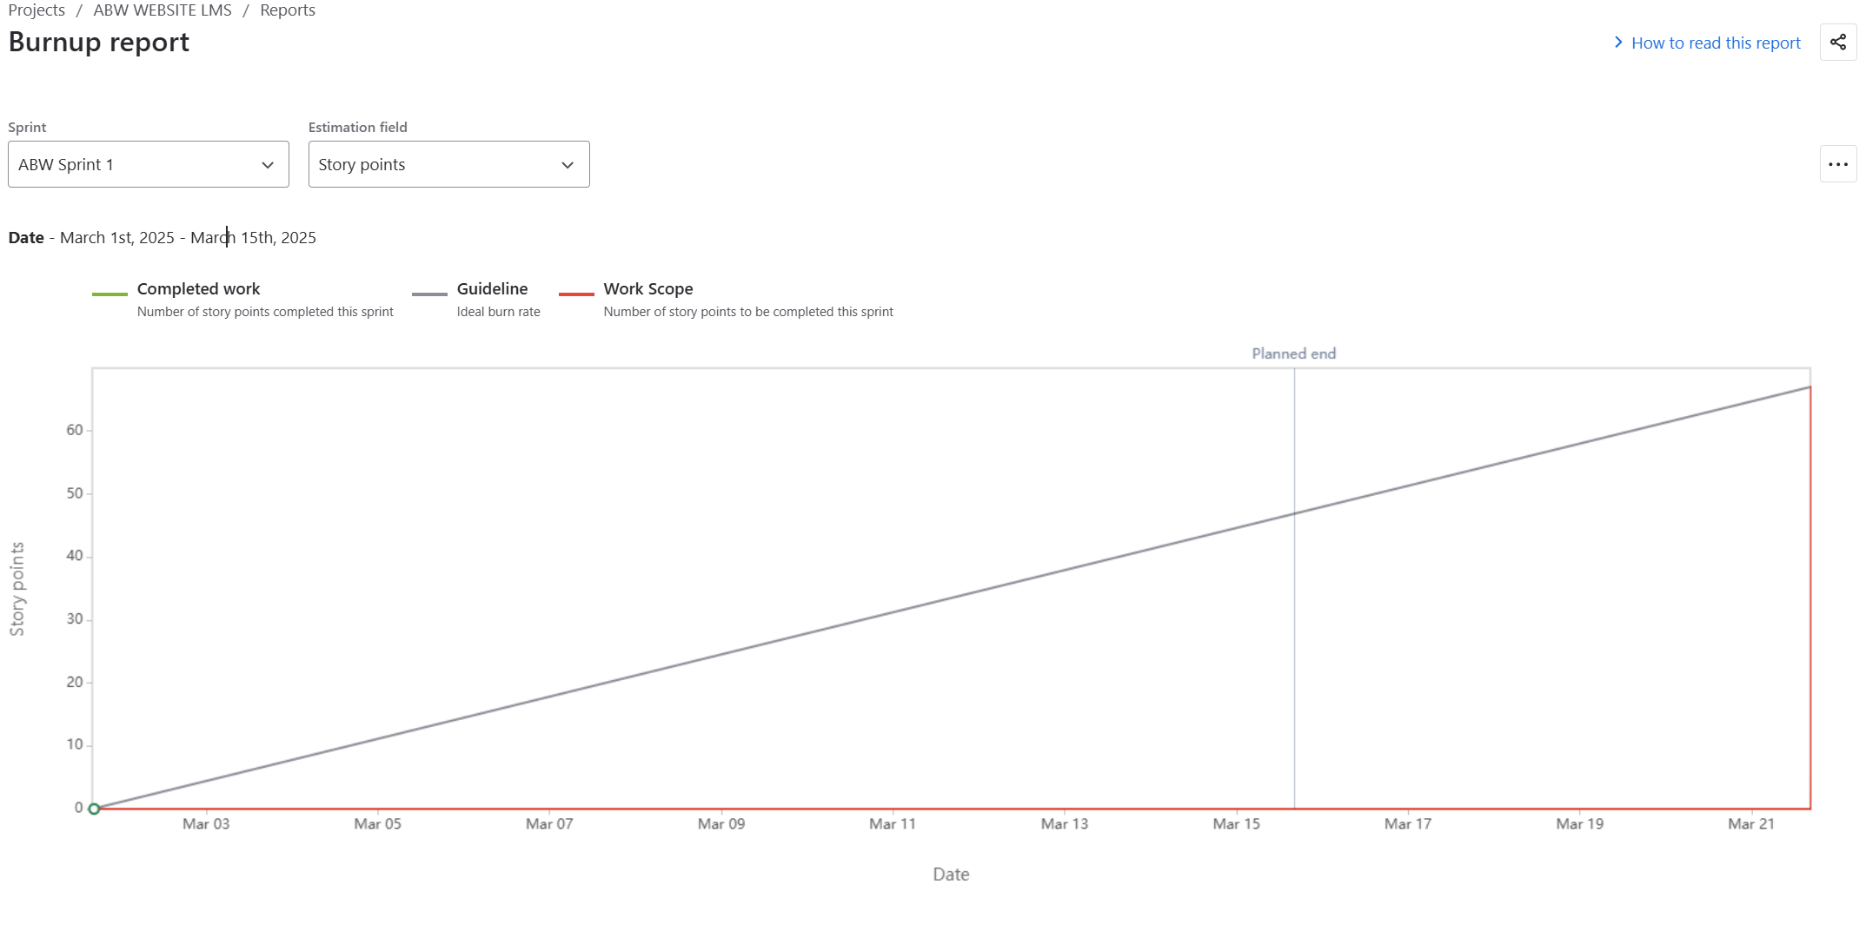

### **Sprint Planning Meeting**

| **Field** | **Details** |
| --- | --- |
| **Date** | 10-03-2025 |
| **Time** | 10:00 AM - 12:00 PM |
| **Location** | ABW Headquarters / Zoom Meeting |
| **Prepared By** | Scrum Master - Rakesh Nair |
| **Attendees** | Product Owner, Scrum Master, Development Team, QA Team |
| **Agenda Topics** | Define sprint goals, refine backlog, assign tasks, estimate efforts |
| **Topic Presenter** | Product Owner - Anjali Deshmukh |
| **Time Allotted** | 2 Hours |
| **Other Information** | The sprint backlog will focus on CRM integration, AI chatbot improvements, and invoice automation. |
| **Observers** | Rajesh Sharma (CEO), Priya Mehta (Marketing Head) |
| **Resources** | Jira, Confluence, Sprint Backlog, Notion |
| **Special Notes** | Ensure all dependencies are identified before the sprint starts. |

### **Sprint Review Meeting**

| **Field** | **Details** |
| --- | --- |
| **Date** | 24-03-2025 |
| **Time** | 3:00 PM - 4:30 PM |
| **Location** | ABW Headquarters / Microsoft Teams |
| **Prepared By** | Scrum Master - Rakesh Nair |
| **Attendees** | Product Owner, Scrum Team, QA Team, Stakeholders |
| **Sprint Status** | 85% of planned tasks completed, 2 features moved to next sprint |
| **Things to Demo** | AI chatbot improvements, CRM dashboard, automated invoice reminders |
| **Quick Updates** | Minor UI fixes pending, chatbot logic updated, security enhancements added |
| **What’s Next** | Next sprint to focus on multi-language support, performance optimizations |

### **Sprint Retrospective Meeting**

| **Field** | **Details** |
| --- | --- |
| **Date** | 25-03-2025 |
| **Time** | 2:00 PM - 3:00 PM |
| **Location** | ABW Headquarters / Google Meet |
| **Prepared By** | Scrum Master - Rakesh Nair |
| **Attendees** | Development Team, QA, Product Owner |
| **Agenda** | Review sprint performance, discuss improvements |
| **What Went Well** | AI chatbot logic was completed ahead of schedule, CRM integration successful |
| **What Didn’t Go Well** | Delayed UI testing, unclear API documentation caused integration issues |
| **Questions** | How to improve testing speed? How to avoid last-minute changes? |
| **Reference** | Jira Sprint Report, Developer Feedback Notes |

### **Daily Stand-up Meeting (Week 1 Example: 1-03-2025 to 15-03-2025)**

| **DAY** | **Developer 1 (Sandeep Yadav)** | **Developer 2 (Arjun Menon)** | **Developer 3 (Rohit Patel)** |
| --- | --- | --- | --- |
| **Monday** | Completed chatbot login feature | Fixed CRM bug | Worked on invoice automation |
| **Tuesday** | Implemented chatbot NLP training | Designed CRM UI | Updated payment logic |
| **Wednesday** | Integrated chatbot with backend | Connected CRM database | Validated invoice notifications |
| **Thursday** | Optimized chatbot responses | Conducted CRM testing | Debugged API issues |
| **Friday** | Deployed chatbot update | Fixed UI inconsistencies | Improved invoice reminders UI |
| **Saturday** | Sprint review preparation | Updated API docs | Conducted system testing |
| **Sunday** | No work (weekend) | No work (weekend) | No work (weekend) |

| **Question** | **Developer 1 (Sandeep Yadav)** | **Developer 2 (Arjun Menon)** | **Developer 3 (Rohit Patel)** |
| --- | --- | --- | --- |
| **What will you do today?** | Start chatbot regression testing | Finalize CRM UI | Run performance tests |
| **What (if any) is blocking your progress?** | API response delays | Incomplete test data | Need final approval on invoice layout |