**Waterfall Project2 – Part -2/2**

**Question 1 Document 6**

Please prepare a use case diagram, activity diagram and a use case specification document.

**Answer**

*Use case diagram*

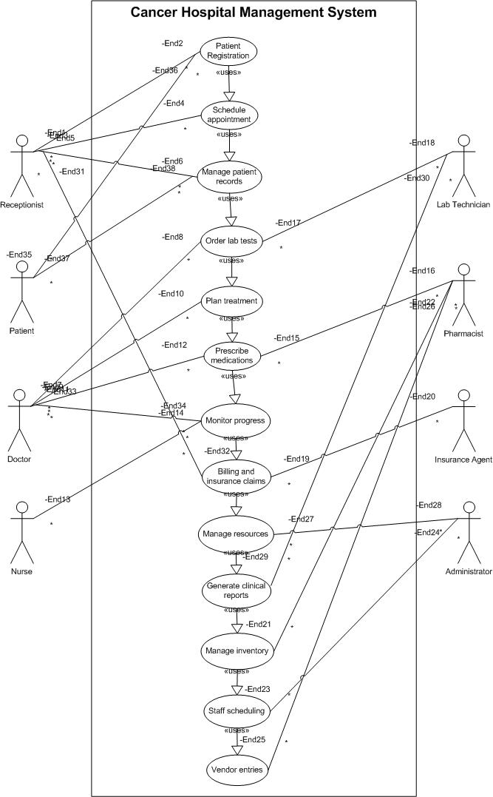

*Activity Diagram*

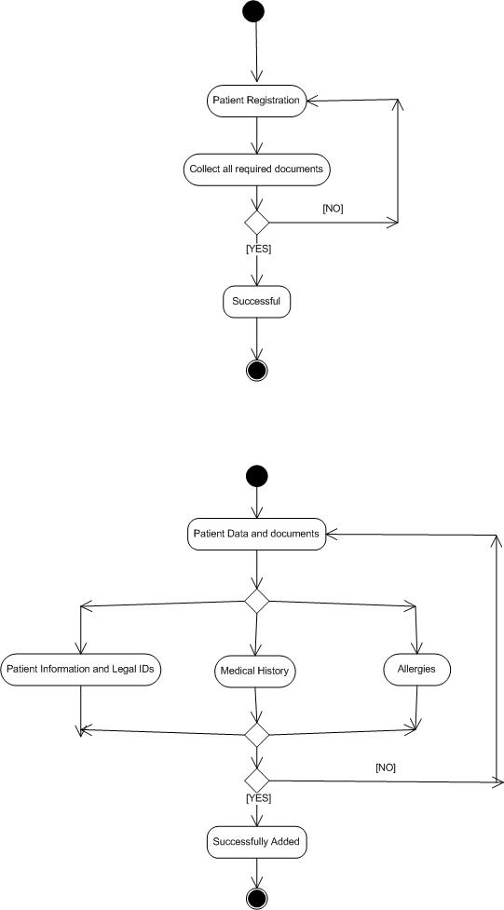

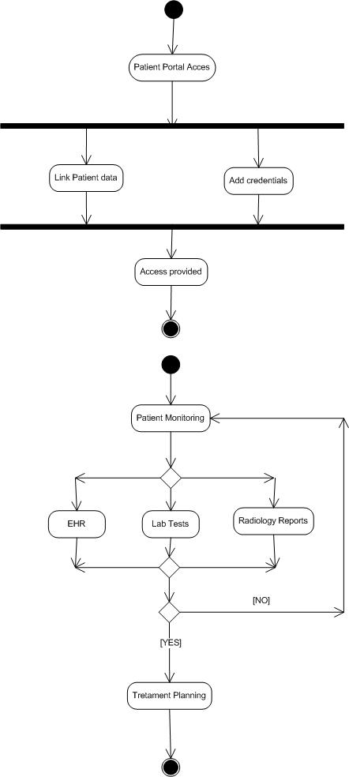

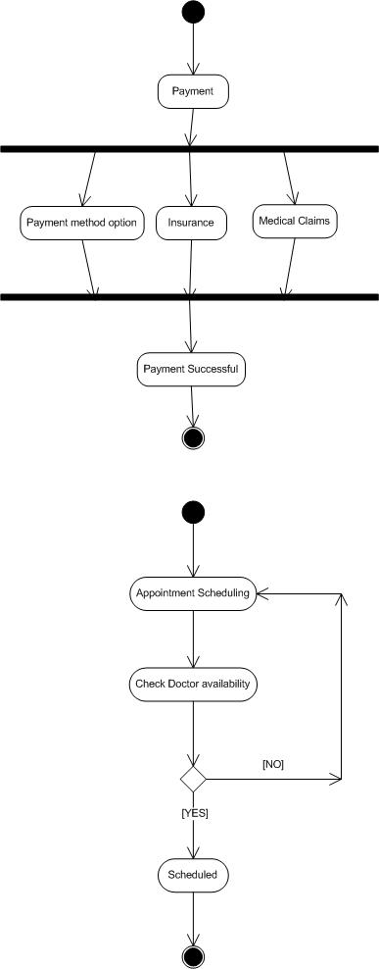

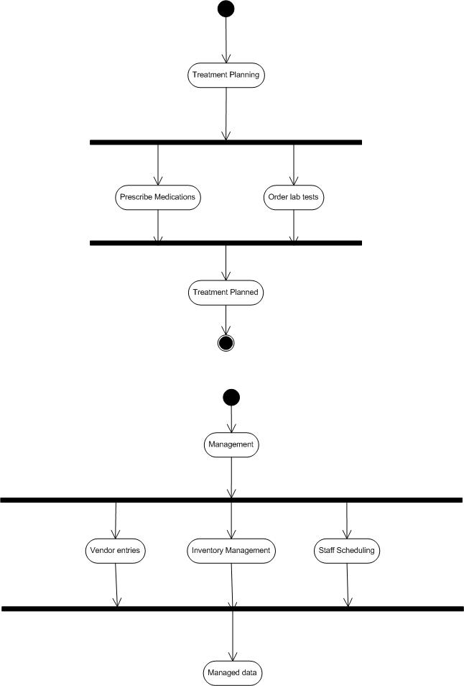

*Use Case Specification*

***Use Case Specification: Patient Registration***

1. Use Case Name

Patient Registration

2. Use Case Description

This use case describes the process of registering a new patient in the cancer hospital management system, capturing essential patient information, medical history, and initializing patient records.

3. Actors

*Primary Actor*: Registration Staff

*Secondary Actors*: Patient, Insurance Verification System

4. Basic Flow

1. Registration staff initiates new patient registration

2. System displays registration form

3. Staff enters patient’s personal information (name, DOB, contact details, ID)

4. Staff enters patient’s insurance information

5. System validates insurance details with Insurance Verification System

6. Staff assigns unique patient ID

7. Staff records reason for visit and referring physician

8. System creates patient record

9. System generates registration confirmation

10. Staff provides patient with registration confirmation

5. Alternate Flow

*Returning Patient*

1. Staff searches for existing patient record

2. System displays patient record

3. Staff verifies and updates patient information

4. System saves updated information

*Emergency Registration*

1. Staff selects emergency registration option

2. System displays abbreviated registration form

3. Staff enters minimal patient information

4. System creates temporary patient record

5. Full registration completed after emergency treatment

6. Exceptional Flows

*System Failure*

1. System fails during registration

2. Staff records patient information on paper form

3. Staff enters information when system is restored

*Insurance Verification Failure*

1. Insurance verification fails

2. Staff notifies patient

3. Staff records patient as self-pay or reschedules after insurance issues resolved

7. Pre-Conditions

- Registration staff is logged into the system

- System is operational

- Insurance Verification System is accessible

8. Post-Conditions

- Patient record is created in the system

- Patient is assigned a unique ID

- Patient appears in the hospital database

- Registration confirmation is generated

9. Assumptions

- Registration staff is trained on the system

- Patients provide accurate information

- Basic hospital infrastructure is functional

- Patients have valid identification

10. Constraints

- Privacy regulations (HIPAA) must be followed

- System must handle high volume during peak hours

- Registration process must be completed within 15 minutes

- System must be available 24/7

11. Dependencies

- Insurance Verification System

- Electronic Health Record (HER) System

- Hospital Database System

- Patient Identification System

12. Inputs and Outputs

*Inputs*:

- Patient personal information

- Insurance details

- Medical history summary

- Reason for visit

- Referring physician information

*Outputs*:

- Unique patient ID

- Registration confirmation

- Patient record in database

- Initial appointment schedule

13. Business Rules

- All cancer patients must be assigned an oncology case manager

- Insurance verification is mandatory except in emergency cases

- Patient consent forms must be completed before treatment

- Returning patients must verify information every 6 months

- Priority registration for acute cases

- Patient data must be backed up in real-time

14. Miscellaneous Information

- Integration with national cancer registry for reporting

- System should support multiple languages for diverse patient population

- Mobile registration capability for outreach programs

- Patient portal access should be created during registration process

***Use Case Specification: Treatment Plan***

1. Use Case Name

Manage Patient Treatment Plan

2. Use Case Description

This use case enables oncologists to create, view, update, and track standardized treatment plans for cancer patients based on diagnosis, staging, and patient-specific factors.

3. Actors

Primary Actors: Oncologist and Nurse

Secondary Actors: Patient, Pharmacist, Radiologist, and Lab Technician

4. Basic Flow

1. Oncologist selects patient record

2. System displays patient’s medical history and diagnosis

3. Oncologist creates new treatment plan

4. Oncologist selects treatment protocols based on cancer type/stage

5. System validates treatment protocols for conflicts/contraindications

6. Oncologist finalizes and saves treatment plan

7. System notifies relevant departments (pharmacy, radiology, nursing)

5. Alternate Flow

*5.1 Modify Existing Plan*

- Oncologist selects existing treatment plan

- Oncologist modifies treatment parameters

- System validates changes

- Oncologist saves updated plan

- System notifies relevant departments

*5.2 Treatment Plan Templates*

- Oncologist selects from pre-defined treatment templates

- Oncologist customizes template for patient

- Flow continues

6. Exceptional Flows

*6.1 Treatment Conflict Detected*

- System identifies contraindication or drug interaction

- System displays warning with details

- Oncologist reviews and adjusts plan or provides override reason

- Flow continues at step 5

*6.2 Emergency Treatment Modification*

- Nurse reports severe patient reaction

- Oncologist immediately modifies treatment plan

- System fast-tracks approval and notification

- Flow continues at step 7

7. Pre-Conditions

1. Patient is registered in the system

2. Patient has confirmed cancer diagnosis with staging

3. Oncologist has system access with appropriate permissions

4. Required lab results and imaging are available

8. Post-Conditions

1. Treatment plan is stored in patient’s electronic record

2. Relevant departments receive treatment orders

3. Treatment schedule is generated

4. System tracks treatment plan compliance and progress

9. Assumptions

1. Hospital has standard treatment protocols for common cancer types

2. Electronic health record system is operational

3. Departments have access to the system to receive notifications

4. Oncologists are trained on the system

10. Constraints

1. System must comply with healthcare data privacy regulations

2. Treatment plans must adhere to hospital protocols and guidelines

3. System must be available 24/7 with minimal downtime

4. Response time for treatment plan validation < 5 seconds

11. Dependencies

1. Patient Registration System

2. Laboratory Information System

3. Pharmacy Management System

4. Medical Imaging System

5. Electronic Health Record System

12. Inputs and Outputs

*Inputs*

- Patient demographics and medical history

- Diagnosis and cancer staging information

- Laboratory results

- Imaging reports

- Medication history and allergies

*Outputs*

- Comprehensive treatment plan

- Medication orders

- Radiation therapy schedule

- Lab test orders

- Treatment timeline and milestones

- Patient educational materials

13. Business Rules

1. Treatment plans must be authorized by board-certified oncologists

2. High-risk treatments require secondary physician approval

3. Treatment modifications must be documented with rationale

4. System must enforce medication dosing limits based on patient parameters

5. Treatment plans must include at least one follow-up appointment

14. Miscellaneous Information

1. Future integration with clinical decision support systems planned

2. Mobile access for oncologists required for emergency modifications

3. System should support export of anonymized treatment data for research

4. Audit trail of all treatment plan changes must be maintained

***Use Case Specification: Appointment Scheduling***

1. Use Case Name

Patient Appointment Scheduling

2. Use Case Description

This use case defines the process of scheduling, rescheduling, and cancelling appointments for patients in a cancer hospital management system. It covers the complete appointment lifecycle from initial request through confirmation, including management of conflicts, special requirements, and priority cases.

3. Actors

*Primary Actors:* Reception Staff, Medical Secretary, Scheduling Coordinator, Doctors/Specialists

*Secondary Actors:* Patients, Patient’s Family/Caregivers*,* Diagnostic Department Personnel*,* and Laboratory Staff

4. Basic Flow

1. Staff logs into system and selects “Appointment Scheduling”

2. Staff searches for patient by ID/name

3. System displays patient information and history

4. Staff selects appointment type

5. System displays available slots based on specialist/equipment availability and treatment protocol

6. Staff selects time slot and enters appointment details

7. System validates appointment and generates confirmation

8. System sends notification to patient and updates calendars

5. Alternate Flows

*5.1 Reschedule Appointment*

1. Staff locates appointment and selects “Reschedule”

2. Staff selects new time from available slots

3. System validates, notifies patient, and updates calendars

*5.2 Emergency/Priority Appointment*

1. Staff marks appointment as “Priority/Emergency”

2. System applies special rules and suggests possible schedule adjustments

3. Staff confirms priority booking and system expedites notifications

6. Exceptional Flows

*6.1 System Failure*

1. Staff records details manually and notifies IT

2. Staff enters appointments once system is restored

7. Pre-Conditions

1. User is authenticated with appropriate scheduling privileges

2. Patient is registered in the system

3. Required medical staff profiles are updated with availability

8. Post-Conditions

1. Appointment is recorded in the system

2. Patient receives confirmation notification

3. Medical staff calendars are updated

4. Required resources (rooms, equipment) are reserved

9. Assumptions

1. All users have been trained on the appointment scheduling module

2. The system has updated information on staff availability

3. Patients have provided current contact information

10. Constraints

1. Appointments can only be scheduled during hospital operating hours

2. Certain specialists are available only on specific days

3. Some equipment requires maintenance periods that block scheduling

4. Emergency appointments may disrupt regular scheduling

11. Dependencies

1. Patient Registration module

2. Staff Management module

3. Medical Resource Management module

12. Inputs and Outputs

*Inputs*

1. Patient identification information

2. Appointment type and purpose

3. Preferred date/time ranges

*Outputs*

1. Confirmed appointment record in system

2. Appointment confirmation notification for patient

3. Updated calendars for medical staff

13. Business Rules

1. Oncologists must have at least 30 minutes allocated per new patient consultation

2. Radiation therapy appointments require equipment preparation time of 15 minutes before patient arrival

3. Follow-up appointments must be scheduled according to treatment protocol timelines

4. Patients with acute symptoms must be scheduled within 24 hours

14. Miscellaneous Information

1. Future system enhancements will include patient self-scheduling via portal

2. Integration with transportation services for patients requiring assistance is planned

3. Automated waitlist management will be implemented in future releases

4. Mobile notifications and reminders are planned for phase 2 implementation

***Use Case Specification: Laboratory Test Management***

1. Use Case Name

Laboratory Test Management

2. Use Case Description

This use case describes the process of ordering, conducting, reporting, and tracking laboratory tests for cancer patients within the hospital management system.

3. Actors

*Primary Actors*: Physicians, Laboratory Technicians, and Pathologists

*Secondary Actors*: Patients, Nurses, and Medical Records Staff

4. Basic Flow

1. Physician creates a laboratory test order in the system

2. System validates order and sends notification to laboratory

3. Lab technician receives and schedules the test

4. Patient sample is collected and labelled with barcode

5. Lab technician processes the sample and records results

6. Pathologist reviews and approves results

7. System notifies physician of completed test results

8. Physician reviews results and adds them to patient’s record

5. Alternate Flow

*5.1 Sample Retest Required*

- Lab technician marks test for retest

- System flags the test and notifies relevant staff

- New sample is collected or existing sample is reprocessed

- Process continues from Basic Flow step 5

*5.2 Urgent Test Request*

- Physician marks test as urgent

- System prioritizes the test in laboratory queue

- Lab staff receives immediate notification

- Process follows expedited timeline

6. Exceptional Flows

*6.1 Sample Contamination/Degradation*

- Lab technician records sample as compromised

- System notifies physician and generates new test request

- Patient is scheduled for new sample collection

*6.2 System Failure During Testing*

- System provides mechanism for manual recording of results

- IT support is notified of the failure

- Data is synchronized when system is restored

7. Pre-Conditions

- Patient must be registered in the system

- Ordering physician must have appropriate system privileges

- Test types must be configured in the system catalog

- Laboratory equipment must be integrated with the system

8. Post-Conditions

- Complete test results are stored in patient’s electronic record

- Test charges are forwarded to billing system

- Test data is available for analytics and reporting

- Physician is notified of abnormal results

9. Assumptions

- Laboratory equipment interfaces with the hospital system

- Sufficient laboratory supplies are available

- Trained staff is available to perform tests

- Barcode/identification system is operational

10. Constraints

- System must comply with healthcare data regulations (HIPAA)

- Test turnaround time must meet clinical guidelines

- System must handle peak loads during high-volume periods

- Results must be secure and accessible only to authorized staff

11. Dependencies

- Patient Registration System

- Electronic Medical Records System

- Billing System

- Notification System

- Equipment Interfacing System

12. Inputs and Outputs

*Inputs*

- Patient identification

- Physician order details

- Test type selection

- Sample information

- Clinical notes and patient history

*Outputs*

- Test results with normal ranges

- Pathology interpretations

- Historical test comparisons

- Statistical reports

- Billing information

13. Business Rules

- Only authorized personnel can order specific tests

- Critical results must be reported immediately (within 60 minutes)

- All tests require pathologist verification before release

- Test order cancellation requires documentation

- Samples must be processed within timeframe appropriate for test type

14. Miscellaneous Information

- System should support batch processing for routine tests

- Mobile notifications for critical results

- Integration with cancer research databases for anonymized data sharing

- Support for image attachment for relevant test results

***Use case Specification: Patient Records Management***

1. Use Case Name

Patient Record Management

2. Use Case Description

This use case describes the process of creating, updating, retrieving, and managing patient medical records in a cancer hospital management system. It includes recording patient demographics, medical history, diagnosis, treatment plans, test results, and follow-up appointments.

3. Actors

*Primary Actors*: Physicians, Nurses, Medical Staff, Receptionist

*Secondary Actors*: Patients, Laboratory Technicians, Billing Department

4. Basic Flow

1. Medical staff logs into the system using secure credentials

2. Staff searches for existing patient or creates new patient record

3. System displays patient information dashboard

4. Staff enters/updates patient information

5. Staff saves the patient record

6. System validates and stores information

7. Staff can generate reports or print patient information

5. Alternate Flow

*5.1 Retrieve Existing Patient Record*:

- Staff enters patient ID or searches by name/contact information

- System retrieves and displays patient record

- Staff views or updates information as needed

*5.2 Transfer Patient Record*:

- Staff initiates record transfer to another department

- Staff selects target department/specialist

- System transfers record and notifies receiving department

6. Exceptional Flows

*6.1 System Unavailable*:

- If system is down, staff uses paper forms

- Records are entered into system when available

- System flags records for reconciliation

*6.2 Duplicate Patient Record*:

- System detects potential duplicate based on identifiers

- Staff reviews both records

- Staff merges record or confirms as separate patients

7. Pre-Conditions

- User must be authenticated with appropriate access rights

- System must be operational

- Network connectivity must be available

8. Post-Conditions

- Patient record is created/updated in database

- Audit trail of changes is logged

- Notifications are sent to relevant departments if needed

9. Assumptions

- Staff has basic computer literacy

- Hospital has consistent network access

- Data backup processes are in place

- Staff has received system training

10. Constraints

- System must comply with healthcare data regulations (HIPAA, etc.)

- Response time for record retrieval must be under 3 seconds

- System must support concurrent users

- Patient data must be encrypted

11. Dependencies

- Integration with laboratory information system

- Integration with pharmacy management system

- Integration with billing system

- Authentication system

12. Inputs and Outputs

*Inputs*:

- Patient demographic information

- Medical history

- Diagnostic information

- Treatment plans

- Test results

- Medications

- Follow-up appointments

*Outputs*:

- Complete patient record

- Patient summary reports

- Treatment history

- Test result reports

- Appointment schedules

13. Business Rules

- Only authorized personnel can access patient records

- Critical test results must trigger immediate notifications

- Record changes must be tracked with user ID and timestamp

- Discharge summaries must be completed within 24 hours

- Patient records must be retained for minimum 10 years

14. Miscellaneous Information

- System should provide templates for common cancer types

- Mobile access capabilities for physicians on rounds

- Batch processing for lab results import

- Support for document scanning and attachment

***Use Case Specification: Billing and Insurance***

1. Use Case Name

Patient Billing and Insurance Claim Processing

2. Use Case Description

This use case describes the process of generating patient bills, verifying insurance coverage, submitting insurance claims, and processing payments in a cancer hospital management system.

3. Actors

*Primary Actors*: Billing Staff, Finance Manager

*Secondary Actors*: Patient, Insurance Provider, Hospital Administrator

4. Basic Flow

1. Billing staff verifies patient's insurance information

2. System retrieves treatment details from patient records

3. System generates itemized bill based on treatment codes

4. Billing staff submits claim to insurance provider

5. System tracks claim status

6. Insurance provider processes claim and sends payment details

7. System updates patient account with payment information

8. System generates patient statement for remaining balance

9. Patient makes payment for remaining balance

10. System records transaction and closes billing cycle

5. Alternate Flow

*5.1 Self-Pay Patients*:

1. System identifies patient as self-pay

2. System applies any applicable discount policies

3. System generates complete bill for patient

4. Patient makes payment arrangements

5. System tracks payment plan compliance

*5.2 Secondary Insurance Processing*:

1. After primary insurance processes claim

2. System generates claim for secondary insurance

3. Process continues until all insurance options exhausted

6. Exceptional Flows

*6.1 Insurance Claim Denial*:

1. System receives claim denial notification

2. Billing staff reviews denial reason

3. System flags account for follow-up

4. Billing staff appeals or corrects claim

5. Revised claim submitted to insurance

*6.2 Payment Default*:

1. System detects overdue payment

2. System generates automated reminder

3. Billing staff contacts patient for payment resolution

4. If unresolved, account flagged for collections process

7. Pre-Conditions

- Patient must be registered in the system

- Treatment/service details must be documented with proper medical codes

- Valid insurance information must be on file

- Treatment authorization obtained where required

8. Post-Conditions

- Complete billing record created in system

- Insurance claims processed and tracked

- Patient financial responsibility determined

- Payment records updated

- Financial reports reflect transaction

9. Assumptions

- Electronic data interchange (EDI) with insurance providers is available

- Billing codes are standardized and up-to-date

- Staff has appropriate system access rights

- Insurance verification can be performed in real-time

10. Constraints

- System must comply with HIPAA regulations

- Insurance claim formats must meet industry standards

- Financial data security protocols must be enforced

- System uptime must be maintained for critical billing functions

11. Dependencies

- Patient Registration System

- Electronic Medical Records (EMR) System

- Treatment Documentation System

- Payment Processing System

- Reporting System

12. Inputs and Outputs

*Inputs:*

- Patient demographic data

- Insurance policy information

- Treatment/procedure codes

- Service dates and provider information

- Payment information

*Outputs*:

- Insurance claims

- Patient bills/statements

- Payment receipts

- Account status reports

- Financial summaries

13. Business Rules

- Insurance verification required before non-emergency treatment

- Claims must be submitted within contract-specified timeframes

- Patient statements generated on 30-day cycle

- Payment plans available for balances exceeding $500

- Financial assistance evaluation required for self-pay patients

- Claim appeals must be filed within 60 days of denial

14. Miscellaneous Information

- System should support automatic code validation to reduce claim errors

- Dashboard metrics should track claim success rates and payment cycles

- Integration with cancer-specific billing codes and treatment protocols

- Support for clinical trial billing segregation

**Question 2 Document 7**

Screens and pages

**Answer**

Home Page

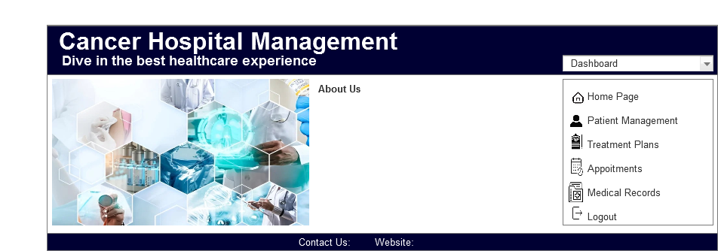

Facilities



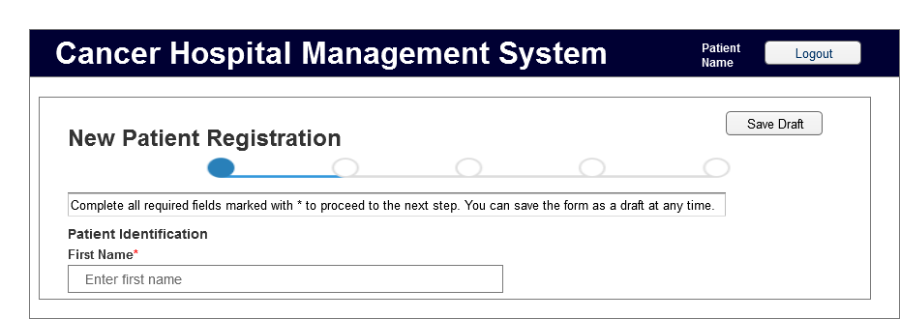Patient Registration

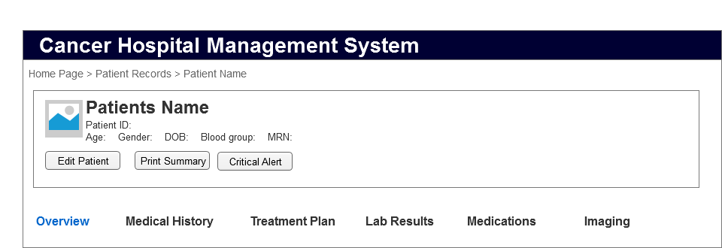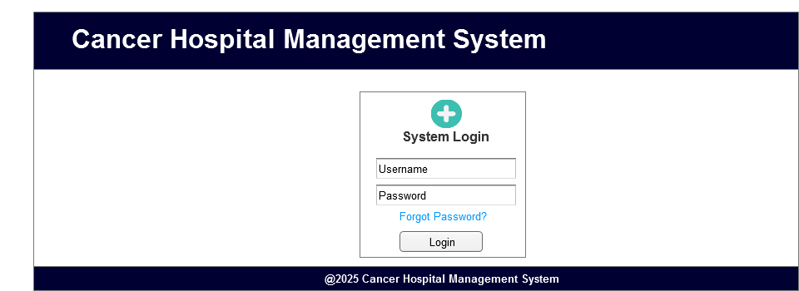Patient Records

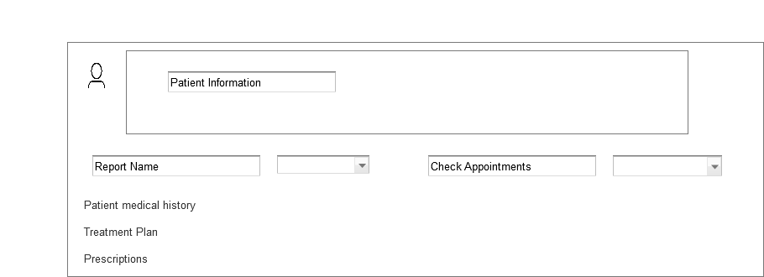System Login

Patient Portal

Insurance

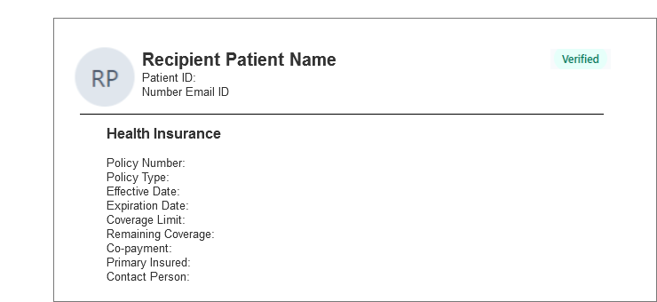

Lab Results

Medical Prescription

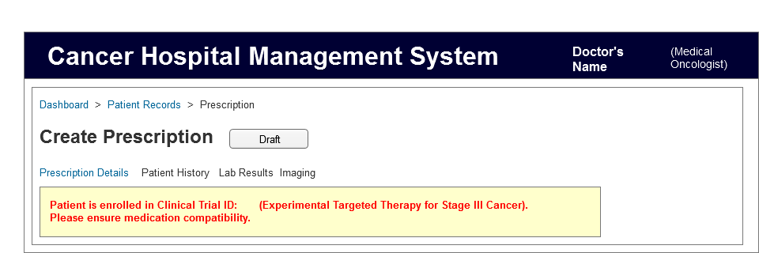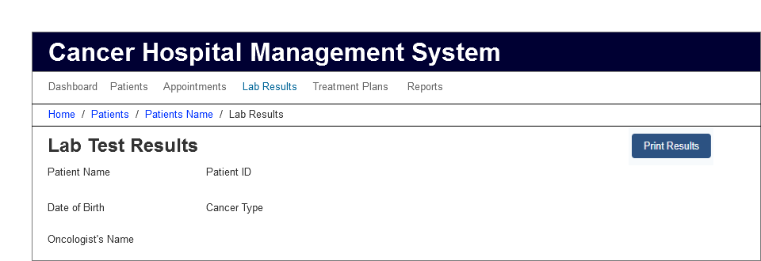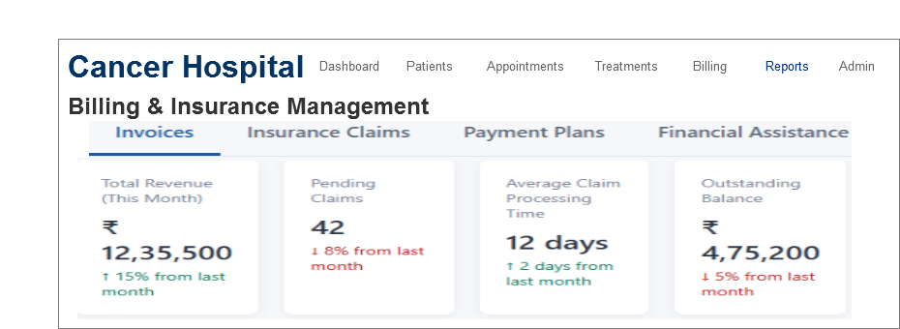Billing

**Question 3 Document 8**

Tools Visio and Axure

**Answer**

In my experience working on the cancer hospital management system project using the waterfall model, both Visio and Axure proved to be invaluable tools with distinct strengths. Visio excelled at creating detailed use case diagrams, and activity diagrams during the requirements and design phases, providing clear visual documentation that stakeholders could easily understand and approve before development began. The tool's precision in creating standardized UML diagrams was particularly helpful when mapping out the complex relationships between various hospital departments and patient care workflows.

Meanwhile, Axure transformed our static wireframes into interactive prototypes that simulated the actual user experience, allowing me to test complex interactions for critical processes like patient registration, treatment plan management, and payment processing. The ability to create master components in Axure significantly streamlined my work when designing consistent UI elements across multiple screens.

The combination of both tools enables thorough document requirements and validate user interfaces before coding began, adhering to the waterfall methodology's emphasis on complete documentation and sequential development. This approach minimized costly changes during later development stages and ensured that the final system accurately reflected the detailed specifications we had meticulously documented.

**Question 4 Document 9**

BA Experience

**Answer**

My experience as a Business Analyst for the cancer hospital management system was both challenging and rewarding.

-During requirement gathering, I applied the MoSCoW technique to prioritize features and used FURPS for validation, though client unavailability periodically forced me to work with alternative stakeholders to maintain momentum.

-In the analysis phase, creating UML and activity diagrams proved invaluable for visualizing complex workflows specific to cancer care. When team members disagreed with certain aspects, I facilitated focused discussions to incorporate their insights, ultimately strengthening the solution architecture.

-The design phase involved translating requirements into detailed test cases and working extensively with clinical experts to create realistic test scenarios that accurately reflected oncology care complexities. Developing negative test cases proved particularly valuable for safety-critical features like medication management.

-During development, I found my role as translator between technical and clinical stakeholders to be crucial. JAD sessions helped resolve implementation challenges, though managing resistant team members required diplomatic one-on-one conversations to address underlying concerns.

-Testing demanded meticulous attention to healthcare-specific validation requirements, and I worked closely with oncology staff to obtain appropriate test data while continuously updating the RTM to ensure complete coverage.

-Throughout deployment, coordinating end-user training while accommodating hospital staff's demanding schedules was particularly challenging. Creating role-specific documentation and organizing multiple training sessions helped ensure successful adoption.

The waterfall methodology's structured approach proved appropriate for this healthcare project, where patient safety and regulatory compliance necessitated thorough documentation and systematic validation at each stage.