Question 1. Functional Requirements

Answer :- Functional Requirements describe the behavior and information that solution will manage. They describe capabilities the system will able to perform in terms of behaviors or operations – specific information technology application actions or responses

|  |  |  |  |
| --- | --- | --- | --- |
| Req ID | Req Name | Req Description | Priority |
| FR0001 | Farmers Registration | Allow farmers to register themselves in application by providing their basic information and E mail id | 10 |
| FR0002 | Registration alert /notification | Farmers should get themselves registered by Email id and setting Password and get notification of successful registration. | 9 |
| FR0003 | Login | The farmer can login the application with their Email ID and password . | 10 |
| FR0004 | Login credentials | E mail ID & password should be used for login | 9 |
| FR0005 | Setting Password | Password strength should be strong which include minimum 5 alphabets(one capital),one special character and number | 8 |
| FR0006 | Search of Product | Farmers should be able to see all products with their details like manufacturing year ,contents used ,validity etc . on application | 9 |
| FR0007 | Check Availability | Farmers should able to check the availability of the product in store. | 8 |
| FR0008 | Notification of Availability | If a product is unavailable ,farmers should get notification of when it will be available. | 9 |
| FR0009 | Check reviews | Farmers should be able to check the review of the product . | 8 |
| FR0010 | Selection of product | Farmers should be able to select required product and add to the cart . | 8 |
| FR0011 | Drop of a product | Farmer should be able to drop a product from cart after selection | 7 |
| FR0012 | Amount to be paid | Farmers should get the total of amount to be paid after adding product to cart . | 7 |
| FR0013 | Add Delivery Address | Farmers should be able to add the address for the delivery of the product . | 9 |
| FR0014 | Traceable and within range | The address should be traceable and within the range of delivery | 8 |
| FR0015 | Payment | Farmers should be able to select the appropriate mode of payment. | 8 |
| FR0016 | Multiple payment option | There should be multiple payment option to make payment i.e Cash on Delivery ,Debit /Credit Card ,UPI | 9 |
| FR0017 | Confirmation of Payment | Order Ref Id/ Transaction Id should be generated for confirmation of payment received . | 8 |
| FR0018 | Order confirmation | Farmers should get E-mail confirmation about the confirmation order. | 8 |
| FR0019 | Delivery Tracking | The farmer should be able to track the delivery using order Ref id/Transaction id | 9 |
| FR0020 | Delivery notification | The farmers should get notification for the delivery of their order | 8 |
| FR0021 | Return of product if not satisfied | The farmers should able to return the defective or wrong product. | 9 |
| FR0022 | Rating & Review | The farmer should be able to give their feedback about the experience. | 8 |
| FR0023 | Customer Help Desk | Farmers should be able to contact customer Support centre at any stage and resolve their query | 7 |

Question 2 – Page Design

Answer :-

1. Home Page :-

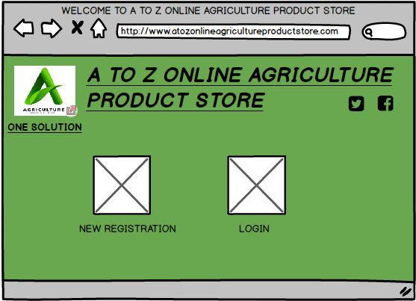

2. New Registration by entering basic details :-

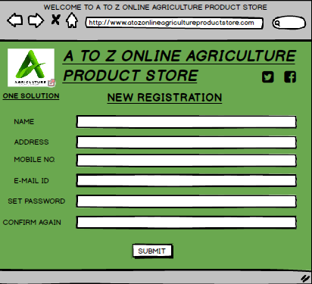

3. Login Page

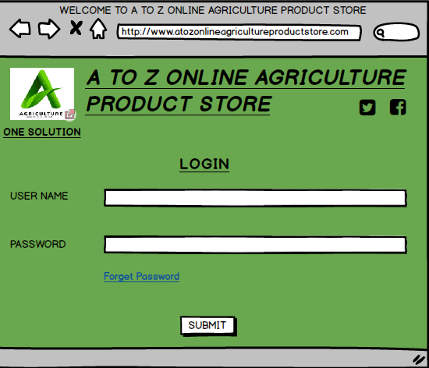

4. Search Product

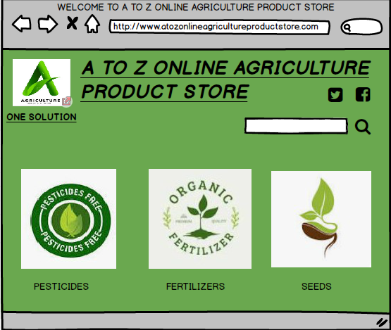

5. Make Payment

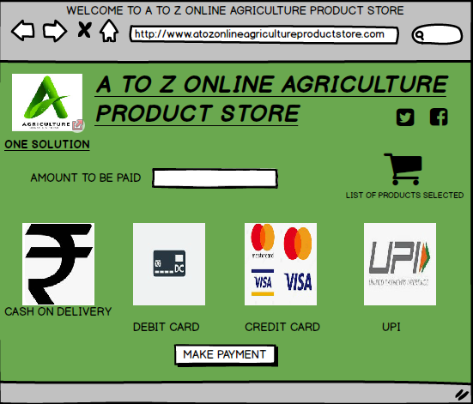

Question 3 – Tools (Visio & Balsamiq)

In this project we have used MS Visio tool for Use case diagram and Activity diagram and Balsamiq tool for prototyping.

1.**MS VISIO**

Microsoft Visio is a diagramming and vector graphics application. MS Visio used to create flowcharts, organization charts, building plans, floor plans, data flow diagrams, process flow diagrams, UML diagrams, business process modelling, swim lane diagrams, 3D maps and other visual representations of complex nature . MS Visio is part of the Microsoft Office software suite, although it is sold as a stand alone program. MS Visio is software which is used for drawing various diagrams. It is easy to use and understand. MS Visio is also widely used in various industries including building and Finance, IT and Networking, Architecture and Real Estate and Education and Research. Overall Microsoft Visio is a powerful tool for creating information, ideas and concepts.

**2. Balsamiq**

Balsamiq is a rapid wireframing tool .It creates mockups and wireframes for websites, web apps, and desktop software. It allows you to picture ideas and concepts through a simple drag and drop interface. The wireframes created using Balsamiq have a hand drawn style. It focuses on the structure and content of the product rather than visual details.

The main goal of Balsamiq is to facilitate effective communication between teams about user interface design. It encourages discussion and feedback on early designs before developers start coding the product. Balsamiq simplifies the process of turning ideas and concepts into concrete wireframes that represent the page structure, layouts, and interface elements.

Balsamiq is primarily used for creating low fidelity wireframes and mockups. Some of the main use cases of Balsamiq are Rapid prototyping ,UX design, Responsive design, collaboration, documentation and client presentation.

Some of the main benefits of Balsamiq technique are :

1) Low -fidelity : The hand drawn style of Balsamiq wireframes focuses the conversation on the interface structure and content rather than visual design details. This makes it easy to make changes to the wireframes based on feedback.

2) Affordable : It offers affordable subscription for freelancers and teams. They also have free trials and education licenses available.

3) Easy to use : It has an intuitive drag and drop UI, making it easy to create wireframes even if you don’t have much experience. The learning curve is short and its simple to get started.

4) Large UI element library : It include hundreds of UI elements like buttons, icons, input fields, navigation menus, tabs and more. This makes it quick to add interface elements to your wireframes.

Question 4 – RTM

Answer :- Requirement Traceability Matrix (RTM)maps all requirements with the test cases. By using this document one can verify test cases cover all functionality of the application as per requirements of the customer. The main purpose of the RTM is to verify that all requirements of client are covered in the test cases designed by the testers.

|  |  |  |  |  |  |  |  |  |  |  |  |  |
| --- | --- | --- | --- | --- | --- | --- | --- | --- | --- | --- | --- | --- |
| **Req ID** | **Req Name** | **Req Description** | Design | D1 | T1 | D2 | T2 | D3 | T3 | D4 | T4 | UAT |
| FR0001 | Farmer Registration | Allow farmers to register themselves in application by providing their basic information and E-mail Id. | COMPLETE | COMPLETE | COMPLETE | COMPLETE | COMPLETE | COMPLETE | COMPLETE | COMPLETE | COMPLETE | COMPLETE |
| FR0002 | Registration alert/notification | Farmers should get themselves registered by E-mail Id and setting Password and get notification of successful registration. | COMPLETE | COMPLETE | COMPLETE | INCOMPLETE | INCOMPLETE | INCOMPLETE | INCOMPLETE | INCOMPLETE | INCOMPLETE | INCOMPLETE |
| FR0003 | Login | The farmers can login the application with their Email ID and password. | COMPLETE | COMPLETE | COMPLETE | COMPLETE | COMPLETE | COMPLETE | COMPLETE | COMPLETE | COMPLETE | COMPLETE |
| FR0004 | Login credentials | E-mail Id & Password should be used for Login | COMPLETE | COMPLETE | COMPLETE | COMPLETE | COMPLETE | COMPLETE | COMPLETE | INCOMPLETE | INCOMPLETE | INCOMPLETE |
| FR0005 | Setting Password | Password strength should be strong which include minimum 5 alphabets (one capital), one special character and number. | COMPLETE | COMPLETE | COMPLETE | COMPLETE | COMPLETE | INCOMPLETE | INCOMPLETE | INCOMPLETE | INCOMPLETE | INCOMPLETE |
| FR0006 | Search of Product | Farmers should be able to see all products with their details like Manufacturing Year, Contents used, validity etc. on application. | COMPLETE | COMPLETE | COMPLETE | COMPLETE | COMPLETE | INCOMPLETE | INCOMPLETE | INCOMPLETE | INCOMPLETE | INCOMPLETE |
| FR0007 | Check Availability | Farmers should able to check the availability of the product in store. | COMPLETE | COMPLETE | COMPLETE | INCOMPLETE | INCOMPLETE | INCOMPLETE | INCOMPLETE | INCOMPLETE | INCOMPLETE | INCOMPLETE |
| FR0008 | Notification of Availability | If a product is unavailable, farmers should get notification of when it will be available. | COMPLETE | COMPLETE | COMPLETE | COMPLETE | COMPLETE | COMPLETE | COMPLETE | COMPLETE | COMPLETE | COMPLETE |
| FR0009 | check reviews | Farmers should be able to check the review of the product. | COMPLETE | COMPLETE | COMPLETE | COMPLETE | COMPLETE | COMPLETE | COMPLETE | COMPLETE | COMPLETE | COMPLETE |
| FR0010 | selection of a product | Farmers should be able to select required product and add to the cart. | COMPLETE | COMPLETE | COMPLETE | COMPLETE | COMPLETE | INCOMPLETE | INCOMPLETE | INCOMPLETE | INCOMPLETE | INCOMPLETE |
| FR0011 | Drop of a product | Farmer should be able to drop a product from cart after selection. | COMPLETE | COMPLETE | COMPLETE | COMPLETE | COMPLETE | COMPLETE | COMPLETE | COMPLETE | COMPLETE | COMPLETE |
| FR0012 | Amount to be paid | Farmers should get the total of amount to be paid after adding product to cart. | COMPLETE | COMPLETE | COMPLETE | COMPLETE | COMPLETE | INCOMPLETE | INCOMPLETE | INCOMPLETE | INCOMPLETE | INCOMPLETE |
| FR0013 | Add Delivery Address | Farmers should be able to add the address for the delivery of the product. | COMPLETE | COMPLETE | COMPLETE | COMPLETE | COMPLETE | COMPLETE | COMPLETE | COMPLETE | COMPLETE | COMPLETE |
| FR0014 | Traceable and within range | The address should be traceable and within the range of delivery. | COMPLETE | COMPLETE | COMPLETE | INCOMPLETE | INCOMPLETE | INCOMPLETE | INCOMPLETE | INCOMPLETE | INCOMPLETE | INCOMPLETE |
| FR0015 | Payment | Farmers should be able to select the appropriate mode of payment. | COMPLETE | COMPLETE | COMPLETE | COMPLETE | COMPLETE | COMPLETE | COMPLETE | COMPLETE | COMPLETE | COMPLETE |
| FR0016 | Multiple payment option | There should multiple payment option to make payment i.e. Cash on Delivery, Debit/Credit Card, UPI. | COMPLETE | COMPLETE | COMPLETE | COMPLETE | COMPLETE | COMPLETE | COMPLETE | COMPLETE | COMPLETE | COMPLETE |
| FR0017 | Confirmation of Payment | Order Ref Id / Transaction Id should be generated for confirmation of payment received. | COMPLETE | COMPLETE | COMPLETE | INCOMPLETE | INCOMPLETE | INCOMPLETE | INCOMPLETE | INCOMPLETE | INCOMPLETE | INCOMPLETE |
| FR0018 | Order confirmation | Farmer should get E-mail confirmation about the confirmation of order. | COMPLETE | COMPLETE | COMPLETE | COMPLETE | COMPLETE | INCOMPLETE | INCOMPLETE | INCOMPLETE | INCOMPLETE | INCOMPLETE |
| FR0019 | Delivery Tracking | The farmer should be able to track the delivery using Order Ref Id / Transaction Id. | COMPLETE | COMPLETE | COMPLETE | COMPLETE | COMPLETE | INCOMPLETE | INCOMPLETE | INCOMPLETE | INCOMPLETE | INCOMPLETE |
| FR0020 | Delivery Notification | The farmer should get notification for the delivery of their order. | COMPLETE | COMPLETE | COMPLETE | COMPLETE | COMPLETE | INCOMPLETE | INCOMPLETE | INCOMPLETE | INCOMPLETE | INCOMPLETE |
| FR0021 | Return of product if not satisfied | The farmer should able to return the defective or wrong product. | COMPLETE | COMPLETE | COMPLETE | INCOMPLETE | INCOMPLETE | INCOMPLETE | INCOMPLETE | INCOMPLETE | INCOMPLETE | INCOMPLETE |
| FR0022 | Rating & Review | The farmer should be able to give their feedback about the experience. | COMPLETE | COMPLETE | COMPLETE | COMPLETE | COMPLETE | COMPLETE | COMPLETE | COMPLETE | COMPLETE | COMPLETE |
| FR0023 | Customer Help Desk | Farmers should be able to contact Customer Support Centre at any stage and resolve their query. | INCOMPLETE | INCOMPLETE | INCOMPLETE | INCOMPLETE | INCOMPLETE | INCOMPLETE | INCOMPLETE | INCOMPLETE | INCOMPLETE | INCOMPLETE |
| NFR0101 | Page loading time | Each page should load within 2 seconds time | COMPLETE | COMPLETE | COMPLETE | COMPLETE | INCOMPLETE | INCOMPLETE | INCOMPLETE | INCOMPLETE | INCOMPLETE | INCOMPLETE |
| NFR0102 | WCAG 2.1. | The system must meet web content accessibility guidelines WCAG 2.1. | COMPLETE | COMPLETE | COMPLETE | COMPLETE | COMPLETE | COMPLETE | COMPLETE | COMPLETE | COMPLETE | COMPLETE |
| NFR0101 | Connectivity | Application server should be connected to internet 24/7 | COMPLETE | COMPLETE | COMPLETE | COMPLETE | COMPLETE | COMPLETE | COMPLETE | COMPLETE | COMPLETE | COMPLETE |
| NFR0102 | Back Up of Data | System should take back-up of data at the end of every day | COMPLETE | COMPLETE | COMPLETE | COMPLETE | COMPLETE | COMPLETE | INCOMPLETE | INCOMPLETE | INCOMPLETE | INCOMPLETE |
| NFR0103 | Print out of Order confirmation | Application should allow farmers to take print out of order confirmation | COMPLETE | COMPLETE | COMPLETE | COMPLETE | INCOMPLETE | INCOMPLETE | INCOMPLETE | INCOMPLETE | INCOMPLETE | INCOMPLETE |
| NFR0104 | Interface | Interface must be user friendly for farmers to understand better | COMPLETE | COMPLETE | COMPLETE | COMPLETE | COMPLETE | COMPLETE | COMPLETE | COMPLETE | INCOMPLETE | INCOMPLETE |
| NFR0105 | Change of Password | Farmers should get notification while login to change password after 4 months | COMPLETE | COMPLETE | COMPLETE | COMPLETE | INCOMPLETE | INCOMPLETE | INCOMPLETE | INCOMPLETE | INCOMPLETE | INCOMPLETE |
| NFR0106 | No of users | System must allow N number of user to login at a time | COMPLETE | COMPLETE | COMPLETE | COMPLETE | COMPLETE | COMPLETE | COMPLETE | COMPLETE | COMPLETE | COMPLETE |
| NFR0107 | Compatibility | Application should be run on any Desktop, Laptop and Mobile | COMPLETE | COMPLETE | COMPLETE | COMPLETE | COMPLETE | COMPLETE | COMPLETE | COMPLETE | COMPLETE | COMPLETE |
| NFR0108 | Previous transaction details | Farmers should be able to see the details of previous transactions. | COMPLETE | COMPLETE | COMPLETE | COMPLETE | COMPLETE | COMPLETE | INCOMPLETE | INCOMPLETE | INCOMPLETE | INCOMPLETE |
| NFR0109 | Ratings | Farmers should be able to give rating about payment experience | COMPLETE | COMPLETE | COMPLETE | COMPLETE | COMPLETE | COMPLETE | COMPLETE | INCOMPLETE | INCOMPLETE | INCOMPLETE |

Question 5 Test Case Document

Answer :- A test case document includes test steps, test data, preconditions and post conditions that verify requirements.

Test Case No 1

|  |  |  |  |
| --- | --- | --- | --- |
| Test Case Id | OAPS321TS001 | Test Case Name | Registration |
| Project Id | OAPS321 | Project Name | Online Agriculture Product Store |
| PM Id | 7898 | PM Name | Mr. Vandanam |
| Test Strategy Id | OAPS321TS001 | Tester Id | T01 |
| Test Plan Id | OAPS321TP001 | Tester Name | Mr. Jason |
| Test Schedule Id | OAPS321TS001 | Date of Test | 01.03.2024 |

|  |
| --- |
| Scenario : New registration in application by entering basic information |
| Link to that page: |

|  |  |  |
| --- | --- | --- |
|  | Set 1 | Set 2 |
| Input Data | * 1. Name   2. Address   3. Mobile No.   4. E-Mail Id   5. Set Password   6. Confirm Password | * 1. Name   2. Address   3. Mobile No.   4. E-Mail Id   5. Set Password   6. Confirm Password |
| Expected behavior | Farmers should be able to Register themselves | Farmers should be able to Register themselves |
| Actual behavior |  |  |
| Comments |  |  |
| Result Pass/Fail |  |  |

Test Case No 2

|  |  |  |  |
| --- | --- | --- | --- |
| Test Case Id | OAPS321TS002 | Test Case Name | Login into the application |
| Project Id | OAPS321 | Project Name | Online Agriculture Product Store |
| PM Id | 7898 | PM Name | Mr. Vandanam |
| Test Strategy Id | OAPS321TS002 | Tester Id | T02 |
| Test Plan Id | OAPS321TP002 | Tester Name | Ms. Alekya |
| Test Schedule Id | OAPS321TS002 | Date of Test | 15.03.2024 |

|  |
| --- |
| Scenario : Login to the application by using E-mail Id and Password |
| Link to that page: |

|  |  |  |
| --- | --- | --- |
|  | Set 1 | Set 2 |
| Input Data | * 1. E-mail Id   2. Password | * 1. E-mail Id   2. Password |
| Expected behavior | Farmers should be able to Login into the application | Farmers should be able to Login into the application |
| Actual behavior |  |  |
| Comments |  |  |
| Result Pass/Fail |  |  |

Test Case no 3

|  |  |  |  |
| --- | --- | --- | --- |
| Test Case Id | OAPS321TS003 | Test Case Name | Search for the product |
| Project Id | OAPS321 | Project Name | Online Agriculture Product Store |
| PM Id | 7898 | PM Name | Mr. Vandanam |
| Test Strategy Id | OAPS321TS003 | Tester Id | T03 |
| Test Plan Id | OAPS321TP003 | Tester Name | Mr. Jason |
| Test Schedule Id | OAPS321TS003 | Date of Test | 01.04.2024 |

|  |
| --- |
| Scenario : Farmers should be able to search for the product from available options… by clicking on product, details of product like manufacturing date, contents, expiry date also be shown along with status available or not… If not available then it should display when the product will be available. |
| Link to that page: |

|  |  |  |
| --- | --- | --- |
|  | Set 1 | Set 2 |
| Input Data | * 1. Name of Fertilizer   2. Name of Pesticides   3. Name of Seeds | * 1. Name of Fertilizer   2. Name of Pesticides   3. Name of Seeds |
| Expected behavior | Farmers should be able to search the product along with details and availability | Farmers should be able to search the product along with details and availability |
| Actual behavior |  |  |
| Comments |  |  |
| Result Pass/Fail |  |  |

Test Case No 4

|  |  |  |  |
| --- | --- | --- | --- |
| Test Case Id | OAPS321TS004 | Test Case Name | Select and drop product |
| Project Id | OAPS321 | Project Name | Online Agriculture Product Store |
| PM Id | 7898 | PM Name | Mr. Vandanam |
| Test Strategy Id | OAPS321TS004 | Tester Id | T04 |
| Test Plan Id | OAPS321TP004 | Tester Name | Ms. Alekya |
| Test Schedule Id | OAPS321TS004 | Date of Test | 15.04.2024 |

|  |
| --- |
| Scenario : Farmers should be able to add/drop the product from cart… total price of product added to cart also can be displayed… |
| Link to that page: |

|  |  |  |
| --- | --- | --- |
|  | Set 1 | Set 2 |
| Input Data | * 1. Name of Fertilizer   2. Name of Pesticides   3. Name of Seeds | * 1. Name of Fertilizer   2. Name of Pesticides   3. Name of Seeds |
| Expected behavior | Farmers should be able to add / drop the product from cart. The total price for selection also displayed. | Farmers should be able to add / drop the product from cart. The total price for selection also displayed. |
| Actual behavior |  |  |
| Comments |  |  |
| Result Pass/Fail |  |  |

Test Case No 5

|  |  |  |  |
| --- | --- | --- | --- |
| Test Case Id | OAPS321TS005 | Test Case Name | Add delivery address |
| Project Id | OAPS321 | Project Name | Online Agriculture Product Store |
| PM Id | 7898 | PM Name | Mr. Vandanam |
| Test Strategy Id | OAPS321TS005 | Tester Id | T05 |
| Test Plan Id | OAPS321TP005 | Tester Name | Mr. Jason |
| Test Schedule Id | OAPS321TS005 | Date of Test | 01.05.2024 |

|  |
| --- |
| Scenario : Farmers should be able to add delivery address for obtaining delivery of product. |
| Link to that page: |

|  |  |  |
| --- | --- | --- |
|  | Set 1 | Set 2 |
| Input Data | * 1. Address   2. Pin Code   3. Nearby Landmark | * 1. Address   2. Pin Code   3. Nearby Landmark |
| Expected behavior | Farmers should be able to add the address for taking delivery. | Farmers should be able to add the address for taking delivery. |
| Actual behavior |  |  |
| Comments |  |  |
| Result Pass/Fail |  |  |

Test Case No 6

|  |  |  |  |
| --- | --- | --- | --- |
| Test Case Id | OAPS321TS006 | Test Case Name | Make Payment |
| Project Id | OAPS321 | Project Name | Online Agriculture Product Store |
| PM Id | 7898 | PM Name | Mr. Vandanam |
| Test Strategy Id | OAPS321TS006 | Tester Id | T06 |
| Test Plan Id | OAPS321TP006 | Tester Name | Ms. Alekya |
| Test Schedule Id | OAPS321TS006 | Date of Test | 15.05.2024 |

|  |
| --- |
| Scenario : Farmers should be able to select the mode of payment i.e. Cash on Delivery, Debit/Credit Card, UPI... In case of Card / UPI payment the OTP should be generated and it has to be entered to confirm the transaction… Order confirmation id / Transaction id should be generated after successful payment… |
| Link to that page: |

|  |  |  |
| --- | --- | --- |
|  | Set 1 | Set 2 |
| Input Data | * 1. Debit / Credit Card No.   2. Name on the card   3. Date of Expiry of card   4. CVV No. on back of card   5. UPI login Pin   6. UPI transaction pin   7. OTP for every transaction | * 1. Debit / Credit Card No.   2. Name on the card   3. Date of Expiry of card   4. CVV No. on back of card   5. UPI login Pin   6. UPI transaction pin   7. OTP for every transaction |
| Expected behavior | Farmers should be able to make payment by either of mode i.e. Cash on delivery, Debit / Credit Card, UPI. | Farmers should be able to make payment by either of mode i.e. Cash on delivery, Debit / Credit Card, UPI. |
| Actual behavior |  |  |
| Comments |  |  |
| Result Pass/Fail |  |  |

Test Case No 7

|  |  |  |  |
| --- | --- | --- | --- |
| Test Case Id | OAPS321TS007 | Test Case Name | Confirmation of payment along with E-mail & SMS |
| Project Id | OAPS321 | Project Name | Online Agriculture Product Store |
| PM Id | 7898 | PM Name | Mr. Vandanam |
| Test Strategy Id | OAPS321TS007 | Tester Id | T07 |
| Test Plan Id | OAPS321TP007 | Tester Name | Mr. Jason |
| Test Schedule Id | OAPS321TS007 | Date of Test | 01.06.2024 |

|  |
| --- |
| Scenario : Farmers should get payment confirmation on E-mail and SMS immediately. |
| Link to that page: |

|  |  |  |
| --- | --- | --- |
|  | Set 1 | Set 2 |
| Input Data | * 1. E-mail Address   2. Mobile No. | * 1. E-mail Address   2. Mobile No. |
| Expected behavior | Farmers should be able to get confirmation of payment by E-mail and SMS | Farmers should be able to get confirmation of payment by E-mail and SMS |
| Actual behavior |  |  |
| Comments |  |  |
| Result Pass/Fail |  |  |

Test Case No 8

|  |  |  |  |
| --- | --- | --- | --- |
| Test Case Id | OAPS321TS008 | Test Case Name | Traking of order |
| Project Id | OAPS321 | Project Name | Online Agriculture Product Store |
| PM Id | 7898 | PM Name | Mr. Vandanam |
| Test Strategy Id | OAPS321TS008 | Tester Id | T08 |
| Test Plan Id | OAPS321TP008 | Tester Name | Ms. Alekya |
| Test Schedule Id | OAPS321TS008 | Date of Test | 15.06.2024 |

|  |
| --- |
| Scenario : Farmers should be able to track the delivery status with the help of Order Confirmation Id / Transaction Id |
| Link to that page: |

|  |  |  |
| --- | --- | --- |
|  | Set 1 | Set 2 |
| Input Data | * 1. Order Confirmation Id / Transaction Id   2. Date of transaction | * 1. Order Confirmation Id / Transaction Id   2. Date of transaction |
| Expected behavior | Farmers should be able to track the transit position of ordered product. | Farmers should be able to track the transit position of ordered product. |
| Actual behavior |  |  |
| Comments |  |  |
| Result Pass/Fail |  |  |

Test Case No 9

|  |  |  |  |
| --- | --- | --- | --- |
| Test Case Id | OAPS321TS009 | Test Case Name | Return of goods |
| Project Id | OAPS321 | Project Name | Online Agriculture Product Store |
| PM Id | 7898 | PM Name | Mr. Vandanam |
| Test Strategy Id | OAPS321TS009 | Tester Id | T09 |
| Test Plan Id | OAPS321TP009 | Tester Name | Mr. Jason |
| Test Schedule Id | OAPS321TS009 | Date of Test | 01.07.2024 |

|  |
| --- |
| Scenario : Farmers should be able to return the goods due to defectiveness, due to delivery of different product than ordered or due to late delivery… claim for refund of amount paid. |
| Link to that page: |

|  |  |  |
| --- | --- | --- |
|  | Set 1 | Set 2 |
| Input Data | * 1. E-mail Address   2. Mobile No.   3. Order Confirmation Id / Transaction Id | * 1. E-mail Address   2. Mobile No.   3. Order Confirmation Id / Transaction Id. |
| Expected behavior | Farmers should be able to return the goods and claim for refund of amount paid. | Farmers should be able to return the goods and claim for refund of amount paid. |
| Actual behavior |  |  |
| Comments |  |  |
| Result Pass/Fail |  |  |

Test Case No 10

|  |  |  |  |
| --- | --- | --- | --- |
| Test Case Id | OAPS321TS010 | Test Case Name | Customer Support |
| Project Id | OAPS321 | Project Name | Online Agriculture Product Store |
| PM Id | 7898 | PM Name | Mr. Vandanam |
| Test Strategy Id | OAPS321TS010 | Tester Id | T10 |
| Test Plan Id | OAPS321TP010 | Tester Name | Ms. Alekya |
| Test Schedule Id | OAPS321TS010 | Date of Test | 15.07.2024 |

|  |
| --- |
| Scenario : Farmers should be able to get customer support from Help Desk Centre at any point of stage. |
| Link to that page: |

|  |  |  |
| --- | --- | --- |
|  | Set 1 | Set 2 |
| Input Data | * 1. E-mail Id   2. Password | * 1. E-mail Id   2. Password |
| Expected behavior | Farmers should be able to get customer support at any stage. | Farmers should be able to get customer support at any stage. |
| Actual behavior |  |  |
| Comments |  |  |
| Result Pass/Fail |  |  |

Question 6 – DB Schema and ER Diagram

DB Schema : DB Schema is a blueprint that outlines the structure of a database, including its tables, fields, relationships, constraints and other characteristics. It shows how different data elements relate to each other.

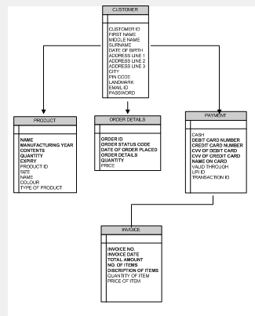

ER Diagram : A Entity – Relationship Diagram(ERD) is a visual representation of the relationships between entities in a database. It depicts the entities(such as tables),attributes (properties or fields),and relationships between them.

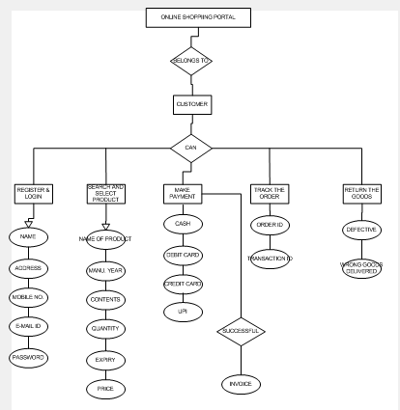

Question 7 – Data flow Diagram

Answer :- A Data Flow Diagram(DFD) is a graphical representation of the flow of data within a system. It visually shows how data moves from one process to another, how its stored and where it ends up.

It helps analysts and designers to understand the flow of data within a system, identify potential bottlenecks or inefficiencies and communicate system requirements to stakeholders.

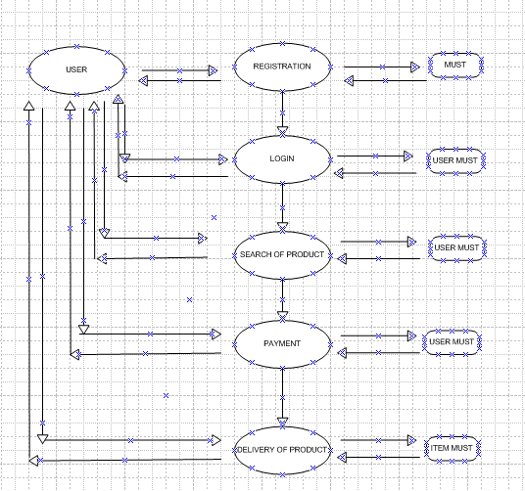

Question 8 – Change Request

Answer :-

A change request is a formal proposal to alter a system , product or project.

There will not be major effect on farmers demand for Pesticides, Fertilizers and seeds due to change in government Taxation Structure. These are the basic needs of farming so there may be comparatively less demand from farmers but demands will not end due to increase in taxation.

As a BA we need to make changes in every stage of product i.e Design, Development and testing as we used V Model strategy. Following are the steps involved in handling Change request :

**1. Understand the scope of change :**

The scope of change request is determined in this stage. This change request is out of the scope as it has emerged after the starting of project. It is unavoidable so must be incorporated in application.

**2. Do the Analysis :**

The change request should be analyzed properly. What is the gravity of request and what will be the impact of change request on process, all these things should be considered while analysis. This change request is unavoidable and impact on each and every transaction because taxation is an unavoidable thing. This change must be incorporate in the application because every single product price will be increased up to certain level and the company have to pass on the effect to match the difference in tax amount.

**3. Prioritizes the change request :**

The next step is to analyse how important the change is. Is it completely essential to the business or is it more something that is just nice to have ? How big is the benefit to the business ? There may also be other change requests in which case you will need to decide which is more important and should be implemented first.

**4. Approve or Reject the change request :**

The change request analysis should be sent to Change control board for approval.

**5. Communicate and implement the change request :**

After approval from change control board, the change request can be communicated to designing team, development team and testing team . Proper implementation should also be monitored at testing stage and UAT.

Question 9 – Change Request Vs An Enhancement

Answer :-

|  |  |
| --- | --- |
| Change Request | Enhancement |
| 1. A change request is a formal request to modify or alter an existing product, system or process.  2. To correct defects, fix errors or make changes to meet the original requirements or specification.  3. Typically change request are within the original project scope and budget.  Ex : Fixing a bug, Updating a software version or modifying a report layout. | 1. A Enhancement request is a formal request to add new functionality, features, or capabilities to an existing product, system or process.  2. To improve the product or system by adding new value ,functionality or usability.  3. Enhancement request often require changes to the original project scope and may impact the budget.  Ex. Adding a new features, integrating with another system, or improving user experience. |

In this case it is a Enhancement because the stakeholders want to add new features i.e farmers should be able to add their crop yields or products and display to general public and should be able to sell them. They also want to introduce Auction system to their crop yields. To According to stakeholders these features should be added because the system there and due to addition of these features more people will get connected to the application and the new domain for sale of production added which will help farmers to sell their produced to more people .Due to addition in users the profitability of the company will also increase and company will able to generate good profit.

As a BA first we have to document the request and work with the development team to determine the feasibility and impact of this request. We have to look for risk and cost associated while working on the request. This request is difficult to incorporate into the application at last moment as we have selected V Model approach. In V Model to incorporate change request is difficult because it has to pass from all stages i.e Design, Development and Testing so it will take time.

Extra man hours and funds will be required to incorporate the same request to the application. The budget allocated for the project and duration to complete the project may increase.

Question 10 – Estimation

Answer :-

There are total 11 peoples working in this project so if we considered they work for 9 hours per day for 5 days in a week,

For a day : 11 * 9 = 99 Man Hours

For a week : 99 * 5 = 495 Man Hours

For a month : 495 * 4 = 1980 Man Hours

* But all the peoples are not working from the very first day. As the project moves phase wise , the team members are added like in initial stage BA will gathering requirements, then design members will design ,based on that developers will develop the codes, then tester will test and UAT . So Man Hours will be calculated on weekly or monthly basis depends on how many team members worked in that particular week or month.

Question 11 – UAT

Answer :-

As the project has completed in all the stages , BA would contact the client for User Acceptance Testing . UAT is done by client. Testers will also be part of UAT activity.

Following is UAT process :

**Stage 1 – Planning :-**

1) BA will do Enterprise Analysis , SWOT Analysis ,GAP Analysis.

2) BA will try to understand the project and identify the stakeholders.

3)BA will do stakeholders Analysis, plan a strategy about requirements, gathering, tools to use, change request handling methodology etc.

4) Requirements gathering ,sorting, prioritizing and validating.

**Stage 2 - Designing :-**

1) Draw UML Diagrams (Use Case and Activity Diagram ).

2) Prepare list of Business requirements and Functional requirements.

3) Based on Use Case Diagram and Test Case Document is prepared by Test Manager/BA and communicate to development team.

**Stage 3 – Development :-**

1) Developers will develop the codes based on UML diagrams.

2) BA will clarifies the queries of technical team during the development process.

3) BA will keep track of every requirement through Requirement Traceability Matrix so that no requirement can skip.

**Stage 4 -Testing and Bug fixing :-**

1) The testers will test the cases developed by developers.

2) If found some bugs they refer the case back to developers.

3) Again developers will work on it to fix the bug and pass on to testing team for further testing .

4) This activity continues till the software becomes error free.

5) Tester will indicate completion of software

**Stage 5 – Sign Off**

All the stakeholders will test the software and come to the conclusion that software is ready to go live and sign it off.

Question 12 – Project Closure Document

Answer :-

A Project closure document is the final document of the project which is like report card of the project . It shows whether the objectives of project is achieved or not within all set parameters like time, budget, resources utilization and client satisfaction. A project closure document includes following points :

* Purpose of the project.
* Sign off by client on UAT.
* List of objectives of the project achieved or not.
* Whether the client is satisfied or not.
* List of functionalities worked on.
* Successful completion of functionalities or not.
* Budget allotted and funds utilized.
* Overall project information .
* Values to the company.
* Reference links.

A sample project closure document as below :

|  |  |  |  |
| --- | --- | --- | --- |
| SR NO | POINT TO INCLUDE | DETAILS | REFERENCE LINKS |
| 1 | Purpose of the Project | To make an Online Agriculture product store for remote area farmers to facilitate them to buy agriculture product (Fertilizers, seeds , Pesticides) |  |
|  |  |  |  |
| 2 | Did the client sign off on the UAT testing |  | Business scope document.docx |
|  | Date of sign off | 15th March 2024 |  |
|  |  |  |  |
| 3. | Objectives of the project |  |  |
|  | a. User friendliness Application | Achieved |  |
|  | b. Connect with more people | Achieved |  |
|  | c. Customer satisfaction | Achieved |  |
|  |  |  |  |
| 4. | Functionalities worked on |  |  |
|  | a. Variety of products | Achieved |  |
|  | b. Secure & Easy Payment | Achieved |  |
|  | c. Home delivery to farmers | Achieved |  |
|  |  |  |  |
| 5. | Budget |  |  |
|  | Budget allotted | 2.00 crores |  |
|  | Amount spend | 1.90 crores |  |
|  | Shortage or Excess | 10.00 crores (Excess) |  |
|  | Reason | Optimum utilization of funds |  |
|  |  |  |  |
| 6. | Overall Project Information |  |  |
|  | a. Escalation | 50 |  |
|  | b. Customer Satisfaction | High |  |
|  | c. Utilization of Resources | Optimum level |  |
|  |  |  |  |
| 7. | Value to the Company | Gained an Edge over competitors   * Increased customers * Trained Resources * Good Database * New project in pipeline |  |