Question 1: Use Case Diagram
Answer 1:
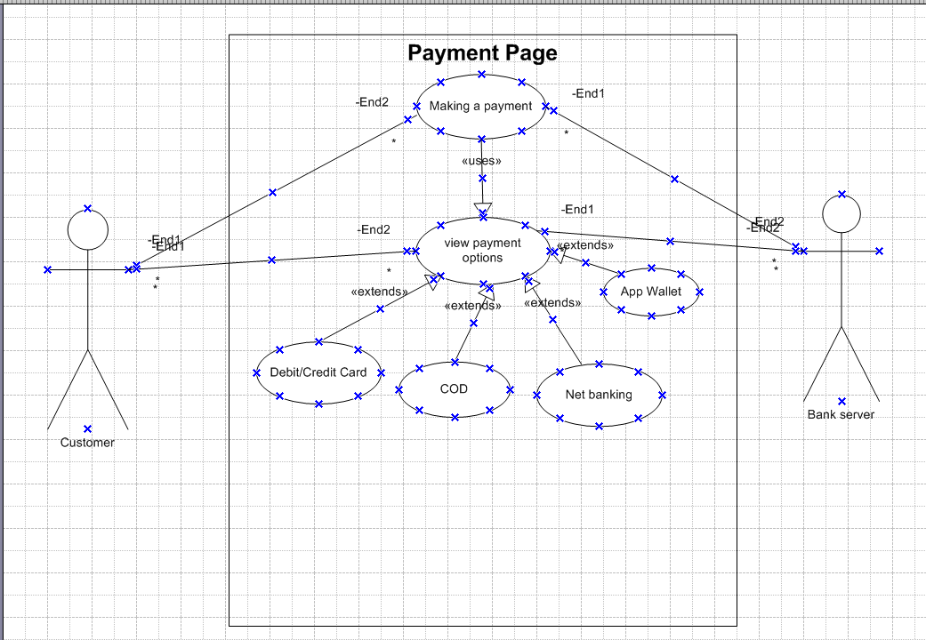

Question 2: Derive Boundary Classes, Controller classes, Entity Classes
Answer 2:
- Boundary :- The boundary class is a class that is the boundary of the system and other system or user(which is actor in the use case diagram). It is a class used to model interaction between the system's surroundings and its inner workings
Features of boundary class
- This class is easier to be changed than the entity and control class
- The attribute of this class and screen layout are defined at the basic design,
- In a class diagram, there are cases that the stereotype
- In the class diagram, there are cases that is shown by the following icon
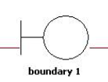
Payment option boundary
Card payment boundary
Cash payment boundary
Net banking payment boundary
Wallet payment boundary

- Controller class : It acts as intermediaries between boundary and entity class
Features of control class-
- This class has few attributes
- In a class diagram, there are cases that the stereotype(<<control>>) is added
- This class is a class to achieves use cases in the use case diagram.
- In a class diagram, there are cases that is shown by the following icon

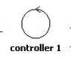
Payment initiated controller
Card payment controller
Cash payment controller
Net banking payment controller
Wallet payment controller

- Entity class: Represent the core data and business logic of the application
The E of the ER diagram means “Entity”.

Features of control class-
- There are many cases that these objects of this class are perpetuated the DB
- The extraction of the class is like ER diagram
- This class is related to the DOA(Data-oriented approach)
- The module cohesion of this class is high, and is not easy to be changed
- In a class diagram, there are cases that the stereotype(entity) is added
- In a class diagram, there are cases that is shown by the following icon
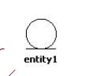

Customer
Payment
Card
Wallet
Server

Question 3: Three tier Architecture
Answer 3:

User layer
Customer Registration
Payment method selection boundary
Bank server login
card payment boundary
Cash payment boundary
Netbanking payment boundary
wallet payment boundary
Business logic
Payment controller
Card payment controller
Cash payment controller
Netbanking payment controller
Wallet payment controller
Data Tier
Customer
Payment
Card
Wallet
Server/Bank account

In this three-tier architecture, the application tier handles the user interface, the Business Logic Layer manages the Business logic and coordinates between the other tiers, the data tier handles data storage and retrieval.

Question 4- Explain Domain Model for Customer making payment through Net Banking
Answer 4:
A domain model is a conceptual/Visual representation that defines the structure, relationship, and behaviour of entities within a specific problem domain, it defines the relationship between diff components tables and entity in the database.
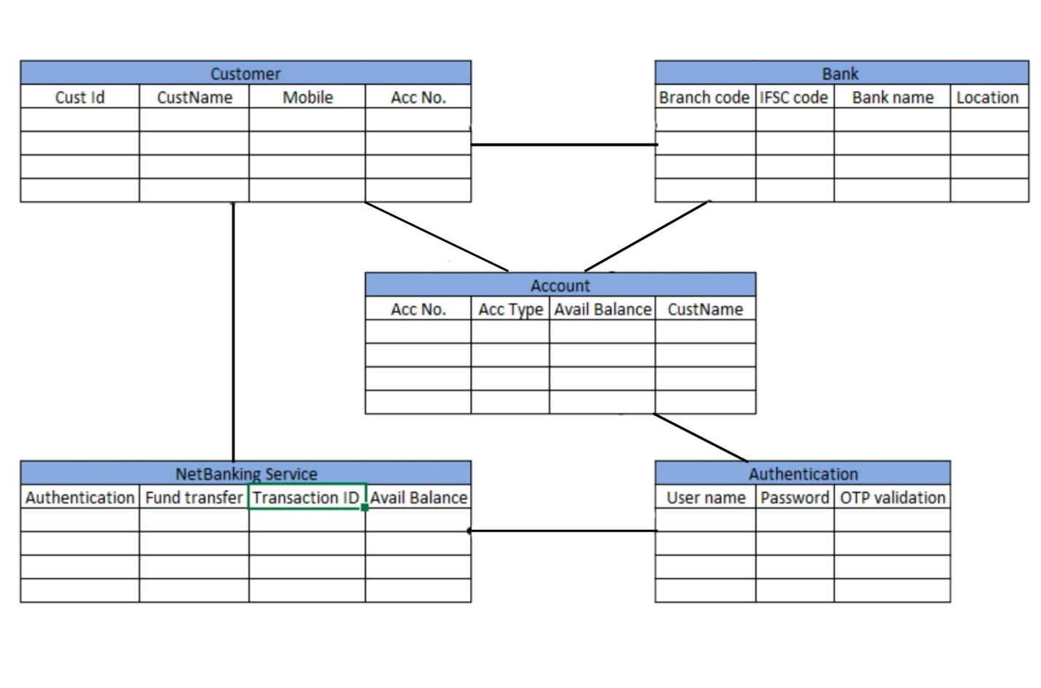
Question 5: Sequence diagram
Answer 5:

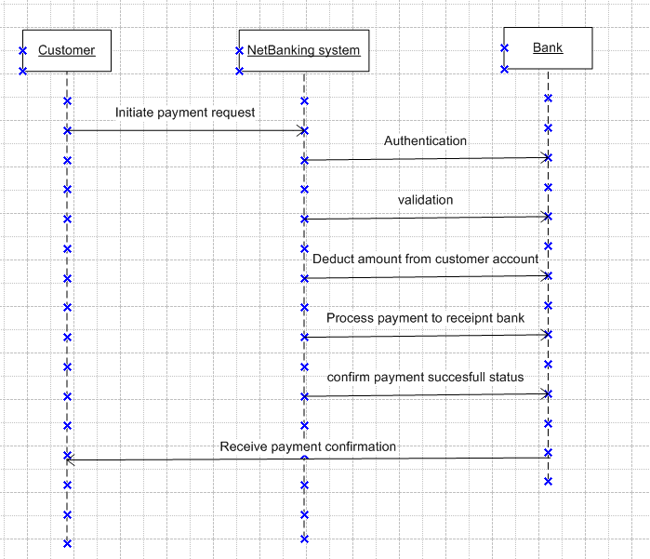

Question 6: Conceptual Model
Answer 6:
Conceptual model is very similar to the domain model it also talks about the relationship between payment net banking and bank. A conceptual model for the payment process done by a customer using net banking provides a high-level understanding of the key concepts and their relationship involved in the payment transaction.
It helps in visualizing the overall structure and flow of the payment process.

Question 7: MVC architecture? Explain MVC rules to derive classes from use case diagram and guidelines to place classes in 3-tier architecture
Answer 7:
The model-view controller (MVC) is a well-known design patter in the web development field. It is a way to organize our code. It specifies that a program or application shall consist of data model, presentation information and control information. The MVC pattern needs all these components to be separated as different objects.
1. Model
- Responsibility: The Model represents the data and the business logic of the application. It is responsible for retrieving data, storing data, and updating data. The Model is often responsible for interacting with the database or other data sources.
- Rule: The Model should not be concerned with how data is presented to the user or how it is interacted with. It purely focuses on the data and its manipulation.
2. View
- Responsibility: The View is responsible for displaying the data to the user. It presents the data in a format that is easy for users to understand and interact with. The View is what the user sees and interacts with.
- Rule: The View should not handle any business logic or data manipulation. Its sole purpose is to present the data provided by the Model in a user-friendly manner.
3. Controller
- Responsibility: The Controller acts as an intermediary between the Model and the View. It handles user input and updates the Model accordingly. It also selects the appropriate View to display based on the user's actions.
- Rule: The Controller should not handle data presentation or business logic directly. Instead, it should handle the flow of data between the Model and the View.
Rules for MVC Architecture:
- Combination of one actor and an use case results in one boundary class.
- Combination of two actors and an use case results in two boundary classes.
- Combination of three actors and an use case results in three boundary classes an so on…
Note-Only one primary actor is to be considered with a use case.
- Use case will result in a controller class
- Each actor will result in one entity class

By following these rules, MVC helps in creating applications that are easier to manage and scale. It promotes a clean separation of concerns, which can lead to more organized code and a better structure for development.
Three-tier architecture, which separates application into three logical and physical computing tier, is the predominant software architecture for traditional client server applications.
Guidelines to place identified MVC classes in a 3 tier architecture:
- Place all entity classes in DB layer
- Place primary actor associated boundary class in application layer
- Place controller class in application layer
- If governing body influence or reusability is there with any of remaining boundary classes, place them in business logic layer else place them in application layer.

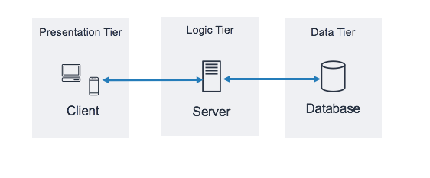
Question 8: BA contributions in project
Answer 8:
A waterfall model is very old and traditional model in IT industries. It is a progressive implementation of the projects which is divided into different phrases of SDLC.

Role of a BA in project

Stages | Activities | Artifacts and Resources
Pre-Project | Enterprise Analysis-SWOT analysis, GAP analysis, Market research, Feasibility study, Root cause analysis, Decision analysis, strategy analysis, risk analysis | Business case  SOW (statement of work)  PO (purchase order)
Planning & estimation & assessment | - Understand assumptions and constraints along with business rules and business goals  - Plan packages for big projects  - Understands the project plan from PM  - BA conducts stakeholder analysis  - Plan BA approach strategy for this project | PM  And Sr. BA
Requirement Gathering | - Stakeholders identify and documents  - Client gives BRD and BA prepares BRD by interacting with client (brainstorming, document analysis, reverse engineering, interviews, workshop, focus group, observation, questionnaires.  - Prototyping can be used by BA to make the client to give more specific requirements  - Sort the gathered requirements  - Prioritize requirements-MoSCoW  - Validate requirements-FURPS | BRD  BA  PM
Requirement Analysis | - Draws UML diagrams  - Prepare functional requirements from business requirements  - All architects come up with technical requirements  - SRS will have functional requirements and technical requirements  - Takes signoff on SRS from client, SRS is the first legal binding doc between the business and the technical team  - BA prepared RTP from SRS before design phase starts  - BA traces how requirements are dealt in each phase of development life cycle from design till UAT | Functional Requirements specification  SSD (supplementary support specification)  RTM  BA  PM  Solution architect  DB architect
Design | - From Use case diagram, test manger or BA will prepare test cases  - Communicate with the client on the design and make them understand how the solution would look like to prepare them to drive UAT  - BA will initiate the preparation of end user manuals  - Updates RTM  - From use case diagram solution architect recommends architecture of the it solution  - DB architect uses persistence classes and comes up with ER diagrams or DB schema  - GUI designer will look into transient classes and designs all possible screens for the its solution | Design document-HDD-ADD  BA  PM  Solution architect  DB architect  Test manager
Coding | - BA organizes JAD sessions  - BA clarifies queries of technical team during coding  - Developers refer diagrams and transient of BA and code their unit  - Update end user manuals  - Update RTM  - Conducts regular status meetings with technical team and the client and tuning client for participation in UAT | LDD-CDD  Application  Development team  BA  PM
Testing | - BA prepares test cases from use cases  - BA performs high level testing  - BA prepares client for UAT  - Test data is requested by BA from client  - Updates end user manuals  - Update RTM  - Take signoff from client on project acceptance form | Test concerning documents  Application with less errors  Testing Team  BA  PM  Client
Deployment and Implementation | - Forwards RTP to client or the PM which should be attached to the project closure document  - Coordinates to complete and share end user manuals  - Plans and organizes training sessions for end users  - Prepares lessons learned from this project

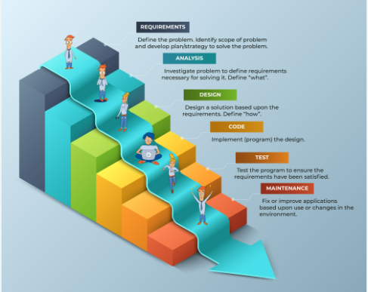

Question 9: What is conflict management? Explain using Thomas – Kilmann technique
Answer 9:
In the 1970s, researchers Kenneth Thomas and Ralph Kilmann developed a model for conflict resolution. It was called the Thomas-Kilmann model after them. Under this model, the term ‘conflict’ is described with the others. If two or more people or groups care about things that are contradictory to each other, then the outcome is conflict.
This model describes the two core dimensions while choosing a mode of conduct in a situation of conflict: ‘assertiveness’ and ‘cooperativeness’. Assertiveness is the extent to which you try to solve and resolve for your preferred outcomes. Think of this as the factor on the Y-Axis of a graph, on the other hand, cooperativeness is the level to which you try to resolve the other party’s problem, this is the facto on the X-axis of the graph.

Thomas-Kilmann’s 5 modes for handling conflicts are:
- Competing: Competing, the first Thomas-Kilmann conflict mode is assertive and non-cooperative. It refers to addressing only one’s own concerns at the cost of the concerns of the other. It is a power-oriented mode—one uses whatever power dynamic seems appropriate to get a favourable outcome for oneself. An individual’s ability to debate, their position in the hierarchy, or their financial power matters the most. Competing is defensive—it strictly means standing up for your individual beliefs and simply trying to win.
- Accommodating: According to the Thomas-Kilmann model, the accommodating mode is both accepting and cooperative. It is the opposite of competing. While accommodating, the individual in question neglects their own problems or beliefs to address the problems of the other party. The elements of self-sacrifice is highlighted in this mod. Accommodating typically involves selfless understanding. At times, accommodating would require you to follow the other persons orders when you would not like to do so, or submit to the other’s perspective or decisions.
- Avoiding: In the Thomas-Kilmann model, avoiding is both unassertive and uncooperative. The individual wants to neither address their own problems not the problems of others. This ultimately means that they do not want to engage in the conflict at all. Avoiding might be seen at times as a diplomatic move involving bypassing or ignoring the issue. It could also involve putting off the issue until the time is favourable, or simply stepping back from an uncomfortable situation.
- Collaborating: Collaborating, the most beneficial outcome in the Thomas-Kilmann conflict model, is both assertive and cooperative. This model is the complete opposite of avoiding. Collaborating includes a voluntary effort to work alongside the opposition to find a perfect solution that wholly addresses the collective problem. Collaborating involves deep-diving into an issue to locate the critical demands of the concerned individuals or parties. Collaborating between two or more people might take the form of a quest to understand the why of the disagreement.
- Compromising: The last outcome in the Thomas-Kilmann conflict model fails on the average point on both the assertiveness and cooperativeness scales. The goal here is to find a mutually acceptable and robust solution that, in some ways, satisfies both the individuals. It comes midway between competing and accommodating. It addresses an issue more directly than avoiding but fails short of investigating it with as much depth and rigor as collaborating.

The Thomas-Kilmann model is based on two dimensions: Assertiveness and empathy. There are 5 conflict resolution strategies: Compete, Avoid, Accommodate, Collaborate and Compromise. Each strategy has its benefits and disadvantages.

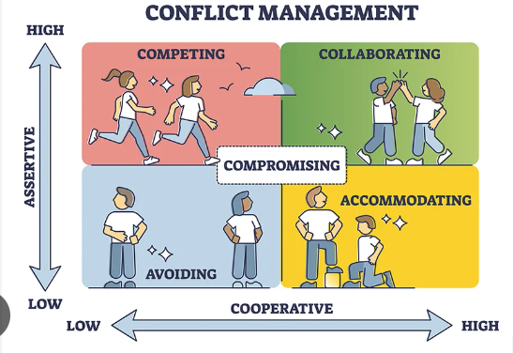

Question 10: Reasons for project failure
Answer 10:
- Improper planning
Lack of proper planning can make a project fail.
Having a successful project depends on property defining in details the scope the time frame, and each member’s role. Proper route has to be laid down to be followed while execution.
- Incosistently defined resources
Planning should not be limited to agendas, meetings, and responsibilities. It should also include human, intellectual, financial or structural resources. If these are not consistently determined, deadlines can’t be met which can harm project’s conclusion
- Unclear Objectives
Objectives should be clearly defined, so as time goes by, we all know if we are doing right or not. Choosing measurable goals helps us better to visualize progress and close monitoring and achieving the results.
- Lack of transparency
It’s essential that everyone involved in the projects have complete project visibility so that it doesn’t fail-not only the project manager, but other team members too.
This includes clear communication, good document management, and transparency about tasks status, all of which can be achieved with centralized mode
- Lack of communication
Communication is the key to good project management, without the right tools and processes to allow interaction among team members
- Unrealistic expectation
Expectation should be matched with project objective, and planning should be done accordingly and should be properly communicated to stakeholders.

Question 11: Challenges faced in projects for BA
Answer 11:
As BA is responsible for multiple tasks at the same time, from handling the projects, maintaining client relationships, interacting with stakeholders, and managing project deadlines.

Few if the challenges faced by business analysts are:
- Ambiguous or changing requirements
- Stakeholder management
- Lack of stakeholder’s involvement
- Unclear project objectives
- Managing conflicts and negotiations
- Project communication
- Time and resource constraints
- Resistance to change-lack of domain knowledge

Question 12: Document Naming Standards
Answer 12:
Document Naming Standards are guidelines designed to ensure consistency, clarity, and manageability in the naming of documents within an organization or project. These standards help in organizing, retrieving, and sharing documents efficiently. Here’s an overview of the key aspects of Document Naming Standards:
1. Clarity and Descriptiveness:
- Objective: Names should clearly convey the content or purpose of the document.
- Guideline: Use descriptive names that provide enough context to understand the document's content without needing to open it.
- Example: Instead of "Report1.docx", use "2024_Sales_Quarterly_Report_Q1.docx".
2. Consistency:
- Objective: Maintain uniformity in naming conventions across all documents to avoid confusion and streamline search and retrieval.
- Guideline: Follow a standardized format for naming documents. This may include using specific date formats, separators, and naming conventions.
- Example: Always use "YYYY-MM-DD" for dates, such as "2024-08-22_Project_Plan.docx".
3. Avoid Special Characters:
- Objective: Ensure compatibility with different systems and avoid potential issues with file handling.
- Guideline: Avoid using special characters (e.g., \ / : * ? " < > |) that may not be supported across all operating systems or file systems.
- Example: Replace spaces with underscores or hyphens, e.g., "Project_Details_Final.pdf" instead of "Project Details Final.pdf".
4. Version Control:
- Objective: Keep track of different versions of a document to manage updates and revisions effectively.
- Guideline: Include version numbers or dates in the document name to differentiate between revisions.
- Example: "Annual_Report_2024_v2.docx" or "Annual_Report_2024_2024-08-22.docx".
5. Document Type Indication:
- Objective: Identify the type of document at a glance.
- Guideline: Include the document type or purpose in the name to make it easier to understand its use.
- Example: "Meeting_Notes_2024-08-22.docx" or "Invoice_12345_2024.pdf".
6. Project or Department Identification:
- Objective: Facilitate organization and retrieval by associating documents with specific projects, departments, or categories.
- Guideline: Include relevant identifiers such as project names, department codes, or client names in the document name.
- Example: "ClientABC_Contract_Draft_2024-08-22.docx".
7. Avoid Ambiguity:
- Objective: Prevent confusion and misinterpretation.
- Guideline: Choose names that are unambiguous and specific to the document’s content and purpose.
- Example: Instead of "Summary.docx", use "Project_X_Summary_August_2024.docx".
8. Length and Readability:
- Objective: Ensure document names are not overly long and remain readable.
- Guideline: Aim for names that are concise yet descriptive. Avoid overly lengthy names that may be truncated or cumbersome.
- Example: "2024_Marketing_Strategy_Overview.docx" is preferred over "2024_Marketing_Strategy_Overview_and_Goals_for_Q1_Q2_Q3_Q4.docx".
9. Date Format:
- Objective: Ensure consistency in date representation to avoid confusion.
- Guideline: Use a consistent date format, typically "YYYY-MM-DD" for clarity.
- Example: "Project_Plan_2024-08-22.docx".
10. Access and Security Considerations:
- Objective: Protect sensitive information and ensure appropriate access.
- Guideline: Avoid including sensitive or confidential information in the document name that could be exposed inadvertently.
- Example: Instead of "Employee_Salary_Confidential_2024.pdf", use "Employee_Salary_Summary_2024.pdf".
By adhering to these Document Naming Standards, organizations can improve document management practices, enhance collaboration, and ensure that documents are easily retrievable and understood by all team members.

Question 13: What are the Do’s and Don’ts of a Business analyst
Answer 13:
- Never say No to the client
- There is NO word called as “BY DEFAULT”
- Never imagine anything in terms of GUI
- Question the existence of existence/question everything in the world
- Ex: what client gives is not always correct
- Consult and SME for clarification in requirements
- Every problem of client is unique. No two problems of different client are same. May be the approach technology, place of use, local laws may be varied to make them to be different.
- Go to client with a plain mind with no assumptions.
- Listen carefully and completely until client is done and then you can ask your queries. Please do not interrupt the client, when he/she is giving you the problem.
- Maximum try to extract the leads to solution from the client itself.
- Never try to give solutions to client straight away with your previous experience and assumptions, try to concentrate on the important and truly required requirements.
- Don’t be washed away by add on functionalities or don’t imagine solutions on screen basis.

Question 14: Difference between packages and sub-systems
Answer 14:
- Packages
A Packages is a grouping and organizing elements in which other elements reside, which must be uniquely named. In the UML, packages are used in a manner similar to the way directories and folder in an operating system group and organize files. For example, the project management system may be decomposed into a collection of classes organised into packages
Example-
packages like com.example.myapp.model, com.example.myapp.service, and com.example.myapp.controller. Each package groups related classes and interfaces together.

- Sub-System
A Sub-System is a larger, independent functional component or module of a software system that encapsulates a significant portion of functionality. It represents a major building block of the software architecture.
Example-
"Order Management System," "Inventory Management System," and "Customer Service System.
Aspects | Packages | Sub-Systems
Level of Abstraction | Lower -level, within a single application | Higher-level, representing major functional areas
Scope | Fine-grained, organizes code within a module | Coarse-grained, represent large functional components
Purpose | Organize related classes and avoid name conflicts | Define major functional boundaries and interaction
Implementation | Language specific, e.g., Java packages, python modules | Independent units or services within the system

while packages are used to organize code within a single application, sub-systems represent broader, self-contained units of functionality that interact with each other to form a complete software system. Packages contribute to modularizing the codebase, whereas sub-systems define the high-level structure and architecture of the system.

Question 15: Camel-casing and Where it will be used
Answer 15:
Camel casing is nothing but a unique way of writing about the code, the developers will write so that they can understand is latter, It is exclusively used by the developers in sequence diagrams.
It is a naming convention used in computer programming and is characterized by removing spaces between words and capitalizing the first letter of each word except for the first word. The name “Camel Casing “is derived from the appearance of the resulting string, which resembles the humps of a camel.
By using camel casing developers can create meaningful and reachable names that are easier to understand and follow coding standards. It promotes consistency within the codebase and improves collaboration among team members.
Examples
- Lower Camel Case:
  - Variable: userName, totalAmount, orderNumber
  - Function: getUserInfo(), calculateDiscount(), processOrder()
- Upper Camel Case:
  - Class: UserAccount, OrderProcessor, DiscountCalculator
  - Namespace: ECommercePlatform, DataAnalytics, CustomerManagement

Question 16: Development server and what are the accesses does business analyst has?
Answer 16:

A development server is just a platform where development team just saves for shorter time till the project is complete and to test, recode, bugs fixing before they are deployed in actual environment

A development server is a type of server that is designed to facilitate the development and testing of programs, websites, software or applications for software programmers. It provides a run-time environment, as well as all hardware/software utilities that are essential to program debugging and development.
A development server is the core tier in a software development environment, where software developers test code directly. It is comprised of essential hardware software and other components used to deploy and test the software under development, including bulk storage development platform tools and utilities, network access and high-end processor.

BA has the below mentioned access-(do not have exclusive rights)
- Visualizing access
- Read only access
- Collaborative access
- Limited configuration access

Question 17: Data Mapping?
Answer 17:
Data mapping is the process of establishing a relationship or connection between data elements in two or more different data sources or data formats. It involves defining how data from one source corresponds to or transforms into data in another source. Data mapping is commonly used in data integration, data migration, and data transformation process.
The purpose of data mapping is to ensure that the data can be accurately and effectively transferred, converted or transformed between different system, database or format. It involves identifying the source data elements, determining their meaning and structure and mapping them to the corresponding target data.
Data mapping bridges the gap between two systems so that when data is moved from a source is is accurate and usable at the destination
Example:

Let’s assume I go to amazon and I want 100 shoe that are pink in colour, now when I say 100 shoe in pink colour the query will go to database and check how many pink items are there with multiple database and revert in very quick manner as today’s environment is very fast.

Question 18: What is API. Explain how you would use API integration in the case of your application Date format is dd-mm-yyyy and it is accepting some data from Other Application from US whose Date Format is mm-dd-yyyy
Answer 18:
An Application Programming interface (API) is a set of rules and protocols that allows different software applications to communicate and interact with each other. It is nothing but a communication channel between your application and 3rd party application.
It provides a secure and standardized way for applications to work with each other and deliver the information or functionality requested without user intervention.
It acts as a intermediary layer that process data transfers between systems, letting companies open their application data and functionality to external parties and developers.
Process that API follows for integration

Establish API Communication: Set up API communication between your application and the other application to exchange data.
- Data formatting: when sending date data from your application to the other application, convert the date from the dd-mm-yyyy format to the mm-dd-yyyy format. This can be achieved by extracting the day, month and year components from the date and rearranging them according to the target format.
Example- Let’s assume there are two application A and B 1st we have to set a relationship between A and B and then we have to make sure we send the data in correct format from our application A i.e., dd-mm-yyyy which will be formatted as per rules and protocols set with their application B i.e., mm-dd-yyyy, we need to make sure this rearranges according to target format.

- Data Parsing: When receiving the date data from another application, parse the mm-dd-yyyy formatted date into your application’s dd-mm-yyyy format. Again, you will need to extract day, month and year components and rearrange them accordingly.

- Data Validation: Perform data validation and ensure that the converted data remains valid after the format conversion. Check for edge cases, such as invalid date or date ranges that might be affected by the format conversion.

Example- While receiving the data I want the data to be in my format the data will be parsed and it will rearrange in my format i.e., dd-mm-yyyy
While transferring validation should be done

DD-MM-YYYY
22-08-2024

Convert the date to

MM-DD-YYYY
08-22-2024

