Document 6- Please prepare a use case diagram, activity diagram and a use case specification document.

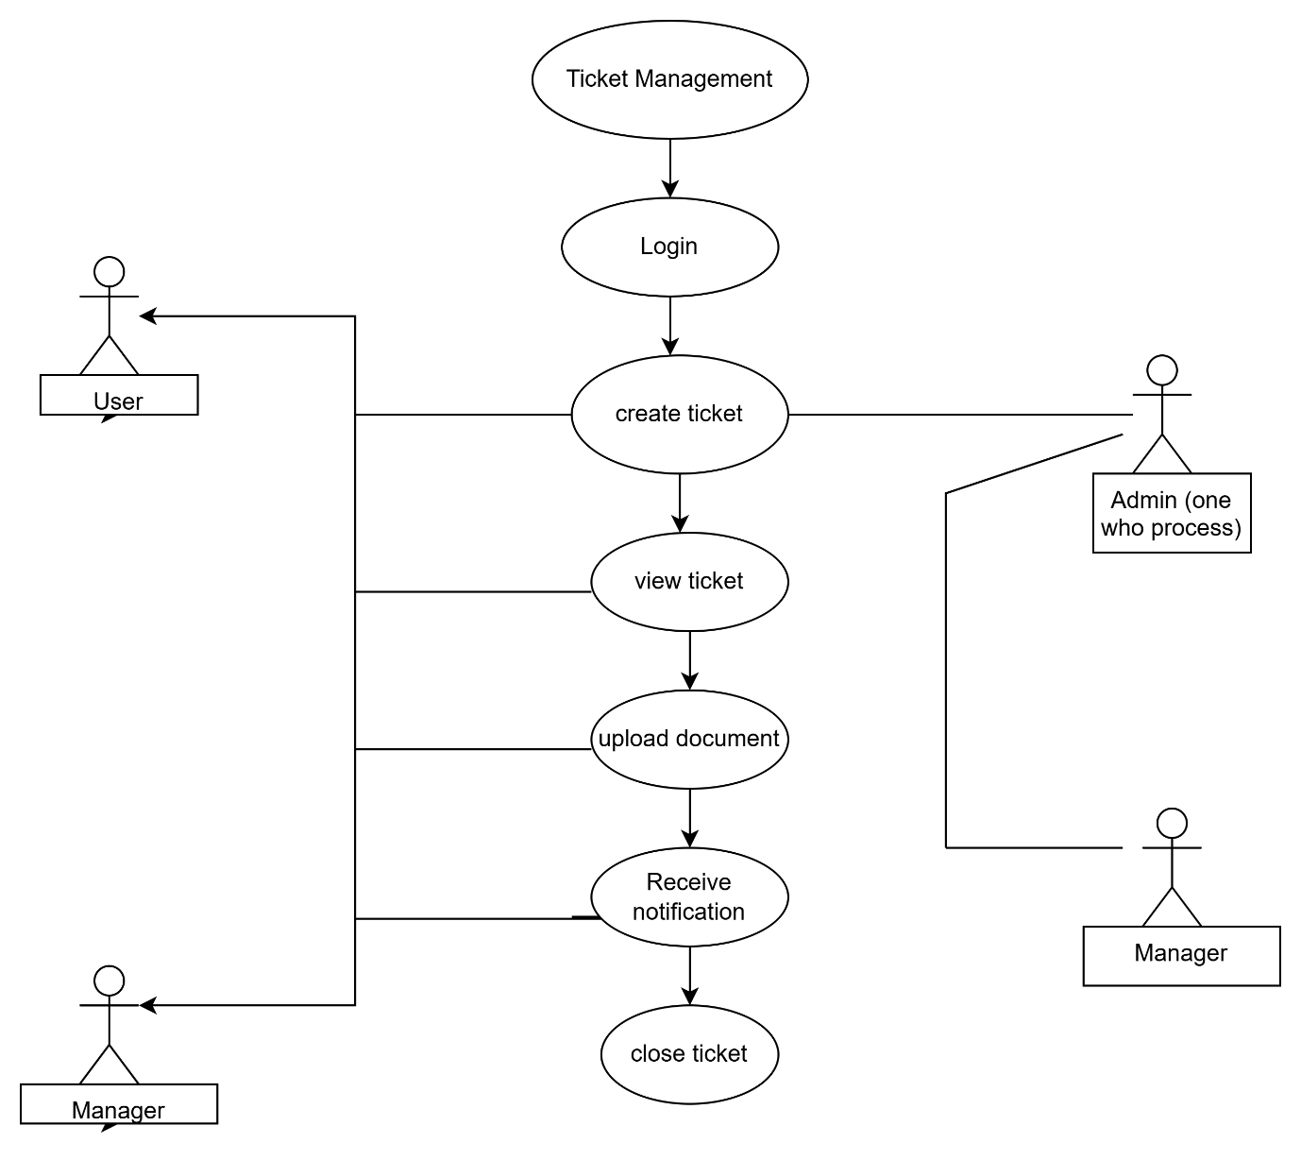
Field | Details
Use case Name | Create Ticket
Use case Description | This case allows the user to raise new service request in the SUITCRM, SYSTEM including attaching docs and selecting the type of issue
Actors Primary Actors Secondary actors | Primary actor: user  Secondary : admin
Basic Flow | - User login 2. Navigates to create ticket. 3. Enter ticket details, 4 uploads documents, 5 Submits the ticket 6 system auto generates ticket id and assigns to appropriates team
ALTERNATE FLOW | User skips non mandatory fields system allows submition but warns user
Exceptional flows | If internet is disconnected or server error message shown- Duplicate ticket ID scenario handled by system.
Pre- Conditions | User must authenticate (logged in)
post-conditions | Ticket is successfully created assigned and acknowledged in the system
Assumptions | System is up and accessible -user has valid login credentials
Constraints | All mandatory fields must be filled only valid format allowed for upload
Dependencies | Server uptime- workflow routing rules set by admin
Inputs | Ticket title category description document attachment
Outputs | Ticket ID system confirmation email/sms acknowledgment
Business Rules | Ticket ID must be unique some ticket types require manager approval
Miscellaneous Information | Ticket creation is logged in audit trail forcompliance.

Activity diagram

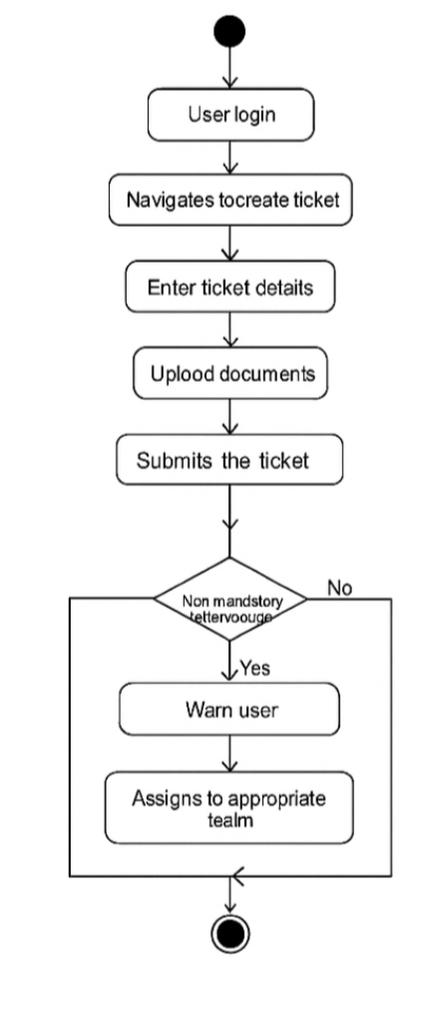
- Use Case Name: Create Ticket
- Use Case Description:
Allows users to create a new ticket in the SUITCRM system, including filling in details, attaching documents, and submitting the ticket.
- Actors:
  - Primary: User
  - Secondary: Admin
- Basic Flow:
  - User logs in
  - Navigates to the “Create Ticket” page
  - Enters ticket details
  - Uploads documents
  - Submits the ticket
  - System generates a ticket ID and assigns it to the appropriate team
- Alternate Flow:
  - If the user skips non-mandatory fields, the system allows submission but shows a warning message
- Exception Flows:
  - If the internet is disconnected or a server error occurs, an error message is shown
  - Duplicate ticket ID is handled by the system
- Post-Conditions:
  - The ticket is successfully created, assigned to a team, and logged in the system
- Assumptions:
  - The system is up and running
  - The user has valid login credentials
- Constraints:
  - All mandatory fields must be filled
  - Only valid formats are allowed for document uploads
- Dependencies:
- Server uptime
- Workflow routing rules set by the admin
- Inputs:
- Ticket title
- Category
- Description
- Document attachments
- Outputs:
- Unique Ticket ID
- System-generated confirmation email/SMS
- Business Rules:
- Ticket ID must be unique
- Some ticket types require manager approval
- Miscellaneous Information:
Ticket creation is logged in the audit trail for compliance

A use case specification document.

Use case 1 Ticket Creation

Actors | User, System, Agent
Use case name | Ticket Creation
Description | To allow users to create a new ticket for issues like refunds, policy issuance, etc.
Precondition | User must be logged in.
Post condition | Ticket is created and assigned to the correct team.

Use case 2 : Ticket Assignment

Actor | System, Agent
Use Case Name | Ticket Assignment
Description | Automatically assign tickets to appropriate teams based on workflow.
Precondition | Ticket must be created.
Postcondition | Ticket is assigned and team is notified.

Use case 3 : Document Upload

Actor | User, System
Use Case Name | Document Upload
Description | Upload policy or approval documents during ticket creation.
Precondition | Ticket form is active.
Postcondition | Document is saved with the ticket.

Use case 4 : Notification Trigger
Actor | System
Use Case Name | Notification Trigger
Description | To send automated emails/SMS on ticket activity.
Precondition | Ticket action must occur (create/update/close)
Postcondition | User and team receive notification.

Use case 5 : Ticket Tracking

Actor | User, System
Use Case Name | Ticket Tracking
Description | Users can track real-time status of their tickets.
Precondition | Ticket must be submitted.
Postcondition | User sees ticket progress.

Document 7- Screens and pages

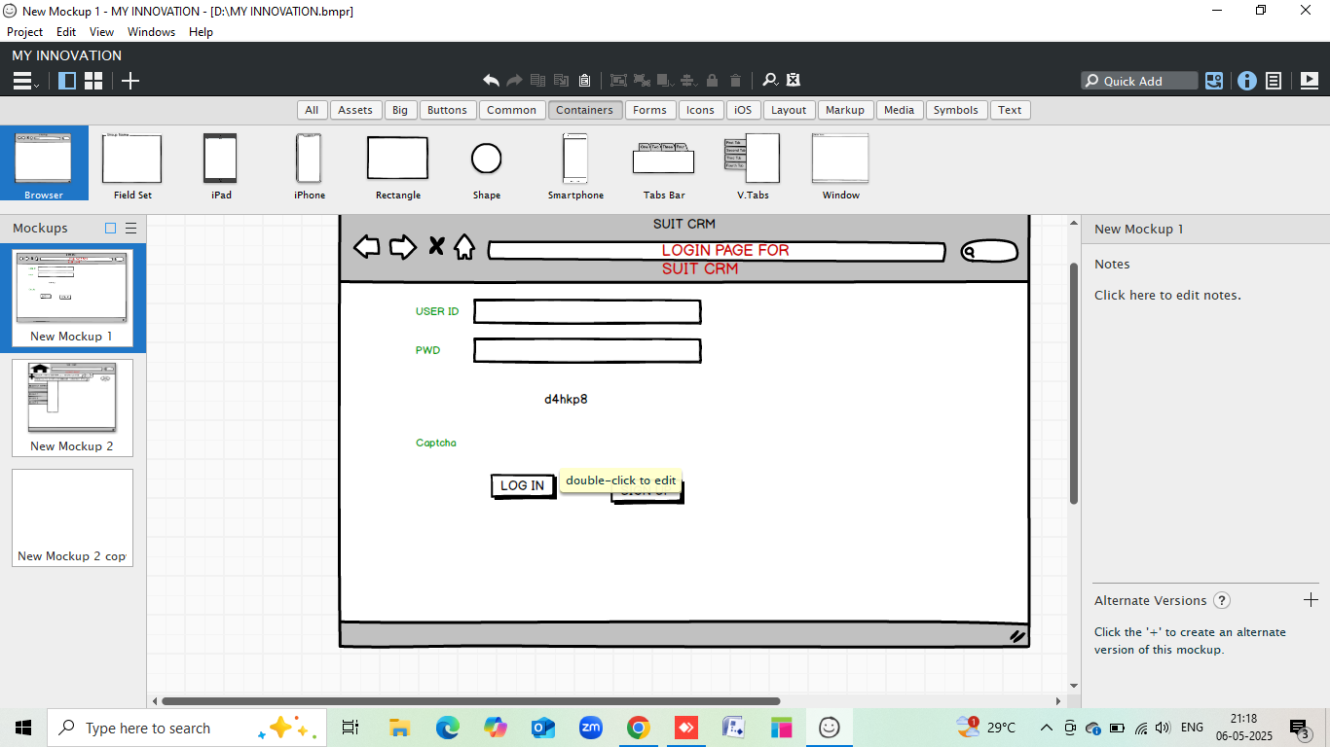

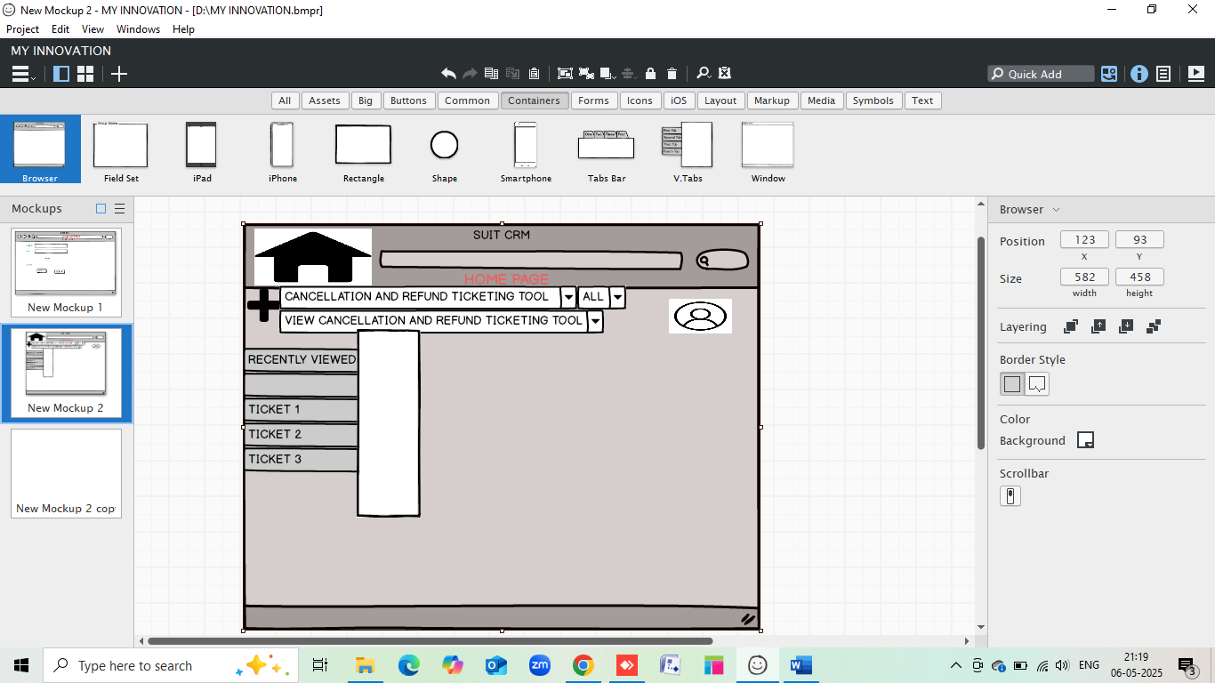

POLICY ISSUENCE SCREEN
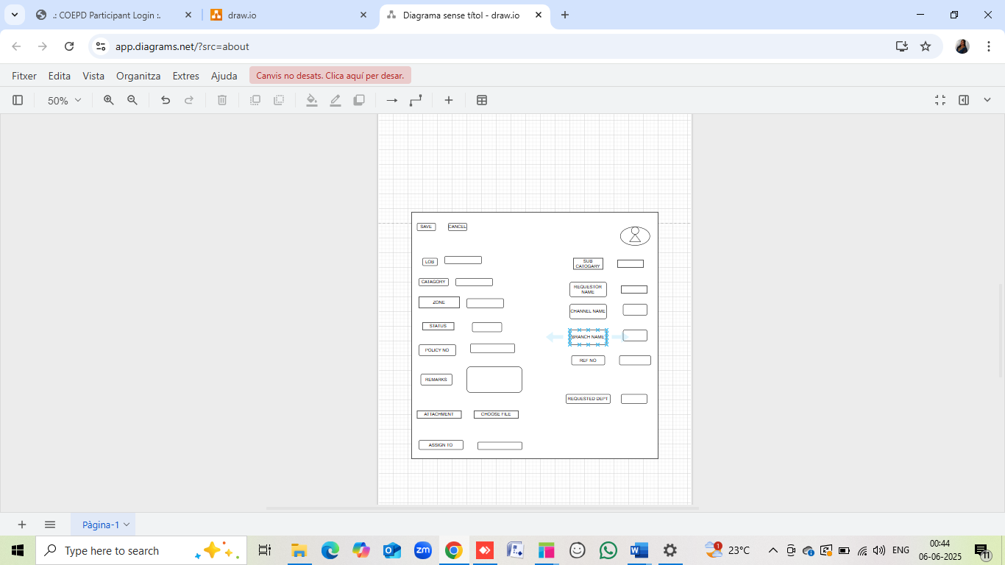

CANCELLATION AND REFUND

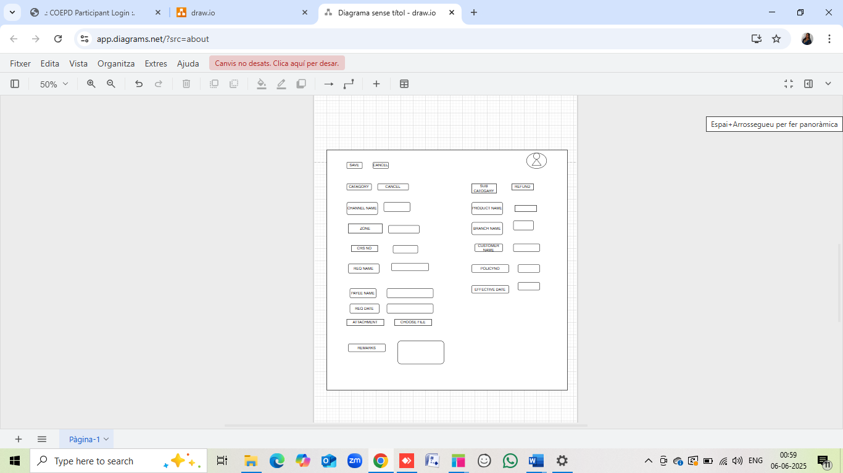

APPROVAL PAGE:
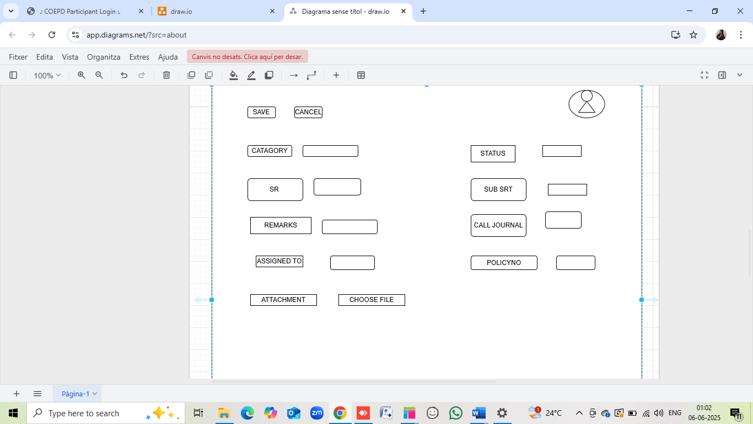

Document 8- Tools-Visio and Axure

My Experience Using Visio and Axure for the Project
As a Business Analyst, I utilized Microsoft Visio to create various UML diagrams, including use case diagrams, activity diagrams, and process flows. Visio helped me to visually represent complex workflows and system interactions in a clear and structured manner. I used standard notations to ensure the technical team could easily interpret the diagrams. This enabled better communication of requirements and improved clarity during discussions with stakeholders.
On the other hand, Axure was used for designing interactive wireframes and mock-ups. With Axure, I was able to demonstrate the user interface behaviour, transitions between screens, and dynamic content functionalities. This tool was especially useful during stakeholder presentations and validations, as it allowed them to understand the look and feel of the application before development started. Axure’s drag-and-drop features and widget library made the design process fast and efficient. Overall, both tools significantly contributed to accurately capturing and communicating the requirements throughout the SDLC.
Although I created my diagrams using draw.io for simplicity and accessibility, I also explored Visio and Axure to understand their industry relevance. Microsoft Visio is a powerful tool for designing UML diagrams like use case and activity diagrams. It offers a wide range of templates and drag-and-drop features that simplify diagramming. Axure is excellent for creating interactive wireframes and screen mock-ups. It helps visualize how users interact with the system by providing realistic prototypes. While I didn’t use these tools for final submission, I now understand how they are beneficial for BA documentation and prototyping in real-time projects.

Document 9- BA experience
BA Experience (SuitCRM Project)
1. Requirement Gathering:
In the SuitCRM project, I used the MoSCoW technique to prioritize the client’s needs. As the client was intermittently unavailable, I identified alternate stakeholders to ensure the timely collection of business requirements. I validated all gathered requirements using the FURPS model, ensuring that they met the necessary Functionality, Usability, Reliability, Performance, and Supportability criteria. To avoid confusion, I eliminated redundant requirements. Additionally, I leveraged prototyping to refine unclear requirements, which helped the client visualize the final product early.
2. Requirement Analysis:
I created UML diagrams (like use case and activity diagrams) to help the team understand processes visually. These were shared across teams and revised based on feedback. This phase also included the preparation of key artifacts like BRS (Business Requirement Specification) and SRS (Software Requirement Specification), ensuring every stakeholder was aligned with project goals and scope.
3. Design:
From the use cases, I developed comprehensive test cases, covering both positive and negative scenarios. I ensured nothing was missed, as each test case had the potential to impact project delivery. I worked closely with the client to finalize the design and solution documents. Additionally, I maintained and updated the Requirement Traceability Matrix (RTM), ensuring every requirement was linked to its corresponding design and test case.
4. Development:
During development, I conducted JAD (Joint Application Development) sessions to bridge communication between business and technical teams. I resolved any interpersonal issues among team members through one-on-one sessions to maintain a collaborative environment. I regularly clarified doubts raised by the development team, referred to earlier diagrams and documents, and coordinated closely with the client and team through status meetings. For those who missed meetings, I recorded and shared the sessions to ensure alignment.
5. Testing:
I collaborated with QA teams, providing them with all necessary documentation and test data. I reviewed test scenarios and ensured they were aligned with business requirements. Any bugs reported were discussed with the dev team and retested once resolved. I was actively involved in User Acceptance Testing (UAT) and coordinated client feedback for final adjustments.
6. Deployment:
I was part of the final go-live checklist validation. I ensured all client expectations were met and no critical issues were pending. I also helped prepare user manuals and training materials for end-users and conducted walkthrough sessions to ensure a smooth transition. Post-deployment, I monitored the solution for any issues and facilitated quick resolutions.

