Q.1 – Functional Requirements
Ans. – Functional Requirements

Req Id | Req Name | Req Description | Priority
FR0001 | Farmer Registration | Farmers should be able to register with the Application | 9
FR0002 | Farmer search for Product | Farmer should be able to search for available product in fertilizers, seeds, pesticides | 8
FR0003 | No Matching Product | Farmer should notify if search product not found | 5
FR0004 | Product selection | Farmer should be able to select the product | 7
FR0005 | Out of Stock | Farmer should be notified, if the product is out of stock | 7
FR0006 | Filter | Farmer should be able to filter and select the product as per brand and Price | 7
FR0007 | Similar Product | Farmers should be able to select similar products, if the search product is out of stock | 6
FR0008 | Bought together | Once the product is finalized, farmers should be suggested with related product as a package with the price | 6
FR0009 | Add to Cart | Farmers Should be able to add the product to the cart for purchase | 8
FR0010 | Wishlist | Farmers Should have an option to Add the product to Wishlist | 6
FR0011 | Save it for Later | Farmers should be able to see the option for Save it for Later, to purchase later | 7
FR0012 | Delivery Address | Farmers should be able to select the Delivery Address to deliver the product | 8
FR0013 | Payment Option | Once the Delivery Address is selected, Application should show the Payment option to the farmer for purchasing the product | 8
FR0014 | Payment Confirmation | Farmers should receive the payment confirmation Email and SMS | 10
FR0015 | Order Confirmation | Farmers should receive the Order confirmation Email and SMS | 9
FR0016 | Expected Delivery Date | Farmers should also see the Expected Delivery date of the product | 9
FR0017 | Track Delivery | Farmer should have the option to Track the delivery on the Application | 8
FR0018 | Cancel/Return/Replacement | Farmers should be able to cancel/return/Replacement of the product | 9
FR0019 | Return Pick Up | Farmers should be given Pick up date for cancel/return | 7
FR0020 | Return Confirmation | Farmers should receive SMS and Email confirmation for cancellation/Return | 7

Non-Functional Requirements
Req ID | Req Name | Req Description | Priority
NFR001 | Page Loading time | Each page should load Within 2 sec | 9
NFR002 | Technical Support System | Application can be used on any OS (Android/IOS) | 9
NFR003 | Time limit for OTP | OTP time limit should be given maximum of 5 min for Login and Registration Process | 4
NFR004 | Logout System | If the page is not accessed for more than 5 min, the page should log out automatically | 4
NFR005 | Stock Availability | Stock Availability should be updated on a real time Basis | 8
NFR006 | SMS and Mail Confirmation | Automated Email and SMS notification should be sent to users | 8
NFR007 | Back up | All data should be gotten backup Automatically | 9
NFR008 | Connectivity | System should be connected with internet | 10
NFR009 | Stock Alert | Seller should receive stock alert notification when stock is reduced, every week | 8
NFR010 | Net Banking | Bank accounts should be active in nature for a smooth payment process | 9
NFR011 | Check Stock | Once the product is sold, the stock of the product should be reduced | 7
NFR012 | Email Address | Email address should be active to receive Email notifications | 3
NFR013 | Taxation system | All products should be included with additional Tax | 8
NFR014 | Password | Users should receive Password change alert every 30 days | 5

Q.2 – Minimum 5-page designs (make wireframe and Prototypes)
Ans. - wireframe and Prototypes
- Home Page

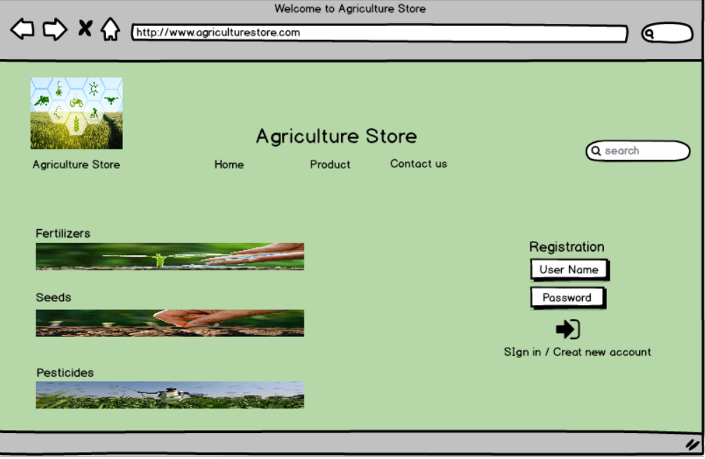
- Registration Page

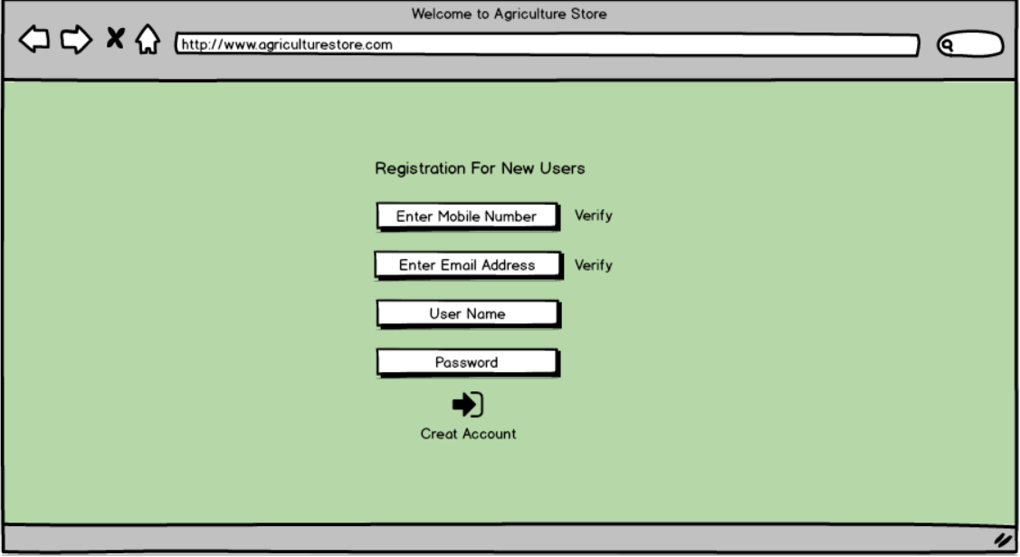

- Product Page
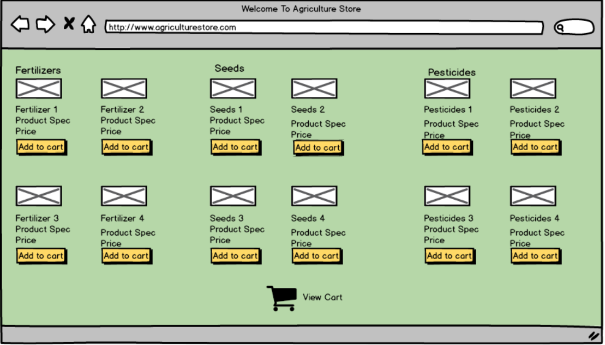

- View Cart Page
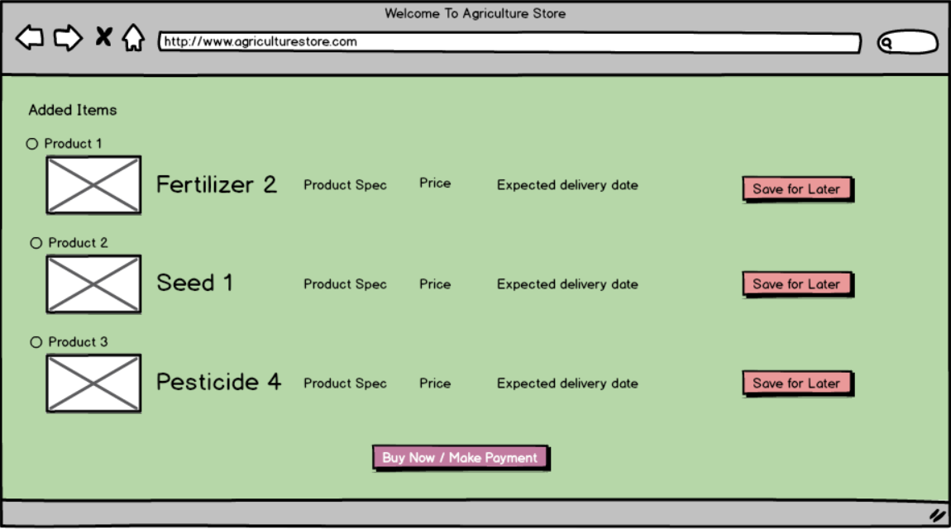

- Payment Page
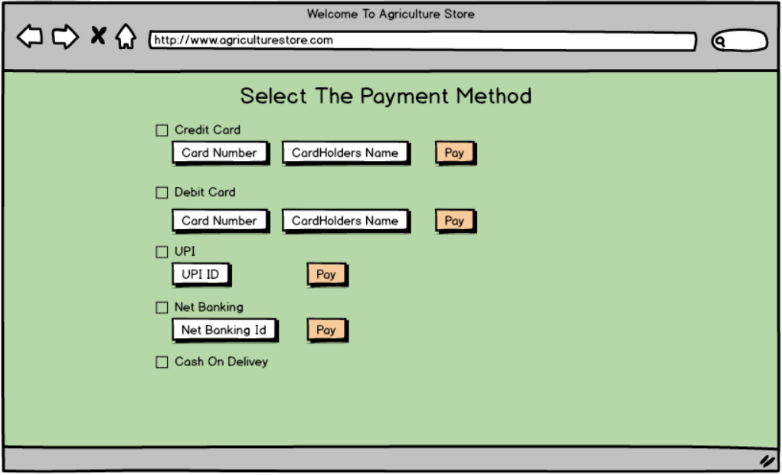

Q.3 – Tools (Visio, Balsamiq). Make a note of the tools which you are using for the above concept.

Ans. – Visio and Balsamiq
- Microsoft Office Visio – Microsoft Visio is a diagramming and vector graphic application and is part of Microsoft Office family. It is used to create diagram types such as Flowchart, Org chart, Floor Plan, Network Diagram, UML diagrams Mind Maps and more. It is also commonly used for scenarios such as process Mapping and Visual collaboration. The latest version of Visio also had Data Visualization that allows users to create diagram from Excel data and also embed Visio diagram in Power BI dashboard.
Visio is a tool that eases the process of making complex diagrams. Especially for Business Purpose. It can help with the making of presentations, floor plans, org chart etc. Listed below are some uses of Visio:
- Flowchart – A Flowchart helps to show the steps in sequential order. These are steps that need to be taken to complete a certain process. It is effective in conveying information. Thus, it can be used in various other fields too.
- Organization Chart – An Org chart displays the roles and reporting relationship in a business organization. It can be used in also any other organization. It depicts the names and positions of employees in a business organization. In short we can say that it shows the structure of an organization.
- Floor Plan – A floor plan is a structure of a room or floor. Architects use floor plans to place order, windows and other objects. Visio also offer the floor plan template.
- Business process Modelling Notation – BPMN is a flowchart method of displaying all the process in a business that is be taken. In other words, it helps in giving a clear understanding of the process in a particular business through visual representation.

- Balsamiq – Balsamiq Mockups is an effective tool for presenting the software requirement in the form of wireframe. This helps the software development team to visualize how the software project will look like in the very early stage of development. This is a small tutorial where we will cover all the basic steps needed to start with Balsamiq Mockups.

Q.4 – RTM

Ans. – RTM
Req ID | Req Name | Req Description | Design | D1 | T1 |  | D2 | T2 | D3 | T3 | D4 | T4 | UAT
FR0001 | Farmers Registration | Farmers should be able to register with the application | Y | Y |  | Y | Y | Y | Y | Y | Y | Y | N
FR0002 | Farmer search for product | Farmers should be able to search for available products in fertilizer, seeds and Pesticides | Y | Y |  | Y | Y | Y | Y | Y | Y | Y | N
FR0003 | No Matching Product | Farmer should be notified if the search product is not found | Y | Y |  | Y | Y | Y | Y | Y | N | N | N
FR0004 | Product Selection | Farmer should be able to select the product | Y | Y |  | Y | Y | Y | Y | N | N | N | N
FR0005 | Out of Stock | Farmer should be notified if the product is out of stock | Y | Y |  | Y | N | N | N | N | N | N | N
FR0006 | Filter | Farmer should be able to filter and select the product as per brand and price | Y | Y |  | Y | N | N | N | N | N | N | N
FR0007 | Similar Product | Farmer should be able to select similar product, if the searched product is out of stock | Y | Y |  | Y | N | N | N | N | N | N | N
FR0008 | Bought Together | Once the product is finalized, farmer should be suggested with related product as a package with price | Y | Y |  | Y | Y | Y | N | N | N | N | N
FR0009 | Add to Cart | Farmer should be able to Add the product to the cart for purchase | Y | Y |  | Y | Y | N | N | N | N | N | N
FR0010 | Wishlist | Farmers should have an option to Add the product into Wishlist | Y | Y |  | Y | N | N | N | N | N | N | N
FR0011 | Save it for Later | Farmers should be able to see the option for save it Later, to purchase later | Y | Y |  | Y | N | N | N | N | N | N | N
FR0012 | Delivery Address | Farmers should be able to select the delivery address to the deliver the product | Y | Y |  | Y | N | N | N | N | N | N | N
FR0013 | Payment Option | Once the Delivery Address is selected, Application should show the Payment option to the farmer for purchasing the product | Y | Y |  | Y | N | N | N | N | N | N | N
FR0014 | Payment Confirmation | Farmers should receive the payment confirmation Email and SMS | Y | Y |  | Y | Y | Y | N | N | N | N | N
FR0015 | Order Confirmation | Farmers should receive the Order confirmation Email and SMS | Y | Y |  | Y | N | N | N | N | N | N | N
FR0016 | Expected Delivery Date | Farmers should also see the Expected Delivery date of the product | Y | Y |  | Y | N | N | N | N | N | N | N
FR0017 | Track Delivery | Farmer should have the option to Track the delivery on the Application | Y | Y |  | Y | N | N | N | N | N | N | N
FR0018 | Cancel/Return/Replacement | Farmers should be able to cancel/return/Replacement of the product | Y | Y |  | Y | Y | Y | N | N | N | N | N
FR0019 | Return Pick Up | Farmers should be given Pick up date for cancel/return | Y | Y |  | Y | N | N | N | N | N | N | N
FR0020 | Return Confirmation | Farmers should receive SMS and Email confirmation for cancellation/Return | Y | Y |  | Y | N | N | N | N | N | N | N

Non-Functional Requirements
Req ID | Req Name | Req Description | Design | D1 | T1 | D2 | T2 | D3 | T3 | D4 | T4 | UAT
NFR001 | Page Loading time | Each page should load Within 2 sec | Y | Y | Y | Y | Y | Y | Y | Y | Y | N
NFR002 | Technical Support System | Application can be used on any OS (Android/IOS) | Y | Y | Y | Y | Y | N | N | N | N | N
NFR003 | Time limit for OTP | OTP time limit should be given maximum of 5 min for Login and Registration Process | Y | Y | Y | N | N | N | N | N | N | N
NFR004 | Logout System | If the page is not accessed for more than 5 min, the page should log out automatically | Y | Y | Y | N | N | N | N | N | N | N
NFR005 | Stock Availability | Stock Availability should be updated on a real time Basis | Y | Y | Y | N | N | N | N | N | N | N
NFR006 | SMS and Mail Confirmation | Automated Email and SMS notification should be sent to users | Y | Y | Y | Y | Y | N | N | N | N | N
NFR007 | Back up | All data should be gotten backup Automatically | Y | Y | Y | Y | N | N | N | N | N | N
NFR008 | Connectivity | System should be connected with internet | Y | Y | Y | Y | Y | N | N | N | N | N
NFR009 | Stock Alert | Seller should receive stock alert notification when stock is reduced, every week | Y | Y | Y | N | N | N | N | N | N | N
NFR010 | Net Banking | Bank accounts should be active in nature for a smooth payment process | Y | Y | Y | N | N | N | N | N | N | N
NFR011 | Check Stock | Once the product is sold, the stock of the product should be reduced | Y | Y | Y | Y | Y | N | N | N | N | N
NFR012 | Email Address | Email address should be active to receive Email notifications | Y | Y | Y | N | N | N | N | N | N | N
NFR013 | Taxation system | All products should be included with additional Tax | Y | Y | Y | N | N | N | N | N | N | N
NFR014 | Password | Users should receive Password change alert every 30 days | Y | Y | Y | N | N | N | N | N | N | N

Q.5 – 10 Test case Documents
Ans. – 10 Test case Documents
Q.5 – 10 Test case Documents
Ans. – 10 Test case Documents
1.Test case for User Login Details
Project Name: Online Agriculture Product Store | Test Designed By: Priyanka
Module Name: Login With User Details | Test Designed Date: 5 July 2025
Release Version: | Test Executed By: Priyanka
 | Test Execution Date: 5 July 2025

Pre-Condition | User Need a valid Username and password for login the online store
Dependencies | Users should have an active internet
Test Priority

Test Scenario | Test Cases | Test Steps | Test Data | Expected Result | Post Condition | Actual Result | Status
Verify the login of Online Agriculture Product Store | Entered valid Username and Password | Enter Username | <valid username> | Successful Login | Home Page | Successfully Logged in | Pass
Verify the login of Online Agriculture Product Store | Entered valid Username and Password | Enter Password | <valid password>
Verify the login of Online Agriculture Product Store | Entered valid Username and Password | Click Login Button
Verify the login of Online Agriculture Product Store | Entered valid Username and invalid  Password | Enter Username | <valid username> | The username or password is not correct. Please enter correct username and password | Invalid Username or Password | Popup banner shows “Invalid Password” | Fail
Verify the login of Online Agriculture Product Store | Entered valid Username and invalid  Password | Enter Password | <invalid password>
Verify the login of Online Agriculture Product Store | Entered valid Username and invalid  Password | Click Login Button
Verify the login of Online Agriculture Product Store | Entered Invalid Username and Valid Password | Enter Username | <Invalid username> | The username or password is not correct. Please enter correct username and password | Invalid Username or Password | Popup banner shows “Invalid Password” | Fail
Verify the login of Online Agriculture Product Store | Entered Invalid Username and Valid Password | Enter Password | <valid password>
Verify the login of Online Agriculture Product Store | Entered Invalid Username and Valid Password | Click Login Button
Verify the login of Online Agriculture Product Store | Entered Invalid Username and Invalid Password | Enter Username | <Invalid username> | The username or password is not correct. Please enter correct username and password | Invalid Username or Password | Popup banner shows “Invalid User Details” | Fail
Verify the login of Online Agriculture Product Store | Entered Invalid Username and Invalid Password | Enter Password | <invalid password>
Verify the login of Online Agriculture Product Store | Entered Invalid Username and Invalid Password | Click Login Button
2.Test Case for Cash on Delivery/Pay on Delivery
Project Name: Online Agriculture Product Store | Test Designed By: Priyanka
Module Name: Cash on Delivery/Pay on Delivery | Test Designed Date: 5 July 2025
Release Version: | Test Executed By: Priyanka
 | Test Execution Date: 5 July 2025

Pre-Condition | User should have a Bank account for any payment Gateway to select
Dependencies | Users should have an active internet
Test Priority

Test Scenario | Test Cases | Test Steps | Test Data | Expected Result | Post Condition | Actual Result | Status
Verify the Availability of COD | Select COD payment gateway | COD | <cash, UPI, card also accepted> | Order Placed | Home Page | Order Placed | Pass
Verify the Availability of COD | COD not available | COD not available | <COD available on selected items> | Choose another payment method | Payment Page | COD not available | Fail

3.Test Case for Debit Card

Project Name: Online Agriculture Product Store | Test Designed By: Priyanka
Module Name: Using Debit Card | Test Designed Date: 5 July 2025
Release Version: | Test Executed By: Priyanka
 | Test Execution Date: 5 July 2025

Pre-Condition | User should have a Debit card and bank account for this payment method
Dependencies | Users should have an active internet
Test Priority

Test Scenario | Test Cases | Test Steps | Test Data | Expected Result | Post Condition | Actual Result | Status
Verifying the selection Debit card as Payment Method | Enter card Details and OTP correctly | Enter Card Number | <valid card number> | Payment Successful | Order Page | Order Placed Successfully | Pass
Verifying the selection Debit card as Payment Method | Enter card Details and OTP correctly | Enter Expiry Date | <valid expiry>
Verifying the selection Debit card as Payment Method | Enter card Details and OTP correctly | Enter CVV
Verifying the selection Debit card as Payment Method | Enter card Details and OTP correctly | Enter OTP | <valid OTP>
Verifying the selection Debit card as Payment Method | Entered card number correctly but incorrect expiry date | Enter Card Number | <valid card number> | Enter correct Expiry Date | Incorrect Expiry Date | Enter the correct expiry date | Fail
Verifying the selection Debit card as Payment Method | Entered card number correctly but incorrect expiry date | Enter Expiry Date | <Incorrect expiry date>
Verifying the selection Debit card as Payment Method | Entered card number correctly but incorrect expiry date | Enter CVV
Verifying the selection Debit card as Payment Method | Entered card number correctly but incorrect expiry date | Enter OTP | <valid OTP>
Verifying the selection Debit card as Payment Method | Entered incorrect card number but incorrect OTP | Enter Card Number | <valid card number> | Enter Correct OTP | Incorrect OTP entered | Enter Correct OTP | Fail
Verifying the selection Debit card as Payment Method | Entered incorrect card number but incorrect OTP | Enter Expiry Date | <valid expiry>
Verifying the selection Debit card as Payment Method | Entered incorrect card number but incorrect OTP | Enter CVV
Verifying the selection Debit card as Payment Method | Entered incorrect card number but incorrect OTP | Enter OTP | <Incorrect OTP>

4.Test for Credit Card

Project Name: Online Agriculture Product Store | Test Designed By: Priyanka
Module Name: Using Credit Card | Test Designed Date: 5 July 2025
Release Version: | Test Executed By: Priyanka
 | Test Execution Date: 5 July 2025

Pre-Condition | User should have a Credit card and bank account for this payment method
Dependencies | Users should have an active internet
Test Priority

Test Scenario | Test Cases | Test Steps | Test Data | Expected Result | Post Condition | Actual Result | Status
Verifying the selection of credit cards as Payment Method | Enter card Details and OTP correctly | Enter Card Number | <valid card number> | Payment Successful | Order Page | Order Placed Successfully | Pass
Verifying the selection of credit cards as Payment Method | Enter card Details and OTP correctly | Enter Expiry Date | <valid expiry>
Verifying the selection of credit cards as Payment Method | Enter card Details and OTP correctly | Enter CVV
Verifying the selection of credit cards as Payment Method | Enter card Details and OTP correctly | Enter OTP | <valid OTP>
Verifying the selection of credit cards as Payment Method | Entered card number correctly but incorrect expiry date | Enter Card Number | <valid card number> | Enter correct Expiry Date | Incorrect Expiry Date | Enter the correct expiry date | Fail
Verifying the selection of credit cards as Payment Method | Entered card number correctly but incorrect expiry date | Enter Expiry Date | <Incorrect expiry date>
Verifying the selection of credit cards as Payment Method | Entered card number correctly but incorrect expiry date | Enter CVV
Verifying the selection of credit cards as Payment Method | Entered card number correctly but incorrect expiry date | Enter OTP | <valid OTP>
Verifying the selection of credit cards as Payment Method | Entered correct card number but incorrect OTP | Enter Card Number | <valid card number> | Enter Correct OTP | Incorrect OTP entered | Enter Correct OTP | Fail
Verifying the selection of credit cards as Payment Method | Entered correct card number but incorrect OTP | Enter Expiry Date | <valid expiry>
Verifying the selection of credit cards as Payment Method | Entered correct card number but incorrect OTP | Enter CVV
Verifying the selection of credit cards as Payment Method | Entered correct card number but incorrect OTP | Enter OTP | <Incorrect OTP>

5. Test Case for Product Availability for Selected Address

Project Name: Online Agriculture Product Store | Test Designed By: Priyanka
Module Name: Product Availability for Selected address | Test Designed Date: 5 july 2025
Release Version: | Test Executed By: Priyanka
 | Test Execution Date: 5 July 2025

Pre-Condition | Users should have a valid postal address with postal code
Dependencies | Users should have an active internet
Test Priority

Test Scenario | Test Cases | Test Steps | Test Data | Expected Result | Post Condition | Actual Result | Status
Verify the product delivery on the selected Postal code | Entered valid postal code to check the delivery | Enter the Postal code | <Postal code Available> | Product is available to this Postal code | Product Page | Page accepts the postal code for product selection | Pass
Verify the product delivery on the selected Postal code | Entered incorrect Postal code to check the delivery | Enter Postal Code | <currently out of stock> | Product is not available in this postal code | Product Page | Pop up banner shows “currently out of stock for this postal code” | Fail

- Test case for Product Cancellation/Return
Project Name: Online Agriculture Product Store | Test Designed By: Priyanka
Module Name: Product Cancellation/Return | Test Designed Date: 5 July 2025
Release Version: | Test Executed By: Priyanka
 | Test Execution Date: 5 July 2025

Pre-Condition | Users should have a valid Order Processed
Dependencies | Users should have an active internet
Test Priority

Test Scenario | Test Cases | Test Steps | Test Data | Expected Result | Post Condition | Actual Result | Status
Testing the Product cancellation/  Return | Select the product cancellation/ return within the return period | Select cancel/ Return | <cancel/ return selected> | Product cancellation/ return successful | Product cancellation page | Product cancellation/ Return successful | Pass
Testing the Product cancellation/  Return |  | Select cancel/ Return reason | <cancel reason selected>
Testing the Product cancellation/  Return |  | Select Pickup address | <pickup address selected>
Testing the Product cancellation/  Return | Select the product cancellation/ return within the return period | Select cancel/ Return | <cancellation not available> | Product is not available cancellation as its out of cancellation period | Order Page | Pop up banner shows “cancellation/ return not available | Fail

- Test case for Shopping Cart
Project Name: Online Agriculture Product Store | Test Designed By: Priyanka
Module Name: Shopping Cart | Test Designed Date: 5 July 2025
Release Version: | Test Executed By: Priyanka
 | Test Execution Date: 5 july 2025

Pre-Condition | Users should be a Registered Customer
Dependencies | Users should have an active internet
Test Priority

Test Scenario | Test Cases | Test Steps | Test Data | Expected Result | Post Condition | Actual Result | Status
Test that all items are added into cart | Selected Items are added in cart successfully | Select Add to cart | <item Added to cart> | Selected items in cart | Items in cart page | Items are added to cart successfully | Pass
Test that the user is able to increase/ decrease quantity from the cart | Item quantity is increased/ decreased successfully | Select item quantity | <item quantity selected> | Item quantity is selected and added to cart | Items in cart page | Items added to cart successfully | Pass
 | Item quantity is increased/ decreased successfully | Select add to cart | <item added to cart>

- Test case for applying coupon code
Project Name: Online Agriculture Product Store | Test Designed By: Priyanka
Module Name: Applying Coupon | Test Designed Date: 5 July 2025
Release Version: | Test Executed By: Priyanka
 | Test Execution Date: 5 July 2025

Pre-Condition | Users should be a Registered Customer
Dependencies | Users should have an active internet
Test Priority

Test Scenario | Test Cases | Test Steps | Test Data | Expected Result | Post Condition | Actual Result | Status
Test that user should be able to add coupon | Entering the correct coupon code in checkout page | Apply coupon code | <coupon code accepted> | Coupon code accepted and Price adjusted accordingly | Checkout page | Banner shows up “coupon code applied” | Pass
Test that user should be able to add coupon | Entering the incorrect coupon code in checkout page | Apply coupon code | <Coupon code already used> | Coupon code not accepted | Checkout page | Banner shows up “coupon code already used. Enter new coupon” | Fail

- Test case for Seller adding Product within limit
Project Name: Online Agriculture Product Store | Test Designed By: Priyanka
Module Name: Seller adding product | Test Designed Date: 5 July 2025
Release Version: | Test Executed By: Priyanka
 | Test Execution Date: 5 july 2025

Pre-Condition | Users should be a Registered Seller
Dependencies | Users should have an active internet
Test Priority

Test Scenario | Test Cases | Test Steps | Test Data | Expected Result | Post Condition | Actual Result | Status
Test the Maximum product adding limit | Seller adding product within limit | Upload product image | <Product image uploaded> | Product added successfully | Home Page | Banner shows up “Product added successfully” | Pass
Test the Maximum product adding limit | Seller adding product within limit | Enter Product name | <Product name uploaded>
Test the Maximum product adding limit | Seller adding product within limit | Update product price | <Product price updated>
Test the Maximum product adding limit | Seller adding product within limit | Upload product image | <Product image uploaded> | Duplicate product already available | Home Page | Banner shows up “Product already available. Upload new product | Fail
Test the Maximum product adding limit | Seller adding product within limit | Enter Product name | <duplicate Product available>
Test the Maximum product adding limit | Seller adding product within limit | Update product price

10. Test case for Product Search

Project Name: Online Agriculture Product Store | Test Designed By: Priyanka
Module Name: Searching Product | Test Designed Date: 5 July 2025
Release Version: | Test Executed By: Priyanka
 | Test Execution Date: 5 July 2025

Pre-Condition | Users should be a Online application Installed
Dependencies | Users should have an active internet
Test Priority

Test Scenario | Test Cases | Test Steps | Test Data | Expected Result | Post Condition | Actual Result | Status
Tests to see if the user is able to search for the product | Entered the name of Product User want to search | Enter Product Name | <Product lists up per search> | Product lists up successfully | Product search page | Banner shows up “searched item listed” | Pass
Tests to see if the user is able to search for the product | Enter the name of product user wants to search which is not available | Enter Product name | <Product searched not available> | Product searched not successful | Product search page | Banner shows “Searched item not available” | Fail

Q.6 – DB Design
Ans. – DB Design
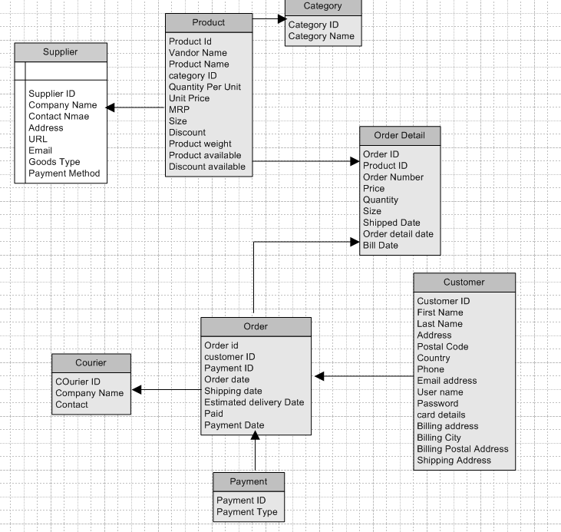

Q.7 – Data Flow Diagram

Ans. - Data Flow Diagram
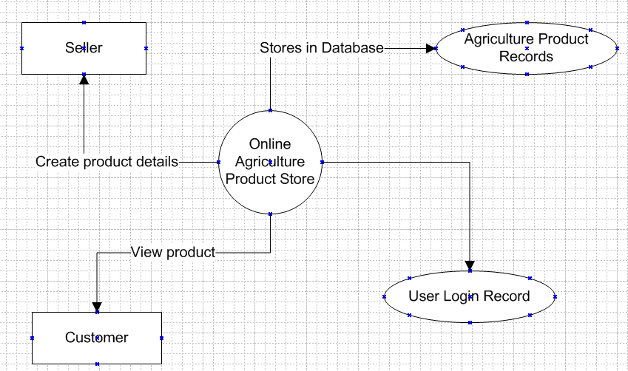

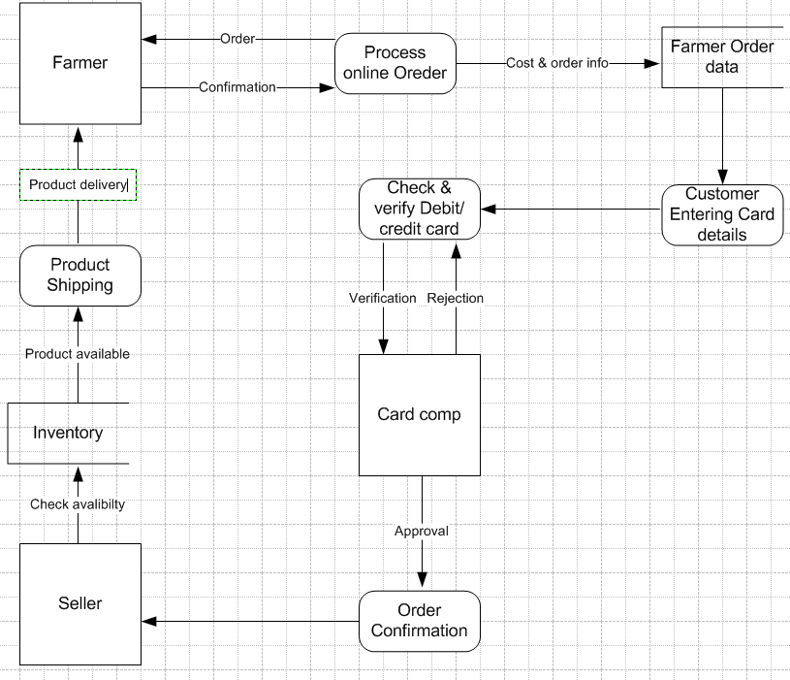

Q.8 – Change Request
Ans. - Change Request
What is a change Request - Change Request are when a stakeholder, either a client or an internal team or department, requests a change to the processes or deliverables that had already been decided upon in the project scope.
However, in the scenario, this change request has come up due to change in the government Taxation structure. As a BA I would analyze the request and clarify the stakeholders exactly what the request is asking us to do in the Online Agriculture Product Store. In a normal scenario, as a BA, I would first do a feasibility test to check how feasible it is to change the current ongoing project with the new change request.
However, in this case, Feasibility study is not required as it’s a government structure which needs to be updated and followed. Therefore, I will follow the steps below to change the project as per client requirement.
- Document the change request.
- Look for any supporting materials to help in adding the change.
- Need to assess whether the change is an inside or outside scope. As its an outside scope the Budget and time will get impacted.
- BA and PM should ensure whether the change is minor or a major change. Policy changes by government is a major change request and we need to ensure that the change should be made according to the government instructions.
- Fill the change request form and get the approval from the Project Manager.
- We also need to ensure that our team understands the priority of this change request.
- We also need to discuss the change with the Change control board who will recommend the necessary changes to the project.
- Once this change is approved, the project deliverables will need to be updated. This can include plans and schedules, Business process documents, and the requirement document.
- Once these updates have been made, the project manager can communicate the new course of action to everyone who will be impacted. Now you can delegate the necessary tasks to the people in charge of implementing this new change.

Q.9 – Change Request Vs an Enhancement
Ans. - Change Request Vs an Enhancement
The request from Ben and Kevin is an Enhancement request, as they want to add another feature in the online store which will also help the Farmers to sell the yields directly in the online store apart from buying products. Hence my response would be a positive response to them.
Therefore, as a BA, I should analyze the request and provide a project plan, requirement, design, and testing plan for this request. I must prepare an enhancement request form and decide how much men power and men hours required for this Enhancement Request.

Q.10 – Estimation (How many Manhours required)
Ans. - Estimation - Manhours required
Manhours Required = Total hours working per day * Total number of members * Total number of days worked over the specific period

Number of working Hours a day = 8 hours
Number of Resources = 12
Time Period Provided = 18 months = 547 days = 78 weeks (including weekends and public holidays)

Assuming Weekends = 156
Assuming public holidays = 10
Total = 166
547 – 166 = 381 working days

Hence Estimated Manhours = 8 hours * 12 resources * 381 days = 36,576 hours required.

Q.11 – UAT
Ans. – UAT – User Accept Testing (UAT) is a phase in the software development life cycle where the users of Online Agriculture Product store participate in validating that if meets their need.
As a BA I will verify all the validation prior to the design of the UAT test cases, which will cover the functionality of the product, system environment, any possible defect which could arise and how to deal with these defects.
Steps for UAT –
- Analysis of Business Requirements – One of the most important activities in the UAT is to identify and develop test scenarios. These test scenarios are derived from the following documents:
- Business Use cases
- Process flow diagram
- Business Requirements document (BRD)
- System requirement specification (SRS)

- Creation of UAT plan – The UAT test plan outlines the strategy that will be used to verify and ensure an application meets its business requirement. It documents entry and exits criteria for UAT, test scenario and test cases approach and timeline of testing.
- Identify Test scenario and Test cases – Identify test scenarios with respect to high level business process and create test cases with clear test steps. Test cases should sufficiently cover most of the UAT scenarios. Business use cases are input for creating test cases.
- Preparation for Test data – It is best advised to use live data from UAT. Data should be scrambled for privacy and security reasons. Testers should be familiar with the database flow.
- Run and Record the Result – Execute the test cases and report bugs if any. Re- test bugs once fixed. Test management tools can be used for execution.
- Confirm Business Objective met – Business Analyst or UAT tester need to send a sign off mail after the UAT testing. After signing off the product is good to go for production. Deliverables for UAT testing are test plans, UAT scenarios and Test cases, Test result and defect log.

Q.12 – Project Closure Document
Ans. - Project Closure Document

Project Closure
Online Agriculture Product Store
Version: 1.0
Revision Date: MM/DD/YYYY
Submit the document to Project Sponsor, Business Owner and PPMO/PMO Division Director; and archive this closure document with the project artifacts once completed.
Approver Name | Title/Role | Signature | Date
Peter and Ben | Project Stakeholder* | OK | xx/xx/xxxx
Mr. Henry | Exec Sponsor (Exec director) | OK | xx/xx/xxxx
Mr. Pandu | Financial Head | OK | xx/xx/xxxx
Mr. Vandanam | Project Manager | OK | xx/xx/xxxx
Mr. Karthik | Delivery Head | OK | xx/xx/xxxx
Mr. Dooku | Project Coordinator | OK | xx/xx/xxxx
*By authorizing this Project closure, the Project stakeholders and Executive Sponsor agree to all terms within this document.
Revision History
Identify document changes
Version | Date | Name | Description
1.0 | xx/xx/xxxx | Mr. Henry | Ok to process

Section 1. General Information
Project Activity | Date
Project Start | 12 April 2025
Project Closure* | 12 October 2026
*Date of Project Closure refers to Project finish date, meaning all project tasks have been completed.

Section 2. Business Objective
As Identified in section 2.2 of the Business Case
Business Case Ref # | Business Objective | Met/ Not Met | Comments
BI0001 | Farmer should be able to buy and sell Agriculture Product online | Yes | OK

Section 3. Customer Expectation Management
Item | Question | Description | Comment
1 | Were all expected benefits and Business outcomes realized? | Yes | OK
2 | Were all expected performance standards satisfied? | Yes | OK

Section 4. Outstanding Action Items and Issues
Action Items | Transition and / or Resolution

Section 5. Project Office Checklist
Deliverable | Description
Risk assessment completed and posted on suitable shared storage | Yes No
Business case completed and posted on suitable shared storage | Yes No
Project charter completed and posted on suitable shared storage | Yes No
Meeting Notes completed and posted on suitable shared storage | Yes No
Additional project documents and artifacts posted on suitable shared storage, including requirement Template, Project change request, Milestone Timeline, work breakdown structure etc. | Yes No
Lessons Learned document | Yes No
Project folder moved completed project on suitable shared storage | Yes No
Support Handover document completed and archived | Yes No
Comments:
OK to process. Application running properly.

