**Live Project, Waterfall Deliverables – Part -2/2-**

**Q1,** Document 6- Use case diagram, activity diagram and a use case specification document.

**Use Case Diagram**

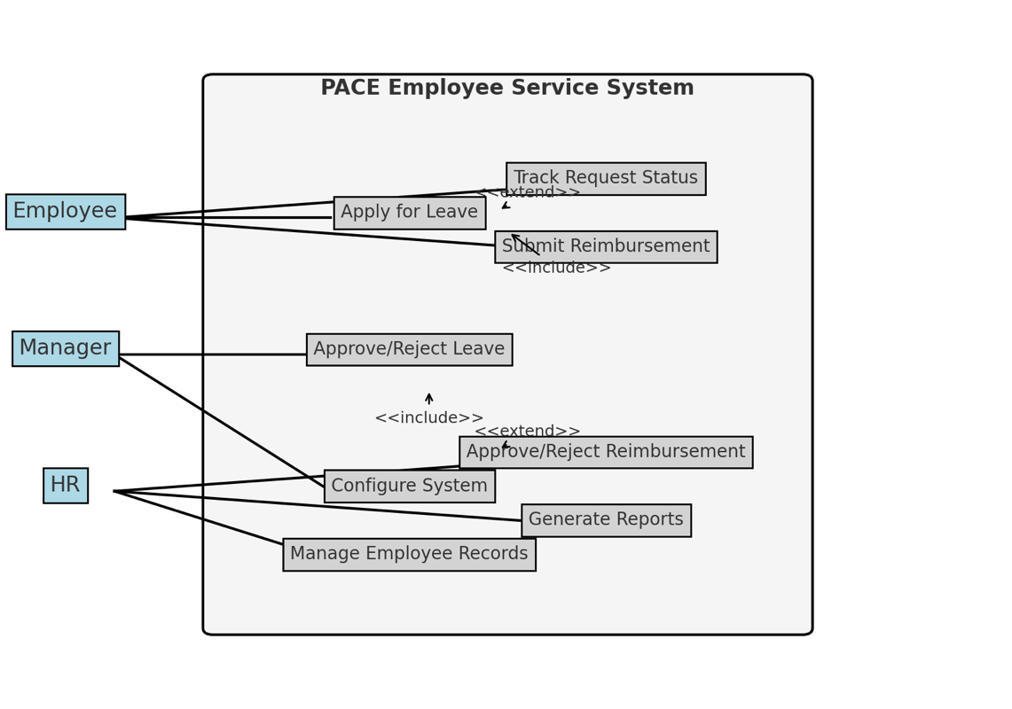

**Activity diagram**