**ASSIGNMENT-1**

1.Please make a BRD which can be presented to the client along with complete development and resource plan.

**Document - BRD**

**Project name:** Software for Managing Inventory and Quick Delivery for Customers

**Project Id**: 20130503

**Version ID**: V1.0

**Author**: T jenny

1. **Document Revisions**

|  |  |  |
| --- | --- | --- |
| **Date** | **Version Number** | **Document Changes** |
| 05/07/2023 | 0.1 | Initial draft |
| 18/07/2023 | 1.1 | Updated requirements based on stakeholder feedback |
| 30/07/2023 | 1.2 | Incorporated design changes for UI enhancements |

1. **Approvals**

|  |  |  |  |  |
| --- | --- | --- | --- | --- |
| **Role** | **Name** | **Title** | **Signature** | **Date** |
| Project Sponsor | Mr.Karthik | Software for Managing Inventory and Quick Delivery for Customers |  | 12/08/2023 |
| Business Owner | Mr.druv | Software for Managing Inventory and Quick Delivery for Customers |  | 12/08/2023 |
| Project Manager | Mr.Pavan | Software for Managing Inventory and Quick Delivery for Customers |  | 12/08/2023 |
| System Architect | Ms.swapna | Software for Managing Inventory and Quick Delivery for Customers |  | 12/08/2023 |
| Development Lead | Mr.Nidhil | Software for Managing Inventory and Quick Delivery for Customers |  | 12/08/2023 |
| User Experience | Mr.Evaan | Software for Managing Inventory and Quick Delivery for Customers |  | 12/08/2023 |
| Lead Quality Lead | Mr.James | Software for Managing Inventory and Quick Delivery for Customers |  | 12/08/2023 |
| Content Lead | Mr.Biju | Software for Managing Inventory and Quick Delivery for Customers |  | 12/08/2023 |

1. **RACI Chart for This Document**

* **R (Responsible)**: The person or role responsible for completing the task.
* **A (Accountable)**: The person who is ultimately answerable for the correct and thorough completion of the task.
* **C (Consulted)**: Those whose opinions are sought, typically subject matter experts.
* **I (Informed)**: Those who are kept up-to-date on progress or decisions.
* **S (Support)**: Those who assist with the completion of the task, but are not primarily responsible.
* **Authorize**: Has ultimate signing authority for any changes to the document.

|  |  |  |  |  |  |  |  |
| --- | --- | --- | --- | --- | --- | --- | --- |
| **Name** | **Position** | **\*** | **R** | **A** | **S** | **C** | **I** |
| Mr.Pavan | Project Manager | **\*** | **\*** |  | **\*** |  |  |
| Mr.Augustine | Stakeholder | **\*** |  |  | **\*** | **\*** | **\*** |
| Mr.Nidhil | Developers |  |  | **\*** | **\*** |  |  |
| Mr.Rajesh | QA Tester |  |  | **\*** | **\*** |  |  |
| Mr.druv | Business Owner | **\*** |  | **\*** | **\*** |  |  |

1. **Introduction**
   1. **Business Goals:**

The primary business goals of this software are:

1. **Inventory Management**: Efficient tracking and management of inventory across multiple locations (manufacturing plants and warehouses) to avoid stockouts and minimize wastage.
2. **Quickest Delivery to Customers**: Optimize delivery logistics, ensuring that orders are delivered to customers in the shortest possible time while reducing transportation costs and improving operational efficiency.
   1. **Business Objectives:**

1.Provide real-time visibility of inventory.

2.Automate order processing and reduce manual errors.

3.Ensure optimal inventory levels across locations.

4.Improve delivery time and accuracy.

5.Track inventory movement and expiry dates of perishable goods (milk and ice cream).

* 1. **Business Rules**

This document outlines the key Organization Policies, Procedures, and Rules & Regulations that need to be incorporated into the software for managing inventory and ensuring the quickest delivery of products (ice cream and milk products) to customers. These rules are intended to guide the system's operation to meet company standards, optimize operations, and comply with regulatory requirements.

1. **Organization Policies:**

* Inventory data must be accurate and reflect real-time stock levels across all plants, warehouses, and dispatch centres
* All stock movements (incoming, outgoing, transfers, and adjustments) must be recorded in real-time to maintain inventory accuracy.
* The system should support periodic audits to ensure inventory matches the actual stock.
* All perishable products (milk and ice cream) must have clearly defined expiry dates, and the system must automatically alert inventory managers when stock is nearing expiry.
* Orders must be processed promptly, with stock availability verified before order confirmation to prevent delays.
* Sensitive data such as customer information, inventory data, and financial records must be encrypted both at rest and in transit.

1. **Procedures**

* All inventory transactions (including stock additions, removals, and transfers) must be captured in the system before any physical movement of products occurs.
* The system must automatically generate inventory replenishment orders when stock levels fall below minimum thresholds set by the inventory manager.
* The system should provide alerts and reports for stock levels, expiry dates, and aging stock to help prevent overstocking and reduce waste.
* Upon receiving an order, the system should validate product availability. If the order cannot be fully fulfilled from one location, the system should prioritize fulfillment from the nearest location.
* When an order is confirmed, the system must generate a picking list for warehouse staff, indicating the location of the products to be picked.
* All customer orders should be packaged according to company standards, ensuring the products are secure and appropriately labeled.
* For perishable products, packaging must include temperature sensitive labels or instructions for handling, particularly for ice cream and milk.
* The system must generate the most efficient route for delivery based on the customer’s location, delivery window, and inventory availability.
* All deliveries must be tracked in real-time, and customers should be notified of their order status throughout the delivery process.
* If there is an issue with a delivery (late delivery, incorrect products, etc.), customer service representatives must have access to the system to review the order history, delivery status, and take corrective actions.
* The system must track customer complaints and feedback and provide reports to the management team for continuous improvement.

1. **Rules & Regulations**

* The software must adhere to all regulatory requirements related to food safety, such as compliance with the Food and Drug Administration (FDA) regulations and other local health and safety laws for perishable items.
* All perishable goods, including ice cream and milk products, must be tracked for
* temperature control throughout the supply chain to comply with safety standards.
* The system must prioritize the quickest route for delivery while considering regulatory restrictions
* All inventory and order data must be stored in the system for a minimum of 5 years (or the period required by applicable laws) for auditing and compliance purposes.
* Inventory records should include details of batch numbers, expiry dates, storage locations, and quantities.
* Ice cream and milk products must be stored and transported according to quality and safety standards (maintaining a certain temperature during storage and transit).
* The system must flag any product with compromised quality (out-of-temperature range, near-expiry) as unsellable and prevent it from being shipped or sold.

1. **Security Rules:**

* All users must authenticate via a secure method (username, password, multi-factor authentication) before accessing sensitive systems or data.
* All sensitive data (customer information, payment details, inventory records) must be encrypted using industry-standard encryption protocols
* The system must comply with data protection regulations, including the requirement to securely delete customer data upon request, if applicable.
  1. **Background**

The company is a manufacturing entity that produces milk and ice cream products. The company operates with multiple manufacturing plants and warehouses strategically located across various regions. These plants and warehouses house a wide array of dairy products and frozen goods, including milk, ice cream, and other related products. The company supplies products to a diverse customer base, ranging from wholesalers to direct consumers. Given the nature of their products, which include perishable items, the company faces unique challenges in managing inventory effectively and ensuring the quickest, most efficient delivery to customers. The perishable nature of products like milk and ice cream also requires careful attention to temperature control, shelf-life management, and compliance with food safety standards.

**Challenges and Pain Points**

The company is experiencing several key operational challenges that need to be addressed through the development of a custom software solution

* The company currently lacks real-time visibility of stock levels across multiple plants and warehouses. This results in inefficient inventory management, stockouts, and overstocking in some areas.
* Coordination of stock between various plants and warehouses is inefficient. There is a need to improve visibility and communication for transferring stock quickly when required to fulfill orders.
* Due to the widespread geographical locations of the manufacturing plants and warehouses, delivery times can be unpredictable. The company lacks an optimized delivery route planning system that can provide the fastest delivery possible to customers.
* Customers demand quick delivery, especially for time-sensitive products like ice cream and milk, which require delivery within a certain time window to ensure freshness.
* The company must adhere to strict food safety regulations, such as temperature controls during manufacturing, warehousing, and delivery, and ensuring proper documentation and batch tracking. Compliance with regulations like the FDA (Food and Drug Administration) and local food safety laws must be automated to avoid human error.

**Objectives of the Software Solution**

The new software solution is intended to streamline and optimize key aspects of the company’s operations, especially in the areas of inventory management and delivery logistics. The objectives of the software are as follows

* Provide real-time visibility of inventory across all locations (plants, warehouses) to ensure that stock levels are constantly updated and can be managed efficiently.
* Track the expiry dates of products and manage stock according to the **FEFO (First Expiry, First Out)** method to minimize waste and avoid expired products being dispatched.
* Implement automatic stock alerts and reorder points to maintain optimal stock levels, preventing both stockouts and overstock situations.
* Enable batch tracking for quality assurance and traceability, ensuring that batches can be identified and tracked through production, storage, and delivery.
* Allow customers to track their orders in real-time, receiving updates on the order’s status and delivery times.
* Track and ensure that temperature-sensitive products like milk and ice cream are transported under optimal conditions throughout the delivery process.
* Ensure that the software meets all local and international food safety regulations, including accurate record-keeping of expiry dates, product batches, and temperature conditions during transit.
* The software will send alerts in case any product is near expiration or stored under improper conditions, ensuring quick corrective action.
* Enhance customer satisfaction by providing accurate, timely updates on the status of their orders.
* Reduce delivery times through better route optimization and real-time stock availability, meeting customer expectations for quick deliveries.
  1. **Project Objective**

To develop and implement an efficient inventory management system and delivery process to ensure optimal stock levels, reduce waste, and enhance customer satisfaction by providing timely and accurate deliveries of ice cream and milk products.

* Implement a real-time inventory tracking system to monitor stock levels across all stages of production and distribution.
* Minimize product waste by optimizing stock rotation and forecasting demand accurately.
* Integrate GPS tracking and route optimization software to reduce delivery time and cost.
* Improve packaging for better product preservation during transportation, especially for perishable items like ice cream.
* Ensure customers receive fresh, high-quality products on time through improved scheduling, order processing, and delivery systems.
* Build strong relationships with customers by providing consistent and reliable service.
* Collect and analyze customer feedback to continuously improve service quality and satisfaction.

**4.6 Project Scope**

This project aims to develop and implement an integrated system for managing inventory and streamlining delivery processes for a manufacturing company that produces ice cream and milk products. The scope includes the creation of a real-time inventory tracking system, enhanced order processing, and optimized delivery logistics to improve customer satisfaction and operational efficiency.

* + 1. **In Scope Functionality**
* Track raw materials, work-in-progress, finished products, and packaging supplies across warehouses, production lines, and distribution centres.
* Implement tools to forecast demand for raw materials and finished products (based on historical sales data, seasonal trends etc.)
* Automated notifications for low-stock items, expiration dates (critical for perishable items), and reorder alerts.
* System for tracking the expiration dates of perishable products like ice cream and milk.
* Ensure proper stock rotation (FIFO) to minimize spoilage and wastage.
* Customers (both business and retail) can place orders online, with integrated systems for real time tracking.
* Order status updates (received, in production, dispatched, delivered).
* Notify customers when their orders are processed, dispatched, and delivered, via email, SMS, or app notifications.
* A return management process for defective products (broken ice cream or damaged packaging).
* Optimize delivery schedules for timely and cost-effective deliveries, especially for temperature-sensitive products.
* Ensure that all vehicles transporting ice cream and milk products are equipped with temperature control, and that their status is continuously monitored.
* Provide customer support via chat, phone, or email for order inquiries and issues.
* Collect customer feedback after each delivery, including order satisfaction, delivery timeliness, and product quality.
  + 1. **Out Scope Functionality**
* The project will not focus on the development of new ice cream or milk product lines or changes in production methods.
* The project will not integrate with or modify relationships or ordering systems with external suppliers of raw materials (dairy suppliers, flavour providers).
* Tracking of raw materials at the supplier’s location or supplier-to-manufacturer integration.
* Any physical expansion of warehouses, storage facilities, or modifications to transportation infrastructure (new trucks or warehouses) is excluded.

1. **Assumptions**

* company has accurate and reliable data for both inventory levels (raw materials, finished goods) and demand patterns to implement the inventory management system successfully.
* real-time data can be accessed and updated across different departments (production, warehouse, sales etc.) for accurate decision-making.
* The company will provide the necessary tools for inventory tracking (barcode scanners, RFID systems etc.) to track stock accurately in real time.
* Historical sales data and demand patterns can be used effectively to predict future orders and prioritize production and delivery processes.
* Delivery routes will be optimized using accurate data about customer locations, including potential delivery challenges (traffic, road conditions, etc.)
* desired delivery timeframes are realistic given current operational capabilities and that quick deliveries will be feasible within the company’s current logistical reach.
* It is assumed that customers are willing to use digital platforms (emails, SMS, or order tracking systems) for order updates and can easily interact with the system.
* The company will be able to collect and process customer feedback efficiently to make improvements to the system and service offerings.
* employees, especially those in logistics, production, and customer service, are familiar with or will be trained to use the new systems

1. **Constraints**

* Ice cream and milk products are highly perishable, so customers expect fast deliveries. Meeting these tight delivery windows (especially in urban areas or seasonal peaks) might be challenging.
* Ongoing maintenance, software licensing, and staff training for the new systems could increase operational costs, which might need to be carefully managed to avoid exceeding budget limits.
* Real time tracking and monitoring of inventory and delivery routes depend on the availability of accurate and up to date data. Inaccurate data or poor data entry could compromise system efficiency and decision making.
* Adequate warehouse space must be available for storing inventory in the short term, including raw materials, finished goods, and packaging. Space constraints could limit the amount of inventory managed and stored efficiently.
* The introduction of new systems will require training for employees. Resistance to change or lack of technical skill could delay the adoption of new processes, impacting the system's efficiency and overall project success.
* Customer demand for ice cream and milk products may fluctuate significantly, especially with seasonality or promotional campaigns. Accurately forecasting demand and ensuring stock levels meet customer needs without overstocking or understocking will be a challenge.

1. **Risks**

* Ice cream and milk production heavily rely on raw materials like milk, cream, sugar, and flavourings. Disruptions in the supply of these ingredients due to supplier issues, weather conditions, or global trade disruptions could lead to production delays, shortages, or increased costs.
* Delays in the delivery of raw materials or packaging could cause production bottlenecks, affecting the ability to meet customer demand. These delays can disrupt inventory forecasting and create inefficiencies in the system.
* Incorrect tracking of inventory can lead to stockouts (shortage of products) or overstocking (excess inventory).
* If demand exceeds the production capacity, the company may struggle to meet delivery deadlines.
* Ice cream and milk require strict temperature control during storage and transportation. Failures in refrigeration systems (truck refrigeration breakdowns or power outages at warehouses) could lead to product spoilage, damaging customer satisfaction and brand reputation.
* High employee turnover or insufficient training could disrupt the implementation of new systems. Employees who are not fully trained on the new systems could introduce errors into inventory management or order processing, affecting operational efficiency.
* Delayed deliveries, particularly for perishable goods, can significantly harm customer satisfaction. Any failure to meet customer expectations for delivery times could lead to negative reviews, complaints, and loss of business.
* Ice cream and milk products are subject to strict food safety regulations. Non-compliance with health, safety, and hygiene standards could result in product recalls, fines, or legal issues. Changes in regulations (labelling, ingredient sourcing, or packaging) could also require costly adjustments to operations.

1. **Business Process Overview**

* Customer Order Placement
* Order Verification
* Inventory Check
* Order Fulfillment
* Production Process
* Quality Control
* Packaging
* Cold Storage
* Delivery Routing
* Real-Time Updates
* Delivery Confirmation
* Returns and Customer Support
* Post-Delivery Feedback
* Process Improvement
  1. **Legacy System (AS-IS)**
* Order Placement (Customer Interaction via Phone/Email/Website)
* Inventory Management (Raw Materials and Finished Goods)
* Production Process
* Packaging & Labeling
* Warehouse & Storage
* Delivery & Distribution
* Reporting & Performance Monitoring

**Process flow diagram**

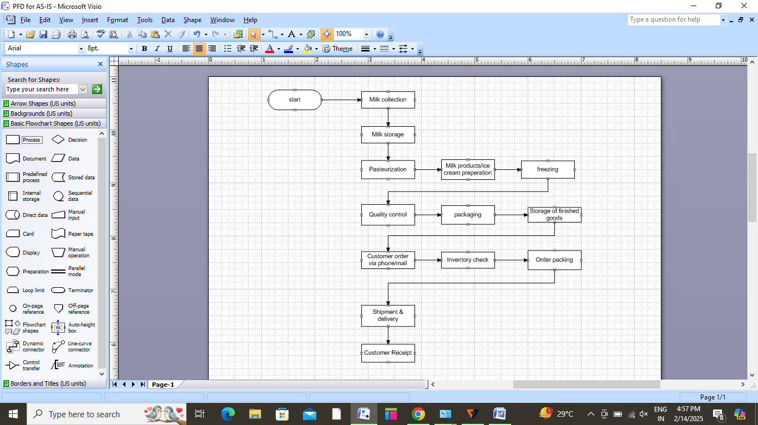

* 1. **Proposed Recommendations (TO-BE)**
* Automated order management and real-time inventory tracking
* Integrated production scheduling based on demand and stock levels
* Automated route optimization for quicker deliveries
* Data-driven reporting and performance monitoring

**Process flow diagram**

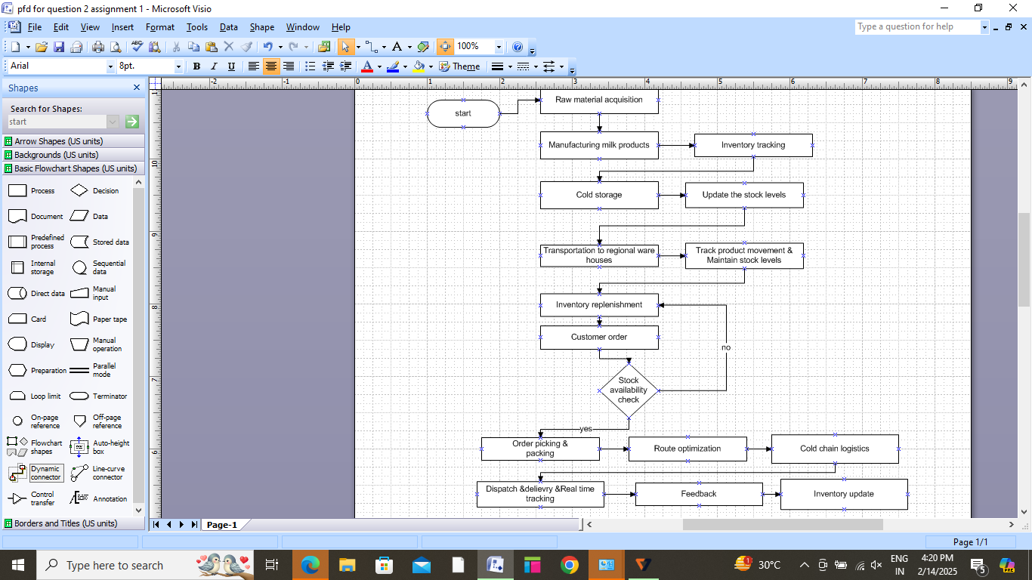

1. **Business Requirements**

* **BR001:** The system should track raw materials and finished products in real time across multiple locations (manufacturing plants, warehouses, and distribution centres).
* **BR002:** The system must support inventory management across multiple locations (manufacturing plants and distribution warehouses).
* **BR003:** Since ice cream and milk products are perishable, the system should use **FIFO (First In, First Out)** methodology to prioritize the use or sale of older stock.
* **BR004**: The system should predict inventory needs based on historical data, seasonal trends, and sales forecasts.
* **BR005**: The system should automatically reorder raw materials (milk, flavoring agents, etc.) when they reach a predefined minimum stock threshold.
* **BR006:** The system must be able to track each batch of ice cream or milk product produced, including ingredients, production time, and quality control checks.
* **BR007**: The system should generate detailed reports on inventory levels, consumption rates, and aging stock to support decision-making.
* **BR008**: The system should handle orders from multiple sales channels (online, retail, distributors).
* **BR009**: The system should check available stock in real time to confirm order fulfillment.
* **BR011**: The system should suggest the quickest and most cost-effective delivery routes.
* **BR012**: Ensure that ice cream and milk products are delivered in temperature-controlled conditions to maintain product integrity.
* **BR013**: The system should offer multiple delivery options, such as standard delivery, express delivery, and same-day delivery.
* **BR014**: Customers should be able to track the status of their orders in real-time.
* **BR015**: The system should send notifications to customers at key stages of the delivery process.

1. **Appendices**
   1. **List of Acronyms**

* ERP – Enterprise Resource Planning
* MRP – Material Requirements Planning
* WMS – Warehouse Management System
* FIFO – First In, First Out
* QA – Quality Assurance
  1. **Glossary of Terms**
* **Inventory Turnover**: The rate at which inventory is used and replaced over a period of time. A higher turnover rate indicates efficient inventory management.
* **Batch Number**: A unique identifier for a batch of products produced at the same time, often used for traceability in case of quality issues.
* **Last In, First Out (LIFO)**: A method of inventory management where the most recently produced or purchased goods are used or sold first, though less commonly used for perishable goods.
* **Minimum Order Quantity (MOQ)**: The minimum quantity of an item that must be ordered from a supplier or sold to a customer.
* **Raw Materials**: The basic materials (e.g., milk, cream, sugar, flavoring agents) required for production. Proper management of these materials is essential for production efficiency.
* Perishable Goods: Products with a limited shelf life, like ice cream and milk, that require special handling, storage, and transportation to prevent spoilage.
* **Cold Storage**: Specialized storage facilities that maintain low temperatures to prevent perishable products from spoiling.
* **Fulfilment**: The process of receiving, packing, and shipping customer orders. Involves inventory management, picking, packing, and dispatching products to customers.
  1. **Related Document**
* **Inventory Management Policy**: Outlines the procedures and guidelines for managing inventory, including stocking, storing, and replenishing raw materials and finished goods.
* **Inventory Report:** A regularly updated document detailing the quantity and condition of items in inventory.
* **Purchase Order (PO) Document:** Document used for requesting raw materials, ingredients, or packaging items from suppliers.
* **Stock Replenishment Form:** Trigger document to reorder inventory items when stock levels drop below predefined thresholds**.**
* **Quality Control (QC) Checklist:** A document for inspecting the quality of products during and after manufacturing.
* **Shipping Label:** A label containing information for the transportation and tracking of products to customers.

**2. Prepare process flow diagram using your imagination.**



**Assignment 2**

1.Write an introduction letter to a client introducing yourself as a business analyst in charge of working with the client and his team to start the business understanding process.

**Subject:** Introduction as Your Business Analyst for Business Understanding Process

Dear Sir,

I hope this message finds you well.

My name is Jenny nidhil, and I am excited to introduce myself as the Business Analyst assigned to work closely with you and your team throughout the upcoming business understanding process. I will be leading the efforts in initiating the business understanding process, ensuring that we clearly define your business goals, challenges, and requirements. I look forward to collaborating with you and your team to gain a deep understanding of your business needs, challenges, and expectations. Our goal is to ensure that we deliver solutions that truly support your strategic vision and drive measurable results.

Over the coming weeks, we will work together to establish a clear framework for the project, outlining the key steps and milestones. I am here to answer any questions you may have and to ensure we communicate effectively every step of the way.

I look forward to working with you and your team and I am available to address any questions or concerns you may have throughout this process.

Thank you, and I’m excited to get started.

Best regards,  
Jenny nidhil  
Business Analyst  
COEPD  
7796523421

**2. Prepare a brief BRD and SRS for a project- Horoscope or Ticketing system or online store.**

**BUSINESS REQUIREMENT DOCUMENT -BRD**

**Project name: E-commerce application for online shopping**

**Project Id**: **20130503**

**Version ID**: **V1.0**

**Author**: **T jenny**

1. **Document Revisions**

|  |  |  |
| --- | --- | --- |
| **Date** | **Version Number** | **Document Changes** |
| 05/07/2023 | 0.1 | Initial draft |
| 18/07/2023 | 1.1 | Updated requirements based on stakeholder feedback |
| 30/07/2023 | 1.2 | Incorporated design changes for UI enhancements |

1. **Approvals**

|  |  |  |  |  |
| --- | --- | --- | --- | --- |
| **Role** | **Name** | **Title** | **Signature** | **Date** |
| Project Sponsor | Mr.Karthik | E-commerce application for online shopping |  | 12/08/2023 |
| Business Owner | Mr.druv | E-commerce application for online shopping |  | 12/08/2023 |
| Project Manager | Mr.Pavan | E-commerce application for online shopping |  | 12/08/2023 |
| System Architect | Ms.swapna | E-commerce application for online shopping |  | 12/08/2023 |
| Development Lead | Mr.Nidhil | E-commerce application for online shopping |  | 12/08/2023 |
| User Experience | Mr.Evaan | E-commerce application for online shopping |  | 12/08/2023 |
| Lead Quality Lead | Mr.James | E-commerce application for online shopping |  | 12/08/2023 |
| Content Lead | Mr.Biju | E-commerce application for online shopping |  | 12/08/2023 |

1. **RACI Chart for This Document**

|  |  |  |  |  |  |  |  |
| --- | --- | --- | --- | --- | --- | --- | --- |
| **Name** | **Position** | **\*** | **R** | **A** | **S** | **C** | **I** |
| Mr.Pavan | Project Manager | **\*** | **\*** |  | **\*** |  |  |
| Mr.Augustine | Stakeholder | **\*** |  |  | **\*** | **\*** | **\*** |
| Mr.Nidhil | Developers |  |  | **\*** | **\*** |  |  |
| Mr.Rajesh | QA Tester |  |  | **\*** | **\*** |  |  |
| Mr.druv | Business Owner | **\*** |  | **\*** | **\*** |  |  |

1. **Introduction**
   1. **Business Goals:**
2. Focusing on maximizing sales and driving profitability through both existing customers and attracting new ones.
3. Implement pricing strategies, seasonal promotions, and upselling techniques.
4. Increase the number of new users and convert them into paying customers.
5. Utilize SEO, social media marketing, email campaigns, and paid advertisements to attract a wider audience.
6. Adapt the platform to different languages and currencies to appeal to a global audience.
7. Form partnerships with other brands, suppliers, and third-party services for expansion and better offerings.
   1. **Business Objectives:**
8. Design an intuitive and easy-to-navigate interface that promotes effortless shopping.
9. Provide a diverse selection of products to cater to the varied preferences of customers.
10. Implement efficient inventory management to ensure popular products are always in stock.
11. Include various payment methods (credit/debit cards, PayPal etc) and ensure mobile payment compatibility.
12. Ensure that the eCommerce platform loads quickly to enhance the user experience and reduce bounce rates.
13. Offer multiple communication channels for customer support, such as live chat, email, and phone.
14. Develop a robust FAQ section and customer self-service tools to reduce reliance on support agents.
15. Encourage customer reviews, ratings, and testimonials to build trust and credibility.
16. Utilize AI and machine learning to personalize product recommendations and offers based on customer behaviour and preferences.
17. Offer personalized discounts or incentives to encourage repeat purchases.
    1. **Business Rules**

Business rules for an eCommerce application are a set of defined guidelines that govern the behaviour, operations, and interactions within the online shopping platform. These rules ensure that the platform operates smoothly, adheres to legal standards, and provides an optimal user experience.

**Organization Policies:**

1. Collect only necessary customer information (name, email, address, payment details) and ensure it is stored securely.
2. Use customer data only for order processing, marketing (with consent), and improving user experience.
3. All transactions must be processed through secure, PCI DSS-compliant payment gateways.
4. Monitor transactions for suspicious activities and implement measures to detect and prevent fraud.
5. Clearly communicate shipping costs and delivery timelines at checkout.
6. Define the return window (i.e,30 days) and product condition for eligibility (eunused, with tags).
7. Set expected response times for customer inquiries and offer multiple support channels.
8. Define steps for handling returns, exchanges, complaints, and disputes.
9. Provide clear terms of service that customers must agree to before completing a purchase.
10. Maintain real-time inventory tracking and update product availability on the platform accordingly.
11. Provide regular training to employees on privacy, security, customer service, and compliance policies.
12. Encourage the use of sustainable packaging materials where possible.

**Procedures:**

1. Order Fulfilment by Detailed procedures for order processing, packaging, and dispatching.
2. Define how to handle urgent, standard, or international orders.
3. Payment Process by establish procedures for accepting payments, including integration with payment gateways (PayPal, Stripe, credit cards).
4. Define security protocols for handling transactions and customer data.
5. Ensure procedures for user account creation, including email verification and password recovery.
6. Procedures for monitoring stock levels and placing orders with suppliers.
7. Step-by-step procedure for handling customer returns, receive, inspect, restock (if applicable), issue refunds or store credits.
8. Detailed procedure for addressing customer issues, including returns, damaged goods, or order discrepancies.

**Rules & Regulations:**

1. The application must comply with data protection laws depending on the region.
2. Implement data encryption and secure protocols for all transactions.
3. Ensure fraud detection systems are in place to prevent unauthorized transactions.
4. Clearly state the terms of use for customers, outlining purchase processes, product usage, and dispute resolution.
5. Ensure the platform correctly calculates and charges sales tax based on the customer’s location.
6. Adhere to rules regarding affiliate marketing and influencer partnerships.
   1. **Background**

The proposal and initiation of ecommerce applications for online shopping stemmed from the need to overcome traditional retail limitations and leverage the transformative potential of the internet. Overcoming initial challenges such as security concerns and consumer trust paved the way for the widespread adoption of ecommerce, resulting in a blooming industry that continues to evolve and innovate, offering unprecedented opportunities for businesses and enhanced shopping experiences for consumers worldwide.

**Business Issues/Problems Identified:**

1. Geographical Limitations
2. Limited Shopping Hours
3. Product Variety and Availability
4. Transaction Security

**Expected Benefits of Implementing Ecommerce Projects:**

1. Global Market Reach
2. 24/7 Accessibility
3. Expanded Product Selection
4. Improved Customer Experience
5. Cost Efficiency
   1. **Project Objective**
6. Market Reach and Expansion
7. User Experience Enhancement
8. Product and Service Offering
9. Security and Trust
10. Mobile Responsiveness
11. Marketing and Promotion
12. Customer Service Excellence
    1. **Project Scope**

In the current project we are developing an ecommerce application, so we will focus on creating a robust platform that meets the needs of both customers and the business.

* + 1. **In Scope Functionality**

1. Product Management
2. Shopping and Checkout
3. User Management
4. Customer Support
5. Security and Compliance
6. Marketing and Promotions
   * 1. **Out Scope Functionality**
7. Personalized AI Chatbots
8. Adaptation of the platform for multiple languages and currencies
9. Attainment of specific security certifications beyond basic SSL encryption and PCI DSS compliance.
10. Long-term planning for additional features or functionalities beyond the current project scope
11. **Assumptions**
12. **Market Demand:** There is sufficient market demand for the products/services offered through the ecommerce platform
13. **Technology Infrastructure:** Existing technology infrastructure (hardware, software, networks) can support the planned ecommerce application without major upgrades.
14. **User Behavior:** Users prefer shopping online for convenience, selection, and competitive pricing
15. **Operational Efficiency**: Implementing the ecommerce platform will lead to improved operational efficiency and cost savings compared to traditional retail methods
16. **Technology Adoption:** Users will adopt and adapt to new technologies and features introduced in the ecommerce platform.
17. **Constraints**
18. Time Constraints
19. Budget Constraints
20. Resource Constraints
21. Technology Constraints
22. **Risks**
23. Security Risks
24. Technical Risks
25. Legal and Compliance Risks
26. Operational Risks
27. Market Risks
28. **Business Process Overview**
29. Order Placement
30. Order Processing
31. Fulfillment and Shipping
32. Customer Service
33. Marketing and Sales
34. Website Maintenance & security
35. Feedback & innovation
    1. **Legacy System (AS-IS)**
36. Customers browse and search through product categories and listings on the e-commerce website and add them to the shopping cart.
37. Customers proceed to checkout where they enter shipping details, select a payment method, and review their order before finalizing the purchase.
38. Upon completion of the checkout process, the system confirms the order and generates an order number for tracking purposes.
39. Once payment is confirmed, the order is prepared for shipment. This involves picking items from inventory, packing them securely, and preparing shipping labels.
40. The system handles customer inquiries, providing support through various channels such as email, live chat, or phone.
41. Processes for handling returns, exchanges, or refunds are managed according to the e-commerce platform’s policies and procedures.
42. The system manages and stores customer information, order histories, product catalogs, and other relevant data in a structured database.
43. Measures are implemented to protect customer data, payment information, and other sensitive information from unauthorized access or breaches.

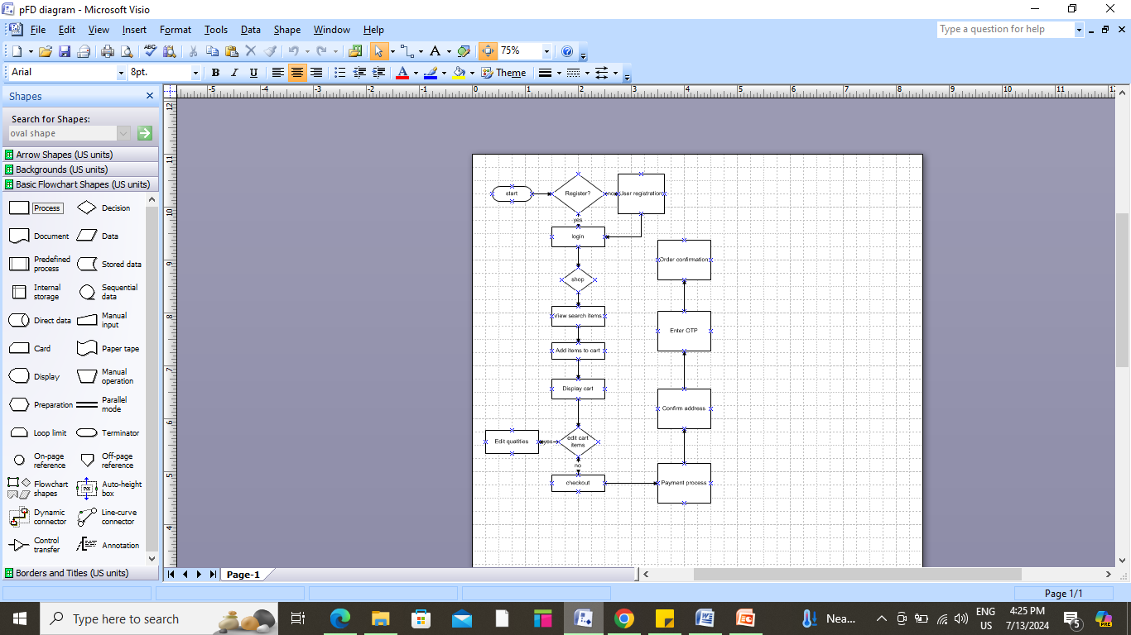

* 1. **Proposed Recommendations (TO-BE)**

This proposed system will enhance user experience, streamline operations, and increase sales through improved functionalities and efficiency.

1. User accesses the modernized and responsive ecommerce website.
2. AI-driven engine suggests relevant products based on user behavior and preferences.
3. Customer selects products and adds them to the cart with streamlined navigation.
4. Single-page checkout process with integrated payment options and guest checkout capability.
5. Inventory levels are updated in real-time to ensure accurate stock availability.
6. Orders are automatically processed and verified, triggering fulfillment processes.
7. Automated fulfillment process with real-time tracking updates for customers.
8. Support interactions are integrated with order and customer data for efficient resolution.
9. Seamless integration for customers to provide feedback and reviews, enhancing user engagement.

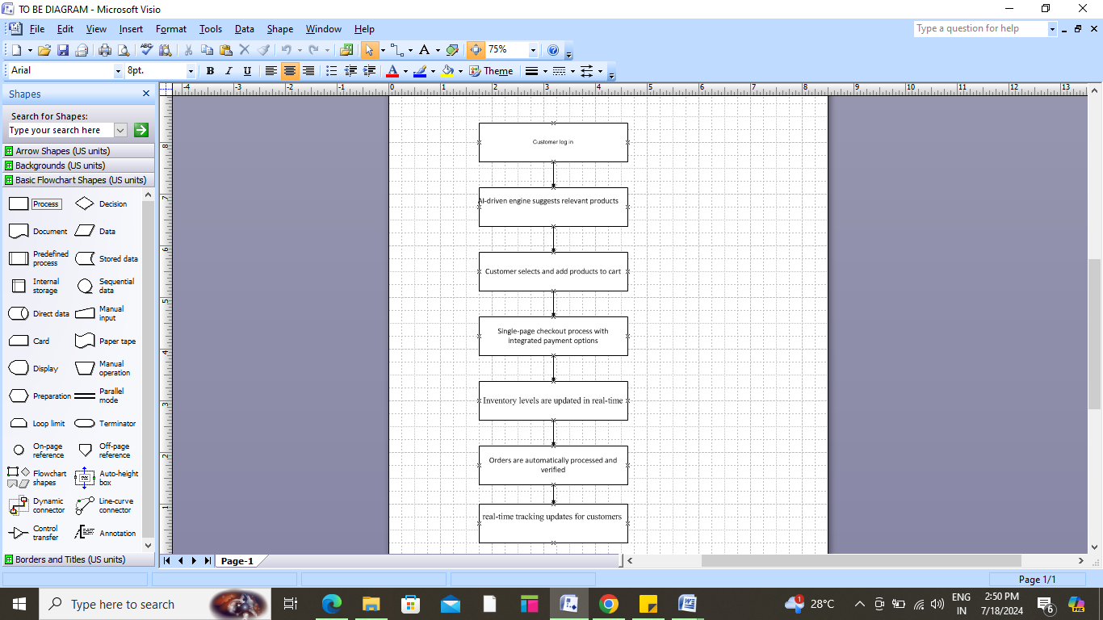

1. **Business Requirements**

* **BR001:** Users must be able to securely log in using email and password
* **BR002:** Passwords must meet security standards (e.g., minimum length, complexity).
* **BR003:** Customers should be able to pay using credit/debit cards with different options.
* **BR004**: Payment transactions must be processed securely via HTTPS.
* **BR005**: Display product details including name, description, price, and availability
* **BR006:** Allow filtering products by category and price range
* **BR007**: Users should be able to view their order history
* **BR008**: Provide notifications for order status updates (shipped, delivered).
* **BR009**: Enable users to share products on social media platforms
* **BR010**: Users must be easily able to search / browse items

1. **Appendices**
   1. **List of Acronyms**

* **API**: Application Programming Interface
* **HTTP**: Hypertext Transfer Protocol
* **UI**: User Interface
* **UX**: User Experience
  1. **Glossary of Terms**
* **Authentication**: The process of verifying the identity of a user or system.
* **HTTPS**: Hypertext Transfer Protocol Secure, a protocol for secure communication over a computer network.
* **Traceability Matrix**: A document that correlates any two baselined documents that require a many to many relationship to determine the completeness of the relationship.
  1. **Related Document**
* **Business Requirements Document**: Details the specific business needs and goals that the e-commerce application is intended to fulfill.
* **Product Catalog Specifications**: Provides detailed information about how products will be categorized, displayed, and managed within the application.
* **Payment Gateway Integration Guide**: Outlines the process and requirements for integrating payment gateways with the application.
* **Security Requirements Document**: Specifies the security measures and protocols to be implemented to protect user data and ensure secure transactions.
* **Shipping and Logistics Integration Specifications**: Details how shipping and logistics services will be integrated to manage order fulfillment and delivery.
* **Privacy Policy and Terms of Service**: Legal documents outlining the terms and conditions under which users interact with the application.
* **Performance Testing Report**: Summarizes the results of performance tests conducted to ensure the application can handle expected traffic and load.

**SOFTWARE REQUIREMENT SPECIFICATION**

1. **INTRODUCTION:**

**Purpose:** The purpose of this Software Requirements Specification (SRS) is to describe the functionality, behaviour, and design specifications for the development of an E-commerce application for online shopping. The system aims to facilitate product browsing, shopping cart management, and secure order processing.

**Project goal:** To develop a secure, user-friendly, and scalable eCommerce platform that enables seamless online shopping experiences for customers.

**Business goal:** To increase sales, expand market reach, and enhance customer satisfaction by offering a convenient and accessible online shopping platform.

**Scope:** The eCommerce application will allow customers to browse a wide range of products, manage their shopping cart, place orders, and make secure payments. The application will support both desktop and mobile devices, with a user-friendly interface. It will integrate with third party payment gateways and support various payment methods like credit card, PayPal, etc and this application will have separate roles for administrators to manage the system, including adding/editing products, managing orders, and handling customer inquiries.

1. **SYSTEM OVERVIEW:**

**key features:**

* **User Management**: Customers can register, login, and manage their accounts.
* **Product Catalogue** : A collection of products that can be browsed, searched, and filtered by users.
* **Shopping Cart**: Users can add items to the cart, update quantities, or remove items before proceeding to checkout.
* **Order Management**: Users can place orders, view order status, and track shipments.
* **Payment Processing**: Secure online payment processing via third-party services.
* **Admin Dashboard**: Admins can manage products, view orders, and oversee customer support.

**User roles:**

* **Customer (End-User)**: Browses products, adds items to the cart, makes purchases, and tracks orders.
* **Administrator**: Manages product inventory, processes orders, updates pricing, and generates reports.

1. **FUNCTIONAL REQUIREMENTS:**

* Users must be able to create accounts by providing their email, password, and other relevant details.
* The system must support password recovery through email.
* Users can log in with their credentials (email and password).
* The system should allow users to search for products by name, category, and other criteria such as price range, ratings, and availability.
* Each product should display a description, price, images, and other relevant details.
* Users can add products to the shopping cart.
* Users can modify the cart by changing quantities or removing products.
* Users can review their shopping cart before proceeding to checkout.
* Payment can be processed via third-party payment gateways (credit cards, PayPal, etc.).
* After successful payment, the user should receive an order confirmation with the estimated delivery time.
* Users can track the status of their orders (processing, shipped, delivered).
* Admins can manage product listings (add, update, or delete products).
* Admins should have access to user management, such as viewing customer profiles and handling support inquiries.

1. **NON-FUNCTIONAL REQUIREMENTS:**

* The system should handle up to 5,000 concurrent users without significant performance degradation.
* Pages should load in under 3 seconds under normal load conditions.
* User passwords must be encrypted using a secure hashing algorithm
* The system should be designed to scale horizontally to handle increasing numbers of users and product listings.
* Mobile responsiveness is essential for a smooth experience on smartphones and tablets.
* The application should be available 99.9% of the time, excluding scheduled maintenance
* The application must comply with data protection laws such as the General Data Protection Regulation (GDPR) and other relevant local regulations.

1. **SYSTEM ARCHITECTURE:**

* The system will follow a three-tier architecture (presentation, logic, data layers) to separate concerns and enhance scalability.
* Technologies used are HTML, CSS, JavaScript
* Relational database (MySQL) to store user data, product information, and orders.
* Integration with third-party services (Stripe, PayPal).
* The system will be deployed on a cloud service.

1. **USE CASE DIAGRAM:**

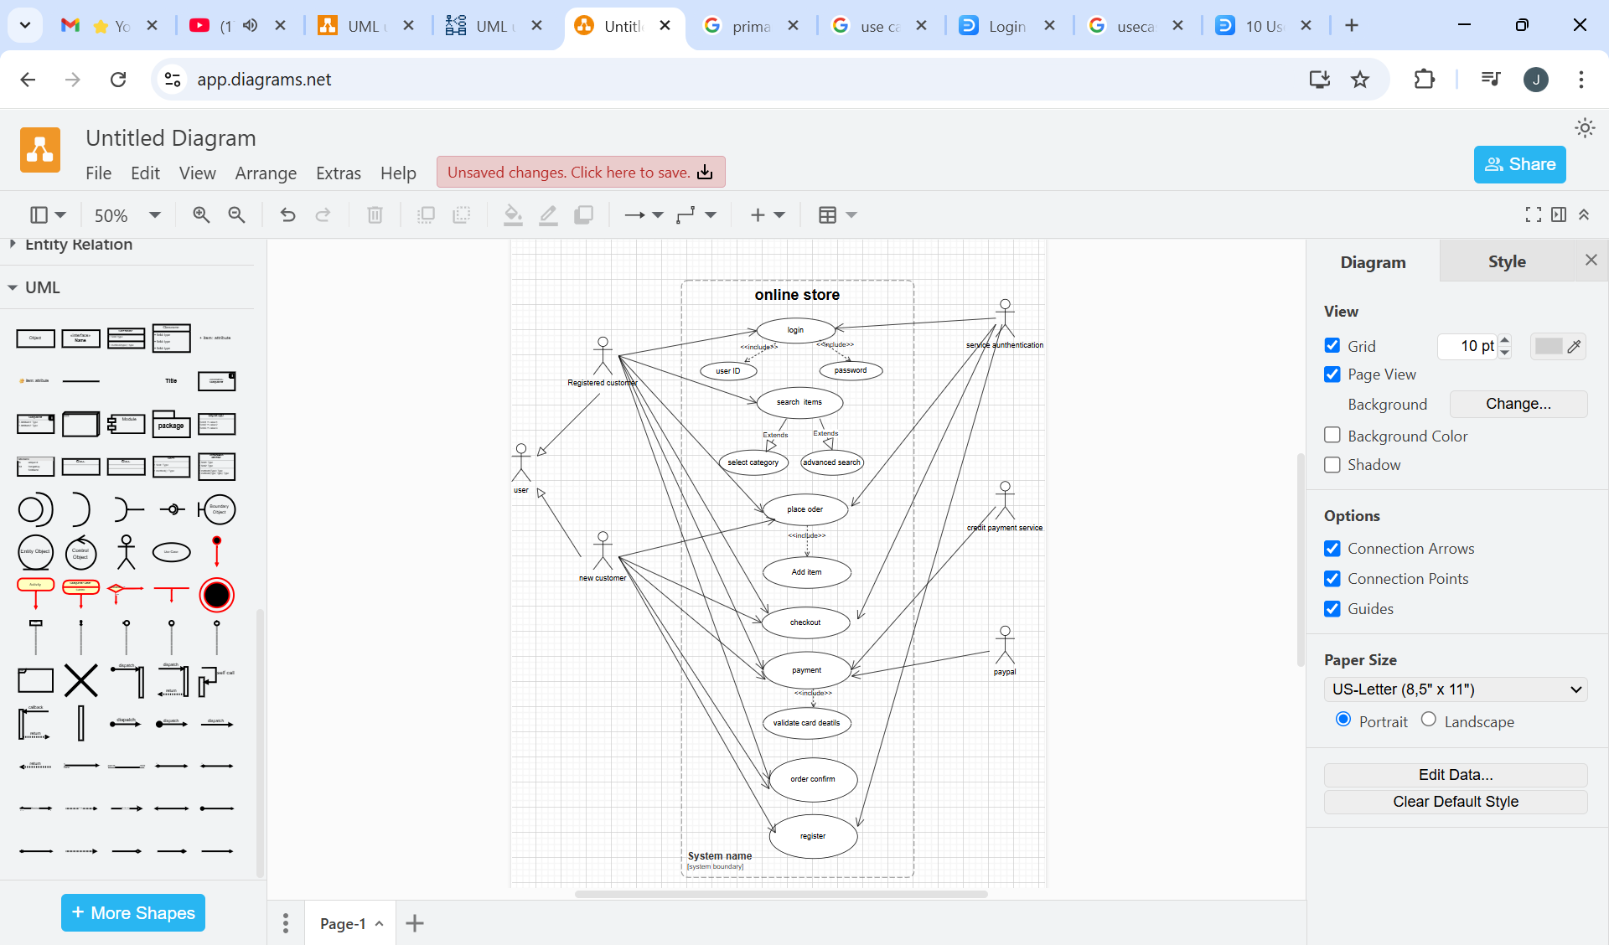

1. **USECASE SPECIFICATION DOCUMENT:**

|  |  |
| --- | --- |
| **Use case Spec** | Login |
| **Description** | When the customer login into the account he/she needs to enter the login details |
| **Actors** | Customer, Authentication System (to validate credentials) |
| **Pre conditions** | The customer has a registered account |
| **post conditions** | The customer is logged into their account  The customer can access their personalized information and perform actions associated with their account. |
| **Basic flow** | The customer enters their username and password on the login page.  The system validates the entered credentials against the stored user data.  If the credentials are valid then the system authenticates the user and logs them into their account. |
| **Alternate flow** | If the credentials entered by the customer are invalid  The system displays an error message indicating the credentials are incorrect  The customer can retry entering their credentials or choose to reset their password. |
| **Exceptional flow** | If the customer's account is locked due to multiple failed login attempts  The system displays a message informing the customer that their account is locked.  The customer can choose to reset their password or contact customer support for assistance. |
| **Assumptions** | Customers have previously registered for an account with valid credentials  Customers are using a compatible web browser or mobile app to access the platform |
| **Constraints** | Usernames cannot be names  At least one number  At least one char  Login attempts may be limited to prevent abuse or unauthorized access |
| **Dependencies** | Depends on the customer's internet connectivity and device capabilities |
| **Inputs-outputs** | Customer's username and password- Successful login message, error messages (for invalid credentials or locked accounts). |
| **Business rules** | Customers must authenticate themselves with valid credentials to access their account |
| **Miscellaneous Information** | The system may offer options for customers to remember their login credentials for future visits  Logging in may grant access to personalized features such as order history, saved items, or account settings |

|  |  |
| --- | --- |
| **Use case Spec 2** | Register |
| **Description** | If a customer is new, he can create a new account |
| **Actors** | Customer |
| **Pre conditions** | The customer has access to a compatible web browser or mobile app |
| **post conditions** | A new customer account is created and stored in the system's database  The customer can log into their newly created account using the registered credentials |
| **Basic flow** | The customer navigates to the registration page or section of the ecommerce platform.  Customer enters their full name, email address, desired username, and password.  The system verifies that the entered email address is unique and in a valid format  The system checks if the chosen username is available and meets any required criteria  The system validates the password against security requirements  If all information is valid then  The system creates a new customer account using the provided details |
| **Alternate flow** | If any entered information (email, username, password) is invalid or does not meet requirements  The system displays error messages indicating the specific issues with the entered data.  The customer is prompted to correct the errors and resubmit the registration form |
| **Exceptional flow** | If the entered email address or username already exists in the system  The system displays an error message informing the customer that the email address or username is already in use.  The customer must choose a different email address or username to proceed with registration |
| **Assumptions** | Customers provide accurate and valid registration information  customers have internet connectivity and are able to access the registration page |
| **Constraints** | Password must include one char,one lower case,one special char |
| **Dependencies** | Registration process |
| **Inputs-outputs** | Customer's full name, email address, desired username, password –successful registration |
| **Business rules** | Valid username,for password or username don’t choose the last name or personal details |
| **Miscellaneous Information** | The system may require customers to verify their email address through a confirmation link sent via email. |

|  |  |
| --- | --- |
| **Use case Spec 3** | Search catalog |
| **Description** | Customers enter the search product parameters and request a search product |
| **Actors** | Customers |
| **Pre conditions** | The product database contains relevant items for searching |
| **post conditions** | The system search through products category in data base and gives information |
| **Basic flow** | Customers’ needs to logged in  Customers search the desired products  Items should be displayed according to the searching |
| **Alternate flow** | If no products match the search criteria  The system displays a message indicating no results were found.  The customer can modify their search query or browse categories |
| **Exceptional flow** | If the customer submits an empty search query  The system may ignore the empty query and display default or trending products |
| **Assumptions** | Customers enter search queries using valid keywords or product names |
| **Constraints** | Search results may be limited by customer-specific filters or preference |
| **Dependencies** | Depends on the availability of the ecommerce platform's search functionality and product database. |
| **Inputs-outputs** | Customer's search query- List of products matching the search criteria, error message (if no results found) |
| **Business rules** | Search functionality may include advanced filters such as price range, brand, or product category |
| **Miscellaneous Information** | Customers may have the option to save or bookmark search results for future reference |

|  |  |
| --- | --- |
| **Use case Spec 4** | Adding to cart |
| **Description** | how a customer adds products to their shopping cart on the ecommerce platform |
| **Primary/secondary Actors** | Customer/ product Inventory System` |
| **Pre conditions** | The customer is logged into their account (if required for adding products to cart). |
| **post conditions** | The customer is logged into their account (if required for adding products to cart).  The shopping cart reflects the updated total and product quantity |
| **Basic flow** | User needs to search the products  The system stores and track the information about the product  User if he/she finds the desired product need to be added in the cart |
| **Alternate flow** | If the selected product is not available  The system displays a message indicating that the product is unavailable  Customer may choose to remove the product from their cart or continue shopping. |
| **Exceptional flow** | If an unauthorized user attempts to add products to the cart without logging in  The system may redirect the user to the login or registration page.  Once authenticated, the customer can proceed with adding products to the cart |
| **Assumptions** | Customers have access to the product detail pages and can navigate the ecommerce platform |
| **Constraints** | Minimum oder quantities |
| **Dependencies** | Needs to registered |
| **Inputs-outputs** | i/p –searching o/p-added to cart |
| **Business rules** | Return /exchange policies |
| **Miscellaneous Information** | Customers may have the option to modify quantities or remove products from the cart before proceeding to checkout. |

|  |  |
| --- | --- |
| **Use case Spec 5** | Make payment |
| **Description** | Once the user completes the shopping he request to checkout and should make payment |
| **Actors** | Customer, Payment Gateway |
| **Pre conditions** | Needs to checkout, update the customer info, the total price shows to the user |
| **post conditions** | Shows mode of payment (credit card/debit card/upi/cod)  Authentication of OTP  Payment confirmation  Invoice |
| **Basic flow** | Search the product  Farmer finds out the products  Products are added to buy later  Products are added to cart  Farmer needs to checkout  Shows the total bill  Make the payment using payment options |
| **Alternate flow** | The customer make payment with discount coupon or with gift card |
| **Exceptional flow** | Incorrect payment details |
| **Assumptions** | Basic knowledge |
| **Constraints** | While doing transaction do not go back |
| **Dependencies** | Strong internet connection, OTPs |
| **Inputs-outputs** | I/p-Cards/cash o/p- product ordered successfully |
| **Business rules** | Do not refresh |
| **Miscellaneous Information** | Multiple currencies and payment methods may be supported based on platform capabilities and customer preferences |

|  |  |
| --- | --- |
| **Use case Spec 6** | Place order |
| **Description** | Allow a customer to select items and place an order for purchase. |
| **Primaryactor /secondary actor** | Customer/payment gateway |
| **Pre conditions** | The customer is logged into the system.  The customer has selected one or more items to purchase. |
| **post conditions** | Order is stored in the system with status "Confirmed".  Customer receives an order confirmation email. |
| **Basic flow** | Customer selects items to purchase.  System calculates the total cost including taxes and shipping.  Customer confirms the order.  System sends payment information to the Payment Gateway.  Payment Gateway processes payment.  System updates order status to "Confirmed" |
| **Alternate flow** | Payment Declined  System informs customer of declined payment.  Customer can retry payment or cancel order. |
| **Exceptional flow** | The customer fails to provide a complete or valid shipping address. The payment processing fails due to issues like network problems, timeout errors, or payment gateway issues. |
| **Assumptions** | Customers have valid payment methods.  Items selected by the customer are in stock. |
| **Constraints** | Payment must be successfully processed before order confirmation. |
| **Dependencies** | Depends on the availability of products and the Payment Gateway service. |
| **Inputs-outputs** | Selected items, shipping details, payment information-Order confirmation email, updated order status |
| **Business rules** | Orders can only be placed during business hours.  Discounts may apply based on promotional rules. |
| **Miscellaneous Information** | The system supports multiple payment methods (credit card, PayPal.).  Orders can be canceled within 24 hours of placement. |

|  |  |
| --- | --- |
| **Use case Spec 7** | Checkout |
| **Description** | When customer proceeds with the checkout after reviewing their shopping cart. It includes providing shipping information, selecting a payment method, applying any available discounts, reviewing the order, and finally confirming the purchase. |
| **Primaryactor /secondary actor** | Customer/payment gateway |
| **Pre conditions** | The customer is logged into the system (if required).  The customer has at least one product in their shopping cart.  The customer has provided necessary information (shipping address, payment method) and the cart is ready for checkout. |
| **post conditions** | The customer’s order is confirmed, and payment is processed. An order is created in the order management system, and an email confirmation is sent to the customer.  The checkout process does not complete due to errors (invalid payment, inventory issues, or missing information). |
| **Basic flow** | The customer navigates to the shopping cart and reviews the products, quantities, and prices.  The customer clicks the “Checkout” button to initiate the checkout process.  The system asks the customer to confirm or enter their shipping address. The customer fills in the required details (address, phone number, etc.).  The customer selects a shipping method from available options (standard, expedited, express).  The customer may apply a coupon code for discounts  The customer reviews the final order, including the product list, shipping method, total cost, taxes, and any applied discounts.  The customer enters their payment details (credit card, PayPal, etc.).  The system processes the payment via the payment gateway. If the payment is successful, the system proceeds to the next step.  Once payment is processed successfully, the system confirms the order and displays a summary of the order details (including an order ID).  The system sends an order confirmation email to the customer, including the order details and estimated delivery date.  The inventory system updates the stock for the purchased items.  The order is saved in the order management system and is ready for fulfilment. |
| **Alternate flow** | Payment Declined’  System informs customer of declined payment.  Customer can retry payment or cancel order. |
| **Exceptional flow** | The customer fails to provide a complete or valid shipping address. The payment processing fails due to issues like network problems, timeout errors, or payment gateway issues. |
| **Assumptions** | Customers have valid payment methods.  Items selected by the customer are in stock. |
| **Constraints** | Payment must be successfully processed before order confirmation. |
| **Dependencies** | Depends on the availability of products and the Payment Gateway service. |
| **Inputs-outputs** | Selected items, shipping details, payment information-Order confirmation email, updated order status |
| **Business rules** | Orders can only be placed during business hours.  Discounts may apply based on promotional rules. |
| **Miscellaneous Information** | The system supports multiple payment methods (credit card, PayPal.).  Orders can be canceled within 24 hours of placement. |

1. **Constraints:**

* **Legal constraints:** The system must ensure that all user data is processed in compliance with GDPR and any applicable eCommerce laws.
* **Technical Constraints:** The platform should be compatible with popular browsers (Chrome, Firefox) and mobile devices (iOS and Android).

1. **Appendices:**

* **Glossary:** Definitions for ecommerce-specific terms.
* **References:** References to standards, libraries, and tools used in the development process.

**3. Make an ERD of creating a support ticket/Ticketing life cycle.**

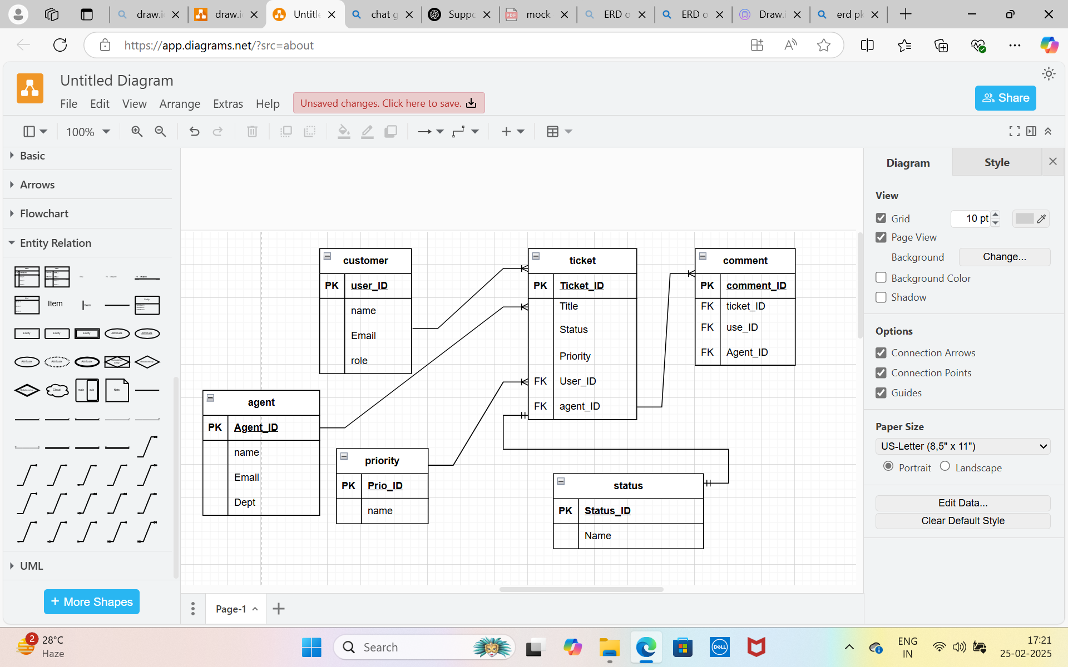

1. **User story of shopping from ecommerce.**

|  |
| --- |
| **User Story No: 1 Tasks: 4 Priority: high** |
| **AS A** CUSTOMER, **I WANT TO** BROWSE PRODUCTS BY CATEGORY, **SO THAT** I CAN EASILY FIND THE ITEMS IM INTERESTED IN. |
| **BV: 500 CP: 5** |
| **ACCEPTANCE CRITERIA:**  products are organized into categories (Electronics, Fashion).  Categories are visible on the homepage or navigation bar. |

|  |
| --- |
| **User Story No: 2 Tasks:4 Priority: HIGH** |
| **AS A** CUSTOMER, **I WANT TO** SEARCH FOR PRODUCTS BY KEYWORDS, **SO THAT** I CAN QUICKLY FIND THE ITEMS I AM LOOKING FOR. |
| **BV: 1000 CP: 5** |
| **ACCEPTANCE CRITERIA:**  The search bar is easily accessible.  Results are returned based on the search keywords. |

|  |
| --- |
| **User Story No: 3 Tasks: 4 Priority: high** |
| **AS A** CUSTOMER, **I WANT TO** FILTER PRODUCTS BY PRICE, RATINGS, BRAND, AND OTHER CRITERIA, **SO THAT** I CAN NARROW DOWN MY SEARCH RESULTS TO MY PREFERENCES. |
| **BV: 500 CP: 8** |
| **ACCEPTANCE CRITERIA:**  Filters can be applied on the search results page.  Filters include price range, brand, ratings, etc. |

|  |
| --- |
| **User Story No: 4 Tasks: 3 Priority: MEDIUM** |
| **AS A** CUSTOMER, **I WANT TO** SORT PRODUCTS BY PRICE, RATING, AND OTHER CRITERIA, **SO THAT** I CAN EASILY FIND THE BEST OPTIONS. |
| **BV: 200 CP: 5** |
| **ACCEPTANCE CRITERIA:**  Sorting options are available on the product listing page (price low-high, high-low).  Sorting updates the product list. |

|  |
| --- |
| **User Story No: 5 Tasks: 4 Priority: HIGH** |
| **AS A** CUSTOMER, **I WANT TO** VIEW DETAILED INFORMATION ABOUT A PRODUCT, **SO THAT** I CAN MAKE AN INFORMED PURCHASE DECISION. |
| **BV: 1000 CP: 8** |
| **ACCEPTANCE CRITERIA:**  Product page contains detailed descriptions, images, price, and specifications.  Users can view customer reviews. |

|  |
| --- |
| **User Story No: 6 Tasks:4 Priority:HIGH** |
| **AS A** CUSTOMER, **I WANT TO** ADD PRODUCTS TO MY SHOPPING CART, **SO THAT** I CAN REVIEW MY ITEMS BEFORE CHECKOUT. |
| **BV: 500 CP: 5** |
| **ACCEPTANCE CRITERIA:**  The user can add items to the cart with quantity options.  Cart icon updates with the number of items. |

|  |
| --- |
| **User Story No: 7 Tasks: 4 Priority: HIGH** |
| **AS A** CUSTOMER, **I WANT TO** VIEW THE CONTENTS OF MY SHOPPING CART, **SO THAT** I CAN REVIEW ITEMS BEFORE CHECKOUT. |
| **BV: 200 CP: 5** |
| **ACCEPTANCE CRITERIA:**  Cart page shows item names, quantities, prices, and total.  Users can modify quantities or remove items. |

|  |
| --- |
| **User Story No: 8 Tasks: 3 Priority: HIGH** |
| **AS A** CUSTOMER, **I WANT TO** PROCEED TO CHECKOUT FROM MY CART, **SO THAT** I CAN COMPLETE MY PURCHASE. |
| **BV: 1000 CP: 5** |
| **ACCEPTANCE CRITERIA:**  The user can click "Proceed to Checkout" and be taken to the checkout page.  Cart details are carried over to the checkout page. |

|  |
| --- |
| **User Story No: 9 Tasks: 4 Priority:HIGH** |
| **AS A** CUSTOMER, **I WANT TO** LOG IN OR CREATE AN ACCOUNT, **SO THAT** I CAN SAVE MY INFORMATION AND TRACK MY ORDERS. |
| **BV: 500 CP: 8** |
| **ACCEPTANCE CRITERIA:**  Users can log in with email/password or social media accounts.  New users can create an account by entering necessary details. |

|  |
| --- |
| **User Story No:10 Tasks: 4 Priority:MEDIUM** |
| **AS A** CUSTOMER, **I WANT TO** APPLY A DISCOUNT CODE AT CHECKOUT, **SO THAT** I CAN SAVE MONEY ON MY PURCHASE. |
| **BV: 200 CP: 5** |
| **ACCEPTANCE CRITERIA:**  The user can enter a valid discount code.  The discount is applied to the total order amount. |

|  |
| --- |
| **User Story No: 11 Tasks: 4 Priority: HIGH** |
| **AS A** CUSTOMER, **I WANT TO** CHOOSE MY PREFERRED PAYMENT METHOD, **SO THAT** I CAN PAY SECURELY AND CONVENIENTLY. |
| **BV: 1000 CP:13** |
| **ACCEPTANCE CRITERIA:**  Payment methods include credit card, PayPal, and other options.  Payment method selection is seamless. |

|  |
| --- |
| **User Story No: 12 Tasks:4 Priority: HIGH** |
| **AS A** CUSTOMER, **I WANT TO** ENTER MY SHIPPING ADDRESS, **SO THAT** MY ORDER IS DELIVERED TO THE CORRECT LOCATION. |
| **BV: 1000 CP: 5** |
| **ACCEPTANCE CRITERIA:**  Users can enter a new shipping address or select an existing one.  Address fields are validated for accuracy. |

|  |
| --- |
| **User Story No: 13 Tasks:4 Priority:HIGH** |
| **AS A** CUSTOMER, **I WANT TO** REVIEW MY ORDER SUMMARY BEFORE FINALIZING THE PURCHASE, **SO THAT** I CAN CONFIRM THE ITEMS, PRICES, AND SHIPPING DETAILS. |
| **BV: 500 CP: 8** |
| **ACCEPTANCE CRITERIA:**  The order summary displays items, quantities, total price, and shipping information.  Users can go back to make changes before confirming the order. |

|  |
| --- |
| **User Story No: 14 Tasks: 4 Priority: HIGH** |
| **AS A** CUSTOMER, **I WANT TO** COMPLETE MY PURCHASE, **SO THAT** I CAN FINALIZE MY ORDER AND RECEIVE AN EMAIL CONFIRMATION. |
| **BV: 1000 CP: 8** |
| **ACCEPTANCE CRITERIA:**  The user receives an order confirmation email after completing the purchase.  Order details are displayed on the confirmation page. |

|  |
| --- |
| **User Story No: 15 Tasks: 4 Priority: MEDIUM** |
| **AS A** CUSTOMER, **I WANT TO** TRACK THE STATUS OF MY ORDER, **SO THAT** I CAN SEE WHEN MY ITEMS WILL BE DELIVERED. |
| **BV: 500 CP: 8** |
| **ACCEPTANCE CRITERIA:**  The user can view order status (processing, shipped, delivered).  Order status updates in real time. |

|  |
| --- |
| **User Story No: 16 Tasks: 4 Priority:MEDIUM** |
| **AS A** CUSTOMER, **I WANT TO** REQUEST A RETURN FOR AN ITEM, **SO THAT** I CAN GET A REFUND IF THE PRODUCT IS DEFECTIVE OR UNWANTED. |
| **BV: 200 CP: 8** |
| **ACCEPTANCE CRITERIA:**  The user can initiate a return from their order history page.  Instructions for returning the item are provided. |

|  |
| --- |
| **User Story No:17 Tasks: 4 Priority: LOW** |
| **AS A** CUSTOMER, **I WANT TO** LEAVE A REVIEW FOR A PRODUCT I PURCHASED, **SO THAT** OTHER CUSTOMERS CAN MAKE INFORMED DECISIONS. |
| **BV: 200 CP: 5** |
| **ACCEPTANCE CRITERIA:**  Users can submit ratings (1-5 stars) and leave written feedback.  Reviews are displayed on the product page |

|  |
| --- |
| **User Story No: 18 Tasks:4 Priority:MEDIUM** |
| **AS A** CUSTOMER, **I WANT TO** CREATE A WISHLIST, **SO THAT** I CAN SAVE PRODUCTS FOR FUTURE PURCHASE. |
| **BV: 100 CP: 8** |
| **ACCEPTANCE CRITERIA:**  Users can add items to their wishlist.  Wishlist can be accessed from the user account. |

|  |
| --- |
| **User Story No: 19 Tasks:4 Priority:LOW** |
| **AS A** CUSTOMER, **I WANT TO** VIEW MY PAST ORDERS, **SO THAT** I CAN TRACK WHAT I'VE PURCHASED. |
| **BV: 50 CP: 2** |
| **ACCEPTANCE CRITERIA:**  Users can view details of past orders (items, prices, shipping details).  Users can reorder items from past orders. |

|  |
| --- |
| **User Story No: 20 Tasks: 3 Priority:MEDIUM** |
| **AS A** CUSTOMER, **I WANT TO** UPDATE MY ACCOUNT INFORMATION, **SO THAT** MY DETAILS ARE CURRENT |
| **BV:500 CP:3** |
| **ACCEPTANCE CRITERIA:**  Users can update their email address, password, and personal information.  Changes are saved securely. |

|  |
| --- |
| **User Story No: 21 Tasks: 3 Priority: medium** |
| AS A CUSTOMER  I WANT TO CHOOSE FROM DIFFERENT SHIPPING METHODS  SO THAT I CAN PICK THE BEST DELIVERY OPTION FOR ME. |
| **BV: 200 CP: 5** |
| **ACCEPTANCE CRITERIA:**  User can choose between available shipping methods.  The correct shipping cost and estimated date are shown. |

|  |
| --- |
| **User Story No: 22 Tasks: Priority: MEDIUM** |
| AS A CUSTOMER  I WANT TO APPLY DISCOUNT CODES DURING CHECKOUT    SO THAT I CAN SAVE MONEY ON MY PURCHASES. |
| **BV: 200 CP: 4** |
| **ACCEPTANCE CRITERIA:**  Users can apply valid discount codes.  Discount is correctly applied and reflected in the total. |

|  |
| --- |
| **User Story No: 22 Tasks: 2 Priority:** |
| AS A CUSTOMER  I WANT TO TRACK MY ORDER STATUS  SO THAT I CAN SEE WHEN MY ITEMS WILL ARRIVE |
| **BV: 100 CP: 7** |
| **ACCEPTANCE CRITERIA:**  Users can track their orders with tracking number.  Tracking information is updated in real-time. |

|  |
| --- |
| **User Story No: 23 Tasks: 3 Priority: medium** |
| AS A CUSTOMER  I WANT TO CHECK OUT AS A GUEST  SO THAT I DON’T NEED TO CREATE AN ACCOUNT. |
| **BV: 50 CP: 5** |
| **ACCEPTANCE CRITERIA:**  Users can complete checkout without registering.  Account creation is optional post purchase. |

|  |
| --- |
| **User Story No: 25 Tasks: 4 Priority: low** |
| AS A CUSTOMER  I WANT TO LOG IN USING MY SOCIAL MEDIA ACCOUNTS  SO THAT I CAN QUICKLY CREATE AN ACCOUNT OR LOG IN. |
| **BV: 200 CP: 5** |
| **ACCEPTANCE CRITERIA:**  Users can log in using social media credentials.  User data is linked correctly to the profile. |

|  |
| --- |
| **User Story No: 26 Tasks: 2 Priority:high** |
| AS AN INTERNATIONAL SHOPPER,  I WANT TO PAY IN MY LOCAL CURRENCY  SO THAT I CAN BETTER UNDERSTAND THE PRICE. |
| **BV: 100 CP: 8** |
| **ACCEPTANCE CRITERIA:**  Currency changes automatically based on location or selection.  Prices are displayed in the correct currency. |

|  |
| --- |
| **User Story No: 27 Tasks: 2 Priority: high** |
| AS A CUSTOMER  I WANT A MOBILE-FRIENDLY DESIGN  SO THAT I CAN SHOP EASILY ON MY PHONE. |
| **BV: 1000 CP: 8** |
| **ACCEPTANCE CRITERIA:**  The site is responsive and functional on mobile devices.  No issues with navigation, checkout, or browsing. |

|  |
| --- |
| **User Story No:28 Tasks: 2 Priority: medium** |
| AS AN INTERNATIONAL SHOPPER,  I WANT TO SHOP IN MY PREFERRED LANGUAGE  SO THAT I CAN NAVIGATE THE SITE EASILY. |
| **BV: 100 CP: 7** |
| **ACCEPTANCE CRITERIA:**  Users can select their preferred language.  All site content is available in the chosen language |

|  |
| --- |
| **User Story No: 29 Tasks: 3 Priority: high** |
| AS A CUSTOMER  I WANT LIVE CHAT SUPPORT  SO THAT I CAN QUICKLY GET ANSWERS TO MY QUESTIONS. |
| **BV: 200 CP: 5** |
| **ACCEPTANCE CRITERIA:**  Live chat is easily accessible.  Users can get real-time responses from support agents. |

|  |
| --- |
| **User Story No: 30 Tasks:2 Priority:medium** |
| AS A CUSTOMER  I want to see product demonstration videos  so that I can understand how the product works. |
| **BV: 100 CP: 6** |
| **ACCEPTANCE CRITERIA:**  Product pages display relevant video demonstrations.  Videos are clear and load properly. |

|  |
| --- |
| **User Story No: 31 Tasks: 3 Priority: high** |
| AS AN ADMIN,  I WANT TO MANAGE PRODUCT LISTINGS  SO THAT I CAN ADD, UPDATE, OR REMOVE PRODUCTS AS NEEDED. |
| **BV: 500 CP: 8** |
| **ACCEPTANCE CRITERIA:**  Admin can successfully add, update, or delete products.  Changes are reflected immediately on the storefront. |

|  |
| --- |
| **User Story No: 32 Tasks: 3 Priority:high** |
| AS AN ADMIN,  I WANT TO MANAGE INVENTORY LEVELS  SO THAT THE STOCK COUNT IS ACCURATE AND UPTODATE. |
| **BV: 500 CP: 8** |
| **ACCEPTANCE CRITERIA:**  Admin can manually adjust inventory levels.  Notifications are triggered for low stock items.  The inventory count is updated across the platform in real time. |

|  |
| --- |
| **User Story No:33 Tasks: 3 Priority: high** |
| AS AN ADMIN,  I WANT TO MANAGE ORDERS  SO THAT I CAN VIEW, PROCESS, AND UPDATE CUSTOMER ORDERS. |
| **BV: 200 CP: 5** |
| **ACCEPTANCE CRITERIA:**  Admin can view all customer orders and their status.  Admin can update the status or cancel orders.  Refunds and cancellations are processed smoothly. |

|  |
| --- |
| **User Story No:35 Tasks: 3 Priority: high** |
| AS AN ADMIN,  I WANT TO HANDLE CUSTOMER SUPPORT REQUESTS  SO THAT I CAN RESOLVE CUSTOMER ISSUES EFFICIENTLY. |
| **BV: 100 CP: 5** |
| **ACCEPTANCE CRITERIA:**  Admin can view all incoming support tickets.  Admin can respond and resolve issues directly through the system.  Users receive notifications when their tickets are updated or resolved. |

|  |
| --- |
| **User Story No: 36 Tasks: 3 Priority: low** |
| AS AN ADMIN,  I WANT TO CREATE AND MANAGE DISCOUNTS AND PROMOTIONAL OFFERS  SO THAT I CAN DRIVE SALES. |
| **BV: 200 CP: 6** |
| **ACCEPTANCE CRITERIA:**  Admin can create, edit, and delete discount codes.  Discounts are applied automatically during checkout.  Admin can set the start and end dates for each promotion. |

|  |
| --- |
| **User Story No: 37 Tasks: 3 Priority:medium** |
| AS AN ADMIN,  I WANT TO VIEW SALES ANALYTICS  SO THAT I CAN TRACK REVENUE, POPULAR PRODUCTS, AND CUSTOMER TRENDS. |
| **BV: 200 CP: 6** |
| **ACCEPTANCE CRITERIA:**  Admin can access a detailed sales dashboard.  Admin can filter sales data by various time periods.  Key performance indicators (KPIs) are clearly displayed. |

|  |
| --- |
| **User Story No: 38 Tasks: 3 Priority: medium** |
| AS AN ADMIN,  I WANT TO MANAGE SHIPPING OPTIONS AND FEES  SO THAT CUSTOMERS ARE CHARGED CORRECTLY FOR SHIPPING |
| **BV: 1000 CP: 6** |
| **ACCEPTANCE CRITERIA:**  Admin can create and modify shipping zones.  Shipping fees are calculated based on the customer’s location and order.  Delivery times are updated and visible to customers. |

|  |
| --- |
| **User Story No: 39 Tasks: 3 Priority:low** |
| AS AN ADMIN,  I WANT TO MODERATE AND MANAGE PRODUCT REVIEWS  SO THAT I CAN ENSURE THAT THEY MEET GUIDELINES. |
| **BV: 200 CP: 2** |
| **ACCEPTANCE CRITERIA:**  ADMIN CAN APPROVE, REJECT, OR DELETE PRODUCT REVIEWS.  ADMIN CAN FLAG REVIEWS FOR FURTHER REVIEW.  USERS ARE NOTIFIED ABOUT THE STATUS OF THEIR REVIEWS. |

|  |
| --- |
| **User Story No: 40 Tasks: 2 Priority: high** |
| AS AN ADMIN,  I WANT TO SET UP AND MANAGE TAX RATES  SO THAT CUSTOMERS ARE CHARGED THE CORRECT AMOUNT BASED ON THEIR LOCATION. |
| **BV: 500 CP: 8** |
| **ACCEPTANCE CRITERIA:**  Tax rates are correctly configured based on regions.  Taxes are applied correctly during checkout based on user location.  Admin can adjust tax settings as needed. |